
Skills for the Workplace
Module Assignment Submission
Student Name: | Kirsty Thomas
Student Number: | 1911073
Module No: | BMSK4005
Module Title: | Professional Career Development

Statement of Confirmation of Authenticity
By the act of making this submission, the student declares that this is the work of the student named above. The work has not, in whole or in part, been knowingly presented elsewhere for assessment, or where assessment has been built on a previous assessment, this has been identified. Where materials have been used from other sources it has been properly acknowledged. If this statement is untrue, the student acknowledges that an assessment offence has been committed.
Attention is drawn to the plagiarism and unfair practice policies of both the University and of ILM.

Table of Contents
Section 1: Know how to identify development needs 3
1.1 Identify learning styles for self and another 3
1.2 Use a simple technique for identifying development needs for self & another 4
1.3 Identify potential barriers to learning for self and another. 5
1.4 Explain how these barriers to learning can be overcome. 6
Section 2: Know how to develop self & others to achieve organisational objectives 6
2.1 Analyse learning/development options to meet needs of self & another. 6
2.2 Identify support mechanisms for the development of self & another 6
2.3 Prepare development plans for yourself and another person 7
2.4 Method used to monitor the development of self & another. 8
Section 3: Know how to prepare for the recruitment process 8
Reflection on the recruitment process 8
3.1 Description 8
3.2 Feelings 9
3.3 Evaluation 9
3.4 Analysis 9
3.5 Conclusion 9
3.6 Action Plan 9
References 10
Appendix A 10
Appendix B 10
Appendix C 10
Appendix D 10

Section 1: Know how to identify development needs

Throughout this assignment I will be utilising various methods and models to determine my own learning style and the learning style of my sister. I will then go on analyzing my findings by using tools available to me to identify my own development needs and the development needs of my sister. This will allow us to recognize any potential barriers we may face and describe how we plan to overcome them and turn those barriers into our strengths. In addition, I will discuss ways in which I will be able to monitor my development going forward.
Later, I will look into the employment process. From creating a CV and a covering letter, to the interview and reflection after employment.

1.1 Identify learning styles for self and another

Every individual learns and develops in different and diverse ways and there are several tools that have been created that can be used to establish a person's learning styles. For the purpose of this assignment I will be using the VARK (Neil Flemming 1987).
Together with Honey and Mumford (Honey and Mumford, 1986) which are widely used academically and in the workplace. Both of these models offer a questionnaire to complete and the results are then provided for the user. The two suggest that there are different learning styles. It gives each style a description on how they learn and retrieve information. This will give an individual an insight to the way in which they learn and then can hopefully go on to learn in a way that works for them. Myself and my sister have both taken the two questionnaires and below are results from both questionnaires for myself and my sister.
Neil Flemming, a teacher from New Zealand, designed a module called Vark. Listed below are the categories in which he has categorized ways people learn. (Fleming, N., and Baume, D. 2006)
- Visual - works with graphs, diagrams, colour and shape
- Aural - talks, debates, discusses
- Read/write - notes, list, text format
- Kinesthetic - real life experiences, documentaries, action
- Multimodal - combined preferences for all or a few from V A R K

VARK results
Myself:
Upon completing the VARK questionnaire, the results show that my learning style is Kinesthetic. They describe kinesthetic learners prefer demonstrations, physicality, working as part of a team and doing things with others. It also explains the way I am likely to take in information is by use of all my senses and using a hands on approach. It also states that I'm more likely to take in information by watching videos and looking at photographs and exhibits. intrestly, it mentions that kinesthetic learners are poor at note taking. Laughably, I find this to be true as I often go back to my own note taking and sometimes find myself confused as to what my notes refer to. There is a significant correlation to the results and the way I am as a learner. I struggle to concentrate for long periods of time when I am in a classroom that has no demonstrations or videos. I find I focus more when personal or relatable life experiences are used as examples to explain a particular subject that is being delivered as well as the use of videos or practical work to demonstrate the subject. (VARK,2021)
My Sister:
My sister was given the same results from the VARK questionnaire. She is strongly Kinesthetic too and agreed with the results. In her job she has to work as part of a team and this is how she feels she works best. Also she remembered how she was given a booklet with information to show her how to use the computer programme they have but struggled with it and was able to understand it much better when she was shown how to use it. She also learnt a lot from trial and error. (VARK,2021)

HONEY AND MUMFORD RESULTS
Peter honey and Alan Mumford were colleagues who came together to create this module to find out the way managers learn. It was established from Kolb’s learning styles model (Leaver, 2005) they categorize learning styles as:
- Activist - Learn by doing
- Theorists - Understand theories, statistics, facts
- Pragmatist - Apply learning to real life
- Reflector - Observation and reflecting
(Honey, P., 2011)

Myself:
The Honey and Mumford results show that I am a reflector, activist and somewhat of a pragmatist too. When comparing my results with the VARK results, they both correlate with each other. Again my results from this questionnaire show that I learn by doing things or experiences from others. As well as wanting to see how I can apply what I’ve learnt to actuality. I am very much of an observer and like to sit back and watch and listen to other opinions before I give my own input. I tend to appear shy in groups, however, that is only because I like to obseve.
My Sister:
Interestingly, my sister's results show that she learns by a way of combining all four learning styles with the learning style theorist taking a slight lead. When my sister read the results she was surprised but after reading the explanation of all four styles, she agreed. Certain subjects she prefers to watch and then do and then other subjects she likes to understand the theory behind it. (Mint HR, 2021)
Together these results provide important insights into our learning styles and how everyone learns in different ways.

1.2 Use a simple technique for identifying development needs for self & another

To identify my development needs and the development needs of my sister, I will conduct a SWOT analysis. By completing this SWOT analysis, we can then identify weaknesses that may hinder our learning and career growth and look to turn those weaknesses into strengths. Any threats that we may face, we can then look to turn them into opportunities. If certain steps are taken we can do both so that we make sure we grow throughout our career.

SWOT for myself

STRENGTHS  Able to work under pressure  Good at practical work  Dealing with the public | WEAKNESSES  Procrastinating  Time management  The need to please everyone
OPPORTUNITIES  Time management course  Run my our pub | THREATS  childcare  Work

SWOT My Sister

STRENGTHS  Good at admin  Good with IT  Punctual | WEAKNESSES  procrastinate  prefectionist
OPPORTUNITIES  work from home  Become a virtual assistant to deal with admin jobs | THREATS  Child Care  Distant to work

1.3 Identify potential barriers to learning for self and another.

My sister and I are both single parents so childcare is one of the main barriers for both of us with work and learning. The cost of sending children to a nursery is somewhat expensive so this is another factor to consider. My sister also has to travel an hour to get to and from work. And with the times of day that she makes her journey, there is heavy traffic and this can cause her to be late sometimes.
In my job, every now and then I don't always finish when my shift is supposed to end. An incident can happen that can prevent me leaving and even keep me there for hours after I was due to finish my shift. Everyday is different in one of my jobs, so we have to start the shift with the expectation of this happening. I also have four jobs and sometimes feel that I take on too much. I haven't quite got the work life balance I want or need.

1.4 Explain how these barriers to learning can be overcome.

Fortunately, my sister and I have a good support system and we are lucky enough to have the help that we need to be able to work and learn. My daughter is almost a teenager and is more independent so she does not require as much of my time as compared to if she was younger.
My sister has put in a request to work from home or for a transfer to work in the office that is closer to home. This will then enable her to take and collect her children from school which will also reduce her nursery costs.
One of my jobs is a flexible contract which means I can pick and choose when I want to work. Moving forward, I will not take a shift on the days that I need to leave on time. This will mean that I am not late to collect my daughter or that I don't miss out on other jobs or classes.
I can take a time management course that can teach me how to manage my jobs and plan for the work life balance I desire. I also intend on planning set days and times for my learning, assessment writing and researching that is needed for my course. Procrastinating is another barrier that I am to overcome. I will research ways in which to manage this and find out ways to aid me when I lose focus and drift off.

Section 2: Know how to develop self & others to achieve organisational objectives

As part of this section, I will discuss developing ourselves to accomplish goals that we set for ourselves or those that arise from our work and/or learning.

2.1 Analyse learning/development options to meet needs of self & another.

In order to determine the best course of action in determining my learning development options, I will use the information collected from the SWOT analysis and other information such as job appraisal feedback and job descriptions to identify our development needs.

2.2 Identify support mechanisms for the development of self & another

In my sister’s job she has regular monthly meetings with staff in her department in which they go over what they need to do or continue doing to improve the quality of their work.
In both pubs I work in we have staff meetings every six months or so to keep updated with any promotions or changes that are happening at the establishment. In those meetings we also discuss what is needed from us as a team and we also express what we need in order to do our jobs to the best of our ability.
In the care home we have monthly meetings to talk about the children we have and the general running of the house. Along with individual “supervision” where each team member meets with management and discusses what I feel I'm doing well at and what I need to improve on or need help with. Management will also express what they feel I need to do or continue doing and anything I may need help with.
Colleagues also play a great part in our development as they may have been there longer than us and are able to give us insight as to what to do and what works best. Sometimes it's good to get a different perspective on the same job that you're doing but from a different person. They're a support mechanism as well as our meeting and supervision for our development.
Whilst at University or through my training assessor in work, after I complete work I will receive feedback from my assessors giving me pointers on what I need to improve on. Whether that will be how I write my assessment, spelling or layout of the actual assessment. All feedback will aid me in bettering my work.

2.3 Prepare development plans for yourself and another person

Part 1: Personal Analysis
See SWOT Analysis in 1.2

Part 2: Setting Goals

What do I want to learn? | What do I have to do? | What support and resources will I need? | How will I measure success? | Target Date for Review
Skills for the workplace | complete CertHE in skills for the workplace | Lecturer  Classes  Library  Classmates  Moodle | completion of the course | 2022
Time management skills | Research time management | setting goals  timetable  ted talks  time management programmes | completing goals  reaching deadlines | 6 months

Part 3: Personal Objectives

Short Term Goals (next 12 months)
Complete the level 4 in CertHE skills for the workplace
Medium Term Goals (2-3 years)
Go on to complete level 5 & 6

Long Term Goals (3-5 years)
Take a course in photography
Start the process of creating my own business in photography

2.4 Method used to monitor the development of self & another.

To monitor my development and my sister's development I will use a learning log like the one I use after every class session. The learning log can be used for many situations and could be used at the end of everyday as the questions can correspond to lessons, the recruitment process and many other things. You can find an example of a learning log in Appendix E. I have completed that learning log on this assignment.

Section 3: Know how to prepare for the recruitment process

In this section of the assignment, I am going to look into the process of preparing for the recruitment process. There are several steps to the recruitment process some are listed as:
- Exploring - Job roles, opportunities, requirements, qualifications.
- Research - Research company, research employers, research what they're looking for in a potential candidate.
- Applying - Application forms, covering letter, CV.
- Interviewing - preparation, questions, presentation of yourself.
- Follow up - Gratitude, questions, feedback. (Maund, Schriek and Tinkler, 2017)
In appendix B-D, you can find a job advert, my CV and covering letter. As shown in Appendix, I have created a CV. This will act as a master CV with all my qualifications and previous employment listed. From there I will create a job specific CV where I will copy and paste the information from my master CV that I feel is related to the job I am applying for on a separate document.

Reflection on the recruitment process

For reflection on the recruitment process I am using the Gibbs reflective cycle. Originally published in Learning by Doing (1988), the model was created by Professor Graham Gibbs. David Kolb's experiential learning cycle (1984) was the basis for Gibbs' model.
I've chosen to use this reflective module because in the interest of being able to dive further into different ways to achieve self-improvement, the use of similar questions makes one think deeper on the situation. Below is a diagram explaining how the process works.
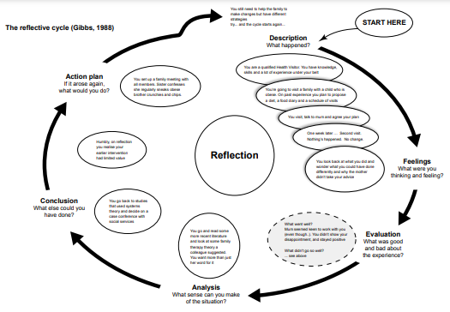

3.1 Description

I was told of a position available at a children's home by my friend’s mother who is a current employee there. She informed me that the position may already be filled as they had interviews all week. I was given the information of the manager there and in an email I attached my CV and covering letter for the position. I wrote in the email that I was aware that the position may already be filled but was hoping that they would consider me for any future positions.
A short while later, I received an email stating the last of the interview’s were being held the next day and asked if I could make the 10am appointment. I informed them that I could. I called my friend’s mother and asked her what type of questions they were asking in the interview to get me somewhat prepared. She shared what she thought I could expect to hear but reassured me that I would be ok.
The interview was taken by the Director of the carehome and the Manager. Firstly, there was a group interview with other interviewee’s. We had to work as a team to explain how we would deal with a situation that they gave to us to handle. The service users were also called into the group interview to ask us some questions too. Then there was an individual interview. During the time I was waiting to have my individual interview, I chatted with other staff that were on shift as well as the service users. In the individual interview I was asked “what would you do in this scenario” questions. They told me that they were making decisions about the role today and they would get in contact with me at some point.
Later in the evening I had a call stating that I had got the position.

3.2 Feelings

The night before, all I felt was panic. I recognised that I was unprepared and overwhelmed that I had just hours to prepare for the interview.
The day of the interview I was feeling extremely nervous because I was interviewing for a job with young people. I had no experience with working with young people in a healthcare setting and was worried that this would be a complication in my recruitment process.
Before the interview started, I chatted to the other interviewee’s and they both had experience in working with children. This made me feel apprehensive as I felt completely under qualified to the two I was interviewing with. They had more input during our group interview in a professional aspect.
I felt a little less anxious during and after the individual interview as I felt I performed better during this time. The questions were pretty much common sense, which I answered from my own experiences or what I would actually do in that scenario instead of what I thought they wanted to hear.
Throughout the day I became very doubtful that I had got the position as time was getting on and I still was yet to hear from them. I felt as though I could have prepared considerably better than I did.
I was extremely overjoyed when the call came through that I had got the position. Especially since I had worried about the process all day.

3.3 Evaluation

What I felt was good about the situation is that I had some advice from someone who was already employed for the position and the home I was applying to work for. This advice helped me to think about what they were looking for from an individual they wanted to employ.
Whilst waiting for my individual interview, I had the opportunity to talk to other employees and the service users. I used this time to ask relevant questions about the home and the position. The service users also asked me questions which allowed them to get to know a little about me. And it revelied things we had in common.
I didn’t feel like I prepared well for this process which led me to take a backseat at times I shouldn't have. I let my nerves take over sometimes and I felt that showed. It was also my first time in a group interview and I didn’t know what to expect which also made me feel overwhelmed.

3.4 Analysis

I realised that they were not just looking for a professional with years of experience working with young people like I thought they were. They were looking for someone that the young people can relate to. The working of the home is to keep it as close as they can to resemble a “normal” family home and they need employees that have the right personal qualities young people need in an adult.

3.5 Conclusion

I definitely could have researched the role and what it entails. I relied on the opinion of an employee and didn't do my own research into the role.
I could have put more input into the group interview. I let the other two interviewees take the lead as I felt I had nothing to give in that part of the interview even though what I wanted to say could have been beneficial to the group.

3.6 Action Plan

If I were to have this situation arise again, I would do several things in order to improve my conduct during this process. I would make sure I did more research on the job role and what the employer was looking for. I would plan for a group interview and prepare for how I would assert myself during that time. I will research how to conduct myself in a group interview and practise with friends and family to gain some experience. I would find ways to overcome my nerves, consequently making me feel more confident in that situation.
Furthermore, I would remind myself to have faith in my ability to prosper even when I am not confident that I will.

References
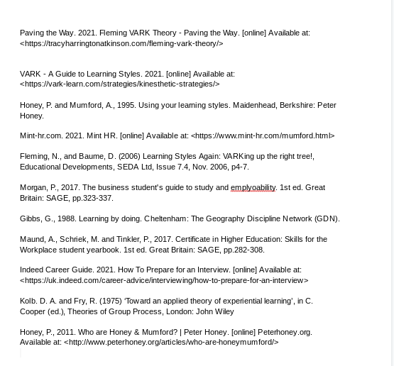

Appendix A

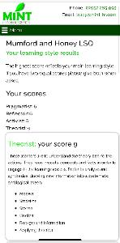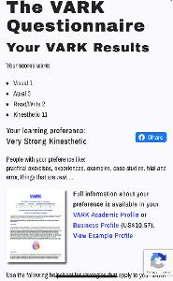

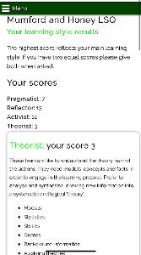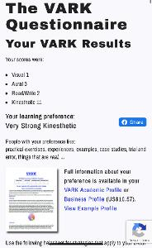

Appendix B

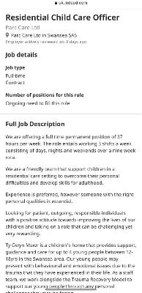

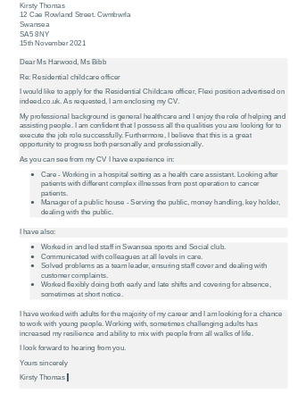

Appendix C
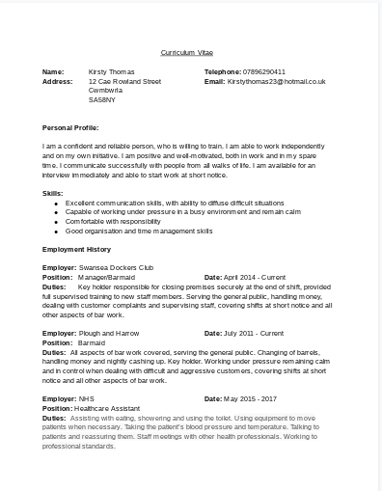

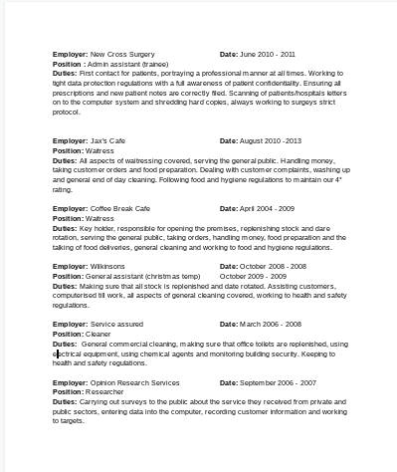

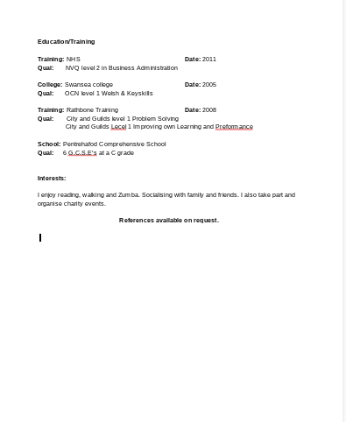

Appendix D

What do I want to learn? | What do I have to do? | What support and resources will I need? | How will I measure success? | Target Date for Review
About virtual assisting | research what virtual assisting entails | Internet  Personal experience  admin course  virtual assisting course | By achieving a position as a virtual assistant part time | 6 months
Procrastinating | find ways to aid with procrastinating | setting goals  timetable  ted talks  setting time for high priority tasks | completing goals  completing tasks  self assessments | 6 months

Short Term Goals (next 12 months)
To move location in work and reduce my hours
Medium Term Goals (2-3 years)
Look into virtual assistance and online admin jobs. Apply for jobs to gain experience

Long Term Goals (3-5 years)
Create my own company that supply virtual assistance



