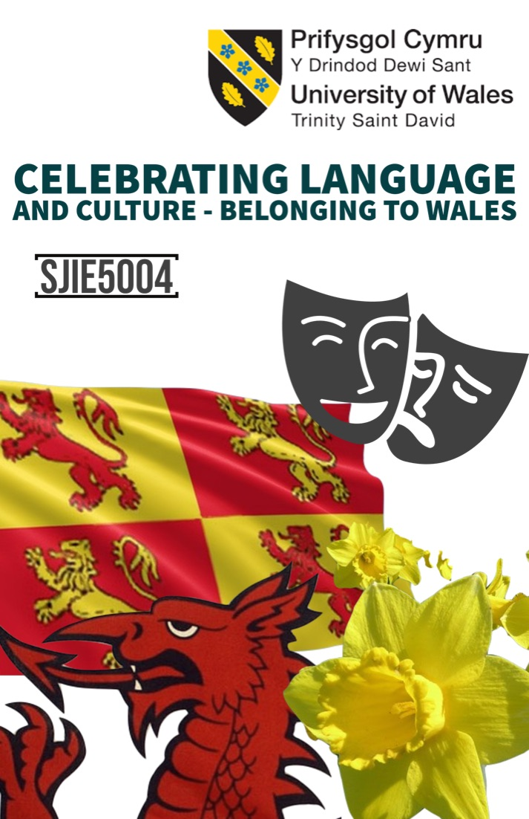
Content

Rationale 3-4

Overview of activities 4-7

Evaluation 8-9

Appendices 10-17

References 18-19

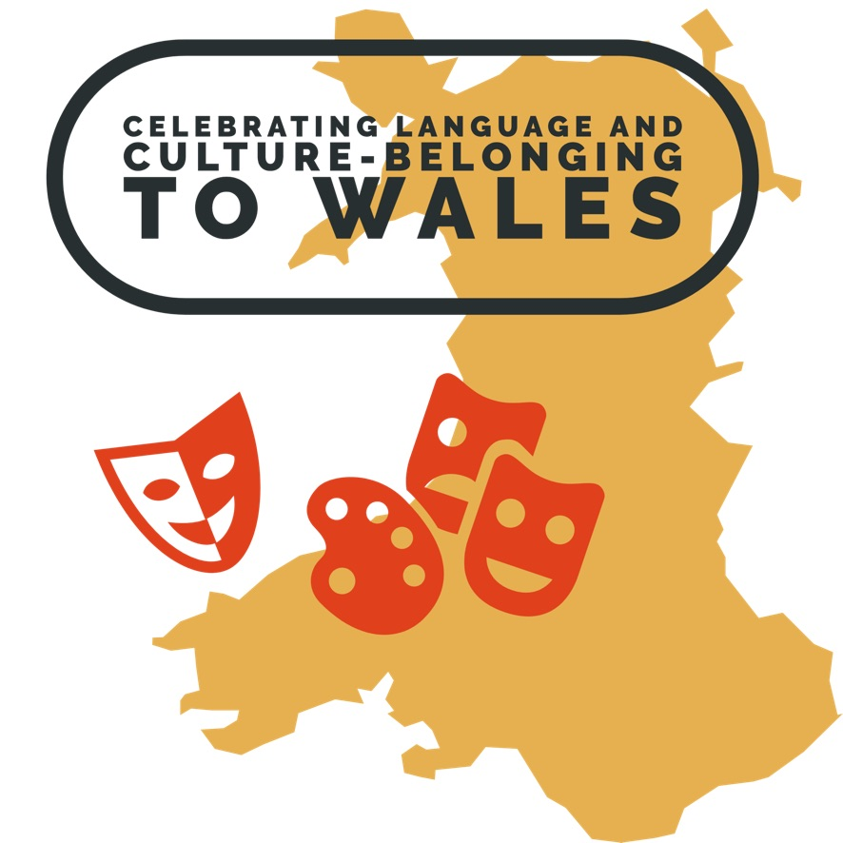

Throughout history, the Welsh language has differed in popularity and at one time could have become lost. Sustaining the Welsh language has forced the Welsh Assembly Government (2017) to create an infrastructure that targets sustainability and development of the Welsh language, announcing the strategy “Cymraeg 2050” to target 1,000,000 people across Wales to be able to speak the Welsh language by 2050.

The Education sector within Wales has been identified in having a significant role in sustaining and developing the Welsh language. The establishment of a separate curriculum to England took place in 1988 but significant steps have been taken in recent years with the Welsh in education action plan 2017–21 being developed by the Welsh Government (2017) has indicated a further emphasis of a curriculum through the medium of Welsh. The Welsh government has targeted Welsh medium education with the emphasis on increasing education through the medium of Welsh. Guidance form the ‘Siarter Iaith’ framework (2019) which allows schools access to resources and advice to conclude a successful curriculum.

“The aim is to embed positive habits and attitudes towards the language through purposeful planning within schools and to promote informal use of it among learners inside and outside school, bringing together various partners to implement.” Welsh Government (2019, p5p1)

Welsh is the language used in the day to day life of school A. Sustaining a Welsh ethos within the school, the local community and beyond is a central part of school A’s work.

According to Donaldson’s Successful Futures report (2015) the curriculum is organised around six key areas of learning and experience. One of those six being the subject Humanities that draws from past subjects targeting culture, historical, geographical, economical, societal factors, political, spirituality and religion with the intent on children learning to become ambitions capable learners, enterprising, creative contributors, informed citizens, healthy, ethical, confident individuals who therefore are equipped to lead fulfilling lives after school as citizens of Wales and valued members of society abiding alongside the Wellbeing of Future Generations Act (2016). Kirsty Williams (2016) stated, “rather than a syllabus that is drilled into children, children should be taught to love education”. The new and reformed curriculum for 2022 could transform the way in which education is taught and enjoyed. The amalgamation of previous topics allows for schools to shape an enjoyable curriculum for all.

Planning is key to engaging pupils within a lesson, Jones (2018). To improve the planning of Welsh medium education the Welsh-medium Education Strategy (2017) was developed. The School Standards and Organisation (Wales) Act 2013 introduced a requirement for local authorities to prepare Welsh in Education Strategic Plans (WESPs). Appendix 2 identifies a planned strategy that includes alternative aspects for all pupils of all abilities and backgrounds. The planning of the lesson includes structure whilst identifying how to achieve aspects such as maintain and developing literacy, identifying tasks for all abilities whilst making sure the lesson is challenging for pupils, but they understand whilst including all pupils regardless of ability. Appendix 2 can allocate an alternative plan to that set allowing the teacher the ability to differentiate if needed to do so.

Throughout the school calendar there are many days that can be used to enrich pupil’s knowledge, culture and drive through the medium of Welsh. Appendix 9, ‘Chwilar’ in coloration with the day ‘Shwd Mae, Sut Mae’ provides an opportunity through a game format with the aim of addressing their literacy skills and problem solving. This task encourages the use of dictionaries to greater expand current vocabulary. On this day after completing their task each class created a video that incorporated one of Donaldson’s (2015) objectives, digital competence. Through celebrating the day ‘Shwd Mae, Sut Mae’, the Welsh department furthermore developed the video (see appendix 10) from the classroom and incorporated past pupils who now through their chosen profession can be branded successful within their chosen profession, past pupils that the pupils can relate as role models. The theorist Bandura (1986) states “people learn from one another, via observation, imitation and modelling”. These past pupils elaborated on the importance of the Welsh language in the hope that today’s pupils would look up to a role model who has had the same education and absorb their advice and concept of the importance of the Welsh language. Overall these videos were extremely successful in building self-confidence within the pupil but also promoting the Welsh language.

Moving from primary school to secondary school can be difficult for many pupils. The theorist Bowlby (1988) believed belonging to be an “incentive need for human motivation”, with this need met pupils are more likely to buy into their education and create a sense of belonging to the school and their communities but also the Welsh language and culture. Wenger (1998) identified identity and belonging to be “ shaped by belonging to a community and culture” (p. 146). The subject Humanities not only allows for identity to the school to take place but also the wider community and Wales by using geographical and cultural topics local to the school and Wales that students can relate to.

Firstly, by discussing “belonging” as a group, social learning theory (Bandura 1977) can be established through discussions. These discussions can broaden a pupil’s knowledge benefiting auditory learners. A number of pupils found this aspect difficult and preferred to write or visually explain their answers through a mind map (see appendix 1) but also the use of pictures in a form of a poster. Through working with peers, a mind map ‘I Ble ydych chi’n perthyn?’(see appendix1) is conducted within the first lesson that implements oracy skills through the medium of Welsh. The mind map would allow a foundation that can be elaborated on further based on their knowledge of their local community, Welsh Culture and the history of Wales. The theorist Vygotsky (1962) acknowledged the active process within his social constructive theory. Social interactions such as group or class discussions can provide a platform to enhance students current understanding whilst building confidence that their able to do the task set, McLeod (2018). Through the use of Vygotsky’s Zone of Proximal Development (Kurt, S 2018) tasks can be measured and altered to suit the capability and learning styles of the class.

Through the visual manner of a mind map (see appendix 1) information can be recalled. A mind map can be applied through a number of different learning strategies by firstly engaging learners through a discussion whilst using a mind map method to aids with memorization and retention. Researches have noted it to be meaningful learning process triggering a connection and concept method of retaining new knowledge, Greene (2012).

Discussing topics that can be linked to their own lives creates a sense of belonging, but it is also important that all pupils identify something or somewhere they belong to so that a relationship between themselves, the school and the Welsh language can be established. The news (see appendix 6) is one-way school A identify relevant topics that can been seen and applied to the classroom. The ability of teaching these topics through the medium of Welsh can only have a positive effect on how they use the Welsh language outside of school. Although school A is a Welsh Medium school the choice of language by the pupils throughout the corridors, school yard and over the school break that can be heard is prominently English. Through verbal group tasks that possibly are seen on such events as the news (appendix 6) or topics such as community and belonging can create a trend of informal discussion that could continue and develop outside of the classroom and therefore create a change in attitude. The Operant Conditioning theory developed by Skinner (1938) can be used to create a positive attitude to the Welsh language, reinforcing that any form of welsh however imperfect and informal is praised by staff and peers and through consistency pupils would naturally speak the welsh language within their social groups. A number of pupils primarily speak English within their homes opportunities to use the Welsh language informally outside the classroom are limited. The Welsh language charter (2020) working alongside such programmes such as the “Urdd’s Cymraeg Bob Dydd” (Urdd Gobaith Cymru, 2020) project can encourage learners to take the knowledge and discussions within the classroom enabling learners to develop their language skills and use outside of school advocating within their social settings.

Providing differentiated tasks can be redeemed essential for all abilities to access education ensuring that schools comply with their Equal Opportunity Policy. The above task and discussion provide opportunity for lower ability students to engage. Simple learning aids such as visual photos (see appendix 11) can guide students to understand and build confidence to undertake the task. Reflecting on the visual aid of the photo and questions (see appendix) failed to challenge the more able and talented (MAT) pupils within the class. According to Bruner (1986) children should be encouraged to use language for thinking providing pupils with a model. Although this was accomplished the model of discussion the visual aid may have made the task easier for the pupil. Vygotsky’s Zone of Proximal Development along with assessment should be used to target a student ability whilst ensuring the work progress the child’s knowledge and is not found to be a simple task. When implemented, learning aids played a pivotal role throughout the topic to scaffold and ensure all pupils would be able to take part. Some pupils can verbally explain their answer but struggle to gather information and write down. The additional learning cards (see appendix 11) were developed as a mix and match process for a pupil who clearly could verbally explain his answer but could not write then down. After matching correctly, the pupil glued the cards down in their book. From such task the teacher identified the need for interventional requirement as well as referring for a dyslexia test that later revealed the pupil to be dyslexic.

Suggestions by the Welsh Government (2019,p3) identify a scheme of work that identifies a structure for lessons that enables students to elaborate on their prior knowledge with the aim to expand their understanding of literacy, Welsh culture and history. Self-assessment tasks and the school’s marking policy allows for improvement in knowledge and literacy. Appendix 8 outlines several important aspects of thinking for improvement with the same Appendices used throughout the curriculum, creating a repetitive method of thinking for students when self-assessing their work. The logo developed by school A “Llaw llwyddiant Llythrenedd” (see appendix 8) by the Welsh department can be redeemed as a visual aid to remind pupils of their five basic literacy points when writing tasks. The visual aid is allocated within all writing books and written tasks. The visual aid reinforcing literacy aspect such as the use of capital letters, paragraphs, mutation, punctuation and checking key vocabulary pupils. Pupils are reminded before and after every writing task of “Llaw llwyddiant Llythrenedd” and are given opportunities to look over their own work self-assessing and correcting in a green pen. The logo creates a repetitive process that pupils would visual identify the logo and identify what the need to do. Using the five aspects that their literacy would improve and eventually students would carry out this self-assessment process without a repetitive visual aid. According to Piaget, “development is the result of repeated patterns of exercise” (Piaget & Inhelder, 1969, p. 8) with the theorist Vygotsky (1978) also identifying “through repeated experiences…children learn covertly (mentally) to plan their activities” (Vygotsky, 1978, p. 29). Eventually Vygotsky identifies through repetition the need for sign-mediated association “becomes no longer necessary” (Vygotsky, 1994b, p. 66) in this case the logo would not be needed and the pupil would naturally create a process of internalization through the pupil self-assessing theses five literacy point without the need of a reminder. The National Literacy and Numeracy Framework (LNF) emphasises and focuses on methods in the attempt of raising standards. Overall this method is a success, but it requires consistency and patience from the teaching staff for the five literacy steps to be embedded within a pupil’s mind. Although successful, those pupils that do not have basic understand of what the five steps would find the use of the visual aid to have no benefit. Interventional target groups are used within school A to build basic literacy skills required to thrive within mainstream classroom through building their skills self-assessment task could be reached or sometimes an alternative curriculum would be required such that available within the Additional Learning Needs setting in the school. From the self-assessment sheet but also the feedback given from the teacher there could be numerous words aimed for improvement in spelling and understanding. Appendix 12 allows for the pupil to self-teach through identifying words unknown or miss spelt throughout the task and use a repetitive process in learning the correct outcome through identifying and reflecting on their work and the individual’s knowledge. The discussed task within this assignment was aimed over numerous planned lessons with the learning objective on enhancing pupils cultural and historical knowledge whilst endorsing the Education for Sustainable Development and Global Citizenship (ESDGC) Glover (2009). Through group work information can be gathered for extended learning tasks. The task discussed throughout begins by identifying pupil’s knowledge moving on to working as a group and engaging visual aids such as videos with the intent on targeting a literacy through encouraging extended writing whilst promotes the welsh language and culture. Every topic will equip students with the skills required to undertake challenges they may encounter whilst focusing on their local culture. (welsh Government, 2012, p2).

To conclude the discussed lessons as a whole worked well as educators to understand pupil’s knowledge of Wales and develop their understanding through speaking Welsh. Discussion allowed all pupils within the class to participate and develop successful as independent learners. The theorist Piaget (1936) concluded children would “learn best through doing and actively exploring”, identifying educators should “facilitate learning rather and direct’ (McLeod, 2018). Throughout the task discussed a number of different approaches where used over a number of lessons. The layered approach as well as the group work allowed for pupils to contribute as they wished, whether that was in their group or reading in the class. Teamwork was developed and the confident higher ability MAT pupils could aid their peers. The lesson that involved verbal discussion based on a photo (see appendix 4 and 11) and the use of their prior knowledge allowed pupils to educate their peers through discussions. A simple homework task such as ‘research three facts about ‘Tryweryn’ reinforced Piaget’s theory of ‘facilitating learning’ as well as encouraging the technology within the Digital Literacy Framework (Donaldson, 2016). The video shown by the teacher coinciding with deeper knowledge and graphical images further established and built on the pupil’s knowledge. The verbal aspects of this task and a realignment task (see appendix 13) encouraged those who struggle to put pen to paper and become independent learners who played and active role in the task

Overall the Welsh language is growing, through the new curriculum 2022 and Donaldson ‘Successful Futures’ subjects such as Humanities have the freedom to allocate engaging topics such as ‘Belonging’ to create a sense of identity for students, identity to the school and the welsh language. To improve the taught topic, I would relocate a form of evaluation asking the students to address what they have learned and what topic they would like to learn.

Word count: 2582
Appendix 1- Spider diagram 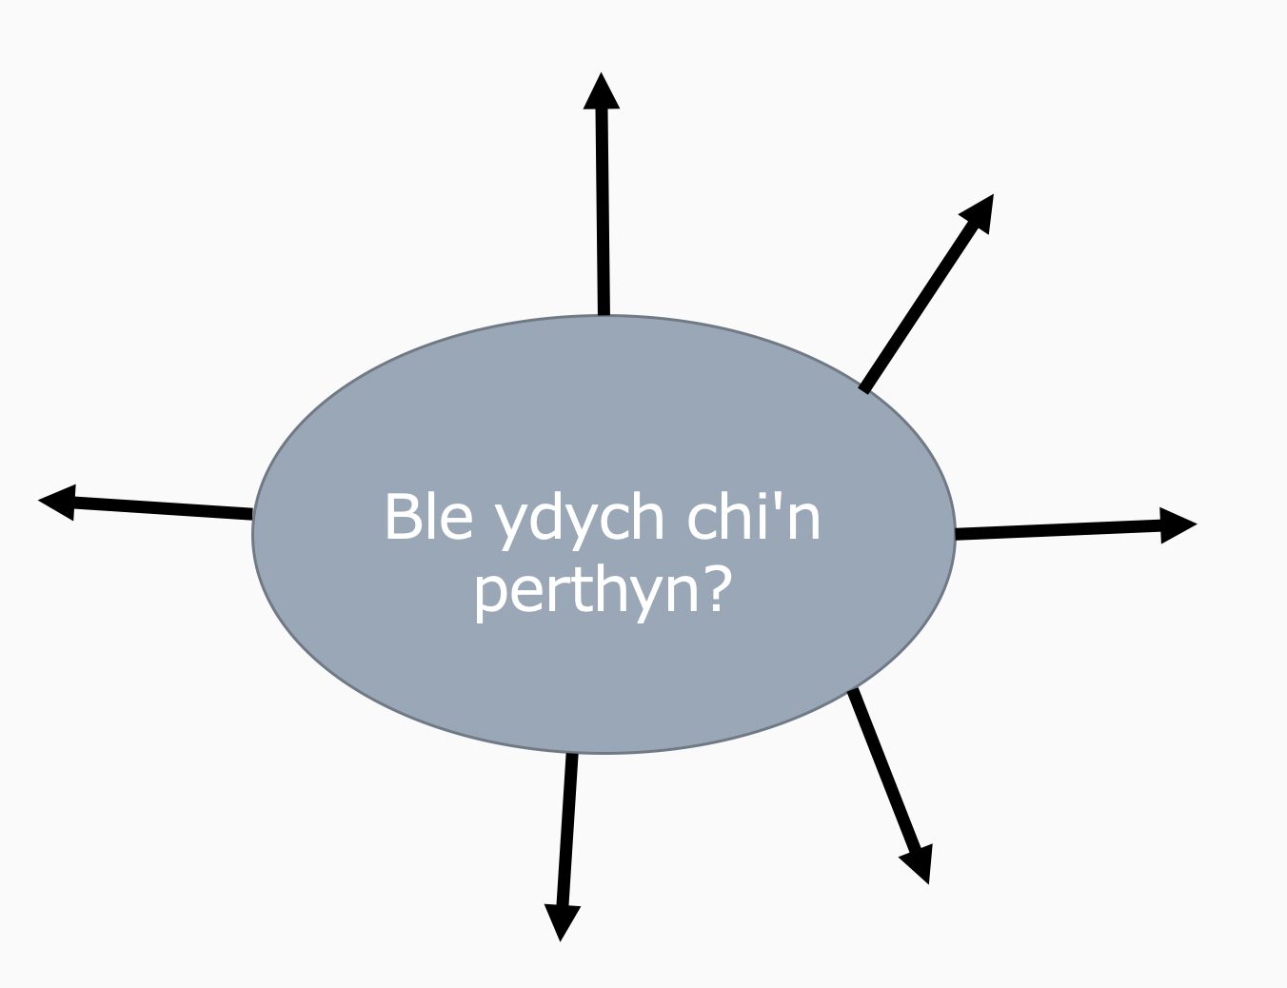

Appendix 2- Planned Strategy 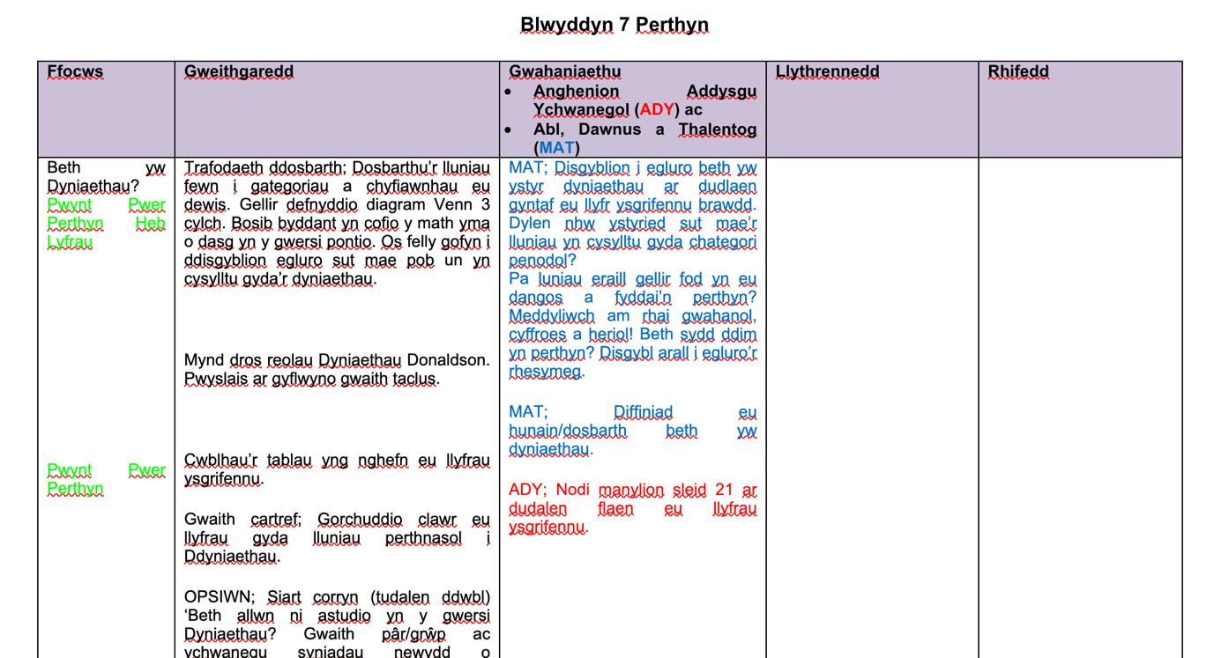

Appendix 3- Task
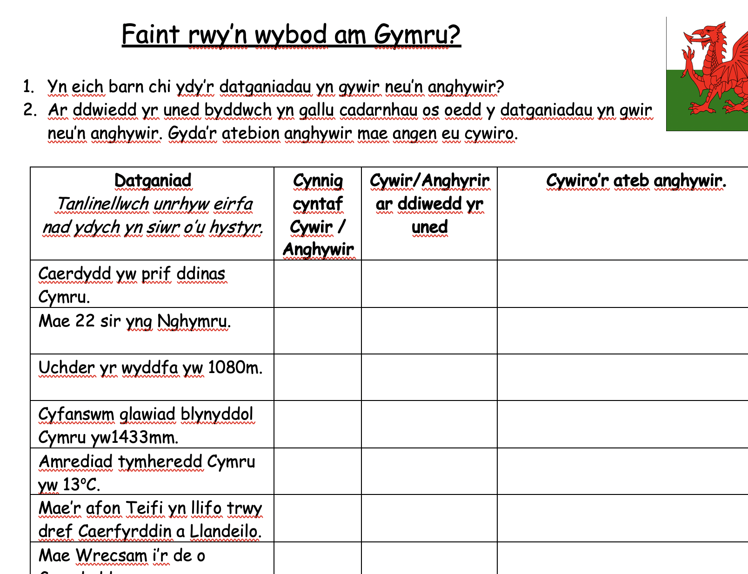

Appendix 4- Task sheet
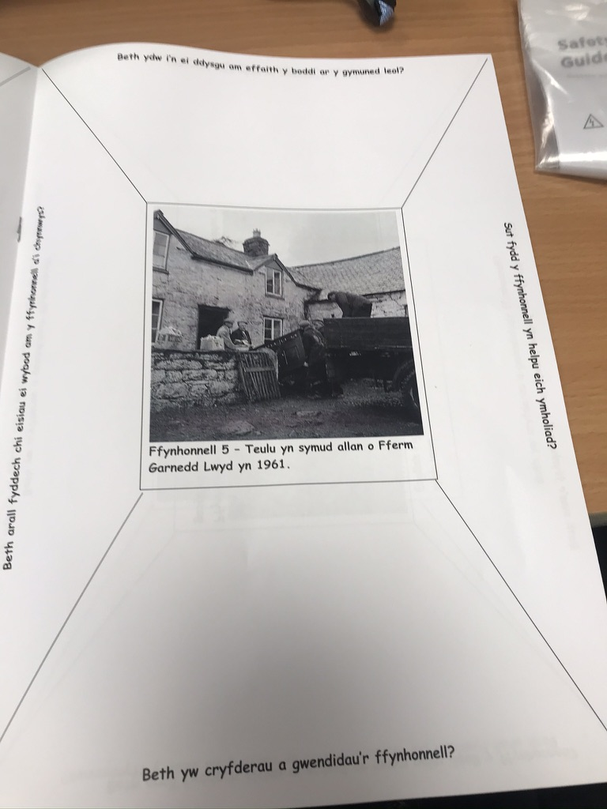

Appendix 5-logo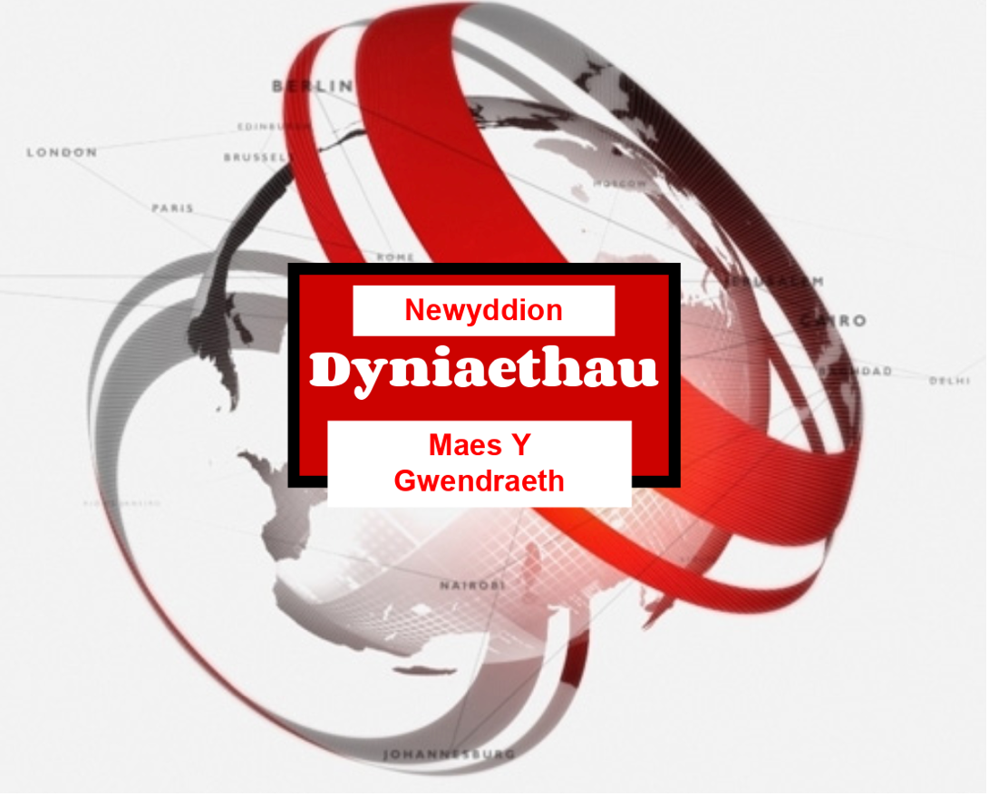

Appendix 6- Dyniaethau yn y Newyddion

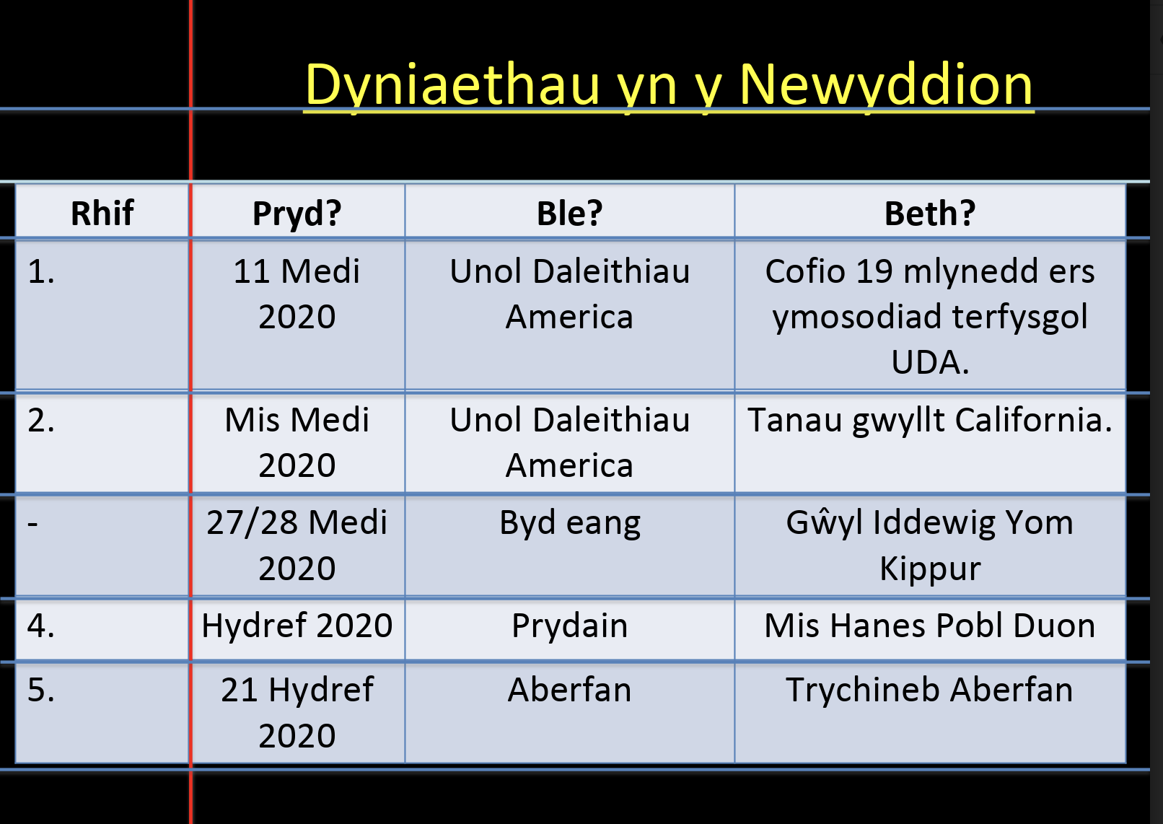
Appendix 7- Iaith ar Waith, Successful test.
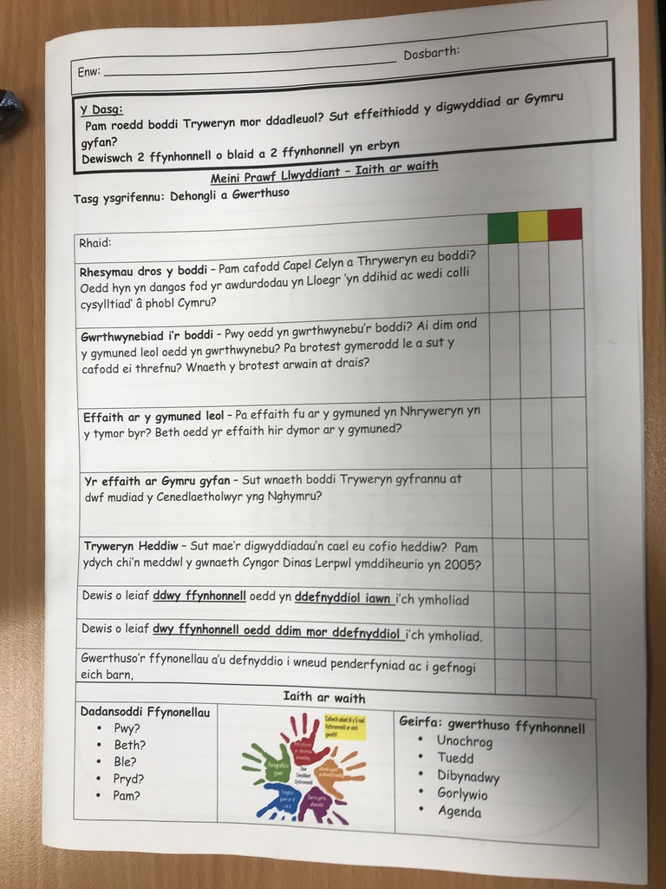

Appendix 8: Closer view of appendix 7.

Appendix 9- Word search
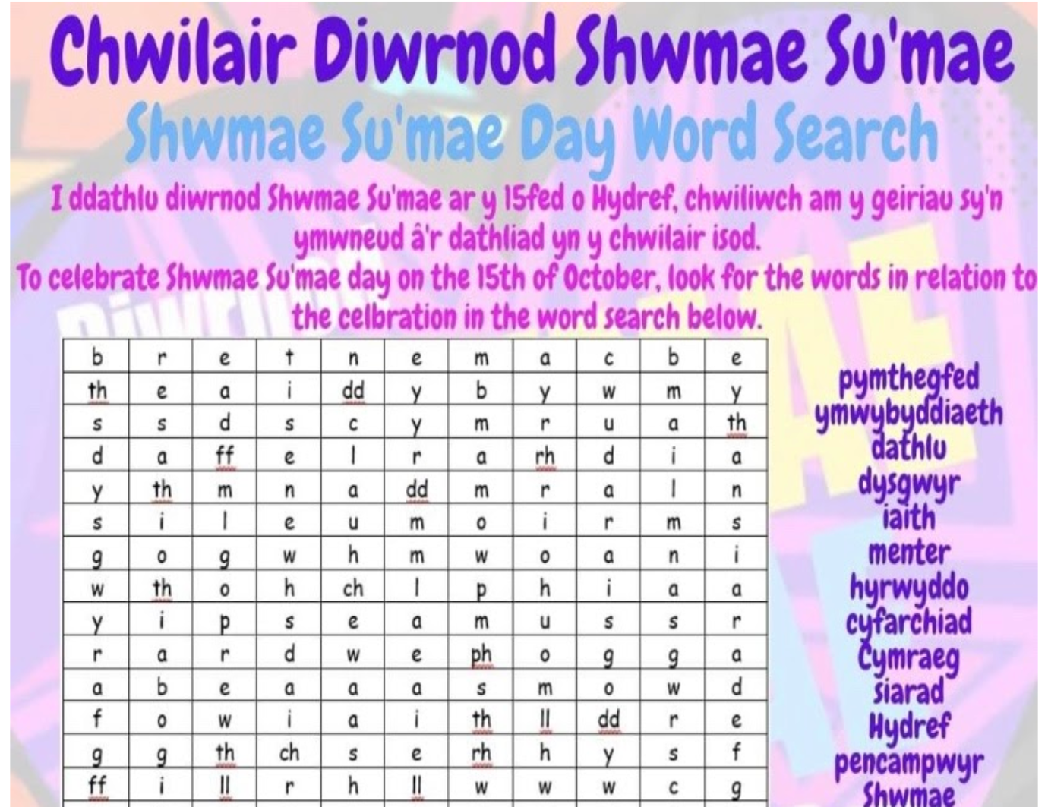

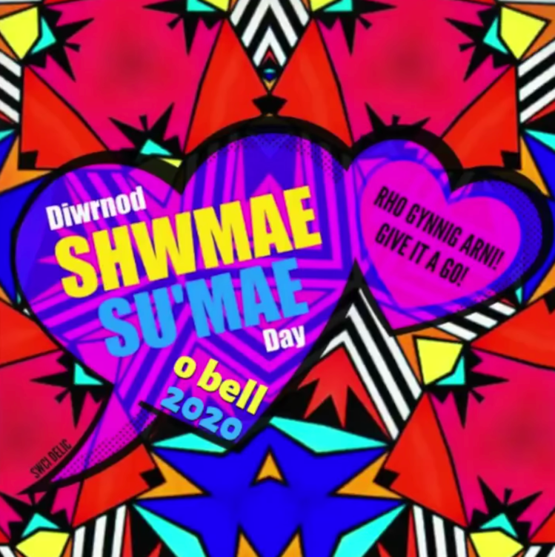
Appendix 10 (Shwd Mae, su’mae day video screen shots)


Appendix 11 “Cofiwch Dryweryn” picture
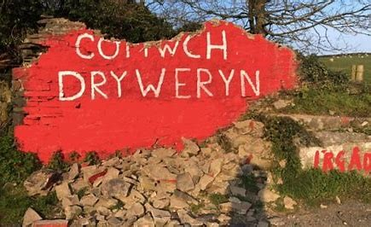

Appendix 12- Understand, write, hide and repeat.
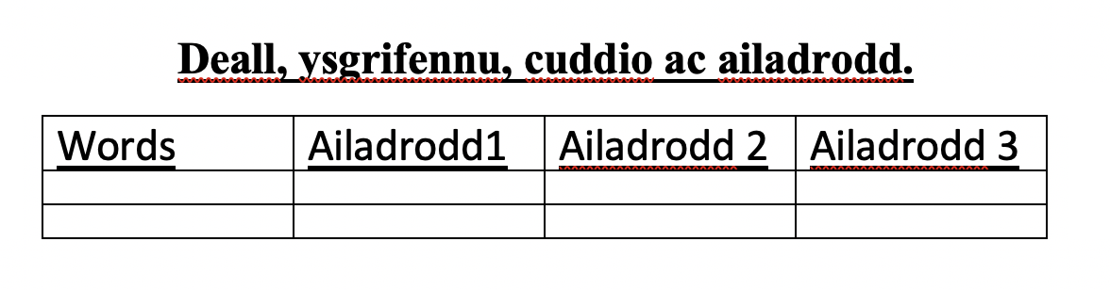

Appendix 13- Mix and match task.
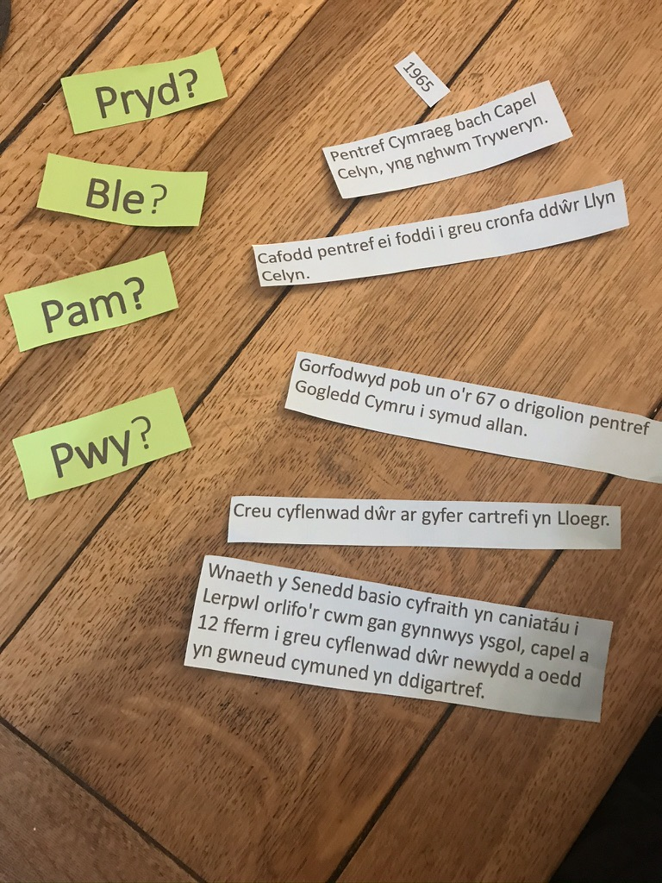

References
- Bandura A. Social foundations of thought and action: A social cognitive theory. Englewood Cliffs, NJ: Prentice-Hall; 1986.
- Bandura, A. (1977). Social learning theory. Englewood Cliffs, NJ: Prentice Hall.
- Bowlby, J. (1988). Secure Base: Clinical Applications of Attachment Theory (1 ed.). New York: Routledge.
- Bruner, J (1986). Play, thought and language
- Daugherty R, (2000), The national curriculum in Wales: Early policy developments 1987-1989. University of Wales Aberystwyth. British Education Research Association
- Donaldson, G (2015) Successful Futures: Independent Review of Curriculum and Assessment Arrangements in Wales. https://gov.wales/sites/default/files/publications/2018-03/successful-futures.pdf Accessed
Glover, A. (2009). Education for sustainable development and global citizenship An evaluation of the validity of the STAUNCH auditing tool. Centre for Excellence in Learning and Teaching, University of Wales, Newport, Newport, UK
- Greene, J (2012). 7 research-backed benefits of mind mapping
- Jones, S (2018 3 reasons why it is important to plan lessons.

Kurt, S 2018. Vygotsky’s Zone of Proximal Development and Scaffolding. Educational Technology. https://educationaltechnology.net/vygotskys-zone-of-proximal-development-and-scaffolding/
- Legislation.gov, School Standards and Organisation (Wales) Act 2013 https://www.legislation.gov.uk/anaw/2013/1/contents/enacted
- McLoed, S. (2018) Lev Vygotsky. Available at www.simplypsychologu.org/vygotsky Accessed
- Piaget & Inhelder, 1969, p. 8, Experimental Psychology: its scope and method VII Intelligence, Routledge & Kegan Paul
- Skinner, B. F. (1938). The behavior of organisms: An experimental analysis. New York: Appleton-Century.

Urdd Gobaith Cymru (2020), Urdd’s Cymraeg Bob dydd” https://www.urdd.cymru/en/youth-work/gweithgareddau-ar-lein/ accessed
- Vygotsky, L. S. (1962). Thought and language. Cambridge MA: MIT Press.
- Vygotsky, L. S. (1978). Mind in society: The development of higher psychological processes. Cambridge, MA: Harvard University Press.
- Vygotsky, L. S. (1994). The problem of the cultural development of the child. In van der Veer, R. & Valsiner, J. , The Vygotsky reader (pp. 57–72). Oxford, England: Blackwell.
- Welsh Government (2016), Wellbeing of Future Generations Act. https://moodle.uwtsd.ac.uk/pluginfile.php/182556/mod_resource/content/1/Wellbeing%20of%20Future%20Generations.pdf
- Welsh Government (2017), Cymraeg 2050, one million welsh speaker
- Welsh Government (2017), welsh in education action plan 2017-21
- Welsh Government (2019), Siarter Iaith Framework: initial guidance for schools.
- Welsh Government (2020), National Litracy and Numeracy Framework. https://hwb.gov.wales/curriculum-for-wales-2008/national-literacy-and-numeracy-framework-curriculum-for-wales-2008-version/framework/?lang=en
- Welsh Government 2003, Developing the Curriculum Cymreig

Welsh Government 2019, p5p1. Siarter Iaith framework: Initial guidance for schools https://hwb.gov.wales/api/storage/3b73bf7c-640d-4c34-855d-9586b0b30c80/siarter-iaith-framework.pdf

Welsh Government, Welsh Language Charter. https://gov.wales/cymraeg-education/schools/welsh-language-charter Accssed 1/11/20

Welsh Parliament (2016), Welsh in Education Strategic Plans (WESPS) https://business.senedd.wales/mgIssueHistoryHome.aspx?IId=12717

Wenger, E. (1998). Communities of Practice. New York, NY: Cambridge University Press.
- Williams, K. (2016). Vision for the new curriculum, speech by the cabinet Secretary of Education Kirsty Williams AM. Delivered at the Pioneer School Network Conference. https://gov.wales/vision-new-curriculum

