Contents
Introduction: Grit & DIKW: 1
What is Data? 2
What is information? 4
What is knowledge? 5
What is wisdom? 6
What is CRAAP? 7
Do you agree with Angela Duckworth? 8
References: 9

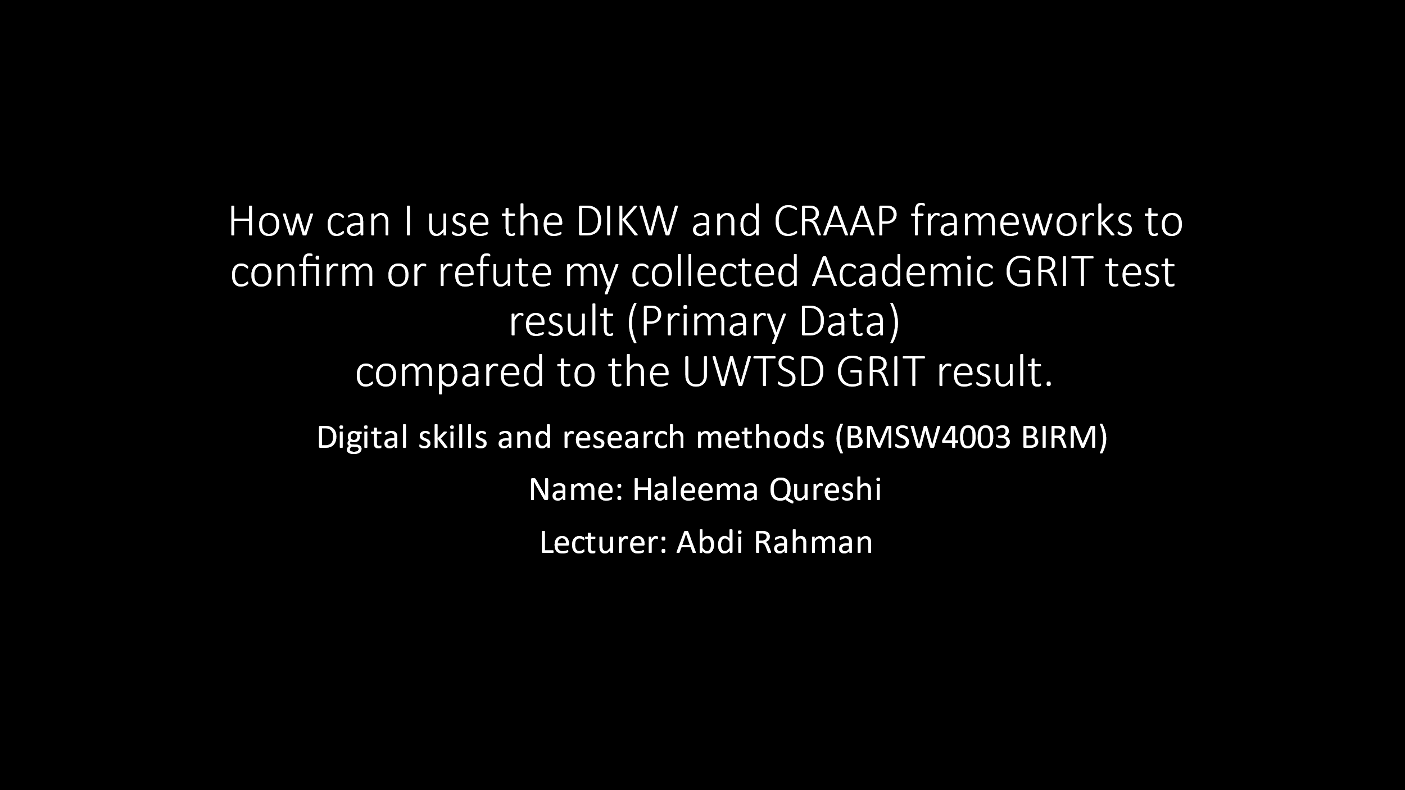



Introduction: Grit & DIKW:
Grit is a personality trait practised by people who show enthusiasm and persistence to achieve their goals despite great obstacles and setbacks. It is the ability to get tasks completed under any sort of circumstance. As Shirk has reported that: “The term Grit is in vogue in parenting, education and business circles, and for good reason: it is a hallmark of success. People with grit combine a strong motivation to achieve long-term goals with the resilience and “stick wittiness” to see a goal through to fruition. Based on the ground-breaking research of Angela Duckworth, author of the bestselling book and wildly popular Ted Talk Grit: The Power of Passion and Perseverance, grit is a character trait that we want to cultivate in our children, our students and ourselves.” (Shirk, 2020)
Grit is used to describe someone ability to bounce back defeat and learn valuable lessons from failure. It is something to emphasise on one’s motivation and ‘hunger for success.’
DIKW Model is an essential part of ITIL Knowledge Management under the Service Transition Module. It is the graphical representation of how knowledge can be organized within the organization.
We know that, when we collect raw data, it comes in a jumbled form. DIKW Model describes how the data can be processed and transformed into information, knowledge, and wisdom. (Brahmachary, 2019)
DIKW is a abbreviation of the following: Data, Information, Knowledge ad Wisdom.

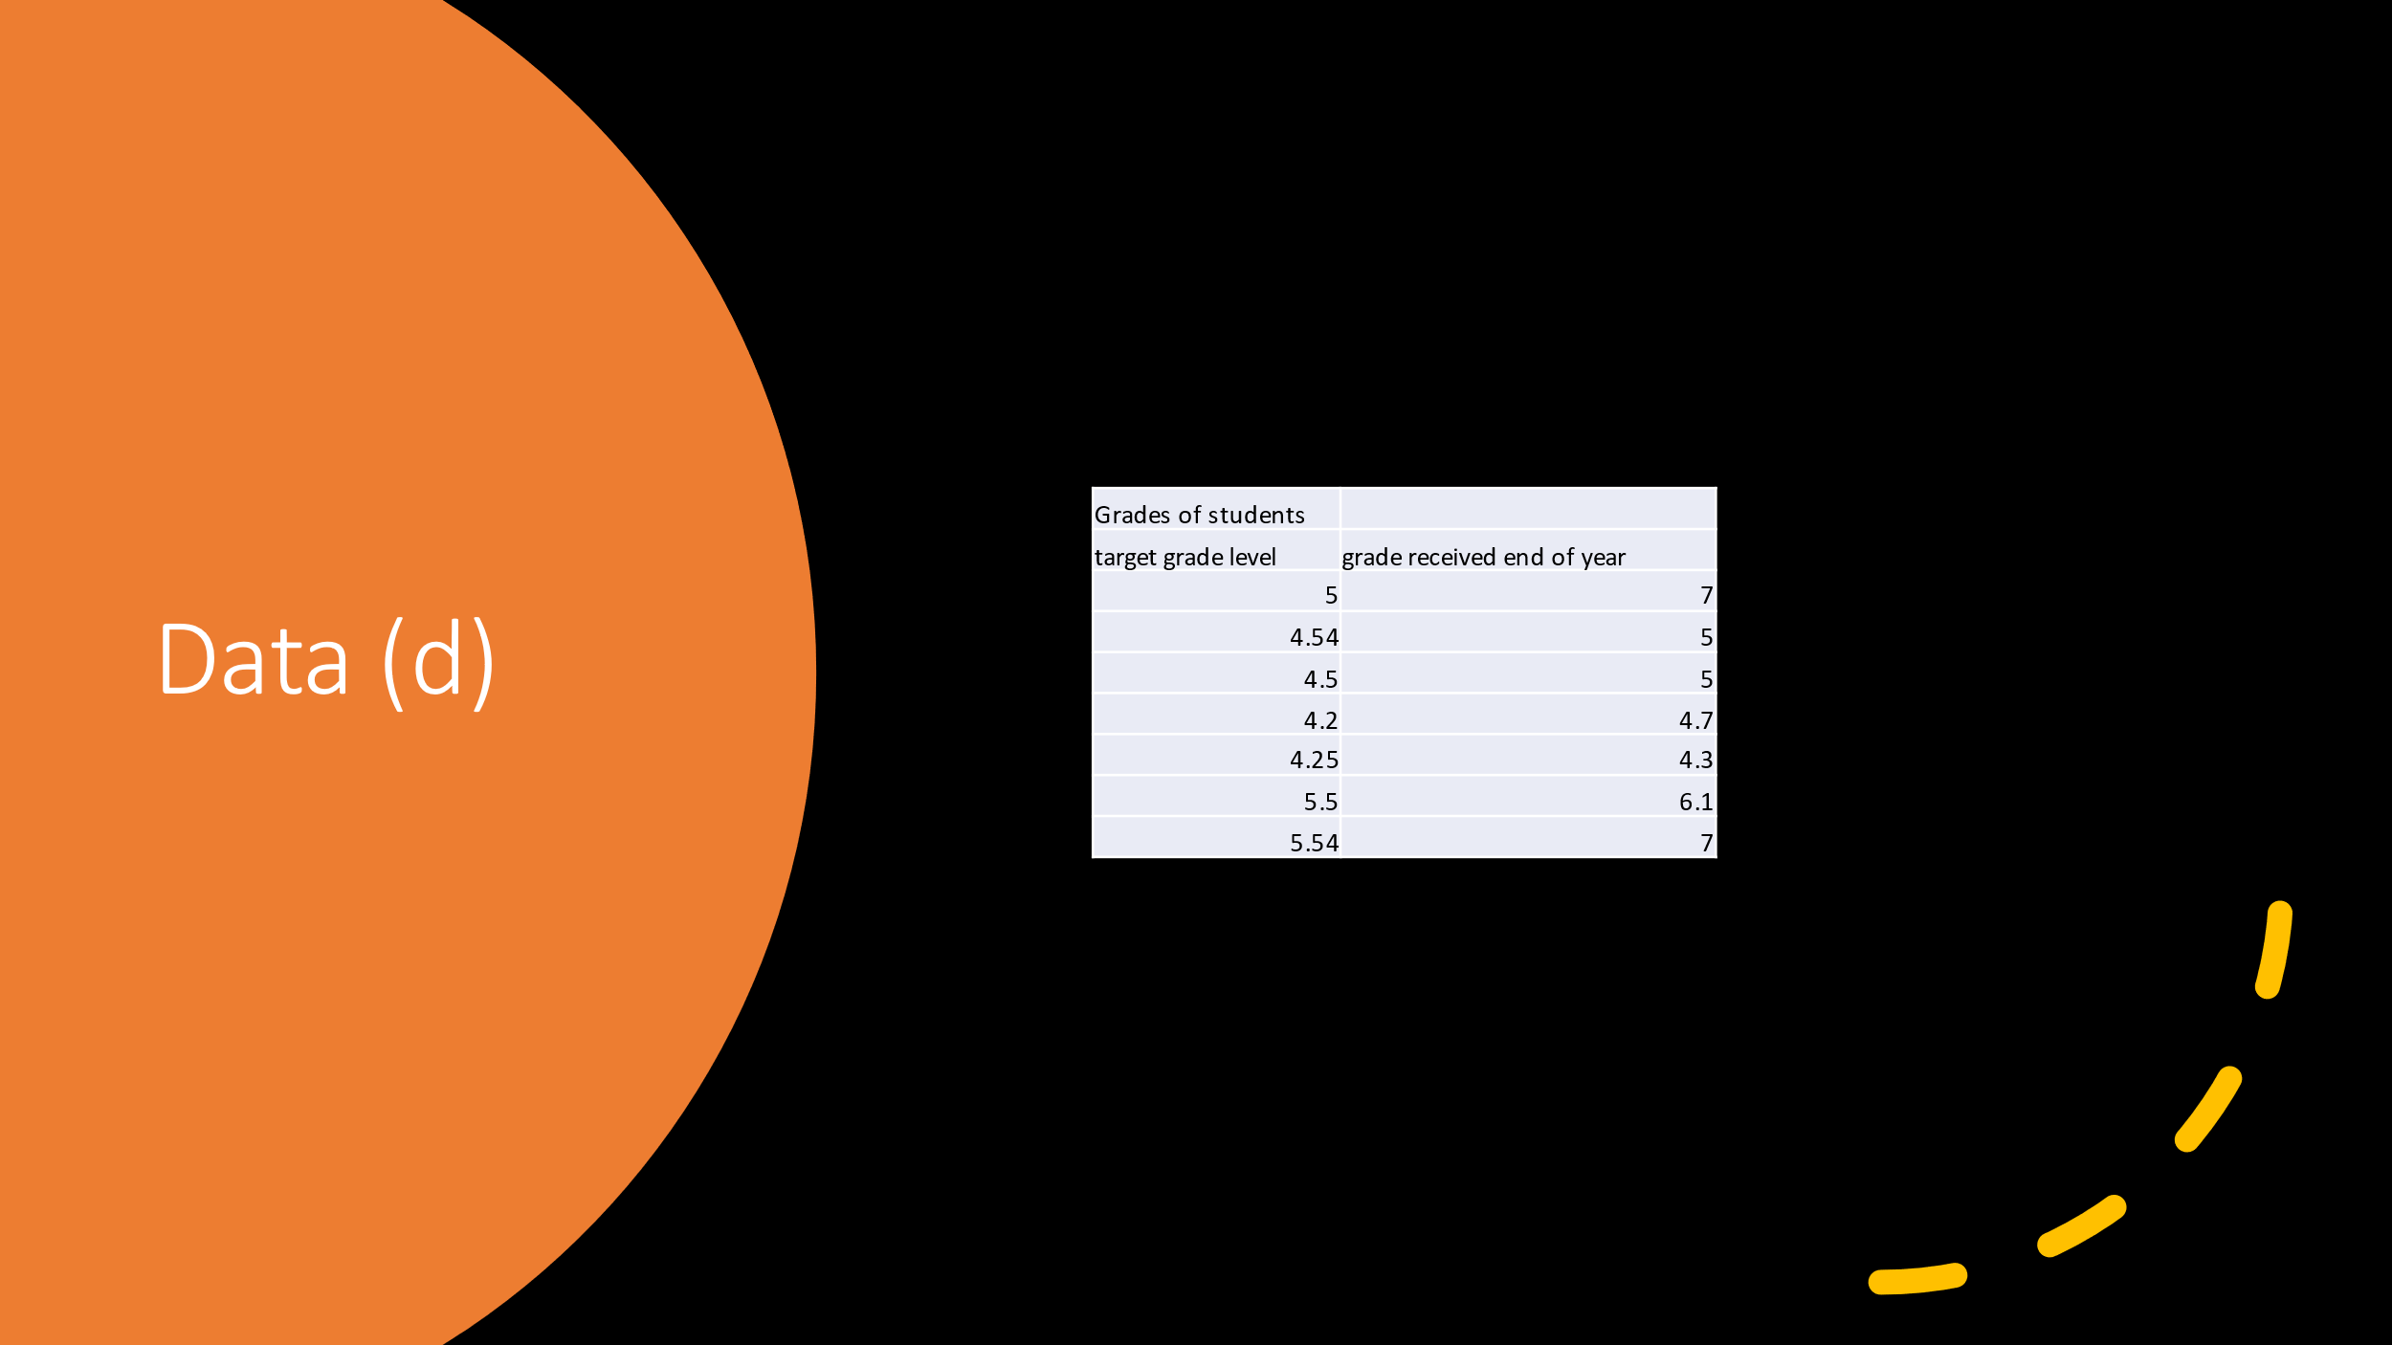

What is Data?
Data is an assortment of information which is gathered from an audience to interpret and analyse. Data can be collected through questionnaires, surveys, census reports, public votes etc. The type of software ‘raw data’ is put into could be Microsoft Excel, or Forms. Without data, most of society’s equipment cannot function, because it is data and many statistics that play a huge factor to manage modern civilization, businesses, firms and organisations. Data can support the quality of life, because we can use data from the public to improve many aspects in a vast majority of communities.
Raw data is fresh data which has been gathered by a group or people or an individual and not been processed yet. Raw data sometimes ends up in databases online, that can be used for future analysis and to support further findings and research.
Data is the plain facts and statistics gathered by the process of a business. It can be used to measure and record a compilation of businesses actions- (internal and external).
However, even if the data doesn’t seem that vital enough to record, this process is crucial in devising business plans and making decisions.
Decisions based on old or wrong information can lead an organization off course. Data used at odds with the intent of its collection can result to erroneous judgments. The use of data is important to provide punctual and dependable information. The data chain of trust from source a type needs to be clear and well documented, for someone to interpret.
Data can be both primary and secondary, graphs, and be turned into datasets in spreadsheet formats like Excel
Primary sources come from those who created it originally or had a correlation with the source. These can be diaries, speeches, letters, and historic things.
Secondary sources come from the work of people who have not experienced their finding first-hand and have updated a primary source. They collect their data either by writing about in journals or online blogs.

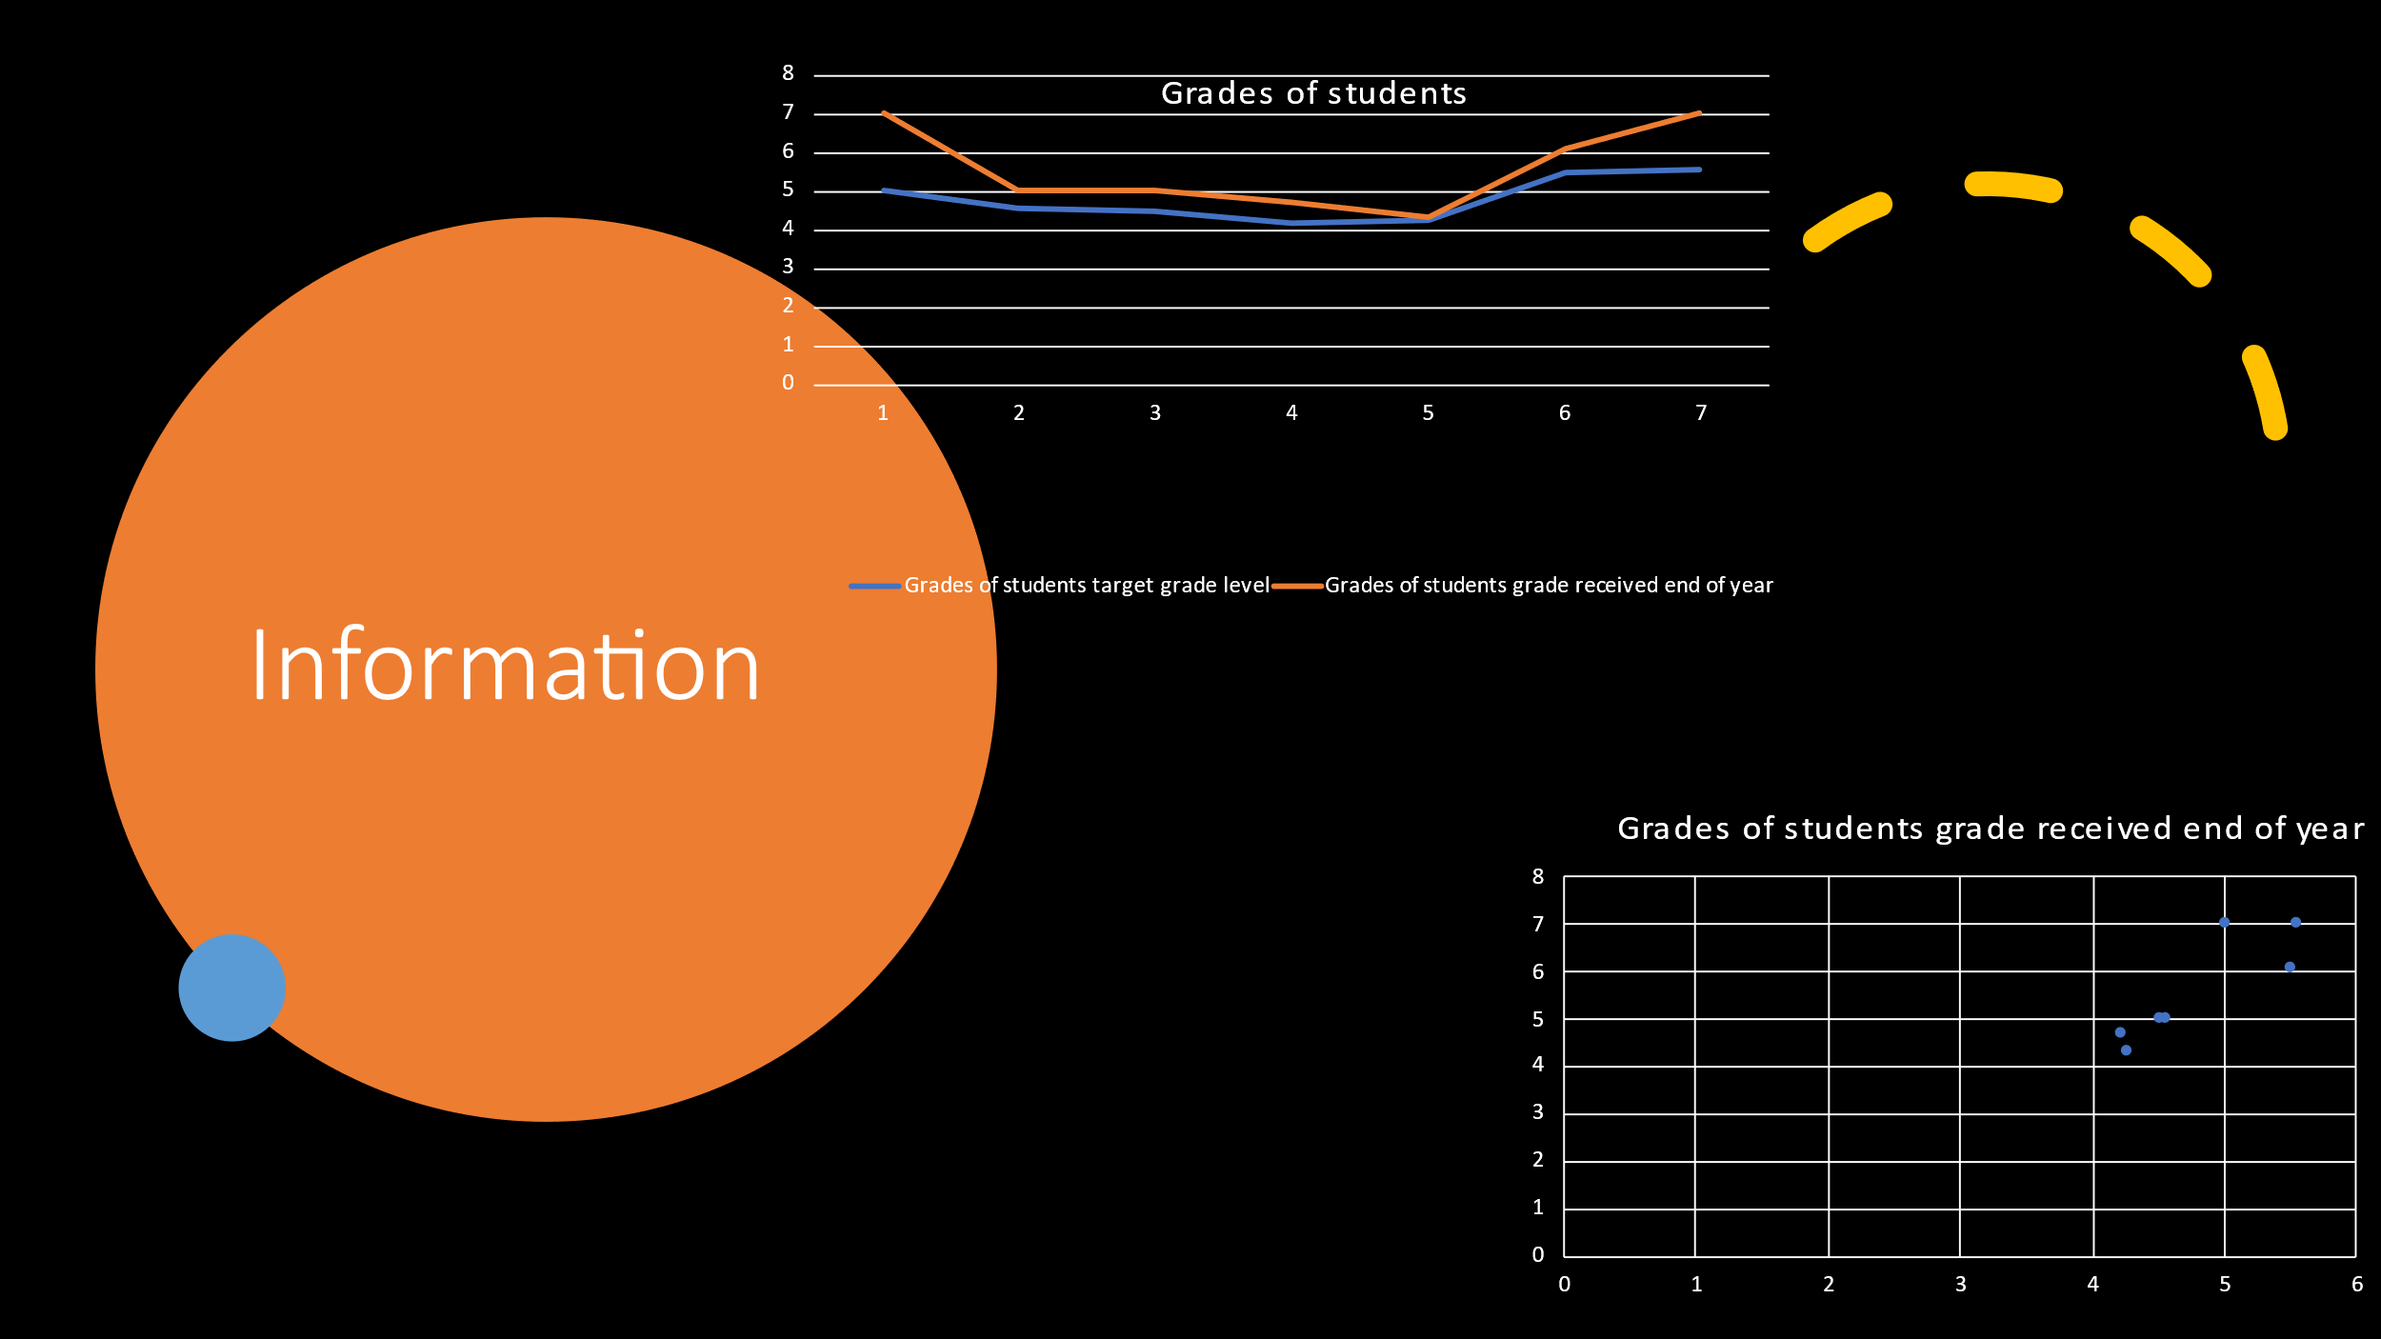

What is information?
Information is a key element to make the right and appropriate decisions or problem-solving.
Information is beneficial in finding out more about things thoroughly in regards of source authenticity, reliability and relevancy. It contributes a great deal in the field of social, economic as well as the health development, and scientific research for the innovations of technology. The graph above portrays the raw data I accumulated and put into a ‘Scatter line graph’, and ‘Line graph’ it is about the target grade per student was given to achieve and what they achieved at the end of the year. I used Microsoft Excel to plot my graphs and store my data.
“Despite technology being implemented across many organisations in order to assist with the management of data, it is not the case for all of them and many of those that do have an adequate information system, are not maximising its potential to make the overall business more efficient.
Through having an effective information system and fully integrating data, organisations can receive multiple benefits than enable them to achieve business objectives whilst remaining cost-effective.” (5 benefits of a fully integrated information system - Eventura, 2015)

Information can also help us develop for the future, in fact to get to where we are today in regard to medicine, history this is regularly getting updated as we speak because it plays a fundamental role in modern civilisation. It is useful to make changes to stuff if the information gathered shows us the pros and cons of a particular service.

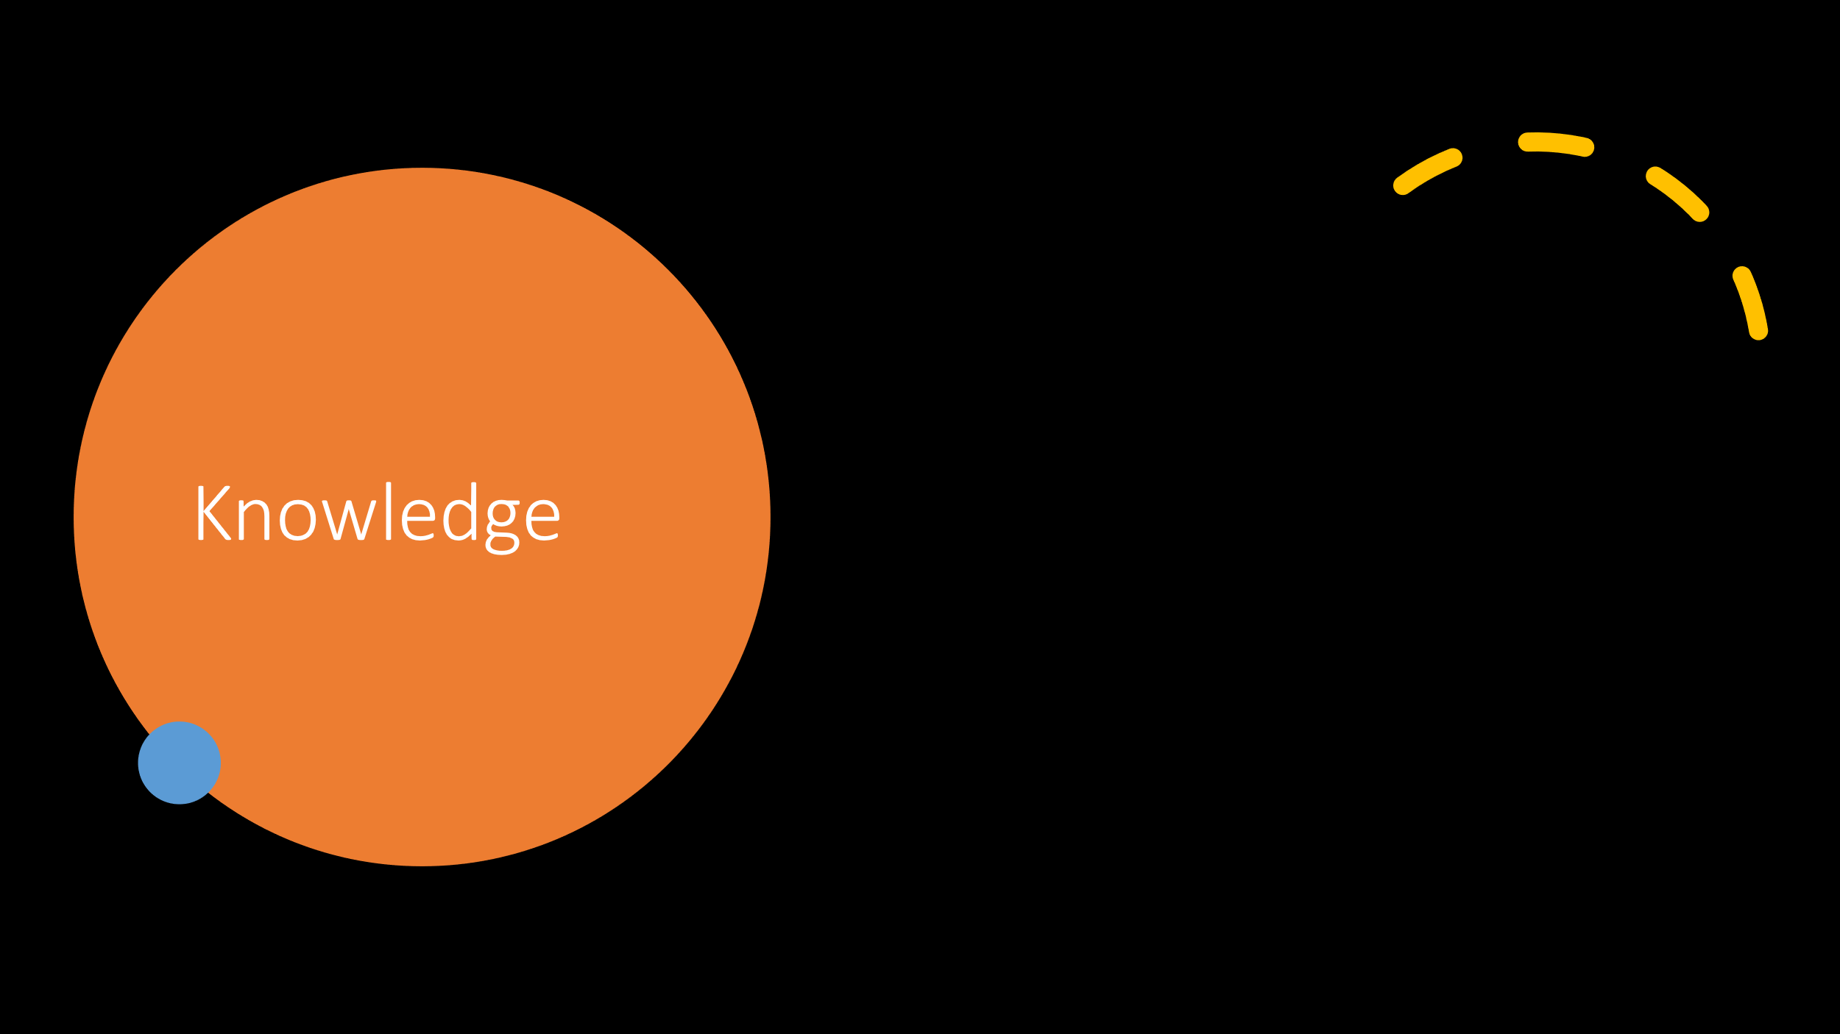

What is knowledge?
Knowledge is a highly useful skill to obtain, as it information with meaning. On one side of the relation is a conscious subject, and on the other side is a portion of reality to which the knower is directly or indirectly related. Knowledge is great for viewing things from a different perspective, because you can learn from human experiences, ethics and education. Knowledge can relate to the practical and theoretical l understanding of a subject, an although knowledge is a fundamental part of growing up, because it isn’t just out there but occurs when a student or individual consolidates their understanding on a subject.
Knowledge can be located from history books, internet/technology, libraries and public sources. On the contrary, it can be used as a key strategy to gather information from a variety of diverse sources and then be used to document data to respond to a task. Knowledge has no limits, from communicating and making wise decisions and improving task performances, its vital to update and gather additional data with more insights to increase its added value.
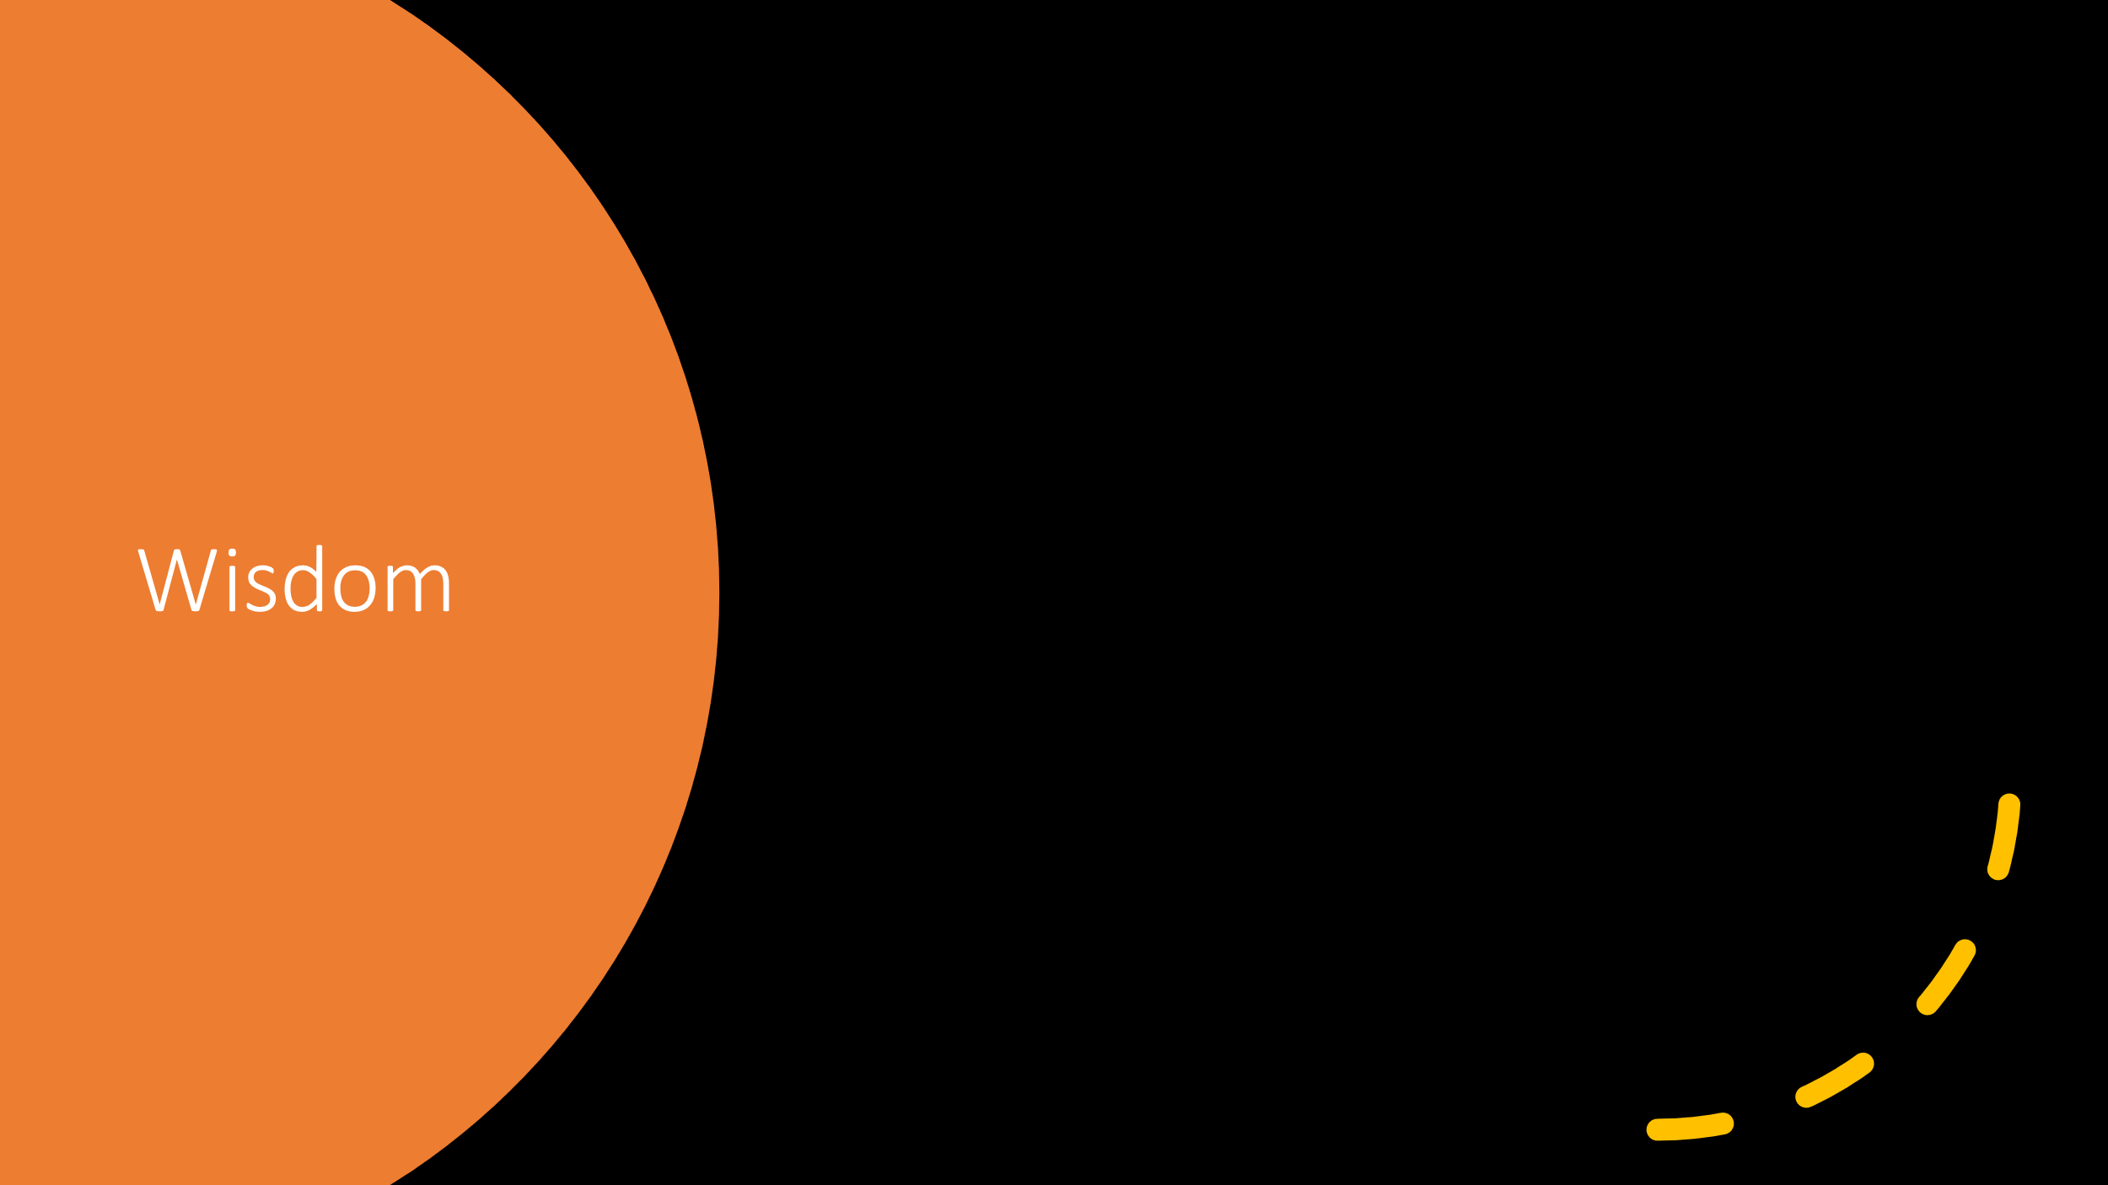

What is wisdom?
Wisdom is the “The quality of being wise; power of judging rightly and following the soundest course of action, based on knowledge, experience, understanding, etc.; good judgment; sagacity.” (Wisdom Meaning | Best 17 Definitions of Wisdom, 2021)
Wisdom can be seen as common sense, in application to theoretical and practical practices, and is the knowledge of creating good choices. Wisdom is knowledge applied.
As explained by Scuderi “Knowledge is the accumulation of facts and data that you have learned about or experienced. It’s being aware of something and having information. Knowledge is really about facts and ideas that we acquire through study, research, investigation, observation, or experience.
Wisdom is the ability to discern and judge which aspects of that knowledge are true, right, lasting, and applicable to your life. It’s the ability to apply that knowledge to the greater scheme of life. It’s also deeper; knowing the meaning or reason; about knowing why something is, and what it means to your life.” (Scuderi, n.d.)
Wisdom is beneficial because it is ‘wise reasoning’ and helps to examine things from different perspectives, and it is intellectual humility. Wisdom is direct and knowledge is informative, because knowledge gives you the information and wisdom tells you how to apply it to something i.e. (what to do with it)



What is CRAAP?
CRAAP is the process of checking information thoroughly. The test is used to verify the authenticity of a source.
To check the validity with any type of source it’s important to evaluate the origin, who wrote it and many other aspects.
Currency: Currency just means how current was the information sourced and found, like the date it was published and how recently it was last reviewed and updated.
Relevance: Relevance is how much it matters to what you are trying to find, and whether it relates to your findings.
Authority: Authority is the source of the information, and who the author is.
Accuracy: Is just how accurate your source is, and if there is evidence to back verify any type of research.
Purpose: And purpose is just the reason it exists. What is the purpose of this information?
By using the CRAAP test I was successfully able to support my findings with thorough checks of authenticity for my previous assignment.


Do you agree with Angela Duckworth?
Based on the findings of Angela Duckworth, I agree with her because she promotes excellent self-growth and defines grit as a consistent graft and passion. It is important that no matter what anybody says, you should use that energy to motivate and yourself to strive and excel in every aspect possible Angela express the ‘ill show you method” meaning that when someone says ‘you cannot’ or ‘you can’t do it’ her response essentially means ‘yes ill prove you wrong’ I find Angela quite inspirational because she portrays a good message for service users in regards of self-growth, resilience, ambition and self-control, and come what may, the end result will always be worth it.
“Instead, grit is about having what some researchers call an “ultimate concern”–a goal you care about so much that it organizes and gives meaning to almost everything you do. And grit is holding steadfast to that goal. Even when you fall. Even when you screw up. Even when progress toward that goal is halting or slow.” (Angela Duckworth, 2021)
While fostering grit is beneficial when it comes to facets of student learning, such as encouraging students to correct mistakes, establish high expectations, and take ownership over their learning experience, details as seemingly small as the temperature or layout of a room can also impact student motivation and perseverance.
“Since her 2013 TED Talk, Duckworth herself has revisited the role of grit in student success and acknowledged in an interview with EdSurge in 2018 that “when we are talking about what kids need to grow up and live lives that are happy and healthy and good for other people, it’s a long list of things. Grit is on that list, but it is not the only thing on the list.” (Anderson and Francisco, 2019)

References:
Anderson, K. and Francisco, A., 2019. The Research Behind the TED Talk: Angela Duckworth on Grit. [online] Digital Promise. Available at: <https://digitalpromise.org/2019/03/06/research-behind-ted-talk-angela-duckworth-grit/> [Accessed 20 December 2021].
Angela Duckworth. 2021. Angela Duckworth. [online] Available at: <https://angeladuckworth.com/qa/> [Accessed 20 December 2021].
Brahmachary, A., 2019. DIKW Model: Explaining the Concept of DIKW Hierarchy in ITIL. [online] CertGuidance. Available at: <https://www.certguidance.com/explaining-dikw-hierarchy/> [Accessed 20 December 2021].
Brahmachary, A., 2019. DIKW Model: Explaining the Concept of DIKW Hierarchy in ITIL. [online] CertGuidance. Available at: <https://www.certguidance.com/explaining-dikw-hierarchy/> [Accessed 20 December 2021].
Scuderi, R., n.d. What Are the Differences Between Knowledge, Wisdom, and Insight?. [online] Lifehack. Available at: <https://www.lifehack.org/articles/communication/what-are-the-differences-between-knowledge-wisdom-and-insight.html> [Accessed 20 December 2021].
Shirk, T., 2020. What is Grit, Why is it Important, & How Can We Develop It? - SchoolRubric. [online] SchoolRubric. Available at: <https://schoolrubric.com/what-is-grit-why-is-it-important-how-can-we-develop-it/> [Accessed 19 December 2021].
Yourdictionary.com. 2021. Wisdom Meaning | Best 17 Definitions of Wisdom. [online] Available at: <https://www.yourdictionary.com/wisdom> [Accessed 20 December 2021].

Appendices: 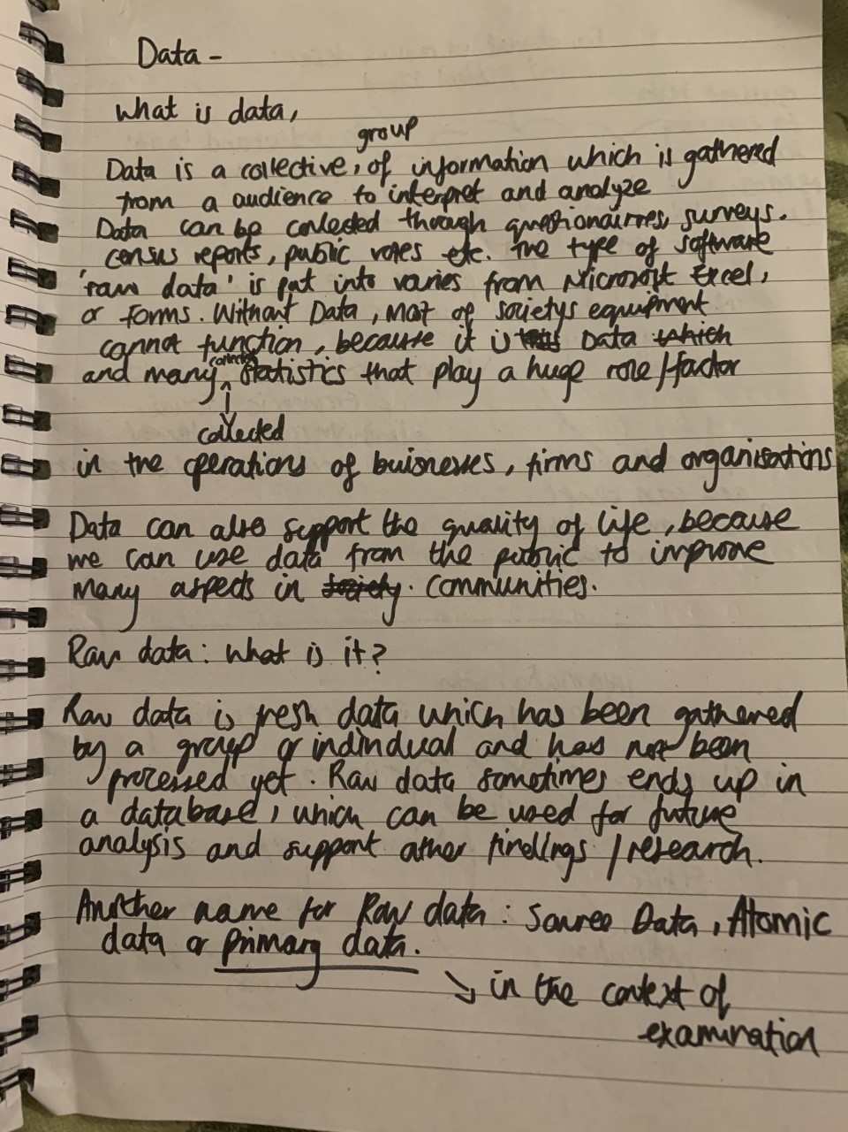
Appendix 1

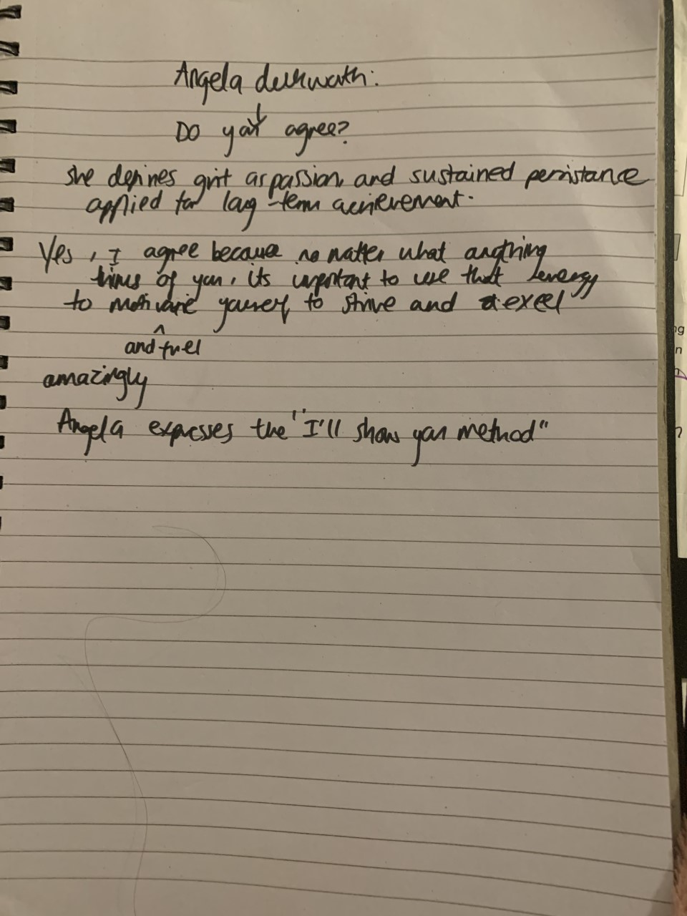
Appendix 2
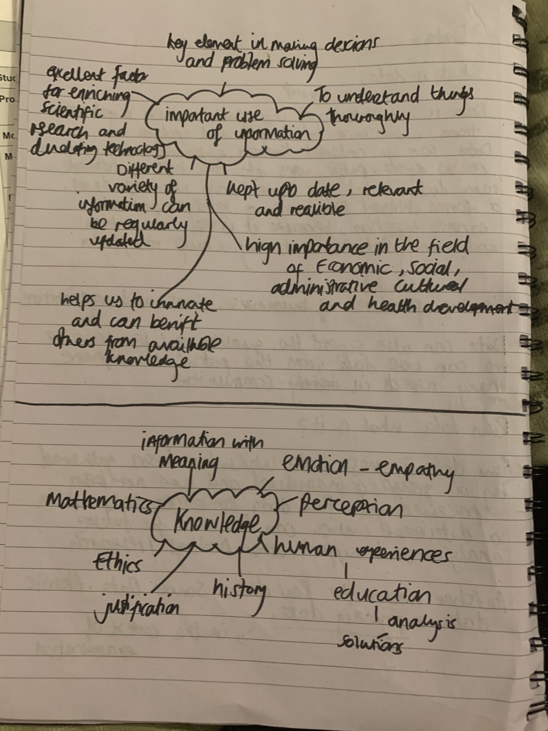
Appendix 3

