Student Id:2112412
Student Name: Dolca Mirela Maria
Module: The Global Business Environment
Module Code: LCBB4005

Assessment 1: Environmental Analysis of Automobile Industry

Table of Contents
1. Introduction 3
2. Automobile industry overview and competitive market for the global business environment 3
3. Structural frameworks for automobile industry with different models 4
4. Macroeconomic factors analysis for managing competitive growth and business environment of the automobile industry 7
5. Managing of sustainability and core values along with value chain for automobile industry with effective recommendations 9
6. Conclusion 9
Reference list: 10

1. Introduction
The global business environment especially indicates various environments in different sovereign countries along with factors exogenous and its proper environmental analysis. The major focus of this concept is to manage best decision making and effective organisational growth by analysing internal as well as external activities on the global stage. The study is mainly focused on the environmental analysis of the automobile industry. The chosen brand for this study is “Porsche”, a German automobile company that provides attractive sports cars with great value. Additionally, PESTLE analysis and Porter’s five forces will be analysed for identifying and understanding the best market implementation with respect to Porsche.

2. Automobile industry overview and competitive market for the global business environment
Porsche is a famous German automobile manufacturer and manages high-performance sports cars that include Sedans and SUVs along with proper quality and services. Headquarter of the company is in Stuttgart, Baden-Wurttemberg, Germany. Porsche also recorded strong growth compared to before the 2019 coronavirus infection. Based on the first half of 2019, sales will increase by 23% to approximately 13.41 billion yen, and operating income will increase by 26% to 2.21 billion yen (Newsroom, 2021). "We are very pleased with these numbers," said Lutz Meschke, Porsche CEO, who is also responsible for finance and IT. Instead of making a large investment in future electrification and
Digitalisation, the company can achieve a high rate of return of 16.9%, which affects the company's rigorous sales, strong sales, and management of all activities. Porsche adheres to its goal of achieving a profit margin of 15% in the fiscal year 2021. As of June 30 June, the net cash flow was € 2.60 billion, up 130% from last year and amounting to around £ 1.13 billion (Newsroom, 2021). In addition, the consulting and financial services sectors are growing very well, and large profitability programs do not endanger the entire work and protect it. Other than that, it does not limit innovation. After that, the company achieved these positive numbers with an almost unchanged workforce. As of June 30 June, Porsche had 36,267 employees. Through the provision and management of sports cars, we will reach our goals and achievements and advance them to manage their significant competitive advantage. Porsche has already collected about 3,000 ideas in-house as part of its 2025 profitability program. The goal is to improve cumulative results by €10 billion by 2025 and €3 billion annually thereafter (Newsroom, 2021).

3. Structural frameworks for automobile industry with different models

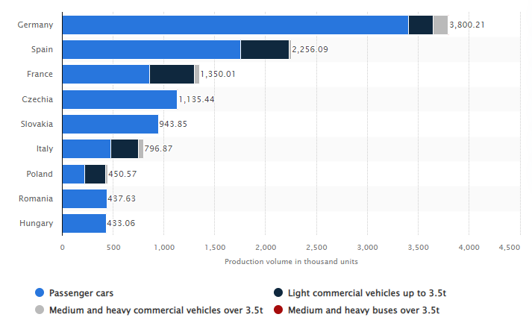
Figure 1: Volume of vehicle production in Europe
(Source: Statista, 2021)
Germany is Europe's largest automaker, producing about 3.4 million cars and about 147,000 commercial vehicles. Germany is one of the largest automobile markets in the world according to 2020 (Statista, 2021). Added to this, all kinds of vehicles like passenger cars, light commercial vehicles and sports cars are also managed by Germany to meet effective economic stability by using the automotive industry. From this, Porsche is the best brand of car manufacturing in Germany, and that has captured more than £2.30 billion cash flow with adequate car selling and its services.

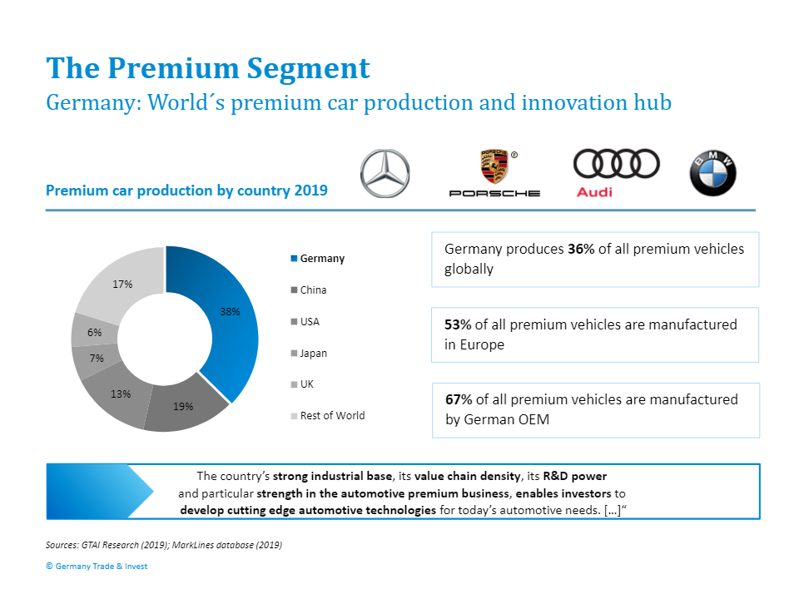
Figure 2: Overview of the automotive industry in Germany
(Source: Germany trade and invest, 2021)
Germany is known worldwide to serve the best quality manufacturing in automobile cars and better management of its services to customers. Added to this, in different countries like Asia, American, and Europe, Germany captures a strong baseline for the automobile industry with proper management of cars and vehicles along with reliability, innovation, design, and safety. Germany placed Europe's number one manufacturing automobile industry along with 3.5 million cars, and that indicates the best accounting of 25% for vehicle manufacturing as well as 20% of new vehicles registrations or about 2.9 million cars (Germany trade and invest, 2021). In 2020, the automobile industry will have sales of £379.3 billion, which is about 20% of Germany's total industrial sales. It is considered that Germany has the ability to manage the European market by its quality and technology for manufacturing vehicles and the world-class R&D infrastructure of Germany indicates the best possible way of developing new brand production. Effective value chain and high-skilled employees, and the best workforce of Germany ensure a unique automotive manufacturing industry across the world, and Porsche is one of the famous brands of Germany in the automobile industry.
Porter’s five forces:
The framework of Porter's five forces is mainly used to manage better competitive analysis and effective growth of Porsche operating management and activities within the automobile industry. The major five factors of this framework can help to identify and analyse better opportunities in marketing growth (Ferras‐Hernandez and Nylund, 2019). These are as follows:
- Threats of new entrants
- Bargaining power of customers
- Bargaining power of suppliers
- Threats from the substitutes
- Competitive rivalry
From this active analysis, the proper management can be based on inherent profit potentiality and strategic decision making by Porsche.
Threats of new entrants (Weak):
A weak force is observed in the case of the automobile industry in Germany as the respect of Porsche and innovation, and effective managing activities of the company can manage new entrant's threats easily. For managing cost advantages, economic scale management and proper manufacturing activities need to be maintained with the Porsche operation and its large, influential activities (Guanghui, 2019). It is very tough to enter the market for a new company, and in this regard, Porsche must look at R & D costs as well as effective investment in the automotive sector.
Bargaining power of customers (Weak):
Porsche tries to find a better platform and effective base, and bargaining power is very low in this regard in the automotive industry. The company must ensure the price and cost of vehicles for managing cost-effectiveness and purchasing criteria of customers (Viltard, 2017). A large market expansion is observed in the case of Porsche that helps to manage products with great services and accessibilities and involves advertising and contributing loyalty within the marketing field.
Bargaining power of suppliers (Weak):
A large number of suppliers are noticed in the case of Porsche, and that is reliable to the weak power of suppliers. Buyers have no proper power in the case of Porsche products, and different countries are involved with this brand. The suppliers are not able to manage competition with other branches of the products, and that is really efficient to meet success and growth (Mandal, 2021). Different raw materials and manufacturing elements are collected from suppliers at a cheap cost. In this regard, Porsche can switch their suppliers in case of not matching with their products and materials.
Threats from the substitutes (Moderate):
No proper alternatives are observed in the case of Porsche and its automobile industry along with the business, and due to this, moderate threats of substitutes are noticed. Different alternatives are shown in the case of low-profit industries, and that includes high-priced, high quality, and effective management of manufacturing. There is no maximum profit in this company to chase the upper limit of the valuable industry, and Porsche must look for their brand quality and product growth in an active way.
Competitive rivalry (Moderate):
Moreover, companies in the industry are not acting clearly. Most of them are also large in size. Porsche needs to focus on product differentiation to reduce the impact of competitors' behaviour on customers looking for their products. As this sector grows, Porsche can focus on new customers instead of acquiring customers from existing companies (Mandal, 2021). This weakens competition between existing companies in the industry. A moderate competitive rivalry is observed in the case of Porsche, and that is really managed through product development and brand quality of the automobile company.

4. Macroeconomic factors analysis for managing competitive growth and business environment of the automobile industry
In order to identify and understand the macroeconomic factors for Porsche, PESTLE analysis can be discussed appropriately. PESTLE indicates political, environmental, and social, economic, and technological.
Political factors:
Porsche is an effective and leading sports brand company of Germany that provides manufacturing of sports cars. In the case of pollution management, repercussions can be effective to manage arrangements and help to pronouncements of proper government agents (van Steenbergen, 2021). Various government laws act and actualisation for business, contract law, and instance indicate the proper definition of Porsche.
Economic Factors:
The pace of improvement in a country's GDP will affect how fast Porsche must grow in the near future. Additionally, higher rates can help to achieve an increasingly prominent effort, which indicates a greater improvement for Porsche. The cost of raising a country affects the number of people who are willing to get and donate money.
Social factors:
If the majority of the masses were in the lower classes, Porsche would not be able to raise anything outstanding to the general public. Instead, they will have to rely on their popularity for promotion by using social media and various contents in this regard (Kovalainen, 2020). After that, the difference in the establishment of education between target markets and promoters can be effective to associate with targeted advertising, and that will make it difficult to engage effectively. As a result, Porsche needs to be careful not to touch the trends and needs of the target market.
Technological factors:
As mentioned earlier, continuous creative upgrades and a leap of competitors. In the time that Porsche encounters further advances that can be appropriate to bring significant quality to the business in question, it is important to check the level of awareness and how quickly it creates and destroys the livelihood of the competitors (Ekaterina, 2021). In advance, the cost impact of progress at risk for most associations in the industry can significantly increase or decrease the resulting benefits.
Legal factors:
Licensed development and other data validation laws are in force to protect the deliberations and licenses of associations that benefit from this information. Added to this, security and prosperity legislation was enacted for dire situations in which representatives clearly had to work during and after a high degree of surprise.
Environmental factors:
Ecological change and climate change can render different things in respect of Porsche operating aspects. For example, on the basis of virtue materials, Germany faces warm winter pieces of clothing; global warming that properly reduced the lesser degree of the market (Chodakowska, 2018). Therefore, Porsche must focus on sustainable growth with effective environmental management in an adequate way.

5. Managing of sustainability and core values along with value chain for automobile industry with effective recommendations
Sustainable and its management is a key indicator of Porsche that will convert the business into strategic growth. The company tries to reduce CO2 emissions and manage greenhouse effects over the entire value chain (Porsche, 2021). The major activity of Porsche is to use green energy for producing and offering full and hybrid electric vehicles. Porsche must support cultural as well as sporting activities to develop sponsorship and donations with a transparent process. Porsche owners' demographics include college graduates with household incomes in excess of $100,000, 15% female, and 85% male (Porsche, 2021). In the "Engineered for magic, everyday" campaign, Porsche is targeting a 25-54-year-old target group looking for a slightly younger audience, according to the owner of this company. As a result, Porsche must ensure the proper value chain by its sustainable development and product management for meeting successful and effective revenue for the automobile industry and its services.

6. Conclusion
From the above discussion, it can be concluded that Porsche is a large sports cars manufacturing company in Germany, and due to this, its market share is exceptional over the world. For identifying and understanding the Porsche market, Porter's five forces and PESTLE have been analysed through this study. Apart from that, for managing the value chain, sustainable growth and its development are really crucial for promoting their brand and its crucial car manufacturing systems through social, technical, and environmental aspects. Thus, Porsche must focus on its car manufacturing systems and their development in an advanced way.

Reference list:
Newsroom, 2021. Porsche more than doubles operating result. Available at https://newsroom.porsche.com/en_US/2021/company/porsche-doubles-operating-result-first-six-months-2021-25315.html. [Accessed on November 29 November 2021]
Statista, 2021. Motor vehicle production volume in Europe in 2020, by country and vehicle type(in 1,000 units). Available at https://www.statista.com/statistics/585024/leading-car-automotive-manufacturer-europe-by-country/. [Accessed on November 29 November 2021]
Germany trade and invest, 2021. Automotive Industry: Germany – The World’s Automotive Hub of Innovation. Available at https://www.gtai.de/gtai-en/invest/industries/mobility/automotive-industry#:~:text=In%202020%2C%20the%20auto%20sector,car%20registrations%20(2.9million). [Accessed on November 29 November 2021]
Porsche, 2021. Sustainability. Available at https://www.porsche.com/taiwan/en/aboutporsche/responsibility/. [Accessed on November 30 November 2021]
Porsche, 2021. About us. Available at https://www.porsche.com/taiwan/en/aboutporsche/responsibility/. [Accessed on November 30 November 2021]
Chodakowska, A., 2018. The mobility revolution in the automobile industry. Electric cars and battery management.
Ekaterina, Z., 2021. Market research and market entry recommendations in the UK, Poland, and Germany for a FinTech company.
Kovalainen, J.M., 2020. Market entry strategy to Germany for Case Company Suomen Retkitukku OY.
van Steenbergen, D.I., 2021. Profitability in a social business: an environmental analysis of the social sector in Portugal (Doctoral dissertation).
Ferras‐Hernandez, X. and Nylund, P.A., 2019. Clusters as innovation engines: The accelerating strengths of proximity. European Management Review, 16(1), pp.37-53.
Guanghui, G., 2019. Research on marketing strategy of Huawei’s high-end smartphones (Doctoral dissertation, SIAM UNIVERSITY).
Viltard, L.A., 2017. Strategic mistakes (AVOIDABLE): the topicality of Michel Porter’s generic strategies. Independent Journal of Management & Production, 8(2), pp.474-497.
Mandal, P.C., 2021. Achieving Business Excellence for Luxury Brands: Strategies and Initiatives. International Journal of Business Strategy and Automation (IJBSA), 2(4), pp.1-14.

