More than 100,000 years ago, man was unable to produce speaking sounds due to a physical limitation. Growls and screams, as well as gestures and other bodily movements, were the primary means of communication for our forefathers. As the human brain and speech organs have changed over time, the complexity of language has increased as well. The communication channels have evolved over time, starting with smoke signals and progressing to what we use today. Scientists have recently begun to examine communication, and they have developed a number of distinct communication models.
Communication is a series of acts that share the transmission of information in the form of messages, news, symbolic signs or gestures, written texts, and so on, between two people known as interlocutors, or more officially, sender and receiver.

Communication Models
The Shannon-Weaver Communication model (1948-1949)
'Recent Contributions to the Mathematical Theory of Communication' by Weaver and 'The Mathematical Theory of Communication' by Shannon were two essays published in 1948 and 1949 that introduced the world to the famous Shannon and Weaver model of communication. Shannon's research was carried out in the Bell Telephone Company's facilities, and it was first published in the Bell System Technical Journal. In information and communication theory, these two essays are considered classics.
Technical communication is represented by the two-terminal model, which has two components: an information source that delivers a message to a transmitter that sends a signal across a channel that is subject to a certain degree of noise; and a receiver that receives the signal. It is the receiver who receives the signal and transmits the message to its final destination.

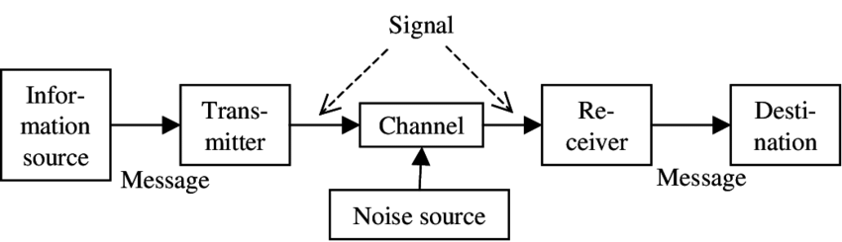
https://www.researchgate.net/figure/1-Communication-model-of-Shannon-Shannon-and-Weaver-1949
Case study
In the course of my workday, I happened to be in an area where there is a lot of mechanical noise. My appearance was intended to inform everyone that there has been an increase in demand for our products, and that we are in need of personnel who are prepared to work overtime. It was suggested to me that anyone interested in doing so should contact the Production Manager after business hours.
Most surprising was that no one offered to volunteer and that everyone went back to their homes. It was brought to my attention by the supervisors that I had not informed the staff of this opportunity to earn additional money. I informed him that I had done so and that I was shocked that no one had shown up because they had been requesting overtime on a regular basis.
On the second day, I went into the changing room area (which is adjacent to the production room) to find out what had happened the day before, and they informed me that everyone had understood there would be no overtime that day, and they had all departed the building.
Because the bulk of us were not native English speakers and were chatting in English, I believe this is the ultimate example of communication noise, noise created by both actual noise - machine noise - and the language barrier.
As soon as I realised that they were hearing but not really listening when I informed them of this opportunity, I realised that they were more concerned about their work than with me.
As a result of this mistake, I always make certain that when I communicate with others, I speak in my finest English, there is no background noise and I have their entire attention.

Schramm’s model of communication (1954)

Wilbur Schramm is regarded as a "expert in mass communications." In 1935, he established the Iowa Writers' Workshop and served as its first director until 1941. Wilbur Schramm is widely regarded as the father of the area of Communication Studies.
Wilber Schramm proposed a paradigm of communication in 1954, and it is still in use today.
Information is of little value to anyone unless and until it is carefully expressed in words and transmitted to others. Encoding is incredibly important because it initiates the process of communication by converting the notion into content, which is the first step and is the most important stage in the process. It is the recipient's first and most crucial responsibility to interpret the information that has been conveyed to them after it has arrived at his or her location. Except and until the second party is capable of comprehending or decoding the information that the sender is seeking to communicate, the message is virtually worthless.

As a result, encoding and decoding are two essential components of effective communication, without which information cannot be exchanged between two persons at any time of day or at any location. Schramm's model is built on the same concept as the one that was discussed previously. Coding and decoding are the two most crucial activities in any good communication system, according to Schramm's paradigm, and they are also the most difficult to perform.
Schramm thought that an individual's knowledge, experience, and cultural background also play a big part in how well they can talk to each other. People from different cultures, religions, or backgrounds tend to see the message in different ways.
The author also emphasises the fact that communication is not considered complete until and until the sender receives a feedback from the intended audience.
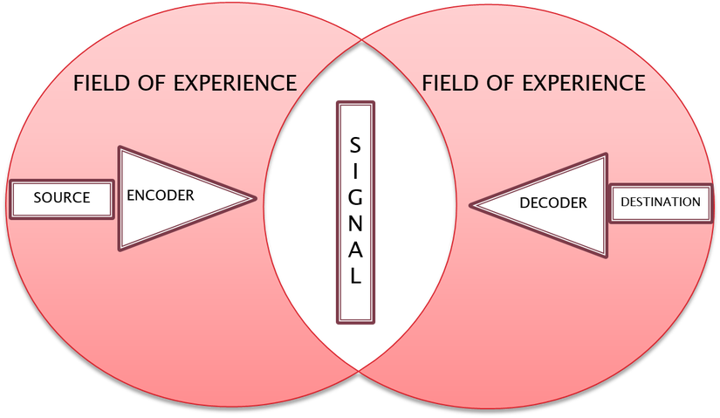
https://studymasscommunication.files.wordpress.com/2019/09/osgood.png

Berlo’s model of communication

David Berlo was a communication theorist who lived in the United States. The Process of Communication was written by him while studying at the University of Illinois, and it is still used today as a communications textbook. Communication skills, attitude, knowledge, and social systems are the components of Berlo's Model, which consists of the following: In this model, the application of communication skills is made to his theory, and in order for the source to communicate effectively, he or she must possess good communication abilities. Listening, speaking, reading, and writing skills are all important aspects of communication. It is critical to understand how to communicate successfully in order to put this strategy into action.
In addition, it is referred to as the SMCR model, where S denotes the source, M denotes the message, C is the channel and R denotes the receiver.
Using communication skills, attitude, knowledge, the social system and culture the source communicates the message.
Communication skills- to be productive and have an impact on the listeners, one must have strong communication abilities. The speaker must know where to halt, where to repeat sentences, how to enunciate words, etc. The speaker cannot drone on. He should also check with the recipients and answer any questions.
Attitude- the world is at your feet if you have the correct mentality. If the person has the appropriate mentality, there is no stopping them. A person can be a great speaker but never win without the correct mindset. To leave an effect on the listeners, the sender must have the correct attitude.
Knowledge- the speaker's educational background or the number of degrees he holds have no bearing on his knowledge. Information that is clear to both parties is known as knowledge. A thorough knowledge of the subject is required. Remember, questions can come at any time, so be prepared. You must know what you are talking about. Before giving any speech, read as much as you can about the subject and prepare thoroughly without skipping a beat.
Social System- Imagine a politician proposing to build a temple in a Muslim-dominated area. What would the listeners' reaction be? They are clearly uninterested. Was the leader's communication lacking or did he lack the necessary attitude? The listeners were displeased because the speaker overlooked the social context in which he was communicating. He forgot the second party's sensitivities, cultural and religious values.
Cultural context- The cultural background of the community or the audience with whom the speaker is communicating or delivering his speech is referred to as the "cultural context."
It is capable of generating a message when an individual puts his or her thoughts into words. The procedure is also referred to as encoding, and it is composed of the elements listed below.

Content- No one can see his grey matter and know what he is thinking. A thought must be expressed in words and prepared substance. The topic or script of the dialogue is called content. In other words, it is the foundation of communication. It is vital that the speaker carefully selects his or her words and carefully crafts his or her speech's content. To make an immediate impact on the listeners, the content must be sensible, accurate, snappy, and relevant to the notion itself.
Element- Speech alone cannot make a difference in communication. Keep talking and the audience will lose interest. To impress the audience, the speaker must use hand gestures, postures, facial emotions, and body movements. These are all elements of the message.
Treatment- Treatment is the manner one treats and transmits his message to the listeners. The message must be understood and managed correctly. To fire an employee, a boss must be authoritative and cannot convey his message casually. This is called message treatment. One must know how to present one's message accurately.
Structure- A message cannot be conveyed in a single breath. It needs to be correctly organised in order to convey the message in the most effective manner possible.
Code- Incorrect codes will not open the locks. Similarly, the communication code must be valid. These are the codes that must be accurate or the message is twisted and the recipient will never be able to decode it correctly.

Channel- When we talk about a channel, we are referring to the means through which information is transmitted from one party to another. All five senses (hearing, seeing, tasting, smelling and touching) are channels via which human beings can connect with one another.
Receiver, also known as the decoder should be on the same platform as the speaker for improved communication and understanding. He should be able to understand the speaker's message. He needs the correct mentality to receive the message positively. His knowledge should be comparable to the listener's. He should share the speaker's socioeconomic and cultural background.
Case study
My current job has a large number of employees from countries other than the United Kingdom, the majority of whom are from Europe, with a few from Asia or Africa. For all of them, English is not their first language, and they occasionally do not understand what is spoken to them due to their limited grasp of the language. In these circumstances, the warehouse supervisor receives an email from his manager asking him to explain the implications of Brexit on the workforce one day. The manager's message was to ensure everyone that their workplace is safe and that they will be assisted in applying for settle or pre-settlement status so that everyone may be safe after Brexit. The warehouse supervisor's message to his team was: "After Brexit, any European citizen without settled or pre-settled status would be unable to work in the UK." As it was in the early days, no one knew about the settlement scheme, no one had it, and they all began to panic as the majority of them began to establish their lives here, leaving their countries behind. Because they were given an incomplete message, they disrupted their work and began to ask each other what needed to be done, causing havoc in the organisation. Seeing this, the manager entered the warehouse and began to clarify the message to everyone, assuring them that they understood by taking any questions they had and assuring them that his door is always open if anyone else has any questions.
This case study, I believe, can be applicable to both the Schramm and Berlo communication models.
It can be applicable to Schramm because of the bad communication in which the supervisor delivered the message - in this case, the language is the area of experience, and he believed that his words meant that they would all be assisted.
It may be connected to Berlo's model of communication since the sender of the message came to the warhouse and helped everyone comprehend that they would be secure and that they would be able to keep their jobs and lives as they were before through his communication skills, attitude, and knowledge.

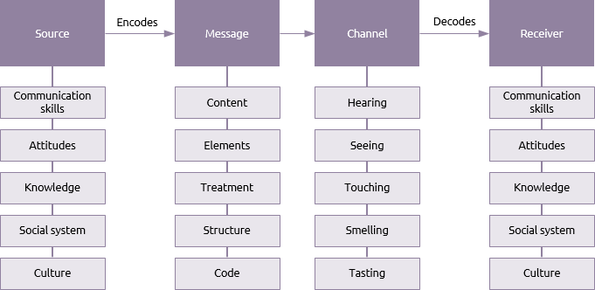
https://www.praxisframework.org/images/berlo.png
It is because of human evolution that communication has progressed as well. As the human race continues to progress, so will the manner in which we communicate. Furthermore, scientists anticipate that, as a result of globalisation, there will be a single common language spoken on the entire planet at some point in the future, and that we will be studied in schools in the same way that we are today with our forefathers.

References

GENOSKO, G. (2012). Remodelling Communication: From WWII to the WWW. University of Toronto Press. http://www.jstor.org/stable/10.3138/j.ctt2tv3r1
Juneja, P., 2022. Schramm's Model of Communication. [online] Managementstudyguide.com. Available at: <https://www.managementstudyguide.com/schramm-model-of-communication.htm> [Accessed 18 April 2022].
En.wikipedia.org. 2022. David Berlo - Wikipedia. [online] Available at: <https://en.wikipedia.org/wiki/David_Berlo> [Accessed 2 May 2022].
Juneja, P., 2022. Berlo's Model of Communication. [online] Managementstudyguide.com. Available at: <https://www.managementstudyguide.com/berlo-model-of-communication.htm> [Accessed 13 April 2022].
<https://www.researchgate.net/figure/1-Communication-model-of-Shannon-Shannon-and-Weaver-1949> [Accessed 2 May 2022].
<https://www.researchgate.net/figure/1-Communication-model-of-Shannon-Shannon-and-Weaver-1949> [Accessed 2 May 2022].
Praxisframework.org. 2022. [online] Available at: <https://www.praxisframework.org/images/berlo.png> [Accessed 2 May 2022].

