

Institute of Inner-City Learning Birmingham Campus
BSc (Hons) Health and Social Care

BARRIERS TO ACCESSING MENTAL HEALTH SERVICES FOR ADULTS IN THE UK

JOHN MOSES IMADE OMOROGBE
2310505

Dissertation submitted as part of the requirements for the award of BSc (Hons) Health and Social Care
Disclaimer
This document was correct at the time of publication. The Module Coordinator reserves the right to modify any statement if necessary, make variations to the content or methods of delivery of programmes of study, to discontinue programmes, or merge or combine programmes if such actions are reasonably considered to be necessary by UWTSD. Every effort will be made to keep disruption to a minimum, and to give as much notice as possible. An electronic copy of this handbook can be found on the Moodle page for the module.
Declaration
This work has not previously been accepted in substance for any degree and is not being concurrently submitted in candidature for any degree.
Signed :John Moses...................................................
Date :26/7/26......................................................
Statement 1
This dissertation is being submitted in partial fulfilment of the requirements for the degree of BSc.
Signed :John Moses....................................................
Date :26/7/26......................................................
Statement 2
This dissertation is the result of my own independent work/investigation, except where otherwise stated. Other sources are acknowledged by footnotes giving explicit references. A bibliography is appended.
Signed :John Moses ...................................................
Date 26/7/26......................................................
Statement 3
I hereby give consent for my dissertation, if accepted, to be available for photocopying and for interlibrary loan, and for the title and summary to be made available to outside organisations.
Signed :John Moses.......................................................
Date :26/7/26.........................................................
Statement 4
I hereby give consent for my dissertation, if accepted, to be available on the university's IT system to those who have consent to use the system.
Signed :John Moses......................................................
Date :26/7/26.........................................................
Acknowledgements
I would like to begin by expressing my sincere gratitude to my project supervisor and the wider academic staff at the Institute of Inner-City Learning Birmingham Campus for their invaluable guidance, constructive feedback, and continued support throughout this research project. Their expertise and encouragement were instrumental in shaping the direction and quality of this dissertation.
I would also like to thank my colleagues and friends, particularly Blessing, Joe, Ruta, Yahaddy, FOlake, Joyce, Mohammed, Rose, Stella, Sabrina Salma and Priya Chandran, for their generosity in sharing ideas, offering feedback on early drafts, and providing moral support during long study sessions. Their camaraderie made this process far less isolating than it might otherwise have been.
Finally, and most importantly, I would like to express my deepest gratitude to my parents, Gladys, Grace and MosesImade , for their unwavering love, patience, and encouragement throughout this dissertation and my entire academic journey. Their constant belief in me gave me the strength to keep going, even during the most challenging moments of this research.
Abstract
This dissertation critically explores the barriers that prevent adults in the United Kingdom from accessing mental health services, an issue of ongoing significance given the persistent gap between policy commitments to “parity of esteem” and the everyday reality of service provision. The study is guided by four objectives: to identify and critically analyse structural, organisational, and social barriers to access; to evaluate the impact of these barriers on service user experiences and outcomes; to examine inequalities in access among different adult population groups; and to assess existing recommendations for improving access to mental health care.
An interpretivist, qualitative approach was adopted, using a narrative critical literature review as the primary research design. This desk-based, secondary research method enabled the synthesis and critical evaluation of peer-reviewed studies, government publications, and policy reports, using a structured search strategy, defined inclusion and exclusion criteria, and a thematic coding approach to analysis.
The findings indicate that access to mental health services is shaped by an interconnected set of structural, organisational, socio-cultural, and inequality-related barriers. Structural underfunding, workforce shortages, and rising demand were found to be the most fundamental constraints, while fragmented care pathways and eligibility thresholds further complicate service navigation. Stigma and cultural misunderstanding continue to discourage help-seeking, and these socio-cultural barriers are compounded by socioeconomic and ethnic inequalities that leave disadvantaged groups disproportionately underserved.
Key limitations of the study include its reliance on existing secondary literature rather than primary data collection, which means the lived experiences of service users are represented only indirectly, and the narrative (rather than systematic) review design, which prioritises critical synthesis over exhaustive coverage of the literature.
The dissertation concludes with six recommendations for future practice and policy: sustained, needs-based investment in mental health services; workforce development that goes beyond recruitment to address retention and wellbeing; stronger integration across primary, secondary, and community care; expansion of culturally competent care and interpreter services; continued digital development alongside targeted action on the digital divide; and wider policy action on the social determinants of mental health, including poverty, housing, and employment.
Table of Contents
1.1 Introduction 9
1.2 Background to the Study 9
1.3 Rationale for the Study 10
1.4 Aim and Objectives 11
1.5 Research Question 11
1.6 Significance of the Study 11
1.7 Structure of the Dissertation 11
CHAPTER TWO 13
LITERATURE REVIEW 13
2.1 Introduction 13
2.2 Theoretical Perspectives on Access to Mental Health Services 13
2.3 Structural Barriers to Access 15
2.4 Organisational Barriers and Service Delivery 16
2.5 Socio-Cultural Barriers and Help-Seeking Behaviour 16
2.6 Inequalities in Access to Mental Health Services 17
2.7 Policy Context and Critical Evaluation 18
CHAPTER THREE 19
METHODOLOGY 19
3.1 Introduction 19
3.2 Research Philosophy and Approach 19
3.3 Research Design 20
3.4 Literature Search Strategy 20
3.5 Literature Selection and Evaluation 21
3.6 Data Analysis 22
3.7 Ethical Considerations and Methodological Limitations 22
3.8 Chapter Summary 23
CHAPTER FOUR 24
FINDINGS, DISCUSSION AND CRITICAL ANALYSIS 24
4.1 Introduction 24
4.2 Overview of Literature and Critical Context 25
4.3 Structural Barriers to Accessing Mental Health Services 26
4.4 Organisational Barriers to Mental Health Service Access 28
4.4.1 Service fragmentation and navigation complexity 29
4.4.2 Workforce shortages and organisational strain 30
4.4.3 Gatekeeping, eligibility thresholds, and institutional filtering 30
4.5 Socio-cultural Barriers to Mental Health Service Access 31
4.5.1 Stigma as a socially produced and system-reinforced barrier 31
4.5.2 Cultural interpretations of mental health and service mismatch 32
4.6 Inequalities in Access to Mental Health Services 32
4.6.1 Socioeconomic inequality and the reproduction of disadvantage 33
4.6.2 Ethnic disparities and institutional exclusion 33
4.6.3 Intersectionality and compounded disadvantage 34
4.7 Critical Evaluation of Existing Recommendations for Improving Access to Mental Health Care 34
4.7.1 NHS Long Term Plan and parity of esteem agenda 35
4.7.2 Expansion of Improving Access to Psychological Therapies (IAPT) 35
4.7.3 Workforce expansion and recruitment strategies 36
4.7.4 Digital mental health and remote service delivery 36
4.7.5 Community-based care and early intervention strategies 37
4.8 Critical synthesis of recommendations 37
CHAPTER FIVE 38
RECOMMENDATIONS AND CONCLUSION 38
5.1 Recommendations 38
5.2 Future Research 40
5.3 Conclusion 40
REFERENCES 42

LIST OF TABLES AND FIGURES
Table 2.1: Comparison of Theoretical Frameworks Used to Explain Access to Mental Health Services ……………………………………………………………………………………… 14
Table 2.2: Summary of Barrier Themes Identified in the Literature ………………………. 18
Table 3.2: Literature Sources and Search Parameters …………………………………… 21.
Figure 3.1: Stages of the Thematic Analysis Process …………………………………… 22
Figure 4.1: Conceptual Model of Interacting Barriers to Mental Health Service Access … 25
Table 4.1: Overview of Key Sources Underpinning the Chapter Four Analysis ………….. 26
Figure 4.2: Referrals to NHS Talking Therapies for Anxiety and Depression, England,
Selected Years …………………………………………………………………………………… 27
Figure 4.3: Proportion of NHS Talking Therapies Referrals Starting Treatment Within 6
Weeks, Selected Years ………………………………………………………………………… 28
Figure 4.4: Route of Referral Into NHS Talking Therapies, England, 2023/24 ………….. 29
Figure 4.5: NHS Talking Therapies Recovery Rate by Deprivation Decile, England …… 33
Table 4.2: Critical Evaluation of Existing Policy Recommendations ……………………… 38
Table 5.1: Recommendations Mapped to the Barrier Themes They Primarily Address … 40

CHAPTER ONE
INTRODUCTION

1.1 Introduction
Mental health is increasingly recognised as a fundamental component of overall health, yet access to appropriate mental health services remains uneven across populations. In the United Kingdom, policy frameworks have progressively emphasised the importance of mental health, particularly through commitments to achieving “parity of esteem” between mental and physical health. However, despite these policy ambitions, significant disparities persist in the accessibility and delivery of mental health services (Department of Health and Social Care, 2022).
The demand for mental health support has risen substantially in recent years, reflecting both increased prevalence and improved awareness of mental health conditions. Nevertheless, this rising demand has not been matched by proportional expansion in service capacity. As a result, individuals frequently encounter barriers such as long waiting times, limited service availability, and fragmented care pathways (NHS England, 2023). This mismatch between demand and provision raises critical concerns regarding the effectiveness of current healthcare strategies and the sustainability of mental health services.
From a critical perspective, the issue of access extends beyond service availability to encompass broader systemic and social factors. While the National Health Service (NHS) operates on the principle of universal access, this does not necessarily translate into equitable access. Evidence suggests that certain groups continue to experience disproportionate challenges in accessing care, indicating that structural inequalities remain embedded within the system (The King’s Fund, 2022). Therefore, examining access requires a nuanced understanding of both institutional limitations and wider social determinants.

1.2 Background to the Study
The UK mental health system operates within a complex socio-political and economic context, shaped by policy decisions, resource allocation, and workforce capacity. Over the past decade, there has been a notable shift towards prioritising mental health within national policy. Initiatives such as the NHS Long Term Plan have aimed to expand services and improve early intervention. However, despite these developments, significant gaps remain between policy intentions and practical outcomes (NHS England, 2023).
One of the central challenges lies in the persistent under-resourcing of mental health services relative to demand. Although funding has increased in recent years, it has not kept pace with the growing need for services. This has resulted in capacity constraints, particularly within community-based services, where early intervention is most critical (The King’s Fund, 2022). Consequently, many individuals are unable to access support until their condition has escalated, undermining preventative approaches to care.
Workforce shortages further exacerbate these issues. The availability of trained mental health professionals remains insufficient to meet demand, leading to increased workloads, staff burnout, and reduced quality of care. The Care Quality Commission (2023) highlights that staffing pressures contribute to delays in assessment and treatment, which can negatively impact patient outcomes.
In addition to systemic challenges, access to mental health services is influenced by social determinants such as socioeconomic status, ethnicity, and geographical location. Individuals from disadvantaged backgrounds are more likely to experience barriers related to affordability, awareness, and accessibility of services. Similarly, ethnic minority groups may encounter cultural stigma, language barriers, and institutional mistrust, all of which can hinder engagement with mental health services (Mental Health Foundation, 2022).
These factors demonstrate that access to mental health services cannot be understood solely in terms of service provision. Instead, it is shaped by a combination of structural, organisational, and social influences, which interact to create complex and often unequal patterns of access.

1.3 Rationale for the Study
The rationale for this study is grounded in the need to critically examine the persistent barriers to accessing mental health services in the UK. While existing research has identified various challenges, there remains a need for a more integrated analysis that considers how different types of barriers interact and reinforce one another.
A key limitation of current approaches is the tendency to address barriers in isolation, rather than recognising their interconnected nature. For example, workforce shortages are often discussed separately from funding constraints, despite the fact that these issues are closely linked. Similarly, social determinants such as poverty and inequality are frequently acknowledged but not fully integrated into service planning and delivery.
This study seeks to address these gaps by synthesising existing literature through a systematic and critical lens. By doing so, it aims to provide a more comprehensive understanding of the barriers affecting access to mental health services and their implications for service users.
The study is also justified by its relevance to current health and social care priorities. Improving access to mental health services is a key objective within UK healthcare policy, yet progress has been uneven. A critical examination of existing evidence can contribute to more informed policy development and support the design of more effective interventions.

1.4 Aim and Objectives

Aim
To critically explore the barriers that prevent adults in the UK from accessing mental health services.

Objectives
- To identify and critically analyse structural, organisational, and social barriers to accessing mental health services
- To evaluate the impact of these barriers on service user experiences and outcomes
- To examine inequalities in access among different adult population groups
- To assess existing recommendations for improving access to mental health care

1.5 Research Question
What barriers prevent adults in the UK from accessing mental health services?

1.6 Significance of the Study
This study is significant in both academic and practical contexts. From an academic perspective, it contributes to the growing body of literature on mental health service accessibility by providing a critical synthesis of existing research. By focusing on the UK context, the study offers insights that are directly relevant to current policy debates and healthcare challenges.
From a practical perspective, the findings have implications for healthcare professionals, policymakers, and service providers. Understanding the barriers to access can support the development of more inclusive and effective services, ultimately improving patient outcomes. Furthermore, addressing these barriers is essential for reducing health inequalities and promoting social justice within healthcare systems.
Critically, the study also highlights the limitations of current approaches to mental health service provision. While policy initiatives have made progress in raising awareness and increasing investment, structural and social inequalities continue to limit access for many individuals. This underscores the need for more comprehensive and coordinated strategies that address the root causes of these challenges.

1.7 Structure of the Dissertation
The dissertation is structured into five chapters: Chapter 1 introduces the study by outlining its background, rationale, aim and objectives; Chapter 2 critically reviews relevant literature and theoretical frameworks; Chapter 3 explains the research design and methodology; Chapter 4 presents and discusses the findings; and Chapter 5 provides recommendations and concludes the study.

CHAPTER TWO

LITERATURE REVIEW

2.1 Introduction
Access to mental health services remains a persistent and complex challenge within the United Kingdom, despite sustained policy attention and increasing societal awareness of mental health issues. Over the past decade, mental health has been elevated within national health priorities, particularly through commitments to achieving parity of esteem between mental and physical health. However, empirical evidence consistently demonstrates that access to services remains uneven, with many individuals experiencing delays, unmet needs, and systemic barriers to care (NHS England, 2023; The King’s Fund, 2022).
The literature increasingly recognises that barriers to access are not attributable to a single factor but emerge from the interaction of structural, organisational, and socio-cultural influences. This complexity has led to a shift away from purely descriptive analyses towards more critical approaches that consider how different determinants intersect to shape service utilisation. Nevertheless, gaps remain in understanding how these barriers operate collectively, particularly in relation to inequalities affecting specific population groups.
This chapter critically reviews existing literature on barriers to accessing mental health services among adults in the UK. It synthesises theoretical frameworks, empirical evidence, and policy analyses to provide a comprehensive understanding of access. The review adopts a critical perspective, highlighting contradictions within the literature, evaluating the effectiveness of existing approaches, and identifying areas where further research is needed. In doing so, it moves beyond surface-level descriptions to examine the deeper structural and social dynamics that influence access to mental health care.

2.2 Theoretical Perspectives on Access to Mental Health Services
The concept of access to healthcare has been widely debated, with no universally accepted definition. Levesque, Harris and Russell (2013) offer one of the most comprehensive frameworks, conceptualising access as a dynamic interaction between health systems and populations. Their model identifies five key dimensions; approachability, acceptability, availability, affordability, and appropriateness which together capture both supply-side and demand-side factors influencing access.
While the Levesque framework has been widely applied in mental health research, it is not without limitations. One critique is that it tends to focus on the interaction between individuals and services without fully accounting for broader structural inequalities. Dixon-Woods et al. (2006) argue that access is deeply embedded within social hierarchies and power relations, suggesting that frameworks which emphasise individual behaviour may overlook systemic barriers. This critique is particularly relevant in the context of mental health, where stigma, discrimination, and socioeconomic disadvantage play a significant role in shaping access.
Similarly, Andersen’s behavioural model, which categorises determinants of healthcare utilisation into predisposing, enabling, and need factors, has been influential in understanding access. However, this model has also been criticised for its individualistic focus. By emphasising personal characteristics and behaviours, it risks obscuring the structural conditions that constrain access, such as service availability and institutional bias.
In the UK context, the principle of universal healthcare under the NHS is often assumed to ensure equitable access. However, research challenges this assumption, demonstrating that universal provision does not eliminate disparities (The King’s Fund, 2022). Instead, access is mediated by social determinants such as income, ethnicity, and geographic location. This highlights a fundamental limitation in policy discourse, which often equates availability with accessibility.
Taken together, these theoretical perspectives suggest that access to mental health services is a complex and contested concept. While existing frameworks provide valuable insights, they often fail to fully integrate structural and socio-cultural determinants. This indicates a need for more holistic models that capture the interplay between individual, systemic, and societal factors.
Table 2.1: Comparison of Theoretical Frameworks Used to Explain Access to Mental Health Services
Framework | Key Source(s) | Core Focus / Dimensions | Key Critique
Access Framework | Levesque, Harris and Russell (2013) | Approachability, acceptability, availability, affordability, appropriateness | Emphasises supply/demand interaction but underplays structural inequality
Behavioural Model of Health Service Use | Andersen (1995) | Predisposing, enabling, and need factors | Individualistic focus risks obscuring structural and institutional constraints
Social Determinants of Health (SDH) | World Health Organization (2008) | Income, housing, employment, education as drivers of health and access | Broad and structural, but less specific about service-level mechanisms
Candidacy Theory | Dixon-Woods et al. (2005) | Access as an ongoing negotiation of eligibility between individuals and services | Highlights institutional gatekeeping but requires pairing with structural theory

2.3 Structural Barriers to Access
Structural barriers are widely recognised as a primary constraint on access to mental health services in the UK. One of the most significant issues identified in the literature is the imbalance between demand and service capacity. NHS England (2023) reports a substantial increase in the number of individuals seeking mental health support, yet service expansion has not kept pace. This has resulted in long waiting times, limited availability of specialist services, and significant unmet need.
Funding constraints are frequently cited as a key contributing factor. Although there has been increased investment in mental health services in recent years, several studies argue that funding remains insufficient relative to demand (Department of Health and Social Care, 2022; The King’s Fund, 2022). Furthermore, the distribution of funding is uneven, leading to regional disparities in service provision. This suggests that simply increasing funding may not be sufficient without addressing issues of resource allocation and efficiency.
Workforce shortages represent another critical structural challenge. The Care Quality Commission (2023) highlights persistent deficits in mental health staffing, including psychiatrists, psychologists, and nurses. While these shortages are often attributed to funding limitations, the literature suggests that they are also linked to broader issues such as training capacity, retention, and working conditions. High levels of burnout among mental health professionals contribute to staff turnover, further exacerbating workforce shortages.
Geographical inequalities further complicate access. Studies consistently show that individuals in rural areas face reduced access to specialist services, often requiring long travel distances (The King’s Fund, 2022). However, access issues are not confined to rural areas; urban regions with high levels of deprivation also experience significant challenges due to high demand and limited resources. This challenges the assumption that increasing service availability in certain areas will automatically improve access.
Critically, structural barriers are interconnected and mutually reinforcing. Funding constraints contribute to workforce shortages, which in turn lead to longer waiting times and reduced service quality. Despite extensive research on these issues, there is limited evidence on effective strategies for addressing them. This highlights a significant gap in the literature, particularly in relation to long-term, system-level solutions.

2.4 Organisational Barriers and Service Delivery
Organisational factors play a crucial role in shaping access to mental health services. Fragmentation of services is a recurring theme within the literature, with multiple studies highlighting the challenges associated with navigating complex care pathways (The King’s Fund, 2022). Poor coordination between primary care, secondary services, and social care often results in delays, duplication of assessments, and discontinuity of care.
Waiting times are frequently identified as a major organisational barrier. The Care Quality Commission (2023) reports that many individuals experience significant delays in accessing both initial assessments and ongoing treatment. While these delays are often attributed to resource limitations, some researchers argue that inefficiencies in service organisation also play a role. For example, bureaucratic referral processes can create additional barriers, particularly for individuals with limited support or health literacy.
Eligibility criteria represent another area of concern. Research indicates that services often prioritise individuals with severe conditions due to limited capacity, leaving those with moderate needs without support (Mental Health Foundation, 2022). This reactive approach has been widely criticised for undermining early intervention strategies, which are essential for preventing the escalation of mental health problems.
The increasing use of digital technologies in mental health care has generated mixed responses within the literature. On one hand, digital platforms are viewed as a means of improving access and reducing pressure on traditional services. On the other hand, concerns have been raised regarding digital exclusion, particularly among older adults and low-income populations. This highlights a tension between innovation and equity, suggesting that technological solutions must be carefully implemented to avoid reinforcing existing inequalities.
Despite extensive research on organisational barriers, there is limited evidence on the effectiveness of interventions aimed at improving service integration. This represents a significant gap, particularly given the emphasis placed on integrated care within policy frameworks.

2.5 Socio-Cultural Barriers and Help-Seeking Behaviour
Socio-cultural factors are widely recognised as critical determinants of access to mental health services, particularly in relation to help-seeking behaviour. Stigma remains one of the most significant barriers, with numerous studies demonstrating its impact on individuals’ willingness to seek care (Mental Health Foundation, 2022). However, the literature also highlights that stigma is not uniform but varies across different population groups.
Cultural beliefs about mental health can significantly influence attitudes towards seeking help. Some studies suggest that individuals from certain ethnic minority backgrounds may be less likely to engage with formal services due to cultural norms and mistrust of healthcare institutions (The King’s Fund, 2022). However, this perspective has been critiqued for potentially reinforcing stereotypes. Alternative interpretations emphasise the role of structural inequalities and experiences of discrimination in shaping mistrust.
Socioeconomic status is another key determinant of access. Individuals from lower-income backgrounds often face practical barriers, such as transportation costs and limited flexibility to attend appointments. These challenges are compounded by lower levels of health literacy, which can affect awareness of available services. While these issues are widely acknowledged, there is limited research exploring how socioeconomic factors interact with other determinants, such as ethnicity and gender.
Gender differences in help-seeking behaviour have also been extensively documented. Studies consistently show that men are less likely to access mental health services, often due to societal expectations surrounding masculinity (World Health Organization, 2022). However, some researchers argue that this focus on gender norms may overlook structural barriers that affect access for all individuals.
Overall, the literature suggests that socio-cultural barriers are complex and multifaceted. While there is substantial evidence on individual-level factors, there is less emphasis on how these interact with structural and organisational determinants, indicating a need for more integrated research approaches.

2.6 Inequalities in Access to Mental Health Services
Inequalities in access to mental health services are a major focus of contemporary research. Evidence consistently shows that certain groups experience disproportionate barriers, including ethnic minorities, individuals living in deprived areas, and those with co-occurring conditions (Mental Health Foundation, 2022).
Ethnic disparities are particularly pronounced, with studies indicating that minority groups are less likely to access early intervention services but more likely to experience compulsory treatment under the Mental Health Act. While some researchers attribute this to cultural factors, others argue that systemic bias and discrimination within healthcare systems play a more significant role.
Socioeconomic inequalities also contribute to disparities in access. Individuals in deprived areas often have higher rates of mental health conditions but face greater barriers to accessing care (The King’s Fund, 2022). This reflects broader health inequalities and highlights the limitations of universal healthcare systems in addressing social determinants of health.
Despite extensive research on inequalities, there is limited consensus on effective strategies for addressing them. While policy initiatives often emphasise targeted interventions, there is a lack of robust evidence evaluating their impact. This suggests that further research is needed to identify and implement effective solutions.

2.7 Policy Context and Critical Evaluation
Policy responses to mental health access in the UK have focused on increasing funding, expanding services, and improving integration. The NHS Long Term Plan represents a significant commitment to improving mental health care, with a particular emphasis on early intervention and community-based services (NHS England, 2023).
However, the literature highlights several limitations in current policy approaches. Firstly, there is a persistent gap between policy intentions and implementation. While funding has increased, it has not kept pace with demand, limiting the effectiveness of reforms (Department of Health and Social Care, 2022). Secondly, policies often focus on service expansion without adequately addressing underlying structural and social determinants.
Critically, there is limited evaluation of policy outcomes, making it difficult to assess their effectiveness. This lack of evidence-based policy development represents a significant challenge, particularly given the complexity of access issues. Furthermore, the emphasis on short-term targets may undermine long-term sustainability, suggesting a need for more comprehensive and integrated policy approaches.
Table 2.2: Summary of Barrier Themes Identified in the Literature
Barrier Theme | Key Manifestations | Illustrative Sources
Structural | Underfunding, workforce shortages, demand-capacity mismatch, geographical inequality | NHS England (2023); The King's Fund (2022); Care Quality Commission (2023)
Organisational | Service fragmentation, long waiting times, restrictive eligibility criteria, digital exclusion | The King's Fund (2022); Mental Health Foundation (2022)
Socio-cultural | Stigma, cultural mistrust, gendered help-seeking norms | Mental Health Foundation (2022); World Health Organization (2022)
Inequalities in access | Ethnic disparities, socioeconomic deprivation, compulsory treatment disparities | Mental Health Foundation (2022); The King's Fund (2022)

CHAPTER THREE

METHODOLOGY

3.1 Introduction
This chapter outlines the methodological approach adopted to investigate the barriers preventing adults in the United Kingdom from accessing mental health services. The chapter discusses the research philosophy, research approach, research design, literature search strategy, literature selection process, data analysis procedures, ethical considerations, and methodological limitations. As the study seeks to critically explore and evaluate existing knowledge rather than generate new empirical evidence, a narrative critical literature review was adopted. This approach enables the researcher to synthesise, compare, and critically analyse evidence from a range of academic and policy sources to develop a comprehensive understanding of the factors influencing access to mental health services among adults in the UK.

3.2 Research Philosophy and Approach
Research philosophy refers to the assumptions that underpin the research process and influence how knowledge is interpreted and understood (Saunders, Lewis and Thornhill, 2023). This study adopts an interpretivist research philosophy. Interpretivism is based on the assumption that social reality is constructed through human experiences, interactions, and perceptions and therefore requires contextual understanding rather than objective measurement (Crotty, 1998).
The interpretivist perspective was considered appropriate because barriers to accessing mental health services are influenced by complex social, cultural, organisational, and economic factors. Experiences of stigma, discrimination, service navigation, and healthcare accessibility differ across individuals and communities. Understanding these experiences requires an exploration of meanings and interpretations rather than statistical measurement alone. Consequently, the study adopts a qualitative secondary research approach, which facilitates the examination of how barriers to mental healthcare are discussed and represented within existing literature.
A deductive approach was employed because the themes identified within the literature review informed the analytical framework used throughout the study. Existing theoretical and empirical evidence relating to structural barriers, organisational challenges, socio-cultural influences, and inequalities in access provided the basis for evaluating the selected literature (Bryman, 2021).

3.3 Research Design
This study adopts a narrative critical literature review as the primary research design. A narrative critical literature review involves the identification, examination, and critical evaluation of existing literature relating to a specific research topic (Grant and Booth, 2009). Unlike systematic literature reviews, which aim to identify all available evidence through highly structured search and screening procedures, narrative reviews place greater emphasis on interpretation, critique, and synthesis of knowledge (Snyder, 2019).
The narrative critical review was considered particularly suitable for this study because access to mental health services is a multifaceted issue influenced by policy, service provision, workforce capacity, social determinants of health, and individual experiences. Examining such complexity requires a methodology capable of integrating evidence from diverse sources, including peer-reviewed studies, government publications, policy reports, and reports from organisations involved in mental health advocacy and service provision.
The narrative review approach also facilitates the identification of areas of agreement and disagreement within the literature. Rather than merely summarising previous research, the study critically evaluates existing evidence to identify gaps, inconsistencies, and emerging trends relating to mental health service accessibility in the UK.
Alternative research approaches were considered. Primary qualitative methods, such as interviews or focus groups, could have provided direct insight into service-user experiences. However, such methods would have required ethical approval, participant recruitment, and extensive data collection processes beyond the scope of this dissertation. Quantitative methods were also considered unsuitable because the study aims to understand and critically evaluate barriers rather than measure their prevalence. Consequently, a narrative critical literature review was considered the most appropriate design for achieving the study aim and objectives.

3.4 Literature Search Strategy
A structured literature search was conducted to identify evidence relating to barriers affecting access to mental health services among adults in the UK. Although the review is narrative in nature, adopting a systematic search strategy enhances transparency and reduces the likelihood of selection bias (Greenhalgh et al., 2018).
The search was conducted using CINAHL, PsycINFO, MEDLINE, Scopus, and Google Scholar. These databases were selected because they provide extensive coverage of healthcare, psychology, social care, and public health research. In addition, grey literature was sourced from NHS England, the Department of Health and Social Care, The King’s Fund, the Care Quality Commission, and the Mental Health Foundation. The inclusion of grey literature was considered important because significant evidence relating to mental health service delivery and accessibility is often published outside traditional academic journals.
To ensure relevance to current policy and service contexts, searches were limited to literature published between 2015 and 2025. Search terms included combinations of keywords such as “mental health services”, “access barriers”, “mental healthcare accessibility”, “adult mental health”, “help-seeking behaviour”, and “United Kingdom”. Boolean operators, including AND and OR, were used to refine search results and improve relevance.
Table 3.2: Literature Sources and Search Parameters
Source Type | Sources Consulted
Academic databases | CINAHL, PsycINFO, MEDLINE, Scopus, Google Scholar
Grey literature | NHS England; Department of Health and Social Care; The King's Fund; Care Quality Commission; Mental Health Foundation
Search date range | 2015-2025
Key search terms | "mental health services"; "access barriers"; "mental healthcare accessibility"; "adult mental health"; "help-seeking behaviour"; "United Kingdom" (combined with AND/OR)

3.5 Literature Selection and Evaluation
To ensure consistency and relevance, clear inclusion and exclusion criteria were applied during the literature selection process.
Inclusion Criteria | Exclusion Criteria
Literature published between 2015 and 2025 | Literature published before 2015
Studies conducted within the UK | Studies conducted outside the UK
Research focusing on adults aged 18 years and above | Research focusing exclusively on children or adolescents
Literature examining barriers to mental health service access | Literature focusing solely on treatment outcomes
Peer-reviewed articles and reputable policy reports | Opinion pieces, editorials, and blogs
English-language publications | Non-English publications
The selected literature was evaluated according to its relevance to the research aim, methodological quality, credibility of source, and contribution to understanding barriers to mental health service access. Greater emphasis was placed on peer-reviewed studies and publications produced by recognised healthcare organisations and policy institutions.

3.6 Data Analysis
The selected literature was analysed using thematic analysis. Thematic analysis is widely recognised as a flexible and rigorous method for identifying and interpreting patterns within qualitative data (Braun and Clarke, 2021). The method was considered appropriate because it enables the synthesis of evidence from multiple sources while facilitating critical examination of recurring themes.
The analysis began with repeated reading of the selected literature to achieve familiarity with the data. Key concepts, findings, and arguments relating to barriers to access were then identified and coded. Similar codes were subsequently grouped into broader categories and refined into overarching themes.
Figure 3.1: Stages of the Thematic Analysis Process
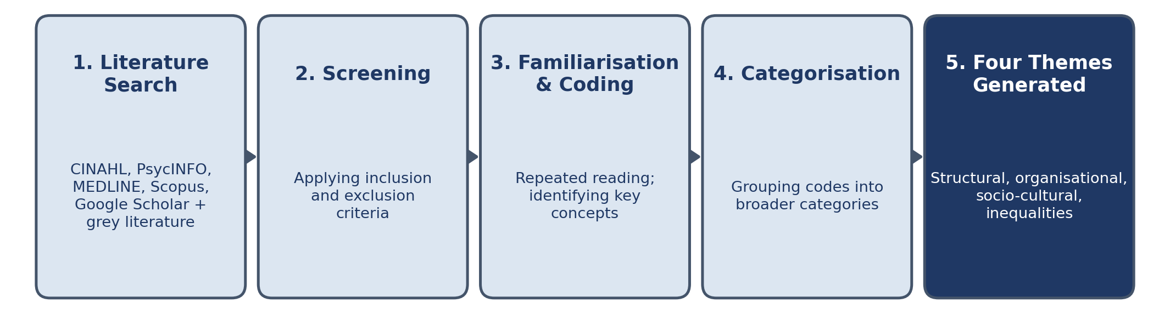

Through this process, four principal themes emerged: structural barriers to access, organisational barriers within mental health services, socio-cultural barriers influencing help-seeking behaviour, and inequalities in access among different population groups. These themes provide the framework for the findings and discussion presented in Chapter Four.
Thematic analysis was selected because it enables both descriptive and interpretive analysis. While the approach facilitates the identification of recurring patterns within the literature, it also allows the researcher to critically evaluate relationships between themes and explore the wider implications of the findings (Braun and Clarke, 2021).

3.7 Ethical Considerations and Methodological Limitations
As the study relies exclusively on secondary data obtained from publicly available sources, formal ethical approval was not required. Nevertheless, ethical principles were maintained throughout the research process. Academic integrity was ensured through accurate citation and referencing of all sources. Transparency was maintained through the clear documentation of search procedures, selection criteria, and analytical decisions. Furthermore, care was taken to represent the findings of reviewed studies accurately and objectively (Flick, 2022).
Several limitations should be acknowledged. First, the findings are dependent upon the quality and scope of the existing literature. Second, restricting the review to English-language publications may have excluded relevant evidence. Third, narrative reviews involve a greater degree of researcher interpretation than systematic reviews, which may increase the potential for subjectivity. To minimise this limitation, literature selection and analysis were guided by explicit criteria and informed by established methodological frameworks.

3.8 Chapter Summary
This chapter has outlined the methodological approach adopted for the study. An interpretivist philosophy, qualitative secondary research approach, and narrative critical literature review design were employed to facilitate a critical examination of barriers to accessing mental health services among adults in the United Kingdom. The chapter described the literature search strategy, literature selection process, thematic analysis procedures, ethical considerations, and methodological limitations. The next chapter presents and critically discusses the findings emerging from the reviewed literature in relation to the research objectives.

CHAPTER FOUR

FINDINGS, DISCUSSION AND CRITICAL ANALYSIS

4.1 Introduction
Access to mental health services in the United Kingdom remains a persistent public health and policy concern despite long-standing commitments to achieving parity of esteem between mental and physical health services (NHS England, 2024). Although successive policy reforms and increased investment have aimed to improve service accessibility, waiting times, and workforce capacity, evidence continues to demonstrate that adults experience significant and unequal barriers when attempting to access mental health care (The King’s Fund, 2024). These barriers are not distributed evenly across the population but are shaped by structural inequality, organisational inefficiencies, and socio-cultural factors that interact in complex ways.
This chapter critically analyses these barriers using evidence from UK policy documents, regulatory reports, and peer-reviewed literature published between 2015 and 2025. Rather than providing a descriptive summary of findings, the chapter adopts a critical approach that interrogates why access barriers persist despite sustained reform efforts. It also examines the tension between policy narratives of improvement and empirical evidence of ongoing inequality in service access.
The analysis is structured around four interrelated themes: structural barriers, organisational barriers, socio-cultural barriers, and inequalities in access. Although these are presented separately for analytical clarity, they are conceptually interdependent and mutually reinforcing in practice. The discussion is informed by three theoretical frameworks. The Social Determinants of Health (SDH) framework (World Health Organization, 2008) situates mental health access within broader socioeconomic conditions such as income, housing, education, and employment. Andersen’s Behavioural Model of Healthcare Utilisation explains access through predisposing factors, enabling resources, and perceived need (Andersen, 1995). Candidacy Theory further conceptualises access as a negotiated process in which individuals must repeatedly establish their eligibility for care within health systems (Dixon-Woods et al., 2005).
Figure 4.1: Conceptual Model of Interacting Barriers to Mental Health Service Access
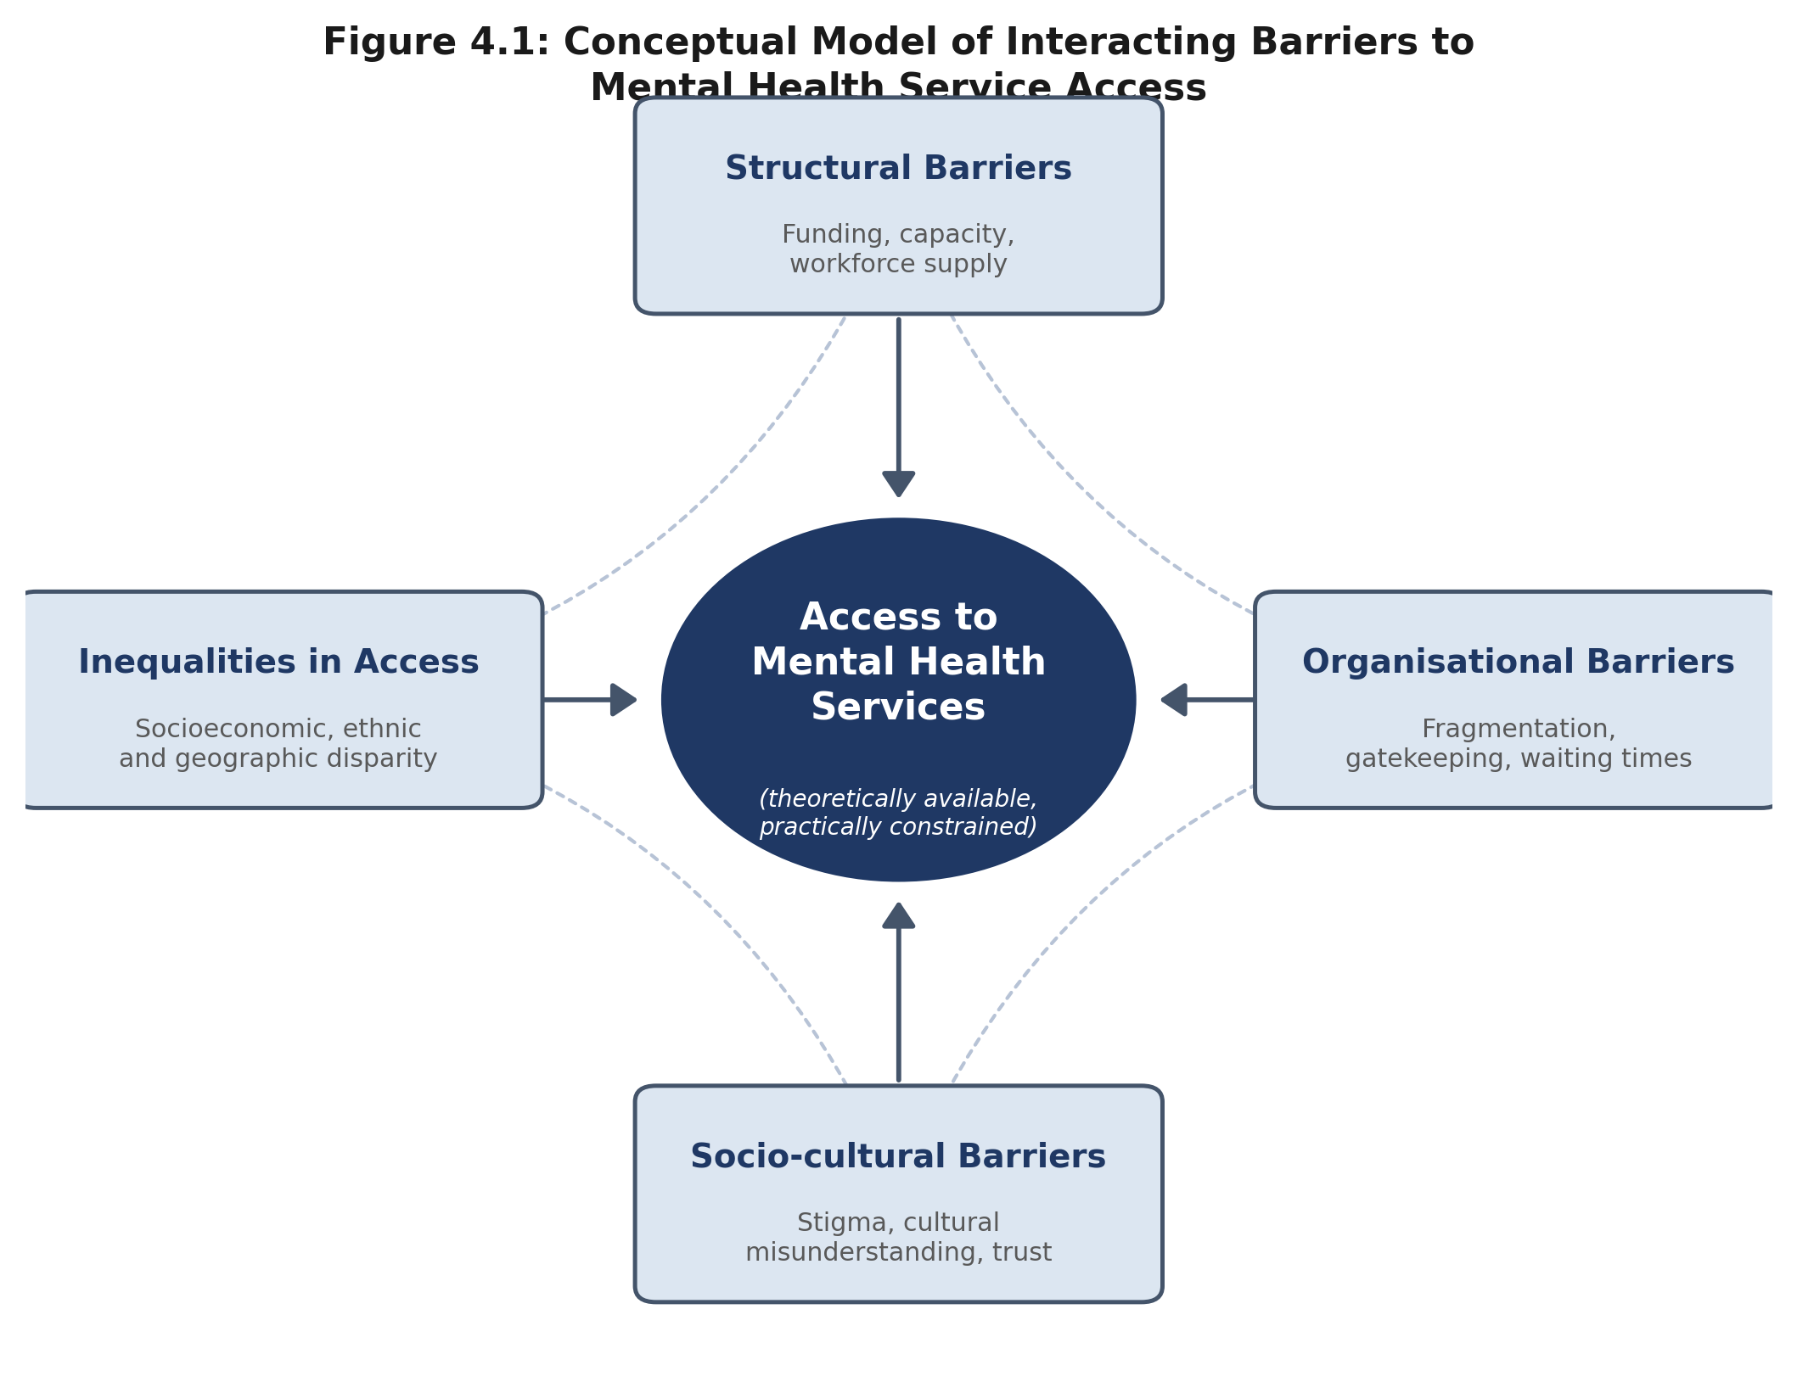
Source: developed by the author, informed by the Social Determinants of Health framework (WHO, 2008), Andersen's Behavioural Model (Andersen, 1995), and Candidacy Theory (Dixon-Woods et al., 2005).

4.2 Overview of Literature and Critical Context
The literature reviewed in this chapter includes peer-reviewed empirical studies, systematic reviews, and UK national policy and regulatory reports published between 2015 and 2025. Key sources include NHS England (2024), The King’s Fund (2024), Healthwatch England (2024), and the Care Quality Commission (2023), alongside academic studies such as Curtin et al. (2023), Huggett et al. (2018), Prajapati and Liebling (2022), Winsper et al. (2023), and Nwokoroku et al. (2022).
A central tension within this body of literature is the divergence between policy narratives of improved access and empirical evidence of persistent barriers experienced by service users. NHS England (2024) reports improvements in service provision, particularly within Improving Access to Psychological Therapies (IAPT), including increased referral rates and reduced waiting times for some services. However, The King’s Fund (2024) argues that such improvements present a partial and potentially misleading picture, as they do not adequately capture pressures within secondary mental health services, where demand continues to exceed capacity and waiting times remain inconsistent.
This divergence reflects a broader methodological and epistemological difference in how “access” is defined and measured. While policy documents tend to focus on quantitative indicators such as waiting times and service activity, academic and service-user research highlights experiential dimensions of access, including navigation difficulties, service fragmentation, and unequal treatment outcomes (Healthwatch England, 2024). This suggests that access cannot be fully understood through performance metrics alone, as these may obscure lived realities of inequality and exclusion.
Table 4.1: Overview of Key Sources Underpinning the Chapter Four Analysis
Source | Type | Primary Focus
NHS England (2024) | National policy / performance report | Service activity, IAPT referral and waiting-time data
The King's Fund (2024) | Independent policy think tank report | Structural pressures, regional inequality, critique of policy narratives
Healthwatch England (2024) | Regulatory / patient-experience report | Waiting times and experiential dimensions of access
Care Quality Commission (2023) | Regulatory monitoring report | Workforce shortages and service quality
Curtin et al. (2023) | Peer-reviewed empirical study | Service fragmentation and navigation complexity
Winsper et al. (2023); Nwokoroku et al. (2022) | Peer-reviewed empirical studies | Ethnic disparities and institutional exclusion
Prajapati and Liebling (2022) | Peer-reviewed empirical study | Cultural interpretations of mental health and service mismatch

4.3 Structural Barriers to Accessing Mental Health Services
Structural barriers operate at the macro level of the healthcare system and reflect broader institutional and socioeconomic conditions that shape service availability and accessibility. When analysed through the Social Determinants of Health framework, these barriers are understood as manifestations of wider social inequalities that are reproduced within healthcare systems rather than resolved by them (World Health Organization, 2008).
A dominant theme across the literature is the persistent mismatch between increasing demand for mental health services and limited system capacity. NHS England (2024) reports a steady rise in demand for adult mental health services, particularly in relation to anxiety and depression. However, service expansion has not kept pace with this increase, resulting in sustained pressure on existing services. The King’s Fund (2024) argues that this reflects long-term underinvestment in mental health relative to physical healthcare, despite policy commitments to parity of esteem.
Figure 4.2: Referrals to NHS Talking Therapies for Anxiety and Depression, England, Selected Years
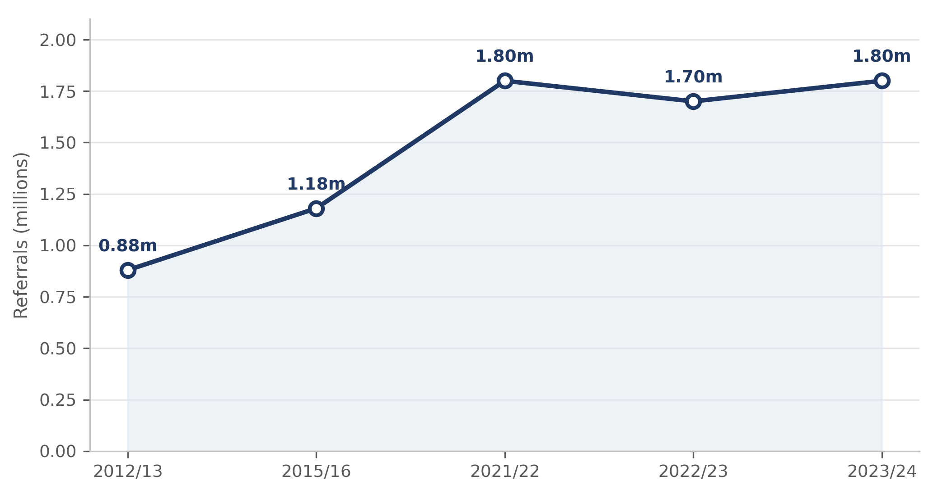
Source: NHS Digital / NHS England, NHS Talking Therapies for Anxiety and Depression Annual Reports; Nuffield Trust QualityWatch (2026).
From the perspective of Andersen’s Behavioural Model, this represents a failure in enabling resources, where individuals may recognise need and be willing to seek help but are constrained by system capacity (Andersen, 1995). This creates a situation in which access is theoretically available but practically restricted.
Waiting times represent a key manifestation of this structural constraint. Healthwatch England (2024) reports that individuals in socioeconomically disadvantaged groups are disproportionately affected by delays in accessing mental health services. These delays are not simply administrative inefficiencies but have significant clinical consequences, including deterioration of mental health conditions and increased likelihood of crisis intervention. Although NHS England (2024) highlights improvements in waiting times for talking therapies, The King’s Fund (2024) critiques this position, arguing that selective performance reporting fails to reflect broader system pressures, particularly in secondary care services.
Figure 4.3: Proportion of NHS Talking Therapies Referrals Starting Treatment Within 6 Weeks, Selected Years
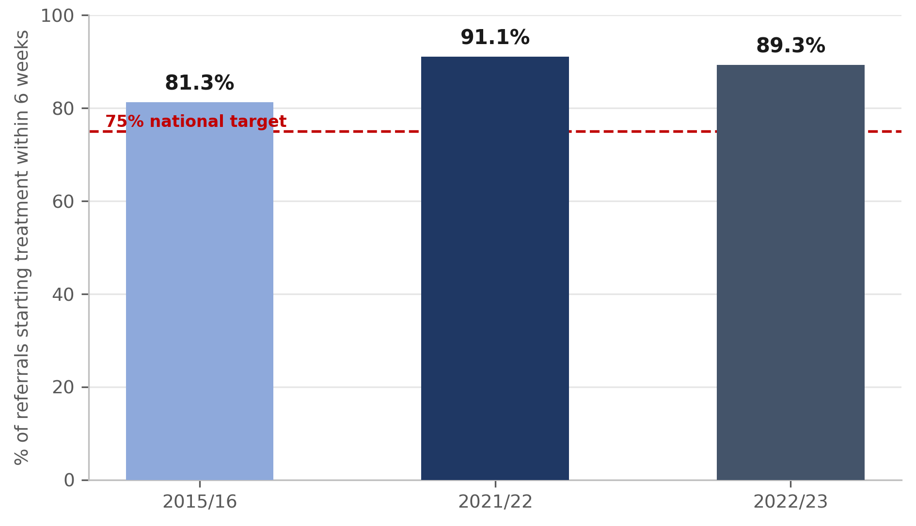
Source: NHS Digital, Psychological Therapies Annual Report 2015-16; House of Commons Library, Mental Health Statistics (2026).
Geographical inequality further reinforces structural barriers. The King’s Fund (2024) identifies significant regional variation in access to mental health services, with deprived areas experiencing the greatest shortages. This reflects the inverse care law, whereby those with the highest level of need often receive the least access to care. From a Social Determinants of Health perspective, this demonstrates how healthcare systems reproduce rather than mitigate existing social inequalities, embedding disadvantage within service distribution itself.

4.4 Organisational Barriers to Mental Health Service Access
Organisational barriers operate at the meso level of healthcare delivery and shape how mental health services are structured, coordinated, and experienced in practice. While structural barriers determine overall capacity, organisational barriers determine how that capacity is translated into real access for service users. These barriers are particularly significant because they often determine whether individuals are able to navigate the system successfully or disengage entirely.

4.4.1 Service fragmentation and navigation complexity
A consistent finding across the literature is that mental health services in the UK are highly fragmented, with care pathways divided across primary care, Improving Access to Psychological Therapies (IAPT), crisis intervention teams, and secondary mental health services (The King’s Fund, 2024; Curtin et al., 2023). This fragmentation creates significant challenges for service users, particularly those with complex or long-term conditions who are required to navigate multiple entry points within the system.
Curtin et al. (2023) highlight that service users frequently experience confusion regarding referral processes, eligibility criteria, and service boundaries. This creates what can be understood through Candidacy Theory as a continuous process of negotiation, where individuals must repeatedly prove their suitability for care at each stage of the pathway (Dixon-Woods et al., 2005). Access is therefore not a single event but an ongoing struggle that requires knowledge, confidence, and persistence.
Figure 4.4: Route of Referral Into NHS Talking Therapies, England, 2023/24
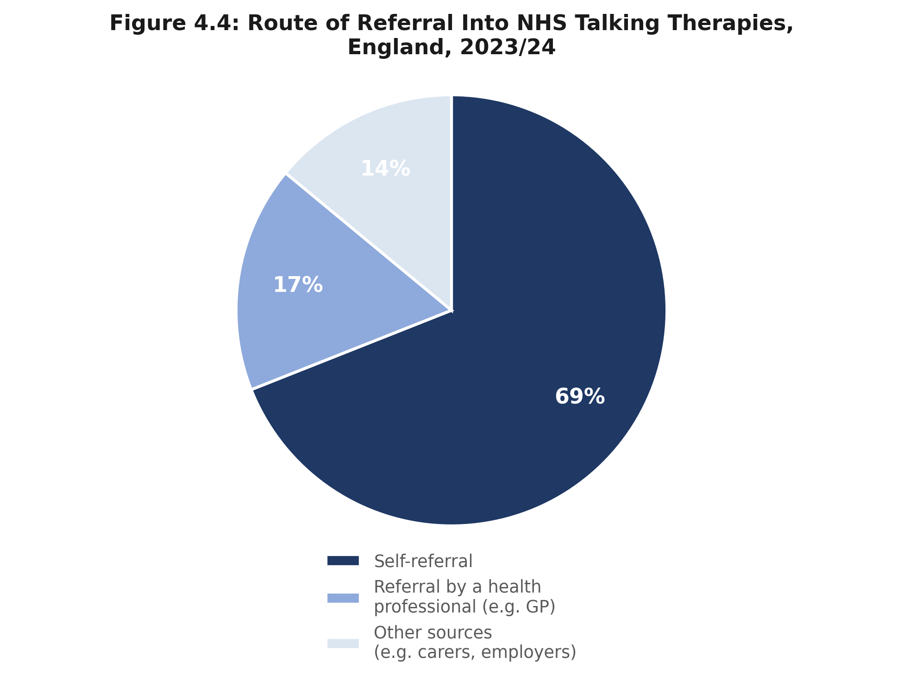
Source: NHS Digital, NHS Talking Therapies Monthly Statistics; Nuffield Trust QualityWatch (2026).
The King’s Fund (2024) further argues that fragmentation is not accidental but reflects the historical development of mental health services in England, where reforms have focused on targeted service expansion rather than system integration. Although Integrated Care Systems (ICSs) were introduced to improve coordination, evidence suggests that structural fragmentation remains embedded in commissioning practices and organisational boundaries.
Critically, this fragmentation disproportionately disadvantages individuals with lower health literacy or reduced social support, reinforcing inequalities in access. From an Andersen model perspective, this reflects unequal enabling resources, where the ability to navigate services becomes a determinant of access in itself.

4.4.2 Workforce shortages and organisational strain
Workforce capacity represents another major organisational barrier affecting mental health service access. The Care Quality Commission (2023) reports persistent shortages across key professional groups, including psychiatrists, mental health nurses, and psychological therapists. These shortages have direct consequences for service delivery, including increased waiting times, reduced continuity of care, and limited therapeutic options.
The King’s Fund (2024) argues that workforce shortages should be understood not as a temporary issue but as a structural feature of the mental health system, driven by long-term recruitment challenges, burnout, and poor retention. High workload intensity and emotional labour contribute to staff attrition, which in turn exacerbates service pressure.
From an Andersen framework, workforce shortages reduce enabling capacity within the system, meaning that even when individuals are willing to seek help and perceive need, services are unable to respond effectively. This results in a form of passive exclusion, where access is restricted not through explicit denial but through system incapacity.
NHS England (2024) policy responses emphasise workforce expansion through training programmes and recruitment initiatives. However, the literature suggests that such approaches may be insufficient without addressing underlying organisational conditions such as workload pressure, staff wellbeing, and service demand distribution. This reveals a critical gap between policy intention and operational reality.

4.4.3 Gatekeeping, eligibility thresholds, and institutional filtering
A further organisational barrier is the use of gatekeeping mechanisms within mental health services, particularly in stepped-care models such as IAPT. These systems are designed to ensure that individuals are directed to appropriate levels of care based on severity and need. However, empirical evidence suggests that such mechanisms can inadvertently create exclusionary effects.
Curtin et al. (2023) note that individuals with complex, co-morbid, or long-term mental health conditions are often deemed unsuitable for low-intensity interventions and subsequently referred to higher-intensity services, where waiting times are significantly longer. This creates a structural paradox in which individuals are excluded from early intervention while simultaneously experiencing delays in specialist care.
From a Candidacy Theory perspective, gatekeeping reflects the institutional definition of who is considered a legitimate candidate for care. Individuals must not only present symptoms but must also align with service-defined categories of “treatability” and “appropriateness.” Those who do not fit these categories risk delayed or denied access.
The King’s Fund (2024) critically argues that such filtering mechanisms prioritise efficiency over equity, effectively privileging individuals with less complex needs who are more likely to achieve rapid recovery. This raises ethical concerns regarding distributive justice in mental health service provision.

4.5 Socio-cultural Barriers to Mental Health Service Access
Socio-cultural barriers operate at the micro level of individual experience but are deeply shaped by structural and organisational conditions. These barriers influence how individuals interpret mental health symptoms, whether they seek help, and how they engage with available services. Importantly, socio-cultural barriers cannot be fully understood in isolation from system design, as service experiences often reinforce or challenge cultural perceptions of mental health care.

4.5.1 Stigma as a socially produced and system-reinforced barrier
Stigma is widely identified as a major barrier to accessing mental health services. Huggett et al. (2018) report that individuals often delay seeking help due to fear of judgement, labelling, and social exclusion. However, a purely individual-level interpretation of stigma is limited and fails to account for how stigma is shaped by structural and institutional factors.
The Mental Health Foundation (2024) argues that stigma is reinforced through healthcare system experiences, including long waiting times, difficulty accessing services, and perceived lack of responsiveness. These factors contribute to perceptions that mental health services are inaccessible or ineffective, which in turn reinforces reluctance to seek help.
From a Social Determinants of Health perspective, stigma is therefore not only a cultural issue but also a structural outcome shaped by inequalities in service provision and social conditions. This shifts the focus away from individual attitudes and towards system-level reform.

4.5.2 Cultural interpretations of mental health and service mismatch
Research by Prajapati and Liebling (2022) and Nwokoroku et al. (2022) highlights that cultural beliefs significantly influence how mental health conditions are understood and managed, particularly among ethnic minority populations. In some communities, mental distress may be interpreted through spiritual, familial, or community-based frameworks, which can delay engagement with formal mental health services.
However, Winsper et al. (2023) challenge explanations that overemphasise cultural differences, arguing that such interpretations risk placing responsibility on individuals rather than examining systemic shortcomings. They suggest that barriers experienced by ethnic minority groups are more strongly related to institutional factors such as lack of culturally competent care, limited interpreter services, and underrepresentation of minority staff within mental health services.
A critical synthesis of this debate suggests that cultural barriers are not fixed or inherent but are produced through interactions with healthcare systems. Inadequate service responsiveness can reinforce cultural disengagement, while culturally competent care can improve trust and uptake. From a Candidacy Theory perspective, individuals from minority backgrounds may face additional challenges in having their mental health needs recognised and legitimised within institutional frameworks.

4.6 Inequalities in Access to Mental Health Services
Inequalities in access to mental health services represent the cumulative outcome of structural, organisational, and socio-cultural barriers discussed in previous sections. Within the Social Determinants of Health (SDH) framework, these inequalities are not random but systematically produced through unequal social, economic, and geographic conditions that shape both mental health need and service accessibility (World Health Organization, 2008).
A key argument emerging from the literature is that mental health inequality in the UK is not only a matter of differential service use but a reflection of broader social stratification embedded within healthcare systems. The King’s Fund (2024) argues that despite universal healthcare provision through the NHS, access to mental health services remains deeply unequal, particularly for individuals in deprived communities.

4.6.1 Socioeconomic inequality and the reproduction of disadvantage
Socioeconomic status remains one of the most significant predictors of mental health service access. Individuals living in deprived areas are more likely to experience mental health conditions due to exposure to chronic stressors such as unemployment, housing insecurity, and financial hardship (Healthwatch England, 2024). However, paradoxically, these same populations face the greatest barriers in accessing timely mental health care.
Figure 4.5: NHS Talking Therapies Recovery Rate by Deprivation Decile, England
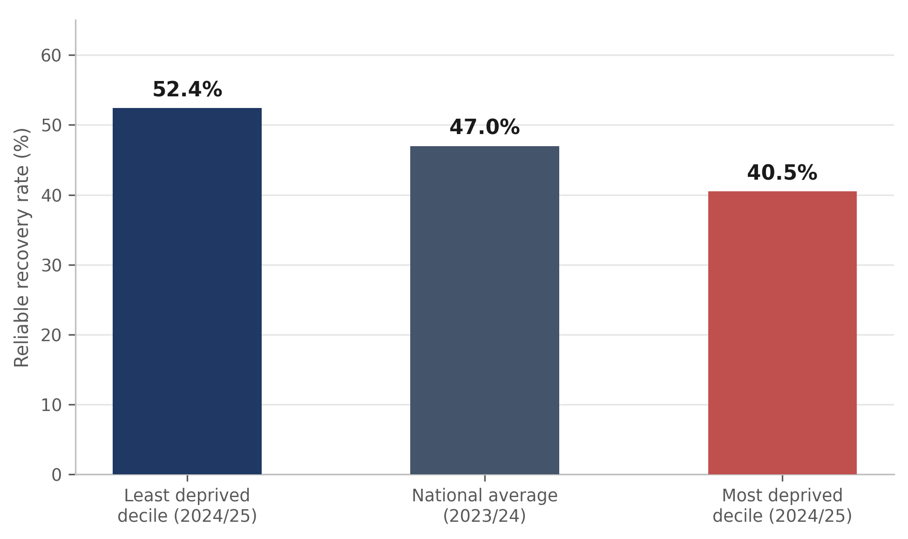
Source: NHS Digital, NHS Talking Therapies for Anxiety and Depression Annual Reports; Nuffield Trust QualityWatch (2026).
The King’s Fund (2024) highlights that services in deprived areas are often under-resourced, under-staffed, and overstretched. This creates a structural contradiction in which need is highest where service availability is lowest, reflecting the inverse care law.
From an Andersen model perspective, socioeconomic disadvantage reduces both enabling resources and access capacity. Individuals may face practical barriers such as transport costs, inability to take time off work, or limited digital access for online services. These barriers accumulate, making access more difficult even when services are formally available.
Critically, this demonstrates that inequality is not simply an outcome of individual behaviour but a systemic feature of service distribution and social organisation.

4.6.2 Ethnic disparities and institutional exclusion
Ethnic minority populations in the UK experience persistent inequalities in mental health service access. Winsper et al. (2023) report lower levels of satisfaction and engagement among ethnic minority service users, alongside higher levels of disengagement and mistrust in services.
Similarly, Prajapati and Liebling (2022) identify barriers such as language difficulties, cultural misunderstanding, and fear of discrimination. However, a critical interpretation suggests that these factors alone are insufficient to explain disparities in access.
Nwokoroku et al. (2022) argue that institutional factors such as lack of culturally competent care, underrepresentation of minority staff, and limited community engagement play a central role in shaping unequal access outcomes. This shifts the explanation from individual cultural differences to systemic exclusion embedded within service design.
From a Candidacy Theory perspective, ethnic minority individuals may face additional barriers in having their mental health needs recognised and legitimised within healthcare systems. This reflects not only differences in access but differences in how need is interpreted and validated by professionals.

4.6.3 Intersectionality and compounded disadvantage
A critical insight in the literature is that inequalities in mental health access are not experienced in isolation but are cumulative and intersectional. Individuals may simultaneously experience multiple forms of disadvantage, including poverty, ethnic minority status, disability, and geographic deprivation.
The King’s Fund (2024) emphasises that mental health inequalities must be understood as intersectional rather than categorical. This means that policy responses targeting single dimensions of inequality are likely to be insufficient, as they fail to address the compounded nature of disadvantage.
From a Social Determinants of Health perspective, intersectionality demonstrates how multiple social and economic factors interact to shape health outcomes. For example, an individual from a deprived background may also face limited transport options, reduced digital access, higher exposure to stigma, and fewer local services. These factors interact to produce layered barriers that significantly reduce access.
Critically, this challenges reductionist policy approaches that treat inequalities as isolated problems rather than interconnected systems of disadvantage.

4.7 Critical Evaluation of Existing Recommendations for Improving Access to Mental Health Care
A range of policy and institutional recommendations have been developed in the United Kingdom to improve access to mental health services for adults. These include NHS England reforms, the NHS Long Term Plan, workforce expansion strategies, digital transformation initiatives, and community-based care models. While these strategies demonstrate clear policy intent to improve access, a critical review of the evidence suggests that their effectiveness remains mixed, uneven, and constrained by structural limitations within the mental health system.

4.7.1 NHS Long Term Plan and parity of esteem agenda
The NHS Long Term Plan (NHS England, 2019; updated implementation reports 2024) represents the most significant national strategy aimed at improving mental health access. It commits to expanding access to psychological therapies, increasing crisis care provision, and improving early intervention services. In principle, these commitments reflect a shift towards parity between mental and physical health services.
However, The King’s Fund (2024) critically argues that while the Long Term Plan has increased service activity in some areas, it has not resolved underlying structural constraints such as workforce shortages and regional inequality. This suggests that improvements are unevenly distributed and often concentrated in already better-served regions.
From a theoretical perspective, this limitation reflects the Social Determinants of Health framework, which highlights that policy interventions often fail when underlying socioeconomic inequalities are not addressed. Although the Long Term Plan improves service design, it does not sufficiently address broader determinants such as deprivation, housing instability, and unemployment, which continue to drive mental health need.
Therefore, while the Long Term Plan represents a strong policy direction, its impact on equitable access remains limited in practice.

4.7.2 Expansion of Improving Access to Psychological Therapies (IAPT)
One of the most widely implemented recommendations has been the expansion of the Improving Access to Psychological Therapies (IAPT) programme, now known as NHS Talking Therapies. NHS England (2024) reports increased referral rates, expanded digital delivery, and improved recovery outcomes for mild to moderate mental health conditions.
However, empirical studies present a more critical perspective. Curtin et al. (2023) argue that IAPT services often struggle with high demand, leading to long waiting times and limited capacity for individuals with complex or long-term conditions. Furthermore, the stepped-care model can function as a form of gatekeeping, where individuals are filtered based on severity thresholds rather than holistic need.
From a Candidacy Theory perspective, IAPT does not eliminate negotiation of access but restructures it, requiring individuals to fit within predefined clinical categories of eligibility. This can exclude individuals with co-morbid or complex presentations who do not align neatly with service criteria.
Therefore, while IAPT improves access for some groups, it simultaneously reinforces exclusion for others, particularly those with more severe or complex mental health needs.

4.7.3 Workforce expansion and recruitment strategies
Workforce development is another key policy recommendation aimed at improving access to mental health care. NHS England (2024) has introduced initiatives to expand training places for psychiatrists, mental health nurses, and psychological therapists, alongside recruitment campaigns aimed at reducing staffing shortages.
However, The King’s Fund (2024) and Care Quality Commission (2023) both highlight that workforce shortages remain a persistent structural issue. This suggests that recruitment alone is insufficient without addressing retention, workload intensity, and burnout.
Critically, high attrition rates within mental health professions indicate that workforce challenges are not simply numerical but organisational. Andersen’s Behavioural Model helps explain this indirectly by showing that enabling resources (staff availability) remain constrained, limiting system capacity regardless of demand.
As a result, workforce strategies improve supply at the margins but fail to resolve deeper systemic instability within mental health services.

4.7.4 Digital mental health and remote service delivery
The expansion of digital mental health services, particularly following the COVID-19 pandemic, has been widely promoted as a strategy to improve access. NHS England (2024) highlights increased use of online cognitive behavioural therapy (CBT), remote consultations, and digital self-referral systems as evidence of improved accessibility.
However, Healthwatch England (2024) identifies significant inequalities in digital access, particularly among older adults, low-income groups, and individuals with limited digital literacy. This raises concerns about the “digital divide,” where technological solutions may unintentionally exclude already disadvantaged populations.
From an SDH perspective, digital interventions reflect broader inequalities in access to technology, internet connectivity, and private space. Rather than reducing inequality, digitalisation may therefore reproduce it in new forms.
Consequently, while digital mental health services increase flexibility and convenience, they cannot be considered a universal solution to access barriers.

4.7.5 Community-based care and early intervention strategies
Policy frameworks increasingly emphasise community-based mental health care and early intervention models as a way of reducing pressure on secondary services. The King’s Fund (2024) supports this shift, arguing that earlier intervention can reduce crisis presentations and improve long-term outcomes.
However, the effectiveness of community-based models depends heavily on local resource availability and integration with wider services. In many areas, community mental health provision remains underdeveloped, limiting the practical impact of this recommendation.
Furthermore, without adequate investment in primary care and social support systems, early intervention risks shifting responsibility onto already overstretched community services rather than genuinely improving access.
From a theoretical standpoint, this reflects SDH principles, as community-based success depends on addressing wider social determinants such as housing, employment, and social support networks.

4.8 Critical synthesis of recommendations
Overall, the evidence suggests that while UK policy recommendations for improving mental health access are well-developed and strategically sound, their implementation is constrained by persistent structural and organisational barriers. Across all interventions, a consistent pattern emerges: reforms improve certain aspects of access but fail to address underlying systemic inequality.
The NHS Long Term Plan improves service activity but does not resolve regional disparities. IAPT expands access but introduces eligibility filtering. Workforce strategies increase recruitment but do not solve retention problems. Digital solutions improve flexibility but risk excluding disadvantaged groups. Community care improves early intervention potential but remains unevenly resourced.
This indicates that policy responses tend to focus on service optimisation rather than structural transformation. As a result, improvements in access are partial, uneven, and often fail to reach the most disadvantaged populations.
From an integrated theoretical perspective, Andersen’s Model explains how enabling resources constrain implementation, Candidacy Theory explains how individuals are still required to negotiate access even within improved systems, and SDH theory demonstrates why these inequalities persist due to broader social and economic conditions.

Table 4.2: Critical Evaluation of Existing Policy Recommendations
Recommendation | Intended Aim | Key Limitation Identified in Literature | Theoretical Lens
NHS Long Term Plan | Expand psychological therapies, crisis care, early intervention | Improvements unevenly distributed; regional inequality and workforce shortages unresolved | SDH
IAPT / NHS Talking Therapies expansion | Increase referral rates and access to psychological therapy | Stepped-care model filters out complex/co-morbid presentations | Candidacy Theory
Workforce expansion and recruitment | Increase training places and reduce staffing shortages | Recruitment does not address retention, workload, or burnout | Andersen's Model
Digital mental health services | Improve flexibility and reduce pressure on traditional services | Risks reproducing inequality through the digital divide | SDH
Community-based care and early intervention | Reduce pressure on secondary services | Effectiveness constrained by uneven local resourcing | SDH

CHAPTER FIVE

RECOMMENDATIONS AND CONCLUSION

5.1 Recommendations
Based on the findings of this study, several key recommendations are proposed to improve access to mental health services in the UK.
Firstly, there is a need for sustained and long-term investment in mental health services to address structural underfunding. Funding allocations should be aligned more closely with population need rather than historical spending patterns. Without addressing resource constraints, other reform efforts will have limited impact.
Secondly, workforce development must be prioritised beyond recruitment targets. Although NHS initiatives have focused on increasing staffing numbers, issues such as burnout, workload intensity, and staff retention continue to undermine service capacity. Improving working conditions and providing adequate support for mental health professionals is essential for building a sustainable workforce.
Thirdly, service integration should be strengthened across primary, secondary, and community care settings. Reducing fragmentation in care pathways would improve continuity of care and reduce the burden on service users navigating complex systems. Integrated Care Systems should be further developed to ensure more consistent coordination between services.
Fourthly, culturally competent care should be expanded to reduce disparities in access among ethnic minority populations. This includes increasing workforce diversity, improving interpreter services, and ensuring that mental health interventions are culturally sensitive and responsive to diverse needs.
Fifthly, digital mental health services should continue to be developed; however, equal attention must be given to addressing the digital divide. Without targeted support for individuals with limited digital access or literacy, there is a risk that digitalisation may widen existing inequalities rather than reduce them.
Finally, greater emphasis must be placed on addressing the wider social determinants of mental health. Policies aimed at reducing poverty, improving housing stability, increasing employment opportunities, and strengthening community support systems are essential for reducing demand pressures on mental health services and improving long-term access.
Table 5.1: Recommendations Mapped to the Barrier Themes They Primarily Address
Recommendation | Barrier Theme(s) Primarily Addressed
Sustained, needs-based investment in mental health services | Structural
Workforce development beyond recruitment (retention, wellbeing, workload) | Structural / Organisational
Strengthened integration across primary, secondary, and community care | Organisational
Expansion of culturally competent care and interpreter services | Socio-cultural / Inequalities
Continued digital development alongside action on the digital divide | Organisational / Inequalities
Action on wider social determinants (poverty, housing, employment) | Inequalities / Structural

5.2 Future Research
Future research should focus on longitudinal studies that examine how mental health service access changes over time in response to ongoing NHS reforms, particularly the development of Integrated Care Systems. This would provide a clearer understanding of whether structural changes are translating into improved access at the population level.
In addition, further qualitative research is needed to explore the lived experiences of individuals from marginalised groups, including ethnic minority populations, low-income communities, and individuals with complex mental health needs. Such research would provide deeper insight into how structural and organisational barriers are experienced in practice.
There is also a need for more evaluation of digital mental health interventions, particularly in relation to equity of access. While digital services have expanded significantly, there is limited evidence on their long-term effectiveness for reducing inequalities in mental health care.
Finally, future research should explore the interaction between social determinants of health and mental health service utilisation in greater depth, particularly how socioeconomic inequalities translate into differential access to care pathways and outcomes.

5.3 Conclusion
This dissertation set out to examine the barriers to accessing mental health services for adults in the United Kingdom and to critically evaluate existing recommendations aimed at improving access. Drawing on empirical literature, policy documents, and theoretical frameworks including the Social Determinants of Health (SDH), Andersen’s Behavioural Model, and Candidacy Theory, the study has demonstrated that access to mental health services is shaped by a complex and interconnected set of structural, organisational, socio-cultural, and inequality-related factors.
The findings indicate that structural barriers remain the most fundamental constraint on access. Persistent underfunding of mental health services, workforce shortages, and increasing demand have resulted in long waiting times and limited service capacity across the UK. Despite policy commitments to parity of esteem between mental and physical health, mental health services continue to experience disproportionate pressure and resource limitations. This creates a system in which access is theoretically available but practically constrained, particularly for individuals requiring timely intervention.
Organisational barriers further intensify these structural limitations. Fragmentation of services across primary, secondary, and community care creates complex and often confusing care pathways for service users. Individuals are frequently required to navigate multiple referral stages, eligibility assessments, and service thresholds before receiving appropriate care. This process places a significant burden on service users and disproportionately disadvantages those with lower health literacy or limited social support. Candidacy Theory helps to explain this process by highlighting that access is not a single event but a continuous negotiation in which individuals must repeatedly demonstrate their eligibility for care.
Socio-cultural factors, particularly stigma and cultural misunderstanding, also play an important role in limiting access to services. However, the findings suggest that stigma is not solely an individual or cultural issue but is reinforced by systemic inefficiencies such as long waiting times and inconsistent service experiences. This indicates that socio-cultural barriers are closely linked to structural and organisational weaknesses within the mental health system.
Finally, the study found that inequalities in access are deeply embedded within the UK mental health system. Individuals from deprived socioeconomic backgrounds, ethnic minority groups, and underserved geographic regions experience significantly greater barriers to accessing care. These inequalities reflect broader social determinants of health, including income, housing, employment, and education, which shape both mental health need and access to services. As a result, mental health inequalities cannot be understood in isolation from wider social and economic structures.
Overall, the study concludes that mental health service access in the UK is not determined solely by clinical need but is shaped by a combination of system capacity, organisational design, and social inequality. Despite ongoing reforms and policy initiatives, these barriers remain persistent and mutually reinforcing, limiting the effectiveness of current service provision.

REFERENCES
Andersen, R. (1995) ‘Revisiting the behavioural model and access to medical care’, Journal of Health and Social Behavior, 36(1), pp.1–10.
Andersen, R. and Newman, J.F. (1973) ‘Societal and individual determinants of medical care utilization’, Milbank Memorial Fund Quarterly, 51(1), pp.95–124.
Baker, C. and Kirk-Wade, E. (2023) Mental health policy in the UK: an overview. London: House of Commons Library.
Care Quality Commission (2023) Monitoring the Mental Health Act 2022/23. London: CQC.
Curtin, L., et al. (2023) ‘Barriers to accessing mental health services in England’, BMC Health Services Research, 23(1), pp.1–12.
Department of Health and Social Care (2019) NHS Long Term Plan. London: DHSC.
Dixon-Woods, M., Cavers, D., Agarwal, S., Annandale, E., Arthur, A., Harvey, J. and Knapp, P. (2005) ‘Conducting a critical interpretive synthesis of the literature on access to healthcare’, Qualitative Health Research, 15(9), pp.1255–1269.
Exworthy, M. and Powell, M. (2018) ‘The NHS: from national policy to local implementation’, Health Policy, 122(4), pp.345–352.
Fisher, R., et al. (2021) ‘Inequalities in mental health service access’, Social Psychiatry and Psychiatric Epidemiology, 56(5), pp.789–798.
Gilburt, H. (2019) Mental health under pressure. London: The King’s Fund.
Gunnell, D., Kidger, J. and Elvidge, H. (2018) ‘Adolescent mental health in crisis’, BMJ, 361, k223.
Healthwatch England (2024) Mental health services: access and waiting times report. London: Healthwatch England.
Huggett, C., et al. (2018) ‘Barriers to accessing mental health services’, Journal of Mental Health, 27(2), pp.123–130.
Killaspy, H. (2016) ‘Mental health services in the UK’, British Journal of Psychiatry, 209(1), pp.1–3.
Knapp, M., McDaid, D. and Parsonage, M. (2016) Mental health promotion and prevention. Oxford: Oxford University Press.
The King’s Fund (2024) Mental health services in England: access and workforce pressures. London: The King’s Fund.
Layard, R. and Clark, D. (2015) Thrive: the power of evidence-based psychological therapies. London: Penguin.
McManus, S., Bebbington, P. and Jenkins, R. (2016) Mental health and wellbeing in England. London: NHS Digital.
Mental Health Foundation (2024) Mental health statistics and stigma report. London: MHF.
Mind (2023) Mental health crisis care in England. London: Mind UK.
NHS England (2019) The NHS Long Term Plan. London: NHS England.
NHS England (2024) Mental health dashboard report. London: NHS England.
NHS Digital (2023) Adult psychiatric morbidity survey. London: NHS Digital.
NHS Providers (2023) Mental health services workforce report. London: NHS Providers.
NICE (2022) Depression in adults: treatment and management guidelines. London: National Institute for Health and Care Excellence.
NHS Confederation (2022) Mental health services funding challenges. London: NHS Confederation.
Nwokoroku, S.C., et al. (2022) ‘Ethnic inequalities in mental health care access’, Social Psychiatry and Psychiatric Epidemiology, 57(5), pp.845–856.
Office for Health Improvement and Disparities (2023) Health inequalities report. London: OHID.
OECD (2021) Mental health and work: UK country report. Paris: OECD.
Patel, V., Saxena, S. and Lund, C. (2018) ‘The Lancet Commission on global mental health’, The Lancet, 392(10157), pp.1553–1598.
Prajapati, R. and Liebling, H. (2022) ‘Ethnic minority barriers to mental health care’, International Journal of Social Psychiatry, 68(4), pp.789–798.
Priebe, S., et al. (2017) ‘Mental health care systems in Europe’, World Psychiatry, 16(2), pp.225–235.
Public Health England (2020) COVID-19 and mental health impact report. London: PHE.
Rethink Mental Illness (2023) Access to care report. London: Rethink.
Sayce, L. (2015) Mental health and social inclusion. London: Palgrave.
Singleton, N., et al. (2001) Psychiatric morbidity survey. London: HMSO.
Slade, M. (2017) ‘100 years of mental health policy’, Lancet Psychiatry, 4(2), pp.97–100.
Stewart, R., et al. (2021) ‘Mental health service inequalities’, The Lancet Psychiatry, 8(6), pp.512–520.
Thornicroft, G. (2017) Shunned: discrimination against people with mental illness. Oxford: Oxford University Press.
The Lancet Psychiatry (2020) ‘Mental health services under strain’, The Lancet Psychiatry, 7(10), pp.815–820.
UK Government (2021) COVID-19 mental health recovery plan. London: HM Government.
UK Parliament (2023) Mental health services inquiry report. London: House of Commons.
WHO (2008) Closing the gap in a generation: health equity through action on social determinants of health. Geneva: WHO.
WHO (2022) World mental health report. Geneva: WHO.
Winsper, C., et al. (2023) ‘Ethnic disparities in mental health care’, British Journal of Psychiatry, 223(3), pp.450–458.
Xavier, M., et al. (2016) ‘Community mental health services’, International Journal of Mental Health Systems, 10(1), pp.1–10.

