Compare the intergenerational conflict between the Primordial Gods, Titans and Olympians with reference to Literary and Artistic interpretations from the Graeco-Roman world
Throughout Greek mythology the idea of gods being overthrown by their children was not uncommon with the same event happening twice, and almost a third time if not for Zeus’ decision to kill the mother rather than the child. The transfer of powers between the Primordial gods under Ouranos and Gaea to Cronus and Rheia, then from Cronus and Rheia to Zeus and Hera was little written about this in comparison to the conflict between the children of Ouranos, the giants, and the children of Cronus, the gods of Olympus, called the Gigantomachy. This essay will discuss the similarities and differences between succession of the kings and queens of the deities that they represent respectively. To achieve this, the essay will be using both artistic and literary representations of the deities in question.
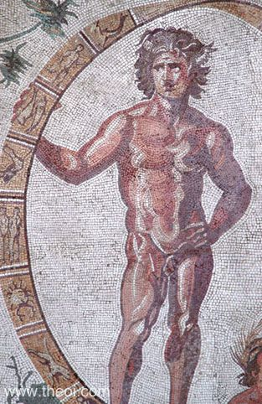
The Primordial Gods, the gods in which make up the world in which these myths and legends take place, were made up of the Earth, Air, Sea, Sky, Fresh Water, Underworld, Darkness, Night, Light, Day, Love and Time. It seems only fair that the first of the Primordials represented in this essay is the king among them and the sky itself. Uranus, also known as Ouranos, was one of the primordial deities and god of the sky, which was believed by the ancient Greeks to be a brass dome peppered with stars and its edges grip to the outer reagons of the flat earth. He was born to Gaia, the earth goddess, who he presides over as her first born. Though being his mother it was Gaia to be the queen consort to his king deity and his eventual downfall persuading their children the titans to rebel against him. Kronos castrated his farther Ouranos, with help from his brothers, and named himself the new king of the gods which became the titans. Ouranos prophesised the fall of the titans and the imprisonment of the perpetrators. Hesiod describes the castration and ouranos’ overthowing in his Theogony claiming that Gaea birthed the titans, Kykopes and the Hekatonkheires, 100 handed giants who later assisted in Zeus’ rebellion. Ouranos is said to have fathered the titanes, which are Okeanos, Koios, Krios, Hyperion, Iapetos and finally Kronos, the titandes, which are Theia, Rheia, Themis, Mnemosyne and Tehtys, The Kyklopes and the Hekatonkheires according to Hesiod and Diodorus. The artistic representation of Ouranos, to the right, is part of a greater mosaic called Aeon, Gaea and the Carpi, depicting Aeon or Ouranos with Gaia in an almost familial setting found in Sentinum, Imperial villa. Ouranos was as despotic as his son, Cronos, and grandson, Zeus, as he imprisoned the eldest of his children, the giant Kyklopes and monstrous Hekatonkheires, in the belly of Gaea causing her immense pain, and just like Cronos later his despicable actions led to his downfall. The mother and lover of Ouranos was Gaea, the goddess of earth, Queen-mother of primordials, Titans and other beings, was the first to form after Chaos and from which all life had formed. She was the first formed after chaos and was the very earth itself. Although this is the origin story accepted by Hesiod in his Theogony but other origins have suggested that she emerged from Hydros, and is the child of Aither and Hermera. It should be said that Gaea, earth, was seen to the ancient Greeks as flat to be proven false later. She would mother many great and powerful beings which are the Kyklopes, the Hekatonkheires, titans (Kronos, Okeanos, Tethys,Koios, Krios, Hyperion, Iapetos, Theia, Rheia, Mnemosyne, Themis, Phiobe, Dione and Prometheus), The sea gods (Nereus, Thaumas, Phorkys, Keto and Eurybia to Pontos and Kharybdis to Poseidon), The Rustic Gods (Kouretes, Daktyloi, Kabeiros, Aristaios, Seilenos, Aitna, Triptolemos, Dysaules, Kentauroi Kyprioi), the Offspring Daimones, the Lesser Giants, monsters, animals, the first kings and human tribes. She was credited to the creation of so many thing that if I was to list them all I would not have enough room to write the rest of my essay. Gaea sided with all four rebellions, Cronos, the Olympians, the Giants and Typhoeus, however the later two failed to Zeus.
Aeon-Uranus and the Zodiac-Wheel, Greco-Roman mosaic C3rd A.D., Glyptothek Munich
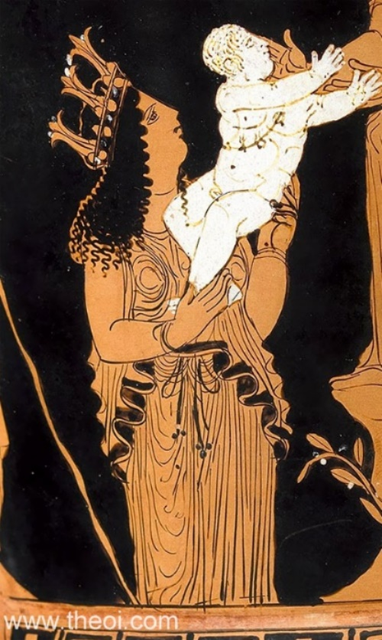
The image on the left represents the god/titan Gaea as a major maternal figure. This is apparent with her character being a figure of motherhood and family but also the chaotic and violent nature of change, which is not represented in this image but can be inferred from her backing of the rebellions.
Gaea the Earth, Athenian red-figure calyx krater C5th B.C., Virginia Museum of Fine Arts

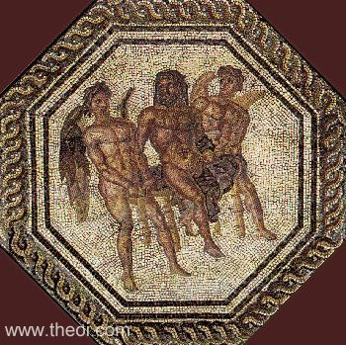
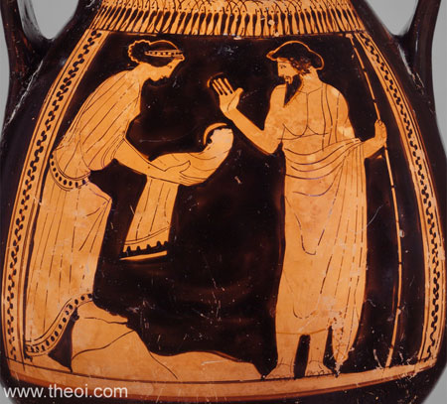
After the Promordials came the Titans, a race of gods who would be the subjects of Kronos. They would be known as Koios, Krios, Hyperion, Okeanos, Iapetos and Kronos himelf. Kronos, king of the Titans, god of Harvest and the embodiment of Time itself, was a destructive force and was very jealous of power. He castrated and dethroned his father, imprisoned his half-siblings and devoured his children, he however did rule over the kosmos during the Golden Age. His fear of being overthrown like his father before him, he ate the children his wife and queen bore to avoid this fate but knowing what we do about prophesy no matter what you do you can’t escape fate. Rheia hid Zeus from the fate that faced his siblings and fed a rock to kronos instead. Zeus made Kronos regurgitate the children that would become known as the Olympians and unlike Kronos, Zeus and his siblings waged war on the Titans for a decade. The Titans fought from Mount Orthys and the Olympians fought from Mount Olympus, after the war was won Zeus forced them into Tartaros only to release them onto the Elysian Islands many years later. After his incarceration he cursed Zeus like his father before him places the same curse for the same cause.
Cronus, Rhea and the Omphalos stone, Athenian red-figure pelike C5th B.C., Metropolitan Museum of Art
Saturn-Cronus as Saturday, Greco-Roman mosaic from Orbe C3rd A.D., Roman villa of Orbe-Boscéaz
Just as Gaea before her, Rheia became the mother of gods, she was a goddess of motherhood, fertility and generation, and has some links to family values. She was the queen of the Titans, and the cause of their fall and overthrowing of her husband. She spared her youngest Zeus and assisted in his rebellion, feeding Kronos a stone and hid Zeus. She was the mother of Zeus, Demeter, Poseidon, Hades,Hestia and Hera. The image of the right portrays the deception of Kronos by
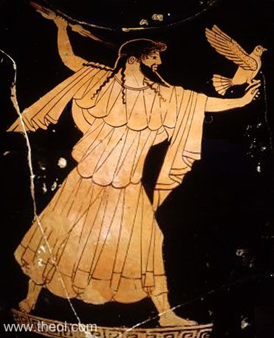
Unlike the Titans and Primordials, the Olympians have a lot more classical literary and artistic interpretations, Zeus in particular was very well recorded with a plethora of myths, legends and stories featuring this great god. He is often depicted as a strong man with a dark beard according to our artistic interpretations and would be represented with certain symbols of which he has gathered like a lightning bolt, a sceptre or an eagle.
Zeus with eagle and lightning, Athenian red-figure amphora C5th B.C., Musée du Louvre
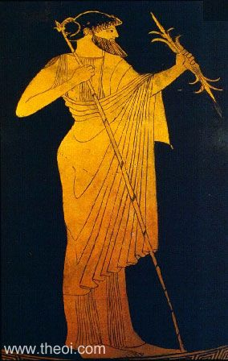
He was king of the gods and god over the realm of man, sky, weather, law, order, fate and kingship. Youngest of Kronos and Rheia’s children and avoided the gruesome fate of his siblings who were devoured by their farther, who was afraid of being usurped by them. It was by the loving heart of his mother, the nursing of the Nymphs and protection of the Kouretes, Zeus live to see the day he grows to be a man strong enough to challenge his father. He forced his farther to regurgitate his brothers and sisters, they together then fought the Titans from Mount Olympus. Eventually Zeus defeated Kronos in a wrestling match in Olympia, officially starting the Olympic Games. After defeating Kronos Zeus banished his father to the depths of Tartaros only to be released many generations later on the Elysian Islands.

Zeus, Athenian red-figure Panathenaic amphora C5th B.C., Staatliche Antikensammlungen

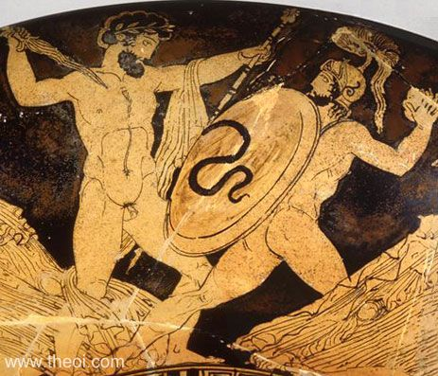
Once king Zeus didn’t go unchallenged as other claimants wanted to take the throne, these were the Giants. This was the beginning of the Gigantomachy, a war between gods and giants which was a very popular topic amongst scholarly, poetic and artistic interpretations. An example of this is the representation of Zeus and Porphyrion doing battle, which is seen to the right of this. Zeus was victorious once again surpassing those before him refusing to abdicate despite the giants being supported by Gaea, Zeus’ grandmother and god of earth itself. After Kronos’ defeat, alike to his father, prophesized that Zeus will be overthrown by the son of Metis. Zeus refusing to repeat the past didn’t eat his children but ate his wife, Metis, instead. From his head came forth the goddess of war, wisdom and olives Athena, the child of Metis.
Zeus and the giant Porphyrion, Athenian red-figure kylix C5th B.C., Antikensammlung Berlin
In conclusion I must surmise that this wheel of usurpation, violence and procreation continued to turn until Zeus. The similarities between these 3 generations are too numerous to remain ignorant to. The importance of the wives assisting in the usurpation of the father due to their love for their children, seen in Gaea helping Kronos usurp Ouranos and Rheia assisting Zeus against his father. The cause of this may be related to men viewing women as deceptive or loving their children, however one may interpret the actions of the mothers it is a theme that seems to repeat itself throughout these myths. Another repeating theme is the Queen gods being related to family, life and female fertility as seen in Gaea, Rheia and Hera. Another repeating theme is Gaea’s assistance to the rebelling parties, as she supports Kronos, Zeus and the Giants. This could be representative of the chaotic changing nature of life, earth and nature itself. Another theme that repeats is the youngest child taking power. This can be seen in both Kronos and Zeus; however, this isn’t seen in Ouranos who was the first born of Gaea. A partial theme can be the victory of the rebelling group and kings being deposed, however this isn’t repeated by Zeus as he defeats the rebelling giants and eats metis before she can produce a male heir. However, unlike Zeus, Kronos didn’t go to war with his father he simply castrated and dethroned him, he didn’t imprison him either unlike Zeus. Overall, I have no other choice but to accept that the evidence that is provided to me that the three generations of deities are very similar indeed, In the way they ruled each other, fought each other and usurped each other.

Bibliography
Kerényi 1951, p. 119.
Hansen 2004, pp. 121–122.
Deacy 2008, p. 18

- Aeschylus, Oresteia. Eumenides (trans.) Alan H. Sommerstein (2009) Harvard University press, Cambridge
- Aeschylus Prometheus Bound, (trans.) Alan H. Sommerstein (2009) Harvard University press, Cambridge
- Apollodorus, the Library (trans.) James G. Frazer (1921) Harvard University press, Cambridge
- Apollonius of Rhodes, Argonautica (trans.) William H. Race (2009) Harvard University press, Cambridge
- Aratus, Phaenomena (trans.) A. W. Mair and G. R. Mair (1921) Harvard University press, Cambridge
- Diodorus Siculus (trans.) Charles L. Sherman (1933) Harvard University press, Cambridge
- Hesiod Theogony (trans.) Glenn W. Most (2018) Harvard University press, Cambridge
- Hesiod, Works and Days (trans.) Glenn W. Most (2018) Harvard University press, Cambridge
- Homer Iliad (trans.) Samuel Butler. (1898) Longmans, Green and Co, London.
- Lycophron, Alexandra (trans.) Alexandra. A.W. Mair. (1921) William Heinemann, Lts. London
- Nonnus Dionysiaca (trans.) W.H.D. Rouse (1940) London, William Heinemann, Ltd.
- Ovid Metamorphoses (trans.) Brookes More (1922) Cornhill Publishing Co, Boston
- Pausanias, Description of Greece. (trans.) W.H.S. Jones, Litt.D., and H.A. Ormerod (1918) William Heinemann Ltd, London
- Pindar, Odes (trans.) Diane Arnson Svarlien (1990) Harvard University Press, Cambridge
- Plato, Euthydemus, Protagoras, Gorgias, Meno (trans.) W.R.M. Lamb (1967) William Heinemann Ltd, London
- Plato, Laws (trans.) R.G. Bury (1967) William Heinemann Ltd, London.
- Plato, Republic (trans.) Paul Shorely (1969) Willaim Heinemann Ltd, London

Hesiod, Theogony 154–166.
Kerényi 1951, p. 119.
Hansen 2004, pp. 121–122.
Deacy 2008, p. 18
Hesiod, Theogony 885-900, 929e-929t
Hesiod, Theogony 115 ff
Hesiod, Theogony 126 ff
Hesiod, Theogony 116 ff
Orphic Rhapsodies 66
Orphic Frag 54 & 57
Epicuras Frag
Hyginus Preface
Eumelus Titanomachia Frag 1
Aeschylus Prometheus Bound 207
Aeschylus Eumenides 1
Hesiod Theogony 135
Apollodorus 1.2
Diodorus Siculus 5.66.1
Apollodorus 1.2
Aeschylus Prometheus Bound 211
Hesiod Theog. 232
Apollodorus 1.10
Hesiod Theogony 176
Ovid Metamorphoses 4.282
Greek Lyric V Anon. Frag 985
Strabo 10.3.9
Diodorus Siculus 5.65.1
Nonnus Dionysiaca 13.135 & 14.23
Nonnus Dionysiaca 14.23
Greek Lyric V Anonymous Frag 985
Greek Lyric IV Bacchylides Frag 45
Nonnus Dionysiaca 29.243
Simonides Frag 52
Scholiast on Theocritus 1.65
Apollodorus 1.32
Greek Lyric V Anonymous Frag 985
Nonnus Dionysiaca 14.193 & 32.65
Hyginus Preface
Virgil Aeneid 4.174
Timotheus, Fragment 796
Hesiod, Theogony 20 ff
Plato, Euthyphro 5e
Plato, Republic 377e
Pseudo-Apollodorus, Bibliotheca 1. 3
Apollonius Rhodius, Argonautica 4. 982 ff
Callimachus, Aetia Fragment 43
Lycophron, Alexandra 760 ff
Strabo, Geography 14. 2. 7
Pausanias, Description of Greece 7. 23. 4
Virgil, Georgics 2. 406 ff
Pseudo-Apollodorus, Bibliotheca 1. 4 - 5
Homer, Iliad 15. 187 ff
Hesiod, Theogony 453
Hesiod, Theogony 617 ff
Homeric Hymn 5 to Aphrodite 20 ff
Hesiod, Works and Days 109 ff
Plato, Laws 713a
Plato, Euthyphro 5e
Corinna, Fragment 654
Callimachus, Hymn 1 to Zeus 50 ff
Pausanias, Description of Greece 5. 7. 10
Homer, Iliad 14. 203 ff
Hesiod, Theogony 390 ff
Hesiod, Theogony 617 ff
Homer, Iliad 8. 479 ff
Hesiod, Works and Days 156 ff
Pindar, Olympian Ode 2. 55 ff
Plato, Gorgias 525a ff
Aeschylus, Prometheus Bound 907 ff
Homeric Hymn 2 to Demeter 69
Homer Iliad 15.187
Homer Iliad 15.187
Hesiod Theogony 453
Apollodorus 1.4
Diodorus Sic. 5.68.1
Homer, Iliad 15. 187 ff
Hesiod, Theogony 617 ff
Homeric Hymn 5 to Aphrodite 42 ff
Hesiod, Theogony 453
Homeric Hymn 5 to Aphrodite 20 ff
Plato, Euthyphro 5e
Corinna, Fragment 654
Aratus, Phaenomena 27 ff
Pseudo-Apollodorus, Bibliotheca 1. 4 - 5
Pseudo-Apollodorus, Bibliotheca 1. 34 - 38
Pindar, Nemean Ode 1 str 4 - ant 4

