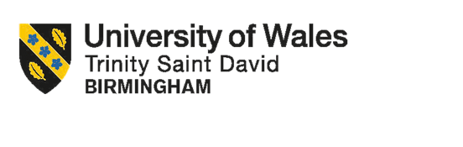
Assignment Title: HR Strategy

Topic: Integrated Human Capital Blueprint

Module Name:
Human Capital Management

Module Code: LCMB7023

Student Name: Carmen Prodan

Student ID: 2223977

Lecturer name: Dr Eno Maycock

Number of Words: 4293 (with Abstract, References, and Appendix)

Abstract
This study examines how a technology-driven organisation may improve performance, engagement, and creativity through an integrated human capital approach. Using current HRM theories as a guide, Part One proposes cultural, structural, and performance management measures that foster creativity, teamwork, and adaptation throughout Aether Innovations to develop a culture of innovation and future work practices. The analysis emphasises how multicultural team management, innovation culture, hybrid work models, and developmental performance systems can improve organisational learning and business performance. Using Gibbs' reflective cycle, Part Two offers a thoughtful commentary that assesses the author's learning experience during the module and how it applies to professional practice. The reflection shows how theoretical understandings were applied to real-world leadership behaviours, such as team empowerment, developmental feedback, and the tactical application of artificial intelligence. In summary, the report highlights the significance of creating reflective and future-ready management capabilities while coordinating human capital practices with innovation strategy.

Table of Content
Abstract 2
Part 1: Building A Culture of Innovation and Future Work 4
1. Introduction 4
2. Organisational Context and Strategic HR Challenge 4
3. Culture of Innovation in Contemporary Tech Organisations 5
4. Cultural and Structural Enablers of Innovation 6
5. Future of Work Models in Knowledge-Based Organisations 7
6. Proposed Future Work Model for Aether Innovations 8
7. Motivating and Enabling High Performance through Innovation 10
8. Integrated Impact on Organisational Performance 11
Conclusion 12
Part 2: Reflection 13
1. Reflection on Learning Journey and Personal Development 13
2. Staying Relevant in an AI-Driven Work Environment 14
References 16
Appendix 19

Part 1: Building A Culture of Innovation and Future Work

1. Introduction
This report considers the scenario of Aether Innovations, a fast-growing 300-person technology firm, which is experiencing stagnating growth, high employee turnover, and declining customer satisfaction. These challenges suggest deeper issues related to organisational culture, work design, and people management rather than purely technical or market failures. Effective human capital strategies that foster creativity, teamwork, and flexibility are becoming increasingly important for sustained performance in modern knowledge-based organisations. Managers must actively foster an innovative culture to enable sustained development as creativity and innovation become essential to organisational progress (Marić, Aleksić, and Kneěvić, 2022).
This report focuses on Building a Culture of Innovation and Future Work Practices, proposing an integrated HR approach that embeds innovation into organisational culture and redesigns work practices to support creativity, engagement, and performance. It critically analyses current technology sector practices and suggests culturally and structurally appropriate remedies for Aether Innovations, drawing on both traditional and modern HRM theories covered during the Human Capital Management Module.

2. Organisational Context and Strategic HR Challenge
The difficulties Aether Innovations faces highlight an obvious disconnect between organisational strategy and people management techniques, which restricts the company's ability to properly utilise its human capital. Research suggests that HR strategies must be in line with organisational objectives and values to promote creativity, teamwork, and ongoing development, especially in international settings (Muhajan, 2024). Furthermore, the strategic application of HR analytics and sophisticated algorithms becomes crucial in converting data into organisational value as workforce digitisation produces ever-increasing volumes of employee data (Cheng and Hackett, 2021). Therefore, Aether Innovations' challenges are a result of both strategic misalignment and a lack of capacity to incorporate data-driven HRM practices into its larger strategic framework.
As Pillai and Sivathanu (2022) argue, the Matching Model of HRM highlights that organisational efficiency is attained when HR practices are well linked with business objectives. In this context, the company's innovation-driven strategy is compromised by a mismatch with its current work methods and culture, which leads to lower performance and employee disengagement.
The Harvard Model of HRM emphasises the significance of taking long-term effects, work structures, and employee influence into account. Employee autonomy, voice, and meaningful engagement, all essential components of innovative environments, may be lacking amid high turnover and declining consumer satisfaction. From a strategic standpoint, HR at Aether Innovations needs to transition from administrative duties to a transformative role in line with Ulrich's HR Champion Model, especially the roles of change agent and strategic partner.

3. Culture of Innovation in Contemporary Tech Organisations
Organisations that prioritise innovation frequently exhibit cultures characterised by cooperation, trust, psychological safety, and continuous learning. Microsoft’s growth mindset transformation under Satya Nadella illustrates this, as the shift away from internal competition towards learning, collaboration, and experimentation helped foster greater employee engagement and innovation capability, supporting sustained organisational performance (Athota, 2021). Rigid hierarchies and control-oriented management styles may hinder creativity, while empowered teams and open communication typically foster innovation, according to research in the technology sector.
By connecting HR procedures to employee attitudes, behaviours, and performance outcomes, the Guest Model of HRM (see Figure 1) provides a useful framework.
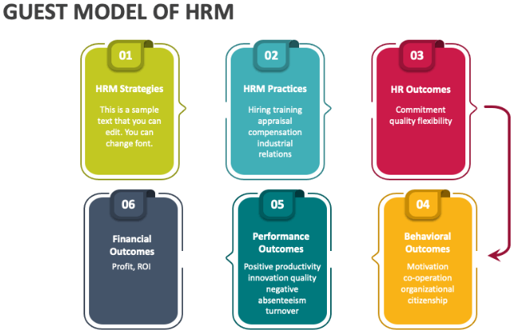
Figure 1: Guest Model of HRM
Source: collidu.com
At Aether Innovations, low engagement and excessive turnover suggest that the company's current culture norms do not encourage dedication and discretionary effort. It takes shared principles, consistent HR procedures that encourage experimentation, learning from mistakes, and cross-functional cooperation to create an innovation-oriented culture.

4. Cultural and Structural Enablers of Innovation
It takes more than just functional cooperation to integrate innovation into organisational structures; it also necessitates the integration of many types of knowledge, beliefs, and viewpoints. Innovation is most successful when social, technological, and economic factors mix with cultural and value-based factors, according to research on trans disciplinarity. By bridging traditional disciplinary barriers and promoting common meaning across professional domains, transdisciplinary approaches enable companies to manage complex, unpredictable situations, according to evidence from the architectural field (Nanayakkara and Wilkinson, 2021). When applied to Aether Innovations, this promotes the utilisation of cross-functional and innovation-focused teams that integrate technical know-how with human, commercial, and cultural knowledge, strengthening a culture where problem-solving and creativity are shared rather than functionally divided.
As innovation teams move through the phases of forming, storming, norming, and performing, Tuckman's approach emphasises the need for support, with leadership fostering productive conflict and common objectives. Decentralised decision-making and flatter organisational structures that adhere to organisational development principles further foster innovation. According to McGregor's Theory Y (2005), managers should take on the role of facilitators, acknowledging that workers are self-motivated and creative when given the right circumstances (see Figure 2).
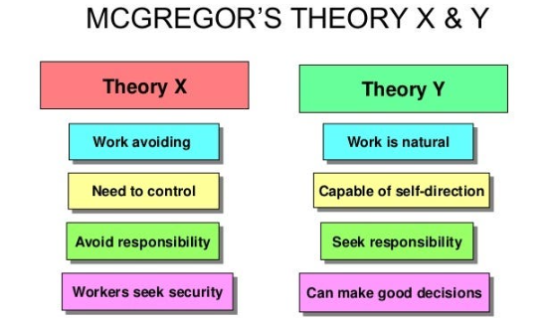
Figure 2: McGregor's Theory Y
Source: fity.club

5. Future of Work Models in Knowledge-Based Organisations
Hybrid and remote work models are becoming more common in technology-driven organisations. According to a CIPD 2025 report, 74% of organisations favour hybrid arrangements (see Figure 3), which shows a change in strategy from emergency to long-term, yet research indicates that flexibility by itself does not ensure better creativity or teamwork (McCartney, 2025).
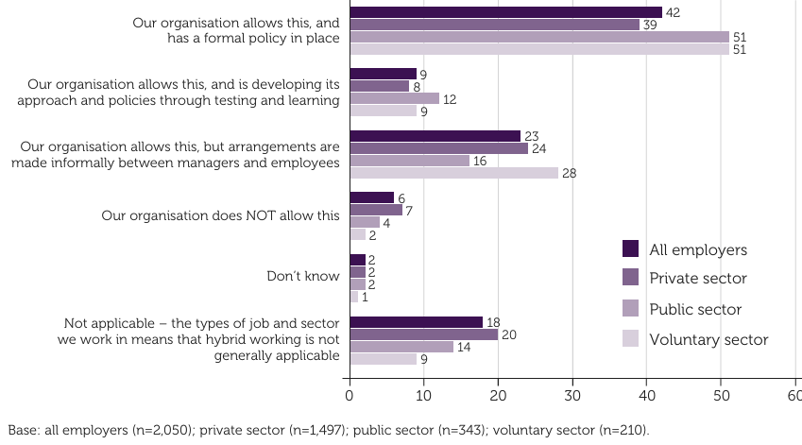
Figure 3: Approach to hybrid working (%)
Source: McCartney (2025)
Increased autonomy reports from companies like Microsoft, Google, and Meta are consistent with a growing body of research showing that digital autonomy, bolstered by technology and training, promotes empowerment, creativity, and knowledge sharing (Huu, 2023). However, a poorly organised work design might lead to a lack of creativity and reduce the sustainability of the team (Kukytė and Jasinskas, 2025). Multicultural teams offer both communication hazards and opportunities for innovation in hybrid, globally distributed environments (Javali et al., 2025). By strengthening psychological safety, trust, and feedback, frameworks like the Johari Window may help Aether Innovations transform cultural diversity from a coordination difficulty to a strategic driver of innovation.

6. Proposed Future Work Model for Aether Innovations
Aether Innovations should adopt a hybrid future-of-work model that balances flexibility with structured collaboration (see Figure 4). Core elements should include flexible working arrangements, digital collaboration platforms, and clearly defined team rhythms to support innovation sprints and project-based work.
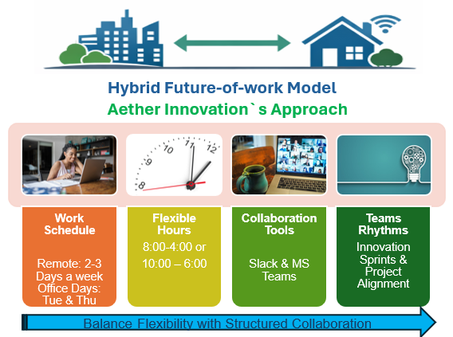
Figure 4: Proposed Hybrid Future-of-Work Model
Source: created by the author
Sokol and Tarulli (2024) explain that by combining talent planning, succession management, and workforce analytics, strategic workforce planning, which is based on the ideas of human resource planning (HRP), can guarantee that organisations have the appropriate talents available both in the short and long term. Additionally, Kraiger and Ford (2021) sustain that developing internal capability through ongoing learning is more sustainable from the standpoint of talent management than depending exclusively on external hiring. Therefore, at Aether Innovations, the hybrid model would enhance experiential learning and creativity by combining flexible remote work with structured in-office collaboration. According to Kolb's reflective observation stage, for instance, employees could work remotely three days a week, concentrating on individual projects, research, and reflective learning. On the other two core days, such as Tuesday and Thursday, they could attend the office for innovation sprints, cross-functional workshops, and experimentation activities that are in line with active experimentation. Virtual training sessions might be used to acquire knowledge, and then in-person collaborative problem-solving exercises could be used to apply what has been learned to actual projects. Employees can continuously experiment, reflect, and refine creative ideas within a flexible yet coordinated framework thanks to this structure, which guarantees that the Training and Development Cycle (Figure 5) is integrated into daily work.
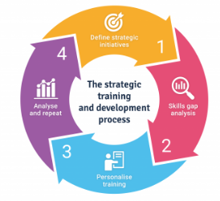
Figure 5: Training and Development Cycle
Source: acornlms.com

7. Motivating and Enabling High Performance through Innovation
Although the hybrid future-of-work model lays the developmental and structural groundwork for innovation, how well work design integrates with performance and motivational systems ultimately determines how effective it is. Creativity is fostered by flexible work schedules, experiential learning, and organised teamwork; yet sustained high performance necessitates the reinforcement of these practices through human-centred performance management and a supportive organisational culture. Because of this, the hybrid model at Aether Innovations has strategic significance not only in the way work is arranged but also in the way that incentive, feedback, and reward systems are combined to convert creative effort into quantifiable performance results. According to Hutapea et al. (2024), aligning organisational culture, work design, and human resource (HR) systems has a favourable impact on motivation and performance. Palma-Moreira and Au-Yong-Oliveira (2025) contend that, with intrinsic and recognised motivation serving as moderating factors, Aether Innovations could improve employee-perceived performance by cultivating a culture focused on support, goal orientation, and perceived affective organisational support. Control-based appraisal should give way to developmental feedback in the Performance Management Cycle (see Figure 5), with an emphasis on collaborative and innovative behaviours. This aligns with contemporary trends in performance management, which prioritise continuous feedback over annual reviews. However, Giamos et al. (2024) consider how the source and content of feedback will affect its efficacy over time. According to their empirical research, feedback offered by a person, rather than through computer-mediated means, tends to have a greater positive impact on performance, drive to improve, and work engagement. Qualitative feedback relates to larger motivational effects compared to quantitative feedback alone. Therefore, Aether Innovations must incorporate human-centred, qualitative, and development-oriented feedback into the performance management cycle to maintain employee motivation, boost self-efficacy, and reinforce innovation-supportive behaviours over time. (More details in the Appendix section)
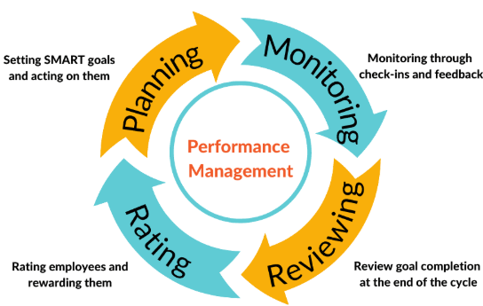
Figure 6: Performance Management Cycle
Source: engagedly.com

8. Integrated Impact on Organisational Performance
Trzeciak et al. (2022) define open innovation (OI) as the deliberate transfer of knowledge across organisational boundaries through carefully considered financial and non-financial channels that are in line with the business model of the company. Collaboration, not just amongst businesses but also with clients, academic institutions, consultants, and other external stakeholders, is essential to this strategy and calls for the right kind of people capital, competencies, and process integration. In this way, OI is a cultural orientation that relies on workers' ability to participate creatively in distributed innovation networks rather than just being a structural strategy. The IT industry's empirical data supports this viewpoint. In their study of 398 workers in Chinese technology companies, Dellova and Tian (2024) show that innovation culture greatly improves market orientation, organisational learning, and empowerment, all of which eventually lead to better firm performance. According to their findings, businesses are better equipped to transform collaborative information flows into quantifiable performance outcomes when creativity is integrated across hierarchical levels, especially through supervisory focus on quality improvement and process innovation. Taken together, these perspectives indicate that cultivating an innovation-oriented culture is essential for operationalising open innovation principles into sustained organisational performance (more details in the Appendix).

Conclusion
Building a culture of innovation supported by future-oriented work practices is critical for Aether Innovations to address its declining engagement, performance, and customer outcomes. This report has shown that innovation arises from the strategic alignment of organisational culture, structure, leadership, and people practices rather than from standalone efforts. Aether Innovations can improve employee creativity, organisational flexibility, and long-term success by integrating innovation at all organisational levels and purposefully creating hybrid work structures that foster learning and cooperation. In the end, the company can better adapt to technological change and maintain a competitive edge in an increasingly complicated business environment by establishing culture as a strategic lever rather than a symbolic concept.

Part 2: Reflection

1. Reflection on Learning Journey and Personal Development
This reflection focuses on Gibbs’ reflective cycle (1988) to examine my learning journey throughout the Human Capital Management program and its influence on my personal and professional development (see Figure 6 in the Appendix). From the moment of our initial interest until we finish the learning, reflect, and apply what we have learned to the future, every learning experience may be laid out as a journey, as Kuzmina and Moran (2024) found in their research studies. At the start of the program, of my MBA journey, my understanding of HRM was mostly operational, influenced by day-to-day supervising responsibilities within the restaurant business. However, via engagement with HRM models, theories, and practical classroom activities, I developed a more strategic perspective on people management and organisational performance.
A significant learning moment happened during discussions on performance management and Social Cognitive Theory (1986), when our lecturer highlighted that what people believe they can or cannot accomplish substantially determines their performance. This realisation completely changed the way I manage my staff. Previously, performance assessments within my workplace focused heavily on individual comments and manager-led evaluations. Drawing on module learning, I launched discussions with my manager about adopting a more developmental approach, which led to the installation of a 360-degree feedback system. By allowing team members to get feedback from superiors and peers, this modification promoted self-awareness, trust, and ongoing development. The importance of this approach is also explained in the studies of O’Neil et al. (2024), emphasising that structured feedback systems that incorporate input from peers and supervisors have been associated with improved self-awareness and team growth in educational and professional development situations.
Additionally, the module improved my capacity to collaborate with varied teams. My multicultural awareness and teamwork abilities were enhanced by classroom activities involving students from various generations, ethnic backgrounds, and professional experiences. Hearing from our lecturer about the concept of "Seeing the good first and allowing people to prove otherwise" to trust employees resonated with me. Using this way of thinking at work has improved relationships, boosted employee empowerment, and sustained creativity.
In assessing this experience, I see that putting theory into practice has allowed me to support my team's long-term development by fostering professional development, receptivity to criticism, and involvement in digital transformation. This reflection demonstrates that the module has given me a solid basis for developing a growth-oriented and innovative mentality in my own leadership approach.

2. Staying Relevant in an AI-Driven Work Environment
The rapid growth of artificial intelligence presents both benefits and concerns for future employability, particularly as AI increasingly automates routine and analytical jobs. This module has highlighted the necessity of adaptation, continual learning, and human-centred skills in sustaining relevance in an AI-driven economy. Instead of seeing AI as a danger, I want to see it as an additional tool that complements my work rather than taking its place.
From a practical viewpoint, I plan to apply AI to enhance decision-making, learning, and efficiency in areas such as workforce scheduling, performance data analysis, training requirements identification, and customer trend insights. For example, AI tools can assist in assessing employee feedback patterns or predicting staffing requirements, enabling managers to make more educated decisions. However, this module has taught me that critical judgment, ethical reasoning, emotional intelligence, and leadership cannot be recreated by AI. These distinctively human qualities are vital in managing individuals, motivating teams, and promoting innovation. Additionally, Dwivedi (2025) maintains that the idea that Emotional Intelligence and AI are complementary rather than interchangeable highlights the fact that effective leadership requires striking a balance between technical and emotional intelligence, a challenge that AI systems are now unable to handle on their own.
As a supervisor in a multicultural restaurant, I have shown that communication, empathy, and trust are still essential components of good leadership. AI might offer insights, but it can't take the place of relationship management tasks like employee mentoring, conflict resolution, or creating a supportive work environment. The module's emphasis on self-efficacy and empowerment has strengthened my conviction that leaders should concentrate on fostering people's potential and confidence, an area where AI has obvious limits.
Reflecting on the assessment process itself, I realise several constraints that influenced my interpretation. Aether Innovations was a hypothetical scenario which prohibited access to real organisational data, such as employee metrics, engagement scores, or external reviews. Empirical data would have allowed for a more thorough and accurate study if this had been an actual organisation. Additionally, while the word limit fostered clarity and conciseness, a larger report with a shorter reflective component may have allowed for more in-depth analysis of strategic HR initiatives. However, this limitation strengthened a crucial managerial ability: the capacity to express complicated concepts succinctly and precisely. According to Gardezi (2025), there are so many uses for managerial thinking, and understanding of its foundations on a personal level can then be applied to wider aspects in the future. This implies that creating a growth-oriented managerial mindset that can adjust to upcoming organisational problems requires fostering personal understanding through reflection.
All things considered, this module has improved my capacity for self-awareness, strategic thinking, and technological change adaptation. As I work toward my MBA, I understand that staying relevant will require striking a balance between digital proficiency and human-centred leadership, making sure that AI improves my work without taking away from my value as a people-focused manager.

References
Alvesson, M. and Sveningsson, S., (2024). Changing organisational culture: Cultural change work in progress. Routledge.
Athota, V.S., (2021). Impact of fixed vs growth mindset in organizations. In Mind over Matter and Artificial Intelligence: Building Employee Mental Fitness for Organisational Success (pp. 29-37). Singapore: Springer Singapore.
Bandura, A. (1986) Social foundations of thought and action: A social cognitive theory. Englewood Cliffs, NJ: Prentice Hall.
Carson, C.M., (2005). A historical view of Douglas McGregor's Theory Y. Management Decision, 43(3), pp.450-460.
Cheng, M.M. and Hackett, R.D., (2021). A critical review of algorithms in HRM: Definition, theory, and practice. Human Resource Management Review, 31(1), p.100698.
Dellova, R.I. and Tian, Y., (2024). Fostering innovation: exploring key factors and their relationship on organizational performance towards innovation management culture. Organization and Human Capital Development, 3(1), p.1.
Dwivedi, D., (2025). Emotional Intelligence and Artificial Intelligence Integration Strategies for Leadership Excellence. Advances in Research, 26(1), pp.84-94.
Gardezi, D.H., (2025). MANAGEMENT DYNAMICS: BALANCING PEOPLE AND PERFORMANCE. Vaagai international publishing house.
Giamos, D., Doucet, O. and Léger, P.-M. (2024) “Continuous Performance Feedback: Investigating the Effects of Feedback Content and Feedback Sources on Performance, Motivation to Improve Performance and Task Engagement,” Journal of organizational behavior management, 44(3), pp. 194–213. Available at: https://doi.org/10.1080/01608061.2023.2238029 (accessed 02 February 2026)
Gibbs, G., (1988). Learning by doing: A guide to teaching and learning methods. Further Education Unit.
Hambissa, B.A., Tadesse, W.M. and Regassa, G.A., (2023). Public Sector Performance Management: The Shift From Annual Performance Review To Regular Feedback. Social Sciences and Education Research Review, 10(1), pp.212-217.
Huu, P.T. (2023) “Impact of employee digital competence on the relationship between digital autonomy and innovative work behavior: a systematic review: Impact of employee digital competence on the relationship,” The Artificial intelligence review, 56(12), pp. 14193–14222. Available at: https://doi.org/10.1007/s10462-023-10492-6 (accessed 02 February 2026)
Javali, G.R., BK, M. and Kumar, K.S., (2025). Multicultural challenges and employee experience in globally dispersed teams: insights from Indian software firms. International Journal of Organizational Analysis.
José, D., Palma-Moreira, A. and Au-Yong-Oliveira, M. (2025) “Organizational Culture and Perceived Performance: Mediation of Perceived Organizational Support and Moderation of Motivation,” Administrative sciences, 15(8), p. 307. Available at: https://doi.org/10.3390/admsci15080307 (accessed 02 February 2026)
Kis, J. and Tudoran, D. (2023) “Integrating Employee Feedback into the Continuous Improvement of Performance Management,” Revista de Management Comparat International, 24(5), pp. 760–772. Available at: https://doi.org/10.24818/RMCI.2023.5.760 (accessed 02 February 2026)
Kraiger, K. and Ford, J.K., (2021). The science of workplace instruction: Learning and development applied to work. Annual Review of Organizational Psychology and Organizational Behavior, 8(1), pp.45-72.
Kukytė , A. and Jasinskas, E. (2025) “THE IMPACT OF ROLE OVERLOAD AND INNOVATION FATIGUE ON TEAM VIABILITY,” Tiltai, 94(1), pp. 63–78. Available at: https://doi.org/10.15181/tbb.v94i1.2714 (accessed 02 February 2026)

Kuzmina, K. and Moran, J., (2024). Reflection by design: Embedding reflective practice into the student learning journey. In Transforming Higher Education With Human-Centred Design (pp. 218-229). Routledge.
Lin, J. and Mao, M. (2024) “How does digital transformation affect sustainable innovation performance? The pivotal roles of digital technology‐business alignment and environmental uncertainty,” Sustainable development (Bradford, West Yorkshire, England), 32(4), pp. 3163–3181. Available at: https://doi.org/10.1002/sd.2830 (accessed 02 February 2026)
Marić, I., Aleksić, A. and Knežević, M., (2022). Enhancing sustainable development: examining factors that foster creativity and productivity in organizations. Sustainability, 14(15), p.9094.
McCartney, C. (2025) Flexible and hybrid working practices in 2025. London: Chartered Institute of Personnel and Development.
Muhajan, V.K., (2024). Strategic Human Resource Management in Multinational Corporations: Challenges and Opportunities. Intersecta Minds Journal, 3(3), pp.1-14.
Nanayakkara, K. and Wilkinson, S., (2021). Organisational Culture Theories: Dimensions of organisational culture and office layouts. In A handbook of theories on designing alignment between people and the office environment (pp. 132-147). Routledge.
O’Neill, T.A. et al. (2024) “Conflict management styles assessment and feedback for student self-awareness and team development,” Assessment and evaluation in higher education, 49(8), pp. 1091–1104. Available at: https://doi.org/10.1080/02602938.2024.2350682 (accessed 02 February 2026)
Pillai, R. and Sivathanu, B., (2022). Measure what matters: descriptive and predictive metrics of HRM-pathway toward organizational performance. International Journal of Productivity and Performance Management, 71(7), pp.3009-3029.
Sokol, M.B. and Tarulli, B.A. (eds.) (2024) Strategic workforce planning: best practices and emerging directions. First edition. New York, NY: Oxford University Press. Available at: https://doi.org/10.1093/oso/9780197759745.001.0001 (accessed 02 February 2026)
Trzeciak, M., Kopec, T.P. and Kwilinski, A., (2022). Constructs of project programme management supporting open innovation at the strategic level of the organisation. Journal of Open Innovation: Technology, Market, and Complexity, 8(1), p.58.
Winda Melina Hutapea et al. (2024) “THE EFFECT OF ORGANIZATIONAL CULTURE AND WORK MOTIVATION ON EMPLOYEE PERFORMANCE WITH JOB SATISFACTION AS AN INTERVENING VARIABLE AT PT SUPRA PRIMATAMA NUSANTARA TERRITORY WEST 1 - SUMATRA,” Соціальна економіка, (68), pp. 186–192. Available at: https://doi.org/10.26565/2524-2547-2024-68-18 (accessed 04 February 2026)

Appendix
7. Motivating and Enabling High Performance through Innovation
By rewarding actions that promote creativity and ongoing development, performance management plays a vital part in fostering the growth and development of employees. Based on Social Cognitive Theory, Bandura (1986) highlights that performance outcomes are significantly impacted by self-efficacy, or people's confidence in their capacity to do tasks. Employee self-belief can be strengthened by performance management systems that relate performance to meaningful rewards and offer developmental feedback, which will increase motivation and creative output. Employees at Aether Innovations would be able to view effort, learning, and performance as both valuable and attainable if performance evaluations were in line with development and incentive systems.
The concept of “fit” is central to sustaining innovation-driven performance, particularly within dynamic technology environments. Leveraging digital transformation in innovation requires also a fit between digital technologies and corporate goals, especially in stable environmental conditions, as Lin and Mao (2024) suggest. Beyond person-job fit, organisations increasingly emphasise person-organisation and person-culture fit to ensure alignment between employee values, behaviours, and innovation-oriented norms. For Aether Innovations, reinforcing cultural fit within performance management and development processes would support consistent innovation behaviours while reducing misalignment that contributes to disengagement and turnover.
Using this approach Aether Innovations stays in line with the current performance management trends, which place more of an emphasis on continuous, continuing feedback than the typical annual reviews (Hambissa and Regassa, 2023). Additionally, by incorporating employee feedback into the performance management process Kis and Tudoran (2023) maintain that, can boost employee motivation and engagement, improve work performance, and make evaluation meetings more transparent and effective. Digital tools can make it easier to gather and evaluate employee input, promoting ongoing enhancements to performance management systems' developmental feedback procedures.

8. Integrated Impact on Organisational Performance
Most people believe that organisational culture is an essential facilitator of change rather than an incidental factor, especially in situations that call for renewal and adaptability. For organisational transformation to be successful, Alvesson and Sveningsson (2024) argue that firms that do not adapt run the risk of long-term decline. By promoting flexibility, learning, and employee involvement, the suggested culture and future work initiatives at Aether Innovations jointly address the fundamental causes of performance decrease. The company can better promote innovation-led transformation and maintain performance in a changing technology environment by framing culture as a strategic instrument rather than a symbolic concern. This could increase employee engagement, lower attrition, and boost customer happiness by coordinating HR strategy with innovation goals. Viewing people, culture, and structure as interdependent systems within an integrated approach reflects the principles of best practice human resource management.

Part 2: Gibbs’ Reflective Cycle (1988):
Application of Gibbs’ Reflective Cycle to Personal Learning and Professional Practice
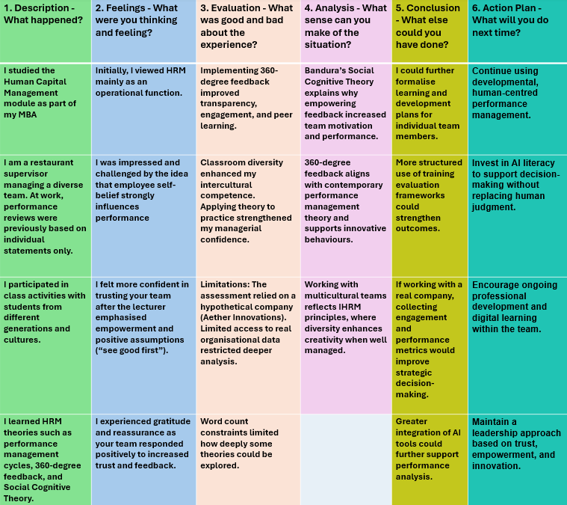Figure 6: Application of Gibbs’ Reflective Cycle to Personal Learning and Professional Practice
Source: created by author

