Quantitative Research Report
Rachel Vetter
1708006
Business and Management
Business Inquiry and Research

Dr Alex Bell
March 2019

Introduction
This report has been commissioned by Dr Alex Bell. It will study the difficulties faced by mature students returning to Higher Education after a prolonged absence and how these differs from those of the young school leavers. In order to procure a statistical view of this subject, all information was gathered through the use of an online survey.
The hypotheses studied was of ‘A Mature Student within a Higher Education setting’. The intention of the report was to determine whether the life experiences of mature students acted as a positive aid to their learning process. Furthermore, that younger students, continuing their studies, held other advantages to those of the mature students, regarding basic study skills like referencing and essay structuring.
Many mature students face barriers that younger school leavers do not. These barriers include family responsibilities, low levels of confidence and self-belief. The transition into study can lead to anxiety, so the need for a support system is essential (Canning , 2010). This report will ask whether the addition of a study skills course would be of benefit to mature students and what obstacles they face.

Procedure
For the purpose of this report a quantitative survey was produced and sent to ten participants.
This form of data collection is considered to be a more scientific approach with easily presentable findings (Balnaves & Caputi, 2010). Quantitative research is equated with discovering evidence either that confirms or eliminates the hypotheses formulated through the research process. Moreover, it studies the association between numerically measured variables through the use of statistical systems (Dudovskiy , 2018).
This study was limited to ten questions, so it was important to choose specific questions very carefully that focused on obtaining the exact information required. The first three questions were constructed using factual inquiries, participants were asked which age group they came under, level of education and what age they finished fulltime education, these questions offered a base for the study. The final seven questions used an attitudinal style requiring the participants to answer using their experiences and beliefs. All questions were written using a closed question approach, this ensured that the respondents were offered a selection of tick box and rating approaches.
Once finalised, the questions were transferred to Survey Monkey, an online survey development company. Invites to complete the survey were sent to ten acquaintances via Facebook’s ‘Messenger’ app. One known drawback of questionnaire and surveys is the low reply rates or incomplete surveys. This was luckily not a personal issue faced because all ten recipients fully completed and returned the survey.
All Surveys were completed from 5th March to 10th March 2019. A copy of the survey can be found in the appendix.

Data collection and Analysis
For the purpose of the study the IBM package ‘Statistical Package for the Social Sciences’ (SPSS) was used. In simple terms this computer program takes data collected and generates it into reports, trends and charts.

Findings
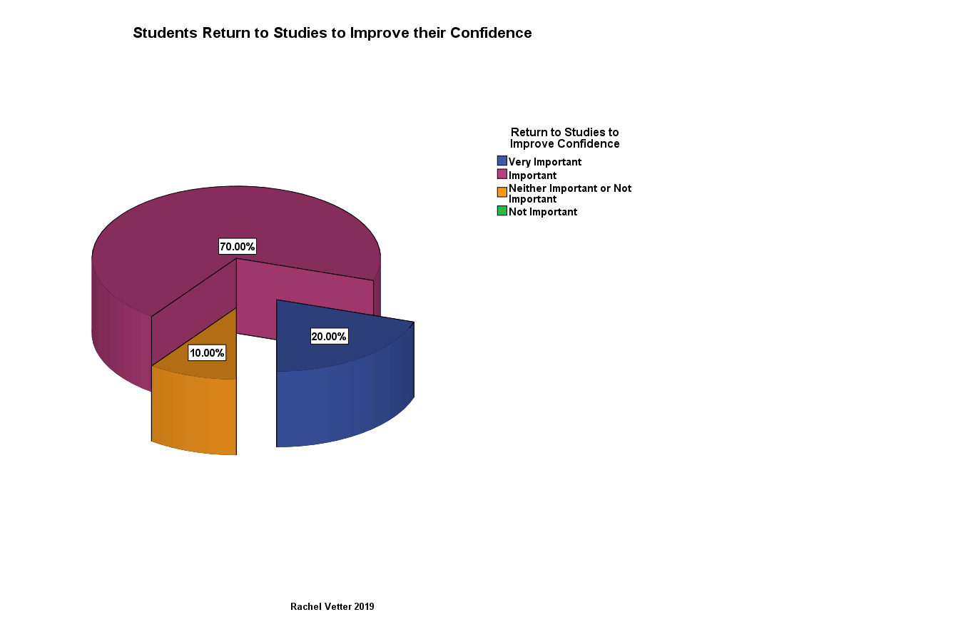
Figure 1
This simple pie chart (Figure 1) expresses the participants’ views in regards to how important gaining confidence is to a mature student and how it relates to their returning to Higher Education. This question was completed by all participants and the high response percentages, illustrate that the ability to gain more confidence is significant. 90% of participants stated that they felt it was either important or very important. However, the remaining 10% appear unclear, categorising it as neither important or not important.

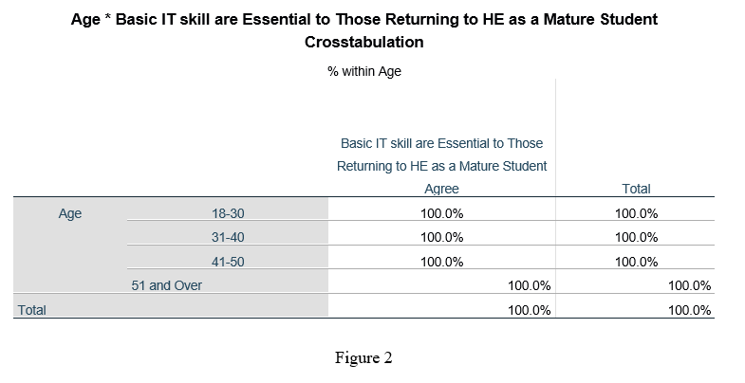

The results from this question were one sided, with 100% of those participants asked agreeing with the statement that ‘Basic IT skills are essential to a Mature student returning to a learning environment’. This response demonstrates that it is universally accepted that a basic IT understanding is an essential skill required by those wishing to return to education. Due to the response being one hundred percent it meant that no pie, or bar chart or crosstabulation graph offered a noteworthy view of the findings.
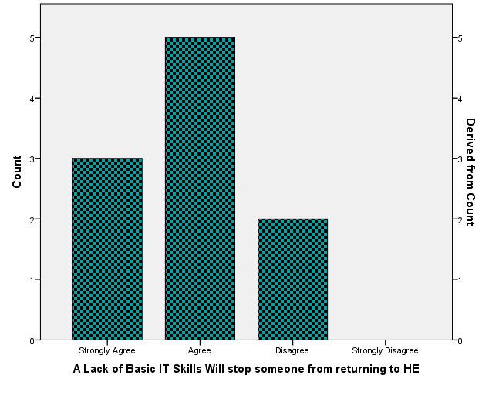
Figure 3
Figure 3 follows on from the importance of IT skills. It questioned whether a lack of IT skills can actually prevent someone from returning to Higher Education. The bar chart simplifies the data obtained by presenting the total number of participants who strongly agreed, agreed or disagreed with the statement. Even though the answer is clear it does not offer a clear enough picture, so the same information was placed into a crosstabulation graph (See figure 4).

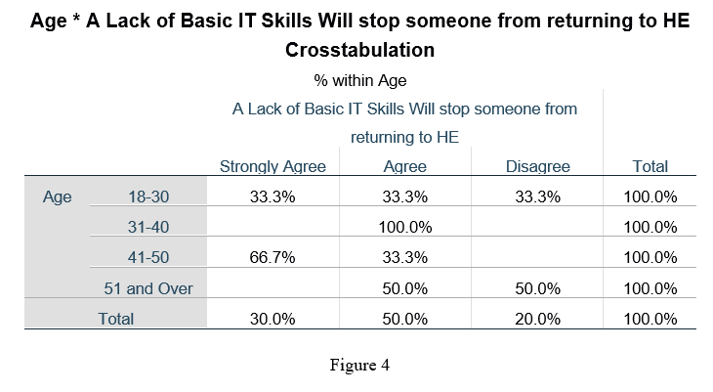

By producing a crosstabulation chart the information is broken down further, by incorporating the age groups of those who answered the survey and presenting the findings using percentages. This graph illustrates the division of answers received in a clearer form. Of those questioned 50% of those over the age of 50, considered a lack of IT skills as a barrier to learning, this is opposed to 100% of those aged between 31-40 who believed that it undeniably acted as a barrier.
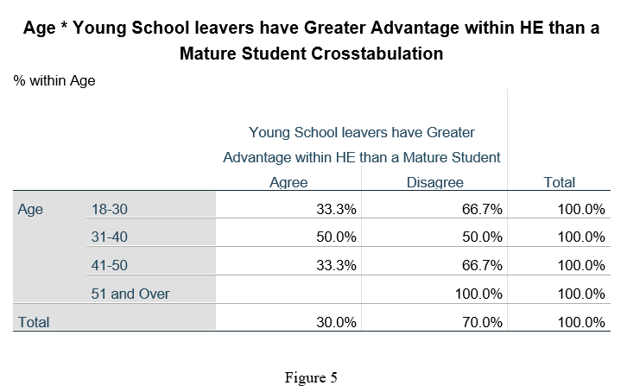

The data found in figure 5, was unexpected, participants were asked whether young students had a greater advantage starting Higher Education than mature students. 70% of those asked deemed them to have no advantage, however 50% of 31-40-year olds believed that there was an advantage. These statistics differ from those collated during my qualitative research in which all participants spoke of the advantage younger students had.

Age * Young School leavers have Greater Advantage within HE than a Mature Student Crosstabulation
% within Age
 |  | Young School leavers have Greater Advantage within HE than a Mature Student |  | Total
 |  | Agree | Disagree | Total
Age | 18-30 | 33.3% | 66.7% | 100.0%
Age | 31-40 | 50.0% | 50.0% | 100.0%
Age | 41-50 | 33.3% | 66.7% | 100.0%
Age | 51 and Over |  | 100.0% | 100.0%
Total |  | 30.0% | 70.0% | 100.0%

Figure 6

As we go through life we encounter events and experiences that influence our behaviours and help us grow as individuals (Throop & Castellucci, 2011). During the survey the participants were asked if they believed that these life skills benefited the mature students when they returned to Higher Education. Overall 90% agreed or strongly agreed with the statement however, one third of 18-30 years olds or 10% of all those questioned saw these skills as having no impact on the learning journey at all.

Age * Study Skills course should be available to all Mature Students Crosstabulation
% within Age
 |  | Study Skills course should be available to all Mature Students |  | Total
 |  | Strongly Agree | Agree | Total
Age | 18-30 | 66.7% | 33.3% | 100.0%
Age | 31-40 | 50.0% | 50.0% | 100.0%
Age | 41-50 | 66.7% | 33.3% | 100.0%
Age | 51 and Over | 100.0% |  | 100.0%
Total |  | 70.0% | 30.0% | 100.0%

Figure 7
The final crosstabulation graph answered the question which was asked in the introduction of this report, regarding the need for a basic study skills course to be available to mature students. The result shows 100% of participants either agreed or strongly agreed that this would aid their learning. 100% of the over 50s strongly agreed and overall 30% of the total questioned only agreed. Thus, confirming the importance of the inclusion of a study skill course on the syllabus.

Conclusion/Reflection
To reflect, my approach to this assignment differed from the qualitative report produced previously. During the aforementioned data collection method, open questions were asked in order to gain participants’ perspectives. The Quantitative method allowed me to ask more participants over a shorter period of time, however, due to the nature of the criteria and structure specified for this assignment I was limited to asking ten questions to ten participants.
This study was limited to ten questions, so it was important to choose specific questions that focused on gaining just the information required. A dummy questionnaire was written and was completed by a small section of participants. It became clear that one of the questions I asked, Gender, made no difference to the overall data required , so this was removed from my study.
The subsequent questions related to the hypotheses regarding the needs of mature students.
Largely the results obtained did not offer any unexpected outcomes. The results agree with many of the statements noted in previous research as well as within my previous qualitative study. I was surprised however, by the answers given to the statement that ‘younger students had a greater advantage when going on to study at University’. When I conducted my qualitative research, all respondents spoke of the advantages that young people had, it should be noted that all of the original participants also took part in this survey. I must therefore conclude that the wording of my statement did not convey the information I had intended. Moreover, I found the writing of the questions for the survey much harder to compose due to their simple close ended approach. However, being mindful of these difficulties, had there been no limit on questions available it may have been possible to achieve a more varied result.

References
Balnaves, M., & Caputi, P. (2010, August 25). Introduction to Quantitative Research Methods (First ed.). London, United Kingdom: Sage Publication . Retrieved from https://www.amazon.co.uk/Introduction-Quantitative-Research-Methods-Investigative/dp/0761968040
Canning , N. (2010, Febuary 16). Playing with Heutagogy: Exploring Strategies to Empower Mature Learners in Higher Education. Journal of Further and Higher Education, 34(1), 59-71. doi: 10.1080/03098770903477102
Dudovskiy , J. (2018, January). Quantitative Data Analysis- research methods. The Ultimate Guide to Writing a Dissertation in Business Studies: a step by step approach . Retrieved March 10, 2019, from Research Methodology : https://research-methodology.net/research-methods/data-analysis/quantitative-data-analysis/
Throop, R. K., & Castellucci, M. B. (2011). Reaching Your Potential: Personal and Professional Development (Fourth ed.). Boston, MA, United States: Wadsworth.

Appendix
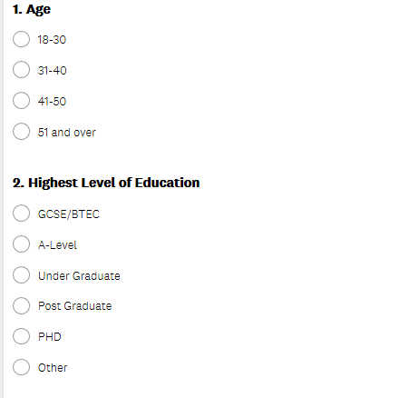
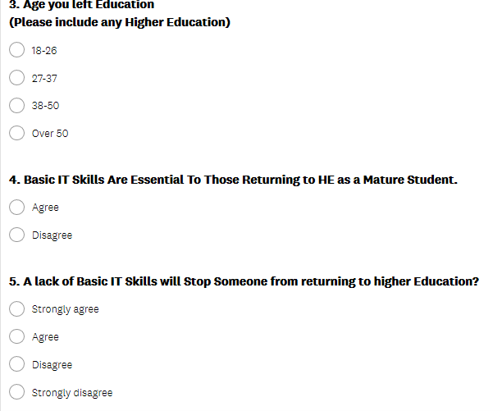
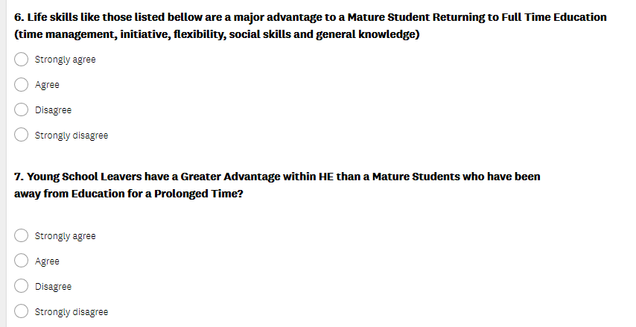
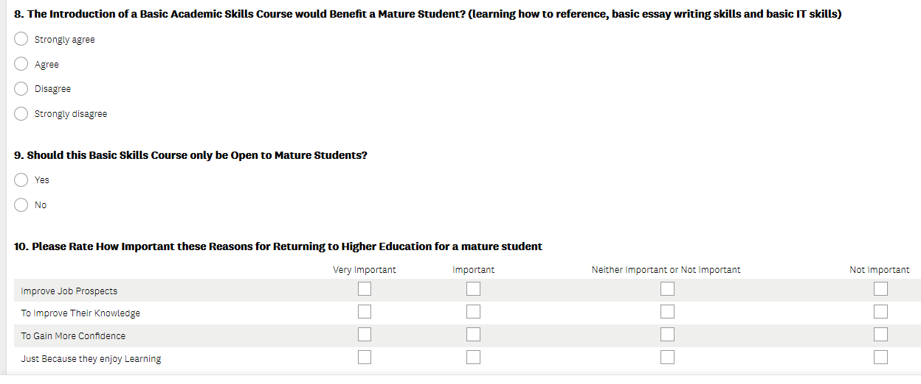

Age * Study Skills course should be available to all Mature Students Crosstabulation
% within Age
 |  | Study Skills course should be available to all Mature Students |  | Total
 |  | Strongly Agree | Agree | Total
Age | 18-30 | 66.7% | 33.3% | 100.0%
Age | 31-40 | 50.0% | 50.0% | 100.0%
Age | 41-50 | 66.7% | 33.3% | 100.0%
Age | 51 and Over | 100.0% |  | 100.0%
Total |  | 70.0% | 30.0% | 100.0%



