Is the external challenge a good or a bad?

A study of Marriott Hotels

Personnel Resourcing and Development
BMIH5005
Deborah Lloyd

Lavinia Lenuta Siminiuc
2208461

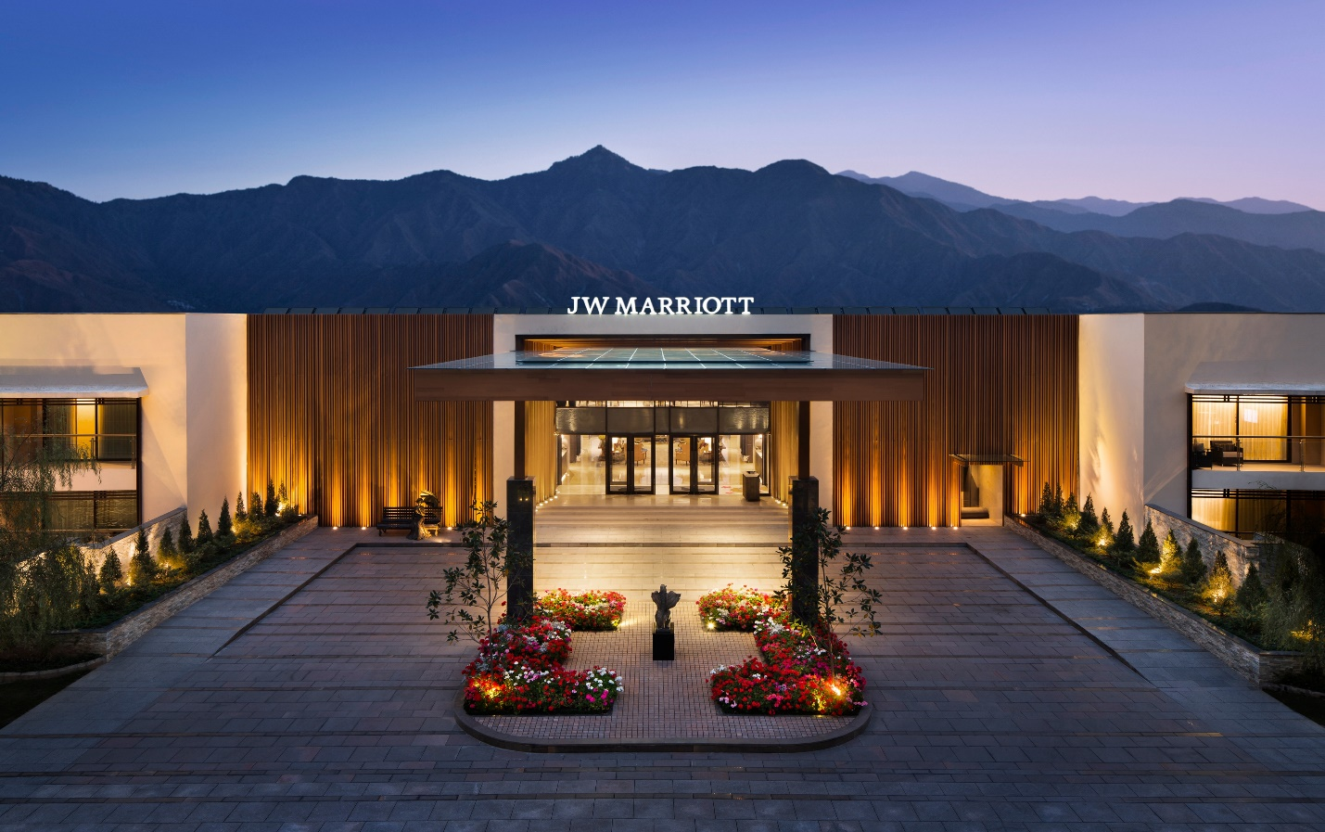
Executive Summary
Marriott International is well known for its exceptional service in the hospitality sector, achieved through effective employee recruitment and retention strategies. This report analyses the role of Marriott's workforce strategies in its sustained success during changing external environmental conditions.
The company's recruitment strategy combines advanced technology and a focus on brand culture to attract a diverse range of talented individuals and establish industry standards. The "TakeCare" programme exemplifies Marriott's commitment to employee well-being, positively impacting on employee retention rates. Marriott's competitive benefits, emphasis on career advancement, and inclusive work environment contribute significantly to its low employee turnover rate.
The SWOT analysis indicates Marriott's ability to withstand challenges and adapt but also identifies vulnerabilities to external factors like economic downturns and industry competition. Marriott's recruitment and retention strategies are effective but require ongoing adaptation to integrate technology with the hospitality industry's human touch.
Marriott International's recruitment and retention strategies have been successful, establishing it as a prominent leader in the hospitality sector. To maintain its current status, Marriott must continuously adapt its strategies to align with the changing global economy and labour market.
Table of Contents

Executive Summary
Introduction
Company Overview
Industry Background
Literature Review
Recruitment Strategies at Marriott International
Retention Strategies at Marriott International
SWOT and PESTLE Analysis
Evaluation of Marriott's Recruitment and Retention
Conclusion
Recommendations


Marriott International is a prominent player in the global hospitality industry, tracing its origins to 1927 (Gregersen and Black, 2002). The company's dedication to innovation and service has led to its presence in more than 130 countries, making it a renowned leader in the hospitality industry (Thomas, 2023). This report examines Marriott's strategic approach to employee recruitment and retention, which is crucial for its operational success and industry leadership (Ghani et al., 2022). Marriott has consistently adjusted its workforce strategies to remain competitive in the face of various external challenges, such as political and economic changes. This report analyses the external environmental factors that impact Marriott's recruitment and retention policies. It will provide a detailed examination of how these factors are managed to create a strong and long-lasting workforce. This report examines how Marriott's employment framework demonstrates resilience and adaptability through its responses to PESTLE factors and current affairs. This study explores the challenges faced by Marriott and the strategies it uses to overcome them (Shaw, 2023).

Company Overview

Marriott International, Inc., established in 1927 by J. Willard and Alice Marriott as a root beer stand in Washington D.C., has grown into a highly esteemed global hospitality company (Gregersen & Black, 2002). Marriott, after acquiring Starwood Hotels & Resorts in 2021, emerged as the largest global hotel chain. It currently operates more than 7,600 properties in 133 countries and territories, offering a diverse portfolio of 30 renowned brands that respond to various customer preferences. The company engages in hotel operations, franchising, and licencing of vacation ownership resorts globally. Its portfolio comprises renowned brand names like Ritz-Carlton, St. Regis, JW Marriott, and Renaissance Hotels (Thomas, 2023).

Marriott's dedication to customer satisfaction and its loyalty programme, Marriott Bonvoy, exemplify the company's commitment to service excellence and customer relationship management (Thomas, 2023). Marriott's global workforce, consisting of hundreds of thousands of employees, is integral to the company's operational philosophy. They embody Marriott's values of prioritising people, striving for excellence, embracing change, and acting with integrity (BSH, 2023). The workforce plays a crucial role in Marriott's global business strategy and corporate social responsibility efforts, as it is responsible for driving the company's commitment to sustainability, community service, and diversity and inclusion.

Industry Background
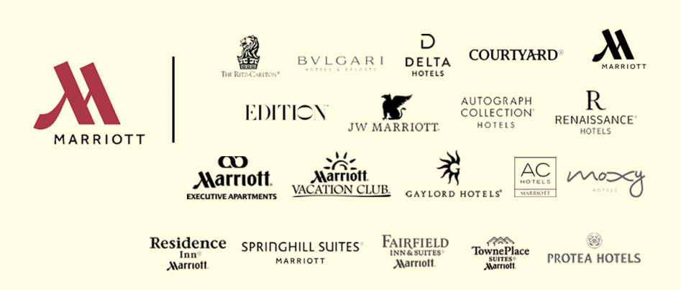
- The Hotel Industry Landscape
The global hotel industry is a complex sector that is highly competitive and requires continuous innovation (EHL Insights, 2018). It covers a wide range of lodging options, serving a diverse clientele with various tastes and needs. The industry has recovered strongly following the COVID-19 pandemic, focusing on digitalization, personalised experiences, and sustainability. The industry's ability to adapt and prosper in challenging circumstances is demonstrated by its resilience.

- Recruitment and Retention Challenges
Recruitment and retention pose significant challenges in the hotel industry. The sector faces competition from various service industries for a limited talent pool, frequently dealing with high turnover rates and a shortage of skilled labour. The inherent fluctuation of employment in the hospitality industry, along with non-traditional working schedules, presents distinct difficulties in the recruitment and retention of staff. The industry needs flexible and attractive employment strategies to maintain a diverse and multigenerational workforce (Ghani et al., 2022).

- Impact of External Factors on the Industry
Ndife (2014) states that the hotel industry is vulnerable to various external factors. Various factors such as political instability, economic fluctuations, technological advancements, and socio-cultural trends have a significant impact on operational efficiency and the dynamics of the job market. Legislative modifications, economic factors, and shifting social norms greatly influence travel and tourism. Wang, Chen, and Chen (2012) argue that environmental sustainability has become a significant factor in shaping consumer preferences and industry practices. The hotel industry must effectively get around these factors to ensure long-term growth and workforce stability.

Literature Review
The hotel industry is greatly affected by external environmental factors, which have important consequences for managing the workforce. Recent studies highlight the influence of PESTLE factors on recruitment and retention strategies. Research suggests that immigration policies and labour laws have a significant impact on the composition of the workforce, especially in regions that heavily rely on international employees (Jones, 2021). The staffing requirements in the travel and tourism industry are greatly influenced by economic fluctuations, which result in seasonal highs and lows (Goulding and Pomfret, 2022).
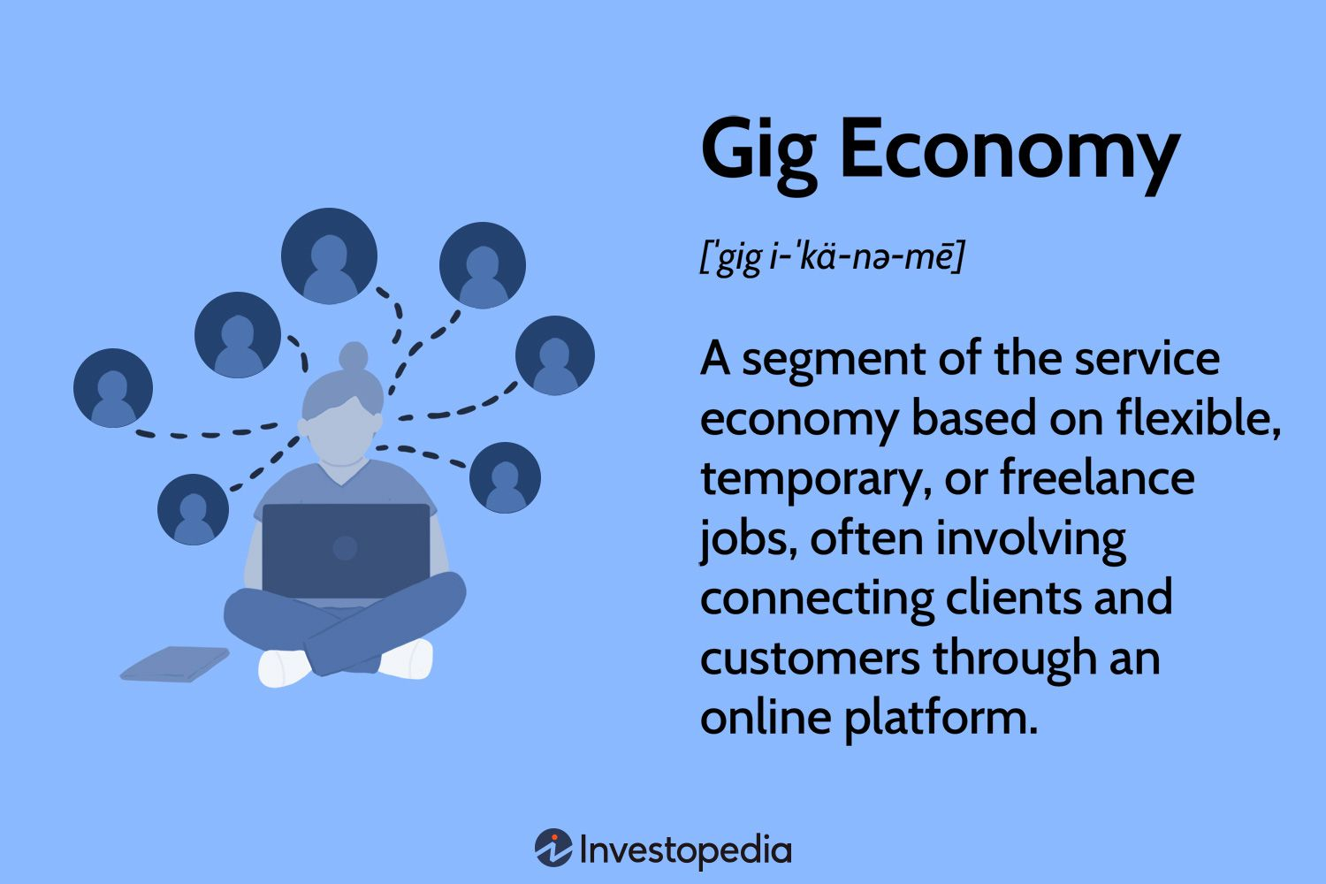
The emergence of the gig economy and shifting workforce demographics necessitate adaptable employment practices (Lehdonvirta, 2018). The automation and digitalization in hotel operations necessitate a change in the desired skill sets for recruitment but also are beginning to impact traditional roles in the industry (Spektor et al., 2023). Hoteliers face ongoing challenges in complying with changing employment legislation (Tawfik et al., 2022). Environmental sustainability is now crucial for attracting and retaining customers and employees who value corporate responsibility (Tanveer, Yusliza, & Fawehinmi, 2023).
Hotels that effectively manage PESTLE factors and implement flexible human resource practices are more likely to succeed in adapting to and capitalising on external changes.

Recruitment Strategies at Marriott International

Marriott International has developed a comprehensive recruitment framework that is in line with its worldwide reputation and the varied requirements of its extensive operations. Marriott's recruitment strategy is centred around attracting highly skilled individuals who align with its core values and culture, demonstrating its commitment to prioritising people. The company utilises various channels, such as online job portals, university partnerships, and social media campaigns, to expand its reach to a wider audience (Kanner, 2023).
Marriott recognises the significance of brand appeal in attracting potential employees. To demonstrate its dedication to employee growth, diversity, and inclusion, the company has made investments in employer branding initiatives. The company's award-winning global careers campaign, called "To the Journey," showcases personal growth stories to inspire potential candidates (Perkins-Chavis, 2017).
Marriott displays its embrace of technological progress in recruitment through the implementation of AI for candidate screenings and the utilisation of virtual reality to provide applicants with a preview of the Marriott work setting. The recruitment strategy is responsive to the labour market, providing competitive compensation, benefits, and career development opportunities to attract and retain talent (Kanner, 2023).
Marriott's recruitment strategy combines traditional and innovative methods, focusing on an excellent employer reputation and the use of advanced technology to gain a competitive advantage in the hospitality talent market.

Retention Strategies at Marriott International

Selin (2022) states that Marriott International considers employee retention to be just as important as recruitment. The company implements various practises to support and maintain its workforce. Marriott has implemented various retention strategies to address the costly and disruptive nature of employee turnover. These strategies align with their philosophy of treating employees as family, referred to as "associates."

Marriott's "TakeCare" initiative is a key component of their strategies, focusing on employee well-being through health programmes, career development, and a supportive work environment. This initiative highlights the company's dedication to prioritising employee satisfaction and well-being as a fundamental aspect of its strategy to retain employees.
Marriott prioritises offering competitive compensation and benefits, such as travel perks, retirement plans, and health care choices. The tangible benefits are enhanced by intangible ones, including a robust company culture and chances for acknowledgement and incentives, which together cultivate a feeling of loyalty and belonging among employees (Karagiannis, 2021).
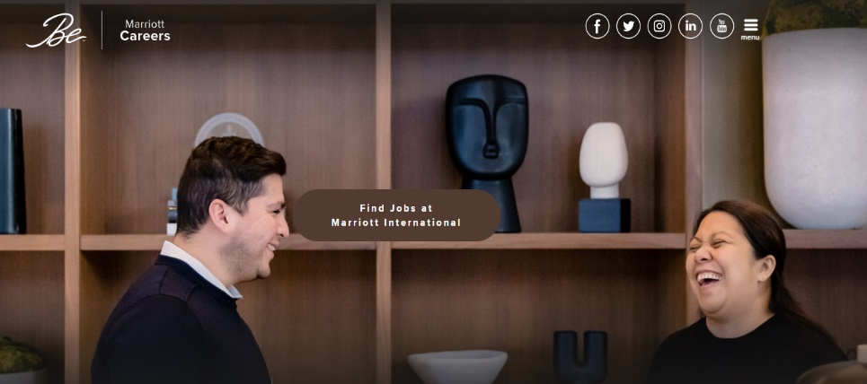
Marriott favours career progression by providing comprehensive training and development initiatives that foster individual and professional development. This practice supports talent retention and establishes a pathway for internal promotions, thereby strengthening the company's commitment to long-term career development for its employees (Selin, 2022).
Marriott International seeks to foster a workplace that values and engages employees, resulting in increased retention rates and a more dedicated workforce.

SWOT and PESTLE Analysis of Marriott International
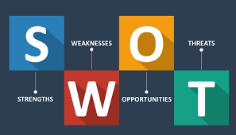
Strengths: Marriott International excels in its extensive worldwide reach and varied brand collection, which effectively serves diverse market segments. The company derives advantages from a robust loyalty programme, namely Marriott Bonvoy, which improves customer retention and strengthens brand equity. Marriott's strong operational systems and employee-centric corporate culture have positioned it as a preferred employer within the hospitality sector (Selin, 2022).
Weaknesses: Professional rules and regulations are crucial for organisational success. Marriott's strict rules have a constraining effect on its employees. Consequently, their performance, productivity, and job satisfaction are decreasing. In 2018, a hotel and resort company terminated an employee for endorsing a controversial tweet on Twitter that had offended China (Shaw, 2023).
Opportunities: The growing trend of experiential travel creates prospects for Marriott to innovate and broaden its offerings in distinctive locations. The increasing popularity of remote work and digital nomadism creates opportunities for extended stays and workspace options at Marriott properties (Barreto and Mayya, 2022).
Threats: Barreto and Mayya (2022) state that Marriott operates in a fiercely competitive industry, encountering challenges from established competitors and emerging alternative accommodation providers such as Airbnb. Economic downturns and geopolitical tensions can negatively impact travel patterns, which in turn can have a detrimental effect on hotel occupancy rates. In addition, the persistent difficulties of navigating the post-pandemic environment, such as fluctuating health conditions.

Political: Marriott operates in a complex global political landscape, where factors like international trade policies and regional stability can impact its operations. Changes in visa regulations and travel advisories directly influence guest inflows and staffing in different regions.
Economic: Economic conditions globally affect travel trends and spending power. Marriott must adapt to varying economic cycles, with a focus on pricing strategies and cost management to maintain profitability across different markets.
Social: Changing social norms and customer expectations, such as an increased focus on health and wellness, require Marriott to adapt its services. The rise of ethical consumerism also impacts guest preferences, pushing Marriott towards more sustainable and socially responsible practices.
Technological: The increasing role of digital platforms in customer engagement and the integration of smart technologies in hotel management are crucial for Marriott to stay ahead in the competitive landscape.
Legal: Compliance with diverse international laws and regulations, including labour laws and data protection standards, is essential for Marriott’s global operations.
Environmental: Environmental sustainability is increasingly important for customers and stakeholders. Marriott must continue to enhance its sustainability initiatives, focusing on energy efficiency, waste reduction, and responsible sourcing.

Evaluation of Marriott's Recruitment and Retention
Marriott International's recruitment and retention strategies are a testament to its recognition of human capital as a key driver of success. The company's multifaceted recruitment approach, integrating technology with its strong brand reputation, has proven effective in attracting a diverse talent pool. Marriott's use of AI and VR in recruitment processes not only streamlines hiring but also provides an immersive experience for candidates, reflecting the company's innovative edge (Kanner, 2023).
The "TakeCare" program exemplifies Marriott's commitment to retention, focusing on employee well-being, which aligns with contemporary expectations of work-life balance and holistic support. This program, alongside competitive benefits and clear pathways for career advancement, contributes to Marriott's lower turnover rates compared to industry averages (Karagiannis, (2021).
However, the evaluation also reveals areas for improvement. The reliance on technology, while beneficial, may overlook the human element critical in the hospitality industry. Furthermore, while Marriott offers substantial development opportunities, the challenge remains to ensure these are accessible to employees at all levels, including those at the front line of hotel operations.
Marriott's strategies for recruitment and retention are robust, aligning with best practices in the industry. Yet, there is room for enhancing the personalization of employee experiences and ensuring the equitable distribution of development opportunities across the company's vast workforce.

Conclusion
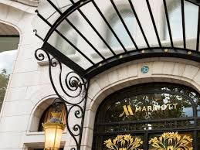
Marriott International’s strategic approach to recruitment and retention underscores its industry leadership. With innovative practices and a strong focus on employee well-being, Marriott has successfully fostered a loyal workforce. However, as the hotel industry continues to evolve, particularly in the post-pandemic era, Marriott must adapt its strategies to meet the changing needs and expectations of its employees. The company’s ongoing commitment to balancing innovation with a people-first philosophy will be key to sustaining its competitive edge and ensuring its reputation as a top employer in the hospitality sector.

Recommendations

Strategic Recommendations
Marriott International should continue to innovate its recruitment strategies to attract a diverse and talented workforce. Strategically, Marriott could expand its outreach to developing markets and invest in employer branding that points out its commitment to diversity, equity, and inclusion. The company should also leverage data analytics to predict staffing needs and optimize recruitment campaigns. Additionally, Marriott could form strategic partnerships with educational institutions to create a talent pipeline tailored to the evolving needs of the hospitality industry (Poggi, 2023).
Operational Recommendations
Operationally, Marriott should focus on enhancing the employee experience to improve retention rates. This could involve investing in employee training programs that not only focus on job skills but also personal development and well-being. Implementing feedback mechanisms where employees can openly share their experiences and suggestions can lead to a more engaging workplace culture. Moreover, Marriott should consider flexible work arrangements to accommodate the diverse needs of its workforce, which has become increasingly important in the post-pandemic era. Finally, Marriott could optimize its benefits package to be more competitive, potentially including mental health support, financial planning services, and family-friendly policies (Schrage et al., 2020).

Reference List
- Barreto, N. and Mayya, S., 2022. SWOC Analysis of Marriott International-A Case Study. International Journal of Case Studies in Business, IT and Education (IJCSBE), 6(2), pp.877-889. Online Available at: https://digitalcommons.unl.edu/cgi/viewcontent.cgi?article=1647&context=honorstheses
- Business Strategy Hub, 2023. Marriott: Vision | Mission | Core Values | 2023 (A Complete Analysis). Online Available at: https://bstrategyhub.com/marriott-vision-mission-core-values-2019-a-complete-analysis/
- EHL Insight, 2018. What is the Hospitality Industry? All your questions answered. Hospitality Industry. Online Available at: https://hospitalityinsights.ehl.edu/hospitality-industry
- Ghani, B., Zada, M., Memon, K.R., Ullah, R., Khattak, A., Han, H., Ariza-Montes, A. and Araya-Castillo, L., 2022. Challenges and strategies for employee retention in the hospitality industry: A review. Sustainability, 14(5), p.2885.
- Goulding, P. and Pomfret, G., 2022. Managing temporal variation at visitor attractions. In Managing visitor attractions (pp. 213-233). Routledge.
- Gregersen, H.B. and Black, J.S., 2002. JW Marriott, jr., on growing the legacy. Academy of Management Perspectives, 16(2), pp.33-39. https://doi.org/10.5465/ame.2002.7173490
- https://commons.lib.jmu.edu/honors202029/166
- Jones, K., 2022. A ‘north star’in governing global labour migration? The ILO and the Fair Recruitment Initiative. Global Social Policy, 22(2), pp.303-322.
- Kanner, 2023. An inside look at Our Job Application & Hiring Processes. Marriott Careers. Blog. Available at: https://careers.marriott.com/blog/hiring-process/
- Karagiannis, I., 2021. Investigating the benefits of hotel loyalty programs. Online Available at: https://apothesis.eap.gr/archive/download/8252b0ee-bce7-408e-91cb-10ed5bbb63c2.pdf
- Lehdonvirta, V., 2018. Flexibility in the gig economy: managing time on three online piecework platforms. New Technology, Work and Employment, 33(1), pp.13-29.
- Ndife, C.F., 2014. Business environment and survival of the tourism industry. IOSR Journal of Business and Management, 16(10), pp.78-83.
- Perkins-Chavis, M., 2017. Diversity and inclusion is key to Marriott International’s success. Journal of Brand Strategy, 6(3), pp.233-236.
- Poggi, Kristen E., "Recruiting and talent acquisition strategies in the hospitality industry during the Great Resignation" (2023). Senior Honors Projects, 2020-current. 166.
- Schrage M., Schwartz J., Jones R., Kiron D. and Buckley N., 2020. Opportunity marketplaces Aligning workforce investment and value creation in the enterprise. Available Online at: https://www2.deloitte.com/us/en/insights/focus/technology-and-the-future-of-work/importance-of-investing-in-employees.html
- Selin, J., 2022. More than Just a Workplace: A Case Study of Diversity, Equity, and Inclusion in Marriott International Inc. Hotels. Online Available at: https://digitalcommons.calpoly.edu/cgi/viewcontent.cgi?article=1026&context=expindsp
- Shaw, A.A, 2023. Marketing Tutor website. SWOT Analysis of Marriott. Online Available at: https://www.marketingtutor.net/swot-analysis-of-marriott/
- Spektor, F., Fox, S.E., Awumey, E., Begleiter, B., Kulkarni, C., Stringam, B., Riordan, C.A., Rho, H.J., Akridge, H. and Forlizzi, J., 2023. Charting the Automation of Hospitality: An Interdisciplinary Literature Review Examining the Evolution of Frontline Service work in the Face of Algorithmic Management. Proceedings of the ACM on Human-Computer Interaction, 7(CSCW1), pp.1-20.
- Tanveer, M.I., Yusliza, M.Y. and Fawehinmi, O., 2023. Green HRM and hospitality industry: challenges and barriers in adopting environmentally friendly practices. Journal of Hospitality and Tourism Insights.
- Tawfik, M., Abu-Taleb, M., Abd-Elaal, E. and Afifi, M.F., 2022. Identifying hotel employees' entitled rights in the light of employment protection legislation and corporate social responsibility. Journal of the Faculty of Tourism and Hotels-University of Sadat City, 6(2/1).
- Thomas, S., 2023. Hotel Chantelle. What Hotel Group Is Marriott Part of? A Look at Marriott’s Parent Company. Online Available at: https://hotelchantelle.com/what-hotel-group-is-marriott-part-of/
- Wang, C.H., Chen, K.Y. and Chen, S.C., 2012. Total quality management, market orientation and hotel performance: The moderating effects of external environmental factors. International journal of hospitality management, 31(1), pp.119-129.

