An Optimisation Framework for Type 1 Hypervisors and Virtual Machines in Failover Clustered Environments
George Searle – Computer Networks & Cyber security (P148812)
Research Methods (M5X01051)
UWTSD School of Applied Computing
Dr. Tim Bashford
Wordcount: 3877
Submitted: 30/04/18

Table of Contents
Section 1: Introduction 3
Section 2: Industrial Context 3
Section 3: Background Literature 4
Section 4: Aims and Objectives 7
Section 5: Research Methodology 8
Section 6: Development Methodology 9
Section 7: Risks 10
Section 8: Analysis and Deliverables 10
Section 9: Physical Resources 11
9.1. Hardware 11
9.2. Software 11
9.3. Benchmarking Software 11
9.4. Other 11
Section 10: Human Resources 11
Section 11: Project Plan and Timeline 11
Section 12: Conclusion 12
References 13
Appendix I 18

Table of Figures
Figure 1. Proposed project Gantt chart 15
Figure 2. Gantt chart calendar view 16
Figure 3. Gantt chart calendar view cont. 17
Figure 4. Resources sheet 18

Section 1: Introduction
The proposed project is to design an optimisation framework for type 1 hypervisors and virtual machines (VMs) in a failover cluster environment. The framework will take the form of a comprehensive step-by-step guide to implement various optimisation methods and techniques. The guide will be the consolidation of academic and day-to-day literature relating to promising optimisation strategies for virtualised environments and type 1 hypervisors.
The framework will then be implemented in a test virtualised environment running on the School of Applied Computing’s ‘Babbage and Von Newman’ cluster. Benchmarks will be conducted before and after to evaluate the effectiveness of the framework.

Section 2: Industrial Context
The proposed project is very relevant as virtualisation and hypervisors play key roles in data centre consolidation and cloud computing; an ever developing and growing platform [1]–[3]. The popularisation and shift towards cloud computing have been due to the high availability, scalability and reduced maintenance cost the platform can provide to businesses [4], [5]. Therefore, it is important to understand what performance can be expected from the technologies supporting cloud infrastructures and how it can be improved [5], [6]. The proposed project is worth doing as it hopes to provide practical guidance to system administrators and engineers; on how the optimal performance of hypervisors and virtualisation can be obtained.

Section 3: Background Literature
Many studies have been conducted to evaluate the performance of different type 1 hypervisors. Fayyad et al. [7] benchmarked the performance of Microsoft (MS) Hyper-V server, VMware ESXi and Xen Hypervisors using the Time Stamp Counter (TSC). It was found that paravirtualisation with hardware-assistance (HW-assisted) outperformed full virtualisation (HW-assisted). Xen was found to have performance close to a non-virtualised machine. Bottlenecks were also identified on a symmetric multiprocessor (SMP) system with shared memory bus when running multiple VMs. Similar performance studies that increase the number of concurrent VMs in various hypervisor setups have been conducted by Hwang et al. [8], Soriga and Barbulescu [1] and Li et al. [9]. The results from these studies present similar conclusions. There is no perfect hypervisor as different workloads and applications perform differently on different hypervisors [8], [9]. CPU-bound benchmarks do not highlight any significant underlying issues in virtualised environments [1], [8], [9]. However, disk input/output (I/O) intensive workloads present difficulties in hypervisor setups causing bottlenecks [1], [9].
Morabito et al. [10] compared the performance of container-based virtualisation and hypervisor-based virtualisation. Many benchmarking tools were used such as Y-cruncher and NBENCH for CPU performance, Bonie++ for disk I/O performance and Netperf for network I/O performance. It was discovered that disk I/O was a bottleneck in hypervisors. Container-based virtualisation also outperformed hypervisor-based virtualisation in many of the tests.
Several studies have conducted benchmarking using virtualisation tailored benchmarks, as opposed to more traditional tools used for non-virtualised system benchmarking. Soundararajan et al. [11] proposed an end-to-end method for evaluating virtualisation platforms. It was argued that benchmarking a virtualisation platform requires a different approach compared to benchmarking a physical system. This is because of the complexity of the virtualisation stack and resource contention that happens with increasing numbers of VMs. Soundararajan et al. used three benchmarks to test all areas of the virtualisation stack. VMark was used to measure consolidation performance; Viewplanner to measure the interactive performance of desktop applications and VCBench to measure the performance of the management layer. It was identified that the virtualisation support in hardware has improved end-to-end performance. It was also identified that such hardware changes may introduce overhead when managing densely-packed hosts. Bakhshayeshi and Akbari [6] studied the performance of virtualised environments using the high-performance computing (HPC) Challenge Benchmark Suite [12]. It was found that VMware ESXi had the best overall performance out of KVM and Xen. However, network performance highlighted a possible bottleneck in ESXi.
Smith and Sebastian’s white paper [13] presented a benchmarking framework called TPC-VMS (Virtual Measurement Single System). TPC-VMS provides a guide on how to use the existing TPC-C, TPC-E, TPC-H and TPC-DS benchmarks to measure database performance in virtualised environments. It was highlighted that TPC-VMS provides a large workload benchmark that may require multiple processor cores. This sets the benchmark apart from other virtualisation benchmarks such as VMmark and SPECvirt_sc2010 [13].
There has been extensive research in areas of optimisation in type 1 hypervisor setups. It is now well excepted that virtualised environments suffer from significant overhead when performing I/O operations (e.g. disk, network and GPU) [14]. This has mainly been accredited to the numerous VM-exits (caused by interrupts) from the guest VM to host that must occur in such situations for handling by the host [14], [15].
The main focus of improving I/O performance has been in the area of networking for the Xen and KVM hypervisors. Liao et al. [16] proposed software techniques to enhance the Virtual Machine Monitor (VMM) scheduler to improve performance. Optimisation improvements were also proposed by designing a simple bridge for improved packet processing, as well as the adaptation of the transmit (TX) queue length in the driver domain. The techniques resulted in a 96% increase in bandwidth in the 10-Gigabit Ethernet (10GE) setting and a 36% saving in core utilisation per gigabit. Gordon et al. [14] proposed a different software approach that handles all interrupts within the guest VM, thus shortening the interrupt handling path by removing host involvement. The proposed Exit-Less Interrupts (ELI) approach improved throughput and latency by 1.3x-1.6x for unmodified, untrusted guest VMs. Jian et al. [17] optimised the interrupt delivery path and shortened the network I/O route. Network throughput was increased by 50% and reduced CPU overhead by 70%. Bourguiba et al. [18] proposed a packet aggregation strategy to reduce memory communication when transferring packets from the driver domain to the guest VM. The approach significantly improved network performance, however, there was a trade-off between increased delay and throughput. Ning et al. [4] proposed yet another approach by developing a new network socket library which used Hypercalls and shared memory for data transmission. Significant improvements were seen in both throughput and latency.
Disk [19], GPU [20]–[26], CPU [27] and Memory [28], [29] have also seen attention in various scenarios for optimisation in virtualised systems. Li et al. [19] proposed a method to improve disk I/O performance in Xen. They proposed a bypass mechanism to eliminate the I/O scheduler layer and generic block layer in the guest VM, as well as a static buffer pool between the driver domain and guest VM. These techniques improved disk I/O performance by 15.6%-36.6%. GPU virtualisation and optimisation techniques (to reduce overhead) have become a popular area of interest. This is due to the complexity to virtualise, the advent of cloud gaming and use of GPUs for high-performance tasks [22], [23]. Vu et al. [23] proposed the use of forwarding application programming interface (API) calls from a guest VM to appliance VM for VMware ESXi. This successfully allowed support for the sharing of GPU resources with VMs. Zhang et al. [22] proposed a GPU resource scheduling mechanism harnessing paravirtualisation for cloud gaming and delivered successful results, however, overhead was seen. Suzuki et al. [24] proposed an open architecture for GPU virtualisation and resource management for full and paravirtualisation. Successful results were seen but overhead was introduced.
Paravirtualisation is a virtualisation technique that utilises special drivers on a guest VM to simplify communication from the guest VM to the host and hardware [30]. Paravirtualisation has become a known strategy to optimise I/O performance in virtualised environments [4]. Motika and Weiss [30] analysed the performance of the well-known paravirtualisation network driver ‘Virtio’ in KVM [31]. The driver increases throughput and reduces overhead by eliminating VM exits for network access. Virtio increased network throughput by 50% and reduced latency by 25% [30]. Fayyad-Kazan et al. [32] performed a performance comparison between Enlightenment (Microsoft’s paravirtualisation technique) and hardware emulation in MS Hyper-V server 2012. The TSC was used to measure performance. It was found that an Enlightened VM brought a 2x performance improvement over a hardware emulated VM. However, the performance of an Enlightened VM was still low compared to that of a non-virtualised machine.
Virtualisation performance has been improved over the years thanks to hardware support with the introduction of Intel VT [33] and AMD-V [34]. This advance in hardware to support virtualisation has been named Hardware-assisted (HW-assisted) virtualisation [1]. Adams and Agesen [35] conducted a study to compare HW-assisted virtualisation to regular software-only techniques. The results were mixed with HW-assisted virtualisation’s underwhelming performance linked to its lack of support for memory management unit (MMU) virtualisation. However, developments in hardware have vastly progressed since the time of this study with the introduction of Intel VT-d [33], [36], [37] and AMD-Vi technologies that provide MMU support [26]. Studies by Zhang and Dong [38] and Fayyad et al. [7] highlight the improvements of HW-assisted virtualisation.
Single root I/O virtualization (SR-IOV) is a standard that allows a supported PCIe device to appear as multiple virtual devices. This allows a VM to have a dedicated virtual device and communicate with hardware directly. Thus, reducing overhead from VMM involvement and extra memory copies. However, disadvantages include special hardware support and increased complexity for VM tasks such as migration [39]. Liu [39] conducted a performance study on 10GE network interface cards (NICs) with SR-IOV support. It was found that SR-IOV achieved a close to line rate of 9.3Gbps. However, CPU utilisation was greater compared to a non-virtualised system. Dong et al. [40] conducted a similar study but also introduced a dynamic network interface switching technique to solve the migration issues linked to SR-IOV. The results were complementary to Liu’s [39], achieving a line rate of 9.48Gbps with scaling potential up to 60 VMs and minimal CPU overhead introduced per VM.
To conclude, there has been considerable research into the areas of benchmarking and optimisation of virtualised environments hosted on type 1 hypervisors. Benchmarking has highlighted various overheads and bottlenecks that can occur in virtualised environments, especially in terms of I/O performance. The global research community has proposed many solutions to reduce overheads and improve performance. A common theme has been low-level system optimisation and path shortening strategies in virtualised architectures. Paravirtualisation, HW-assisted virtualisation and hardware-based SR-IOV are also significant contributions to improving performance in virtualised environments.
The proposed project will relate to work identified in the literature review. This is because identified approaches and technologies will direct further research. This research will consist of more practical methods of achieving improved performance of various system resources. The literature review also highlights the complexity of virtualisation architecture, which many IT professionals will likely find hard to understand. All studies reviewed so far also only optimise one specific area of a hypervisor, not a full comprehensive optimisation strategy for every virtualisation layer and system resource involved. The author aims to resolve these issues through the proposed framework/guide. Firstly, by providing easy to understand commentary that non-virtualisation specialist IT professionals can understand. Secondly, by providing comprehensive coverage of optimisation for all areas of computing resources involved in a virtualised environment.

Section 4: Aims and Objectives
The aim of the project is to design a comprehensive user-friendly guide on how to optimise type 1 hypervisors and VMs in failover cluster environments.
The project consists of four objectives:
- Conduct a literature review relating to benchmarking and optimising type 1 hypervisors and virtualised environments
- Design a comprehensive step-by-step guide on how to optimise type 1 hypervisors and VMs in failover cluster environments
- Implement the recommendations outlined in the guide in a test virtualised environment on the ‘Babbage and Von Newman’ Microsoft Hyper-V 2012 R2 cluster
- Evaluate the effectiveness of the implementations using various benchmarks

Section 5: Research Methodology
The author will use a positivist philosophy with a deductive approach. Positivism is an appropriate research philosophy for the author’s project. This is because it relates to focusing on facts and quantifiable observations in an objective manner. The author will conduct an experiment to validate the implemented framework. This is in line with the positivist aim of explaining and empirically observing data and results [41], [42]. The advantages of positivism are its scientific quantitative approach and the systematic and structured framework it provides. The disadvantages include inflexibility due to the scientific approach and methods which can suppress lateral thinking. Human behaviour and emotion must not have any effect on results, meaning emotions must be suppressed throughout the duration of the study [43], [44]. These disadvantages can easily be managed during the project.
A deductive approach is the developing of a theory and hypothesis/hypotheses which is then tested by a set of research strategies. This is appropriate for the author’s project as the author will be designing a framework and then testing it. The advantages of a deductive approach are that it can be used to explain causal relationships between variables. It allows facts to be measured quantitatively and allows the generalisation of research findings. A disadvantage would be that if the results and conclusion do not fully agree with the theory then modifications will have to be made to the theory and tested again. The author can overcome this by not making unrealistic overly specific theories and hypotheses to test [42].
Three research strategies will be used to test hypotheses. They include a literature review, archival research and an experiment. A literature review is appropriate and advantageous as it will identify theories and ideas in the field of benchmarking and optimising virtualised environments. It will also help to refine the aim and objectives of the project and highlight areas that have been overlooked in current research. It will also confirm the practicality of the project and provide references to compare the author’s results to [42].
Archival research is somewhat relevant to the author’s project. This is because a large part of the project will be deducting a conceptual framework to test. The framework will be formed by consolidating vast amounts of research into a practical guide to aid system administrators and engineers. An archival research strategy will allow research questions to focus on the advancements of optimisation strategies and techniques. Archival research is an aid to the framework formulation by analysing more informal sources that Saunders et al. [42] refers to as ‘a product of day-to-day activities’. The disadvantage of this strategy is that the author is not entirely sure that such a strategy is appropriate for the project. The project supervisor can aid the author on this matter. Archival research could possibly be combined with a grounded theory strategy for framework formulation [42].
An experiment is relevant to the project as it will form the strategy for testing the effectiveness of the framework. The experiments will be in the form of benchmarking a hypervisor and clustered virtual environment before any optimisation approaches have been applied (control group). The system will then be benchmarked again after the optimisation approaches (defined in the framework) have been applied (experimental group). An experiment is advantageous as it can be used to evaluate the effectiveness of the framework and point to possible improvements. A disadvantage could be difficulties to link findings to the interventions if the research is flawed in design. The author’s project is guided by an experienced project supervisor who can verify that the project is not flawed in design [42].
The author’s project will likely have a high reliability as transparency will be used in how the framework has been constructed and the conclusions drawn from the benchmark results. The benchmarks will be repeated to ensure results are consistent on other occasions. The framework is also based on the observations of others, so it would be assumed that other observers would gain similar benchmark results [42].
The project may have low validity due to the sheer complexity of the multiple architectures and technologies that underpin virtualised environments, type 1 hypervisors and clustering. It will likely be uncertain as to whether findings are linked to what they appear to be about [42]. Validity can be improved by vigorous research into the fundamentals of virtualisation and how the x86 architecture was modified to support it. A deep understanding of the various levels of virtualisation will help pinpoint what has been optimised and why.
The project will likely have a high generalisability outside of its research setting. If the project is successful, the framework will be applicable to any organisation wanting to optimise their virtualised services running on Microsoft Hyper-V and possibly other type 1 hypervisors. However, outside of that specific case the project will not be generalisable [42].

Section 6: Development Methodology
As the author is designing a framework/guide a development methodology will help guide and aid the design approach. Feature-driven development (FDD) will likely be the most appropriate development methodology for the framework. However, as this model is being applied to the development of a written framework and not a software development project, not all the processes of FDD will be appropriate.
Feature-driven development traditionally consists of five processes [45]–[47]:
- Process 1: Develop an overall model – This consists of forming an overall idea of what will be developed and the problems that will be solved. In the author’s case, this process is already being explored in this project proposal. This is because the proposal outlines the author’s initial intentions (including aim and objectives) for the project.
- Process 2: Build a features list – This is constructing a hierarchy of features for the development. In the author’s case, this will be defining a list of optimisation topic areas that will be covered in the guide.
- Process 3: Plan by feature – This is a development plan. In the author’s case this will be planning the structure for the guide (e.g. organising topics into chapters).
- Process 4 & 5: Design by feature & Build by feature – This is the practical development. The author will combine these two processes as they would both relate to the writing of the guide based on the structure from process 3.
FDD is the most appropriate choice for a written framework because it is a relatively simple to follow design methodology. It also seems perfectly adaptable for planning and structuring the author’s framework. The disadvantages of FDD is as mentioned before, it is a software development methodology normally used for large projects with multiple members/teams involved; therefore, is not being used in the way it was intended [45]. To overcome this the author has adapted the methodology to make it appropriate. The project supervisor can suggest improvements if required.

Section 7: Risks
The project is not a high-risk project. A few risks that should be considered include time management and not running out of time to complete the project to a high standard. This risk can be reduced by constructing a plan and having regular progress meetings with the project supervisor. Lack of access to the School of Applied Computing’s ‘Babbage and Von Newman’ cluster. This risk can be discussed with the project supervisor. There are no ethical issues with this project.

Section 8: Analysis and Deliverables
The specific problem that is addressed in this project is the lack of consolidated information on how exactly to go about optimising a type 1 hypervisor, for delivering the best performance to VMs. This problem will be investigated by conducting research to develop a practical guide. The guide’s effectiveness will then be tested by conducting various benchmarks. A base non-modified Microsoft Hyper-V 2012 R2 cluster setup with a number of VMs will be first benchmarked. The recommendations from the developed guide will then be applied to the setup and re-benchmarked. The benchmarks before and after can then be evaluated. The author does not believe there are any other approaches that the guide/framework can be investigated. However, there are many different benchmarks that could be used (identified by the literature review).
The benchmark data that will be collected include (but may be subject to change):
- Multi-thread and single thread CPU performance (computation time, MegaFLOPS, integer index, floating point index, memory index)
- Memory and cache bandwidth (MB/s)
- Disk sequential read, sequential write, random write and random seek performance (MB/s)
- Network TCP and UDP stream throughput (Mbps)
- TPC-VMS benchmark metrics
This data will be analysed by comparing the before and after benchmarks. The benchmarks will be conducted after every individual optimisation technique has been applied. This will provide insight into how much each technique contributes to the improvement of various aspects of the VMs and the hypervisor. An overall benchmark will be conducted of all techniques applied to evaluate the total performance improvement.
The minimum criteria for the project to be deemed a success are the successful delivery of the final deliverables listed below. However, the project should also deliver successful results of improved performance, highlighting that the author’s guide provides legitimate advice and recommendations.
The final deliverables for the project are:
- A comprehensive practical guide on how to optimise VMs and type 1 hypervisors in a failover cluster environment
- A set of benchmarking results (before and after)
- Documentation analysing the results

Section 9: Physical Resources
For the project to succeed numerous resources will be required. The below list highlights all the possible hardware and software that is likely required.

9.1. Hardware
- PC/Laptop – required for writing the guide and various documentation for the project
- Access to the School of Applied Computing’s ‘Babbage and Von Newman’ MS Hyper-V 2012 R2 cluster – the infrastructure that the author will use for optimisation and benchmarking

9.2. Software
- Microsoft Word
- Microsoft Excel – used to generate any required graphs
- Ganglia – provides a HPC scalable distributed monitoring system [48]
- System Center Configuration Manager – used for system management and administration [49]
- System Center Virtual Machine Manager – used for deploying and configuring VMs and related resources [50]
- System Center Operation Manager – provides infrastructure and workload monitoring [51]

9.3. Benchmarking Software
Listed below are various open source and freely available benchmark software for testing the identified areas of the hypervisor and VMs. The list contains possible choices available to the author and is subject to change. The exact software used for each benchmark will be confirmed at a later date.
- Multi-benchmarking suites – Sysbench [52], PassMark Performance Test [53], LMbench [54], TPC-VMS [55]
- CPU benchmarks – y-cruncher [56], NBENCH [57], Linpack [58], noploop [59]
- Memory benchmarks – STREAM [60], RAMspeed [61]
- Disk benchmarks – Iozone [62], Filebench [63], Iometer [64]
- Network benchmarks – Netperf [65], iPerf [66], Iometer [64]

9.4. Other
- Access to online journals

Section 10: Human Resources
Minimal human resources will be needed for the project. The only human resource needed will be regular access to the project supervisor (Dr. Tim Bashford) and maybe other staff.

Section 11: Project Plan and Timeline
A plan is vital for the successful management of a project. It will also allow a timescale to be set for each phase of the project and highlight when resources will be used. However, at the time of writing it is unrealistic to accurately plan the project in detail (due to the project not formally starting in over five months’ time). The author has constructed a rough Gantt chart and resource sheet in Microsoft Project 2016 to demonstrate evidence of planning, as can be seen in fig. 1-4 given in Appendix I. However, the plan will likely change during the project.

Section 12: Conclusion
In conclusion, the presented proposal highlights a novel and achievable project. The project is industry relevant and aims to provide a comprehensive user-friendly guide on how to optimise type 1 hypervisors and VMs in failover cluster environments. The positivist research philosophy will be used with a deductive approach. Three strategies will be used including a literature review, archival research and an experiment. Feature-driven development will be used as a development methodology for the framework. The project is low risk with no ethical issues. Collected benchmark data will be the focus during analysis. Numerous physical resources will be needed, especially in terms of benchmarking software. Although this proposal details the scope and intensions of the project, some areas may be subject to change.

References
[1] S. G. Soriga and M. Barbulescu, “A comparison of the performance and scalability of Xen and KVM hypervisors,” in 2013 RoEduNet International Conference 12th Edition: Networking in Education and Research, 2013, pp. 1–6.
[2] S. R. Poojara, N. V. Dharwadkar, and V. Ghule, “Performance benchmarking of hypervisors- A Case Study,” Indian J. Sci. Technol., vol. 10, no. 44, pp. 1–11, 2017.
[3] G. Kousiouris, T. Cucinotta, and T. Varvarigou, “The effects of scheduling, workload type and consolidation scenarios on virtual machine performance and their prediction through optimized artificial neural networks,” J. Syst. Softw., vol. 84, pp. 1270–1291, 2011.
[4] F. Ning, C. Weng, and Y. Luo, “Virtualization I/O optimization based on shared memory,” in Proceedings - 2013 IEEE International Conference on Big Data, Big Data 2013, 2013, pp. 70–77.
[5] C. Graziano, “A performance analysis of Xen and KVM hypervisors for hosting the Xen Worlds Project,” Master’s Thesis, 2011.
[6] R. Bakhshayeshi, M. K. Akbari, and M. S. Javan, “Performance Analysis of Virtualized Environments using HPC Challenge Benchmark Suite and Analytic Hierarchy Process,” IEEE, 2014.
[7] H. Fayyad, L. Perneel, and M. Timmerman, “Benchmarking the Performance of Microsoft Hyper-V server, VMware ESXi and Xen Hypervisors,” J. Emerg. Trends Comput. Inf. Sci., vol. 4, no. 12, pp. 922–933, 2013.
[8] J. Hwang, S. Zeng, and T. Wood, “A component-based performance comparison of four hypervisors,” Integr. Netw. Manag. …, pp. 269–276, 2013.
[9] J. Li, Q. Wang, D. Jayasinghe, J. Park, T. Zhu, and C. Pu, “Performance Overhead Among Three Hypervisors: An Experimental Study using Hadoop Benchmarks.”
[10] R. Morabito, J. Kjallman, and M. Komu, “Hypervisors vs. Lightweight Virtualization: A Performance Comparison,” in 2015 IEEE International Conference on Cloud Engineering, 2015, pp. 386–393.
[11] V. Soundararajan, B. Agrawal, B. Herndon, P. Sethuraman, and R. Taheri, “Benchmarking a virtualization platform,” in 2014 IEEE International Symposium on Workload Characterization (IISWC), 2014, pp. 99–109.
[12] J. J. Dongarra and P. Luszczek, “Overview of the HPC Challenge Benchmark Suite,” ICL Tech. Report, ICL-UT-05-01, 2005.
[13] W. D. Smith and S. Sebastian, “Virtualization Performance Insights from TPC-VMS,” no. Vm, 2013.
[14] A. Gordon et al., “ELI: Bare-Metal Performance for I/O Virtualization,” in Proceedings of the seventeenth international conference on Architectural Support for Programming Languages and Operating Systems - ASPLOS ’12, 2012, p. 411.
[15] X. Wang et al., “Detecting and Analyzing VM-exits,” in 2010 10th IEEE International Conference on Computer and Information Technology, 2010, pp. 2273–2277.
[16] G. Liao, D. Guo, L. Bhuyan, and S. R. King, “Software techniques to improve virtualized I/O performance on multi-core systems,” in Proceedings of the 4th ACM/IEEE Symposium on Architectures for Networking and Communications Systems - ANCS ’08, 2008, p. 161.
[17] Z. Jian, L. Xiaoyong, and G. Haibing, “The Optimization of Xen Network Virtualization,” in 2008 International Conference on Computer Science and Software Engineering, 2008, pp. 431–436.
[18] M. Bourguiba, K. Haddadou, I. El Korbi, and G. Pujolle, “Improving network I/O virtualization for cloud computing,” IEEE Trans. Parallel Distrib. Syst., vol. 25, no. 3, pp. 673–681, 2014.
[19] D. Li, H. Jin, X. Liao, Y. Zhang, and B. Zhou, “Improving disk I/O performance in a virtualized system,” J. Comput. Syst. Sci., vol. 79, pp. 187–200, 2013.
[20] H. A. Lagar-Cavilla, N. Tolia, M. Satyanarayanan, and E. de Lara, “VMM-independent graphics acceleration,” in Proceedings of the 3rd international conference on Virtual execution environments - VEE ’07, 2007, p. 33.
[21] Z. Qi, J. Yao, C. Zhang, M. Yu, Z. Yang, and H. Guan, “VGRIS: Virtualized GPU Resource Isolation and Scheduling in Cloud Gaming,” ACM Trans. Archit. Code Optim., vol. 11, no. 2, pp. 1–25, 2014.
[22] C. Zhang, J. Yao, Z. Qi, M. Yu, and H. Guan, “VGASA: Adaptive scheduling algorithm of virtualized GPU resource in cloud gaming,” IEEE Trans. Parallel Distrib. Syst., vol. 25, no. 11, pp. 3036–3045, 2014.
[23] L. Vu, H. Sivaraman, and R. Bidarkar, “GPU virtualization for high performance general purpose computing on the ESX hypervisor,” Simul. Ser., vol. 46, no. 5, pp. 10–17, 2014.
[24] Y. Suzuki, S. Kato, H. Yamada, and K. Kono, “GPUvm: Why Not Virtualizing GPUs at the Hypervisor?,” in ATC’14, 2014, pp. 109–210.
[25] M. Dowty and J. Sugerman, “GPU virtualization on VMware’s hosted I/O architecture,” ACM SIGOPS Oper. Syst. Rev., vol. 43, no. 3, p. 73, 2009.
[26] R. Shea and J. Liu, “On GPU Pass-Through Performance for Cloud Gaming: Experiments and Analysis,” in Proceedings of Annual Workshop on Network and Systems Support for Games, 2013, pp. 1–6.
[27] A. Zhong, H. Jin, S. Wu, X. Shi, and W. Gen, “Optimizing Xen Hypervisor by Using Lock-Aware Scheduling,” in 2012 Second International Conference on Cloud and Green Computing, 2012, pp. 31–38.
[28] H. Liu, H. Jin, and X. Liao, “Optimize performance of virtual machine checkpointing via memory exclusion,” in 4th ChinaGrid Annual Conference, ChinaGrid 2009, 2009, pp. 199–204.
[29] J. Zhu, W. Dong, Z. Jiang, X. Shi, Z. Xiao, and X. Li, “Improving the performance of hypervisor-based fault tolerance,” in Proceedings of the 2010 IEEE International Symposium on Parallel and Distributed Processing, IPDPS 2010, 2010.
[30] G. Motika and S. Weiss, “Virtio network paravirtualization driver: Implementation and performance of a de-facto standard,” Comput. Stand. Interfaces, vol. 34, no. 1, pp. 36–47, 2012.
[31] R. Russell, “virtio: Towards a De-Facto Standard For Virtual I / O Devices,” ACM SIGOPS Oper. Syst. Rev., vol. 42, pp. 95–103, 2008.
[32] H. Fayyad-kazan, L. Perneel, and M. Timmerman, “A Performance Comparison Between Enlightenment andEmulation in Microsoft Hyper-V,” Glob. J. Comput. Sci. Technol. Hardw. Comput., vol. 13, no. 2, 2013.
[33] Intel Corporation, “Enabling Intel® Virtualization Technology Features and Benefits,” 2010.
[34] AMD, “Putting Server Virtualization to Work,” 2007.
[35] K. Adams and O. Agesen, “A comparison of software and hardware techniques for x86 virtualization,” ACM SIGARCH Comput. Archit. News, vol. 34, no. 5, p. 2, 2006.
[36] D. Abramson et al., “Intel Virtualization Technology for Directed I/O.,” Intel Technol. J., vol. 10, no. 3, pp. 179–192, 2006.
[37] D. Ott, “Understanding VT-d: Intel Virtualization Technology for Directed I/O,” Intel® Software, 2009. [Online]. Available: https://software.intel.com/en-us/blogs/2009/06/25/understanding-vt-d-intel-virtualization-technology-for-directed-io. [Accessed: 09-Apr-2018].
[38] X. Zhang and Y. Dong, “Optimizing Xen VMM Based on Intel® Virtualization Technology,” in 2008 International Conference on Internet Computing in Science and Engineering, 2008.
[39] J. Liu, “Evaluating standard-based self-virtualizing devices: A performance study on 10 GbE NICs with SR-IOV support,” in 2010 IEEE International Symposium on Parallel & Distributed Processing (IPDPS), 2010, pp. 1–12.
[40] Y. Dong, X. Yang, J. Li, G. Liao, K. Tian, and H. Guan, “High performance network virtualization with SR-IOV,” J. Parallel Distrib. Comput, vol. 72, pp. 1471–1480, 2012.
[41] Methodology Research, “Positivism Research Methodology,” research-methodology.net, 2017. [Online]. Available: https://research-methodology.net/research-philosophy/positivism/. [Accessed: 12-Apr-2018].
[42] M. Saunders, P. Lewis, and A. Thornhill, Research Methods for Business Students, 5th ed. Harlow: Pearson Education Limited, 2009.
[43] D. I. Purnamasari, “Mixed Approach Pros And Cons of Positivism and Alternativism:Towards The Perfection of Science Development,” Int. J. Manag. Sci., vol. 7, no. 4, pp. 188–194, 2016.
[44] S. Johnson, “Advantages & Disadvantages of Positivism,” Synonym. [Online]. Available: https://classroom.synonym.com/advantages-disadvantages-positivism-12088541.html. [Accessed: 12-Apr-2018].
[45] S. R. Palmer, “Feature-Driven Development—Practices,” in Practical Guide to Feature-Driven Development, 1st ed., Prentice Hall, 2002.
[46] S. W. Ambler, “Feature Driven Development (FDD) and Agile Modeling,” agilemodeling.com. [Online]. Available: http://agilemodeling.com/essays/fdd.htm. [Accessed: 13-Apr-2018].
[47] R. Lawton, “Feature Driven Development: A Guide,” Arrk Group, 2015. [Online]. Available: https://www.arrkgroup.com/thought-leadership/feature-driven-development-a-guide/. [Accessed: 13-Apr-2018].
[48] Ganglia, “Ganglia Monitoring System,” Sourceforge, 2018. [Online]. Available: http://ganglia.sourceforge.net/. [Accessed: 14-Apr-2018].
[49] Microsoft TechNet, “Configuration Manager,” TechNet Library, 2015. [Online]. Available: https://technet.microsoft.com/library/gg682129.aspx. [Accessed: 14-Apr-2018].
[50] Microsoft TechNet, “Virtual Machine Manager,” TechNet Library, 2016. [Online]. Available: https://technet.microsoft.com/en-us/library/gg610610(v=sc.12).aspx. [Accessed: 14-Apr-2018].
[51] Microsoft TechNet, “Operations Manager,” TechNet Library, 2016. [Online]. Available: https://technet.microsoft.com/library/hh205987.aspx. [Accessed: 14-Apr-2018].
[52] A. Kopytov, “sysbench,” GitHub, 2018. [Online]. Available: https://github.com/akopytov/sysbench. [Accessed: 14-Apr-2018].
[53] PassMark Software, “PassMark PerformanceTest,” www.passmark.com, 2018. [Online]. Available: https://www.passmark.com/products/pt.htm. [Accessed: 14-Apr-2018].
[54] L. McVoy, “LMbench - Tools for Performance Analysis,” www.bitmover.com, 2012. [Online]. Available: http://www.bitmover.com/lmbench/. [Accessed: 14-Apr-2018].
[55] TPC, “Active TPC Benchmarks,” www.tpc.org, 2018. [Online]. Available: http://www.tpc.org/information/benchmarks.asp. [Accessed: 14-Apr-2018].
[56] A. J. Yee, “y-cruncher - A Multi-Threaded Pi Program,” www.numberworld.org, 2018. [Online]. Available: http://www.numberworld.org/y-cruncher/. [Accessed: 14-Apr-2018].
[57] Petabridge, “NBench,” GitHub, 2018. [Online]. Available: https://github.com/petabridge/NBench. [Accessed: 14-Apr-2018].
[58] Intel® Software, “Intel® Math Kernel Library Benchmarks (Intel® MKL Benchmarks),” intel Software Developer Zone, 2018. [Online]. Available: https://software.intel.com/en-us/articles/intel-mkl-benchmarks-suite. [Accessed: 14-Apr-2018].
[59] B. Gregg, “The noploop CPU Benchmark,” Brendan Gregg’s Blog, 2014. [Online]. Available: http://www.brendangregg.com/blog/2014-04-26/the-noploop-cpu-benchmark.html. [Accessed: 14-Apr-2018].
[60] J. D. McCalpin, “STREAM: Sustainable Memory Bandwidth in High Performance Computers,” www.cs.virginia.edu. [Online]. Available: https://www.cs.virginia.edu/stream/. [Accessed: 14-Apr-2018].
[61] Alasir Enterprises, “RAMspeed, a cache and memory benchmark,” alasir.com, 2009. [Online]. Available: http://alasir.com/software/ramspeed/. [Accessed: 14-Apr-2018].
[62] “Iozone Filesystem Benchmark,” www.iozone.org/, 2016. [Online]. Available: http://www.iozone.org/. [Accessed: 14-Apr-2018].
[63] V. Tarasov, “Filebench,” GitHub, 2016. [Online]. Available: https://github.com/filebench/filebench. [Accessed: 14-Apr-2018].
[64] Intel Corporation, “Iometer,” www.iometer.org/, 2003. [Online]. Available: http://www.iometer.org/. [Accessed: 14-Apr-2018].
[65] Hewlett Packard Enterprise, “Netperf,” GitHub, 2015. [Online]. Available: https://github.com/HewlettPackard/netperf. [Accessed: 14-Apr-2018].
[66] Esnet and Lawrence Berkeley National Laboratory, “iPerf - The TCP, UDP and SCTP network bandwidth measurement tool,” iperf.fr, 2016. [Online]. Available: https://iperf.fr/. [Accessed: 14-Apr-2018].

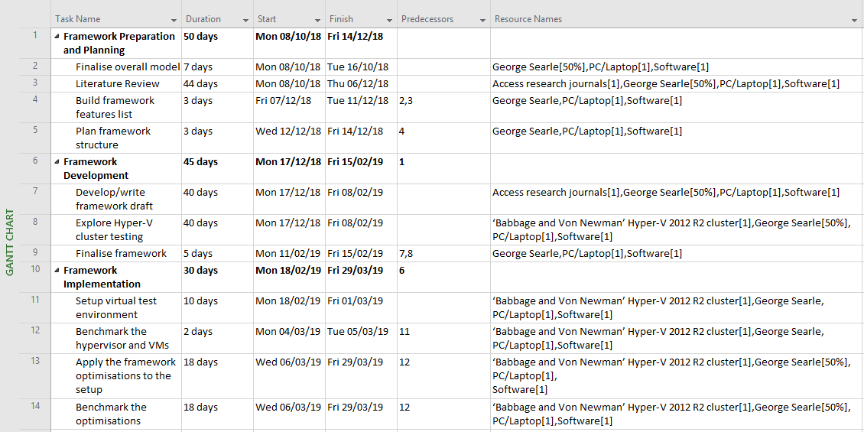
Appendix I
Figure 1. Proposed project Gantt chart
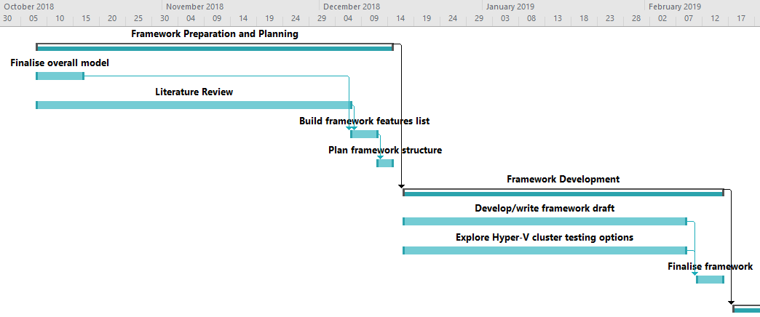
Figure 2. Gantt chart calendar view

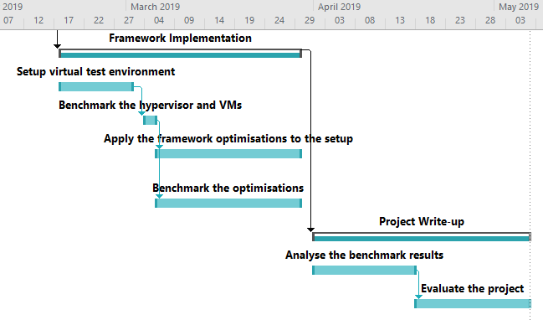
Figure 3. Gantt chart calendar view cont.

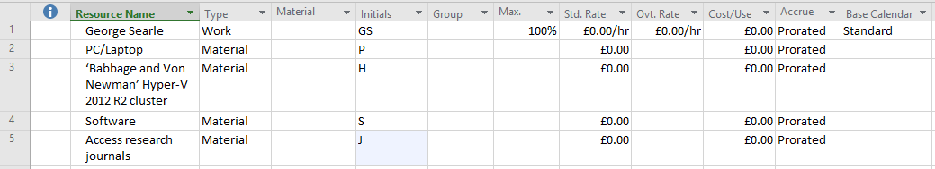
Figure 4. Resources sheet

