Scott Burgess - 1350316
University of Wales Trinity Saint David
Introduction to web and database concepts
Assignment 1: HTML & CSS Web Development

Contents
Introduction 2
1. Requirements 2
2. Implementation 3
2a. HTML Validation 6
2b. CSS Validation 7
3. Evaluation 7
3a. Website Usability, Accessibility and Search Engine Optimisation 7
3b. Website Evaluation 8
3c. Live Websites Comparison 10
References 12
Appendices 13
HTML Source Code 13
CSS Source Code 27

Introduction
This report will discuss and evaluate the design and implementation of a responsive website developed for Tumble United Football Club. The website was coded using HTML and CSS and was designed to provide visitors with information about the club. This includes pages providing information on club information, league fixtures and the league table.
The report will cover topics including the website requirements, such as its purpose and intended audience, and the implementation process and specific design decisions. Validation will be conducted on both HTML and CSS, followed by an evaluation of the website in terms of usability, accessibility and search engine optimisation (SEO).
Finally, a comparison of two existing websites will be conducted, again assessing their usability, accessibility and SEO.

Requirements

The website, which has been coded using HTML and CSS, was developed for Tumble United FC, which is a local football club based in Carmarthenshire.
The aim of the website is to provide an online presence for the club, where visitors can find a variety of information on the club’s activities in an accessible manner. Key information, including the club’s details, fixtures, location and contact information, will be provided, whilst also helping to promote the club within the local community.
The target audience includes current players and committee members of the club, along with supporters, parents, prospective new players and members of the local community who may be interested in learning more about the club. As this is quite a broad target audience, the website needed to be designed to be simple and easy to navigate, allowing specific information to be located quickly.
The website consists of four linked pages, including a homepage introducing the club, dedicated pages for upcoming fixtures and the league table of past and upcoming seasons, and an information page featuring an embedded Google Map to help visitors locate the club. Each page will be accessible via the use of a navigation bar, located at the top, which should improve usability.

Implementation

The Tumble United FC website was created using HTML for structure and CSS for styling. It consists of four pages: Home, Club Information, League Table and Fixtures, all using a consistent layout to make the site easy to navigate.
The header contains the club logo and navigation bar. This is repeated on every page to keep branding consistent and help users recognise the site.
The navigation bar sits at the top of each page and links to all sections of the website. It allows users to move between pages easily, with a hover effect added to show the user which link the mouse is on.
The main content changes depending on the page. The homepage introduces the club, the Club Information page includes contact details, social media links, a kit image and a Google Map, the League Table page uses tables for standings, and the Fixtures page shows upcoming matches and training information.
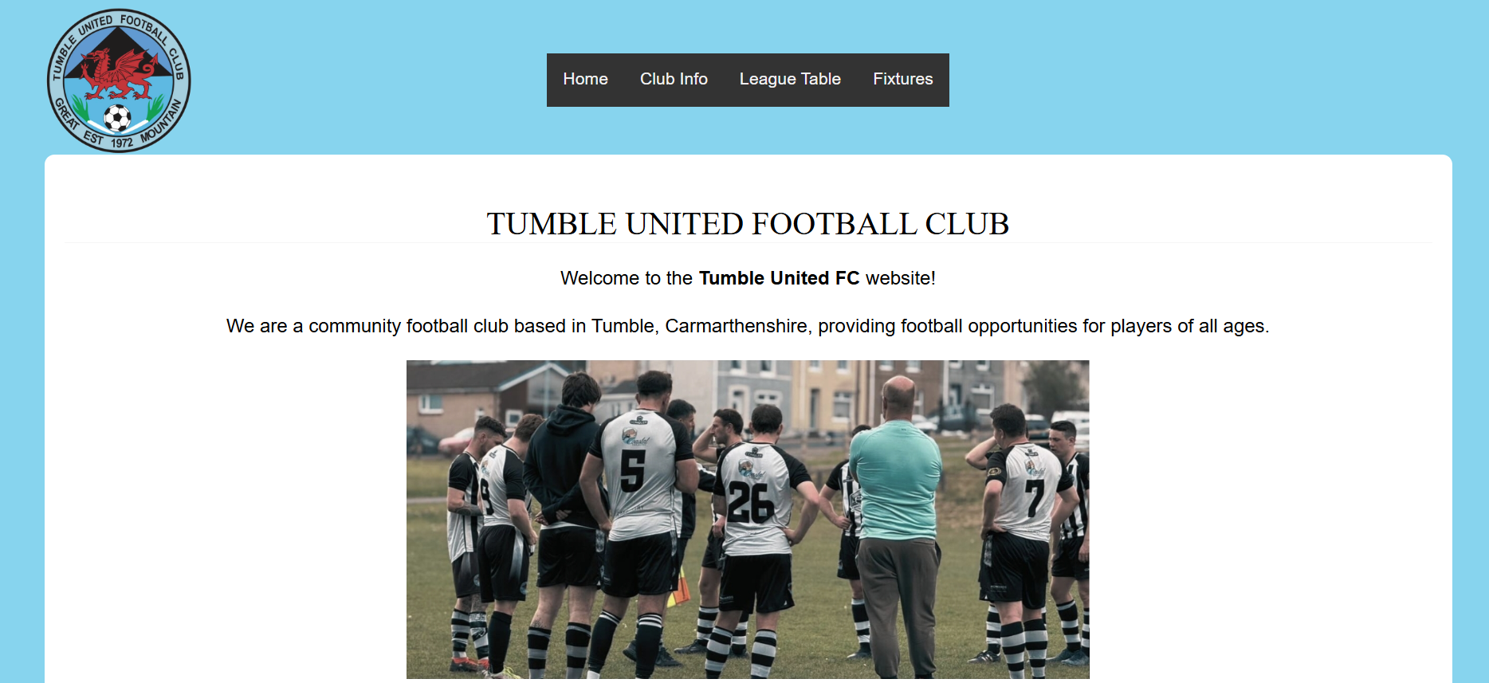
The footer is the same on every page and includes copyright information, contact details, social media links and a “Top of Page” button.
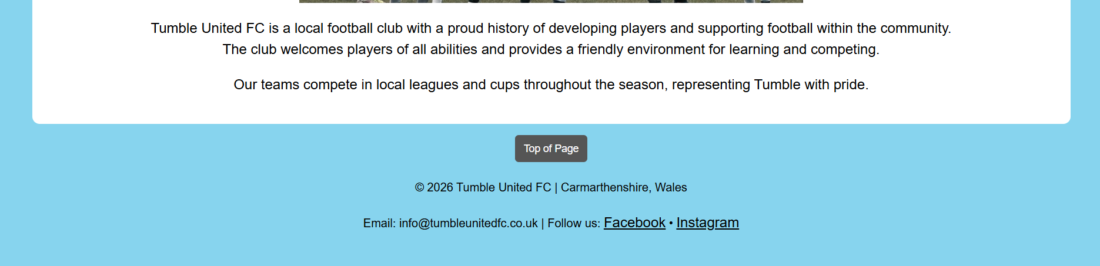
The design choices were made to reflect Tumble United FC’s identity while keeping the site clear and easy to read.
A light blue background was used to match the colour of the club badge. A white content box is placed on top to improve readability, allowing black text to stand out clearly. The black and white also links to the club kit colours, helping keep consistency with the club identity.

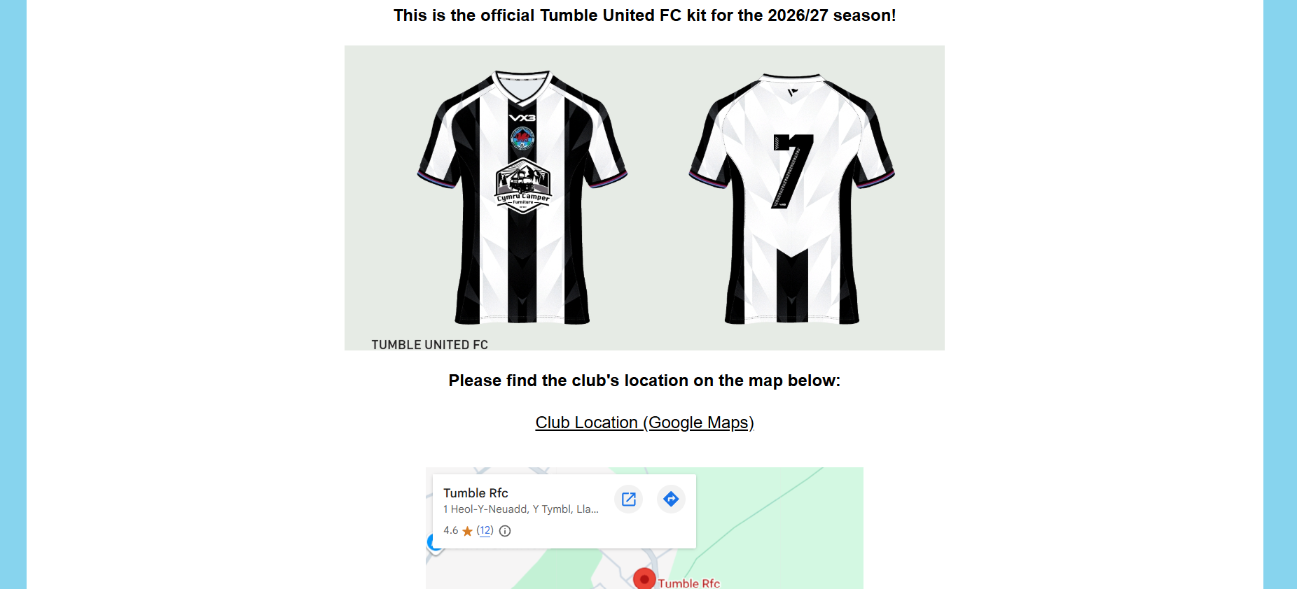
A simple sans-serif font is used for readability, while headings are styled slightly differently to help them stand out.
Relevant images such as the club logo, team photo, kit, and social media icons were included to make the site more engaging. All images include alt text for accessibility.
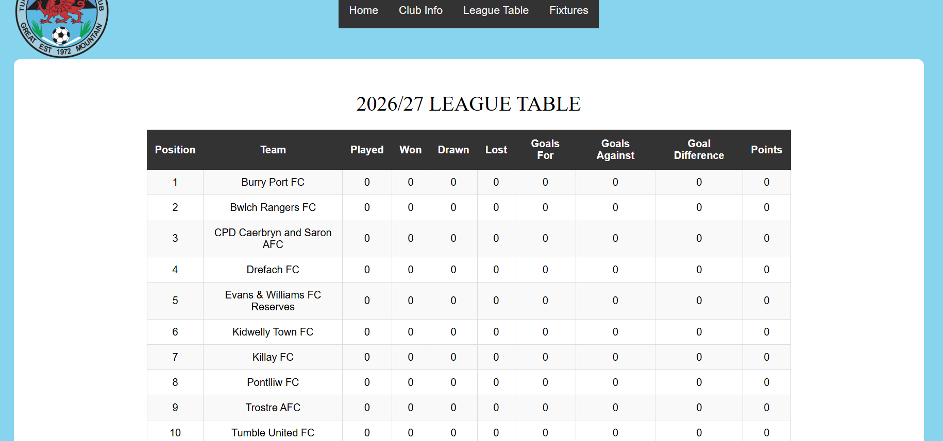
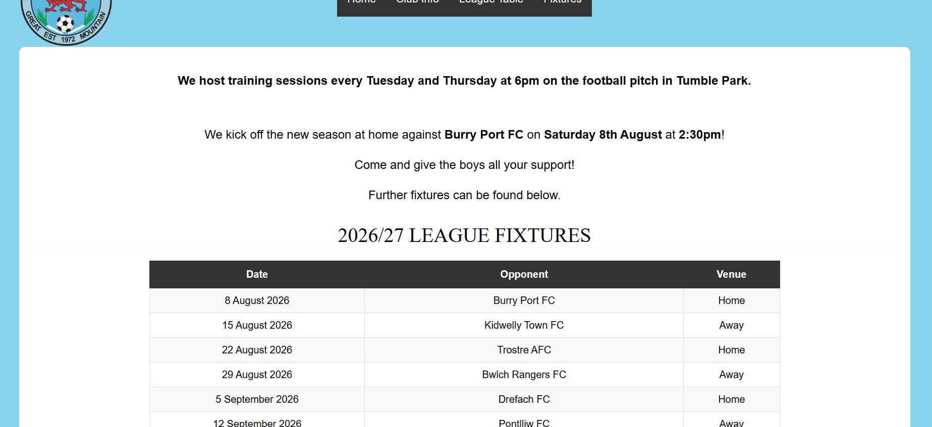
Tables were utilised for the League Table and Fixtures pages, as this was the best way to display the relevant information in a structured format. The table headers have a white font on a black background to make it stand out, and then the table data below is a blank font on slightly alternating lighter backgrounds. This makes the tables more visually appealing and easier to read [1].
Overall, the design is kept simple and consistent while linking closely to the club’s colours and identity.

2a. HTML Validation
HTML Validation was carried out using an online checking tool [2].
The tool came back outlining some errors with the HTML code on the Homepage.
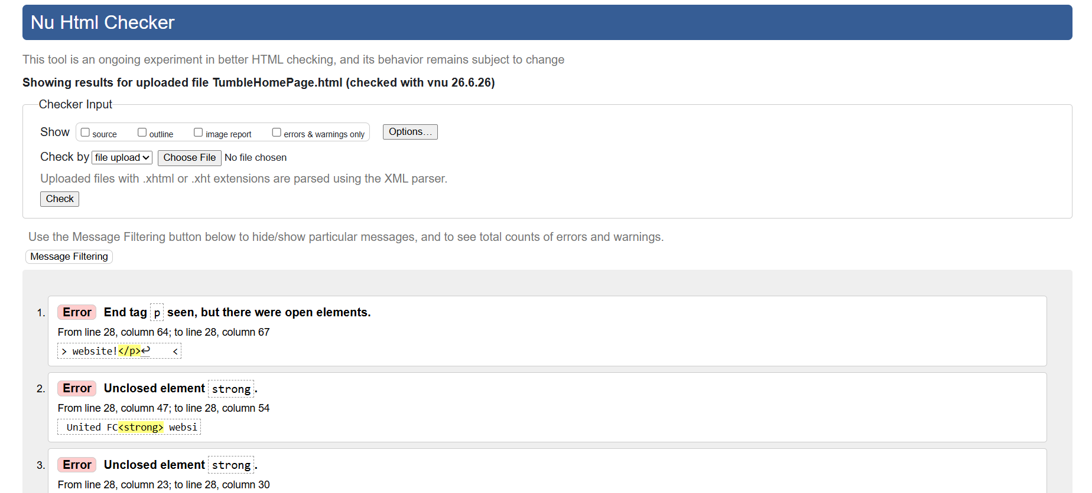
The errors were all relating to elements such as <p> and <strong> not being closed correctly with </p> or </strong>. These were the same across all the pages but were easily identified and correct promptly.
A further check was carried out following these corrections, which came back displaying no further errors.
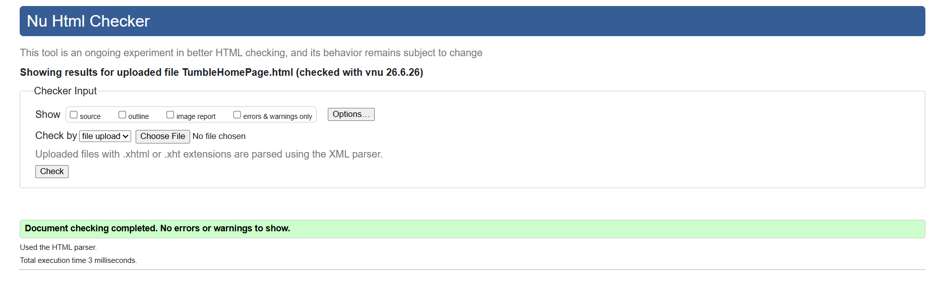

2b. CSS Validation
CSS Validation was carried out using another online tool [3].
There were no errors discovered on the CSS page which was uploaded to the tool.
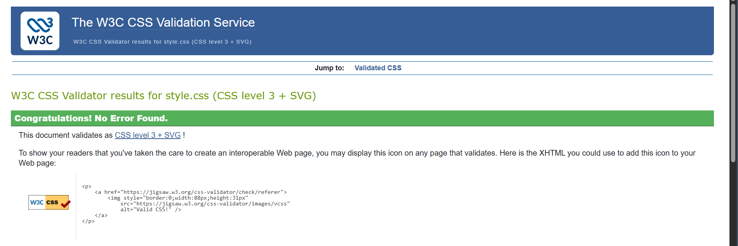

Evaluation

3a. Website Usability, Accessibility and Search Engine Optimisation
Website usability refers to how a user perceives the ease and effectiveness of a website, and how they are able to interact with different pages in order to achieve their goals. Usability focuses on how simple it is for users to navigate a website, locate information, and complete tasks efficiently [4].
Where there is a higher level of usability, there will likely be a corresponding level of user satisfaction, which as a result can influence whether a user revisits the website again.
Web accessibility is about making websites that everyone can use, including people with disabilities such as visual, hearing, cognitive, or physical impairments. It means designing websites so users can still read, navigate, and interact with content regardless of their impairments. The paper “Importance of design in Web Accessibility: a result-based analysis” explains that accessibility is supported by standards like WCAG 2.0 and WCAG 2.1, which give rules and guidance on how to make websites more accessible [5].
The study also highlights that accessibility is not just about following rules and guidance, but also about making sure websites are fair and usable for everyone. This is important because it helps people access information and services online without barriers.
Search Engine Optimisation (SEO) is about making a website easier to find on search engines by improving its ranking in results. The paper explains that SEO is important for building a brand’s online presence, because better visibility usually leads to more visitors and stronger awareness of the website [6].
The study also points out that SEO is not just about adding keywords. It also includes things like improving website content, making the site structure clearer, increasing loading speed, and improving the overall user experience. All of these help search engines understand the website and rank it more effectively.
Overall, usability, accessibility, and SEO are all connected. Good usability helps users have a better experience, accessibility makes sure the website can be used by everyone, and SEO helps people actually find the website in the first place. A good website should incorporate all three to make sure it is easy to use, inclusive, and visible online.

3b. Website Evaluation
This evaluation considers the website's usefulness by examining its utility, usability and content, together with the on-page Search Engine Optimisation (SEO) techniques that have been implemented and its accessibility with reference to the four principles of WCAG 2.1.
The Tumble United FC website has a clear and consistent layout across all four pages. Each page uses the same header, navigation bar, main content area and footer, making it easy for users to move around the website. The navigation menu provides direct links to each page, allowing visitors to find information quickly and easily.
The website is useful because it provides information that is relevant to players, supporters and visitors. The Homepage introduces the football club, while the Club Information page provides contact details, social media links and an embedded Google Map showing the club's location. The League Table page presents league standings in a clear table, and the Fixtures page provides training information and upcoming matches. These features make the website practical and informative.
The content is written in clear language and organised using headings, paragraphs, images and tables, making it easy to read. Images of the club logo, team and kit improve the appearance of the website and help reinforce the club's identity.
Although the website is functional, there are areas that could be improved. The homepage could include more engaging content such as club news, match reports or upcoming events. Replacing manual positioning in the navigation with a more responsive layout would also improve the website on smaller screens.
There is also quite a lot of white space, which can be further refined to ensure that more of the space is utilised whilst keeping the overall design of the webpages.
Search Engine Optimisation (SEO)
Several SEO techniques have been included within the website. Each page has its own unique title, allowing search engines to identify the purpose of each page. However, these titles could be improved by including more descriptive keywords.
The website also uses HTML elements, including the <header>, <main> and <footer> tags which help search engines understand the structure of the content. Each page contains a single <h1> heading, providing a clear topic for both users and search engines.
Images include descriptive alternative text, allowing search engines to understand image content while also supporting users who rely on screen readers. Internal navigation links connect each page of the website, making it easier for search engines to crawl the site, while links to the club's social media pages provide additional online presence.
Some SEO improvements could still be made. The pages do not currently include meta descriptions, which would improve search result listings. Image file names could also be made more descriptive, and additional heading levels such as <h2> could be used to create a clearer content hierarchy.
Accessibility (WCAG 2.1)
The website has been evaluated against the four WCAG 2.1 principles: Perceivable, Operable, Understandable and Robust [7].
The website meets the Perceivable principle by providing alternative text for images, allowing screen readers to describe visual content. Text is presented clearly in a black font against a white background, making it easy to read, while headings and tables organise information logically. The embedded Google Map also provides users with an easy way to locate the club.
An online contract checking tool was used on the Homepage of the website [8], which showed that the selected background and foreground colours passed each of the tests.
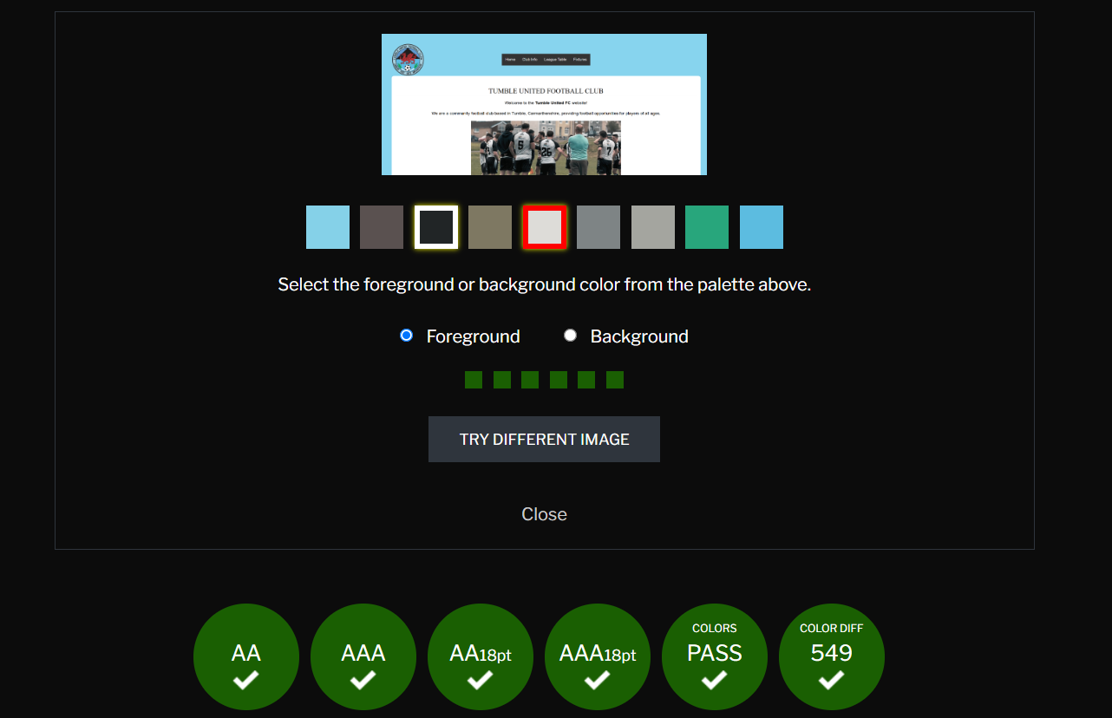
The website is generally Operable because all navigation links can be accessed using a keyboard as standard HTML links. By including a "Top of Page" button on each page helps users move quickly back to the top of longer pages. A useful future improvement would be to include a further links which allow users to skip to specific content on the page, making navigation easier for users.
The website also meets the Understandable principle. The language is identified using lang="en", and the consistent page layout makes navigation easier for the user, as they will know what to expect from each page. The content is written in simple language that is appropriate for the intended audience.
Finally, the website demonstrates the Robust principle by using standard HTML5 elements such as <header>, <main> and <footer>. These elements are widely supported by modern web browsers and assistive technologies, helping to ensure that the website works correctly for a wide range of users. The website also uses a consistent layout and valid HTML, making it easier to maintain and more likely to remain compatible with future browsers and devices. To further improve robustness, the HTML could be validated regularly, and the layout could continue to be refined to ensure the website performs well on different screen sizes.
Overall, the Tumble United FC website provides users with useful information about the football club through a clear and consistent design. Good use of semantic HTML, responsive design, descriptive alternative text and internal navigation contributes to a positive user experience. Basic on-page SEO techniques have also been implemented, helping search engines understand the website's content.
There are still opportunities for improvement, including adding further meta descriptions, improving page titles, expanding homepage content and refining the navigation structure. Implementing these would help further improve the website's usability, accessibility and search engine performance while maintaining its clear design.

3c. Live Websites Comparison

Comparing two live websites, BBC News [9] and WalesOnline [10], shows clear differences in usability, layout, and advertising approach, even though both sites deliver similar types of news content. Overall, BBC News focuses more on simplicity and accessibility, while WalesOnline prioritises a more content-heavy and modern visual style, which can sometimes make usability more difficult for the reader.
BBC News has several strong advantages. The site uses a simple and structured layout that makes it easy for users to find information quickly. Navigation is excellent, with clear menus and consistent organisation across pages. It also contains minimal advertising, which helps reduce distractions while reading. The site loads quickly, supports good colour contrast for readability, and is fully responsive across different devices. In addition, BBC News has strong SEO performance, meaning its content is easy to find through search engines.
WalesOnline also has positives, particularly in terms of content quality and variety. The website is responsive and features a modern design that feels visually engaging. However, heavy advertising is present throughout the site, which can interrupt reading flow. The homepage can feel busy and overwhelming due to the large number of articles and visual elements. This sometimes makes it harder for users to focus on specific stories and can reduce overall usability.
BBC News provides the stronger user experience because its clean interface, accessibility features and minimal visual clutter make information easier to locate. WalesOnline provides similar content, but the large number of advertisements can negatively affect usability.

References
References
[1] "HTML Tables." w3schools. Accessed: Jun 12 2026. [Online]. Available: https://www.w3schools.com/html/html_tables.asp
[2] "Showing results for uploaded file TumbleHomePage.html (checked with vnu 26.6.26) - Nu Html Checker." validator.w3. Accessed: Jun 26 2026. [Online]. Available: https://validator.w3.org/nu/#file
[3] "W3C CSS Validator results for style.css (CSS level 3 + SVG)." w3. Accessed: Jun 26 2026. [Online]. Available: https://jigsaw.w3.org/css-validator/validator
[4] D. Belanche, L. V. Casaló and M. Guinalíu, "Website usability, consumer satisfaction and the intention to use a website: The moderating effect of perceived risk," vol. 19, no. 1, pp.124–132, 2012, doi: 10.1016/j.jretconser.2011.11.001.
[5] A. Sinha, T. Chowdhury and S. Singha, "Importance of Design in Web Accessibility: A Result Based Analysis", inpp. 1–5. doi: 10.1109/IEMENTech65115.2025.10959374.
[6] A. U. Faruq, M. Junainah and Abu Bakar Normazalila, "Search engine optimisation (SEO) strategy as determinants to enhance the online brand positioning - ProQuest," vol. 11, 2024, [Online]. Available: https://www.proquest.com/docview/3062855227?accountid=130472&parentSessionId=RisQcmm%2B2Xq55npt6BlmIU5zJSp0UIybG4M6G3ZcRDc%3D&pq-origsite=primo&sourcetype=Scholarly%20Journals
[7] "Web Content Accessibility Guidelines (WCAG) 2.1," 06 May 2025, [Online]. Available: https://www.w3.org/TR/WCAG21/
[8] P. Hartana. "WCAG." Accessed: Jun 26 2026. [Online]. Available: https://contrastchecker.com/
[9] "BBC News." BBC. Accessed: 25/06 2026. [Online]. Available: https://www.bbc.co.uk/news
[10] "WalesOnline: News, sport, weather and events from across Wales." walesonline. Accessed: Jun 25 2026. [Online]. Available: https://www.walesonline.co.uk

Appendices

HTML Source Code
Homepage:
<!DOCTYPE html>
<html lang="en">
<head>
<meta charset="UTF-8">
<title>Tumble Home Page</title>
<link rel="stylesheet" href="style.css">

</head>
<body id="Top">

<header>
<img src="Images/TumbleLogo.png" alt="Tumble United Logo" class="logo">

<nav>
<a href="TumbleHomePage.html">Home</a>
<a href="TumbleClubInfo.html">Club Info</a>
<a href="TumbleTable.html">League Table </a>
<a href="TumbleFixtures.html">Fixtures</a>
</nav>
</header>

<main>
<h1>Tumble United Football Club</h1>

<p>Welcome to the <strong>Tumble United FC</strong> website!</p>
<p>We are a community football club based in Tumble, Carmarthenshire,
providing football opportunities for players of all ages.</p>

<img src="Images/TeamPhoto.png" alt="Tumble United Team Photo" class="img">

<p>
Tumble United FC is a local football club with a proud history of
developing players and supporting football within the community.<br>
The club welcomes players of all abilities and provides a friendly
environment for learning and competing.
</p>

<p>
Our teams compete in local leagues and cups throughout the season,
representing Tumble with pride.
</p>
</main>

<footer class="footer">
<a href="#top" class="top-button">Top of Page</a>
<p><small>© 2026 Tumble United FC | Carmarthenshire, Wales</small></p>
<p><small>Email: info@tumbleunitedfc.co.uk | Follow us: <a href="https://www.facebook.com/p/Tumble-United-AFC-100064954986275/">Facebook</a> •
<a href="https://www.instagram.com/tumbleunited/">Instagram</a></small></p>
</footer>
</body>
</html>
TumbleClubInfo:
<!DOCTYPE html>
<html lang="en">
<head>
<meta charset="UTF-8">
<title>Tumble Club Info</title>
<link rel="stylesheet" href="style.css">
</head>

<body id="Top">
<header>
<img src="Images/TumbleLogo.png" alt="Tumble United Logo" class="logo">

<nav>
<a href="TumbleHomePage.html">Home</a>
<a href="TumbleClubInfo.html">Club Info</a>
<a href="TumbleTable.html">League Table </a>
<a href="TumbleFixtures.html">Fixtures</a>
</nav>
</header>

<main>
<h1>Club Information</h1>

<p><strong>Contact Information and Social Media</strong></p>
<p>Email: info@tumbleunitedfc.co.uk</p>
<p>Tel. 01267 123456</p>
<p><a href="https://www.facebook.com/p/Tumble-United-AFC-100064954986275/">
<img src="Images/FacebookLogo.png" alt="Facebook Logo" class="sociallogo">Follow us on Facebook</a></p>
<p><a href="https://www.instagram.com/tumbleunited/"><img src="Images/InstagramLogo.png"
alt="Instagram" class="sociallogo">Follow us on Instagram</a></p>

<p><Strong>This is the official Tumble United FC kit for the 2026/27 season!</Strong></p>

<img src="Images/kit.png" alt="Tumble Kit" class="img">
<p><strong>Please find the club's location on the map below:</strong></p>

<a class="maplink"
href="https://www.google.com/maps/place/Tumble+Rfc/@51.7870433,-4.1202863,17z/data=!3m1!4b1!4m6!3m5!1s0x486efa991f89ee49:0x6b783a1aa90906d2!8m2!3d51.7870433!4d-4.1177114!16s%2Fg%2F11j2ypcj8h?entry=ttu&g_ep=EgoyMDI2MDYwMy4xIKXMDSoASAFQAw%3D%3D" target="_blank"> Club Location (Google Maps) </a><br><br>
<iframe src="https://www.google.com/maps/embed?pb=!1m18!1m12!1m3!1d2468.046119813899!2d-4.12028632336314!3d51.78704327187835!2m3!1f0!2f0!3f0!3m2!1i1024!2i768!4f13.1!3m3!1m2!1s0x486efa991f89ee49%3A0x6b783a1aa90906d2!2sTumble%20Rfc!5e0!3m2!1sen!2suk!4v1781015380048!5m2!1sen!2suk" width="500" height="300" style="border:0;" allowfullscreen="" loading="lazy" referrerpolicy="no-referrer-when-downgrade"></iframe>

</main>

<footer class="footer">
<a href="#top" class="top-button">Top of Page</a>
<p><small>© 2026 Tumble United FC | Carmarthenshire, Wales</small></p>
<p><small>Email: info@tumbleunitedfc.co.uk | Follow us: <a href="https://www.facebook.com/p/Tumble-United-AFC-100064954986275/">Facebook</a> •
<a href="https://www.instagram.com/tumbleunited/">Instagram</a></small></p>
</footer>
</body>
</html>

TumbleFixtures:
<!DOCTYPE html>
<html lang="en">
<head>
<meta charset="UTF-8">
<title>Tumble Fixtures</title>
<link rel="stylesheet" href="style.css">
</head>

<body id="Top">

<header>
<img src="Images/TumbleLogo.png" alt="Tumble United Logo" class="logo">

<nav>
<a href="TumbleHomePage.html">Home</a>
<a href="TumbleClubInfo.html">Club Info</a>
<a href="TumbleTable.html">League Table </a>
<a href="TumbleFixtures.html">Fixtures</a>
</nav>
</header>

<main>
<p><strong>We host training sessions every Tuesday and Thursday at 6pm on the football pitch in Tumble Park.</strong></p>
<br>
<p>We kick off the new season at home against <strong>Burry Port FC</strong>
on <strong>Saturday 8th August</strong> at <strong>2:30pm</strong>!</p>
<p>Come and give the boys all your support!</p>
<p>Further fixtures can be found below.</p>

<h1> 2026/27 League Fixtures</h1>
<table class="table">
<thead>
<tr>
<th>Date</th>
<th>Opponent</th>
<th>Venue</th>
</tr>
</thead>
<tbody>
<tr>
<td>8 August 2026</td>
<td>Burry Port FC</td>
<td>Home</td>
</tr>
<tr>
<td>15 August 2026</td>
<td>Kidwelly Town FC</td>
<td>Away</td>
</tr>
<tr>
<td>22 August 2026</td>
<td>Trostre AFC</td>
<td>Home</td>
</tr>
<tr>
<td>29 August 2026</td>
<td>Bwlch Rangers FC</td>
<td>Away</td>
</tr>
<tr>
<td>5 September 2026</td>
<td>Drefach FC</td>
<td>Home</td>
</tr>
<tr>
<td>12 September 2026</td>
<td>Pontlliw FC</td>
<td>Away</td>
</tr>
<tr>
<td>19 September 2026</td>
<td>Killay FC</td>
<td>Home</td>
</tr>
<tr>
<td>26 September 2026</td>
<td>CPD Caerbryn and Saron AFC</td>
<td>Away</td>
</tr>
</tbody>
</table>
</main>

<footer class="footer">
<a href="#top" class="top-button">Top of Page</a>
<p><small>© 2026 Tumble United FC | Carmarthenshire, Wales</small></p>
<p><small>Email: info@tumbleunitedfc.co.uk | Follow us: <a href="https://www.facebook.com/p/Tumble-United-AFC-100064954986275/">Facebook</a> •
<a href="https://www.instagram.com/tumbleunited/">Instagram</a></small></p>
</footer>
</body>
</html>

TumbleTable:
<!DOCTYPE html>
<html lang="en">
<head>
<meta charset="UTF-8">
<title>Tumble League Table</title>
<link rel="stylesheet" href="style.css">
</head>

<body id="Top">

<header>
<img src="Images/TumbleLogo.png" alt="Tumble United Logo" class="logo">
<nav>
<a href="TumbleHomePage.html">Home</a>
<a href="TumbleClubInfo.html">Club Info</a>
<a href="TumbleTable.html">League Table </a>
<a href="TumbleFixtures.html">Fixtures</a>
</nav>
</header>

<main>
<h1>2026/27 League Table</h1>
<table class="table">
<thead>
<tr>
<th>Position</th>
<th>Team</th>
<th>Played</th>
<th>Won</th>
<th>Drawn</th>
<th>Lost</th>
<th>Goals For</th>
<th>Goals Against</th>
<th>Goal Difference</th>
<th>Points</th>
</tr>
</thead>
<tbody>
<tr>
<td>1</td>
<td>Burry Port FC</td>
<td>0</td><td>0</td>
<td>0</td><td>0</td>
<td>0</td><td>0</td>
<td>0</td><td>0</td>
</tr>
<tr>
<td>2</td>
<td>Bwlch Rangers FC</td>
<td>0</td><td>0</td>
<td>0</td><td>0</td>
<td>0</td><td>0</td>
<td>0</td><td>0</td>
</tr>
<tr>
<td>3</td>
<td>CPD Caerbryn and Saron AFC</td>
<td>0</td><td>0</td><td>0</td><td>0</td>
<td>0</td><td>0</td><td>0</td><td>0</td>
</tr>
<tr>
<td>4</td>
<td>Drefach FC</td>
<td>0</td><td>0</td><td>0</td><td>0</td>
<td>0</td><td>0</td><td>0</td><td>0</td>
</tr>
<tr>
<td>5</td>
<td>Evans & Williams FC Reserves</td>
<td>0</td><td>0</td><td>0</td><td>0</td>
<td>0</td><td>0</td><td>0</td><td>0</td>
</tr>
<tr>
<td>6</td>
<td>Kidwelly Town FC</td>
<td>0</td><td>0</td><td>0</td><td>0</td>
<td>0</td><td>0</td><td>0</td><td>0</td>
</tr>
<tr>
<td>7</td>
<td>Killay FC</td>
<td>0</td><td>0</td><td>0</td><td>0</td>
<td>0</td><td>0</td><td>0</td><td>0</td>
</tr>
<tr>
<td>8</td>
<td>Pontlliw FC</td>
<td>0</td><td>0</td><td>0</td><td>0</td>
<td>0</td><td>0</td><td>0</td><td>0</td>
</tr>
<tr>
<td>9</td>
<td>Trostre AFC</td>
<td>0</td><td>0</td><td>0</td><td>0</td>
<td>0</td><td>0</td><td>0</td><td>0</td>
</tr>
<tr>
<td>10</td>
<td>Tumble United FC</td>
<td>0</td><td>0</td><td>0</td><td>0</td>
<td>0</td><td>0</td><td>0</td><td>0</td>
</tr>
</tbody>
</table>
<br>
<h1>2025/26 League Table</h1>

<table class="table">
<thead>
<tr>
<th>Position</th>
<th>Team</th>
<th>Played</th>
<th>Won</th>
<th>Drawn</th>
<th>Lost</th>
<th>Goals For</th>
<th>Goals Against</th>
<th>Goal Difference</th>
<th>Points</th>
</tr>
</thead>

<tbody>
<tr>
<td>1</td>
<td>Killay FC</td>
<td>18</td><td>14</td><td>3</td><td>1</td>
<td>55</td><td>18</td><td>+37</td><td>45</td>
</tr>
<tr>
<td>2</td>
<td>Pontlliw FC</td>
<td>18</td><td>13</td><td>3</td><td>2</td>
<td>50</td><td>22</td><td>+28</td><td>42</td>
</tr>
<tr>
<td>3</td>
<td>Tumble United FC</td>
<td>18</td><td>12</td><td>2</td><td>4</td>
<td>48</td><td>26</td><td>+22</td><td>38</td>
</tr>
<tr>
<td>4</td>
<td>Trostre AFC</td>
<td>18</td><td>11</td><td>2</td><td>5</td>
<td>44</td><td>30</td><td>+14</td><td>35</td>
</tr>
<tr>
<td>5</td>
<td>Burry Port FC</td>
<td>18</td><td>9</td><td>3</td><td>6</td>
<td>40</td><td>35</td><td>+5</td><td>30</td>
</tr>
<tr>
<td>6</td>
<td>Kidwelly Town FC</td>
<td>18</td><td>8</td><td>4</td><td>6</td>
<td>38</td><td>36</td><td>+2</td><td>28</td>
</tr>
<tr>
<td>7</td>
<td>Drefach FC</td>
<td>18</td><td>7</td><td>3</td><td>8</td>
<td>34</td><td>40</td><td>-6</td><td>24</td>
</tr>
<tr>
<td>8</td>
<td>Bwlch Rangers FC</td>
<td>18</td><td>6</td><td>2</td><td>10</td>
<td>30</td><td>45</td><td>-15</td><td>20</td>
</tr>
<tr>
<td>9</td>
<td>CPD Caerbryn and Saron AFC</td>
<td>18</td><td>4</td><td>3</td><td>11</td>
<td>25</td><td>50</td><td>-25</td><td>15</td>
</tr>
<tr>
<td>10</td>
<td>Evans & Williams FC Reserves</td>
<td>18</td><td>3</td><td>1</td><td>14</td>
<td>20</td><td>60</td><td>-40</td><td>10</td>
</tr>
</tbody>
</table>
</main>

<footer class="footer">
<a href="#top" class="top-button">Top of Page</a>
<p><small>© 2026 Tumble United FC | Carmarthenshire, Wales</small></p>
<p><small>Email: info@tumbleunitedfc.co.uk | Follow us: <a href="https://www.facebook.com/p/Tumble-United-AFC-100064954986275/">Facebook</a> •
<a href="https://www.instagram.com/tumbleunited/">Instagram</a></small></p>
</footer>
</body>
</html>

CSS Source Code
CSS:
body {
background-color: #45bde5a5;
margin: 50px;
font-family: sans-serif;
}

header {
display: flex;
align-items: center;
justify-content: flex-start;
gap: 0;
}

.logo {
height: 150px;
margin-right: 0;
}

nav {
background-color: #333;

width: fit-content;
overflow: hidden;
margin: 0 auto;
position: relative;
left: -75px;
text-align: center;
}

nav a {
float: left;
color: #f2f2f2;
text-align: center;
padding: 14px 16px;
text-decoration: none;
font-size: 17px;
}

nav a:hover {
background-color: #ddd;
color: black;
}

h1 {
text-align: center;
font-family: serif;
font-weight: normal;
text-transform: uppercase;
border-bottom: 1px solid whitesmoke;
margin-top: 30px;
}

p {
color: black;
font-size: 1.2em;
line-height: 1.5em;
text-align: center;
}

h2 {
color: #807d7c;
font-size: 1em;
}

a {
color: black;
font-size: 1.2em;
line-height: 1.5em;
text-align: center;
}

iframe {
display: block;
margin: 0 auto;
}

main {
background-color: white;
padding: 20px;
border-radius: 10px;
}

/* Table on fixtures page */
table {
margin: auto;
border-collapse: collapse;
}

th, td {
border: 1px solid black;
padding: 10px;
}

.table {
width: 100%;
max-width: 1000px;
}

.table thead {
background-color: #333;
color: white;
}

.table thead th {
padding: 12px;
text-align: center;
border: 1px solid #333;
}

.table tbody tr:nth-child(odd) {
background-color: #f9f9f9;
}

.table tbody tr:nth-child(even) {
background-color: #ffffff;
}

.table tbody td {
text-align: center;
border: 1px solid #ddd;
}

.img {
display: block;
margin: 20px auto;
max-width: 50%;
height: auto;
}

.sociallogo {
width: 20px;
height: 20px;
vertical-align: middle;
margin-right: 6px;
}

.maplink {
display: block;
text-align: center;
}

.top-button {
display: inline-block;
margin-top: 15px;
padding: 8px 12px;
background-color: #555;
color: white;
text-decoration: none;
border-radius: 5px;
font-size: 14px;
}

.footer {
text-align: center;
}

