Work Based Project
Prefabricated Construction Methods
Brandon Jacob Davison

Table of Contents
Project title 2
Project overview 2
Introduction to Prefabricated construction 2
Aims and objectives 3
Research Methodology 3
Bibliography 3
Work Based Project – Part 2 – Interim Submission – Methodology and Literature Review 5
Questionnaire methodology 5
Literature review 6
Introduction 6
Prefabricated Construction Literature 6
Prefab housing and the future of building : Product to process | Mathew Aitchison 6
Prefab Architecture : A Guide to Modular Design and Construction | Ryan E. Smith 7
Prefabricated Housing : Construction and Design Manual | Jutta Albus Philipp Meuser 7
Traditional Construction Literature 8
Chudley and Greenos Building Construction Handbook | Roy Chudley, Roger Greeno and Karl Kovac 8
The Construction of Houses | Duncan Marshall 9
Conclusion 9
References 9
Bibliography 9
Research Methodology – Questionnaire 10
Self Evaluation 17
Given what I know now would I do anything different? 17
Conclusion 17

Student Name: Brandon Jacob Davison
Student ID: 2110521
Contents:
- Project title
- Project overview
- Introduction to Prefabricated construction
- Aims and Objectives
- Research Methodology
- Bibliography

Project title
The different types of prefabricated construction and their advantages and disadvantages.

Project overview
I am currently an apprentice site manager who endeavours to further my knowledge in the ever-changing field of construction. This research will be very valuable to not just me but also other construction professionals. As although prefabricated construction techniques have been used globally for decades, I believe prefabricated construction is the future of construction.
Within this project I aim to determine the advantages and disadvantages of the different types of prefabricated construction. There are many types of prefabricated construction, some common examples are panellised, modular and steel frame. All have their respective advantages within the construction industry for their many useful attributes. Especially when compared with some of the traditional construction methods used. This project will analyse and evaluate which method of prefabricated construction has more promise and merit in the construction industry.
I believe that this research project will be highly beneficial to my career as it will give me a bigger insight into a growing field in the construction industry. As previously stated I am a apprentice site manager and will most likely deal with many different types of prefabricated construction methods which is another reason why

Introduction to Prefabricated construction
Prefabricated construction techniques have believed to be around for centuries even dating back to 2090BC. However, the first advertised modular example was built by Henry John Manning who was a carpenter from London. His son was immigrating to Australia, and it was Henry’s idea to build a home in different sub constructions and have them shipped across the world to be built. It was deemed the “Manning Cottage” and sent all the way around the world to Australia.
Since the Manning Cottage it sparked a revolution in modular buildings, 100s of modular buildings arrived in Australia. Also, it was documented by Florence Nightingale that there was a modular built hospital constructed during the Crimean war in 1855. This hospital was capable of holding a 1000 patients. This hospital even featured ventilation and flushing toilets. This was the first modular built hospital in history, and it was designed by Isombard Kingdom Brunel.
Since the 1800s many more impressive modular buildings have been constructed and this has led to the proficiently and cost effective buildings we see today.
In South West Wales itself there are a number of companies offering different types of prefabricated constructions, ranging from timber frame panellised homes (Fforest Timber Engineering and Freds timber frame for example) to fully volumetric modular building solutions for education and healthcare etc. (Wernick Buildings).

Aims and objectives
During my project I have different aims which will help structure my research. The main goal is to try to determine which method of prefabricated construction is all around the most proficient, cost effective and preferred by construction professionals. There are many factors that affect proficiency and the price, all of which will be covered within my research. These are my main objectives:
- To determine which type of prefabricated construction is the most time efficient.
- To analyse which of the different prefabricated is preferred amongst construction professionals.
- To find the advantages and disadvantages of both types of prefabricated construction and draw a conclusion on which could be considered as more efficient overall.
- To gain a better understanding and insight into the prefabricated construction industry.
These aims and objectives will enable me to cover a broad range of information within this project.

Research Methodology
There are numerous ways to obtain information in and around this subject. There are various literatures and online documents that have a wealth of information to absorb. For this project I will also need the opinion of many construction professionals. To draw this conclusion, I will create a questionnaire and send it to a selective set of my colleagues and in the previously mentioned companies in South West Wales who provide such construction methods. This will allow the gathered information to be accurate and easily accessed to be analysed.

Bibliography
Quickway-wingham.co.uk. (2019). The History of Prefabricated Buildings | Quickway | Blog. [online] Available at: https://quickway-wingham.co.uk/about-us/latest-news/history-prefabricated-buildings/#:~:text=The%20earliest%20known%20prefabricated%20methods,long%20ago%20as%202090%20BC. [Accessed 22 Nov. 2022].
Prefab Museum. (2018). A short history of prefabrication. [online] Available at: https://www.prefabmuseum.uk/content/history/short-history-prefabrication#:~:text=The%20Crystal%20Palace%2C%20erected%20for,to%20Sydenham%20so%20truly%20demountable! [Accessed 22 Nov. 2022].
Nps.gov. (2018). Prefabricated Homes (U.S. National Park Service). [online] Available at: https://www.nps.gov/articles/prefabricated-homes.htm [Accessed 22 Nov. 2022].
Excelmodular.co.uk. (2022). Did You Know…? The History of the Modular Building. [online] Available at: https://www.excelmodular.co.uk/the-history-of-modular-buildings/ [Accessed 4 Dec. 2022].
Byrne, E. (2020). The story of Brunel’s ‘flatpack’ hospital - praised by Florence Nightingale. [online] BristolLive. Available at: https://www.bristolpost.co.uk/news/bristol-news/story-brunels-flatpack-hospital-florence-4022174 [Accessed 4 Dec. 2022].

Work Based Project – Part 2 – Interim Submission – Methodology and Literature Review

Student Name: Brandon Jacob Davison
Student ID No: 2110521

Questionnaire methodology
Because they provide a quick, effective, and affordable way to acquire a lot of data from huge sample sizes, questionnaires are a common research approach. These instruments are very useful for assessing the choices, views and questionees attitude on the subject. Using an online website such as survey monkey (Linked in references). It allows me to easily create a questionnaire which link can be sent out to many people at once for ease of access. Then these websites will compile all data received for my viewing. Although all submissions will be anonymous, one question in the questionnaire will ask for job title. This is optional and only for me to group data once the questionnaire has been completed.
The questionnaire will allow me to gather the opinions of many different construction professionals. This wide array will include Construction Managers, Contracts Managers, Quantity Surveyors, Directors, Architects, Engineers and a few more. This multitude of different construction professionals will allow me to draw information and opinions from a wide variety of views.
To carry out the questionnaire I will do the following:
- First I will create a questionnaire using a website online which will include valid and sensible questions surrounding the topic area.
- Secondly the questionnaire will be sent out to roughly 20-30 members of the construction industry.
- Next once the questionnaires have been filled out and returned I will collect all the data received and quantify it and create graphs to display the information easier.
- Lastly I will review the data and create a conclusion on preferred methods of prefab, opinions and overall preference on construction methods.
The Questionnaire will include 10-15 questions and will cover the brief basis of different methods of prefab and preferences between the traditional methods and prefabricated construction methods.

Literature review

Introduction
The following literatures listed below are the main books I’ve used as research materials surrounding the field of prefabricated construction for this essay.
- Prefab housing and the future of building : Product to process | Mathew Aitchison
- Prefab Architecture : A Guide to Modular Design and Construction | Ryan E. Smith
- Prefabricated Housing : Construction and Design Manual | Jutta Albus
- Chudley and Greenos Building Construction Handbook | Roy Chudley, Roger Greeno and Karl Kovac
- The Construction of Houses | Duncan Marshall

Prefabricated Construction Literature
The following literatures are books with the topic subject of prefabricated construction. These literatures enable me to gain a wealth of knowledge surrounding the topic of Prefab construction which will help me to gain a firm conclusion in the later stages of this project.

Prefab housing and the future of building : Product to process | Mathew Aitchison
Mathew Aitchison was a designer in the construction industry working as an architect all over the world. Now Mathew is a University Professor teaching a new Future Building Initiative. Alongside this Mathew is also the CEO of Building 4.0 CRC. Where he continues in developing various projects and also new design and research collaborations which are international.
Although Mathew has other books surrounding the topic of prefabrication in the construction industry. This is the first he has taken the position of lead author on the topic of Prefabrication and modular homes.
The book Prefab housing and the future of building : Product to process is one of the first books that delves into the international history of modular homes and prefabrication within the construction industry. The author also reviews current innovations in detail and even goes on to describe what the future of prefabrication could look like.
There are case studies included within the book that come from a wide variety of countries such as the UK, Sweden, Austria and a few others. These case studies cover specific buildings within those countries and provide a great insight into what prefabrication and modular construction looks like globally.

Prefab Architecture : A Guide to Modular Design and Construction | Ryan E. Smith
The author Ryan E .Smith currently is an Architecture professor an also is the director of a School of Architecture in Arizona. Ryan E. Smith is also a member of many different boards within the construction industry. Some of these include the National Institute of Building Sciences, Ivory Innovations for Housing Affordability, Offsite construction Council and many more. Lastly the author is also a founding member of a company MOD X. MOD X is an offsite construction knowledge, management and advisory group.
One of the books he has written titled Prefab Architecture : A Guide to Modular Design and Construction (Ryan E. Smith) gives us a broader overview into the world of the design and construction of modular buildings. The author starts by giving the history of industrialised buildings and the architecture surrounding the field of prefab. The author then goes on to detail the fundamentals and principles of modular construction and design. The book also describes the elements, assembly and sustainability. “It is the fast appropriation of technologies to industries in which they were not originally intended that often is more applicable or better suited to have a sustainable future.” (Page 335, Timberlake, J. and Smith, R.E. (2013). Prefab architecture : a guide to modular design and construction. Hoboken, N.J.: Wiley.)

Ryan E. Smith goes on to cover case studies within the modular design and construction world. These case studies include both domestic and commercial builds. Such as Bensonwood and Project Frog. Throughout the chapter of case studies included within are many different statistics which apply to not just modular but all aspects of prefabrication. Ryan
Overall the book Prefab Architecture : A Guide to Modular Design and Construction (Ryan E. Smith) provides a brilliant insight into the world of modular construction for new construction to experienced professionals.

Prefabricated Housing : Construction and Design Manual | Jutta Albus Philipp Meuser
Jutta Albus is a junior professor and architect who focuses on resource-efficient building techniques, automated construction and prefabrication technologies. She conducts research and gives lectures on resource efficiency in building technologies as junior professor at Dortmund University's department for civil engineering and architecture. Jutta Albus places a lot of emphasis on putting strategies into practice that will boost sustainable features of our built environment while also delivering high-quality architectural design.
Philipp Meuser is an architect and author. His research in prefabrication have taken him from Berlin to Russia. Where he has focused on researching the mass housing across the Soviet Union.
This building and design manual by Jutta Albus co-authored by Philipp Meuser offers a variety of the production and assembly techniques now employed in the prefabricated home industry. It provides 15 different examples and ten design guidelines for prefabricated homes, adding something new to the current conversation on inexpensive housing. It includes process organisation ideas and prime examples that reflect current trends with a primary focus on sustainability, efficiency, and market appliance. The book also delves in to the history of prefabricated home construction.
This construction and design manual looks to show how prefab homes have changed throughout the years going from drab buildings to aesthetically pleasing homes with endless possibilities of structure and as previously mentioned aesthetics.

Traditional Construction Literature
The following books are literatures which cover aspects of traditional construction. The knowledge gained from these literatures not only future my career but also allow me to compare the different attributes of traditional and prefabricated construction.

Chudley and Greenos Building Construction Handbook | Roy Chudley, Roger Greeno and Karl Kovac
Karl Kovac is now a senior lecturer at Sheffield University. He gives lectures on construction and the built environment. Karl has masses of experience starting out on the ground as a builder then surveyor and finally project manager.
Roy Chudley was a senior lecturer at the Guildford College of Technology. He gave lectures on Building Technology.
Roger Greeno was a former lecturer at the University of Portsmouth. He had experience in both practical and consultant roles within the construction industry.
In this 12th Edition of the Building Construction Handbook Karl Kovac updates the Handbook written by Roy Chudley, Roger Greeno and Karl Kovac. This reinstallation of the handbook covers all aspects of the traditional set construction techniques and methods. Covering some of the more recent updates in building regulations the book truly does cover many aspects of construction. Although heavy set in the more traditional methods the handbook does go on to pick up new advances in the construction industry.
Chudley and Greenos Building Construction Handbook (Roy Chudley, Roger Greeno and Karl Kovac) mainly embodies very little in terms of text but makes up for it through the likes of visuals such as diagrams, sketches and etc. The Handbook describes the built environment as “created by man with or without the aid of the natural environment.” (R Chudley and Greeno, R. (2020). Building Construction Handbook. 11th ed. London: Routledge.)

The Construction of Houses | Duncan Marshall
Duncan Marshall was a chartered builder with a wealth of experience in the construction industry. But more specifically house construction. He wrote many books on the topic of house construction. Ending his career he became a senior lecturer within the University of West England.
The book mainly concentrates on the principles and construction practice. However it doesn’t go into any depth surrounding building regulations and doesn’t touch on construction details. It mainly includes graphics and annotated photographs which makes it easy to understand the information the author is presenting. The Construction of Houses (Duncan Marshall) gives an in depth view and further understanding of how modern house construction has evolved.

Conclusion
The above literatures are a key part in terms of knowledge to allow me to complete the last section of this project. They all give insight into different parts of the construction world which insights come from all perspectives of the construction industry. These books were all written by respected members of the construction industry which makes the knowledge and information used within the essay and gained more credible.

References
SurveyMonkey. (2023). SurveyMonkey: The World’s Most Popular Free Online Survey Tool. [online] Available at: https://www.surveymonkey.co.uk/ [Accessed 3 Mar. 2023].
Chudley, R., Greeno, R. and Kovac, K. (2020). Chudley and Greeno’s Building Construction Handbook. Milton: Routledge.
Timberlake, J. and Smith, R.E. (2013). Prefab architecture : a guide to modular design and construction. Hoboken, N.J.: Wiley.

Bibliography
Aitchison, M. and Al, E. (2018). Prefab housing and the future of building : product to process. London: Lund Humphries, Cop.
Chudley, R., Greeno, R. and Kovac, K. (2020). Chudley and Greeno’s Building Construction Handbook. Milton: Routledge.
Marshall, D., Worthing, D., Dann, N. and Heath, R. (2013). The Construction of Houses. Taylor & Francis.
Philipp Meuser, Albus, J., Anatoly Belov and Sergej Kuznecov (2020). Prefabricated Housing Construction and Design Manual. Berlin Dom Publishers.
Timberlake, J. and Smith, R.E. (2013). Prefab architecture : a guide to modular design and construction. Hoboken, N.J.: Wiley.

Research Methodology – Questionnaire
Below is the questionnaire described in the previous research methodology. It is comprised of 10 questions and was sent to 25 different people in the construction industry. All ranging in experience and job role to ensure an unbiased and wide range of responses to ensure the questionnaires credibility. The questionnaire is made up of questions only relevant to the topic of prefabrication and construction.
My hypothesis the with questions posed is that most responses will be in favour of prefabricated construction. And that prefabricated construction is more efficient, economical and preferred amongst construction professionals.
Out of the 25 people I sent it to, 22 of those people responded and filled out the questionnaire. Although the questionnaire is anonymous I personally know the people it was sent too and can ensure their credibility within the construction industry.
Question 1 – What is your profession?
Below is a chart which shows the results of the question in a simple and easy to understand format.
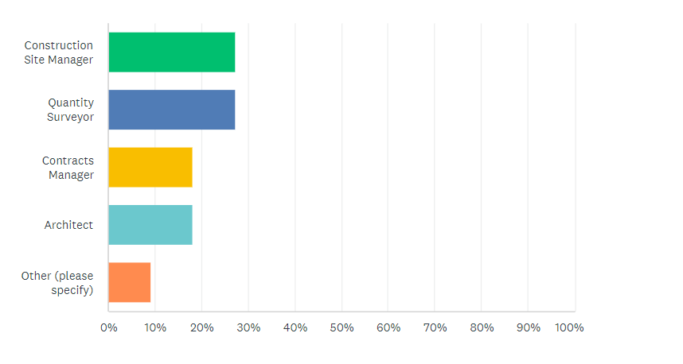
As determined by the chart there is a wide range of different jobs spread amongst the people who completed the questionnaire. This ensures that there is a wide range of opinion throughout the questionnaire. It is mostly comprised of site managers and quantity surveyors. The other section of the chart is made up of only one other job title and that was site engineers.
Question 2 – How long have you worked in the construction industry?
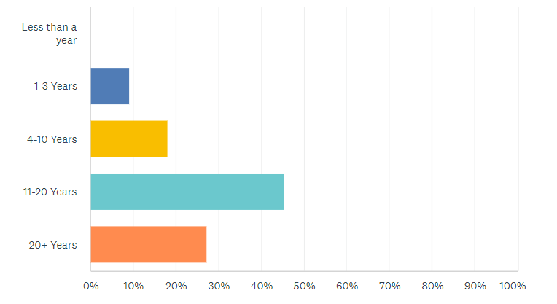
Besides this text is the graph that coincides with question 2. It details how long people have worked in the construction industry and lays it out in a simple format.
As seen in the graph there is a wide spread of responses to the question. This is a good result as we can collect the opinion of the newly experienced to the highly experienced. Which gives the questionnaire a wider range of outlook. As detailed above the questionnaire was filled out mostly by professionals who have been in the construction industry for 11-20 years following that is 20+ years.

Question 3 – What types of Prefabricated Construction are you aware of?
I wanted to find out how much awareness there are for the different methods of prefabricated construction. Although I believed there to be a lot of awareness the results varied with my predictions. Below is the graph detailing the answers.
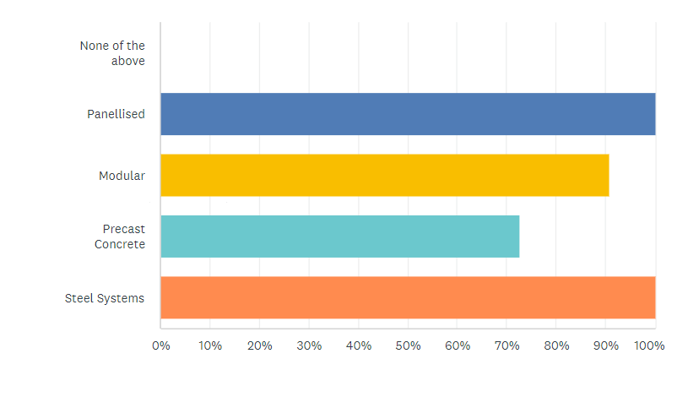
As seen above there is full awareness of panellised and steel systems which I expected. Although I predicted that modular systems would be the least heard of due to the nature of the area we reside in. With systems like Hollowcore planks widely used throughout South West Wales and Modular construction systems rarely used for large scale construction the results are unexpected.

Question 4 - Do you believe Prefabricated Construction benefits the industry?
Below is the bar chart that details the question that is above, results. The results mostly coincide with my predictions and opinion.
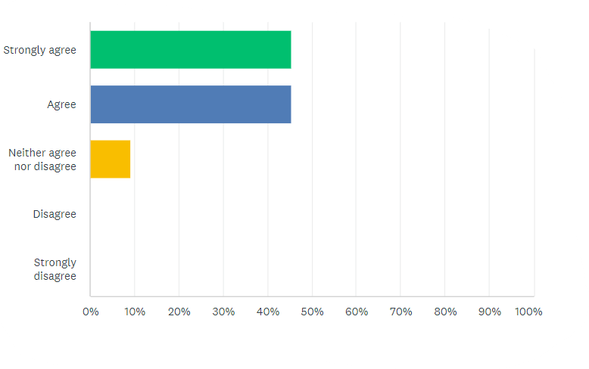
As seen above the results are mostly in agreement with one another as if they do not just agree they strongly agree. Although none of the participants disagreed in any remark although one had no real opinion on the matter.
Question 5 - How often do you use prefabricated construction methods?
The question is to determine how often prefabrication is used within the construction industry in South West Wales. Below is the chart detailing the answers.
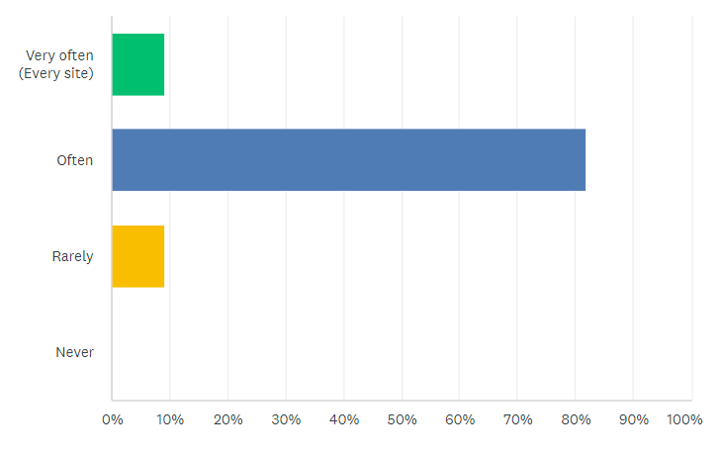
As seen in the chart above, majority of constructors use prefabricated construction methods often. And two use rarely use prefabricated construction methods. The other two use prefabricated construction methods every site. This could be consistent with home developers who use panellised construction methods daily.
Question 6 – Do you prefer to use Traditional or Prefabricated construction methods?
This question was asked to determine how many constructors prefer using prefabricated construction techniques.
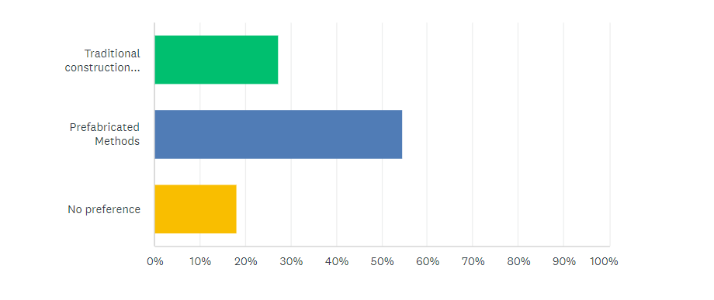
The results happen to be more split than other questions. Although most people selected that they prefer prefabricated methods some still opted for the traditional construction option. And some people have no preference on which method of construction is used.
Question 7 - Do you believe that Prefabricated construction is the way of the future?
Below is the chart relating to the question above.
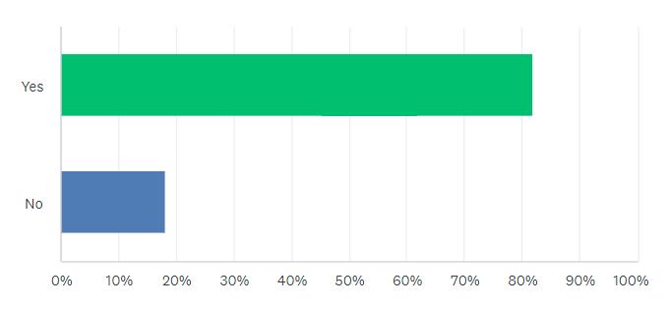
As seen in the above chart most people believe that prefabricated construction is seen as the way of the future. Although some people disagreed with the statement. During the next questionnaire I will have to make use of a reason box. So I can get peoples opinion in detail and understand their points of view.
Question 8 - Do you believe Prefabricated construction is more efficient than Traditional construction?
Below is the chart displaying the information from the above question.
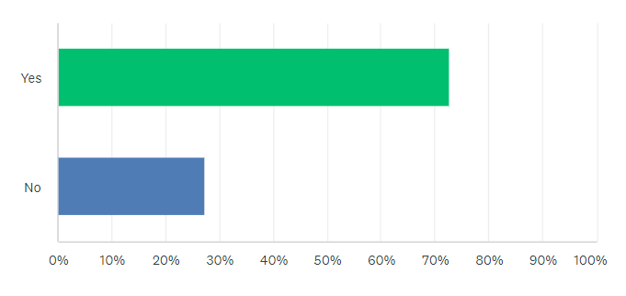
Personally I believed that the results from this question would be identical to question 7. Although the results are similar and most people believe prefabricated construction to be a more efficient means to construct. And around 27% disagreed with the statement.
Question 9 - Do you believe Prefabricated construction is more economical than Traditional construction?
Below is the chart relating to the question above. 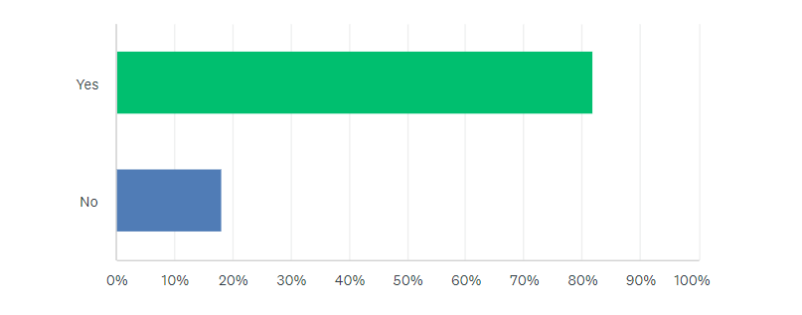
The above chart is the predicted outcome and has the same results as question 7. Most people believe that using prefabricated construction methods is more economical than using traditional construction methods.
Question 10 - What types of Prefabrication have you used?
Below is the bar chart for the above question.
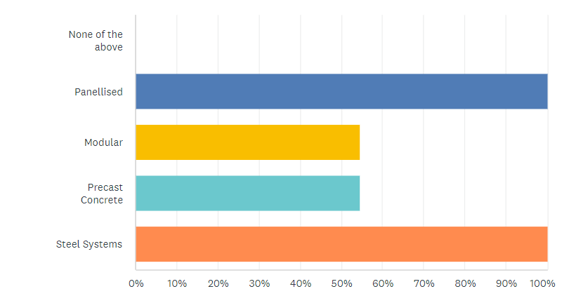
As you can see above all participants of the survey have use panellised prefabricated systems and steel systems. Also the same amount of people have used both modular and precast concrete systems.
To conclude my assumption that prefabricated systems are more efficient, economical and are generally the preference for all new construction projects were mostly correct. ‌The questionnaire also has given me insight to the preferred methods of prefabricated construction and what types of prefabricated construction used in South West Wales.

Self Evaluation
Upon planning and writing out this exercise below are some of the things that it has taught me,
- Time keeping – Ensure that (although none missed) all assignments are handed in on time without a last minute rush. This applies not only to my educational experience but also my professional life too. Ensuring that time deadlines are met can be an essential part of my daily life so from now on I will ensure to time keep better.
- Preparation – Preparation is key to carry out and execute exercises such as the one I have just carried out. Ensuring you have all correct and relevant information, correctly setting the exercise out and putting the necessary time to be able to complete the goal are essential. Preparation is a key part of not only my education but professional life too.

Given what I know now would I do anything different?
Upon coming up to the completion of this exercise I have learnt a few different useful pieces of information that I will use in further exercises. One the things I would do different knowing what I know now is use my time more effectively and start the whole process sooner. As starting too close to deadlines causes me to rush which lessens the quality of my writing and also causes stress. Stress further reduces the quality of my work. Another thing I would do differently is that I would prepare more for the assignment by using mind maps, bullet point lists and by using more a more substantial and detailed methodology.

Conclusion
I believe that this research project on the topic of prefabricated construction methods has given me a better and more understanding insight into another field of construction which is growing every day. So I believe that this research exercise has strengthened my ambitions within the construction industry and possibly has opened up my career path although still confined to the construction industry. There is simply an extraordinary scope to the construction world which makes it impossible to be bored of. And because of the previous statement that is why my aspirations in the construction industry have grown substantially throughout the time I have completed this research exercise.

‌

‌

‌

‌

