University of Wales Trinity Saint David
School of Engineering



Control & Automation
ACMA5001

Application of Automation in Wastewater Treatment

Cori-James Davies
1303441
06/04/2025

Executive Summary
This report explores the role of Instrumentation, Control, and Automation (ICA) in wastewater treatment, emphasising its importance for operational efficiency, regulatory compliance, and public health protection. Effective wastewater management becomes increasingly vital as urban populations grow and regulations tighten. The document outlines the wastewater treatment process, highlighting the necessity of removing suspended solids to safeguard aquatic life. Key stages include screening, primary clarification, aeration, and final treatment, all essential for producing safe effluents. A historical overview tracks the evolution from manual methods to advanced automated systems, detailing the impact of ICA technologies such as sensors, process controllers, and actuators. These innovations have minimised human intervention and enhanced treatment reliability and efficiency.
Furthermore, contemporary advancements in machine learning and artificial intelligence showcase their potential to improve wastewater management practices further. In summary, automation in wastewater treatment is crucial for sustainable water management. Investing in ICA technologies will be essential to meet future challenges and ensure environmental protection and public health.

Table of Contents
Executive Summary 2
1 Introduction 5
2 What is wastewater treatment 6
2.1 Steps in the Wastewater Treatment Process 7
3 Literature Review 8
3.1 History of Automation in Wastewater Treatment 8
3.1.1 Pre-Automation 8
3.1.2 Introduction of Automation 9
3.1.3 Current Methods 12
3.2 Instrumentation Control & Automation (ICA) Components 14
3.2.1 Sensors 14
3.2.2 Process Controllers 15
3.2.3 Actuators 15
4 Conclusions 17
5 References 18

Figure 1: Wastewater Treatment Process Flow Example (Preece, 2024) 2
Figure 2: The Activated Sludge Process (ASP) (NetSol Water, 2022) 4
Figure 3: Traditional Solutions in Wastewater Treatment Plants (Compressed Air Practices, 2015) 5
Figure 4: Grid well PLC ladder diagram (Zhu & Qiu, 2017) 6
Figure 5: Example of SCADA system for water Treatment Plant (Boughton, 2013) 7
Figure 6: Example of ML models and AI techniques used in water treatment and monitoring. (Alprol, et al., 2024) 9

Glossary of Terms
- ICA: Instrumentation, Control, and Automation
- TSS: Total Suspended Solids
- BOD: Biological Oxygen Demand
- SCADA: Supervisory Control and Data Acquisition
- ASP: Activated Sludge Process
- PLC: Programmable Logic Controller
- ML: Machine Learning
- DCWW - Dŵr Cymru Welsh Water

Introduction
Instrumentation, Control, and Automation (ICA) have become integral to managing and operating wastewater treatment facilities in the UK. As urban populations continue to grow and environmental regulations tighten, the increasing global demand for efficient wastewater treatment has led to significant advancements in automation and control technologies within the industry. Modern wastewater treatment facilities require continuous monitoring and precise control of various process variables to ensure safe, efficient, and environmentally compliant operations. Integrating Instrumentation, Control, and Automation (ICA) in these facilities has revolutionised the sector by enhancing operational efficiency, reducing human intervention, and ensuring compliance with regulatory standards. ICA enables the constant monitoring and control of various process parameters, ensuring wastewater treatment is safe and effective.
This report explores the historical development and contemporary applications of ICA within the wastewater treatment sector, focusing on the technologies that enable autonomous operation. Special attention will be paid to the role of sensors, process controllers, and actuators alongside the overarching supervisory control systems that govern plant operations. Furthermore, the industry's recent technological advancements enhance the automation of wastewater treatment facilities. By understanding these elements, we can appreciate how ICA improves operational efficiency and contributes to UK environmental protection and public health.

What is wastewater treatment
Water UK, (2025), suggest that the primary goal of wastewater treatment is to eliminate as many suspended solids as possible before the remaining water, known as effluent, is released back into the environment. As solid materials decompose, they consume oxygen, essential for the plants and animals living in the water.
According to Preece, (2024), clarifiers are essential components in wastewater treatment plants, where solids are separated from water through gravity sedimentation. Each clarifier has two main sections: the clarification zone, where solids settle, and the thickening zone, where settled material forms a dense sludge layer. In primary clarification, solids are physically removed before biological treatment. Incoming water flows into the tank, where floating materials (scum) are skimmed off the surface, and heavier solids (sludge) settle at the bottom and are removed. The clarified water exits over a weir for further treatment.
Performance is measured by total suspended solids (TSS) reductions, biological oxygen demand (BOD), and sludge quality—considering volume, concentration, and septicity. A well-functioning primary clarifier typically removes 90–95% of settleable solids, 40–60% of suspended solids, 25–75% of bacteria, and 25–50% of total BOD.
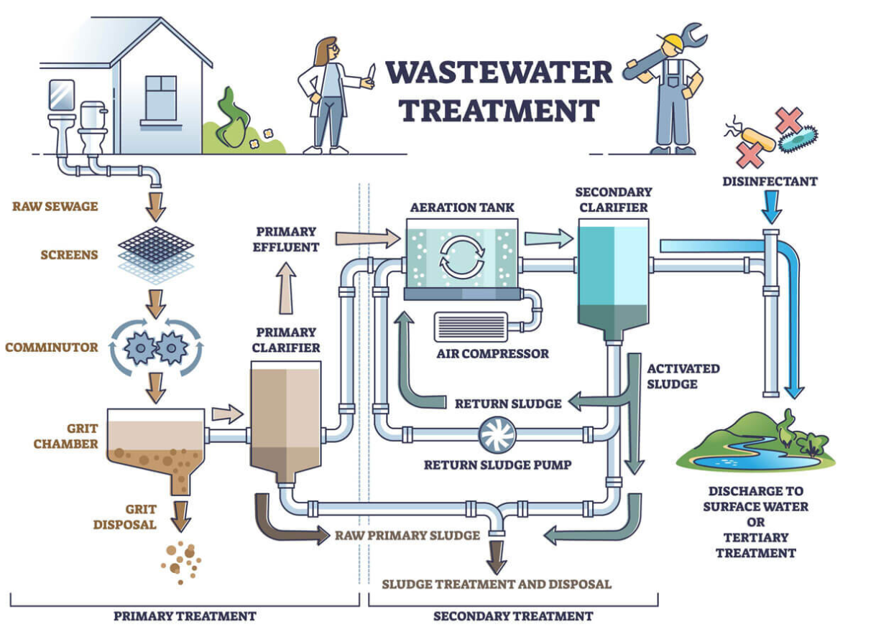
Figure 1: Wastewater Treatment Process Flow Example (Preece, 2024)

Steps in the Wastewater Treatment Process
Dwr Cymru Welsh Water (DCWW), (2025) Briefly explain the steps taken in the wastewater treatment process:
- Screening: Wastewater passes through screens that remove large debris such as rags, plastics, and heavy particles.
- Primary Tanks: Fine solid matter (sludge) settles at the bottom and is removed using scrapers.
- Aeration: Wastewater is treated using either:
  - Filter beds: Bacteria on a bed of materials break down organic matter.
  - Activated sludge: Air is pumped to encourage bacteria to digest impurities.
- Final Treatment: Water undergoes a final settlement process and may receive ultraviolet treatment before being returned to rivers or the sea.
- Sludge Treatment: The sludge is treated and can be used as fertiliser or disposed of in landfills.
- Poo Power: A DCWW initiative where the sludge is processed in a digester at 35°C for 15-20 days, producing methane gas and carbon dioxide. The gas is then burnt, and it generates electricity.
In conclusion, wastewater treatment is essential for environmental protection and public health, effectively removing contaminants from wastewater before its release into natural water bodies. Significant pollution reductions occur through screening, clarification, aeration, and sludge management. Initiatives such as DCWW's Poo Power showcase innovative methods that enhance sustainability and transform waste into valuable resources, highlighting the importance of efficient wastewater management in preserving ecosystems.

Literature Review

History of Automation in Wastewater Treatment
Automation in wastewater treatment dates back to the early 20th century when basic mechanical and electrical systems were introduced to enhance plant operations. In the UK, early sewage treatment relied on manually operated filtration systems, but as industrialisation progressed, mechanical systems such as trickling filters and sedimentation tanks were introduced.

Pre-Automation
Loosdrecht & Brdjanovic (2014), states that rapid urbanisation and industrialisation in the 19th century led to unhealthy environments and widespread epidemic disease. In 1914, as per Figure 2, Ardern and Lockett developed the sludge process in Manchester, which marked a significant milestone in biological wastewater treatment.
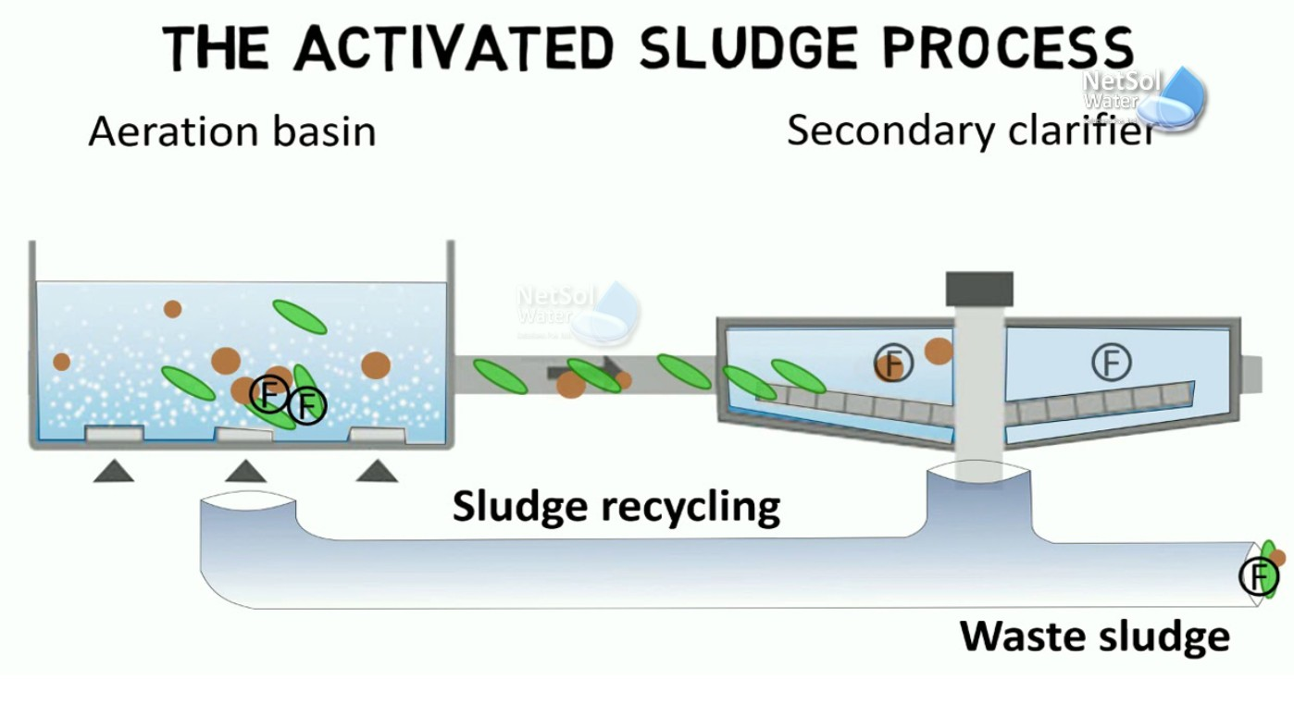
Figure 2: The Activated Sludge Process (ASP) (NetSol Water, 2022)

The Activated Sludge Process (ASP) consists of several designs, but generally, it has three main components: the aeration tank, which functions as a biological reactor; the settling tank, which separates activated sludge (AS) solids from treated wastewater; and the return-activated sludge (RAS) system, which transfers settled AS from the settling tank back to the aeration tank. This process remains central to sewage treatment today, although technological advancements have since improved it.
Veolia’s handbook of industrial water treatment (2025), explains in the early days of wastewater treatment, the process relied heavily on manual operations. Treatment operators were responsible for observing physical indicators, such as watercolour or clarity, and making decisions based on their experience. Some characteristics of pre-automation wastewater treatment included:
- Visual Inspections: Operators monitored effluent and influent by directly observing flow, sludge accumulation, and effluent quality.
- Manual Testing: Operators manually conducted chemical tests for parameters such as pH, biochemical oxygen demand (BOD), total suspended solids (TSS), and turbidity. Based on the test results, adjustments were made.
- Human-Based Control: Operators manually controlled pumps, aeration systems, and chemical dosing based on visual cues and periodic sampling.
- Limited Process Control: There was little to no ability to monitor or control processes in real-time, and operators had to rely on time schedules or manual readings for adjustments.

Introduction of Automation
According to Nathanson and Ambulkar (2025), by the 1950s, wastewater treatment technology progressed to a level where removing nearly all pollutants from sewage became possible. However, the high costs associated with such extensive treatment often did not justify its implementation. However, advancements in sensors and control mechanisms have significantly improved the monitoring of treatment processes. UK water companies began implementing basic control loops to regulate chemical dosing and aeration.
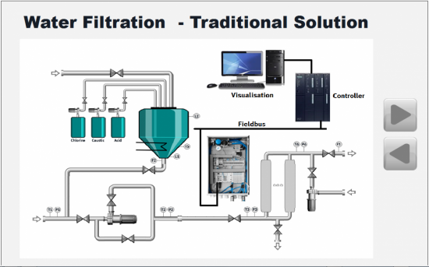
Figure 3: Traditional Solutions in Wastewater Treatment Plants (Compressed Air Practices, 2015)
The introduction of basic automation components, such as timers, relays, and pneumatic controllers, began to transform wastewater treatment operations. These devices allowed for simple automated tasks, like activating pumps based on preset schedules or water levels, which improved operational efficiency and reduced human error. However, despite these advancements, the systems still lacked integration and required significant manual oversight.
According to Walker, et al., (2010), The first Programmable Logic Controllers (PLCs) had their first commercially recognised application in 1969, improving control over mechanical processes such as pumping and aeration. Originally developed as a replacement for relays, early PLCs could perform on-off control using programmable sequential and combinational logic. This innovation allowed plant technicians to modify the sequential logic without needing to rewire the system. Additionally, PLCs did not require the complex programming skills associated with industrial computer applications of that era.
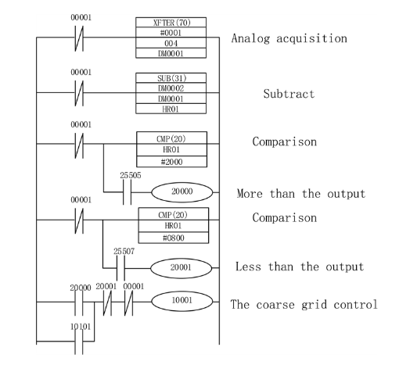
Figure 4: Grid well PLC ladder diagram (Zhu & Qiu, 2017)

Walker continues to explain the advancements made in the late 1970s and early 1980s. During this period, PLC designers leveraged the rapid progress in electronic and microprocessor technologies to improve the functionality of PLCs. A significant development in this era was the capability to read and process analogue instrument signals. In closed-loop configurations, the accuracy of control is determined partly by the precision of the analogue inputs to the controller. Analogue outputs are within the control loop and do not demand such high precision. The critical component is, therefore, the analogue to digital converter, but high precision can be costly.
Further developments explained by Parker (2002), that in the 1980s, Supervisory Control and Data Acquisition (SCADA) systems were introduced in the UK, with Thames Water being one of the pioneers in their adoption. These systems enabled real-time decision-making and the automation of treatment plants. The existing SCADA system was developed in the late 1980s alongside implementing the London Water Control Centre (LWCC), which was established to manage the Thames Water Ring Main (TWRM) operation. This system includes 14 pump-out shafts that deliver drinking water to 60 service reservoirs.
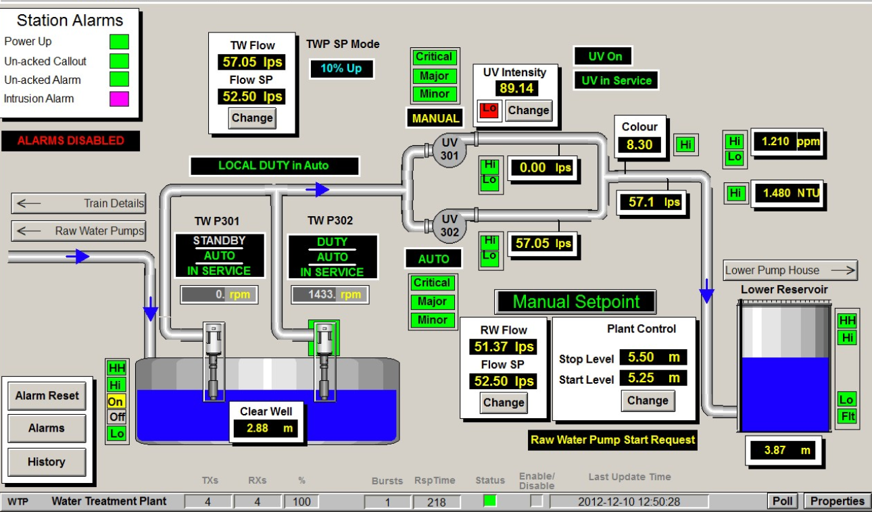
Figure 5: Example of SCADA system for water Treatment Plant (Boughton, 2013)

Purpose of SCADA solution in the wastewater treatment system:
- Keep track of visual data in real-time using HMI or LCD screens.
- Analyse process data collected from the system.
- Set an alarm to notify when the system is experiencing problems.
- Enhance the flexibility of the remote management system.
- Store data: report all available information about the system.
Parker (2002), further explains that by 2002, the LWCC also began overseeing two area control centres (ACCs) in Hammersmith and Merton, along with 12 sub-control centres. These facilities manage over 200 pumping stations, boreholes, and unmanned treatment sites.

Current Methods
In 2025, fully integrated and automated wastewater treatment plants are utilising advanced Instrumentation, Control, and Automation (ICA) technologies to enhance operational efficiency and ensure compliance with environmental standards. Key components of these modern systems include the Internet of Things (IoT), Artificial Intelligence (AI), and real-time monitoring capabilities.
Baarimah, et al., (2024) As global water scarcity intensifies, there is an increasing demand for more efficient wastewater treatment solutions. The integration of advanced artificial intelligence (AI) techniques presents significant potential to optimise treatment processes, improve predictive analysis, and support data-driven decision-making in this essential industrial focus on the role of AI in wastewater management. The utilisation of AI whilst using technologies such as adsorption, microalgae cultivation, and anaerobic digestion is gaining traction, particularly in addressing contaminants like heavy metals and nutrients. These findings offer strategic insights to shape future research priorities and facilitate the advancement of AI-driven, sustainable wastewater treatment solutions.
According to Alprol, et al., (2024), The integration of the Internet of Things (IoT) into wastewater treatment and water quality prediction can transform conventional methods and tackle critical issues, particularly in response to the growing global need for clean water and sustainable systems. The current advancements and the future development of IoT technologies, combined with artificial intelligence (AI) and machine learning (ML), are driving change in these fields. A notable example is an IoT-based automated water quality monitoring system that leverages cloud computing and ML techniques to address these challenges. The IoT has been applied to improve, simulate, and automate various processes, including monitoring and managing natural systems, water treatment, and wastewater treatment.
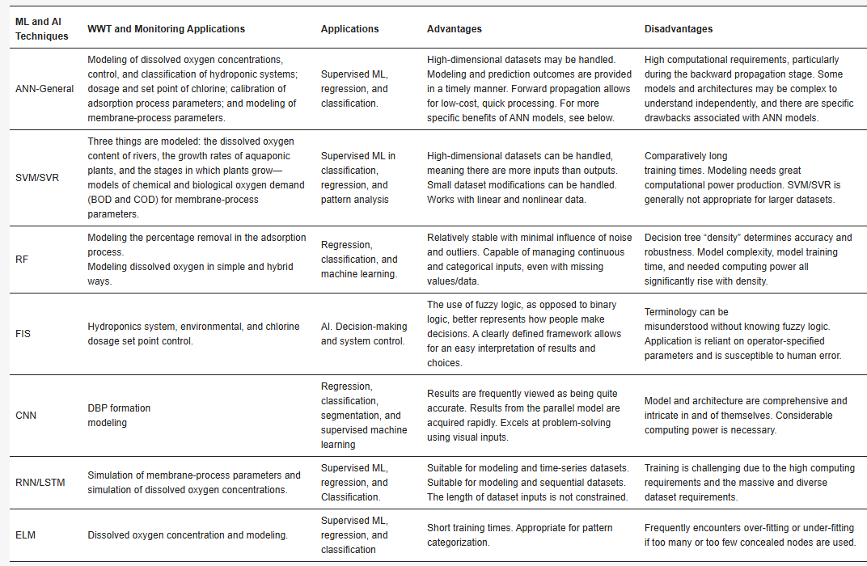
Figure 6: Example of ML models and AI techniques used in water treatment and monitoring. (Alprol, et al., 2024)

Various water applications combine IoT with artificial neural networks and machine learning. It includes critical evaluations of methods such as chlorination, adsorption, membrane filtration, water quality monitoring, river level monitoring, and wastewater treatment in aquaculture. Additionally, the future potential IoT applications and how algorithms are utilised to evaluate the quality of treated water in different aquatic environments.
Smart sensors now provide real-time effluent quality monitoring, reducing human intervention and optimising energy consumption. Scottish Water (2025), has adopted digital twin technology to simulate treatment processes, improving efficiency and resilience in plant operations. Such advancements are transforming the wastewater sector, making it more sustainable and cost-effective while ensuring compliance with regulatory standards.

Instrumentation Control & Automation (ICA) Components
​Instrumentation, Control, and Automation (ICA) are essential in modern wastewater treatment facilities, enhancing efficiency, ensuring regulatory compliance, and promoting sustainability. Below is a detailed overview of the key components of ICA in wastewater treatment:​

Sensors
Sensors play a vital role in wastewater treatment by measuring temperature, pH, dissolved oxygen, and turbidity. These measurements help operators maintain optimal conditions for biological processes, ensure regulatory compliance, and enhance efficiency. By delivering real-time data, sensors facilitate prompt adjustments and improve overall system reliability and performance (Badger Meter, 2025).
Key types include:​
- Flow Meters: These devices measure the water inflow and outflow rate, ensuring balanced flow throughout treatment. Accurate flow measurement is vital for process control and regulatory reporting.​
- pH Sensors: pH sensors monitor water's acidity or alkalinity, which is crucial for maintaining optimal conditions for biological treatment processes and ensuring compliance with discharge standards.​ (Archer, 2021).
- Dissolved Oxygen (DO) Sensors: DO sensors measure the oxygen concentration in water, which is essential for the respiration of aerobic microorganisms used in treatment. Maintaining appropriate DO levels is vital for effective pollutant degradation.​
- Turbidity and Suspended Solids Sensors: These sensors assess water clarity by detecting the presence of suspended particles, aiding in evaluating treatment performance and the quality of treated effluent.​
- Ammonia and Nitrate Sensors: Monitoring ammonia and nitrate levels is essential for nutrient removal processes and helps prevent eutrophication in receiving water bodies.​

Process Controllers
RACO (2024), states that automation is crucial in the wastewater treatment sector. It transforms plant operational methods and boosts overall efficiency. For plant operators, grasping the fundamentals of automation and its potential advantages for their facility is key.
Process controllers automate and regulate various treatment processes to maintain optimal operational conditions:​
- Programmable Logic Controllers (PLCs): PLCs execute control logic based on sensor inputs, managing operations such as pump activation, valve positioning, and alarm signalling. They are known for their reliability and flexibility in industrial applications.​
- Distributed Control Systems (DCS): DCS manage complex, large-scale processes by distributing control functions across multiple controllers. They offer centralised monitoring with decentralised control, enhancing system reliability and scalability.​
- SCADA Systems for supervisory-level control and data visualisation: SCADA, or Supervisory Control and Data Acquisition, monitors and controls industrial processes and infrastructure. It collects real-time sensor data, allowing operators to manage and optimise operations efficiently, enhance decision-making, and ensure safety in manufacturing, energy, and utilities.
- Proportional-Integral-Derivative (PID) Controllers: PID controllers adjust process variables to achieve desired setpoints by calculating error values and applying corrective actions. They are fundamental in maintaining stable and efficient treatment operations.​

Actuators
Treatment Plant Operator (TPO) (2018), states that the actuator serves as the "action" component of the machine, automating the associated processes. It enables a machine's movement by supplying the necessary force or torque. Like a sensor, an actuator functions as a transducer, but its role is reversed. It converts an electrical signal into physical motion, unlike a sensor, which does the reverse.
Actuators are devices that execute control actions by physically adjusting equipment based on commands from process controllers:​
- Pumps: Pumps transport fluids between treatment stages. Controlling pump operation ensures adequate flow rates and energy efficiency.​
- Valves: Valves regulate the flow of liquids and gases within the treatment plant. Automated valve control allows for precise flow management and quick response to process changes.​
- Aerators: Aerators introduce air into water to maintain oxygen for aerobic treatment processes. Adjusting aerator operation based on DO sensor readings optimises energy use and treatment efficiency.​
Integrating sensors, process controllers, and actuators into a unified ICA system allows wastewater treatment plants to function efficiently, adapt to changing conditions, and comply with environmental regulations.

Conclusions
Integrating ICA in wastewater treatment facilities has significantly transformed the industry, enhancing operational efficiency and environmental compliance. This report has outlined the historical evolution of automation in this sector, from its pre-automation days to the sophisticated technologies currently in use. As urban populations grow and environmental regulations become increasingly stringent, the demand for more efficient and reliable wastewater treatment methods continues to rise. The advancements in ICA technologies minimise human intervention and improve the reliability of processes, leading to cleaner effluents that can be safely released back into the environment.
Furthermore, machine learning and artificial intelligence applications within wastewater treatment illustrate the potential for ongoing innovation and improvement in this field. By leveraging these advanced technologies, facilities can enhance decision-making processes and predict maintenance needs, thus ensuring the longevity and efficiency of operations.

References
Alprol, A. E., Mansour, A. T., Ibrahim, M. & Ashour, M., 2024. Current Trends and Future Prospective. Artificial Intelligence Technologies Revolutionising Wastewater Treatment, 16(2).
Archer, C., 2021. How to measure water quality in wastewater treatment plant controls. [Online]
Available at: https://blog.wellaware.us/blog/how-to-measure-water-quality-in-wastewater-treatment-plant-controls
[Accessed 23 March 2025].
Archer, C., 2021. The 4 Types of Sensors Used in Wastewater Treatment Controls. [Online]
Available at: https://wellaware.us/blog/the-4-types-of-sensors-used-in-wastewater-treatment-controls
[Accessed 25 March 2024].
Baarimah, A. et al., 2024. Artificial intelligence in wastewater treatment. Case Studies in Chemical and Environmental Engineering, Volume 10, pp. 2-8.
Badger Meter, 2025. Water Quality Monitoring. [Online]
Available at: https://www.badgermeter.com/en-gb/products/water-quality-monitoring/?utm_source=google&utm_medium=ppc&utm_campaign=application_dnm&utm_term=701Pc00000OvSrRIAV&gad_source=1&gclid=EAIaIQobChMIlImC_KbEjAMVN5dQBh1XzwLqEAAYBCAAEgIT5_D_BwE
[Accessed 25 March 2025].
Boughton, P., 2013. Fully automated SCADA system for water and wastewater treatment. [Online]
Available at: https://www.engineerlive.com/content/fully-automated-scada-system-water-and-wastewater-treatment
[Accessed 26 March 2025].
Compressed Air Practices, 2015. Pneumatic Control in Modular Wastewater Treatment Plants. [Online]
Available at: https://www.airbestpractices.com/technology/pneumatics/pneumatic-control-modular-wastewater-treatment-plants
[Accessed 25 MArch 2025].
Dwr Cymru Welsh Water, 2025. Waste Water Treatment. [Online]
Available at: https://corporate.dwrcymru.com/en/community/education/teaching-resources/primary-resources/waste-water
[Accessed 8 March 2025].
Loosdrecht, M. C. v. & Brdjanovic, D., 2014. Anticipating the next century of wastewater treatment: Advances in activated sludge sewage treatment can improve its energy use and resource recovery. Science Insights, 27 June, 344(6191), pp. 1452-53.
Nathanson, J. A. & Ambulkar, A., 2025. Wastewater Treatment. [Online]
Available at: https://www.britannica.com/technology/wastewater-treatment
[Accessed 14 March 2025].
NetSol Water, 2022. What is the activated sludge process?. [Online]
Available at: https://sewagetreatmentplantmanufacturer.wordpress.com/2022/03/10/what-is-the-activated-sludge-process-benfits-and-working-process/
[Accessed 18 March 2025].
Parker, N., 2002. Replacing the London water supply SCADA system. [Online]
Available at: https://www.waterworld.com/home/article/16203853/replacing-the-london-water-supply-scada-system
[Accessed 14 March 2025].
Preece, C., 2024. Efficient wastewater treatment and the role of TOC in process control. [Online]
Available at: https://www.elementar.com/en/blog/efficient-wastewater-treatment-and-the-role-of-toc-in-process-control
[Accessed 8 March 2025].
RACO, 2024. Understanding Automation for Plant Operators in the Wastewater Industry. [Online]
Available at: https://www.racoman.com/blog/understanding-automation-for-plant-operators-in-the-wastewater-industry?srsltid=AfmBOorXU1odvTZJ7Up32Lwhr99czePHZv0HtuwK2F2eb1zNZxGbGtQE
[Accessed 25 March 2025].
Scottish Water, 2025. Scottish Water Transforms Wastewater Network Management into Intelligent Asset Base. [Online]
Available at: https://eviden.com/insights/client-stories/transforming-wastewater-network-management-for-scottish-water/?utm_source=chatgpt.com
[Accessed 20 March 2025].
TPO, 2018. A Sensor’s Best Friend: Actuators in the Industrial Process, s.l.: Cole Publishing.
Veolia, 2025. Hanbook of Industrial Water Treatment. [Online]
Available at: https://www.watertechnologies.com/handbook/chapter-36-monitoring-and-control-water-treatment
[Accessed 18 March 2025].
Walker, M., Bissel, C. & Monk, J., 2010. Measurement & Control. The PLC: a logical development, 43(9), pp. 280-282.
Water UK, 2025. Treating sewage before it is released into the environment. [Online]
Available at: https://www.water.org.uk/waste-water/sewage-treatment-works
[Accessed 8 March 2025].
Zhu, H. & Qiu, X., 2017. The Application of PLC in Sewage Treatment. Journal of Water Resource and Protection, 9(7), pp. 841-850.

