University of Wales Trinity St David

Wales Institute of Science & Art



Application of CAE Processes

Structural & Fluid Analysis (ACHA6010)

Estimated word count: 2950

Hugo Upsall

2205193

December 2024

Table of Contents
Introduction 1
Validations 2
Simplified Test Cases 2
Thermal Case 2
Static Structural Cases 3
Mesh Independence Study 5
Simulation and Analysis 9
Rigid Dynamics 10
Steady-State Thermal 10
Static Structural 13
Piston Head Optimisation 15
Material Study 15
Conclusion 17
References 18

Introduction
Computer aided engineering (CAE) is the use of computer-based software which performs mathematical analysis of a model or system once physical properties, environment, and loading or constraints have been provided. This allows examination and simulation of a vast array of physics-based cases which can ‘assist in the resolution of engineering problems’, amongst other applications (Siemens, n.d.). As Kojima explains, CAE has many uses, especially within the automotive industry. These include crashworthiness, NVH performance, and strength and durability (Kojima, 2000). This is incredibly useful for manufacturers to be able to perform testing and analysis on components or systems without the cost of physically producing numerous prototypes, some potentially being tested until failure, which can be costly if needing to be repeated.

This report will focus on the latter of uses Kojima mentions, specifically investigating characteristics linked to strength, durability, and mass. This will be achieved through performing static structural, thermal, and kinematic analysis on a partial engine assembly to establish boundary conditions, with the aim to perform optimisation on a chosen component within this. A conclusion will then be presented regarding the best approach for iterative improvement.

Several validations and investigations will be carried out including static structural and thermal modelling, as well as a study into mesh independence. Validations are necessary to verify the accuracy of the CAE software being utilised, confirming further investigations of a similar type will produce credible results. These simulations will be performed in Ansys, an industry-standard CAE modelling software, where kinematic simulation, structural analysis, and optimisation will take place on the partial engine assembly and chosen component while replicating realistic conditions.

Structural analysis of components or assemblies allows engineers to understand their characteristics and limitations when respective forces are applied (Universidad Europea, 2024). As a result, improvements and optimisations can be made ensuring specified requirements are met such as relevant strength, fatigue, or safety targets.

However, CAE is not without its limitations which can affect time consumption when running simulations and accuracy of results. These will be discussed later in the report.

Validations
As mentioned beforehand, validation work is necessary to establish the credibility of results produced from software being utilised, in this case for CAE work. Model validations essentially establish the degree of accuracy to which the software can represent the model in question with respect to its intended use (Lee, et al., 2019). Several simplified test cases were used within Ansys to determine its accuracy with regards to the modelling to be used within this report.

Although research suggests there is no clear accepted error margin which deems a validation attempt ‘accurate’, a variety of sources imply anything below 10% or 5% error as acceptable. This includes Bashir’s report in 2021; however, this was mainly referring to CAD geometries (Bashir, 2021).

Simplified Test Cases
For the following validation cases, examples were used from CAE software provider Dlubal. Setup parameters were replicated with results then compared, allowing a good indication to what degree of accuracy Ansys could model these.

Thermal Case
In this instance a bimetallic strip was used to establish credibility of basic thermal loading simulations. Figure 1 represents setup parameters along with a visual representation of the intended model to be replicated.

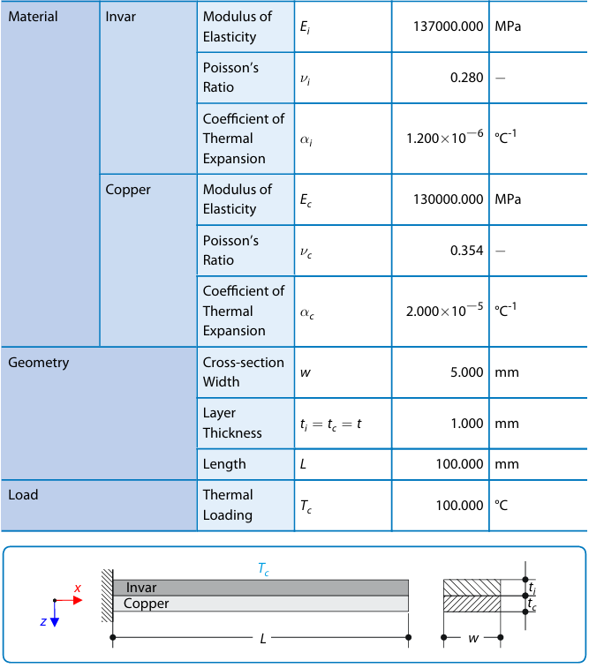
Figure 1 - (Dlubal, 2017)
The output result compared was the amount of total deformation as a result of the thermal loading. This occurs through the bimetallic strip being made from two different materials, Invar and Copper, which have different coefficients of thermal expansion and so elongate when exposed to heat.

Total deformation can be analytically calculated through Equation 1 and 2 as outlined in the validation example from Dlubal.
$$K_{1}=4+6\frac{t_{c}}{t_{i}}+4 (\frac{t_{c}}{t_{i}})^{2}+\frac{E_{c}}{E_{i}} (\frac{t_{c}}{t_{i}})^{3}+\frac{E_{i}t_{i}}{E_{c}t_{c}}$$
Equation 1
Where dimensionless coefficient $K_{1}$ can then be used in Equation 2.
$$u_{z_{1}max}=\frac{6 \left(α_{i}-α_{c}\right)\left(t_{i}+t_{c}\right)T_{c}}{{t_{s}}^{2}K_{1}} \frac{L^{2}}{2}= -7.049mm$$
Equation 2
In Figure 2, results from Ansys can be observed where a maximum deformation value of 7.123mm was recorded, which differs from results calculated in the analytical approach. Between these there is a 98.9% similarity, or a 1.1% error margin, deeming this difference negligible. Results from the validation example also state a negative value which is simply due to this axis used being inverted. In Ansys, deformation occurs along the y-axis in a positive direction, as in Figure 2.

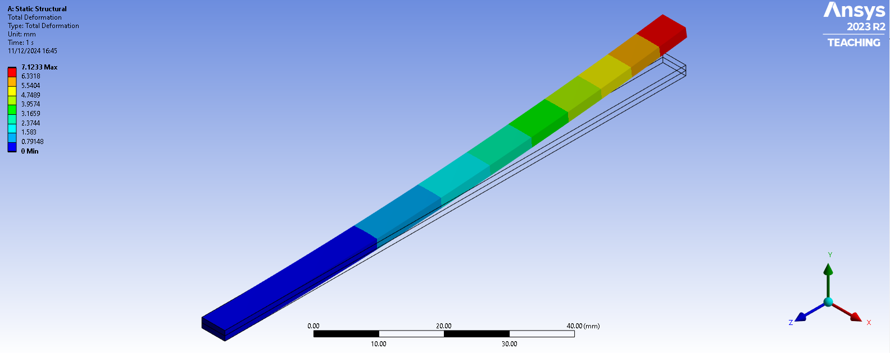
Figure 2 – bimetallic strip thermal loading result using 1mm mesh sizing
From this, it can be said that Ansys calculates thermal loading to a strong degree of accuracy, establishing strong validity for this load case.

Static Structural Cases
Two cases were used from different validation examples. The first included a cantilever beam with an axial force, a visual representation of this shown in Figure 3 and the parameters in Figure 4, where two forces are acting on the end of a beam in different directions.
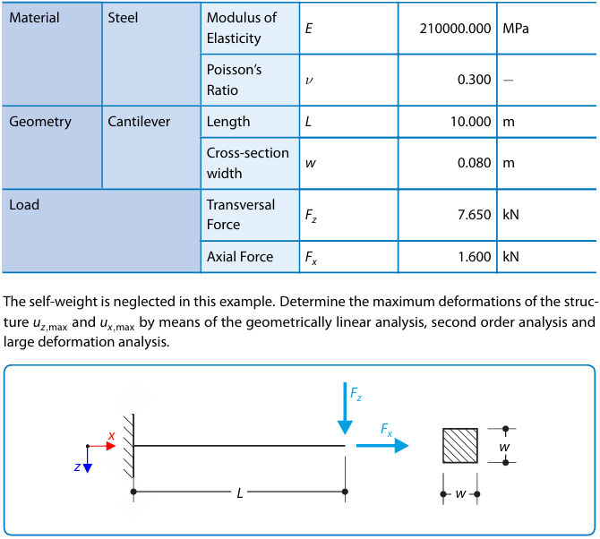
Figure 3 - (Dlubal, 2016)
Figure 4 - (Dlubal, 2016)
In this example, deformation will be compared. Total deformation can be calculated analytically through Equation 3 (Dlubal, 2016).
$$u_{z_{1}max}=\frac{F_{2}L^{3}}{3{EI}_{y}}=3557.478mm$$
Equation 3
In Figure 5 results from this validation case in Ansys can be reviewed, where a maximum deformation value of 3555.5mm was calculated. As a result, there is a 99.94% similarity between the two values, or a 0.06% error margin, thus indicating Ansys can accurately model these loading cases.

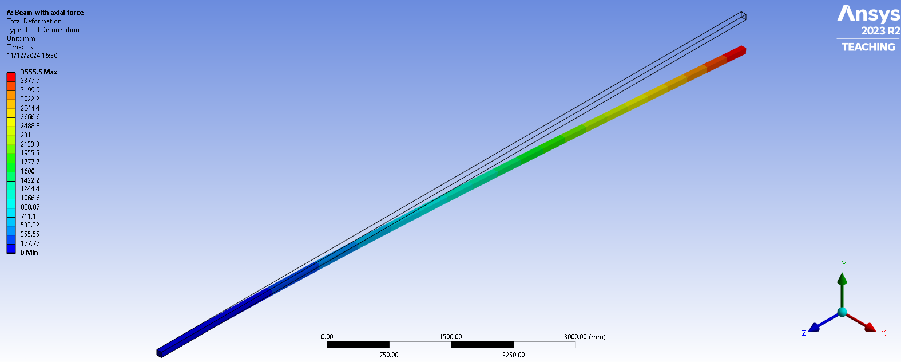
Figure 5 – cantilever beam with axial load result using 22mm mesh sizing
The second static structural validation case was a cantilever beam with uniform loading which can be seen in Figures 6 and 7.

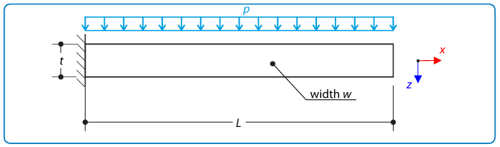
Figure 6 – visual representation of cantilever beam with uniform loading (Dlubal, 2022)

As with the two cases prior, deformation will be compared to validate accuracy of Ansys with respect to this load case. The analytical approach to this case is demonstrated through Equations 4 and 5 as (Dlubal, 2022).

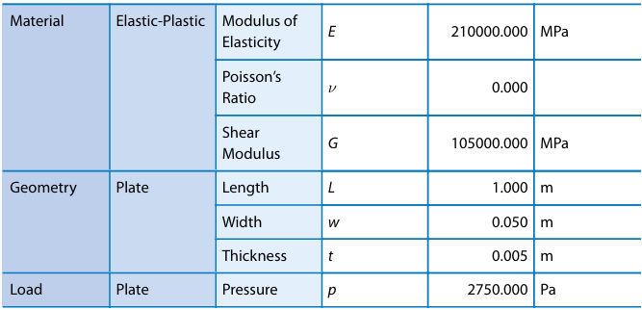
Figure 7 – parameters of cantilever beam with uniform loading (Dlubal, 2022)
For quadratic moment of cross-section with respect to y-axis:
$$I_{y}=\frac{wt^{3}}{12}$$
Equation 4
For maximum deformation:
$$u_{z_{1}max}=\frac{3pL^{4}}{2Ew^{2}t}=157.143mm$$
Equation 5
In Figure 8 results from modelling in Ansys can be viewed, where a maximum deformation value of 157.15mm was calculated. As a result, there is a 99.99% similarity, or a 0.01% error margin, between these two values. Thus, Ansys can be deemed to be able to accurately model uniformly distributed loads in this respect.

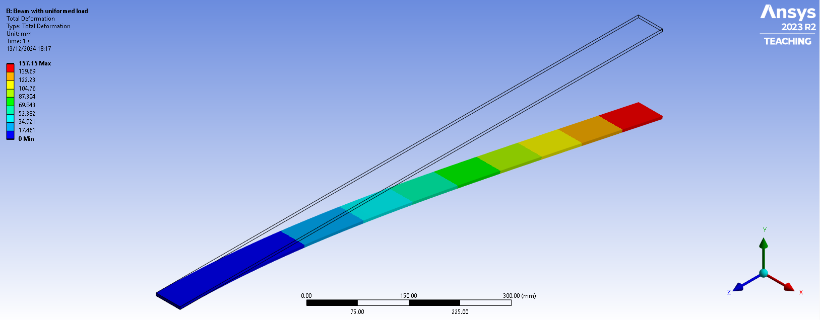
Figure 8 – cantilever beam with uniformed loading result using 10mm mesh sizing

Mesh Independence Study
Mesh independence refers to the point at which further refinement of mesh sizing has little-to-no impact on the output of results. This can also influence simulation solve time, as in general the smaller the mesh element size or greater the volume of nodes the longer the simulation will take to solve, and the larger the computational demand (Gardiner, 2017).

In principle, as Shimada explains, meshing is “discretisation of a two or three-dimensional geometry”, with mesh containing both nodes and elements (Shimada, 2006). The latter of which can consist of a variety of shapes but predominantly consist of quadrilateral, hexahedral, triangular, and tetrahedral shapes, depending on whether the mesh is structured or unstructured (Nielsen & Martins, 2021). The mesh structure is, in turn, influenced by the valence, which designates number of elements shared between a node. In general, two-dimensional mesh surfaces will employ a structured mesh, mainly using quadrilateral shapes, which lends towards better quality meshing due to these elements having corner angles of approximately 90-degrees and uniform grid spacing. However, this can provide less accurate meshing on components including complex geometries and curvature (Paulin Research Group, n.d.). In this case, unstructured mesh may be preferred which predominantly uses varied cell shape and sizing with irregular arrangement, thus providing greater adaptability to suit complex models with enhanced accuracy.

To effectively investigate mesh independence, mesh sizing was compared against calculated deformation and equivalent von-Mises stress in Ansys using the cantilever beam with axial force, previously used as a validation case. The results were plotted on a graph which can be seen in Figure 9, where the area between the black dotted lines represents mesh independence.

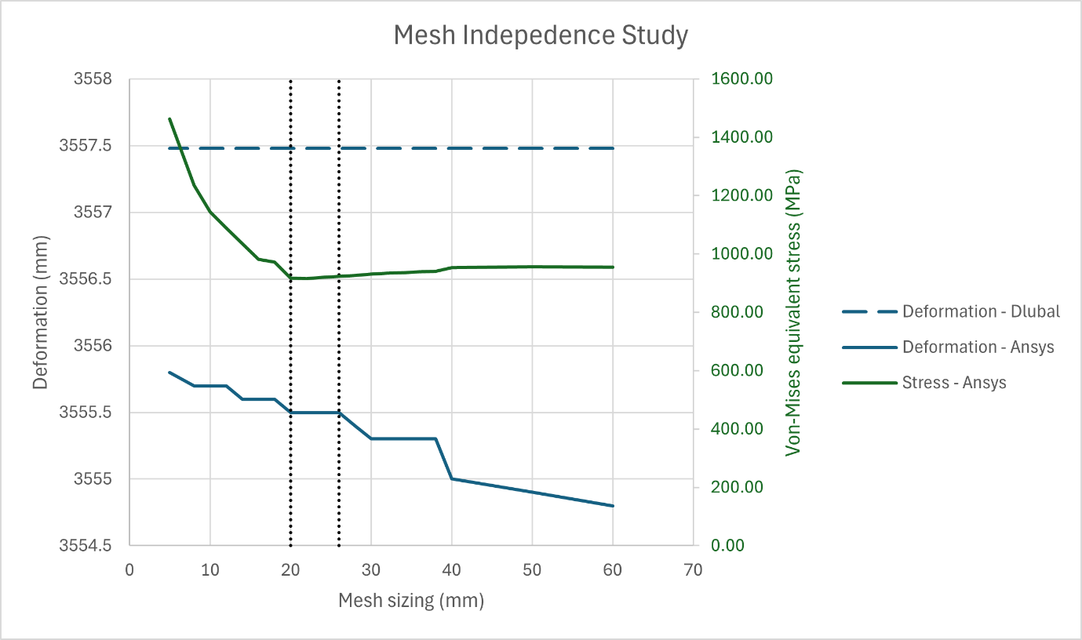
Figure 9
As the validation case used was of simply geometry and loading case there is not much deviation in total deformation upon change of mesh size. However, calculated stress changes drastically once mesh size decreases below 20mm, as depicted by the green plotted line and axis. Table 1 displays raw results from the study, better illustrating the contrasting levels of change between deformation and stress.

Between the largest and smallest mesh sizing modelled, 60mm and 5mm respectively, there is only a 0.03% difference in deformation (mm). However, across the same mesh size variation, there is a 53.14% difference in stress (MPa).

Table 1 also displays error margin in percentage between deformation calculated analytically and within Ansys through the mesh range.
Mesh sizing (mm) | Deformation (mm) | Deformation error margin to Analytical method (%) | Stress (MPa)
60 | 3554.80 | 0.08 | 954.60
50 | 3554.90 | 0.07 | 956.41
40 | 3555.00 | 0.07 | 952.95
38 | 3555.30 | 0.06 | 940.70
36 | 3555.30 | 0.06 | 938.92
34 | 3555.30 | 0.06 | 936.54
32 | 3555.30 | 0.06 | 933.82
30 | 3555.30 | 0.06 | 930.48
28 | 3555.40 | 0.06 | 926.51
26 | 3555.50 | 0.06 | 922.69
24 | 3555.50 | 0.06 | 919.36
22 | 3555.50 | 0.06 | 915.46
20 | 3555.50 | 0.06 | 916.82
18 | 3555.60 | 0.05 | 972.11
16 | 3555.60 | 0.05 | 981.14
14 | 3555.60 | 0.05 | 1035.80
12 | 3555.70 | 0.05 | 1089.50
10 | 3555.70 | 0.05 | 1144.30
8 | 3555.70 | 0.05 | 1236.00
5 | 3555.80 | 0.05 | 1461.90
Table 1
Figures 10 and 11 show mesh sizing where stress values were at their maximum and minimum, respectively.

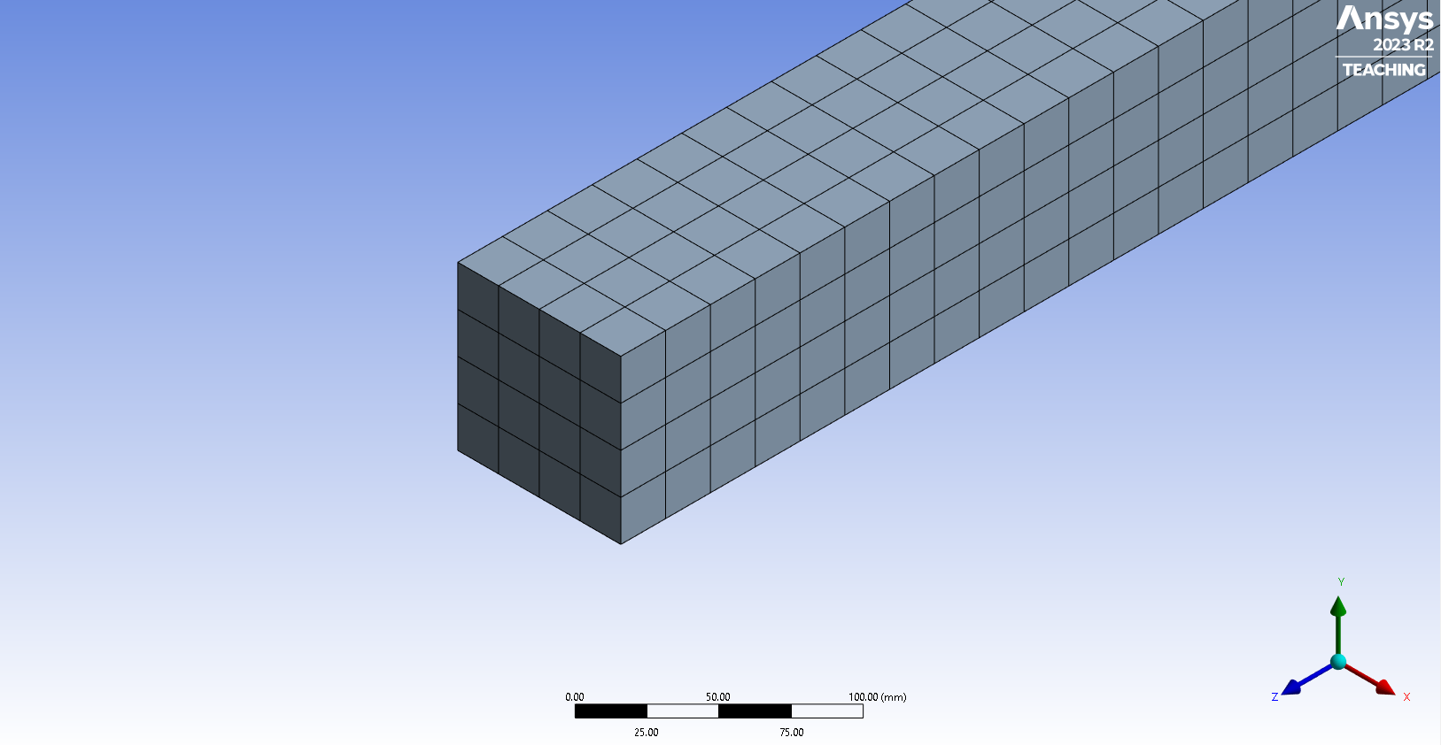
Figure 10 – cantilever beam with 22mm mesh sizing, where minimum stress was experienced, demonstrating structured mesh

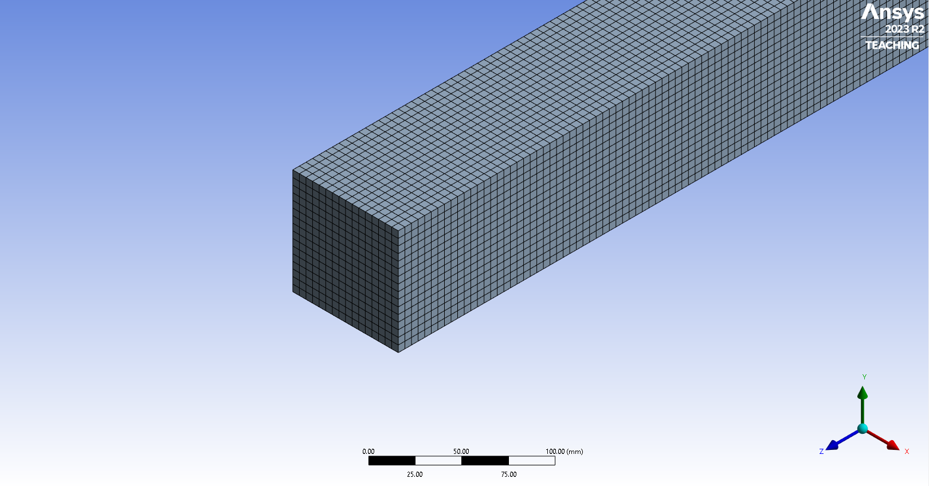
Figure 11 – cantilever beam with 5mm mesh sizing, where maximum stress was experienced, demonstrating structured mesh
As can be seen in Figure 9 and Table 1, with the increase of mesh definition, or reduction in element size, greater accuracy of results can be observed with respect to having less error margin percentage when compared to the analytical method result. For this reason, it would be logical to suggest a finer mesh produces better results overall.

However, once mesh sizing decreases below 20mm, calculated stress increases dramatically. This due to error in the simulation since Ansys starts to model peak stress as being in each corner of the end of the beam attached to the fixed support. This is demonstrated in Figures 12 and 13 and produces a highly unrealistic calculation.

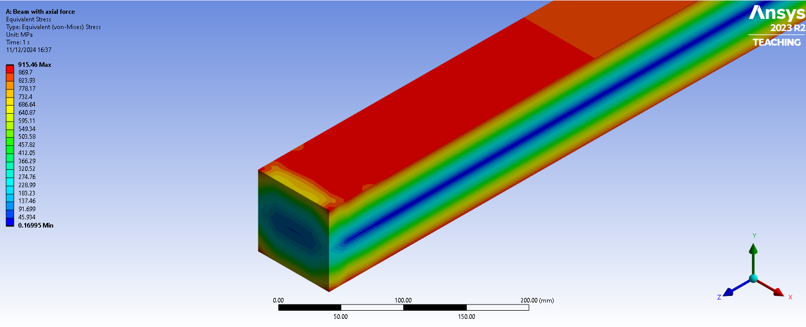
Figure 12 – realistic stress distribution peaking at 915MPa, with 22mm mesh sizing
As a result, since stress remains relatively constant and only increases when mesh is finer than 20mm, it would be reasonable to investigate the area before this change for mesh independence. When studying mesh larger than 20mm, the only observable result change is in deformation. Areas where mesh size does not lead to change in deformation occur between 20-26mm and 30-38mm mesh. However, since it has been established the finer the mesh the more accurate the result, it would be safe to assume the area between 20-26mm mesh as being the most desirable range in which to establish as having achieved mesh independence.

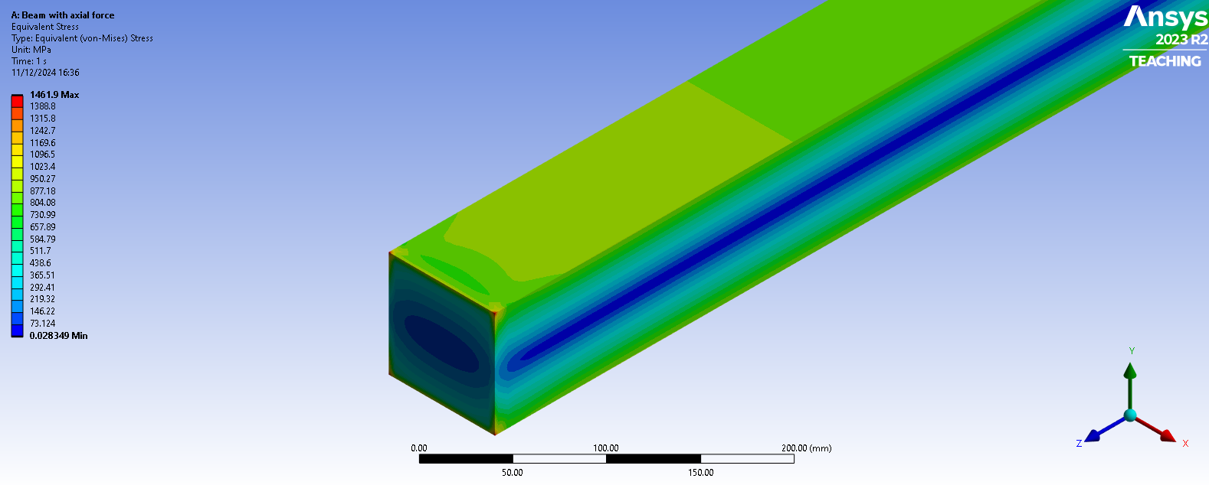
Figure 13 – unrealistic stress distribution peaking at 1461MPa in each of the four corners, with 5mm mesh sizing

Simulation and Analysis
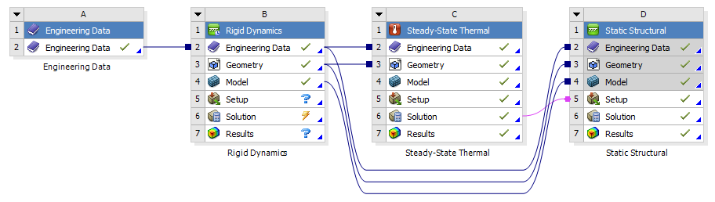
Figure 14 – full system within Ansys
To perform kinematic simulation and structural analysis on the partial engine assembly four systems had to be used in tandem. The assembly itself was provided beforehand and consisted of a crankshaft, piston connecting rod, gudgeon pin, and piston head. All components were assigned the same material, structural steel, throughout the process, besides the piston head. This was subject to a material investigation, detailed later in this report, with the first material used being 6061 T6 aluminium alloy. Properties of this alloy were exported from Granta EduPack 2022, with structural steel being the default material found within Ansys Workbench. For each of these simulations, a variety of boundary conditions are needed in order for them to be successfully carried out. As standard, the systems mentioned in this report always include model geometry and material properties; however, requirements can change between systems, and so these will be outlined accordingly.

Rigid Dynamics
Rigid Dynamics simulates movement and interaction of rigid bodies to provide velocities and accelerations. This results in the calculation and recording of motion loads occurring on any chosen component, once degrees of freedom of components within the model have been restricted in the intended manner (FEA Tips, 2022).

In this case, motion loads were calculated on the gudgeon pin at a given rotational velocity of 4000rpm once degrees of freedom had been restricted in such a way that the engine assembly could only move in the intended way.

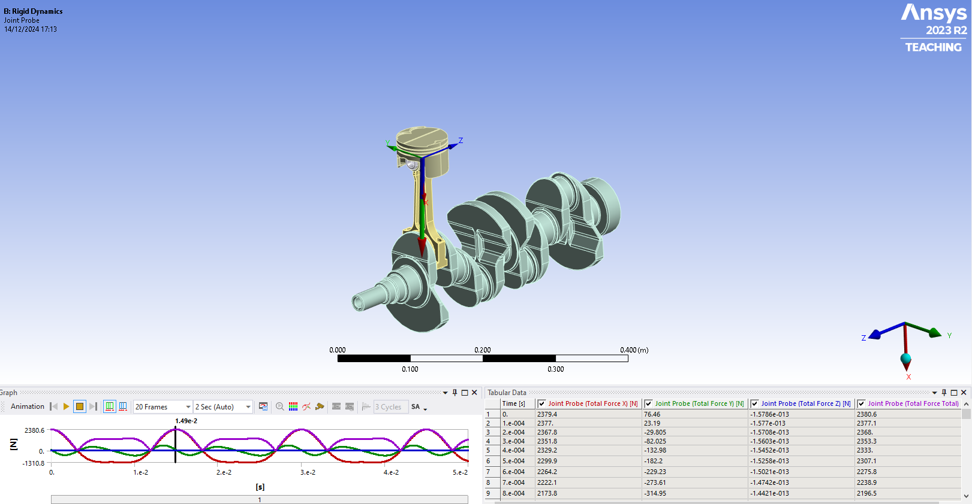
Figure 15 – partial engine assembly in rigid dynamics
In Figure 15 calculated gudgeon motion loads can be viewed. Maximum motion loads are represented by the top of the peaks, the value of which was retrieved to be used later in the finite-element analysis (FEA) system.

The Rigid Dynamics system does have some assumptions, such as not accounting for stress, strain, or deformation. Not solving for these allows for a much more “computationally efficient” process, as these calculations are primarily explored in the Static Structural system (Ansys Innovation Courses, n.d.).

Steady-State Thermal
This analysis system calculates temperatures, thermal gradients, heat flow rates, and heat flux in an object when correct thermal loadings are applied (Ansys, n.d.). As Grebenişan et al. mentions, additional boundary conditions needed to complete this simulation include specified temperature, heat flux, convection heat transfer, or radiation heat transfer (Grebenişan, et al., 2021). In this case, these boundary conditions were modelled as convection heat transfer and can be seen in Figures 16, 17, and Table 2, where temperatures used for piston head were provided by Noble (Noble, n.d.).

Piston feature | Heat Transfer Coefficient | Temperature (Celsius)
Crown (A) | 497.50 | 928.50
Crown side (B) | 447.50 | 425.00
Top groove (C) | 437.50 | 190.00
Middle groove (C) | 437.50 | 190.00
Oil groove (D) | 338.75 | 163.75
Underside (F) | 675.00 | 91.25
Skirt (E) | 462.50 | 107.50
Table 2
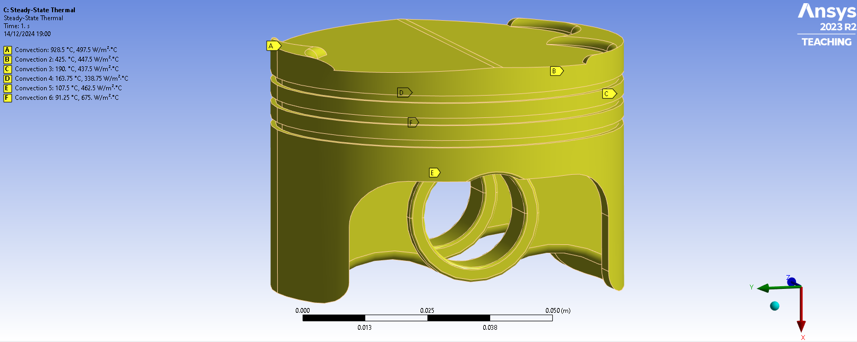
Figure 16
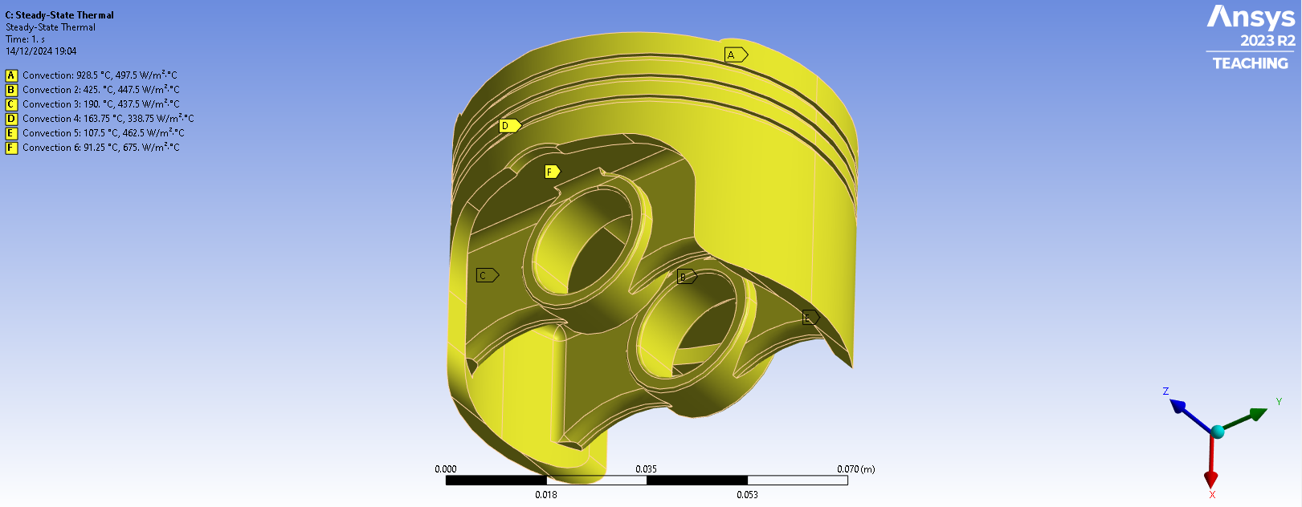
Figure 17
In practical use, simulating thermal loadings on a piston head allows insight into temperature and how this will be distributed across the component. This is an important part of the bigger picture when considering structural analysis of a component, as this information can be used to inform further analysis such as in a Static Structural system.

Results for this simulation can be seen in Figures 18, 19, and 20, with maximum temperature calculated being 300.52°C, minimum 163.98°C, and average 246.16°C.
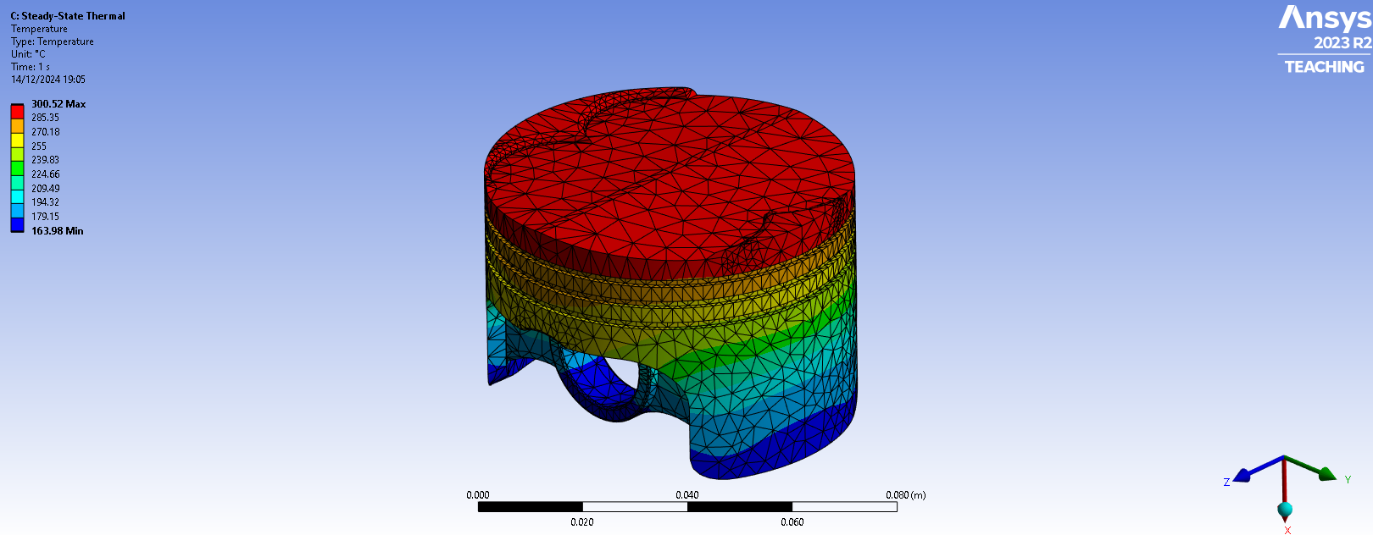
Figure 18 – isometric view of piston head from Steady-State Thermal results
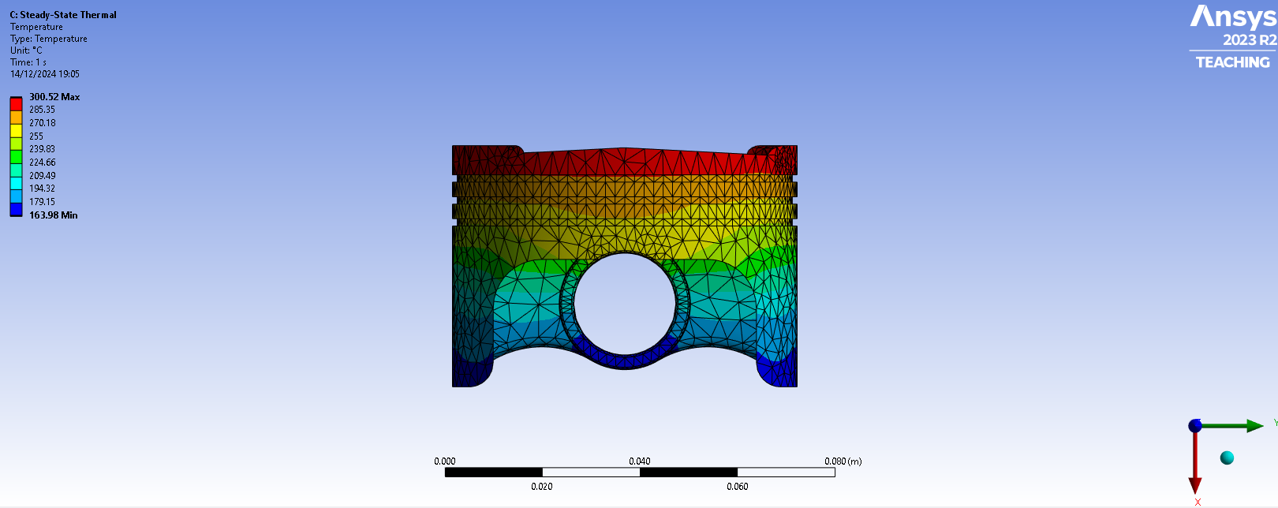
Figure 19 – side view of piston head from Steady-State Thermal results
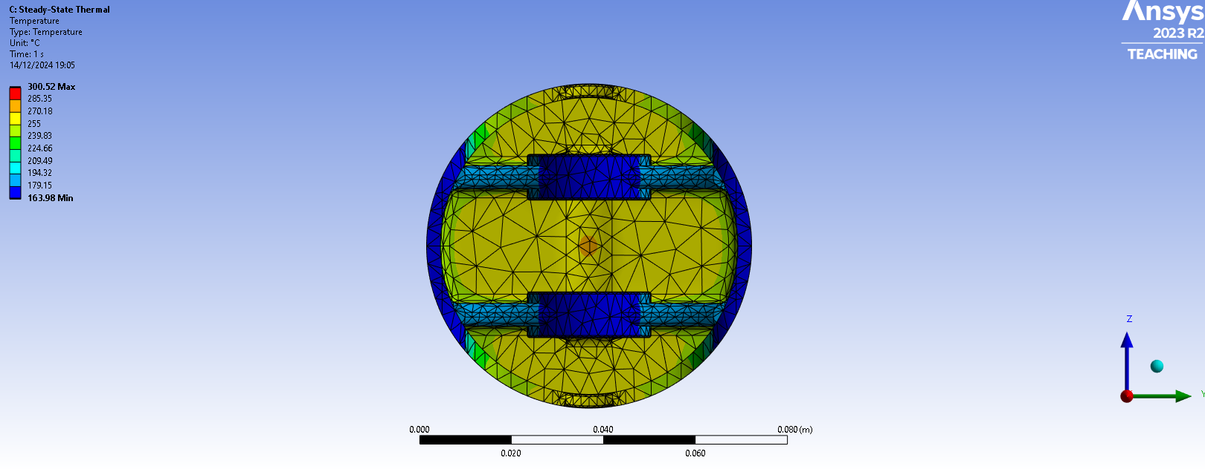
Figure 20 – underside view of piston head from Steady-State Thermal results
However, Steady-State Thermal results are subject to various assumptions. Due to being a steady-state simulation, temperature at any point remains constant and does not change over time, thus simplifying the boundary conditions. For the same reason, there are no transient thermal effects, including time-dependent buildup of heat or dissipation.

Static Structural
This analysis system determines deformation, stress, strain, force, and fatigue from loadings including externally applied forces and pressures, steady-state inertial forces, imposed displacements, and temperatures (Ansys, n.d.). In the case of this report, additional boundary conditions consisted of a pressure applied to the piston crown, a fixed support on the underside in place of the gudgeon pin location, and calculated results from prior systems in the Ansys project. These included the importing of motion loads exported from Rigid Dynamics, as well as the drawing in of the body temperature determined in the Steady-State Thermal analysis, achieved through feeding its ‘Solution’ stage to the ‘Setup’ stage of the Static Structural system. The pressure applied on piston crown measured 10.5 MPa and was sourced from (Noble, n.d.).

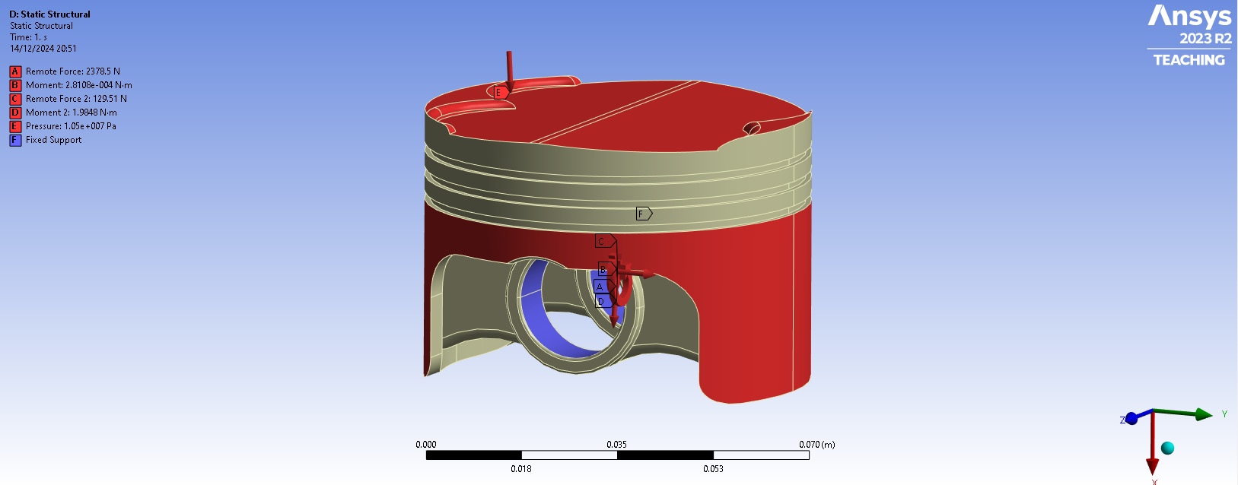
Figure 21 – boundary conditions in Static Structural system
Ideally, the piston would have been simulated with the absence of the fixed supports, highlighted in blue in Figure 21, and instead used ‘Weak springs’. With this analysis setting enabled, Ansys creates “artificial linear springs” with just enough stiffness to constrain the model (FEA Tips, 2020). However, despite showing no error messages, Ansys struggled to simulate using weak springs and so resorting to fixed supports was required. Thus, results were affected, especially deformation on the underside of the piston, and are therefore not as realistic as intended.

Using Static Structural allows boundary conditions calculated in other systems, in this instance in Rigid Dynamics and Steady-State Thermal, to be imported and combined to calculate outputs such as total deformation and equivalent stress. This allows insight into how, when all these loads are combined, the component reacts. In this instance, previous systems are created and simulated to better inform Static Structural boundary conditions for piston head analysis, leading to deformation and stress results with enhanced accuracy and realism.

Figures 22, 23, and 24 display total deformation of piston head as calculated in the Static Structural system. Maximum and minimum deformation were observed as 0.293mm and 0mm respectively. The difference in using weak springs over fixed supports can be seen in Figures 25 and 26, where an identical structural analysis was performed using the same material properties and boundary conditions. For comparison, maximum deformation calculated in this study was 0.349mm (Noble, 2024). This gives the use of fixed supports over weak springs a 19.11% error margin, illustrating the importance of the correct application of boundary conditions when performing setup of an analysis system to ensure accuracy.

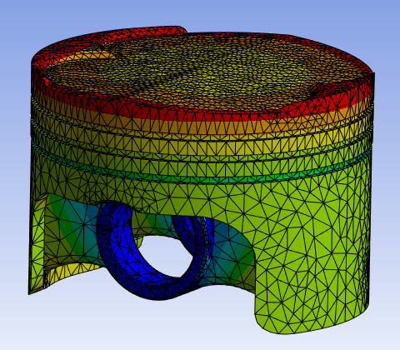  Figure 22 – isometric view of total deformation of piston head, calculated in Static Structural | 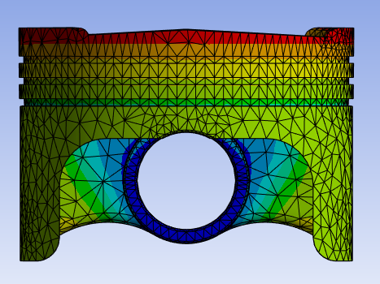  Figure 23 – side view of total deformation of piston head, calculated in Static Structural | 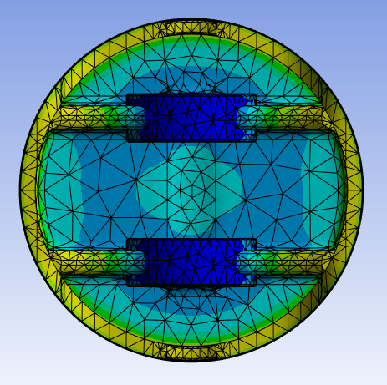  Figure 24 – underside view of deformation of piston head, calculated in Static Structural

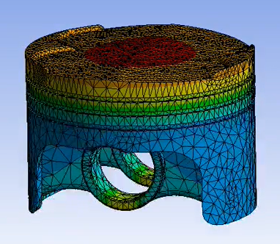  Figure 25 - isometric view of total deformation of piston head when using weak springs, as found in (Noble, 2024) | 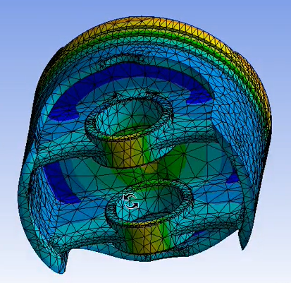  Figure 26 - underside view of total deformation of piston head when using weak springs, as found in (Noble, 2024)
Figures 27, 28, and 29 show calculated equivalent stress results, where maximum and minimum values were determined to be 361.56 MPa and 1.10 MPa, respectively. Again, the difference in using weak springs over fixed supports can be seen in Figures 30 and 31. With weak springs enabled, maximum and minimum stress values were 2232 MPa and 1.303 MPa. This results in a 517.33% maximum stress and 18.45% minimum stress error margin when using fixed supports over weak springs. This again reinforces the magnitude to which boundary conditions can alter results, emphasising the importance of setting these up correctly and as intended.

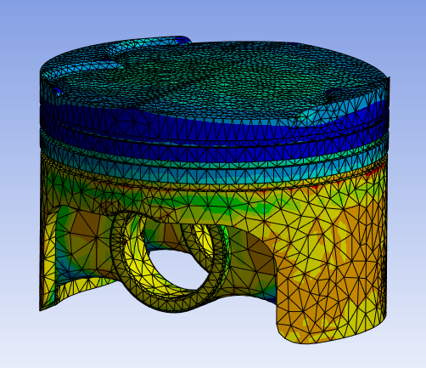  Figure 27 – isometric view of equivalent stress | 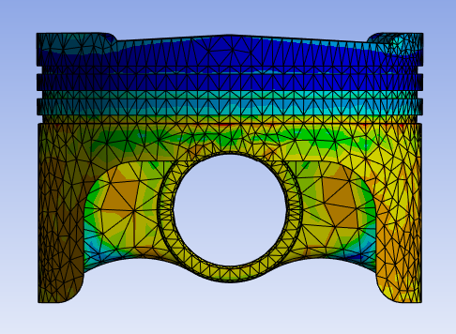  Figure 28 – side view of equivalent stress | 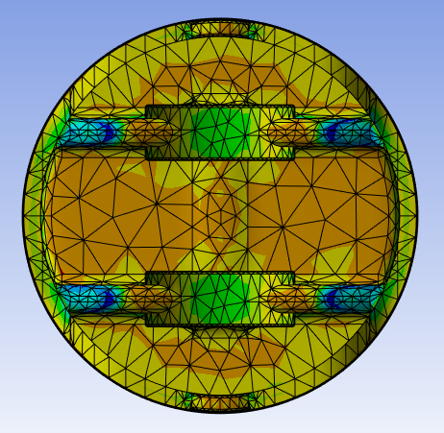  Figure 29 – underside view of equivalent stress

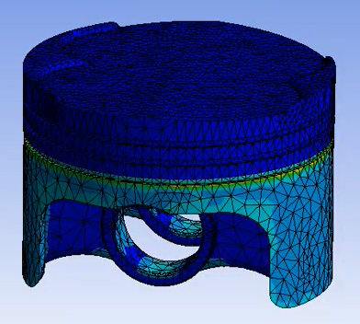  Figure 30 – isometric view of equivalent stress when using weak springs, as found in (Noble, 2024) | 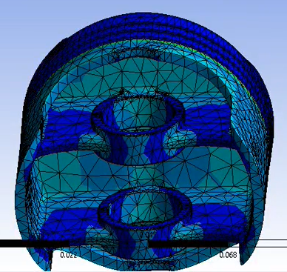  Figure 31 – underside view of equivalent stress when using weak springs, as found in (Noble, 2024)

Piston Head Optimisation

Material Study
Material Properties | 6061 T6 Aluminium alloy | Cast iron
Young's Modulus (GPa) | 66.6-70 | 185-215
Tensile strength (GPa) | 290-338 | 230-460
Poisson's ratio | 0.325-0.335 | 0.27-0.28
Fatigue strength at 10^7 cycles (MPa) | 112-131 | 90-185
Thermal conductivity (W/m.°C) | 152-169 | 18-28
Specific heat capacity (J/kg.°C) | 878-914 | 520-560
Thermal expansion coefficient (μstrain/°C) | 22.7-23.9 | 10-11
Piston mass (kg) | 0.256 | 0.727
Price (GBP/kg) | 1.653 | 0.261
Price (piston) | 0.423 | 0.190
Max deformation (mm) | 0.293 | 0.176
Max stress (MPa) | 361.56 | 390.59
Min stress (MPa) | 1.10 | 1.73
Table 3
Table 3 compares properties and FEA results of two separate material materials. Results for the aluminium alloy are shown previously in Figures 22-24 for deformation, and Figures 27-29 for stress, whereas Figures 32-38 represent results when the piston head was modelled using the cast iron.

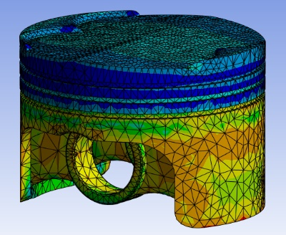  Figure 32 – isometric view of equivalent stress on cast iron piston head | 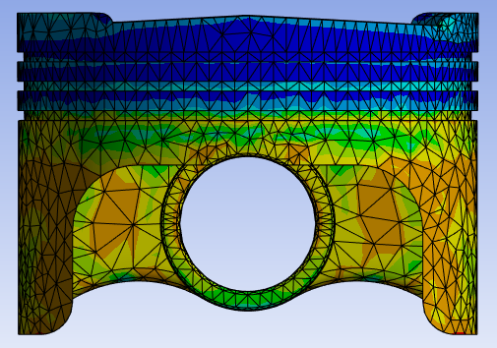  Figure 33 – side view of equivalent stress on cast iron piston head | 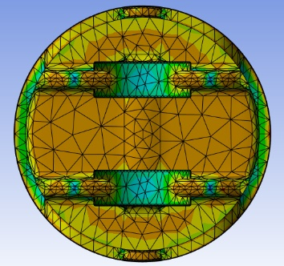  Figure 34 – underside view of equivalent stress on cast iron piston head
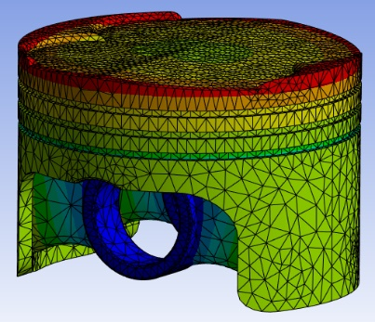  Figure 35 – isometric view of deformation on cast iron piston head | 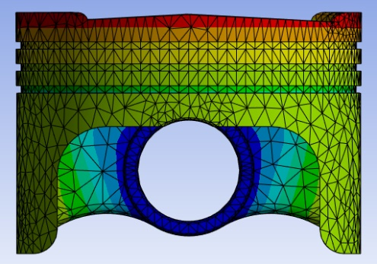  Figure 36 – side view of deformation on cast iron piston head | 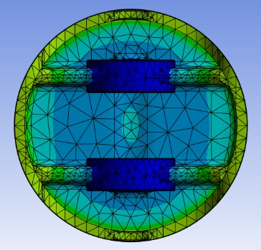  Figure 37 – underside view of deformation on cast iron piston head
From Table 3, deformation value is lower when using cast iron for the piston head over aluminium alloy. This is due to the differences in Young’s modulus, Tensile strength, and Poisson’s ratio. In the cast iron material the latter has a lower value, contributing towards less lateral deformation when forces are applied vertically, whereas Young’s modulus and Tensile strength values are greater.

A smaller deformation value of 0.176mm of the cast iron versus 0.293mm of the aluminium would be seen as beneficial in an engine, with the latter having 66.5% more deformation. However, with cast iron, max stress is 8% higher than aluminium.

Conclusion
To improve upon methodology and results discussed in this report, several factors can be mentioned. Namely, fixing the issue within Ansys which meant the use of weak springs in the Static Structural analysis prevented the simulation from completing would greatly improve accuracy when modelling components in similar fashion in future. This was highlighted in the comparison between simulation performed for this report, and identical simulations of which was performed with weak springs.

Furthermore, calculating fatigue life of components would greatly contribute towards discussions over suitable material choice, especially for components such as those within an engine which suffer great forces repeatedly over an extended period of time. As well as this, a mass optimisation simulation could be performed, which may help reduce inertial forces and wear on connecting components.

References
Ansys Innovation Courses, n.d. Intro to Rigid Body Dynamics - Lesson 4. [Online]
Available at: https://innovationspace.ansys.com/courses/courses/time_integration/lessons/intro-to-rigid-body-dynamics-lesson-4/
[Accessed 14 12 2024].
Ansys, n.d. 5.10. Steady-State Thermal Analysis. [Online]
Available at: https://ansyshelp.ansys.com/public/account/secured?returnurl=/Views/Secured/corp/v242/en/wb_sim/ds_static_thermal_analysis_type.html
[Accessed 14 12 2024].
Ansys, n.d. 5.9. Static Structural Analysis. [Online]
Available at: https://ansyshelp.ansys.com/public/account/secured?returnurl=/Views/Secured/corp/v242/en/wb_sim/ds_static_mechanical_analysis_type.html
[Accessed 14 12 2024].
Bashir, F., 2021. Simplification of CAD Geometries to perform CEM Simulations, Karlskrona: Blekinge Institute of Technology.
Dlubal, 2016. Bending Cantilever with Axial Force. [Online]
Available at: https://www.dlubal.com/en/downloads-and-information/examples-and-tutorials/verification-examples/000042
[Accessed 11 12 2024].
Dlubal, 2017. Bimetallic Strip. [Online]
Available at: https://www.dlubal.com/en/downloads-and-information/examples-and-tutorials/verification-examples/000078
[Accessed 11 12 2024].
Dlubal, 2022. Elastic Bending – Continuous Load. [Online]
Available at: https://www.dlubal.com/en/downloads-and-information/examples-and-tutorials/verification-examples/000016
[Accessed 2024 12 11].
FEA Tips, 2020. Weak Springs – Yes or No?. [Online]
Available at: https://featips.com/2020/05/14/weak-springs-yes-or-no/
[Accessed 15 12 2024].
FEA Tips, 2022. Transient Structural vs Rigid Dynamics Analysis in ANSYS. [Online]
Available at: https://featips.com/2022/10/03/transient-structural-vs-rigid-dynamics-in-ansys/?utm_source=chatgpt.com
[Accessed 14 12 2024].
Gardiner, J., 2017. Finite Element Analysis Convergence and Mesh Independence. [Online]
Available at: https://www.xceed-eng.com/finite-element-analysis-convergence-and-mesh-independence/
[Accessed 13 12 2024].
Grebenişan, G., Negrău, D. C. & Salem, N., 2021. A Connected Steady-State Thermal with a Structural Analysis using FEA in Ansys. Annals of the Oradea University: Fascicle Management and Technological Engineering, 30(20).
Kojima, Y., 2000. Mechanical CAE in Automotive Design. R&D Review of Toyota CRDL, 35(4), pp. 1-10.
Lee, G. et al., 2019. Review of statistical model calibration and validation—from the perspective of uncertainty structures. Structural and Multidisciplinary Optimization, Volume 60, pp. 1619-1644.
Nielsen, C. V. & Martins, P. A., 2021. Chapter 3 - Finite element simulation: A user's perspective. In: Metal Forming. s.l.:Elsevier, pp. 109-180.
Noble, A., 2024. 6 - Fully Linked Systems, s.l.: s.n.
Noble, A., n.d. Piston Thermal Study Data, s.l.: s.n.
Paulin Research Group, n.d. Faster FEA: Structured vs Unstructured Meshing. [Online]
Available at: https://www.paulin.com/insights/compute-accurate-stresses-with-prg-mesh-modeler
[Accessed 14 12 2024].
Shimada, K., 2006. Current Trends and Issues in Automatic Mesh Generation. Computer-Aided Design & Applications, 3(6), pp. 741-750.
Siemens, n.d. Computer-aided engineering (CAE). [Online]
Available at: https://www.sw.siemens.com/en-US/technology/computer-aided-engineering-cae/
[Accessed 11 12 2024].
Universidad Europea, 2024. What is structural analysis?. [Online]
Available at: https://universidadeuropea.com/en/blog/what-is-structural-analysis/#:~:text=In%20simpler%20terms%2C%20structural%20analysis,earthquakes%2C%20or%20even%20human%20occupancy.
[Accessed 11 12 2024].

