Module Title: The Digital Professional for Health and Care
Module Code: BMDS7000
Student Number: 0251817
Assignment Title: System Improvement Programme - Developing a Business Intelligence Performance Dashboard for Corporate Performance Reporting
Lecturer: Philip Scott
Word Count: 4615
Submission Date: 10/12/21

Domain
Setting
NHS Wales has never been under so much pressure to be able to deliver care within an environment where demand for its services is at its highest level and the requirement to deal with large back logs in waiting lists whilst capacity in the system is restricted and set to be restricted for some time (NHS Confederation, 2021).
To enable NHS organisations to continue to focus on delivering patient care it is important that NHS Wales Shared Services Partnership (NWSSP) continues to provide a high-quality service not to distract from the delivery of that care through the monitoring of organisational performance and acting on underperforming areas.
Scope
The system improvement programme identified is to develop a Business Intelligence (BI) Performance Dashboard for Corporate Performance Reporting which is a digital tool to communicate important organisational performance information to a target audience (Ghazisaeidi et al, 2015). BI is used for transformation of data into meaningful information with the aim of providing the audience with strategic and operational information to inform decision making (Young Lee, 2018).
It is important to note that Corporate Performance reporting already exists within the organisation through the utilisation of other standard software but not through BI software or application.
Background
NWSSP was setup in “2011 to provide a range of high quality, customer-focused professional, technical and administrative services on behalf of all Health Boards and Trusts in NHS Wales”. In addition to provide savings back to the Health Boards and Trusts through streamlining processes, improved performance of functions NWSSP perform and increased buying power. NWSSP is accountable to the health board and trusts through Shared Services Partnership Committee (SSPC) which has representatives from all the health organisation within NHS Wales using our services and Welsh Government. The SSPC monitors NWSSP performance and guides NWSSP policy. The purpose of NWSSP is to support health boards and trusts through these services so that they are able to concentrate on effective delivery of front-line patient facing services (NWSSP, 2011).
The services that NWSSP provide are in the most so-called ‘back office’ services like, Payroll, recruitment and accounts payable that support the health boards and trusts deliver care. There are some exceptions to the services we provide that do not fall under that category, for example Surgical Materials Testing Laboratory (SMTL), Medical Examiner and Welsh Infected Blood Support Scheme (WIBSS)
Within NWSSP, Corporate Performance Reporting is currently a manual, broadly paper-based exercise collecting data from multiple different systems and services in relation to Key Performance Indicators (KPIs) and key activity data. The data is collated, reworked and reformatted by the Business and Performance Manager into a Corporate Performance report which is presented to the Senior Leadership Group (SLG) and Shared Services Partnership Committee (SSPC) monthly and bi-monthly respectively, these are the decision makers and strategic leads. The report currently is produced through Microsoft Excel and Microsoft Word. The KPIs are reviewed and refreshed on an annual basis as part of the Integrated Medium-Term Plan (IMTP) that all NHS Wales organisations adhere to and report in to Welsh Government on (NWSSP, 2011).
The production of the current reports is a time-critical exercise and receiving data in many different formats from many sources across our divisions monthly can delay the reporting, it can also be prone to manual error through required data manipulation into the correct format. The current reporting is mainly reactive analysis looking at historical trend data.
Literature Review
This review aimed to identify solutions to developing a performance Business Intelligence (BI) performance dashboard for corporate reporting.
UWTSD Library and Learning Resources, Google Scholar was chosen for the literature review. UWTSD was chosen as the go to resource due to having access to numerous databases that provided access to online content of Journals, Articles and Books. In addition, the databases such as ProQuest, EBSCOhost and VLebooks recommended further content for review based on the search criteria, subsequent searches for further reading were also completed in Google Scholar.
The following keywords were included as a search basis:
- Business Intelligence
- Business Intelligence Benefits
- Business Intelligence Limitations/Disadvantages
- Critical Success Factors Business Intelligence
- Business Intelligence in Health
- Performance Dashboards
- Dashboard Reporting
- Data Quality
- Dashboard Visualisation
- Behaviour Change
- Project methodologies – Scrum, Agile, Prince2, Managing Successful Programmes (MSP)
- Change Management
To limit search results, peer-reviewed articles and journals took priority but to also look for more recent publications where possible. Where applicable the contents of books and abstracts from articles were reviewed to determine if they were useful to this report.
There was limited literature on Business Intelligence use within NHS Wales so the review had to look further afield into Health in General but also Private Sector use.
Aims & Objectives
The BI corporate performance dashboard’s aim is to create a data driven organisation to inform better more time critical business decisions. To avoid these pitfalls and improve NWSSP as a data driven organisation and to inform better decisions the organisation needs to develop a Business Intelligence (BI) dashboard for Corporate performance reporting to improve timeliness and data quality (Khan & Quadri, 2012).
The current performance reporting concentrates on reactive or historical trend data, this data is then used to inform a decision by the decision makers. BI provides the opportunity of proactive analysis through forecasting and insights. This enables measures to be put in place before an issue occurs rather than reacting to a reported issue retrospectively. This enables the decision makes to act and possibly mitigate the risk (Mohd and MrSafdar, 2017)
Decision makers on a strategic and operational level require the performance information to be reported timely and up to date to enable decisions that impact the organisation or service to be made quickly (Parmenter, 2015). The quality of the information reporting is a significant factor with accuracy being vitally important so that decisions are being made on accurate information and for the decision makers to be assured that this information is accurate. To provide assurance on the accuracy Internal Audit which is a service that NWSSP provides will be used (Bassett & Westmore, 2012).
Whilst the BI corporate performance dashboard will not necessarily improve data quality directly as it can only report on the data that has been input into the BI software or application. However, as the BI corporate performance dashboard is used as a tool to inform decision making and understanding on reliance that information being accurate will indirectly drive improvement into the data quality as data providers realise what the data is being used for through review of the data before submission (Yeoh, 2014).
The BI corporate performance dashboard needs to be in a tailored format through enhanced visualisations for the audience it is targeted at. There are many different graphical methods to communicate performance indicators such as the choice between using a tables, charts or a standalone figures. This will provide additional organisational insight and target discussions (Parameter, 2015). There are many different suppliers that provide the architecture for BI Corporate Performance dashboard reporting like, Microsoft Power Bi, Qlikview and Tableau to name a few, which all do a similar job.
The BI Corporate Performance dashboard will also allow the decision makers to drill down and analyse the data to enable decisions to be made at the point of reporting, not waiting for answers to queries and preventing any further delays to decisions on corrective actions (Shao, 2022). The BI corporate performance dashboard will enable the decisions makers to be more engaged with the data due to the interactive nature of the dashboard (Victor, S. & Farooq, A, 2021).
Obtaining consensus will be essential to agreeing the key information the corporate performance dashboard reports, how the dashboard looks, and the type of visualisations used. The delphi method could be a useful tool to facilitate this seeking involvement from the decision makers and obtain feedback through numerous rounds of questioning until a consensus is achieved. In this situation the decision makers are the Senior Leadership Group and the experts in their field that the delphi model requires. (Taylor, 2020).
(Chartered Management Institute, 2020) suggests when setting the objectives, it is important to consider as to whether they are SMART (Specific, Measurable, Achievable, Realistic and Time-bound). These can be defined as:
- Specific – Clear and Focused.
- Measurable – How is it measured?
- Achievable – Can it be Achieved?
- Realistic – Similar to achievable, is it a realistic objective?
- Time-bound – When will it to be achieved?
For this project the identified objectives will be as follows:
- 100% uptake from decision makers using the BI corporate performance dashboard by June 2022.
- By the deadline of each of the monthly meeting the BI corporate performance dashboard available to the decision makers.
- A noticeable improvement in performance for underperforming KPIs within 6 months of implementation.
For the BI corporate performance dashboard to be a success it will be required to be easy to understand and easily accessible for the decision makers. It will be required to be accurate and a trusted tool which is easy to use, with the ultimate aim of improved decision making for the organisation and its customers, partners and stakeholders. These are a requirement and will directly contribute to whether the development of a BI corporate performance dashboard will be a success (Işık, 2013). The functional features and visualisation of the BI corporate performance dashboard is important to ensure that the right decisions are made. The visualisations are recommended to be consistent and allow multi-dimensional analysis. The information must be presented to the decision maker effectively to make best use of their time (Ghazisaeidi et al, 2015).
Under performing areas and specific KPIs should see improvements in the performance quicker as decision makers will be able to act quicker on the information as it is more accurate, more up-to date, easier to engage with more forward looking.
NWSSP is primarily guided by Ministerial Priorities and strategic objectives set out in the ‘programme for government’ (Welsh Government, 2021) which change over time. The KPIs need to support and react to these changes to enable the organisation to meet the priorities and strategic objectives which do require constant review to see if they are fit for purpose. The review of these will impact the BI corporate performance dashboard and as a consequence of this the dashboard will also need to be flexible to be able to bring in new performance indicators and drop out performance indicators as required.
Methodology
Developing a BI Performance Dashboard for Corporate Performance Reporting is a project rather than a programme as per the Prince 2 definition of a project “a temporary organisation that is created for the purpose of delivering one or more business products according to a specified business case” and having an end whereas a programme is considered a group of projects that are long term and sometime spanning years (Axelos, 2017).
In identifying the best Project Methodology to use two were considered. Prince2 which is commonly used within NHS Wales and considered to be a more traditional Methodology and Scrum which is considered an Agile theory (Jovanovic et al, 2018). Managing Successful Programmes was discounted as this piece of work is identified as a project and not a programme as per the Prince2 definition.
The BI corporate performance dashboard is broadly an IT system improvement project moving from a manual system to a digital solution. To identify the project methodology that best fits it is important to understand the project characteristics and scale of the project and to remain within the scope of the project, deliver the project on time within resource limits and within budget whilst also recognising the risks.
Project Limitations or constraints
- Time – Projects has a specific end point where the final solution will be ready.
- Resource – Identify how much resource is available to the project and for how long.
- Cost – How much budget is available to deliver the project
- Quality of the BI corporate performance dashboard
- Satisfaction of the decision makers
To avoid any scope creep and risking the project to fail, it is clearly set out that the project is restricted to the domain of develop a BI Performance Dashboard for Corporate Performance Reporting only and no deviation from this domain. It is considered that scope creep can be the biggest cause of project failure and important to manage the expectation through the project (Komal et al, 2020).
The project methodology decided upon will be based on agile theories using Scrum methodology. Scrum methodology is about breaking down the project into smaller pieces of work and using a process of continuous and constant review, updating iterations through regular Sprints with each iteration or release of the dashboard receiving feedback to review and build into the next release of the dashboard, this will be fast moving due to the dashboard having the customer in mind which in this context is the Senior Leadership Group (Cervone, 2011).
Any project will require representation from key stakeholders which not only involve the end user in this case the decision makers but also representation from subject experts like People & Organisational Development, Finance, Information Governance, Cyber Security and Informatics. These stakeholders are critical to the success of the project and provide feedback incrementally but not seen as part of the Scrum Team (Schwaber, 2004, p.17).
The main difference between Prince2 methodology and Scrum methodology is that Scrum is a so-called light weight approach to project management which concentrates on delivering the dashboard as quick as possible and then continuing to improve and adapt it as part of an iterative process. Using Prince2 methodology will take longer as the concentration is on the perceived finished dashboard and nothing can be altered or changed after the initial design stage (Mahalakshmi et al, 2013). The feedback cycle using Scrum Methodology is quicker between the development team and the end user.
Another difference is that Prince2 uses Project Managers to manage a project whereas the Scrum methodology uses Scrum Masters. The skills may not exist within the organisation as Prince2 has been the legacy approach to projects in the past. However, that being said it is considered that a Prince2 practitioner could simply tailor the skills and apply scrum methodology to a project (Ghosh et al, 2012).
One of the potential risks deviating from the Prince2 methodology to use the Scrum methodology would be that Prince2 traditionally and currently is used within NHS Wales projects and Projects sponsors will be used to the step-by-step approach and a solution delivered at the end of the project (Walsh et al, 2021).
With the customer being at the forefront of the development of the corporate performance dashboard will require early engagement on identifying the product (BI Dashboard) specification and design through stakeholder interviews or workshops. The customer is the decision makers who will be making organisational decisions informed by the dashboard. Due to there being many iterations continuous engagement is highly important to develop the dashboard. The MoSCoW approach to prioritisations can be used with the engagement of decision makers to form a list of the dashboard requirements (Hyseni, 2020). The acronym MoSCow developed by (Clegg, 1994) stands for:
- M = Must have – These are critical and non-negotiable requirements to be included in the dashboard.
- S = Should have – These are a step down from “Must haves” but considered essential but not vital.
- C = Could have – These are desirable or nice to have.
- W = Won’t have - These are initiatives that are not included this time but will be looked at inclusions in future developments.
Upon introduction of the BI corporate performance dashboard, it will be important to recognise that individuals will go through a number of stages of change as identified in the adapted Kubler-Ross Change Curve. The Kubler-Ross curve was originally used as a model for identifying the grief cycle, to alleviate these potential challenges early engagement will be key. When looking at the Kubler-Ross change curve It is important to tailor approaches in dealing with individuals within the different stages (Kubler-Ross, 1969). Dealing with shock and denial will require communication and demonstrating the dashboard whilst the approach to frustration and depression would be to support and understand the user’s frustration with the dashboard. The following stages of experiment and decisions allows individuals to further explore the dashboard, with the last stage of acceptance that the dashboard being integrated.
Below is an example of the Kubler-Ross change curve adapted from the grief cycle (Kubler-Ross, 1969):
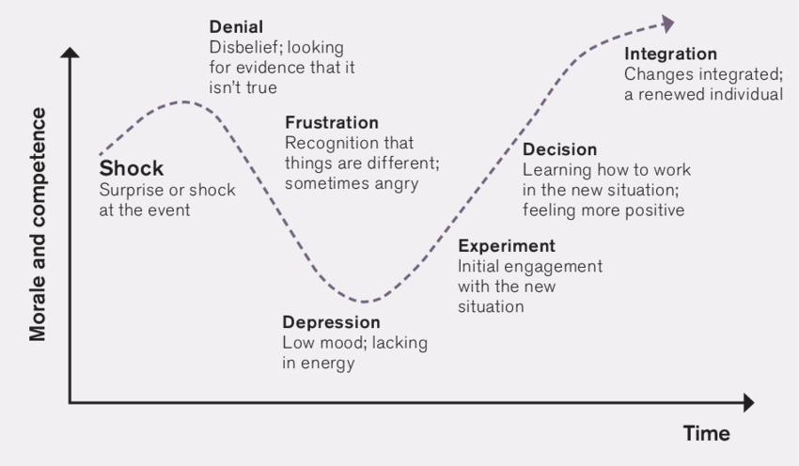
The Topol review into “Preparing the healthcare workforce to deliver the digital future” also recommended that health and care staff need to be encouraged to develop their skills in digital literacy which again highlights the importance of training and support (Topol, 2019). With the fundamental changes proposed to performance reporting, the decision makers are likely to require early engagement in the move from current reporting to BI corporate performance dashboard reporting. The behaviour framework specifically the Behaviour Change Wheel (BCW) is a significant tool to highlight relevant intervention functions for the Senior Leadership Group. These would be training and education on how to use the dashboard which could be in the format of a workshop (Michie et al., 2011).
The diagram below shows the Behaviour Change wheel and the intervention functions (Michie et al., 2011):

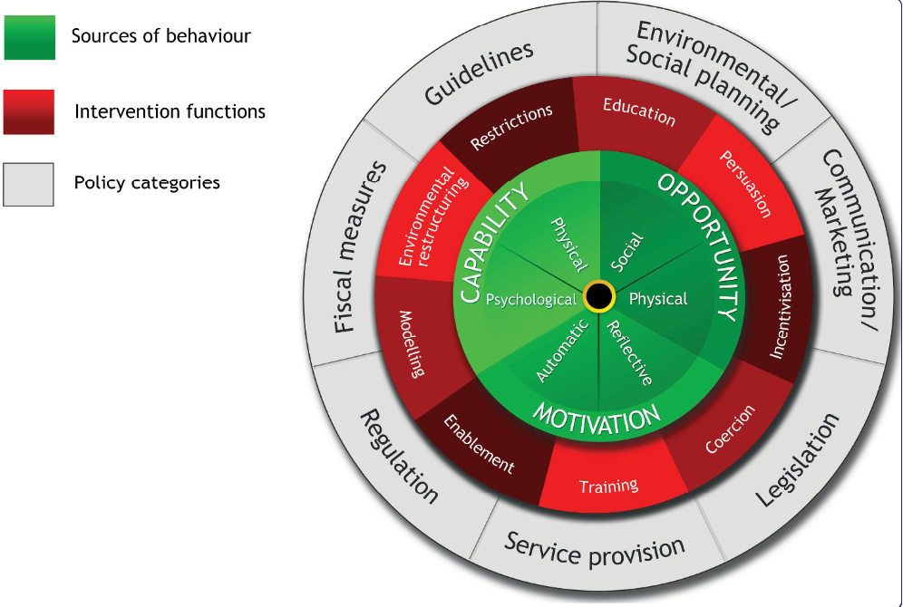
Measures/Interventions
The benefits that arise from using Business Intelligence are not straightforward to capture and often described as intangible or soft benefits. Although there is a cost to developing a corporate performance dashboard utilising BI through a resource cost and purchasing the BI software or application which is set out at the forefront of the project constraints or limitations. The Return on Investment (ROI) which is a common approach to recognising whether a project delivers benefits. This is difficult to demonstrate as the output from a business intelligence tool is information and the benefit arises from the positive decisions made by the decision makers acting on the information (Lönnqvist et al, 2006).
An Internal Audit review will evaluate the effectiveness of the system and the internal controls of the BI Performance Dashboard and provide assurance to the decision makers on the accuracy of the reporting and any recommendation actioned (NWSSP, 2011).
Impact will be measured by feedback from decision makers. A questionnaire or survey to collate evidence on user experiences of the dashboard and will highlight the satisfaction. The feedback sought will then be used to develop future iterations of the BI corporate performance dashboard in line with the Scrum Methodology.
Business and Performance Manager will spend less time spent producing Performance Report enabling them to add value and insight. Instead of just reporting the performance the added value comes from identifying why something is happening, what is the resolution required to resolve the performance issue and how and by when can it be expected to be resolved.
The decision of which graphical form the information takes when presented through the BI corporate performance dashboard is significant as the decision makers will need to absorb and interpret the data not only quickly to grab the audience but also accurately. Ensure that the graphical form is not overall complicated. The measure as to if this achieved will drive improvement in performance as interpretation of charts or tables will be quicker and accurately to give a better opportunity to delivering the right decisions are made for the organisations (Few, 2004).
Under performing areas and specific KPIs should see improvements in the performance quicker as decision makers will be able to act quicker on the information as it is more accurate, more up-to date, easier to engage with more forward looking.
Causality and specifically the identification of risks or negative reactions can be developed using Causal Loop Diagrams (CLD). These diagrams focus on visualising the relationships that exist between cause and effect. There were limited articles where this has been used with BI but fundamentally can be used within any project. The key relationships are the objectives of the project and how failure to meet the objective will impact on the overarching aim (Toole, 2005).
Using examples from this service improvement project of developing a BI corporate performance dashboard.
- If the dashboard doesn’t show accurate information due to data quality, then key decisions made will be incorrect or not made which will impact negatively on the organisation’s performance.
- If the dashboard doesn’t show visualisations which the end user finds useful and understands as they didn’t have user engagement, then they will not rely on it and not make decisions or make incorrect decisions.
- If the functionality is unable to be used due to education or training issue, then the incorrect or no decisions could be made.
- If the performance information is not reported timely then the decisions could be incorrect or made too late.
A practical example using one of the services NWSSP provides would be the Recruitment Service that NWSSP provides to NHS Wales. If there are recruitment delays, then this needs to be brought to the attention of the Senior Leadership Group (SLG) in a timely, accurate and understandable manner so that remedial action can be planned and actioned. Any delays in the recruitment process could indirectly affect patient care due to a delay of onboarding of the necessary resource.
However, the risks identified could be true of the current manual corporate performance reporting but helps to visualise the counter measures required to mitigate the risk.
Improvements/Future opportunities
The scope of the project is limited to developing a BI Corporate performance reporting dashboard to replace the current corporate performance report. The data that is collected for this purpose is specific and relatively small in comparison to the amount of data that NWSSP holds. There would be an opportunity to target all NWSSP divisions with the use of BI software or application so that the opportunities and potential benefits of seeing the data in real time, manipulating the raw data into quality information could be explored. Having many systems and applications already in place often have their own reporting tools, whilst it may prove difficult to have a direct link to these systems due to licensing agreements etc. It will also be problematic as these systems often have their own data standards so that the transformation into information may result in meaningless poor information. In addition, linking systems that may not have been designed for use with BI applications in mind (Yeoh & Koronios, 2010). It could also be the case that one BI solution or application fits the needs of all sections of the organisation (Shadi & Mustafee, 2013).
Ensuring data quality within an organisation is essential to ensure decisions are made on quality information and whilst BI dashboard performance reporting can ensure the data integrity of the performance itself it doesn’t ensure the data quality at source. This would be the next steps to review all data that is relied upon for performance. There may also be a need to look at the data standards that exist within the organisation to ensure it can be understood and there is common language as defined in the Health and Social Care Act 2012.
Most BI software or application allows the user to develop dashboards to be able to be displayed for the purpose of Mobile Phone consumption. This would allow the decision makers to make the decisions on the go or when they don’t have access to a laptop or primary device for whatever reason. Having the option of being able to access the information via a smartphone is important as the majority of the decision makers already have access to such devices and already use them for work purposes in relation to Microsoft Office 365 and e-mails.
Improvements
Different people whilst looking at dashboard visualisations can draw very different conclusions and can end up making different decisions based on the same information (Few, 2004). Therefore, it is very important to engage with the decision makers when designing the visualisations to avoid any potential differing of opinions on the action required and the design is fit for purpose.
There are several disadvantages that can be identified from Utilising BI as a tool. Development may require additional resource in the form of developers as the skills and expertise may not exist within the organisation to develop a BI corporate performance dashboard. This would be an additional cost for training existing staff, employing resource or alternatively utilising external consultancy but these costs would be recognised as part of the project scope (Muhammad et al, 2014). In addition to not only the training and extra resource, the cost of licenses for the BI software or application can be expensive dependent on the scale it will be used (Kascelan, 2011).
Implementation of a BI corporate performance dashboard can take a long time to develop sometimes taking 6 months to a year and even longer (Mahalakshmi et al, 2013) however given that the Scrum methodology for project management has been identified to be used this should mitigate the possible delays and a first draft dashboard could be available quicker due to the iteration and sprint approach.
Resistance to change and the adoption of the BI corporate performance dashboard could be a barrier to the success of this initiative. According to Kotter (2012) for the organisation to embrace the change the decision makers will go through 8 steps of change. Step 1 involves establishing a sense of urgency which in the situation is the unprecedented demand on the NHS and is the driver for the need for change. Step 2 to form a powerful coalition which again is already in place as the SLG, whom are the decision makers and tasked with monitoring performance. Step 3 involves creating a clear vision of what the change will bring about. This is the Aims of the BI corporate performance dashboard project. Step 4 requires the communication of the vision which the Business and Performance manger will need to talk repeatedly about the change to the new dashboard and be open to any questions and concerns through the process. Step 5 is empowering others to act which involves removing any obstacles by listening to issues and concerns they have and offering support. Step 6 involves identifying short term wins which in this situation would mean having an iteration of the BI corporate performance dashboard quickly so that the decision makers can see the benefits identified. Step 7 is consolidating the gains and build on it by applying the lesson learnt and applying this to future opportunities through a continuous improvement cycle. Step 8 is anchoring these new approaches into the culture of the organisation through case studies that help embed these changes.
The diagram below shows the eight-stage process of creating change (Kotter, 2012):
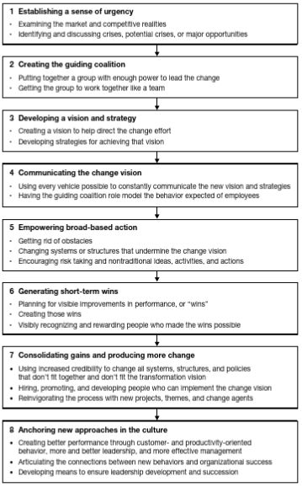
A limitation to the successful development and implementation of the BI corporate performance dashboard would be the existence of poor data quality (Kascelan, 2011). However, if there are data quality issues then these already exist within the current reporting arrangements. If it is found that data quality issues do exist, then a separate project would need to initiated look into data quality issues.
Possible data security is a consideration that needs to apply when moving from a manual corporate performance report to a digital BI corporate performance dashboard solution due to the information being held online and could be at threat of being accessed inappropriately. The NHS has strict controls on cyber security and as such security experts will need to be involved as key stakeholders in the project so that any mitigating risk and correct process can be applied. Even though the current corporate performance reporting is predominantly manual and paper-based data breaches and issues with Information Governance can still apply and are managed accordingly but may just need adapted to fit the digital solution of the BI corporate performance dashboard.

References
Aragon Aragon, M.J., Castelli, A. and Gaughan, J. (2017) ‘Hospital Trusts productivity in the English NHS: Uncovering possible drivers of productivity variations’. PLoS One, 12(8).
Axelos. (2017). ‘Managing Successful Projects with Prince2’
Bassett, S. and Westmore, K. (2012) ‘Robust data enables managers to promote good practice: Effective governance requires that senior management teams base their decisions on accurate, reliable and timely information, such as quality and performance indicators. Sally Bassett and Kathryn Westmore explain’, Nursing management (Harrow, London, England), 19(7), pp. 24–26. doi:10.7748/nm2012.11.19.7.24.c9373.
Bjerke, M.B. and Renger, R. (2017) ‘Being smart about writing SMART objectives’, Evaluation and program planning, 61, pp. 125–127. doi:10.1016/j.evalprogplan.2016.12.009.
Bugwandeen, K. and Ungerer, M. (2019). ‘Exploring the design of Performance Dashboards in relation to achieving Organisational Strategic Goals’. South African Journal of Industrial Engineering, 30(2), pp. 161-175.
Cervone, H.F (2011) ‘Understanding agile project management methods using Scrum’. OCLC systems & services. [Online] 27 (1), 18–.
Chartered Management Institute (2020) – Setting Smart Objectives. Available at: https://www.managers.org.uk/knowledge-and-insights/resource/setting-smart-objectives/ (Accessed 30 November 2021)
Clegg D; Barker, R. Case (1994) ‘Method Fast-Track: A RAD Approach’. 1st ed. Addison-Wesley.
Dănescu, T. and Matei, R.B. (2020) ‘Integrated Reporting Performance – Effect of Organizational Behavior Development’, Acta Marisiensis. Seria Oeconomica, 14(1), pp. 13–20. doi:10.2478/amso-2020-0002.
Fernandez, D.J. and Fernandez, J.D. (2008) ‘Agile Project Management -Agilism versus Traditional Approaches’, The Journal of computer information systems, 49(2), pp. 10–17. doi:10.1080/08874417.2009.11646044.
Few, S. (2004) ‘Show me the numbers’. Analytics Pres.
Foshay, N. and Kuziemsky, C. (2014) ‘Towards an implementation framework for business intelligence in healthcare’, International journal of information management, 34(1), pp. 20–27. doi: 10.1016/j.ijinfomgt.2013.09.003.
Ghasemaghaei, M. (2019) ‘Does data analytics use improve firm decision making quality? The role of knowledge sharing and data analytics competency’, Decision Support Systems, 120, pp. 14–24. doi:10.1016/j.dss.2019.03.004
Ghazisaeidi, M., Safdari, R., Torabi, M., Mirzaee, M., Farzi, J. and Goodini, A. (2015) ‘Development of Performance Dashboards in Healthcare Sector: Key Practical Issues’. Acta Informatica Medica, 23(5), pp. 317-321.
Ghosh, S., Forrest, D., DiNetta, T., Wolfe, B. and Lambert, D.C. (2012) ‘Enhance PMBOK® by comparing it with P2M, ICB, PRINCE2, APM and Scrum project management standards’ PM World Today, 14(1), pp.1-77.
Health and Social Care Act 2012 Available at: https://www.legislation.gov.uk/ukpga/2012/7/section/250 (Accessed 26 November 2021)
Hewko, S.J. and Cummings, G.G. (2016) ‘Performance management in healthcare: a critical analysis’, Leadership in health services (2007), 29(1), pp. 52–68. doi:10.1108/LHS-12-2014-0081.
Hyseni, L., Guzman-Castillo, M., Kypridemos, C., Collins, B., Schwaller, E., Capewell, S., Boland, A., Dickson, R., O’Flaherty, M., Gallacher, K. and Hale, P. (2020) ‘Engaging with stakeholders to inform the development of a decision-support tool for the NHS health check programme: qualitative study’ BMC health services research, 20, pp.1-10.
Isik, Ö. Jones, M.C. and Sidorova, A., 2013. ‘Business intelligence success: The roles of BI capabilities and decision environments. Information & Management’, 50(1).
Jovanovic, P. and Beric, I. (2018) ‘Analysis of the Available Project Management Methodologies’, Management (Belgrade University, Faculty of Organizational Sciences), 23(3), pp. 1–13. doi:10.7595/management.fon.2018.0027
Kascelan, L. (2011) ‘Advantages and limitations in implementation of business intelligence system in Montenegro: Case study Telenor Montenegro’. Economic Review: Journal of Economics and Business, 9(2), pp.19-30.
Khan, R.A. and Quadri, S.M.K. (2012) ‘Business intelligence: an integrated approach’. Business Intelligence Journal, 5(1), pp.64-70.
Kiani, B., Gholamian, M.R., Hamzehei, A. and Hosseini, S.H. (2009) ‘Using Causal Loop Diagram to Achieve a Better Understanding of e-Business Models’. International Journal of Electronic Business Management, 7(3).
Komal, B., Janjua, U.I., Anwar, F., Madni, T.M., Cheema, M.F., Malik, M.N. and Shahid, A.R. (2020). ‘The impact of scope creep on project success: An empirical investigation’ IEEE Access, 8, pp.125755-125775.
Kotter, J.P. (2012) Leading change. Boston, Massachusetts: Harvard Business Review Press.
Laursen, G.H.N. and Thorlund, J. (2017) ‘Business analytics for managers : taking business intelligence beyond reporting’. Second edition. Hoboken, New Jersey: Wiley.
Lönnqvist, A. and Pirttimäki, V. (2006) ‘The measurement of business intelligence’. Inf. Syst. Manag., 23(1), pp.32-40.
Lord Carter of Coles - Operational productivity and performance in English NHS acute hospitals: Unwarranted variations – An independent report for the Department of Health by Lord Carter of Coles – February 2016 (publishing.service.gov.uk)
Lust, J.A. (2000) ‘Performance Drivers: A Practical Guide to the Balanced Scorecard’, Personnel Psychology. Durham: Wiley Subscription Services, Inc, p. 506–
Mahalakshmi, M. and Sundararajan, M. (2013) ‘Traditional SDLC vs scrum methodology–a comparative study’. International Journal of Emerging Technology and Advanced Engineering, 3(6), pp.192-196
Michie, S. et al. (2011) ‘The behaviour change wheel: a new method for characterising and designing behaviour change interventions’. Implementation science : IS. 6.
Mohd, A. and MrSafdar, T. (2017) ‘Impact of Business Intelligence and Predictive Analysis in Big Data’, International journal of advanced research in computer science, 8(5), p. 1324–. doi:10.26483/ijarcs.v8i5.3570.
Muhammad, G., Ibrahim, J., Bhatti, Z. and Waqas, A. (2014). ‘Business intelligence as a knowledge management tool in providing financial consultancy services’. American Journal of Information Systems, 2(2), pp.26-32.
NHS Confederation (2021) NHS Wales system pressures. Available at: https://www.nhsconfed.org/publications/briefing-nhs-wales-system-pressures (Accessed 26 November 2021)
NWSSP (2011) About Us. Available at: https://nwssp.nhs.wales/about-us (Accessed: 23 November 2021)
NWSSP (2011) – Integrated Medium Term Plan. Available at: https://nwssp.nhs.wales/corporate-documents/corporate-integrated-medium-term-plan-imtp/imtp-executive-summary-2020-2023/ (Accessed 23 November 2021)
Ovchinnikov, D. et al. (2021) ‘Digitalizing quality of care control: a Business Intelligence system for COVID-19 inpatients’, European journal of public health, 31(Supplement_3). doi: 10.1093/eurpub/ckab164.504.
Parmenter, D. (2015) ‘Key performance indicators : developing, implementing, and using winning KPIs’. Third edition. Hoboken, New Jersey: Wiley.
Popli, R. and Chauhan, N. (2011) ‘Scrum: an agile framework. International Journal of Information Technology and Knowledge Management’, 4(1), pp.147-149.
Rohloff, R. (2014) ‘BI as a real-world solution’. Healthcare financial management. 68 (9), 132–134.
Schwaber, K. (2004) ‘Agile Project Management with Scrum’. United States: Microsoft Press.
Shao, C. et al. (2022) ‘IoT data visualization for business intelligence in corporate finance’, Information processing & management, 59(1), p. 102736–. doi:10.1016/j.ipm.2021.102736.
Shadi, S.A and Mustafee, N. (2013) ‘Business Intelligence in NHS WALES’. UK Academy for Information Systems Conference Proceedings 2013. 33. http://aisel.aisnet.org/ukais2013/33
Taylor, E. (2020) ‘We Agree, Don’t We? The Delphi Method for Health Environments Research’, HERD, 13(1), pp. 11–23. doi:10.1177/1937586719887709
Toole, T.M. (2005) September. A project management causal loop diagram. In arcom Conference (pp. 5-7)Wachter, Prof. R. (2016). ‘Making IT work: Harnessing the Power of Health Information Technology to Improve Care in England’. London, Department of Health and Social Care.
Topol, E. (2019) The Topol Review. Preparing the Healthcare Workforce to Deliver the Digital Future, pp.1-48
Torres, D. R. et al. (2021) ‘Applicability and potentiality in the use of Business Intelligence tools in Primary Health Care’, Ciência & saude coletiva, 26(6), pp. 2065–2074. doi: 10.1590/1413-81232021266.03792021.
Victor, S. & Farooq, A. (2021) ‘Dashboard Visualisation for Healthcare Performance Management: Balanced scorecard method’. Asia Pacific journal of health management. [Online] 16 (2), 28–38
Walsh, K.R., Mahesh, S. and Trumbach, C.C. (2021) ‘Agile scrum implementation and its long-term impact on organizations’. Hershey, Pennsylvania: IGI Global.
Wazurkar, P., Bhadoria, R.S. and Bajpai, D. (2017) ‘November. Predictive analytics in data science for business intelligence solutions’. In 2017 7th International Conference on Communication Systems and Network Technologies (CSNT) (pp. 367-370). IEEE.
Welsh Government (2016) Informed Health and Care: A Digital Health and Social Care Strategy for Wales
Welsh Government (2021) – Programme for Government. Available at: Welsh Government Programme for government [HTML] | GOV.WALES (Accessed 30 November 2021)
Yeoh, W. and Koronios, A. (2010) ‘Critical Success Factors for Business Intelligence Systems’, The Journal of computer information systems, 50(3), pp. 23–32. doi:10.1080/08874417.2010.11645404
Yeoh, W., Talburt, J. and Zhou, Y. (2014) Information quality and governance for business intelligence. Hershey, PA: Business Science Reference.
Young Lee, S. (2018) ‘Architecture for Business Intelligence in the Healthcare Sector’, IOP conference series. Materials Science and Engineering, 317(1), p. 12033–. doi: 10.1088/1757-899X/317/1/012033.

