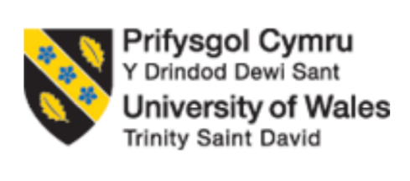
Module Code and Title: LCLM5003 Project Management
Assignment Title: A Project Portfolio
Student name : Ana Capatina
Student ID: 2408124
Table of contents
Part A: Project proposal poster 3
Part B: Reflection on Feedback 4
Part C: Project Management Plan 6
1. Introduction 6
2. Project description 6
3. Scope 7
4. Work breakdown structure 8
5. Quad Chart 9
6. Gantt Chart 10
7. Stakeholders' involvement 11
8. Allocation of resources 13
9. Risk Analysis 13
10. Conclusion 15
References 17

Part A: Project proposal poster
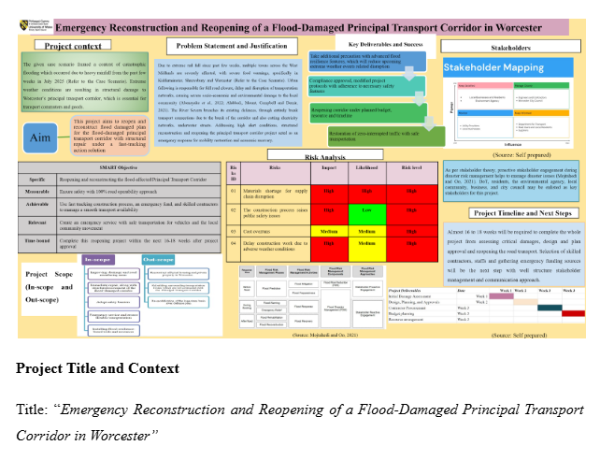

Part B: Reflection on Feedback
Driscoll’s (1994) “What? So what? Now what?” The model is used for the reflective piece (Linsenmeyer and Long, 2023).
What
The poster presentation task was a great opportunity to better understand project management practically. It gave me an idea of understanding how to do a project when the urgency is high in disaster-driven situations. With the constructive feedback received from the tutor, this further gave me an opportunity to improve on my next section. Feedback highlighted that the good parts of this poster presentation were the clarity in the project context, the objectives and the SMART goals. It shows that I was able to understand the requirements for the project and the situational awareness. The feedback praised the project title as a response to the problem addressed in the scenario. Initial risk analysis was also positive. However, some areas for improvement were in the unclear project management tools, justification and understanding of the planning aspects. The feedback also emphasised more on theory and aligned with the project for Task C.
So what
Feedback or two-way communication is considered the key criterion for project success (Project Management Institute (PMI), 2021). I was thankful for the feedback that was given to me regarding my poster, which made me realise that I needed to work harder to deliver better performance through my report. The feedback made it clear that I need to deliver a higher level of expertise in terms of a project management report, but academically oriented. Stakeholder management approaches, Gantt charts, and work breakdown structures were some of the areas in which I needed to show my knowledge, not just descriptions, but much beyond that. I had to apply the principle of project management to project development. The feedback, as I understood, was how I use all the principles of project management to make this particular project work, even if risks come, how I mitigate them and so on. In short, the final presentation should be academic and professional.
Now what
The final project management task has been carefully created based on the feedback. In implementing the feedback, I have used different project management tools and also connected them to the report correctly. I first explained the concepts and tools, and then I applied them to the project. I have ensured that the description part does not exceed the analytical parts. The scope part and the WBS part have been expanded, and they have been expanded in detail, such that no ambiguity remains. After that, I have used the stakeholder matrix to identify the interests and influence of the stakeholders and how they can be managed better for this project to be successful, linking scholarly literature findings as well. The risk analysis involved ranking the impacts as high, low, and medium, with mitigating strategies previously explained against each risk. All parts have been kept as realistic as possible. Overall, the feedback from the poster presentation was really important for this report to have come out much better.

Part C: Project Management Plan

1. Introduction
A project basically means to engage in a temporary endeavour which is needed for the creation of some products, services or give the result to some ideas (Project Management Institute (PMI), 2021). Project management refers to applying knowledge or skills, techniques or tools to meet project requirements. Project management may also deal with creating new forms of organisational states, such as through adapted services, products or processes or creating a new one (Plattfaut, 2022). The purpose of this report is to elaborate on the project management plan that will be undertaken for the emergency reconstruction, repair and reopening of the Worcester transportation link corridor. For this purpose, this plan discusses the project, with scope, then moves on to the Work breakdown structure, with a Quad chart and a Gantt chart. After that, the project plan discusses the involvement of the stakeholders, the risk analysis and the allocation of resources. This report closes with a concluding section which wraps up the entire plan.

2. Project description
The purpose of this project is to create a plan for the emergency construction and reopening of the Worcester transport corridor, which has been heavily impacted and damaged because of flooding since the catastrophic flooding since 2025 July across the West Midlands (BBC News, 2022). After severe rainfall, the River Severn was not able to protect the defence and boundaries, which resulted in power outages, road damage, and the destruction of essential transportation links. The main transport corridor in Worcester has been affected, which has resulted in the obstruction of public transport, loss of fuel, roads and many people being affected in residential and business areas. Even the emergency service has been obstructed.
At the moment, this project is fast tracked and thus prioritised. It is prioritised since it forms an important link for transportation, which carries people, freight and other emergency access. Thus, it is not only essential as part of human transportation and business, but it also has huge economic activity going on in those areas. As part of the Environment Agency’s severe flood warnings, danger to life, this project will try to make plans to ensure the recovery of infrastructure and reopen it soon for normal lives to continue around that route.
This project will adopt a fast-track technique where there may be overlaps between the activities. These projects are usually considered to be of high risk, and often may also require concurrent works going on due to risk (Bogus, Valentin and Martins, 2023). For instance, procurement, design and reconstruction all happen together side by side and overlap where relevant. This is considered suitable given that the project aims to work after a disaster has struck, and thus it is deemed suitable due to the availability of contractors, skilled workmen and funding required. The final project result will be repairing roads and drainage systems. This will also involve opening the transport link to the general public and installing infrastructure that would be made of flood-proof materials.

3. Scope
The scope of project management comprises all tasks that are related to the delineation of the project. This is to ensure that the project will include all the tasks and activities that will be required for completion (Plattfaut, 2022). The cost, time and quality are the three pillars of project success and also entail the Iron Triangle or project constraints, which determine the scope (Atkinson, 1999). While the latest dioceses mention that scope, time, and cost are the three constraints which determine the project quality (Asana, 2025).
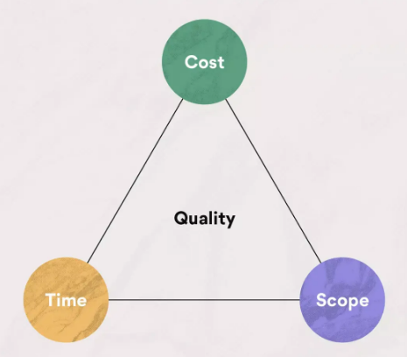
Figure 1: Project management triangle
(Source: Asana, 2025)
Project time will be about 16 to 18 weeks. The in-scope activities will first conduct a thorough assessment of the infrastructure that has been damaged due to the food around the transport corridor. This will give the total area that needs to be modified and repaired. The other in scope activists also consist of making improvements to the drainage system, besides roadway constructions and stabilisation of the areas, so that the entire damaged area can be fully restored and made operational like before. The building or the infrastructure that has been damaged will be changed with materials that are resilient to floods. There will be a better system for running off the flood so that the future does not experience such a crisis due to flooding. Temporary barriers will be put up so that construction works can go on normally without hassle, and people will be safe as well. Local authorities and contact points will be contacted in case of an emergency.
Out of scope activities consist of reconstructing the commercial building, private uses and other facilities which have been damaged or partially damaged due to flooding. Any other repair or damage control will be beyond this project, such as river defect mechanisms, transportation links that are not connected to Worcester, etc.

4. Work breakdown structure
WBS is a building block for any project that sets its foundation. It shows how projects are initiated, how planning will happen, how execution will take place, and how monitoring is controlled and how processes are controlled (Brotherton, Fried and Norman, 2008). WBs consist of the intimate stage of any project agent, which divides the projects into small activities and tasks that would make it simpler and easier to perform (Hudoyo, Latief and Sagita, 2019).
The project will be divided into 3 levels, under which tasks will be further divided. At level 1, the project is divided into full lifecycle stages with construction, repair and then the re-opening phase. Here, there will be some phases, such as initiation of the project, assessment, and until the construction, testing, and project handover (refer to the figure 2).
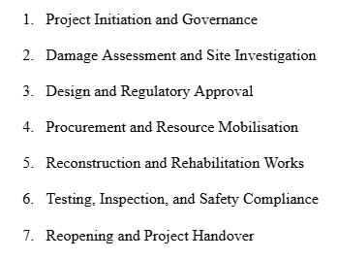
Figure 2: Level 1 phase
(Source: self-developed)
In the next level 2, each of the 7 stages is further broken down. For example, the assessment will consist of inspection of the site, visual assessment and investigation and even short interviews of stakeholders locally situated. In level 3, the tasks associated with level 2 will be further estimated for costing, scheduling and other related aspects such as removal of debris, rusted materials, and setting up barriers, etc.

5. Quad Chart
Below is the quad chart table, which gives a clear idea of the project overview in a quick and easy manner. It shows the project objectives, the barriers, their milestones and the success criteria of the project. With such summary information, the stakeholders will be able to understand the project easily. This would help them make better decisions on how the aims of the project may be fulfilled, how the challenges can be dealt with when they arise and how success can be measured.
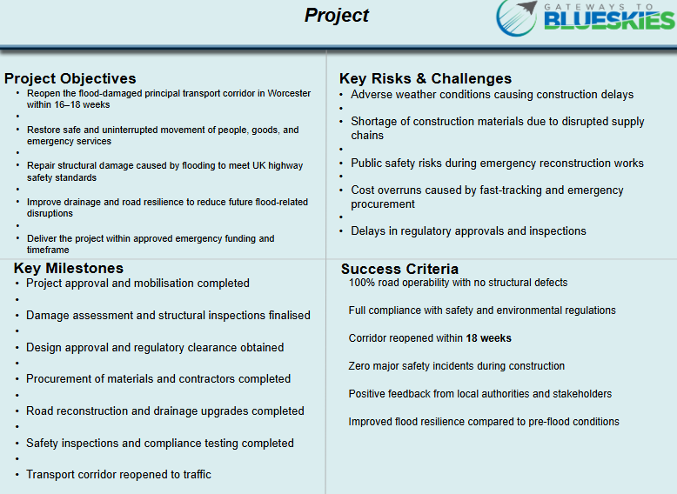
Table 1: Quad chart
(Source: self-developed)

6. Gantt Chart
The table below is that of a Gantt chart, which helps explain the project plan and the 18-week time frame. The project has been listed with the activities in these weeks. This chart is like a progress tracker, which also identifies which task will happen, which task is prioritised and can be completed on time, so that delays can be avoided. Some tasks with the time frame can overlap, as depicted in the chart. This is because this project is taking a fast-track approach, given the emergency and urgency of the project.
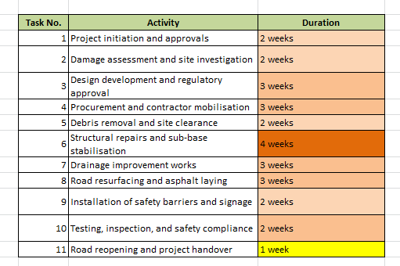
Table 2: Gantt chart and timelines of the project
(Source: self-developed)

7. Stakeholders' involvement
Not only during the project, but overall involvement of stakeholders related to any crisis management after a disaster helps in the better management of the disaster (Mojtahedi and Oo, 2021). The project has applied the stakeholder mapping approach to identify the relevant stakeholders, their needs, their opinions and interest in the project, so that the project manager can prioritise them and manage their interests for the successful completion of the project. This approach is also called the stakeholder Power influential or power interest matrix. The power means the stakeholders' ability to influence the project based on force, coercion, utilitarian means, or other ways, influencing their impact or their concerns related to the problem the project aims to address (Zhu et al., 2024).
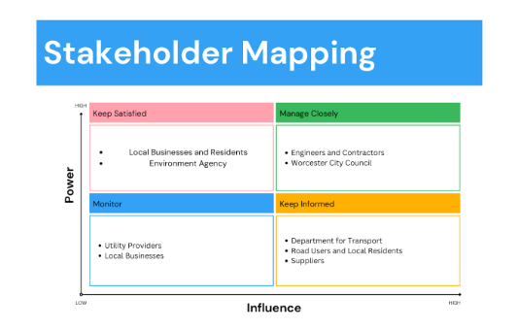
Figure 3: Power influence matrix
(Source: self-developed)
High power-high interest: these are the stakeholders who have high power to influence the project's decisions. Like the transport department, local council authority and environmental agencies. This is because the groups of stakeholders are involved in funding the project, and they look for whether the project is following regulatory compliance or not. They also see the impacts of the project on the environment. Hence, they need to be closely managed by the project management team. Their decisions also determine the project's fate. They can be managed with formal meetings, permission-granting and involvement in decision-making.
High interest-low power: stakeholders such as local businesses, commercial firms, local residents and community organisations have high interest, but their power is not much. They have an interest because they need to sue the transport coordinator regularly, either for economic activity or for transporting, commuting daily. Even though they may have limited power, they also impact the project since if they do not cooperate and support the project, then it will not be possible to implement the project's tasks smoothly. Therefore, they must also be strategically engaged and managed. These people may be asked to join meetings where they will be given a briefing on the project and updated, even though digital platforms like WhatsApp are used. During crisis situations and aftermath, it is necessary that leadership offer supportive and effective communication so that expectations can be managed from the public and their resistance, if any, can be avoided (Gigliotti and Alvarez-Robinson, 2025).
High power-lo interest: utility providers and emergency service companies tend to have low interest but high power. Thus, they need to be monitored well so that during any phase of the planning or execution stage, if any mishap happens, then these services should be ready to help and support. Their involvement is possible around the time the roads are closed to the public.
There are employees, staff and workers who are involved as stakeholders as they work, such as engineers, contractors and even the suppliers. However, they have moderate power with a high interest in the project. Therefore, they need to be managed through performance monitoring, agreements and coordination such that the project scope is maintained.

8. Allocation of resources
Resources such as talented, skilled, and human resources are needed for the project. Such as engineers, project managers, technicians, safety officers, and construction contractors, to name a few. Material resources will be needed, such as for construction materials like asphalt, drainage system components and even the creation of safety barriers. Other equipment, like repair tools, will also be required. Financial resources, including contingency funding, are needed. Thus, all the equipment, materials, and human resources costs will be added to the financial returns so that the funding requirements can be smoothly processed and allocated accordingly.

9. Risk Analysis
Risk analysis is a process in which the biggest vulnerabilities of any project can be understood beforehand. Risk analysis is primarily based on perceptions of the project manager (APM, 2019). With the support of stakeholders, they can identify the risks quite early in the project. The risk events need to be defended early; they need to be separated from the facts, and form the events of their sinks, and form the effects so that the different perceptions can be understood. This not only helps in risk analysis but also in risk management simultaneously. Risk assessment, also known as analysis, is a quantitative analysis of how the risk events of the project may have an impact on people's lives and properties (Fang et al., 2022). It is an important part of determining project investment. Risk analysis has been mostly conducted based on the expertise and knowledge of people in the project. Below are some key risks to this project (refer to Table 3).
Risk 01: Materials shortage for supply chain disruption
Shortage of materials for construction due to distortions in supply chains can be caused by flooding. This is the most important risk that this project can face. This is a high-impact risk, since the delay in the supply and delivery of materials can increase the timelines of completion, and also some important tasks will have to be kept waiting. This may also increase the cost of the project, and some people may have to pay extra. The likelihood of the issue is also high since flooding has actually caused greater damage regionally, thus, sourcing of materials may be an issue. Risk mitigation will be to get alternate suppliers from diverse locations and get them approved. If possible, manage with suppliers locally, which may not require much transportation.
Risk 02: The construction process raises public safety issues
Safety issues for construction, public and road users are present. The likelihood of accidents because of this risk is low since all regulations will be complied with. However, if one incident occurs, then the project may get delayed. Therefore, risk mitigation will include putting in cameras around the barriers to avoid any accidents and to manage the traffic better with stringent plans. Local citizens and the public around the construction areas will be informed frequently to avoid any confusion.
Risks No. | Risks | Impacts | Likelihood | Risk levels
1 | Materials shortage for supply chain disruption | High | High | High
2 | The construction process raises public safety issues | High | Low | High
3 | Cost overruns | Medium | Medium | High
4 | Delay construction work due to adverse weather conditions | High | Medium | High
Table 3: Risk assessment matrix
(source-self-developed)
Risk 03: Cost overruns
Running out of the budget is a key probable and high-risk issue since this is a fast-track project where some uncertain and random procurement materials may be required suddenly. There is a low chance of this happening. If it happens, then it will impact the funding, and even the stakeholders may become impatient and lose confidence. Risk mitigation will involve a separate budget for situations like this if they occur, under contingency funding.
Risk 04: Delay construction work due to adverse weather conditions
Bad weather poses a great risk to project completion, which is a high risk because the frequency and volume of rainfall may get worse in the future due to climate change. In that case, mitigation strategies would first monitor the weather properly and then change scheduling. If needed, night-time work may be done instead of daytime when it will rain.

10. Conclusion
It can be concluded that the project for the reconstruction and reopening of the airport corridor in Worcester will adopt a fast-track approach. This will ensure that all tasks will happen quickly and may overlap. The construction project until reopening will take up to 18 weeks. With the allocated human resources, budget and material and with various stakeholder support, this project will be able to successfully complete its objective. Some risk around materials supply disruptions, cost overruns, bad weather and accidents may be possible. Mitigation strategies will be taken early.

References
APM (2019) APM Body of Knowledge. 7th edn. Association for Project Management.
Asana (2025) The Project Management Triangle: What It Is and How to Use It, Asana. Available at: https://asana.com/resources/project-management-triangle (Accessed: 4 February 2026).
Atkinson, R. (1999) ‘Project management: cost, Time and quality, Two Best Guesses and a phenomenon, It's Time to Accept Other Success Criteria’, International Journal of Project Management, 17(6), pp. 337–342.
BBC News (2022) ‘River Severn Flooding: Homes and businesses evacuated’, BBC News, 22 February. Available at: https://www.bbc.com/news/uk-england-shropshire-60475077 (Accessed: 4 February 2026).
Bogus, S.M., Valentin, V. and Martins, C.G. (2023) ‘Perceptions of Construction Risks Due to Fast-Track Activity Overlapping’, Eng, 4(4), pp. 2879–2895.
Brotherton, S.A., Fried, R.T. and Norman, E.S. (2008) ‘Applying Work Breakdown Structure to Project Lifecycle’, Project Management Institute. [Preprint].
Fang, R., Liao, H., Xu, Z. and Herrera-Viedma, E. (2022) ‘Risk assessment in project management by a graph-theory-based group decision making method with comprehensive linguistic preference information’, Economic Research-Ekonomska Istraživanja, 36(1), pp. 86–115.
Gigliotti, R.A. and Alvarez-Robinson, S. (2025) ‘The Role of Leadership Communication in Building Crisis Readiness and Resilient Leadership in Times of Disruption: An Exploratory Study’, Behavioural Sciences, 15(9), p. 1260.
Hudoyo, C.P., Latief, Y. and Sagita, L. (2019) ‘Development of WBS (Work Breakdown Structure) Risk-Based Standard for Planning Cost Estimation at Port Project’, IOP Conference Series: Earth and Environmental Science, 258(1), p. 012051.
Linsenmeyer, M. and Long, G. (2023) ‘Goal-Oriented and Habit-Oriented Reflective Models to Support Professional Identity Formation and Metacognitive Thinking’, Medical Science Educator, 33(2), pp. 569–575.
Mojtahedi, M. and Oo, B.L. (2021) ‘Built Infrastructure Conditions Mediate the Relationship between Stakeholders Attributes and Flood Damage: An Empirical Case Study’, Sustainability, 13(17), p. 9739.
Plattfaut, R. (2022) ‘On the Importance of Project Management Capabilities for Sustainable Business Process Management’, Sustainability, 14(13), pp. 1–12.
Project Management Institute (PMI) (2021) Guide to the Project Management Body of Knowledge. 7th edn. Project Management Institute.
Zhu, Q., Xi, J., Hu, X., Chong, H.-Y., Zhou, Y. and Lyu, S. (2024) ‘Stakeholder Mapping and Analysis of Off-Site Construction Projects: Utilising a Power–Interest Matrix and the Fuzzy Logic Theory’, Buildings, 14(9), p. 2865.

