Planning and Delivering an International Sustainability Conference at Riaz London

ANNISA SATHI
STUDENT NUMBER- 2119261
MODULE TITLE: International Meeting Management
MODULE CODE: BMI6007
MODULE LECTURER: Philippa Fitzgerald
Table of Contents
Introduction 3
The Event Cycle 3
Staffing and Stakeholders 4
Contingency Planning, Health and Safety 4
Event Concept and Itinerary 4
Aims and Objectives 6
SWOT Analysis 6
PESTLE Analysis 6
Event Operations 7
Venue and Logistics Management 7
Staffing and Skills 7
Technical and A/V Requirements 7
Catering and Food & Beverage 8
Waste Management 8
Event Provisions 8
Event Budget 9
Conclusion 13

Introduction
The following report proposes a one-day sustainability conference to be held on March 15, 2024, at The Ritz London Hotel in the UK. The given report has been titled “Innovations in Green Hospitality”, the proposed event aims to bring together 150 hospitality professionals to discuss the latest technologies, trends, and best practices to integrate environmental responsibility in hotels. The Ritz London offers a fitting venue as a heritage luxury brand pursuing sustainability certification, allowing to outline how storied institutions have the potential to be innovative and play their crucial part in limiting the carbon footprint. The target audience comprises hotel owners, general managers, architects, and suppliers, who have been working on sustainable practices and keen insights on practical green solutions suited for upscale European hospitality brands. With climate change concerns and rising stakeholder expectations, there is a growing need within the hospitality industry to transition towards environmentally friendly operations.

The Event Cycle
The event cycle articulates the end-to-end process required to successfully plan, organize, and deliver an event. It offers a structured approach that articulates the key stages spanning the initiation to completion of an event. Hence, the following event will consist of five different stages (Mair et al. 2022). The first stage will be concept and initiation. The proposed stage will involve crafting the event concept, objectives, and budget. For our sustainability conference, the proposal will consist of formulating the theme, target audience, program outline, revenue, and cost projections. This will direct the following event toward the second stage which is also known as planning and ensuring smooth logistics (Legrand et al. 2022). The second stage focuses on detailed planning of the event components like venue, schedule, catering, speakers, and technical aspects (Mzembe et al. 2020). For the proposed conference, the aim will be to conduct a site visit at The Ritz London to evaluate the facilities, coordinate with the hotel team on catering options, and develop a run of show for sessions.
The third stage is marketing and sales, which aims to promote the event and drive registrations. For the following aspect, the proposed event aims to be in a position where it can design promotional materials and a website for the conference while reaching out to potential attendees over email and social media. Furthermore, sponsorships will also be secured during the outlined stage (Neugebauer et al. 2020). After this, the plan will be to ensure the smooth execution of an event. Hence, the fourth stage will be named event execution, which will involve on-site delivery of the event as per plans. On the conference day, the idea will be to manage delegate check-in, seating, stage set-up, catering, presentations, and troubleshooting any issues (An et al. 2021). Once, the execution aspect is done, the evaluation or monitoring cannot be compromised. As a result of this, the fifth stage has been kept as the evaluation, where the success factors will be identified while mitigating the developed or understood weaknesses. Hence, it can be said that the given final stage will play an essential role when it comes to gathering the required feedback, assessing outcomes against objectives, and accounting for budgets (Asadi et al. 2020).

Staffing and Stakeholders
The event team will include an Event Director, Marketing Manager, Operations Manager, and Customer Service Representatives, all working in sync with The Ritz London staff to ensure a smooth and successful event. Stakeholders will include sponsors, partners, speakers, and delegates, each playing a crucial role in the event's ecosystem. The conference will bring together hoteliers, suppliers, sustainable solution providers, and industry experts to discuss the latest trends, technologies, and best practices that promote environmental responsibility in hospitality, (Tomašević, 2018).

Contingency Planning, Health and Safety
A comprehensive contingency plan will address potential risks such as speaker cancellations, technical issues, and health emergencies. Health and safety protocols will be in place, including sanitation stations, social distancing measures, and dietary accommodations to ensure an inclusive and safe environment for all attendees (Zorzenon et al. 2022).

Event Concept and Itinerary
The Innovations in Green Hospitality conference, scheduled for March 15, 2024, at The Ritz London, is more than just an event; it's a ground-breaking summit aimed at redefining luxury hospitality through the lens of sustainability. This one-day symposium is meticulously designed to serve as a melting pot for 150 of the best of the best in the hospitality industry, including hotel magnates, visionary general managers, avant-garde architects, and leading suppliers, all united by a common goal: to forge a sustainable future for luxury hospitality in Europe and beyond.

The Innovations in Green Hospitality conference is designed as an interactive one-day event to facilitate idea exchange and learning focused on sustainability solutions customized for heritage hotels. From 9 am to 10 am, attendees will arrive at the iconic Ritz London venue and proceed to the designated Imperial Suite conference hall for seamless check-in and registration. They will be served a sustainable breakfast menu featuring organic pastries, locally sourced fruits, fair-trade coffee, and herbal teas. At 10 am, the conference will officially kick off with a 15-minute welcome address delivered by the organizers. It will outline the context, objectives, agenda, and format for the day ahead, setting the stage for the sessions. From 10:15 am to 11 am, the sustainability keynote address will be delivered by an influential senior hotel industry leader who has spearheaded impactful green initiatives and certifications for a global luxury chain. Hence, through sharing their real-world experiences and insights, the keynote will inspire attendees on the strategic need and diverse benefits of embracing environmentally friendly operations.
From 11 am to 11:30 am, attendees will get the opportunity to network over sustainably sourced tea, coffee, juices, and snacks, facilitating peer connections and idea exchange. Likewise, it will be followed at 11:30 am by an engaging 90-minute panel discussion featuring technology experts from prominent hospitality solutions firms. From 1 pm to 2 pm, guests will be served a buffet networking lunch prepared using seasonal, organic, and locally sourced ingredients and avoiding plastic ware. The agenda will then progress at 2 pm to an impactful session involving in-depth case studies from three pioneering sustainability leaders in the UK’s heritage hotel space, where examples from real-world hotels to be shared with the attendees and how they have been successful throughout the effective application of sustainable practices in the hospitality sector.
At 3:15 pm, attendees will once again network over sustainably sourced beverages and snacks for 30 minutes to continue conversations before the final session. From 3:45 pm to 5 pm, a broad panel of industry associations, sustainability consultants, and solution providers will shed light on the latest trends, global best practices, and strategies to overcome common barriers to implementing sustainability in heritage hotels through an insightful moderated discussion. Finally, from 5 pm to 5:30 pm, the conference will conclude with closing remarks from organizers.

Aims and Objectives
The overarching aim of the Innovations in Green Hospitality conference is to catalyse the application of sustainability practices across heritage and luxury hotels in the UK.
The specific objectives are:
- To educate heritage hotel professionals on practical green solutions by providing 5 relevant case studies and expert perspectives.
- To inspire the adoption of sustainability in heritage hotels by showcasing The Ritz London's certification journey and measurable sustainability impact.
- To facilitate the exchange of insights between 100 heritage hoteliers, technology vendors, and industry experts through two-panel discussions and two networking sessions during the one-day conference.

SWOT Analysis
Table 1 illustrates the SWOT analysis of the proposed event (Hussain et al. 2020).
Table 1: SWOT Analysis
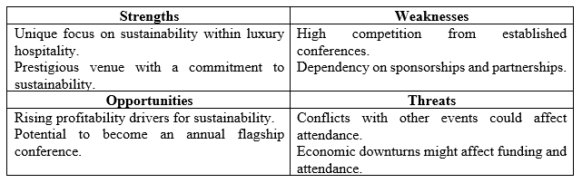

PESTLE Analysis
Table 2 illustrates how external factors will shape the success factors of the proposed event (Dalirazar et al. 2023).
Table 2: PESTLE Analysis
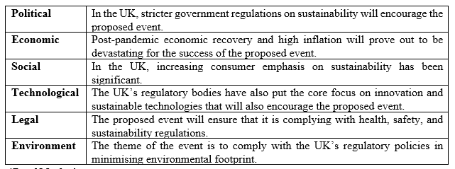

Event Operations

Venue and Logistics Management
The Ritz London offers an apt venue for the event given its prestige and recent sustainability initiatives. Its Imperial Suite holds the potential to accommodate 150 guests in banquet style facing the stage. Moreover, natural lighting will be maximized and seating arranged accordingly (Sann et al. 2020). Registration desks will be placed at the entrance for seamless check-in. Signages will guide attendees to the hall. The hotel's experienced event team will coordinate onsite facilities, A/V, F&B, and seating arrangements as per requirements.

Staffing and Skills
The organising team will comprise an Event Director to handle overall planning, oversee on-site coordination, and manage registrations/communications, and an Accounts Executive to track budgets (Susanti et al. 2022). The hotel will arrange service staff for catering, housekeeping, and security, but the budget has been allocated accordingly. Moreover, technical staff will manage A/V equipment and live-streaming. All personnel will be requested to demonstrate customer service, problem-solving skills, and sustainability knowledge.

Technical and A/V Requirements
The Imperial Suite offers inbuilt screens and advanced A/V facilities to support presentations and live-streaming. Additional requirements are projectors, microphones, speakers, wireless internet, laptops, laser pointers, video recording, and a registration app (Fang et al. 2022). Technicians will ensure flawless functioning of equipment. Printing will remain controlled by using digital signage and collaterals.

Catering and Food & Beverage
Catering will be sourced from the hotel's award-winning sustainable kitchens. The menus focus on organic, seasonal, and locally sourced ingredients served using compostable/recyclable ware. Breakfast includes pastries, fruits, juices, coffee and tea. The seated lunch features vegetarian, vegan, and gluten-free choices, also echoed in (Camilleri, 2021). Tea breaks offer snacks like sandwiches, fruits, and sweets. Where possible, locally produced food and beverages will be procured to limit or control the footprint.
Transportation and Accommodation
Hotel accommodation will be reserved via a quota for national/international delegates along with discounted rates. Eco-friendly buses will provide pick-up/drop-off from the nearest metro stations to the venue (Kitamura et al. 2020). Hence, it will encourage using public transport, reducing carbon emissions. Parking arrangements will also made for drivers. Information on access modes will be shared in confirmation emails.

Waste Management
Comprehensive waste management will be implemented like food waste composting, recycling stations for paper/plastic/glass, avoiding single-use plastic, sending leftover food to shelters, and donating extra materials (Filimonau, 2021). Staff will be trained on proper disposal procedures. Attendees will be encouraged to avoid printing and use digital methods to eradicate the need for printers.

Event Provisions
The event will be fully catered, with a focus on sustainability. Menus will feature organic, locally sourced ingredients, and eco-friendly service ware. A selection of merchandise, such as reusable water bottles and eco-friendly tote bags, will be available to promote sustainable practices beyond the event.

Event Budget
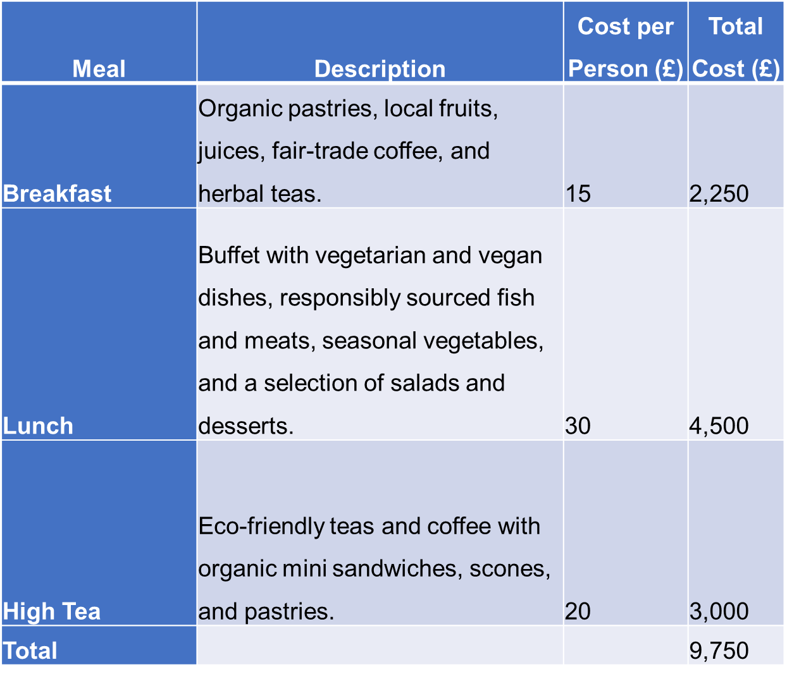

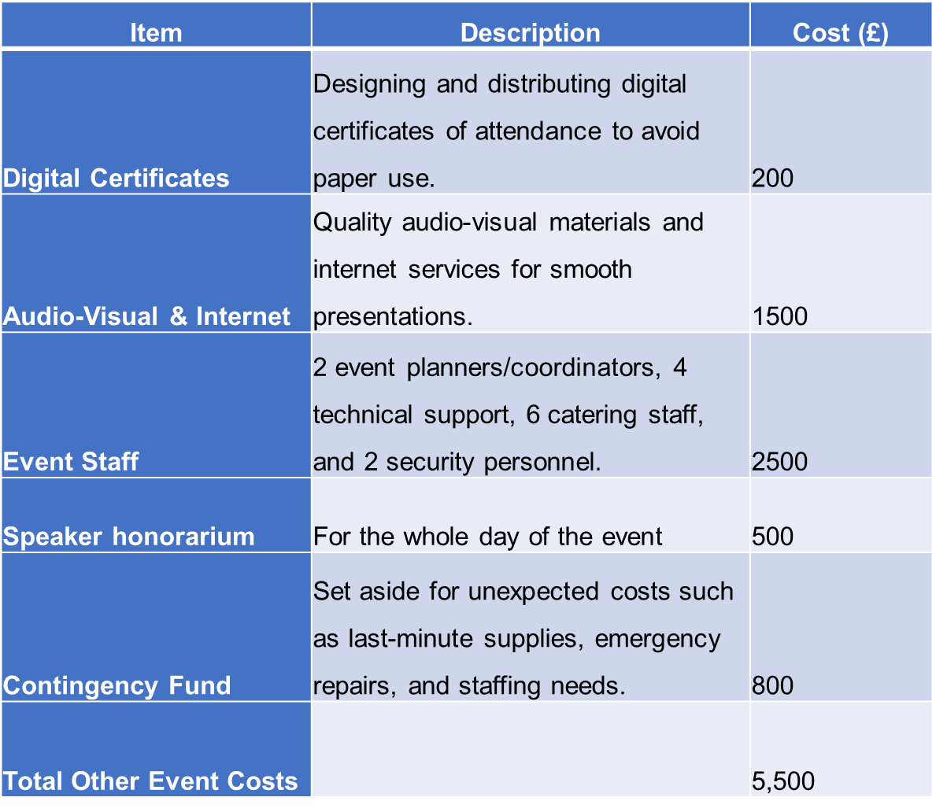

Description | Amount (£)
Registration Fees | 50*150= 7500
Sponsors (Hellow fresh organic food+Think Green .Co.Uk+ Siera Solar Energy Group+ Mindfullness paper cup ltd) | 3000+5000+7000+2000=17000
Total Revenues | 24500
Total Expenses | 20500
Net Profit | 4000

The total revenue for the conference is projected at £20,500. Delegate fees account for £7500, with 150 participants charged £50 per person. This covers access to all sessions, catering, and transportation. Sponsorships and grants make up the other £17,000. Hospitality brands providing sustainable solutions will sponsor in return for exhibiting their products/services. Relevant industry associations and NGOs focused on green hospitality will offer grants to fund specific aspects like catering, speaker costs, and sustainability measures.
The venue constitutes a significant cost at £5250 for the exclusive rental of The Ritz London's Imperial Suite for the full day. Catering for breakfast, lunch, and tea breaks for 150 attendees totals £9,750. Sustainable menus and local sourcing are expected to increase catering costs but offer environmental benefits, also discussed in (Denizci Guillet, 2020). In addition, transport logistics including eco-friendly buses, digital conference materials, and high-speed WiFi, and staffing for event managers, technical support, caterers, and security will total £5,500. Hence, the total revenues are supposed to be around £24,500 with total expenses of £20,500 allowing the proposed event to be profitable of around £4000
It shows that costs are kept accessible for delegates by securing sponsorships for expenses like catering and collateral, and subsidising components where possible, also echoed (Floričić, 2020). Careful income generation and budgeting will lead to a successful, financially sustainable event.

Industry Trends and Impacts
The planning for the Innovations in Green Hospitality conference requires careful consideration of prevailing industry trends to employ relevant innovations that elevate the event experience (Hagen, 2021). Given the rise of virtual and hybrid events during the pandemic enabling broader engagement through remote live-streaming and online platforms, the conference will offer virtual attendee tickets allowing those who cannot join in person to still benefit from the sessions through a seamless live broadcast (Mair et al. 2022). However, the core remains an in-person immersive sustainability experience (Floričić, 2020).
To meet the growing appetite for experiential learning, hands-on workshops, tours of The Ritz London's sustainability installations, and interactive demonstrations of eco-solutions will allow attendees to actively engage with green technologies and concepts (Tao et al. 2021). Given the ongoing importance of health and safety, the organisers will implement stringent protocols around sanitisation, distancing, indoor air quality, and food safety guided by venue and F&B partners (Yacoub et al. 2021). Finally, harnessing personalisation powered by event apps and data analytics, a tailored experience will be developed for each delegate based on their preferences and interests to recommend networking connections, sessions, dining options, and product demos (Yousaf et al. 2021) and (Ziakas, 2021).
Cultural and Situational Considerations
Planning the sustainability conference requires closely evaluating the wider cultural and situational context in the UK’s hospitality industry to inter-link the event to the needs of the target audience. The current economic climate remains uncertain post-pandemic, with many hotels still recovering from revenue losses. However, travel demand is rebounding, an indication that the industry is on the path to stability (Sadraei et al. 2023). The challenge of high energy and food costs persists, compelling hotels, particularly heritage properties with aging infrastructure, to seek efficiencies. Hence, the proposed element strengthens the rationale for the following event’s theme which is to educate hoteliers on technologies and best practices to limit resource consumption and costs (Sadraei et al. 2023).
Moreover, strict regulations also make sustainability an imperative initiative like the EU Taxonomy and proposed energy efficiency mandates will require hotels to integrate environment-friendly solutions for compliance. Moreover, consumer preferences are rapidly shifting, with patrons highly valuing green hotels. Hence, from the analysis of Ahmed et al. (2021), it has been indicated that over 80% of travelers now actively opt for sustainable accommodation and are willing to pay a premium, providing a compelling incentive for adoption. Heritage brands remain concerned about balancing sustainability with their legacy of luxury hospitality.
In addition, Ritz London, being a prestigious venue proves through its efforts that incorporating green solutions need not compromise luxury guest experiences. Considering these situational factors will allow the event content to counter key pain points and priorities, articulating how sustainability is a strategic opportunity, not a challenge, for long-term profitability, reputation, and competitive edge. The event experience will resonate more deeply by aligning with the external context. In-depth planning around regulations, guest expectations, operational efficiencies, and cost savings will make this inaugural conference a powerful catalyst for sustainability in the heritage hospitality sector.

Conclusion
To summarise, the following designed conference will not only prove to be successful in terms of finance, it will also prove to be successful in terms of articulating the importance of sustainable practices and how with the effective application of sustainability, the hospitality sector of the UK can play its part in the overall development of ensuring the sustainable practices. Once, the sector starts complying with the sustainable practices to the fullest, it will help them to target the customers while complying with their varying needs and preferences that now are interlinked with the smooth sustainable practices.

References
Ahmed, M. F., Mokhtar, M. B., Lim, C. K., Hooi, A. W. K., & Lee, K. E. (2021). Leadership roles for sustainable development: The case of a Malaysian green hotel. Sustainability, 13(18), 10260.
An, J., Kim, H., & Hur, D. (2021). Keeping the competitive edge of a convention and exhibition center in MICE Environment: identification of event attributes for long-run success. Sustainability, 13(9), 5030.
Asadi, S., Pourhashemi, S. O., Nilashi, M., Abdullah, R., Samad, S., Yadegaridehkordi, E., ... & Razali, N. S. (2020). Investigating the influence of green innovation on sustainability performance: A case on Malaysian hotel industry. Journal of cleaner production, 258, 120860.
Camilleri, M.A. (2022) Thriving family businesses in tourism and hospitality: A systematic review and a synthesis of the relevant literature, SSRN. Available at: https://papers.ssrn.com/sol3/papers.cfm?abstract_id=3981420
(Accessed: 20 February 2024).
Dalirazar, S., & Sabzi, Z. (2023). Strategic analysis of barriers and solutions to development of sustainable buildings using PESTLE technique. International Journal of Construction Management, 23(1), 167-181.
Denizci Guillet, B. (2020). An evolutionary analysis of revenue management research in hospitality and tourism: is there a paradigm shift?. International Journal of Contemporary Hospitality Management, 32(2), 560-587.
Fang, J., & Partovi, F. Y. (2022). Technology planning in the hotel industry. Tourism Management Perspectives, 44, 101018.
Filimonau, V. (2021). The prospects of waste management in the hospitality sector post COVID-19. Resources, Conservation and Recycling, 168, 105272.
Floričić, T. (2020). Sustainable solutions in the hospitality industry and competitiveness context of “green hotels”. Civil Engineering Journal, 6(6), 1104-1113.
Hagen, D. (2021). Sustainable event management: new perspectives for the meeting industry through innovation and digitalisation?. Innovations and Traditions for Sustainable Development, 259-275.
Hussain, I., Mu, S., Mohiuddin, M., Danish, R. Q., & Sair, S. A. (2020). Effects of sustainable brand equity and marketing innovation on market performance in hospitality industry: Mediating effects of sustainable competitive advantage. Sustainability, 12(7), 2939.
Kitamura, Y., Karkour, S., Ichisugi, Y., & Itsubo, N. (2020). Carbon footprint evaluation of the business event sector in Japan. Sustainability, 12(12), 5001.
Legrand, W., Chen, J. S., & Laeis, G. C. (2022). Sustainability in the hospitality industry: Principles of sustainable operations. Taylor & Francis.
Mair, J., & Smith, A. (2022). Events and sustainability: why making events more sustainable is not enough. In Events and Sustainability (pp. 1-17). Routledge.
Mzembe, A. N., Lindgreen, A., Idemudia, U., & Melissen, F. (2020). A club perspective of sustainability certification schemes in the tourism and hospitality industry. Journal of Sustainable Tourism, 28(9), 1332-1350.
Neugebauer, S., Bolz, M., Mankaa, R., & Traverso, M. (2020). How sustainable are sustainability conferences?–Comprehensive Life Cycle Assessment of an international conference series in Europe. Journal of cleaner production, 242, 118516.
Sadraei, R., Biancone, P., Lanzalonga, F., Jafari‐Sadeghi, V., & Chmet, F. (2023). How to increase sustainable production in the food sector? Mapping industrial and business strategies and providing future research agenda. Business Strategy and the Environment, 32(4), 2209-2228.
Sann, R., & Lai, P. C. (2020). Understanding homophily of service failure within the hotel guest cycle: Applying NLP-aspect-based sentiment analysis to the hospitality industry. International Journal of Hospitality Management, 91, 102678.
Susanti, D., Putra, A. S., & Aisyah, N. (2022). IMPROVING STUDENTS SPEAKING SKILLS MOTIVATION USING YOUTUBE VIDEO AND ROLE PLAY. JOEL: Journal of Educational and Language Research, 1(9), 1303-1310.
Tao, Y., Steckel, D., Klemeš, J. J., & You, F. (2021). Trend towards virtual and hybrid conferences may be an effective climate change mitigation strategy. Nature communications, 12(1), 7324.
Tomašević, A. (2018). Luxury Hotels. In Quality services and experiences in hospitality and tourism (Vol. 9, pp. 195-211). Emerald Publishing Limited.
Yacoub, L., & ElHajjar, S. (2021). How do hotels in developing countries manage the impact of COVID-19? The case of Lebanese hotels. International Journal of Contemporary Hospitality Management, 33(3), 929-948.
Yousaf, Z., Radulescu, M., Sinisi, C. I., Serbanescu, L., & Paunescu, L. M. (2021). Harmonization of green motives and green business strategies towards sustainable development of hospitality and tourism industry: Green environmental policies. Sustainability, 13(12), 6592.
Ziakas, V. (2021). Event portfolio management: An emerging transdisciplinary field of theory and praxis. Tourism Management, 83, 104233.
Zorzenon, R., Lizarelli, F. L., & Daniel, B. D. A. (2022). What is the potential impact of Industry 4.0 on health and safety at work?. Safety Science, 153, 105802.

