Student name: Alexandru Gurgu

Student number 1814056

Certificate of higher education and skills for the workplace

Group 2 Term 2

Academic and employability skills (Bmsw4001)

Assignment report
1.1Introduction In this reflective report I will introduce you to the journey of the learning process and the development stages of my academic and employability skills studying for this module in” University of Whales Trinity Saint David London “

1.2Scope
The scope of this report it’s to build an appropriate vie

1.3Purpose
To provide the tutor teacher and the university with the student learning outcome in this module and to identify if the following aims or objectives of the course have been completed successfully by the students.
In order to prove how this module helped me and other students I create a plan in which I will take you, step by step through the information that have been given to students in class, trough all in class exercises , and the outcome of them.
What are employability skills?
“A set of achievements – skills, understandings and personal attributes – that make graduates more likely to gain employment and be successful in their chosen occupations, which benefits themselves, the workforce, the community and the economy” Mantz Yorke (2004)

First day of the module starts with an review course over the general graduate employability skills necessary in all the workplaces, or occupations, these skills are as follow:
- Communication skills
- Interpersonal skills
- Personal skills
- Numeracy skills
- General awareness
After a closer look over the employability skills discussed in the previous term and an in class exercise in which all the student had to choose a job from 5 different jobs brought by the teacher in class every student had to identify the employability skills that may be necessary to cope with the selected job requirement .
I strongly believe that this exercise enhanced my attention over the future jobs application I may have , because I got to understand by doing this exercise that you as an individual can always understand if you having the necessary set of skills for the job from the company advert on different media platforms as internet and etc , reading the advert trough .
Next course it’s aimed to teach us how to write a winning cv, as well as how to write a wining personal statement for your cv.
In order to prepare an appropriate application you need time , most of the jobs will only consider the individuals that will have the appropriate qualification and competences , an incomplete application or one that contains gasp , or competences that are not up to the company requirements will be automatically discarded .The most common mistakes in jobs application are as following :
- Spelling errors
- Poor grammar
- Failing to provide answer to all the company questions
- Showing commitment to a competitor organization
- Failing to properly read the job requirement.
As in week for we had to complete a in class exercise filing up a job application I did some of the basic mistakes presented earlier, the teacher feedback was to focus on my grammar and my spelling. Please see appendix 1.

It is recommended that if you cannot build and send an appropriate application, better not do it at all, you are wasting your time. Andrew Maund (2017)
On the other hand, through the course we have been presented with a 3-step plan in building a successful personal statement as follows:
- Who you are?
- Your suitability and values
- Your career goals
First step should include who you are, and what level you reached in your professional career.
Second step should include your own achievements in relation with the job requirement.
Step three should include your personal career goals you wish to achieve trough work in the company.
That’s how I learned to build a personal wining statement.
When writhing a curriculum vitae, it’s important that you create your own brand “selling yourself “, It’s very simple to build a cv and start sending it to multiple jobs thinking that you may be lucky, and an employer will call you for an interview.
Getting the job, you want may be hard if you don’t know how to properly apply for one. In “The Business Student’s Guide to Study and Employability “by Peter Morgan we are presented with a few steps every individual in search for a job needs to do before even applying for the job, for example:
You certainly need to research about the organisation you wish to get a job in , not only the employer should be the one asking you questions , you need to ask questions to , in order to prove your genuine interest for the job you are applying for .
Your curriculum vitae should only enclose real fact and data about yourself and I believe that it should be your own mirror. False information and lying in your curriculum vitae will be discovered and you won’t pass the first stages of the interview if you obtain one.
I believe that being presented with all these facts will raise my self-awareness, and will provide me with enough knowledge, to be a good asset to any future job.
Next course we have been presented with Reflective Writhing methodology.
What it’s reflective writhing?
Reflection it’s a mental process and it takes place in long periods of time, time in which opinions or ideas, are taking in consideration. And represent the connection between thoughts and learning.
How the reflective process works?
“Reflective writhing it’s evidence of reflective thinking “
From an academic point of view, reflection can involve throwback to a past experience, idea or object deep thinking about it, analysing it from different points of view or perspectives.
Reflecting writhing follow a 3-step plan.
- Description -What are you examining and why?
- Interpretation-it is there anything relevant, useful or important about the idea or event? I will be able to explain it by using theory. What makes it different or similar from other subjects or idea or events?
- Outcome – It’s this going to help in my academic future? Do I learn something from this?
By reflecting on a subject or event you not only search for a description but you explore the subject, trying to find answer that haven’t been given to you, real reflective writing may show gaffs, errors, and weaknesses but also reveal success and power.
In reflective writhing it’s usually needed to focus on the important parts, the ones with a higher meaning that may enclose your answer. It’s usually helpful to reflect forward on the future but reflecting back on the past on similar ideas, events or experiences may gave you the answer you seek from.
I believe that a reflective way of thinking and analysing had enhanced my communication skills, my personal skills as well, because “It’s not only enough to have experiences in order to learn, with no reflecting over the experience , it may be forgotten soon , or it’s learning potential lost “ Gibbs 1988.
In the next lessons we have been presented and introduced to analytical thinking.
What it’s analytical thinking?
Analytical thinking it’s an important tool, trough which you can see a certain situation event or information, from different points of view or perspectives, allowing yourself to think, and asses all the options you have in that certain situation in order to take the best decision.
The analytical thinking it’s built from three components:
- Thinking
- Technique
- Practice
- Thinking like an analyst require peace of mind, and the power to see over the small and non-important things, allowing you to get only the necessary information.
- There are different techniques, but there its recommended to use techniques that facilitates ease of thought.
- Practice it’s one of the most important, as you only get to handle the analytical thinking by practicing and practicing and practicing.
The father of the Japanese industrial revolution “Sakichi Toyoda” developed an analytical system in which he uses the power of 5 questions “The 5 Whys “
Initiative interrogative technique, in which it’s said that sometimes my take more than one question to obtain a clear answer.
Cause and effect, which seek for the essence of the situation.
Multiple root causes that tell us that sometimes a situation can have more than just one cause to occur.
By using the “5 Whys “, exercise may enhance our team work skills if the exercise its encouraged between teams.
There other analytical techniques as following:
- Top down analysis state that you start by analysing information from the highest point breaking it down and getting more specific as you get to the bottom of the information.
- Bottom up analysis, in which you start from the bottom of the information and work your way up getting less specific.
- Ad-hoc analysis that combine both top down and bottom up, depending on the subject you are working on.
I personally believe that a good analytical thinking will enhance and seriously up lift the communication skills at a new level, as well as the personal skills and as well my general awareness.
Next course we have been presenting with “How to do a power point presentation”
We have been presented and introduced to nine steps we need to follow for a perfect power point presentation, and these nine steps are as follow:
1.Pre-talk preparation: which state that you need to arrive earlier, so you have time to prepare your equipment, and to deal with any unexpected errors that may occur, things as how you are dressed and your phone being closed are as well very important as you don’t want your phone to ring mid presentation , interrupting you and all your colleagues.
2.Handouts: It may be really helpful for you audience if you have any handouts to spread in class.
3.Opening: We have been advised to go right to the point as you don’t want your audience to try to find from themselves what are you presenting them as well with a good opening method you can catch the attention of the audience from the first moment , no last moment improvising.
4.Speaking: While presenting , your voice should be loud enough so even the member of audience in the back will hear you , your voice should be clear and distinctly , repeating the critical information , pausing yourself for talking after a strong point , may give the opportunity to the audience to process the information given.
5. Body language: Your body language it’s one of the most important criteria you need to follow while presenting, as your facial expression, your body language and eye contact stand for 55% of the total information you send while your words only account for 7%. Mehabrian’s (1981).
6.Question: Allow time at the end of your presentation for question and if any of the question it’s to personal or offensive in any way you can always refuse to answer to it.
7.Length: You need to practice your presentation before, so you make sure you finish on time, keeping in mind that while you are presenting , there may be interruptions from the audience .
8.Behaviour: You need to show your audience genuine interest or enthusiasm for what you presenting , and you don’t need to let yourself distracted by noise or other forms of distraction , a bit of humour may make the situation more comfortable and you may get the total audience attention .
9.Conclusion; Should involve, the key ideas of your presentation, by summarising your ideas one more time you allow your audience to reflect again over the information you have been given them.
Learning how to properly give a power point presentation has enhanced my personal, interpersonal skills and communication skills. I believe that after this course anytime I will be presenting something in front of an audience, I will have more confidence and I will now exactly the steps I need to follow.
Conclusion.
In conclusion I want say that everything I learn in term one and term two of this course helped me gadder knowledge from different arias of the employability skills needed in any jobs , and that helped me to improve my personal, interpersonal, communication, numeracy and it raised my general awareness , making me a good asset for the company I’m working in at the moment but as well for future jobs .

Appendix
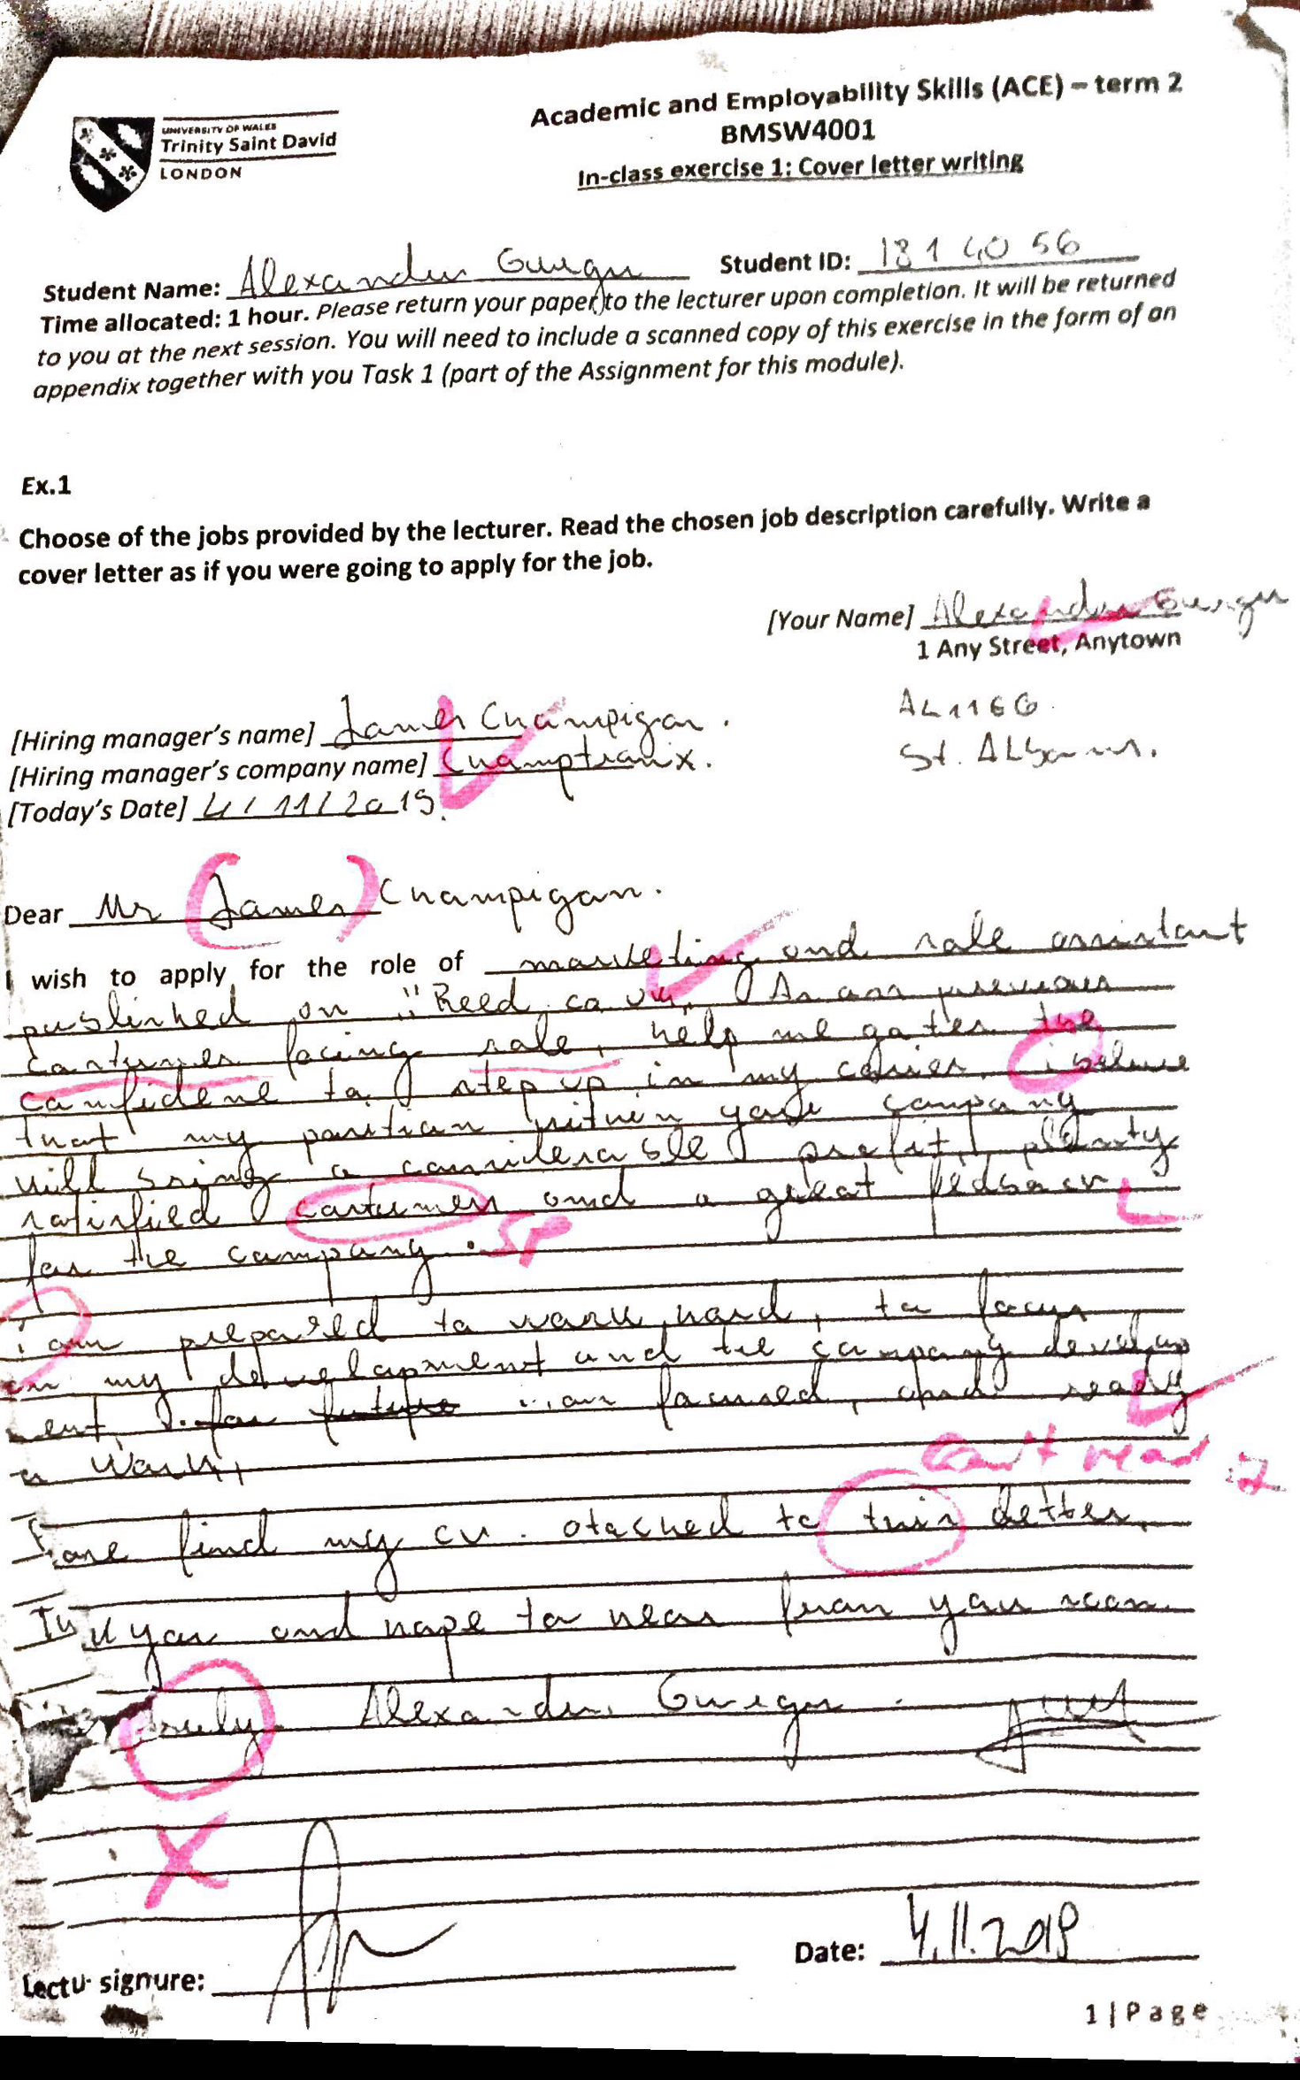
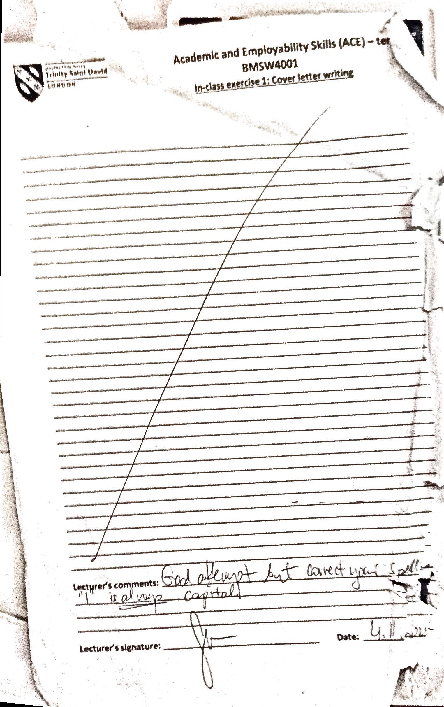
Reference

Mantz Yorke (2004)'Employability in Higher Education: what it is- what it is not', Higher Education Academy/ESECT
Neugebauer, J. and Evans -Brain, J. 2016 Chapter 13 Finding Work Sage publication.
Peter Morgan 2017 The Business Student’s Guide to Study and Employability Chapter 16 page 338 -345 London
Peter Morgan 2017 The Business Student’s Guide to Study and Employability Chapter 9 page 177-179 London
Mike Splane 2006 Power Point Presentation Advice
Http://www.cob.sjsu.edu/splane_m/presentationtips.htm Accessed 1st of January 2020. 17:45 pm
Http://subjectguides.york.ac.uk/skills Accessed on 2of January 2020 at 14:33 pm
Http://www.port.ac.uk/departaments/studentssupport/ask/resurces/handouts/writenassigments/filetodownload,73259,en.pdf Accessed through Moodle on 2of January 2020 at 19:13 pm
Topcv.co.uk Accessed on 2of January at 20:17pm

