Ryan Morris (1550957)
1550957@student.uwtsd.ac.uk
[ACCA6024]
Cloud based web services

Introduction
The purpose of this assignment was to create a dynamic web-app for a car sales business utilising AJAX, a RESTful API, and modern web technologies, such as JavaScript.

The key features of the web-app are to display available cars to potential customers and then allow them to filter and then ‘buy’ a car. Real-time updates using polling ensure that the customers always see a current list of available vehicles, without needing to manually refresh the page, as this happens automatically every 30 seconds. The administrators should be able to add, delete, edit and change the status of a vehicle from an admin page.

Vanilla JS has been used alongside HTML and CSS as it allows for dynamic table updates and event handling such as opening and closing modals to enhance clarity and user experience. CSS has been used to ensure consistent styling across pages and modals. Fetch API has been used make asynchronous HTTP requests to link the frontend with the backend RESTful API. Node.js has been used for the back end with Express.js brought in to simplify the development process.

A PostgreSQL server has been used to store vehicles and be manipulated using SQL.

System Design

Overview
I have used a client-server architecture, with the frontend being built with HTML, CSS and Vanilla JS, and the backend built using Node.js with Express.js. RESTful API endpoints allow the frontend to interact with the backend through Fetch API, allowing users to do Create, Read, Update & Delete (CRUD) operations.
The customer facing interface (homepage/index.html) shows the user a dynamic list of cars and allows for car filtering on make and model by using bespoke endpoints, it also allows users to access a more details modal which then displays a description and allows the user to buy the vehicle.
The admin interface consists of a separate webpage which has an add car button, upon clicking a modal appears allowing an admin to add a new car. There are validation methods, some fields are required and cannot be left blank, the price cannot be a negative number and the milage must be 0 or greater.

Frontend Design
Vanilla JS was used to implement event handling and modal windows. For the homepage, cars were refreshed using polling to ensure that, if a car is added whilst a user is browsing, the list of available cars will automatically be available to the user.
Modal windows were utilised on both the homepage and admin page, customers can select a car to view more details and ‘buy now’, whereas admins adding a car are greeted with a modal view to ensure ease of adding vehicles.
Dynamic filtering has been implemented on the homepage, using JS to populate the drop-down lists to ensure only available cars are searchable by customers. Dedicated end points, GET cars/models and cars/makes have been implemented to ensure searching for vehicles is efficient.
I have utilised CSS to ensure continuity between web pages, ensuring the user experience is seamless throughout the web-application.

Backend Design
Node.js coupled with Expess.js have been utilised, which offering an efficient solution for HTTP requests and routing. RESTful API endpoints are utilised to handle data throughout the web-app, including;
- GET – is used to display data to both the homepage and admin page via displaying all available vehicles (cars/available) to the homepage, and all vehicles (despite their availability status) to the admin page.
The homepage has filtering options, utilising the cars/makes and cars/models endpoints to display relevant data to customers based on their requirements.
- POST - /cars, by utilising this end point, admins can add new cars which are available for sale.
- PATCH. This end point is utilised when admins need to change car details, or when customers buy a car, and the availability needs to be changed.
- DELETE – If a car/record needs to be entirely removed from the database, DELETE is used.
By utilising these end points, the backend efficiently handles input validation and sends appropriate responses to the front end, e.g. car successfully deleted, car purchases successfully.

Database Design
I have used a PostgreSQL database to store the vehicles and associated fields, see the data types and table below:
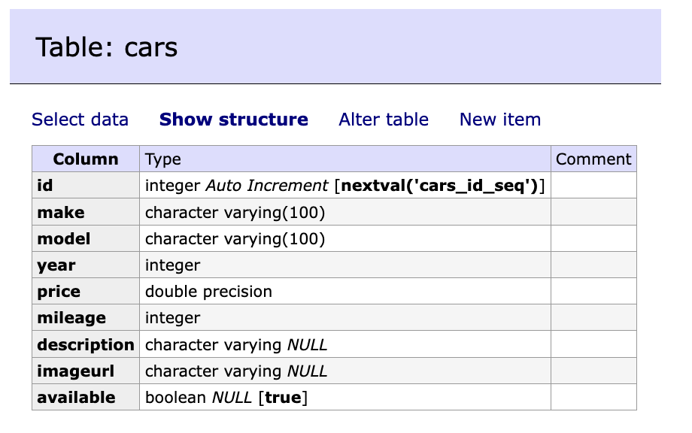

I have used SQL queries to query the database to obtain necessary information to display on the database. Some queries I have used are as follows:

- Fetch all cars: SELECT * FROM cars;
- Fetch all available cars: SELECT * FROM cars WHERE available = true;
- Add a car: INSERT INTO cars (make, model, year, price, mileage, description, imageurl, available) VALUES ($1, $2, … $7, true);
- Update car availability: UPDATE cars SET available = false WHERE id X; (and vice versa)
- Deleting a car: DELETE FROM cars WHERE id X;

Node-Postgres library (pg) is used to connect the database to the backend. The SQL queries mentioned above are executed within the API endpoints to fetch and modify data from the database according to user input. I’ve used NOT NULL fields for fields such as make and model, and for features such as price and mileage, I have used validation to ensure the price is positive and the milage is greater than 0. I’ve used error handling to ensure that if a request fails, a message is passed to the frontend.

Testing

Test Title | Description | Steps | Expected Outcome | Actual Outcome
Add Car | Test to check that a car can be added | -Click “Add Car” button.  -Fill in valid details.  -Submit the form. | The new car should appear in the list of new cars and the database. | Success: The Car was added to the list of available cars on the homepage,
Add a car with missing info | Submit a valid car but omit key details eg make. | -Leave “Make” field blank.  -Submit the form | Error message prompts you to fill in more details. | Success: Car can’t be added.  Requests more details.
Fetch Available Cars | Check that homepage only displays all available cars | -Open homepage  -Check list of cars against database | All available cars should be displayed. | Success: Only available cars were displayed.
Delete a Car | Ensure that a car is removed from the database once deleted. | -Click the ‘delete button’ next to a car in the admin table, and confirm the selection.  -Check the database no longer contains the car. | Vehicle should be removed from the database, and no longer appear on admin page or homepage. | Success: Car deleted and no longer appears on homepage or admin page.
Buying a car | Test the process of marking a car as ‘sold’ once it has been bought. | -Open homepage  -Click “More Details”  -Click “Buy Now” | Car should no longer appear on homepage, availability changed to sold on admin page. | Success: Car marked as sold and removed from homepage.
Polling for Updates | Check that the homepage is dynamically updated if a car is added. | -Open the homepage  -Open admin page in new tab  -Add a new car | The homepage should automatically refresh to display new car. | Success: The homepage automatically refreshed and displays current list of available cars.
Filer by Make | Test that filtering cars by “Make” updates the displayed cars | -Select a “Make” from the drop down  -Click Search | Only cars matching the “Make” selected should appear | Success: Only cars matching the selected “Make” are displayed.
Invalid Price Input | Test validation by entering a negative price while adding a new car. | -Enter a negative number in the “Price” field  -Submit the form | An error message should appear, and the car shouldn’t be added to the database. | Success: Validation message appeared, and no car was added.

Deployment
I will provide all relevant files needed to run my application on a host machine, I have used Docker and will include the Dockerfile and docker-compose.yml to handle installing all required dependencies, ensuring the application will run the same on any machine.

Prerequisites
- Docker Desktop installed on your machine.

How to Deploy
Download the project files and store them locally. Open a terminal window and navigate to the project directory (this is where the Dockerfile will be found). Build a Docker Image by entering the following into the terminal:
docker-compose up
If this doesn’t work, try: docker compose up

To access the application, open a browser and go to:
http://localhost:81/index.html - for the homepage
http://localhost:81/admin.html - for the admin page
http://localhost:8080 for the database

To log into the database, use the following:
Server: postgres
Username: docker
Password: password
Database: carsales

Once finished using the application, use:
docker-compose down OR docker compose down

Conclusion

Overall, I am pleased with the outcome of my car sales application. I feel I have successfully implemented the functionalities required by the assignment brief and have a dynamic web-application for a car sales business.
There are areas of my application that I would improve upon, given I had more time. For instance, I would seek to protect the database from SQL injection attacks. I would also add a log in system which would differentiate users (customer/admin) to further improve security.
Despite the lack of these features, I feel that my application demonstrates my ability to design and develop a functioning product using modern web technologies.

YouTube Link
https://youtu.be/5nhMSHGyS74

