Introduction to Web Development
  - Lecture 8a Lab Tutorial Exercise

Installing Drupal

Objectives
In today’s exercise, you will set up a web server and install a Drupal website on your webserver.

Exercise 1: Installing UwAmp
- Go to http://www.uwamp.com/en/ and hit the download button to download the installation files.
- Important! Extract the files either to:
  - Your USB or Portable Hard Disk Drive
  - OneDrive, DropBox or similar
If you are unsure, please ask me.
- Now, it is very likely that a webserver such as WAMP or IIS is already installed on the lab computers and you will need to use different ports for your installation as two webservers cannot use the same port. The same thing applies to the database, MySql.

Checking if you need different ports
- Locate your UwAmp folder and double-click on the UwAmp file to run it.
- If the status is nice and green as shown below, you are good to go, skip to the next exercise (Exercise 2: Configuration Settings). Please make sure both Apache and MySQL are running as shown.
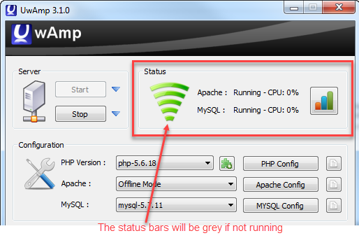
- It probably means you need to change the port numbers for your web and database servers and you would likely have been prompted that port 80 is already in use.

Changing Apache (Web Server) Port
- This is the easy bit.
- In the UwAmp window, click on the Apache Config button.
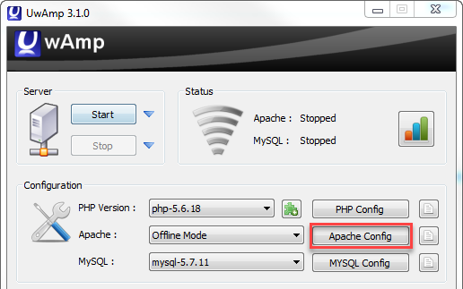
- In the window that displays:
  - Click the main-serveur *:80 option in the left window
  - Then change the Port to 8080 (hopefully this is not used yet, or you can use another number).
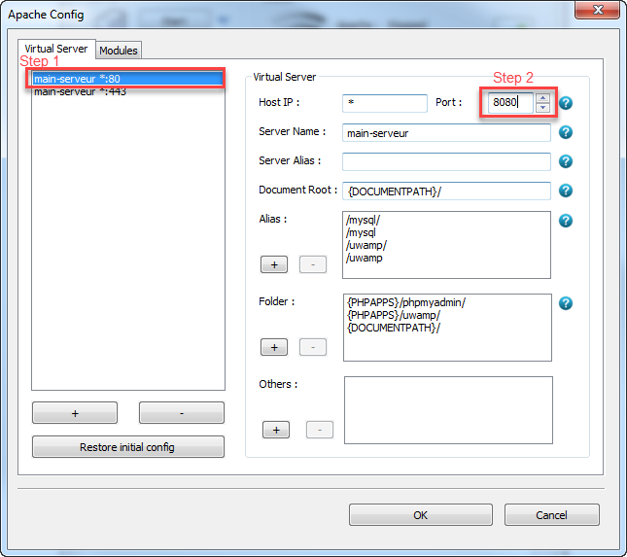
- Hit the OK button.

Changing MySQL (Database Server) Ports
- Check to see if both servers are up and running first. If both Apache and MySQL are now running, you can skip this exercise.
- This is a bit trickier and requires changes to a number of files.
- Go to file explorer and browse to your UwAmp folder.

bin\database\mysql-5.7.11\ folder
- Go to the following subfolder: bin\database\mysql-5.7.11\ and set the port to 3307 as shown in the following two files in this folder. To open the files, right-click and select Edit with NotePad++. Remember to save the changes when done.
- my_uwamp.ini
- my_initial.ini
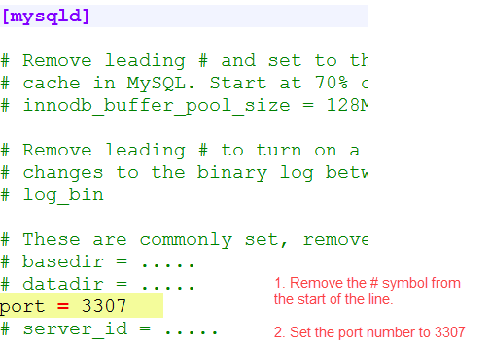

bin\php\php-5.6.18\ folder
- Go to the bin\php\php-5.6.18\ subfolder.
- Open up the php_uwamp.ini in NotePadd++
- Do a search for mysqli.default_port and change the port number to 3307 (as shown below).
- Save your changes when done.
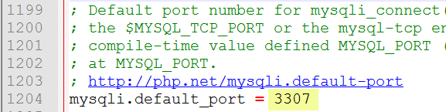

bin\php\php-7.0.3\ folder
- Go to the bin\php\php-7.0.3\ subfolder.
- Open up the php_uwamp.ini in NotePadd++
- As before, do a search for mysqli.default_port and change the port number to 3307 (as shown in the previous step).
- Save your changes when done.
- Now go back to the UwAmp window.
  - If it is not visible, click on the icon in the right-side of the task bar and double-click on the UwAmp icon as shown.
  - If the UwAmp icon is not visible, then browse to your UwAmp folder and double-click on the UwAmp file to run it.
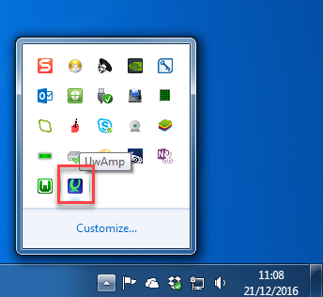
- Now click on the Start button to start the server
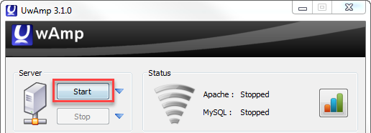
- Hopefully, you should see the status bars change to green and the indicators telling you the webserver and database server is running.
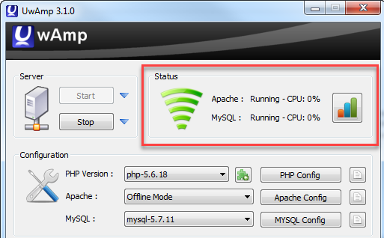
- If it is still not working, contact me.

Exercise 2: Configuration Settings
- Open up the UwAmp window if it is not already open.
  - If it is not visible, click on the icon in the right-side of the task bar and double-click on the UwAmp icon as shown.
  - If the UwAmp icon is not visible, then browse to your UwAmp folder and right-click on the UwAmp file and select Run as Administrator.
- You need to make some configuration changes before continuing. Click on the little notepad icon beside the PHP Config button.
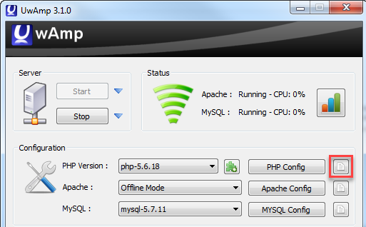
- It should open up a file in notepad with lots of configuration settings.
- Search for max_execution_time and change the value from 30 to 240 as shown and remember to save the changes and close the file.
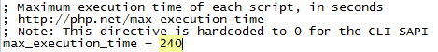

- Now, search for date.timezone. You should find the following:
;date.timezone =
- Make the following changes:
  - Remove the semi-colon (;) from the start of the line
  - Set the value to Europe/London as shown.
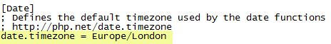
- Important! Making these changes is likely to stop the Apache webserver. You will need to restart it by clicking on the icon beside the Start button and clicking Start Apache.

Exercise 3: Connecting to the Database Server
- Now, you can check to see if you can connect to the Database server.
- The User Interface for managing the Database is known as PHP My Admin. Click the PHPMyAdmin button.
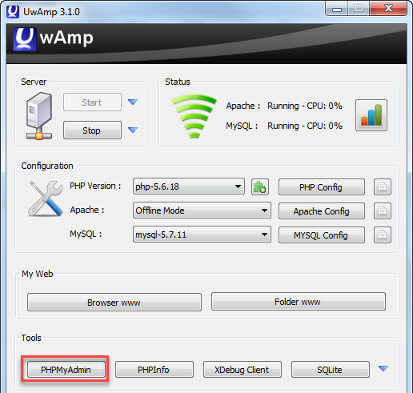
- Clicking the button should open the following page in a web browser.
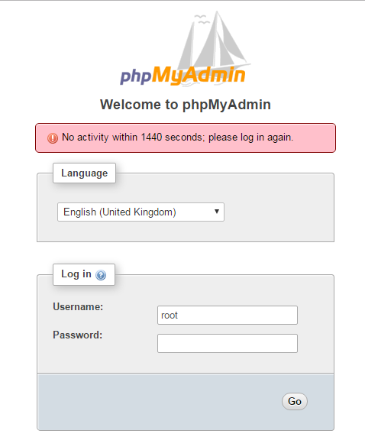
- The username and password should both default to the following. See if you can log in okay (if not, please let me know).
  - Username: root
  - Password: root
- Make note of the address to access your webserver and if any port number is needed:
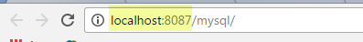

Exercise 4: Adding a Drupal Site
- Go to https://www.drupal.org/ and press the “Get the code” link to download Drupal.
- Important! You need to extract the downloaded Drupal files in the www subfolder of your UwAmp folder.
  - Extract the Drupal files in the www folder
  - Rename the folder from drupal-8.2.4 to something reflecting your website e.g. MovieBox (no spaces please)
- Once that’s done, open up your browser and browse to your website address, which will be in the following format. Replace MovieBox with whatever you renamed the Drupal folder to.
  - localhost/MovieBox/
  - localhost:8080/MovieBox/ - if you need a port
- You should get the following screen. Select English as the language and press Save and Continue.
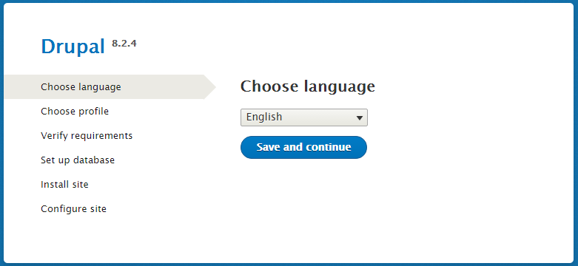
- Choose the Standard installation.
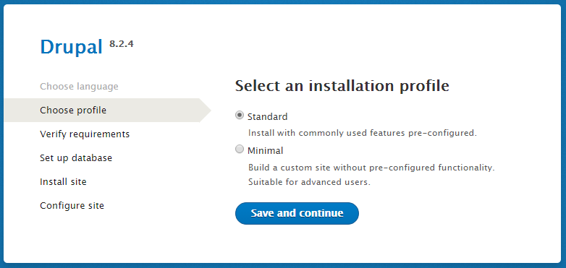

- In the next screen, you may get the following warning. Just scroll to the bottom of the page and click on the “continue anyway” link.
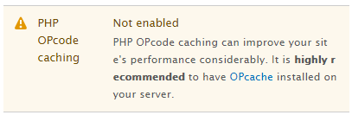
- For the database configuration, you need to:
  - Choose a database name – no spaces please.
  - Specify the database username and password – both should be root.
  - Note.
    - If you did not have to change the port number for MySql, the database server, you do not need to configure the Advanced options.
    - If you had to change the port number for MySql, the database server, you will also need to specify the port number (3307) for MySQL (the database server). Expand Advanced settings and set the port number to 3307.
    - You will know if you have done something wrong if you get an error message saying it could not connect to the database server when you click the Save and continue button.
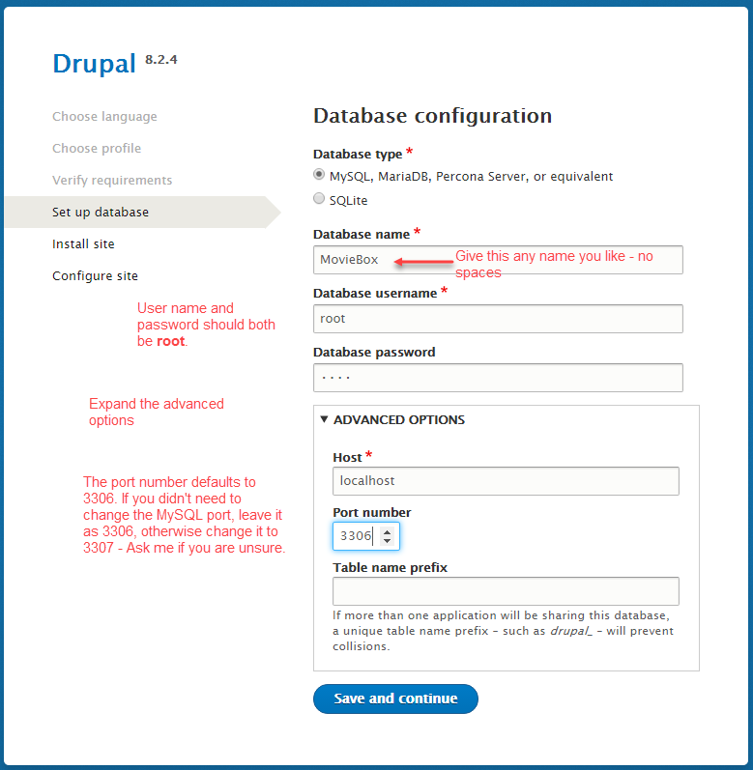
- Be patient and wait for the installation to complete, it takes a few minutes.
- When the installation completes (the page is too long for me to paste):
  - Note: you may get a warning message about the Date Time Zone when the installation completes. If you do get this error it means you need to go back and complete Exercise 2.
  - Configure the following on this screen:
    - Site Name: something to reflect your website name. This is what will display in the title/tab bar.
    - Site Email Address: your email address
    - Username: whatever you want
    - Password: whatever you want (please note that I do not have access to this password so make sure you set it to something you will remember)
    - Default Country: United Kingdom
    - Default Time Zone: Europe/London
    - You can uncheck the Receive email notifications.
- Hopefully, your site successfully installed and you have a screen similar to the following.
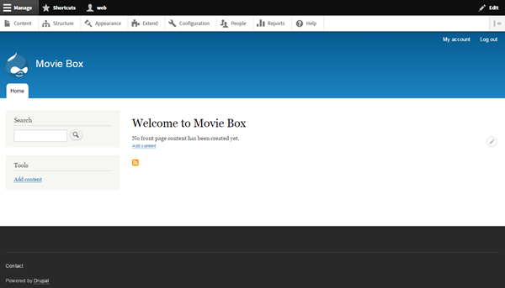
- Log in to your site if you are not already logged in.
- From the menu at the top, click on the Configuration menu option.
- You may get the following warning message. If you do, click on the status report link

Enabling Trusted Host Settings
This prevents other people from pointing their IP address to your website if it is published on the Internet. See more.
- Scroll down the page. If you have the following error follow the steps below:
  - Locate your UwAmp folder on your portable device or cloud storage and double-click the www folder. All websites are added to this folder.
  - Locate the folder you created for your Drupal site – step 2.b above and browse to the following location in this folder: sites default
  - Locate the settings.php file.
    - Right-click on it and select Properties. If it is set to Read-only, uncheck this box.
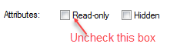
    - Right-click on it and select Edit with Notepad++
  - Scroll to the end of the document and add the following (you can copy and paste this):
$settings['trusted_host_patterns'] = array(
'^127\.0\.0\.1$',
'^localhost$',
);
  - Save the file and close it. You can also set it back to read-only if you wish.
- Go back to your website and refresh the configuration page. The error should have disappeared.
- That’s all for this part!

