SERIES REGULATED POWER SUPPLY REQUIREMENTS

A simple, unregulated, capacitor filtered power supply is shown below:
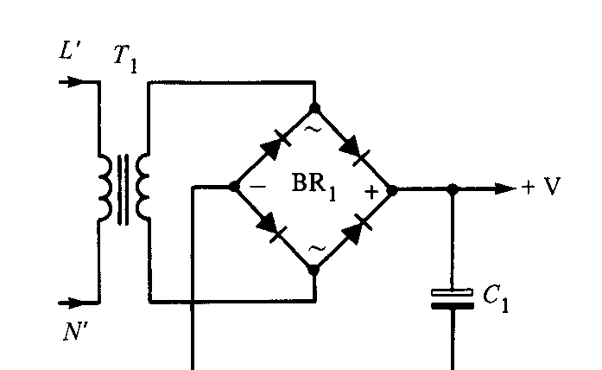
Vo
Load
The problem with this circuit is that it is unregulated and therefore the output voltage tends to vary with load current.

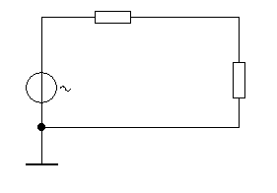
The Thevenin equivalent circuit of the supply is shown below:

Load
Vo
Rs

A potential divider is formed between the supply and the load. As the load resistance decreases, the current rises and the output voltage of the supply (Vo) will drop due to the increased voltage drop across Rs.
A voltage regulator circuit is placed in series with the supply line in order to regulate the Vo supply so that, in theory, the output voltage of the supply will remain fixed at Vo and will not change as the load resistance and current changes.
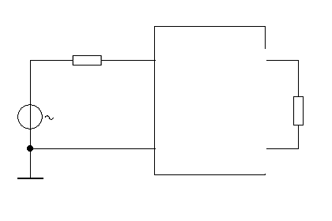
Load
Vo

Voltage
Regulator
Vi

The purpose of the regulator is to:

- Stabilise the output voltage against load current variations.
- Reduce mains ripple and other noise on the output.

A simple block diagram of a stabilised series regulated power supply is shown below.
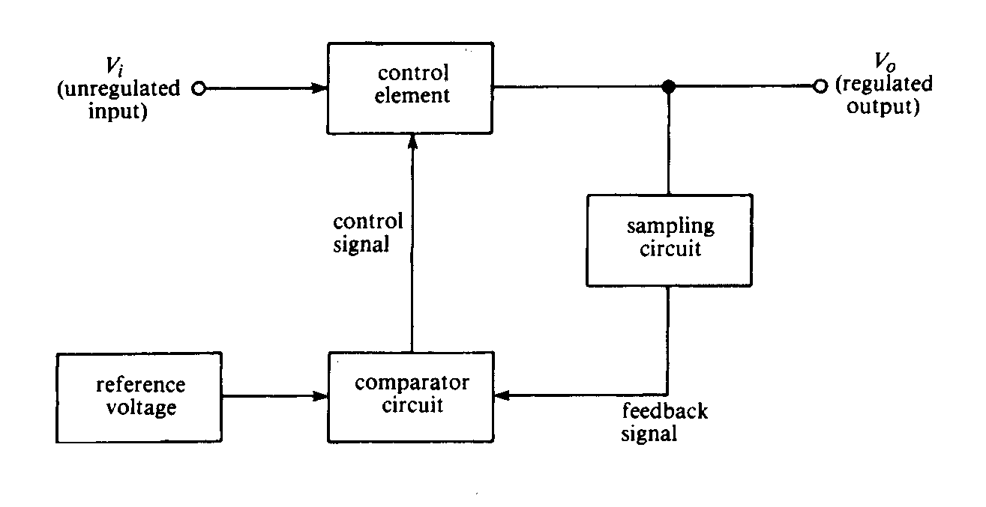
Protection

The unregulated input is the Vo terminal of the unregulated supply show on page 1. This is fed into the control element.

The control element is a transistor which acts as a resistor in series with the supply and the load.

The control signal controls the resistance of the transistor.

A comparator is used to compare a sample of the output and compare it with some reference.

The reference defines the required output voltage and if the output voltage is not as required the comparator detects the difference an provides a negative feedback signal to the control element to make the control element adjust the output voltage to what it is supposed to be.

Protection: may be provided, the purpose of the protection may be two-fold:

- To protect the regulator from load problems (constant current control).

- To protect the load from power supply problems (over-voltage protection).

Stabilised power supplies may come in three main forms:

Series Regulated

Shunt Regulated

Switch Mode

The series regulated and switch mode power supplies are the most common.

Series Regulators:

- Regulator transistor is in series with device.
- Regulator always drops some of the supply across itself
- Regulator carries full load current
4. Series regulators used for high voltage/low current
applications.

Shunt Regulators:

- Regulating transistor is in parallel with the load
- The transistor doesn’t have to carry the full load current.
- The transistor must carry current at all times.
- Used for low voltage/high current applications. (RELATIVELY SPEAKING)
- Not that common compared with series type.

Zener Stabilised Supply
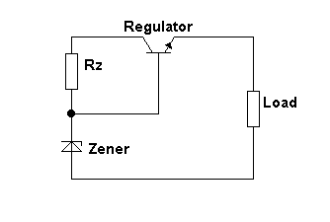
An example of a simplistic series regulator design.
IL
Unregulated supply input
Vo (regulated)
The zener diode provides the reference voltage determines the output voltage since
Vout = Vz – Vbe.

Vz is approximately fixed at the zener voltage even if the unregulated input varies.

In practice, a small fraction of any mains ripple on the unregulated input will appear at the output of the zener and so some mains ripple will appear across the load.
It is common to place a capacitor across the zener in order to short any unwanted mains noise, or any other noise, to ground.
Vbe remains relatively constant and independent of base current variations, hence Vout remains relatively constant.

SERIES VOLTAGE REGULATOR EMPLOYING AMPLIFICATION AND FEEDBACK

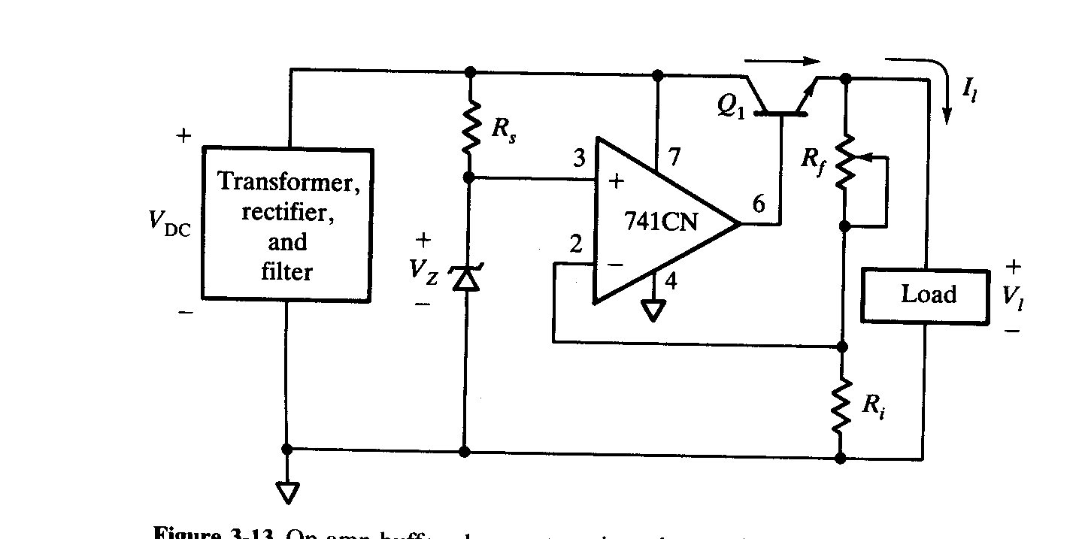
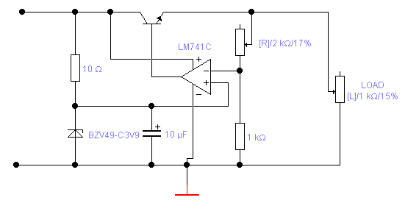
Vx
Rs
Vz
Ri
Rf
Load
C

Vo

Vx

The purpose of this circuit is to provide a stable , regulated and low noise d.c. supply for a given load.

Circuit operation.

Ri and Rf form a potential divider and feeds-back a sample of the output voltage to pin 2 of the op-amp. This sample voltage is compared with a reference produced by Rs and Vz.

If Vx > Vz then pin 6 of the op-amp. will drop. This will cause Vo to drop. However, if Vo drops then so does Vx which returns pin 6 to its original position. Hence negative feedback is stabilising the output voltage.

Consider the situation where Vx = .5 x Vo , now Vx and Vz must be almost equal since the op-amp is acting as a non inverting amplifier with a gain 1+ Rf/Ri. Now if Rf = Ri this will make Vx = ½ of the output voltage. This means that the output voltage, therefore, is 2. Vx but Vx is approximately Vz.

Hence Vo = 2. Vz approximately.

NOTE: Feedback factor β = Rf / ( Ri + Rf ) = 0.5 , therefore gain =1/β = 2
The circuit is therefore acting like an amplifier which is amplifying Vz by the gain of the op-amp. This voltage is then fed to an emitter follower (the regulator ) and therefore supplied to the output as a low output impedance d.c. voltage source.

In practice the base –emitter diode of the series transistor is in line with pin 6 and the actual output terminals and so Vo is 0.6 volts below that of the op-amp. output voltage.

Points to note:

- The unregulated supply (including ripple) must not exceed the maximum supply voltage for the op-amp.

- The regulator must drop some voltage across its collector –emitter region. This is typically a few volts minimum. (DROP-OUT VOLTAGE) ***** Add to your notes!

- The lower the output voltage , the greater the dissipation within the regulating transistor. This means that lower output voltages stress the circuit more than higher level output voltages.

- By adjusting Rf we can adjust the output voltage within a limited range and hence produce a variable output supply. However, you will not be able to get the output down to zero volts.

Worked Example.

Determine the approximate output voltage for the circuit if Vz = 6.2 volts, Rf is adjusted to 1.2 k and Ri = 1k.

Ans. 1

Therefore Vo = ( 1 + 1.2k/1k ) . Vz = 13.64 volts.

In practice this would only be achieved if the unregulated supply were at least a few volts higher than 13.64 v.

APPLICATION OF CURRENT LIMIT CIRCUIT TO SERIES REGULATOR.

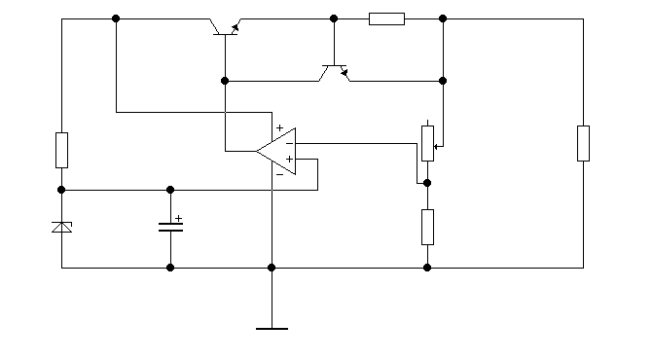The circuit shown above does not have any current limiting. This is a useful feature on many power supplies and it can easily be implemented on this circuit as shown below.
Tr2
Tr1
Rcc
Rload
The protection circuit consists of Rcc (the constant current limiting resistor) and Tr2. As the load current increases it drops as an increasing voltage across Rcc. This then eventually forward biases Tr2 base. Tr2 starts to conduct and diverts some of the base current for Tr1 away from the base of Tr1. This current flows through Tr2 instead. If less current is fed to the base of Tr1 then Less current will be fed to the load. So as the load current reaches a limiting value ( set by the value of Rcc) there comes a time when Tr2 conducts and limits any further increase in the load current. Any further demand for current from the load will cause the output terminal voltage to drop and hence reduce the current supplied to the load back to its limiting value.

The capacitor across Vz is used to reduce the ripple from the unregulated supply that manages to by-pass the zener diode.

OVER –VOLTAGE PROTECTION

This form of protection is used to prevent excess voltage on the unregulated side from getting to the load and possibly damaging it.

Vz
Ig
fuse
Regulated output
Load
X

This circuit could be placed after the regulator and before the load.

If the voltage at X is > Vz then the zener diode will conduct. This will allow a gate current to enter the thyristor and trigger it into conduction. The thyristor will then become almost a short circuit and cause the fuse to blow. This will then require the over-voltage to be removed and the fuse repaired.

POWER SUPPLY SPECIFICATIONS.

Voltage stabilisation factor ( s )
An alternative name often used is Line Regulation. This describes how the output voltage changes with respect to mains voltage changes at a fixed load.

s = Δ Vout / Δ Vin ( with RL constant )

E.g. In a stabilised power supply the unstabilised voltage changes from 100 V to 80V and the load is assumed constant. If “s” = 0.05, determine the variation in output voltage that will occur.

s = Δ Vout / Δ Vin therefore Δ Vout = s . Δ Vin = 0.05 . (100 – 80 )

Therefore Δ Vout = 1 V

NB. The output will change in the same sense as the input.

Output resistance.
The output resistance of a good power supply should be as small as possible, typically in the mΩ region for a commercial supply.
In order to determine Rout we need to know how Vout changes with respect to Iout.

Rout = Δ Vout / Δ Iout ( constant Vin)

e.g.. If a change in Vout of 0.2 V occurs when a change in load current from 50 to 100 mA occurs then :

Rout = Δ Vout / Δ Iout = 0.2 / (100 – 50 ) mA

Therefore Rout = 4Ω

Load regulation.
Load regulation defines how the output voltage varies with changes in load current from zero to full load (as a %) , assuming Vin remains constant.

% load regulation = (VNL – VFL) x 100% where VNL = no load o/p voltage and
VNL VFL = full load output voltage.

e.g. if the output voltage of a 10 V series regulator drops by 0.1 V as the load current goes from zero to maximum value, the % load regulation is given by:

% load regulation = (VNL – VFL) x 100% = (10 – 9.9) x 100 = 1%
VNL 10

Integrated circuit voltage regulators
The 7805 I.C. voltage regulator is an industrial standard device for providing a stabilized d.c. supply with a minimum component count.

Typical markings x x 7 8 0 5

Manufacturer 05,09,12,15 output voltage
8 = positive regulator
9 = negative regulator

This is a three terminal I.C. device with i/p, o/p and ground terminals.
Typical examples are:

7805 +5 V regulator
7812 +12 V regulator
- - 5 V regulator
7915 -15 V regulator.

Typical circuit application.

Unregulated I/p o/p
7805
This device has built-in protection and feedback. It has very good regulation properties despite its apparent simplistic structure. The circuit actually consists of around 20 semiconductor devices and as many passive devices. These type of regulators are essentially fixed voltage regulators, however, it is possible to convert them into variable supplies provided we are prepared to accept reduced regulation performance. There are, however, specially designed adjustable voltage regulators, such as theLM317 and μA723 I.C. regulator. Such devices have good regulation, temperature stability, output resistance and noise performance.

Typical circuit application.
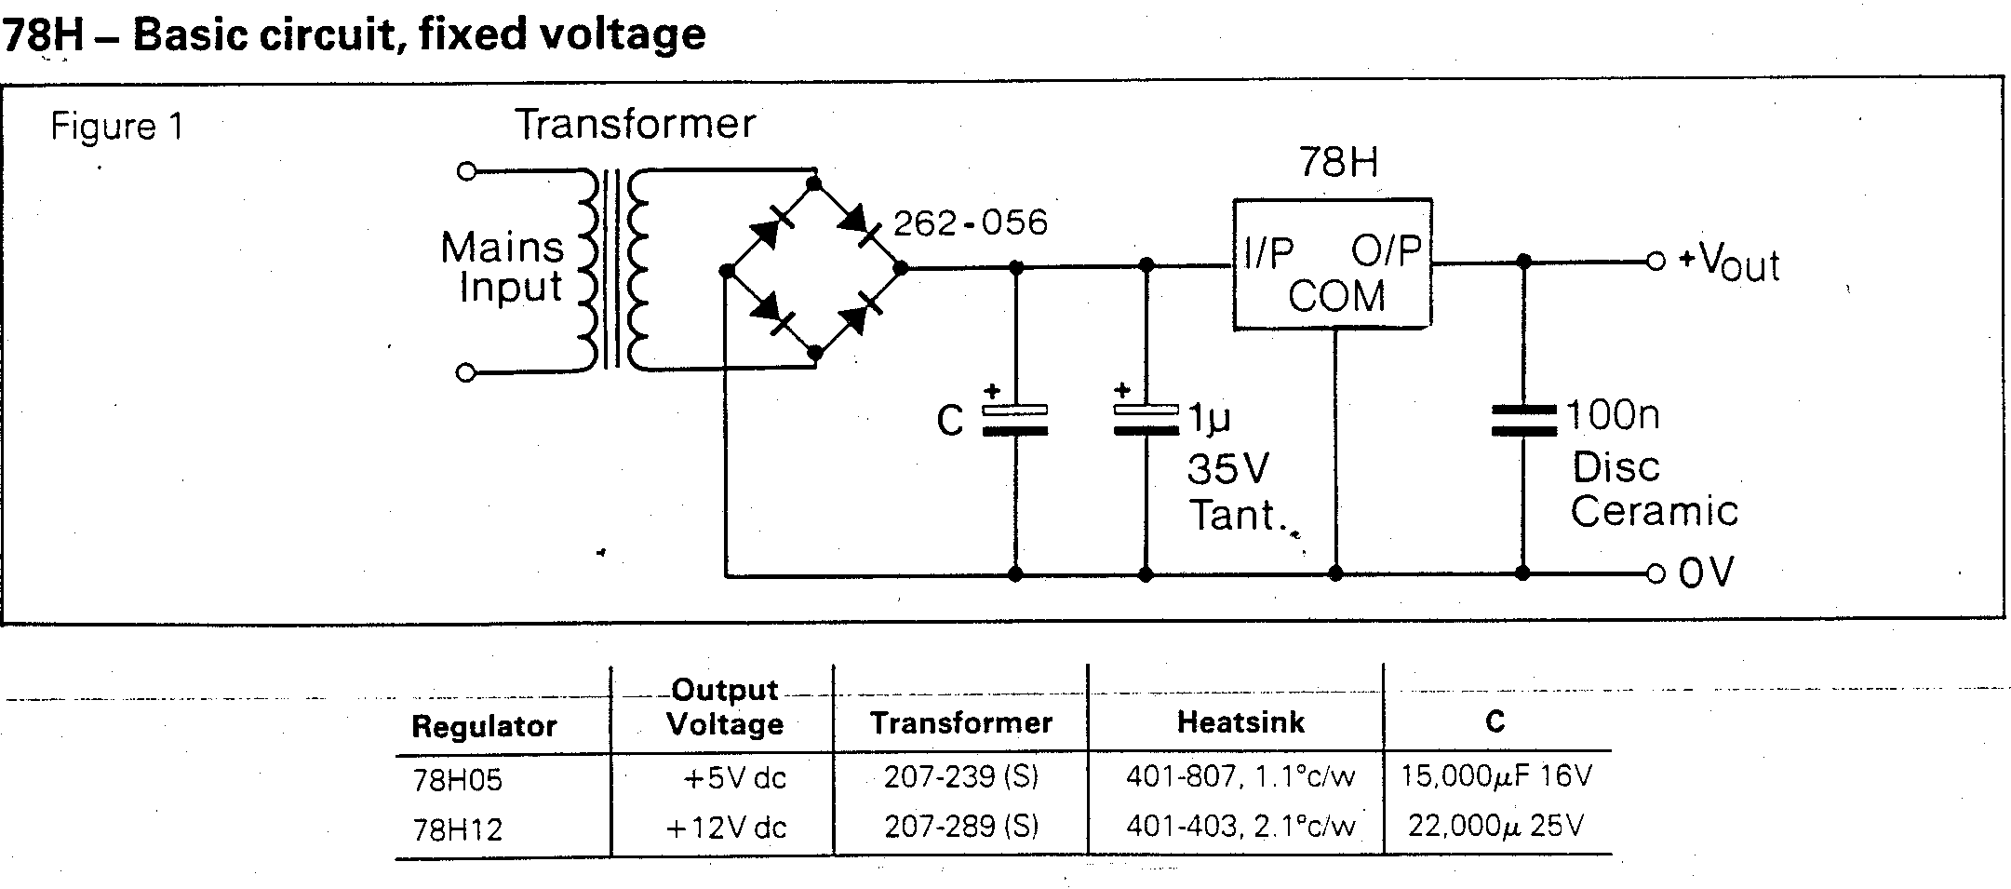

This device has built-in protection and feedback. It has very good regulation properties despite its apparent simplistic structure. Internally the circuit actually consists of around 20 semiconductor devices and as many passive devices. These type of regulators are essentially fixed voltage regulators, however, it is possible to convert them into variable supplies provided we are prepared to accept reduced regulation performance. There are, however, specially designed adjustable voltage regulators, such as theLM317 and μA723 I.C. regulator. Such devices have good regulation, temperature stability, output resistance and noise performance.

EXAMPLE OF A SPLIT POWER SUPPLY USING POSITIVE AND NEGATIVE VOLTAGE REGULATORS

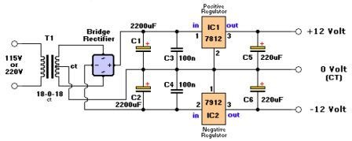

A Dual Rail (Split) Power Supply , utilising two commercial IC Regulators is shown above.
The Bridge Rectifier provides un-regulated DC to the positive ( 7812) and negative (7912) regulators.
C1 and C2 provide bulk ac filtering to remove low frequency mains ripple whilst C3 and C4 provide noise filtering for higher frequencies. The electrolytic capacitors are not good at filtering high frequencies because they have significant Effective Series Inductance and this prevents high frequency noise filtering.
The filtered un-regulated supply is then fed simultaneously to both positive and negative regulators.
The 7812 and 7912 commercial IC regulators are chips and have regulation circuitry built within them. However their application is quite straight forward, they have input, output and Ground pins and that’s it.
These devices provide a very stable, regulated and noise free output and are industry standards.
C5 and C6 provide additional filtering and provide extra current that may be demanded by the load in order to support the output voltage under demanding load conditions.

An example of an LM317 variable voltage regulator is shown below.

220Ω

The LM 317K is an adjustable voltage regulator capable of providing a regulated voltage over the range:1.25 V to 37 volts provided it is supplied with sufficient amplitude unregulated supply.

The manufacturer advises that the 220 ohm resistor be mounted close to the o/p terminal of the regulator to minimise noise problems.

In addition R1 has been specified as 220 ohms and Iadj. = 50 μA.

Hence we may re-arrange the above equation to determine the value of R2 required to give us the required output voltage.

The regulator must have at least 5 volts drop across its i/p - o/p terminals in order to operate properly. This voltage drop is known as the “drop-out” voltage.

The device is designed to maintain 1.25 volts between the output terminal and the control input.

DESIGN EXAMPLE

Use an LM317K regulator to design a 24 volt power supply, capable of supplying 0.5 amps. of current.

Procedure.

Using the main design equation : Vout = 1.25 ( 1 + R2/R1) + Iadj. R2, input the value of 220 for R1 and Iadj = 50 μA. We also know that Vout = 24v. We can therefore manipulate the equation to define R2 in terms of the other known quantities.

therefore: 24 = 1.25 ( 1 + (R2/220)) + (50 . 10-6 .R2)

therefore 24 = 1.25 + 1.25. R2 + (50 . 10-6 .R2)
220

therefore 24 - 1.25 = (5.68 . 10-3 . R2) + (50 . 10-6 .R2)

therefore 22.75 = (5.68 . 10-3 + 50 . 10-6 ). R2

therefore R2 = 22.75 / (5.73 . 10-3 )

therefore R2 = 3.97 k
In practice this is not a preferred value and so a potentiometer of 5k or 10k would be used and adjusted until the output was as required.

We now have to determine the unregulated supply specification.
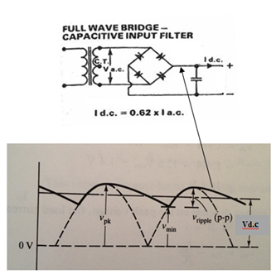

Here you can see the unregulated
circuit and a simplified diagram of
the relevant waveforms. Id.c. is the
required full-load current required to
supply the regulator and hence the
load.

The ripple is defined in terms of its peak-peak value. The average value
is approximated by Vdc.
V_{pk} represents the peak of the voltage across the capacitor, due to
the full-wave rectified output of the transformer and equals (V_{min} + V_{ripple}), where V_{min} is the minimum
value of the ripple voltage and this
has to be at least Vout of the regulator plus the drop-out voltage.

With Vout = 24 V we need 24 + 5 = 29 volts minimum on the input to the regulator in order to satisfy the 5V drop-out voltage required across the regulator. NB: the drop out voltage is not always 5V.

The d.c. supplied to the regulator must therefore lie between a minimum ( V_{min}) of 29V and a maximum of 40 volts, where 40V is the maximum allowed input voltage for this device.

Minimum peak a.c. voltage required (V_{ac}) rms) from the transformer = V_{pk} = (V_{min} + V_{ripple} )
remove
Suppose the ripple is 1V pk-pk. Now add two diode drops to account for the rectifier diode losses, say 1v per diode.

Therefore V_{pk} = (29 + 1) = 30V Now add the two diode drops so that required Vpk = 32V
insert
Therfore : V_{ac(rms)} = 0.707 ( Vpk + 2 diode drops ) = 0.707 x ( 30 + 2) = 23Vrms approx.

Therefore the minimum a.c. voltage is 23Vrms approx.

The nearest preferred transformer, with two 12V windings connected in series will provide 24 Vrms a.c. This will convert into a peak of 24 x 1.4 = 34 volts. This lies well within the required range.
Required range >30V and < 40V.
Any voltage in excess of the minimum 30 volts will give rise to increased dissipation within the regulator and therefore, too much excess voltage is not helpful. However, there will be some voltage drop from the transformer terminals and bridge rectifier so some extra voltage will be of help.

The transformer rms current is given by Ia.c. = Id.c. / 0.62 = 0.5A / 0.62 = 0.8A rms.

Power dissipation within regulator = (Vd.c. - Vout) x Id.c. where Vdc is the average dc.
insert
V d.c. = V_{min} + ( V_{ripple} / 2 ) = 29 + 0.5 = 29.5 V

Therefore Power Dissipation in regulator = ( 29.5 – 24 ) x 0.5 = 2.75W

this is well within the specification for the regulator. Pmax = 20 Watts.(regulator should use a heatsink)

A transformer is rated in terms of V.A. i.e. its volt/amps rating.

The VA required for this transformer = V_{ac} x I_{ac}

= 23 x .8 = 18.4 VA approx

A 20 VA transformer is the closest available on the up side, however, it may be more sensible to select the next available higher VA rating to avoid straining the transformer to its limits.
NB: Even though a 20VA transformer is capable of supplying up to .83 amps it will only supply what is needed, our design only requires .8A.

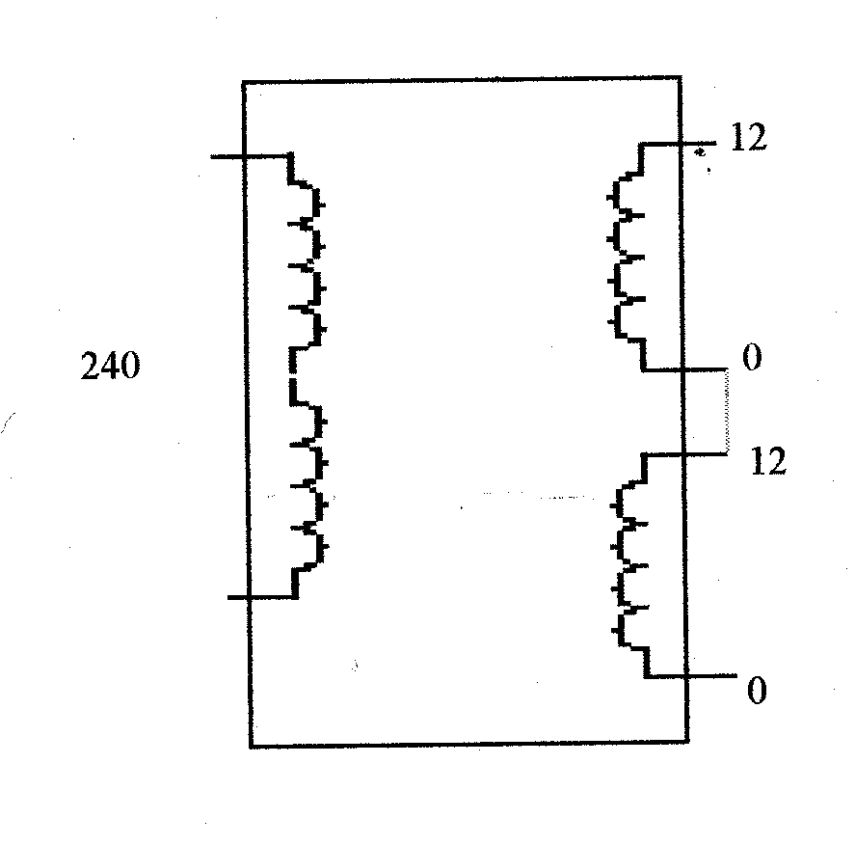
Primary has two 120V series connected windings.
V
Note: the little black dots along-side the secondary terminals indicates relative polarity of output with respect to input.
The way that this transformer is connected is such that the output voltage will be in-phase with the input.
This arrangement provides us with 24V output BUT limited to the maximum current of one coil.

20VA
This transformer can be connected in a variety of ways, the two most common arrangements are:

- series connected (as above)
- parallel connected secondary winding configurations.

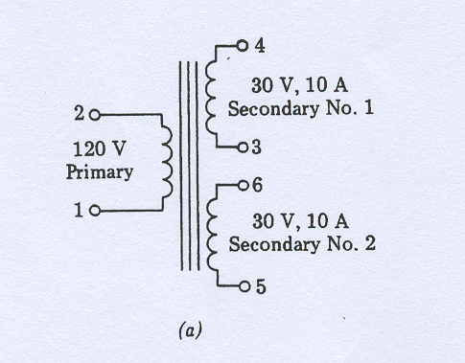
There are several ways of interconnecting transformer windings, the two most common are shown below.

Series connected secondary windings.

Example of a 120V single primary wound transformer with a two secondary windings. Each winding is rated as 30V,10A i.e. 300 VA. Total VA rating is 600VA.

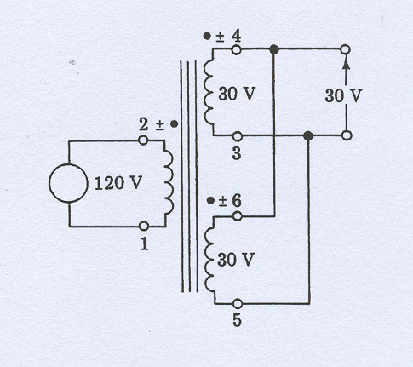
Parallel connected secondary windings.

This arrangement provides twice the current drive capability compared with series connection BUT it will only provide an output voltage equal to the maximum voltage of just one of the coils.
E.g. assuming that this transformer has a total VA rating of 600W, this will provide 30V @ 10A per coil.

With the coils connected in parallel, as shown, the output is rated as 30V,20A = 600 VA.

Connected in series, the output would be rated at 60V@ 10A = 600VA.

Therefore we can achieved 600VA in a variety of ways.

Filter Capacitor Choice

It can be shown that an approximate, but useable, value for the filter capacitor can be determined from:

C ≥ Id.c / ( f. V_{ripple}), where f is the main ripple frequency = 2 x 50Hz = 100 Hz.

hence C ≥ 0.5 / ( 100 x 1) = 5000μF, therefore use either 8700 μF or 10,000μF (NPV)

Choice of Bridge Rectifier

Ensure the average forward current ( I_{FAVE} ) is ≥ Id.c. and the maximum repetitive reverse voltage for the (V_{RRM} ) is ≥ V_{pk} .

Therefore bridge rectifier spec: I_{FAVE} should be a minimum of 0.5 A, possibly larger.
And V_{RRM} ≥ 32V.

E.g. V_{RRM} = 50V and I_{FAVE} = 1A : Commercially available from RS.

ADD THIS

SWITCHED MODE POWER SUPPLIES

The disadvantages of the series regulated supplies are :
- the necessity to encorporate a large and costly step-down transformer which operates at mains frequency .
- the need for a powerful regulating device capable of handling full load current.
- they are not very efficient, 50% at best.

Switch mode powers supplies (SMPS) overcome these disadvantages by operating the transformer at much higher frequencies ( 20 – 50 kHz) and by regulating the output voltage by employing a switching device i.e. a switching transistor. The switching transistor is either turned fully on or fully off . Under these conditions it is consuming zero power since if it is on its current is high but its collector-emitter voltage is zero. Alternatively if it is off then its current is zero, its collector emitter- voltage is a maximum. In either case the V,I product = 0. In practice the transistor does consume some power since it has to transit between on and off and during this period both transistor current and voltage are finite. In general, however, the SMPS is much more efficient than a comparable output series regulator.
Typically a SMPS is smaller and more efficient than a series regulator but it is more complex to design, manufacture and repair.

Block diagram of a switched mode power supply.
Step down
transformer
P.W.M
Oscillator
Control
Circuit
Rectifier &
Smoothing Circuit.
Switch
Regulator.
Mains Rectifier.
Stabilised d.c.
O/p
Mains
I/p
V
t
t
on
off
V
t
Reference

The mains rectifier provides unregulated d.c. to the switching regulator. The switched regulator is a switching transistor which is turned on and off by means of the PWM oscillator. When the transistor is on a large d.c. voltage is applied to the rectifier circuit. When it turns off , zero volts is applied. This pulsed waveform is then smoothed by the rectifier and smoothing circuit to produce a smooth output.
In order achieve a stable output there is feedback from the output to the control circuit. This signal is compared with a reference input to the control circuit. Any discrepancy will give rise to a correcting signal being passed to the PWM. If the output is too high then the PWM pulse width will be reduced. The PWM pulses supplied to the transistor cause it to turn on and off. The wider the on time the greater the average output voltage and visa versa.

