
Communication skills
Workplace bullying

Table of Contents
Introduction 2
Case scenario 3
Impact of workplace bullying 3
Role of communication in addressing workplace bullying 5
Solution 6
Conclusion 7
References 8
Appendices 10
PowerPoint Presentation: 11

Introduction
According to the Survey of Unison (2017), the black women are more likely to be experienced with bullying compared to their white counterparts. For example; 33% of white employees reported being bullied compared to 56% of black African, 51% of UK-born black employees (Unison, 2017). See appendix # 1. Besides, CIPD (2012) showed that 16% of employees reported being bullied to their line managers. The workplace bullying is rising gradually in the UK (BBC, 2015). For example; Acas reported that they had received 20000 complaint about workplace bulling. These have raised concern to employees to speak up frankly.
“Offensive, intimidating, malicious, insulting behavior, an abuse or misuse of power through means that undermine, humiliate, denigrate, or injure the person being bullied” (The Guardian, 2017).
There is no common definition of workplace bullying (Salin & Hoel, 2011). The fact is to have different forms of workplace bullying. For example; criticism, blocking promotion, and making threat and comments about job security are most common forms of bullying at workplace in the UK. The NHS staff survey in 2017 showed that 24% of all NHS staff reported being bullied. The survey also found that 29.9% of NHS staff are still from suffering from psychological stress due to workplace bullying (NHS employers, 2018). These observations highlight the significance of the report, as it sheds light on investigating the workplace bullying in the UK. It also analyzes the way to resolve workplace bullying. The report will initially discuss about the case of workplace bullying from work based experience. It will then demonstrate the impact of workplace bullying. It will turn next to identify the role of communication in addressing the workplace bullying. It will also discuss the solutions of workplace bullying. Finally, it will summarize the whole work.

Case scenario


Last three months ago, I worked in a small restaurant in London namely Alauddin Sweets. The business sells fast food to the customers. I worked as a customer service assistant. Being a small restaurant, the business does not follow any formal management procedure, especially the human resource management. My boss did not like me, and thereby, I am still unclear about why he recruited me. He bullied me extensively. For example; he often used slang language about my background and ethnicity. Furthermore, he threatened me about job security.

Impact of workplace bullying
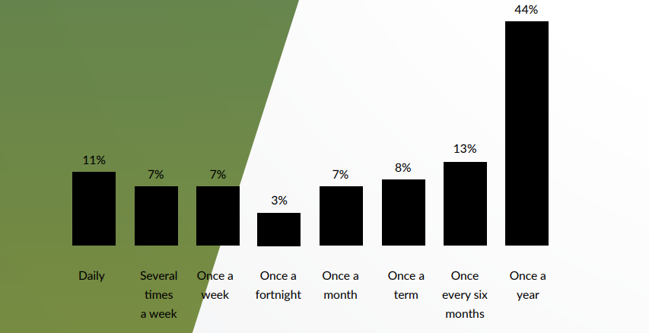
The figure shows the frequency of bullying done by employees who responded that they have bullied someone in the annual bullying survey 2017.

Figure 1 Frequency of workplace bullying (Source: The annual bullying survey, 2017)
In the annual bullying survey 2017, respondents were asked about the impact of workplace bullying. In response to this question, respondents claimed that workplace bullying has adverse impact on social anxiety, depression, self-harmed, eating disorder, stress, anti-social behaviors, and ran away from the home (Ditch the level, 2017). There is a wealth of literature around the impact of workplace bullying (Barttett & Barettett, 2011). Carter et al., (2013) argued that workplace bullying causes adverse impact on physical and mental health of employees. In addition to this, bullying can cause distress, frustration, and anxiety among employees who are being bullied. For example; 29.9% of NHS staff are still being suffering from psychological stress. A research by Zapf et al., (2011) identified several health risks caused by workplace bullying. These include panic attacks, stress, ulcers, high blood pressure, and trouble in sleeping. Beyond the physical and psychological effects, workplace bullying adversely influences the job performance of an employees. For example; an employee who is being bullied perceive negative attitude towards his/her job.
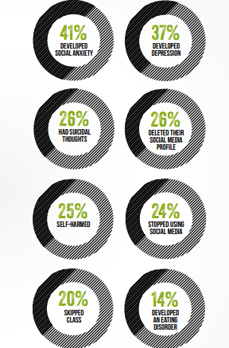
The figure shows the effects of workplace bullying
Figure 2 Impact of bullying (Source: The annual bullying survey, 2017)
An empirical study by Hoel et al., (2011) argued that workplace bullying has an adverse impact on job performance and productivity by reducing the decision making ability. Furthermore, it creates loss of self-esteem. Additionally, workplace bullying has a long term effect on health. Long term sick leave and prescriptions for anti-depressants are common examples of long term health issue in terms of workplace bullying (Belae & Hoel, 2011). Research found that workplace bullying does not only deteriorate the physical and mental health but also lowers job performance and productivity. However, workplace bullying has a great negative impact on physical, and mental health as well as job performance. It has become panic among workers. Therefore, it has become burning issue to resolve the workplace bullying.

Role of communication in addressing workplace bullying
Research found that aggressive people are more likely to misbehave or deliver threatening message to others. From my own workplace, my boss was an aggressive people, who often threatens me about my job security. However, I perceive positive attitude towards the boss until he threatened about the job security. A research by Park et al., (2011) categorized people into three important categories based on communication. These are aggressive, passive, and assertive. Assertive people are more likely to talk in a straightforward manner. They persuade other in a positive way to make understand their viewpoint. Although, I am an assertive, it was intolerable to digest the slang language of boos. Therefore, I reported the owner of the restaurant about workplace bullying. In this case, Robbinson et al., (2015) showed the significance of both verbal and non-verbal communication in communicating at workplace. The body language, choice of word, expression, and speaking style are very important in the verbal communication. For example; the choice of word, body language, and speaking style of the boss was very aggressive.
However, Kawn et al., (2017) claimed that managers and leaders should speak in an assertive manner to gain respect from employees. Employees desire supportive communication from their boss. Therefore, focusing on verbal message is important while delivering verbal communication. On the contrary, non-verbal communication has a great importance in the workplace. Non-verbal communication means written communication that is presented via letter, email, PowerPoint presentation, and notice and so on. In terms of non-verbal communication, the sentence structure, choice of word, grammar structure, and presentation play a significant role (Martin & Nakayama, 2015).
While informing the issue towards the owner of the restaurant, I used formal language with professional style. I was very careful about the choice of word, grammar, and spelling. However, the owner of the restaurant resolved the issue. It was really happy for me. There are many employees in the workplace experiencing bullying. The workplace bullying has a serious impact on the physical and mental growth of an individual. Therefore, employees should perform their own role to resolve the workplace issues. In the UK, there are many employees who are being bullied due to their sex, race, gender, ethnicity, religion, color, and belief. However, the employment act, discrimination act, and equality act work accordingly to resolve the workplace bullying.

Solution
Preventing workplace bullying is moral responsibility of an employee. The UK government is very strict about workplace bullying. There are several legislations about the age, sex, disability, married, and civil relationship, gender, race, ethnicity, pregnancy and maternity, sexual, and religious belief. These legislations work against the workplace bullying (Nielsen et al., 2011).
However, the UK government has clarified the responsibility of employees about the workplace bullying. While occurring bullying, an employee can talk to his/her manager, human resource department, and trade union representative to resolve the problem. However, if the problem is not resolved, the employee has a right to make a formal complaint by following grievance procedure. Despise this, employee can file case to the employment tribunal to resolve workplace bullying. The advisory, conciliation, and arbitrary service (Acas) works for addressing the workplace bullying issue.

Conclusion
The increasing percentage of workplace bullying in the UK has raised concern to mainstream media, academicians, scholars, and researchers. The famous newspaper, such as BBC and Guardian has published several articles about the workplace bullying. In addition to this, the NHS, and Acas have conducted several surveys on workplace bullying. The survey results shows that the workplace bullying is increasing gradually. The workplace bullying has adverse impacts on physical and mental health of employees. Besides, it negative influence the job performance, growth, and productivity of employees. However, Acas along with government actors work accordingly to resolve workplace bullying. However, the increasing rate of workplace bullying raise questions about the role and responsibilities of concerned parties. However, improving the communication at workplace can reduce the percentage of workplace bullying. If every employee performs their moral role, the workplace bullying will reduce dramatically.

References
Bartlett, J. E., & Bartlett, M. E. (2011). Workplace bullying: An integrative literature review. Advances in Developing Human Resources, 13(1), 69-84.
BBC. (2015). Workplace bullying on the rise in UK, says Acas. [Online] Available at> https://www.bbc.co.uk/news/business-34833261 [Accessed: 5 August 2018]
Beale, D., & Hoel, H. (2011). Workplace bullying and the employment relationship: exploring questions of prevention, control and context. Work, employment and society, 25(1), 5-18.
Carter, M., Thompson, N., Crampton, P., Morrow, G., Burford, B., Gray, C., & Illing, J. (2013). Workplace bullying in the UK NHS: a questionnaire and interview study on prevalence, impact and barriers to reporting. BMJ open, 3(6), e002628.
DITCH the level. (2017). The annual bullying survey 2017. [Online] Available at> https://www.ditchthelabel.org/wp-content/uploads/2017/07/The-Annual-Bullying-Survey-2017-1.pdf [Accessed: 1 August 2018]
Hoel, H., Sheehan, M. J., Cooper, C. L., & Einarsen, S. (2011). Organisational effects of workplace bullying. Bullying and harassment in the workplace: Developments in theory, research, and practice, 129-148.
Kwan, S. S. M., Tuckey, M. R., & Dollard, M. F. (2016). The role of the psychosocial safety climate in coping with workplace bullying: A grounded theory and sequential tree analysis. European Journal of Work and Organizational Psychology, 25(1), 133-148.
Martin, J. N., & Nakayama, T. K. (2015). Reconsidering intercultural (communication) competence in the workplace: A dialectical approach. Language and Intercultural Communication, 15(1), 13-28.
NHS Employers. (2018). Tackling bullying in the NHS. [Online] Available at> https://www.nhsemployers.org/your-workforce/retain-and-improve/staff-experience/tackling-bullying-in-the-nhs [Accessed: 7 August 2018]
Nielsen, M. B., Notelaers, G., & Einarsen, S. (2011). Measuring exposure to workplace bullying. Bullying and harassment in the workplace: Developments in theory, research, and practice, 2, 149-174.
Park, Y., Fritz, C., & Jex, S. M. (2011). Relationships between work-home segmentation and psychological detachment from work: The role of communication technology use at home. Journal of Occupational Health Psychology, 16(4), 457.
Robinson, L., Kocum, L., Loughlin, C., Bryson, L., & Dimoff, J. K. (2015). I wanted you to know: Breast cancer survivors’ control of workplace communication about cancer. Journal of occupational health psychology, 20(4), 446.
Salin, D., & Hoel, H. (2011). Organisational causes of workplace bullying. Bullying and harassment in the workplace: Developments in theory, research, and practice, 2, 227-243.
The Guardian. (201). Bullying at work: your legal rights. [Online] Available at> https://www.theguardian.com/careers/2017/mar/29/bullying-at-work-your-legal-rights [Accessed: 10 August 2018]
UNISON. (2017). Tackling bullying at work. [Online] Available at> https://www.unison.org.uk/content/uploads/2013/07/On-line-Catalogue216953.pdf [Accessed: 9 August 2018]
Zapf, D., Escartín, J., Einarsen, S., Hoel, H., & Vartia, M. (2011). Empirical findings on prevalence and risk groups of bullying in the workplace. Bullying and harassment in the workplace: Developments in theory, research, and practice, 2, 75-106.

Appendices
Appendix # 1: Workplace bullying
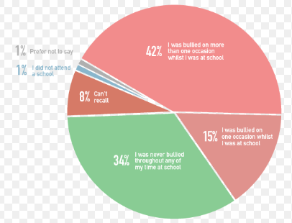
(Source: NHS Employer, 2018)

PowerPoint Presentation:
Slide 1

Slide 2

Slide 3

Slide 4

Slide 5

Slide 6

Slide 7

Slide 8

Slide 9

Slide 10

Slide 11



