My digital life
Student Name: Diana Chiriac
CCL Number: 2542848

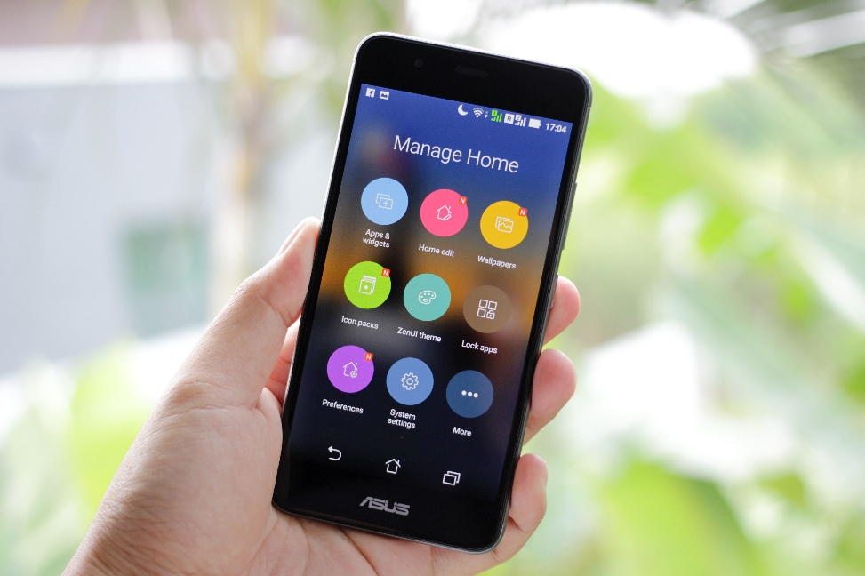

I use my mobile phone to talk to my friends and family every day. I use it to search for information.

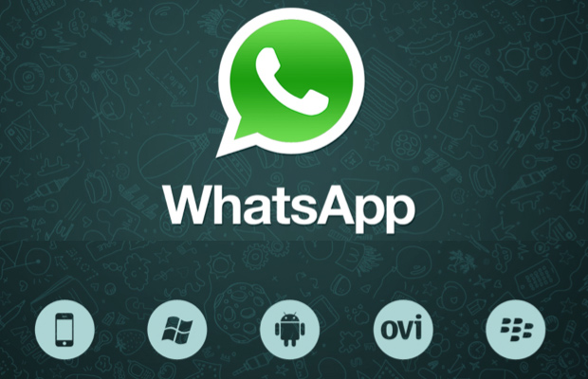

I also used to call people in phone or on video on WhatsApp. I used to Call for talking to other people.
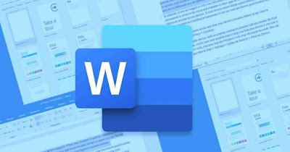

I use Microsoft Word to finish my assignments. It allows me to write down and arrange my work.

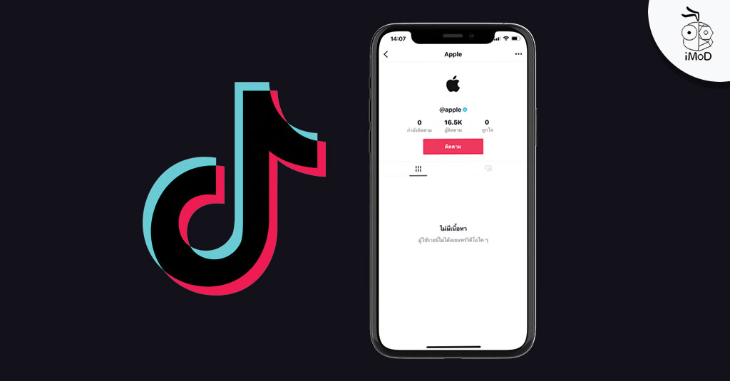

I look at Tik Tok in my spare time to see short movies. It helps me get inspirations, music and entertainment.



I use the internet to search for information and learn new things. It' s great for my studies and my life in general.

I use digital technology everyday: I use my phone to contact my friends and family I use the internet to get some information I use Microsoft Word on my laptop to do my assignments at college I like to watch Tik Tok when I am bored I feel confident about using this digital technology I want to learn more about digital technology and I want to develop my digital skills.

