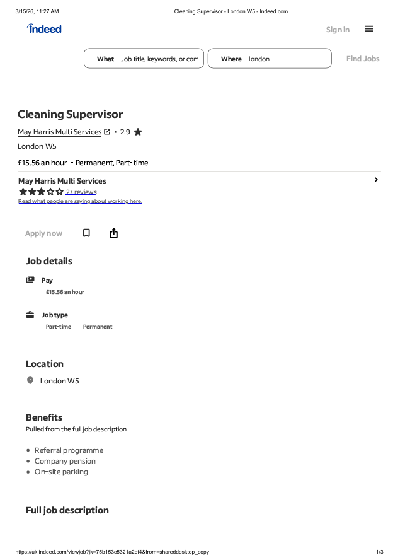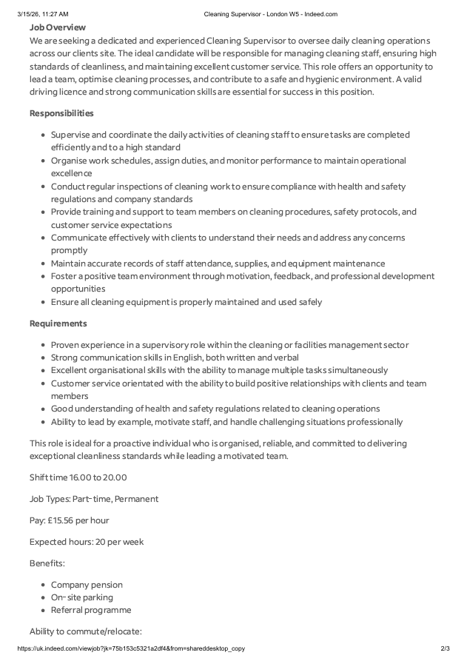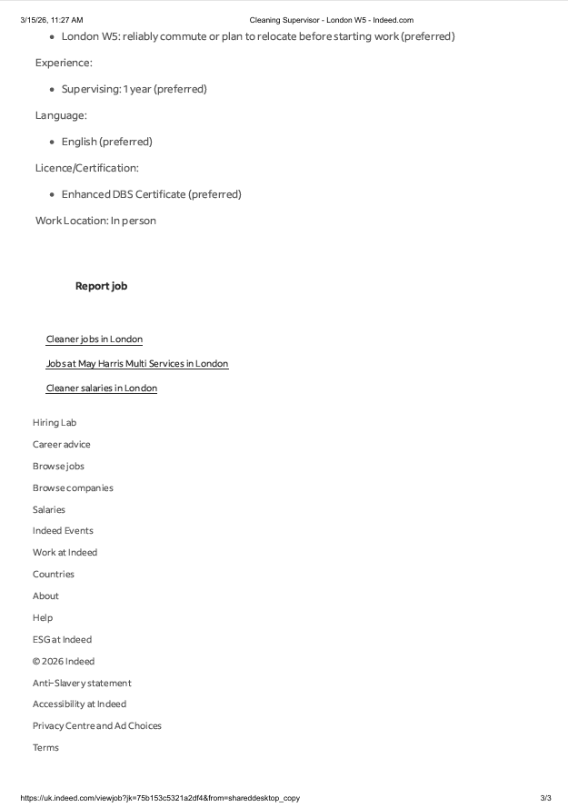

Blaga Naydenova
56 Church street London
Dave Obrien
May Harris Multi Services
London
15 March 2026

Dear Dave Obrien
I wish to apply for the role of cleaner supervisor, currently being advertised on you website Indeed. Please find enclosed my CV for your consideration.
As you can see from my CV, I have over three years of experience in the cleaning and customer service industry. During this time, I have developed strong skills in hard work, reliability, organisation, and attention to detail, which I believe make me an excellent candidate for this position.
In my current role as a Cleaner at a cleaning company in London, I am responsible for maintaining high standards of cleanliness, working efficiently, and ensuring a pleasant and safe environment for both customers and staff. I also assist with organising cleaning schedules, managing tasks, and supporting team members when required.
During my experience in this industry, I have learned the importance of teamwork, good communication, time management, and providing a positive service to customers. These skills allow me to work effectively both independently and as part of a team.
All of this, combined with my enthusiasm and dedication, has helped me develop strong customer service skills, leadership ability, reliability, and a strong work ethic. I am also comfortable working under pressure and ensuring that cleaning standards are always maintained at a high level.
I am confident that I can bring the same level of commitment and professionalism to your organisation and help support your team in delivering excellent service to customers while maintaining the strong reputation of your company.
Thank you for your time and consideration. I look forward to hearing from you soon.
Yours sincerely,
Blaga Naydenova
CV

Blaga Mancheva Naydenova
London, UK
07826 657451
Naydenovablaga@gmail.com
Professional Profile
Reliable and hardworking cleaning professional with over three years of experience in the commercial cleaning industry. Skilled in maintaining high standards of hygiene, organising cleaning tasks, and ensuring a safe and clean environment for staff and customers. Experienced in working as part of a team and supporting colleagues to complete tasks efficiently. Strong attention to detail, good communication skills, and the ability to work under pressure. Currently seeking a Cleaning Supervisor position where I can use my experience to help maintain quality standards and support a team of cleaners.
Key Skills
Cleaning supervision and task organisation
High standards of hygiene and cleanliness
Team leadership and teamwork
Time management and reliability
Health and safety awareness
Attention to detail
Customer service skills
Ability to work under pressure
Work Experience
Cleaner Supervisor – SMP Group, London (2023 – Present)
Maintain high standards of cleanliness in commercial and customer environments
Follow strict hygiene and health & safety procedures
Work efficiently as part of a cleaning team to complete tasks within deadlines
Ensure cleaning equipment and materials are used safely and correctly
Report maintenance issues or cleaning concerns to supervisors
Assist in organising daily cleaning duties to ensure all areas are cleaned to a high standard
Support team members and help maintain a positive working environment
Education
Secondary Education – 89th School 'Hristo Mihaylov', Bulgaria
Languages
Bulgarian – Native
English – Good
Russian – Good
Additional Strengths
Strong work ethic and reliability
Positive attitude and willingness to learn
Ability to support and guide team members
Flexible and able to adapt to different working environments

