STUDENT: NAME ADENIKE BOLA-SANNI
STUDENT ID: 1808705
MODULE: EFFECTIVE TEAM WORK AND COMMUNICATION
MODULE CODE: BMSK 4002
LECTURERS: ANITA NAN
TOPIC: ESTABLISHING PRECISE COMMUNICATION IN THE WORKPLACE

CONTENTS Page no.
INTRODUCTION…………………………………………………………………………………………………….03
DEFINITION OF COMMUNICATION ……………………………………………………………………….03
TYPES OF COMMUNICATION ………………………………………………………………………………..03
MODELS OF COMMUNICATION …………………………………………………………………………….05
COMMUNICATION IN THE WORKPLACE ………………………………………………………………..07
HOW TO IMPROVE COMMUNICATION IN THE WORKPLACE…………………………………..07
CONCLUSION………………………………………………………………………………………………………….08
REFERENCE…………………………………………………………………………………………………………….09

INTRODUCTION
Communication is believed to be an art and a science, simple communication is needed to be in the world, to improve on this, utmost needs to learn to develop a good clear verbal and body gesture skills are important.
To succeed in getting or delivering an information across is having an effective communication like verbal or any other method of transferring, effective communication has occurred when the other party pays attention, understand and digests the message.
DEFINITION OF COMMUNICATION
Communication is a method of connecting people, using a two way process of exchange known as coding and decoding, to pass on information, news feelings concerns and sharing to arrive at or achieve a desired goal, no organisation or enterprise can survive in business without it. Interpersonal or soft skills as communication skill is always referred to are very important to share information to a group or just one person to maintain a competent healthy workplace.
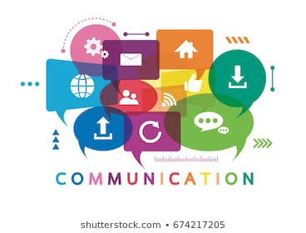

We communication in various environment in different ways including in the workplace. a simple nod of the head might be agreement, this useful unavoidable skill needs lots of practice and there’s is room for improving to succeed.

TYPES OF COMMUNICATION
Communication are majorly four types used daily, these are verbal, nonverbal, written and visual, each type is significantly important, a combination of two or more springs a huge improvement in relation to personal and collective goals and achievement. Various acceptable mean can be used but must 6 well considered to deliver proper information.
Verbal: this communication uses language to send information by sign or speech language, this mostly common type is for discussion, telephone calling, presentation, meetings, and chats. This important method can be used with written and non verbal for an effective communication.
Clear strong voice: is essential especially when giving instruction or presenting so as everyone hears and understands to a team or a group, confidence in the voice drives home the information
Listening: this key to verbal communication can never be over emphasised, ability to listening and hearing others out helps communication growth.
No filler words: tempting as it could be, it is a big no no to filler words, this is very distracting and causes less of concentration in communication.
Nonverbal
This are process of using wordless actions rather than words which send out messages or information to generate meaning, examples are facial expressions, gestures, body movement, and position.
Distracting mannerisms
Facial expressions
Angry and sarcastic tone
Speaking rather too soft or loud
Body language, behaviour
Might sometimes be too strong it overwhelms written and verbal message
Written

This style of communication is majorly on writing in different way, example are typing, printing, number, letters all this are used to deliver messages and information. Written document mostly delivers their information through books publishing, letters, emails, pamphlets, create blogs, memos and graphs are mostly used in organization and workplace.

Be simple: information in writing must be simple, clear and well detailed instruction easy to understand for effective communication to occur.
Check: it is very important to always go over every written information and Communication, taking time to review helps to detect mistakes or to adjust some words used.
Store: information fancied and might be of use in future must be promptly saved for future use or reference as this might save time later.
Watch the tone.: don’t be overexcited, sarcastic or make unnecessary jokes that could be misinterpreted, keeping all writings as simple as possible would go a long way in the workplace.
Visual
This method with the combination of verbal and written communication using graphs, sketches and drawing arts and photography to deliver the message or information. Usually what the eyes see the mind dose not quickly forget, that is why this learning style is unique especially in presentation, it assist in driving the information home quicker.
Steps to consider:
Think of the task: this helps by putting the audience or task at hand first to decide in using visual communication and explain uncommon graphs, charts or data slowly and clearly
Seek help or advice and feedback: this will really assist the communication skill because it may put some value in what is done but care must be taken since visual can at times be confusing therefore always ask for feedback.
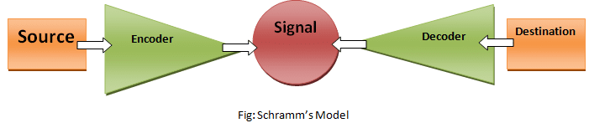
MODELS OF COMMUNICATION

The Schramm model of communication seeks to explain how meaning is transferred between individuals, corporations, and others.
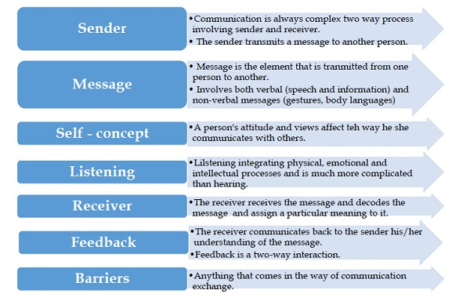
The most commonly taught and widely used theory of communication is that proposed by Wilbur Schramm widely adopted in the late 1940s views communication as a process of conveying a message between a sender who is believe to be the transmitter and a receiver, a message, and a medium are involved for transmission. (Schramm, 1948). Through coding and decoding which is a two-way circular communication between sender and receiver, and passing an effective message is achieved when encoded by sender and decoded by the receiver, through a feedback, then it is called decoder.
Information can be encoded through three means which are Acoustic is sound, Visual this is picture and Semantic which is meaning
Encoding: It is the process of using a medium to send or transfer message, the art of turning thoughts into communication, a phone call, email, text message could be used, this model sees communication as an unending course that requires feedback as the sender and receiver must both interpreted the information.
Decoding: this is the ability to understand and relate letter-sound to interpret the message, getting the message in a meaningful way that makes sense. Verbal and non-verbal ways are used to communication, body language can perfectly be used without words, examples are signs of anger, crying, frequent hand movement, eye rolling, stressed or total silence.
. Feedback Is a vital component in the model of communication it allows the sender know the receiver has either understand and interpret the required l. message through the response of verbal or nonverbal.
COMMUNICATION IN THE WORKPLACE
For a business to thrive, where technology, team and remote work are increasing, to achieve and meet deadlines, solid good communication relationship is essential principally in the workplace, a poor unhealthy communication brings about a sense of anxiety, fear, vulnerability and weakness, this leads to stress, unreliability, restlessness, low morale, unhappy client, relationship breakdown and unmet expectation. When there is counter production and high stress level in the workplace these are signs and the root cause mostly is poor and lack of effective communication which will inevitably lead to tension, feel of guilt and staff that are not motivated who eventually lost confidence in their ability.
TYPES of communication in the workplace
Verbal—face to face
Nonverbal— smile, eye contact
Written—memos, email, notes
Body language—facial expression or movement

HOW TO IMPROVE COMMUNICATION IN THE WORKPLACE
A workplace with unhealthy and poor communication will unavoidably surely lead to unmotivated employee, importance of strong communication runs deep in an organisation, a good manager needs the important keys to excel.
Important Keys
- Listen and give attention to details
- Have meaningful meetings when necessary
- Give good detailed information and reasons for task
- Avoid assumptions, be reliable
- Lean on one another’s strengths and weaknesses

Team building – To build a strong effective team, members must collaborate, share and communicate, to achieve this, implementing strategies to boost communication is highly required to create satisfied employees and boost their morale.
Innovation – this happens when employees are free and confident to share their thought and ideas, any workplace that lacks this will be stagnant. Teamwork especially needs innovative minds to flourish..
Strong management – When managers communicates well, they are able to build empower and manage employees, relationship building, motivation, task delegation and managing conflict will not be a problem, good communication is not all about speaking but also empowering people and relationship building. Strong communication is not just the ability to speak but to empower and facilitating people to speak to one another.
Define goals and expectations – Delivering goals clearly that are achievable as a manager is important, proper outline of task to individual, team or group will go a long way to ensure that all understand the objectives of the task expectation.
Clearly deliver your message – Messages must essentially be very clear, simple, direct and accessible to those receiving it, speaking clearly and politely will reduce confusion letting your message pass across with no offence. Take care to pick the medium of sending the message, deliver it in the best format, depending on the task, either through a memo, face to face, email or writing.
Carry everyone along– Distant and private, shy and slow staff must be adequately tagged catered and cared for through open friendly communication, fair monitoring of their tasks with good encouragement on updates and project reports give them more courage and confidence for future events.
Freedom to speak– A happy satisfied employee is one recognised and given the chance to have a voice to speak to share his or her idea at all levels in the workplace, freedom to talk amongst superior, peers, and colleagues without been looked down on or cut short.
Listen- Communication is always two-way process, learn to listen, don’t interrupt or pre-empt what someone is about to say, try not to use filler words, it is rude and frustrating.

CONCLUSION
Communication is speaking, writing or body language and for effective communication to occur, the sender must put strong clarity, listening, a d factual information in process. This is required for the transmitted content to be received and understood by the receiver in the intended state. When there is change in behaviour through acquiring information and a common concept is achieved, the then effective communication is established.

REFERENCE
Gluyas, H., 2015. Effective communication and teamwork promote patient safety. Nursing Standard (2014+), 29(49), p.50.
Wilbur, Schramm, 1954. Research Gate.net
Cronen, V., & Pearce, W. B. (1982). The coordinated management of meaning: A theory of communication. In F. E. Dance (Ed.), Human communication theory (pp. 61–89). New York, NY: Harper & Row.
Habermas, J. (1984). The theory of communicative action (Vol. 1, p. 100). Boston, MA: Beacon Press.
Leavitt, H., & Mueller, R. (1951). Some effects of feedback on communication. Human Relations, 4, 401–410.
McLean, S. (2003). The basics of speech communication. Boston, MA: Allyn & Bacon.
McLean, S. (2005). The basics of interpersonal communication. Boston, MA: Allyn & Bacon.
Robert E. Babe (2015). Wilbur Schramm and Noam Chomsky Meet Harold Innis: Media, Power, and Democracy. London: Lexington books. ISBN 978-0-7391-2368-3.
Pearce, W. B., & Cronen, V. (1980). Communication, action, and meaning: The creating of social realities. New York, NY: Praeger.
Barnard, G. A.(1949).Statistical Inference, Journal of the Royal Statistical Society. Vol. X1, No.2

The Effects of Poor Communication in Business
by Anne Kinsey; Reviewed by Jayne Thompson, LLB, LLM; Updated January 31, 2019
Pearson, J., & Nelson, P. (2000). An introduction to human communication: understanding and sharing (p. 6). Boston, MA: McGraw-Hill.
Weekley, E. (1967). An etymological dictionary of modern English (Vol. 1, p. 338). New York, NY: Dover Publications.
Wood, J. (1997). Communication in our lives (p. 22). Boston, MA: Wadsworth.
Vocate, D. (Ed.). (1994). Intrapersonal communication: Different voices, different minds. Hillsdale, NJ: Lawrence Erlbaum.
Petty.G (Forth edition) Teaching Today: Communication blocks, p40 to p41
Gravells, A, Simpson, S, (2008) Planning and Enabling Learning: Communication p71-p8
Clampitt, P.G. and Girard, D. (1993) ‘Communication satisfaction: A useful construct?’, New Jersey Journal of Communication, vol 1, no. 2, pp. 84–102

Peggy Noonan: A Remedial Communication Class
-- The Wall Street Journal: July 21, 2012

