Cyber Security

Learning in the Digital Era
Assignment 1: E-Portfolio
David Berry 0450146

Table of Contents

E-Portfolio ……………………………………………………………………………………………..... Page 3

Task 1 Written Summary ……………………………………………………………………………Page 4

Task 2 Mind Map ……………...……………………………………………………………………… Page 5

Task 3 Video Presentation ……………………………………………………………………….. Page 6

Task 4 Academic Poster …………………………………..………………………………………. Page 6

Electronic portfolio home Page
- davidberry.co.uk/uni

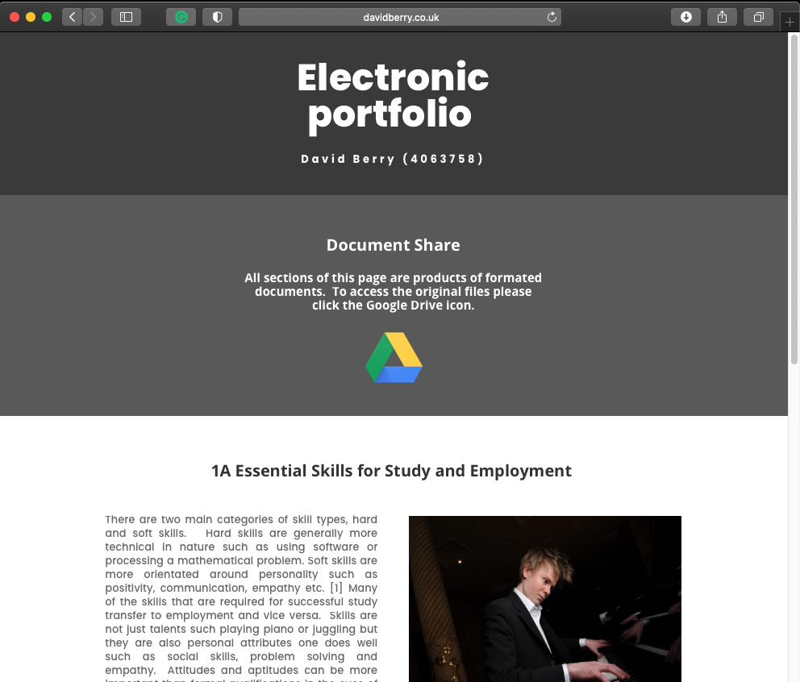

- Written Summery
- https://drive.google.com/drive/folders/1y1shjsS03T2cNYOsZGRF5pCoMVXceIhI

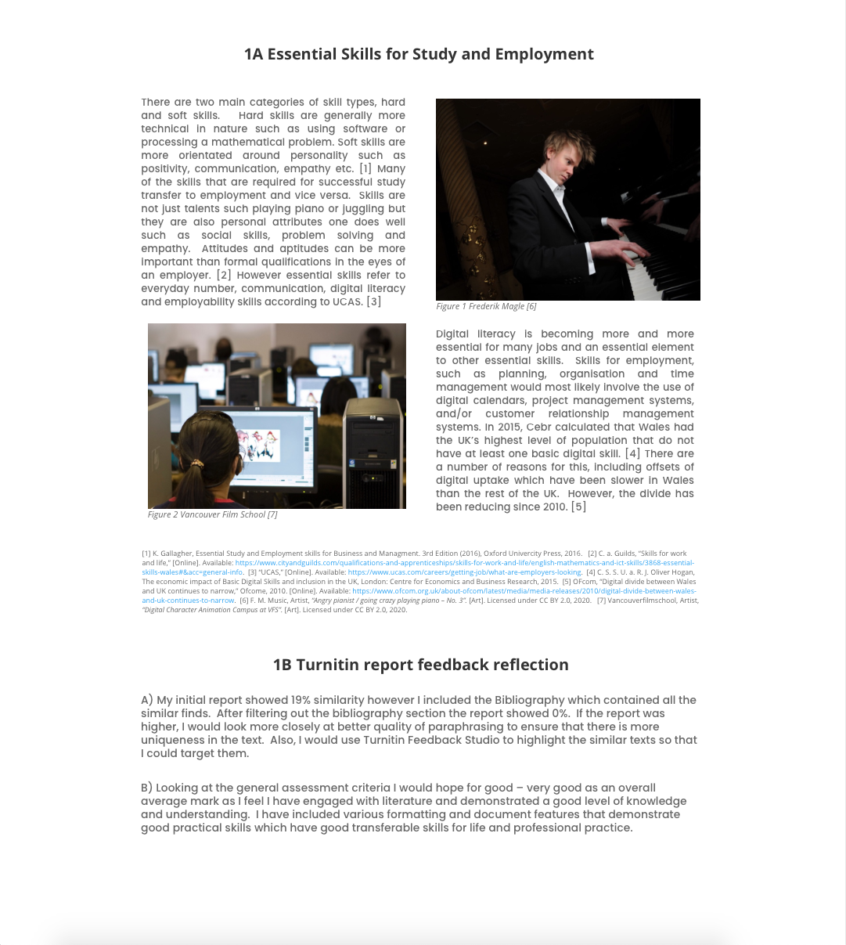

- Mind map
- https://drive.google.com/drive/folders/1y1shjsS03T2cNYOsZGRF5pCoMVXceIhI

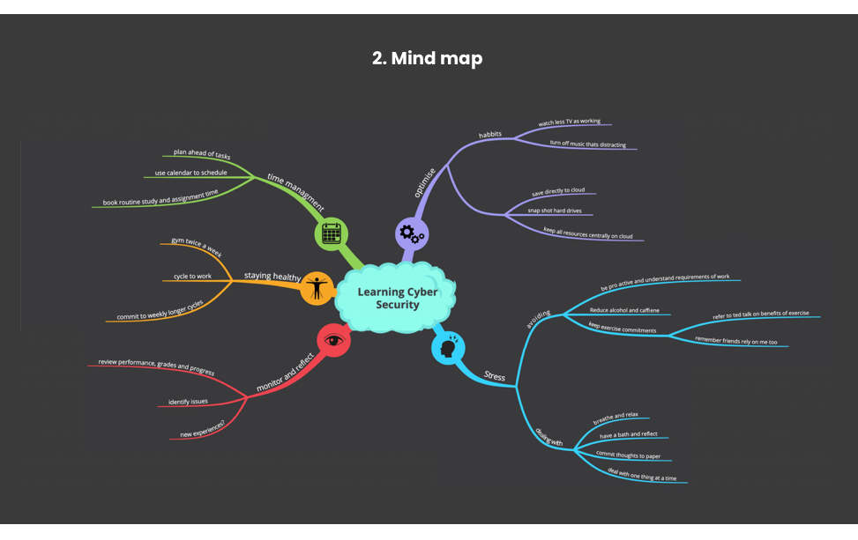

- Video
- Direct link https://youtu.be/o71AQG6Awnw
- Poster
- https://drive.google.com/drive/folders/1y1shjsS03T2cNYOsZGRF5pCoMVXceIhI



