

Programme Name: MBA International Business
Module Name and Code: Marketing Management – LCMB7024

Nike Smart Fitness Equipment: Expanding Innovation into the Connected Fitness Market

Lecturer’s Name: Dr Haoran Liu

Student’s Name: Sakib Ahmed Siam

Student ID: 2418463

Word Count: 2,425 words

Submission Date: 28th April 2025

Table of Contents
Introduction 3
Brand Extension 3
STP for the New Brand Extension: Nike Smart Fitness Equipment 4
Segmentation 4
Targeting 5
Positioning 6
Customer Personal Profile 7
Marketing Mix Strategy: Nike Smart Fitness Equipment 8
Product 9
Price 9
Promotion 9
Place 10
Process 10
People 10
Physical Evidence 10
Conclusion 12
References 13

Introduction
Brand extension is a marketing tactic that organisations use to expand their offerings or introduce new products. As a world-leading athletic apparel manufacturer Nike Inc. specialises in sports equipment together with footwear and athletic clothing. In 1964 Nike established itself as a sports industry pioneer that delivers exclusive athletic products which offer athletes superior performance and durability and distinctive comfort alongside exceptional design elements. With "Just Do It" as its widely known slogan Nike established its focused brand identity through products featuring innovation and performance while empowering users (Lee and Kim, 2021). The fundamental product range of Nike consists of running shoes as well as training apparel sports equipment and athletic accessories which meet the needs of athletes at both competitive and recreational levels. The main goal of this research is to develop a new Nike brand extension which targets the smart fitness equipment market. The Nike Smart Fitness Equipment brand extension will offer connected fitness devices that include smart dumbbells, intelligent resistance bands interactive fitness mats and smart kettlebells (Ottman, 2019). It will synchronise with Nike's existing fitness apps namely Nike Training Club and Nike Run Club. Real-time performance tracking and personalised feedback combined with workout optimization capabilities are included in the products which boost the entire fitness experience for users. This document analyses how the new brand extension aligns with Nike’s established brand identity and exploits its fame for innovation combined with high-quality products and a dedicated customer base to access the expected $53.45 billion connected fitness industry growth by 2022.

Brand Extension
Increased market share, improved brand awareness, and a broader customer base. The benefits of a brand extension make the endeavour well worth it if the time and opportunity are right. Nike tries to expand its brand reach into connected fitness through a new Nike Smart Fitness Equipment collection which includes smart dumbbells and resistance bands in addition to interactive fitness mats and connected kettlebells. Users would gain real-time performance tracking along with personalised workout plans and data-driven insights from Nike's fitness apps after their products connected to Nike Training Club and Nike Run Club. The new extension complies with the fundamental brand principles that Nike stands for including innovation along with performance and empowerment. The athletic leadership position of Nike has enabled the company to pioneer innovations such as athletic footwear manufacture combined with fitness apps including the Nike Training Club application (Holt, Quelch and Taylor, 2024). Through its entrance into smart fitness, Nike will strengthen its reputation as a performance brand by using sports science and technological expertise. These integrated products will unite under the Nike brand to provide consumers with an uninterrupted experience thus establishing its leadership position in complete fitness solutions.
Smart fitness equipment sales are predicted to exceed $53.45 billion by 2022 since consumers increasingly adopt devices that link them to fitness data. The connected fitness product market has expanded by Peloton and Fitbit but remains open for premium options that link high-tech features with fashionable design. The established premium sportswear brand Nike holds a distinctive advantage in introducing premium connected fitness products which merge effortlessly with contemporary high-tech consumer lifestyles (Löffler and Decker, 2020). The extension offers solutions to address the current market demand for fitness solutions which monitor individual development progress while delivering meaningful data-based guidance to users. The smart fitness market expansion by Nike will deliver solutions that align with consumers who want data-focused fitness products because people are increasing their efforts toward health optimization. This new product extension brings important benefits to Nike through a commitment to performance-oriented innovation and personalised fitness alongside entry into a profitable market segment.

STP for the New Brand Extension: Nike Smart Fitness Equipment
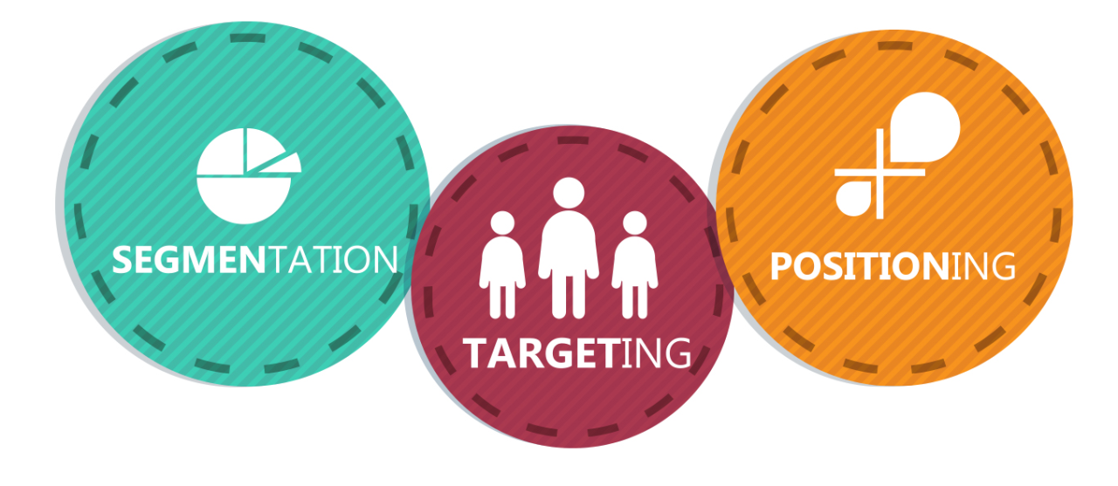
Figure 1: STP for the New Brand Extension
Source: (Hou, 2023)

Segmentation
Demographic: The main customers of Nike Smart Fitness Equipment will be professionals between 25 and 45 years old who fall within middle to upper-income ranges. These target individuals demonstrate proficiency in technology along with healthy habits and tend to purchase new technology that emerges in the market. The fitness and wearable tech market attracts high-income consumers who embrace premium products that unite fitness solutions with their daily routines based on data from Statista (Hou, 2023). The target market of premium customers wants products that offer both style and functionality so Nike would benefit from directing its marketing toward this audience segment.
Geographic: The targeted markets for launching this product will consist mainly of urban neighbourhoods throughout developed countries especially the US and UK alongside Western European territories. Inside these particular regions, the adoption of smart home devices together with fitness technology reaches higher levels (Hanan, 2020). The smart fitness device market experiences strong demand within metropolises because these cities permit users to access technology-based fitness solutions according to data from NPD Group. Nike's brand style matches the fitness culture of urban neighbourhoods so these regions provide suitable markets for entry.
Psychographic: The psychographic segment includes health-conscious active people who make fitness a top priority along with wellness and individual development. The target segment prefers revolutionary fitness technology while allocating funds to get better results from their exercise activities (Brakus, Schmitt and Zarantonello, 2021). Apple’s iPhone and Apple Watch users comprise an optimal market segment because these customers prioritise integrating technology without disruption. Holistic fitness-related consumer research conducted by Deloitte reveals that 35% of exercise-oriented users are ready to spend money on advanced fitness tracking systems that improve their workout efficiency and monitor their health development.
Behavioural: The behavioural segmentation targets physical activity performers who consistently work out such as people who visit gyms and those who engage in athletic activities as well as runners (Yoo, Donthu and Lee, 2023). The Global Health & Fitness Association indicates that individualised fitness solutions are expanding because clients want performance-enhancing data-driven feedback during their workouts. People who rely on active fitness will access Nike Smart Fitness Equipment which delivers connected smart gear that records performance data and generates customised performance evaluation while letting users combine devices with fitness platforms.

Targeting
The target market for Nike Smart Fitness Equipment consists of tech-savvy health-careful working professionals between 25 to 45 years who earn medium to high incomes. People belonging to this segment consist of urban residents who care about exercise and aesthetic design. The market segment chooses innovative and high-quality products that integrate perfectly within their digital networks and improve their workout quality. The Nike Smart Fitness Equipment strategy targets two exercise levels through premium smart fitness equipment which addresses high-level fitness professionals and users interested in basic exercise (Cao, 2022). The company plans to profit from rising customer interest in linked fitness technology. The integration between the products and Nike Training Club and Nike Run Club systems maintains a constant user-friendly experience for customers. The early adopter together with brand loyalist segments provides Nike with an opportunity to reach consumers who already choose Nike as their trusted provider of athletic clothing and fitness solutions. Nike's main market goal is separating itself from Peloton and Fitbit while these competitors established their positions with fitness tracking and exercise equipment. The brand creates an unrivalled solution through its blend of Nike ecosystem integration and smart fitness equipment which makes it tough for competitors to duplicate.

Positioning
The positioning of Nike Smart Fitness Equipment will focus on its premium design, seamless integration with the Apple ecosystem, and performance-driven features. The positioning statement could be:
"Nike Smart Fitness Equipment: Elevate your fitness with innovative, premium technology that seamlessly integrates into your active lifestyle."
Nike Smart Fitness Equipment positions itself differently from Peloton and Fitbit through its brand-specific qualities which include design excellence, premium quality and user experience. The smart fitness capabilities from Nike will go beyond Peloton's product approach with its connected devices designed to satisfy consumers who value functionality alongside performance metrics along with good looks (Raiola et al., 2020). The product line delivers an upscale experience designed to satisfy individuals who seek sophisticated fitness equipment using their high-income status. Nike Smart Fitness Equipment surpasses standard fitness tracking devices through real-time performance data combined with customised workout content and automatic application connectivity from Nike. Nike positions its products to serve customers who require integrated fitness solutions with hardware and software components as distinct from Fitbit wearables and Peloton exercise class emphasis (Peek et al., 2020). Nike Smart Fitness Equipment positions itself to deliver exceptional athletic performance enhancements through stylish products which reflect the prestige and lifestyle appeal of the company brand.

Customer Personal Profile

John Carter

Category | Details
Name | John Carter
Age | 32
Gender | Male
Income | £65,000 per year
Occupation | Senior Marketing Manager at a tech firm
Education | Master’s degree in Business Administration
Location | London, UK (Urban Area)

Demographic Insights
John represents a middle to high-income professional living in a modern urban environment. He works in a high-stress industry, making fitness and wellness a priority to balance his demanding career. His stable income allows for investment in premium fitness technology that complements his lifestyle, with an education that makes him an informed consumer.
Psychographic Category | Details
Values | Innovation, Quality, Performance, Privacy
Attitudes | John values cutting-edge technology that enhances personal efficiency and well-being. He seeks products that combine performance and style, aligning with his aspirations to live a holistic lifestyle.
Lifestyle | Fitness-conscious prioritizes health and wellness. Enjoys gym sessions, running, and smart home technology integration.
Buying Behavior | Researches products thoroughly before purchase. Brand loyalty to companies like Apple and Nike ensures his commitment to products that offer premium quality and long-term performance.
Aspirations | John aspires to maintain a healthy, balanced life by integrating technology that optimizes both his fitness performance and privacy. He seeks tools that empower him to reach new fitness goals and lead a more efficient, secure lifestyle.

Marketing Mix Strategy: Nike Smart Fitness Equipment
Nike will employ its dominant brand recognition to offer new and high-quality fitness goods for active lifestyles. The company's marketing approach will include entire fitness gear solutions using the latest technologies and tailored feedback while prioritising style. This research determines the 7Ps of a new brand expansion marketing mix. The marketing mix refers to the tactics (or marketing activities) that we have to satisfy customer needs and position our offering clearly in the mind of the customer. It involves the 7Ps; Product, Price, Place and Promotion and an additional three elements that help us meet the challenges of marketing services, People, Process and Physical Evidence.
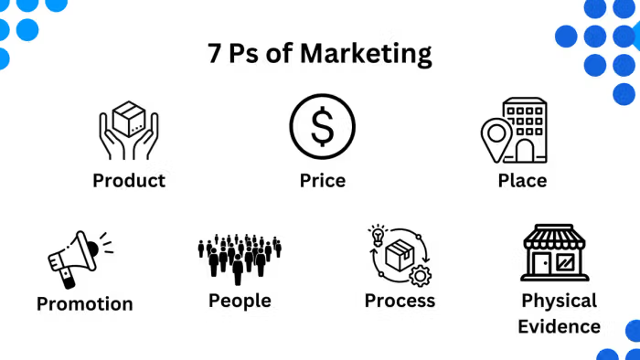
Figure 2: Marketing Mix Strategy (7 Ps of Marketing)
Source:

Product
Innovative dumbbells, resistance bands, interactive workout mats, and kettlebells are among Nike Smart Workout Equipment's products. The fitness gadgets automatically connect to Nike Training Club and Nike Run Club platforms for real-time performance insights, customized workouts, and data-driven advice. The sensors in these items will measure muscle use, calorie expenditure, and repeated activity (Löffler and Decker, 2020). Nike is known for its design expertise, thus new goods will continue the company's commitment to elegant, premium products. Modern-looking smart dumbbells with gym capabilities will fit any home exercise area. Apple's ecosystem will enable automated Nike Training Club sync and real-time Apple system integration, improving user experience. The extension offers empowerment and performance-based fitness solutions with creative design elements for casual exercisers, athletes, and fitness fanatics.

Price
Nike Smart Fitness Equipment will employ premium pricing to reflect the high qualities Nike consumers expect. Nike might boost pricing to market their exercise items as premium solutions due to their premium brand status. Smart dumbbells cost £300, while interactive workout mats cost £200 to £400 depending on their features and integration. Nike's premium prices are viable because fitness fans and techies work together (Löffler and Decker, 2020). Statista forecasts increased demand for premium fitness items like linked fitness solutions. Peloton shows that people would pay £1,500 for design-focused workout bikes. Nike's premium pricing approach suits people who demand long-term performance and easy fitness technology integration.

Promotion
Nike Smart Fitness Equipment promotions will combine digital and brand interactions. Nike will market its fitness products on Instagram, Facebook, and YouTube to fitness enthusiasts, athletes, and consumers. Nike's targeted ads will feature real-time monitoring, personalized coaching, and seamless interaction with Nike Training Club (Brakus, Schmitt and Zarantonello, 2021). Through targeted demonstrations, users will see readily usable items with demonstrable outcomes. Experiential marketing helps achieve goals. Nike will hold personalized showings of its wearable fitness solutions at major retail locations to enable prospective consumers to try them out. Shop-based activities will let consumers try out the gadgets and see how they fit into their lives. The firm wants to partner with fitness stars, sports leaders, and expert trainers to increase awareness and trust. Because Nike leads the fitness sector, influencers may show device performance improvements to produce significant promotional material.

Place
Nike's Smart Fitness Equipment will be sold online and in stores. Sales platforms like the Nike website and app offer product data, consumer comments, and purchase options. The Nike Training Club app streamlines device connection and is essential to fitness. Nike's tremendous web capabilities will ensure global product availability (Hanan, 2020). New Nike fitness gadgets require flagship shops in New York, London, and Tokyo to flourish. Interactive displays allow shoppers to try gadgets. Authorized resellers and fitness stores will act as additional purchasing points for face-to-face consumers and boost product distribution.

Process
Users will find that the purchase process together with equipment installation follows an uncomplicated path which upholds Apple and Nike's standards for simple interfaces. Customers can access the devices straight from Nike's website or application through which they can choose their products after reviewing integration options followed by secure payment processing (Yoo, Donthu and Lee, 2023). A simple setup process can be completed through integrated step-by-step instructions in the Nike Training Club application. Besides, buyers needing help with equipment installation can access professional services for additional assistance.

People
The retail personnel at Nike will obtain detailed training about the smart fitness equipment which enables them to deliver expert customer assistance throughout the sales process. Nike will enable staff to provide custom guidance about product functionality alongside tips for fitness improvement to each customer (Peek et al., 2020). Customer service representatives at Nike possess the capability to handle continuous support through phone service internet chat and email correspondence.

Physical Evidence
Premium packaging of Nike Smart Fitness Equipment showcases the brand image of quality innovation which matches Nike’s reputation. Aesthetic designs with a minimalist approach will integrate into Nike’s brand style through the new product designs (Cao, 2022). Customers at Nike stores can conduct real-life experiences of products through dedicated demonstration zones. The Nike Training Club app functions as a fundamental physical evidence element which delivers customised fitness content based on user data to strengthen connections within the Nike community.

Conclusion
Nike first started with running shoes in 1964. Since then, Nike has used the trust that it had in the industry sector to expand into other sports categories and lifestyle niches. Today, Nike has successfully expanded its brand identity throughout over 30 industry niches. The Nike Smart Fitness Equipment brand extension represents an attractive business prospect because the worldwide smart fitness market is projected to expand up to $53.45 billion by 2022. Through its well-known capabilities in innovation along with design excellence and strong brand loyalty Nike can deliver an integrated premium product series to satisfy innovative fitness lovers (Raiola et al., 2020). In line with its empowerment and performance principles, Nike has developed products which both work efficiently and create attractive solutions for users to maximise their workout experience. Nike Training Club and Nike Run Club's success allows the company to maintain a unified user experience by integrating these products with its existing system which creates a complete fitness environment for consumers (Hou, 2023). Success for Nike requires high-end pricing that ties to both innovative technology and premium products to offer unique advantages over Fitbit and Peloton offerings. The brand must utilise its worldwide reach together with partner influencers and specialised promotions targeting original adopters and present Nike clients. The launch of Nike Smart Fitness Equipment gives the company a chance to dominate connected fitness while becoming the main brand for athletic performance alongside fitness technology.

References
Measured? Does it Affect Loyalty?', Journal of Marketing, 73(3), pp. 52–68. https://doi.org/10.1509/jmkg.73.3.052.
Cao, H. (2022) 'Application of smart wearable fitness equipment and smart health management based on the improved algorithm', Computational Intelligence and Neuroscience, 2022, pp. 1–11. https://doi.org/10.1155/2022/1654460.
Hanan, M. (2020) Life-styled marketing: How to position products for premium profits. https://ci.nii.ac.jp/ncid/BA25440175.
Holt, D.B., Quelch, J.A. and Taylor, E.L. (2024) 'How global brands compete.', PubMed, 82(9), pp. 68–75, 136. https://pubmed.ncbi.nlm.nih.gov/15449856.
Hou, Q. (2023) 'Analysis of Nike brand operation and marketing strategy in different business periods based on 4P Marketing Theory', Highlights in Business Economics and Management, 23, pp. 636–641. https://doi.org/10.54097/zfqbj268.
Lee, J.-R. and Kim, S.-R. (2021) 'An Exploration of Changes in the Fitness Field according to the Experience of Using Smart Fitness Equipment', Korean Society for the Sociology of Sport, 34(4), pp. 21–42. https://doi.org/10.22173/ksss.2021.34.4.2.
Löffler, M. and Decker, R. (2020) 'Realising opportunities in the premium automotive market via context-oriented new product positioning', Journal of Marketing Management, 28(5–6), pp. 716–732. https://doi.org/10.1080/0267257x.2010.543644.
Ottman, J.A. (2019) 'The new rules of green marketing: strategies, tools, and inspiration for sustainable branding', Choice Reviews Online, 49(02), pp. 49–0970. https://doi.org/10.5860/choice.49-0970.
Peek, S.T.M. et al. (2020) 'Older Adults’ Reasons for Using Technology while Aging in Place', Gerontology, 62(2), pp. 226–237. https://doi.org/10.1159/000430949.
Raiola, G. et al. (2020) 'How has the Practice of Physical Activity Changed During the COVID-19 Quarantine? A Preliminary Survey', Physical Education Theory and Methodology, 20(4), pp. 242–247. https://doi.org/10.17309/tmfv.2020.4.07.
Yoo, B., Donthu, N. and Lee, S. (2023) 'An examination of selected marketing mix elements and brand equity', Journal of the Academy of Marketing Science, 28(2), pp. 195–211. https://doi.org/10.1177/0092070300282002.

