
Digital Skills for Personal and Professional Growth
BMSW4008

Student Id:
Student Name:
Date:
Table of Contents
LinkedIn Profile: About Me 5
Importance Of Story Telling 7
Questionnaire Analysis 9
Website and Marketing materials 15
Reference: 20

LinkedIn Profile: About Me
This is about my professional network for which I am motivated by a passion for improving my skills in modern technologies to enhance workplace proficiency and employability, I am dedicated to continuously changing and learning in the changing environment of digital technologies. With a solid establishment in computerized innovation and extended administration, I have viably progressed my aptitudes to confront major issues and handle diverse obstructions within the advanced workplace.
My journey to move forward with work environment proficiency started with a deep understanding of the right use of cutting-edge innovations. Through cautious inquire about and down-to-earth encounters, I have refined a strong sense of identifying technological arrangements that update forms and lead to upgraded efficiency. Whether applying robotics devices or joining information analytics for educated decision-making, I thrive on investigating cutting-edge arrangements that propel organizational success.
Beyond technical capability, I recognize the significance of individual branding in today's interconnected world. I am committed to teaching a strong digital presence that reflects my professional expertise and values. By leveraging stages like LinkedIn, I plan to associate with like-minded people and contribute to a dynamic professional network.
In the expansion of my advanced judgment, I bring a strong establishment in project management to the table. I excel in organizing and prioritizing tasks, collaborating with cross-functional groups, and delivering results within deadlines. My capacity to familiarize myself with changing project requirements and proactively address challenges and issues too guarantees effective results that help in a growth increment.
Moreover, I am gifted at handling working environment information and evacuating significant encounters that too lead to educated decision-making. From information collection and examination to presenting findings clearly and concisely, I am capable of tackling the control of information to drive vital activities and optimize performance.
In making my LinkedIn profile, I aim to display my different skills, energy for development, and commitment to professional development. I invite you to associate with me to investigate potential synergies, share experiences, and embark on collaborative ventures that drive common success.
I made sure that my skills and expertise were mentioned in such a way that the recruiters found me good enough for various job roles. My LinkedIn profile depicts the confidence carry with myself for entering into the world of business. Navigate the technological environment together and unlock new opportunities 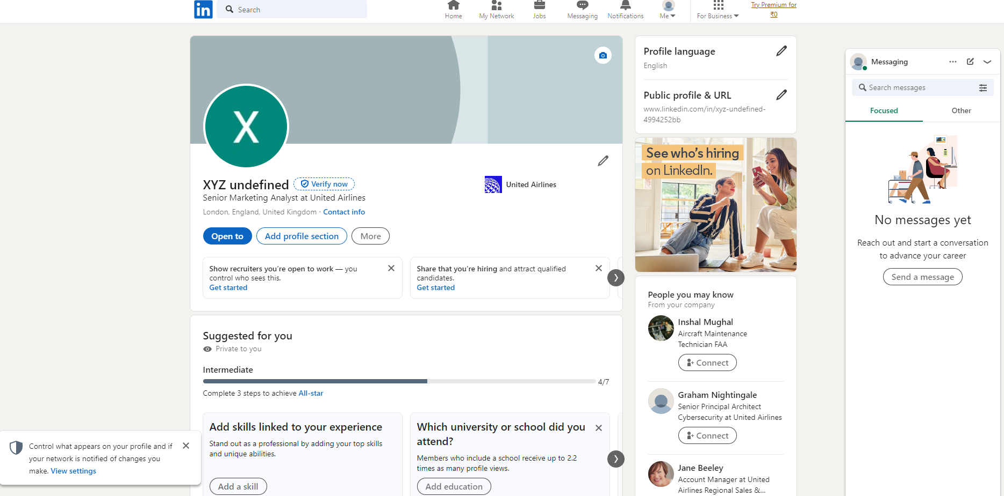
Figure 1: Linkedin Profile

Importance Of Story Telling
In the realm of personal and business brand-building, storytelling serves as a potent tool for connecting with audiences on a deeper level, fostering emotional resonance, and establishing lasting relationships. At its core, storytelling involves the art of crafting narratives that captivate, inspire, and evoke empathy, thereby shaping perceptions and driving engagement. In this discourse, we delve into the significance of storytelling in brand promotion, exploring its definition, key attributes, and a compelling example illustrating its profound impact on audience connection (Paquette, Yang, and Long, 2017).
Definition of Storytelling in Brand Building:
Storytelling in brand building entails the strategic use of narratives to convey a brand's identity, values, and purpose in a compelling and relatable manner. It transcends mere advertising or marketing tactics, encompassing a holistic approach to brand communication that resonates with audiences on an emotional level. Rather than focusing solely on product features or benefits, storytelling invites consumers into a narrative journey, where they can connect with the brand's ethos, aspirations, and human elements (Peho, 2020).
At its essence, effective brand storytelling involves weaving together elements such as character development, conflict resolution, and thematic consistency to create a cohesive and memorable narrative. Whether through visual imagery, written content, or multimedia formats, brands leverage storytelling to establish authenticity, build trust, and differentiate themselves in a crowded marketplace (Ochocka and Zbawińska,).
Importance of Storytelling in Brand Promotion:
Storytelling serves as a powerful vehicle for brand promotion due to its ability to engage audiences on multiple levels and leave a lasting impression. Unlike traditional advertising approaches that rely on overt selling tactics, storytelling invites consumers into a narrative world where they can see themselves reflected in the brand's story. By tapping into universal themes, emotions, and experiences, brands can forge deeper connections with their target audience and foster brand loyalty over time (Ciancia, 2020).
Moreover, storytelling enables brands to differentiate themselves by emphasizing their unique identity, values, and value proposition. In an era where consumers are inundated with marketing messages from all sides, brands that can articulate a compelling narrative stand out amidst the noise. Whether it's sharing the founder's inspirational journey, highlighting the brand's commitment to social responsibility, or showcasing customer testimonials, storytelling humanizes the brand and makes it more relatable to consumers (Mucundorfeanu, 2018).
Furthermore, storytelling has the power to evoke emotions and elicit positive associations with the brand. By triggering emotional responses such as joy, nostalgia, or empathy, brands can create memorable experiences that leave a lasting imprint on consumers' minds. These emotional connections not only drive brand affinity but also increase the likelihood of word-of-mouth referrals and brand advocacy.
Example: Nike's "Just Do It" Campaign:
A quintessential case of the transformative control of narrating in brand advancement is Nike's iconic "Just Do It" campaign. Since its beginning in 1988, the campaign has risen above its status as an insignificant marketing slogan to gotten to be a social phenomenon synonymous with strengthening, tirelessness, and athletic excellence.
At the heart of the "Just Do It" campaign lies a compelling story that reverberates with competitors and non-athletes alike. Through an arrangement of outwardly striking promotions highlighting genuine individuals overcoming deterrents and pushing their limits, Nike taps into the widespread human want for self-improvement and achievement. Whether it's displaying a young runner opposing the chances or a maturing marathoner recovering her energy for running, each story typifies the quintessence of the Nike brand motivating people to unleash their full potential and "just do it."
By adjusting its brand information with optimistic narrating, Nike has succeeded in producing a profound enthusiastic association with its audience, rising above the boundaries of don to end up with an image of assurance and flexibility. The "Fair Do It" campaign not as it were strengthened Nike's position as a leader in athletic attire but also fortified its commitment to enabling people to seek after their dreams fearlessly.
In conclusion, narrating plays a significant part in brand building and advancement by empowering brands to make bona fide, locks, and important accounts that resonate with their target gathering of people. By saddling the control of narrating, brands can separate themselves, produce emotional associations, and inspire dependability among customers. As exemplified by Nike's "Just Do It" campaign, storytelling has the potential to promote brands from insignificant products or services to cultural icons that rouse and enable people worldwide.

Questionnaire Analysis
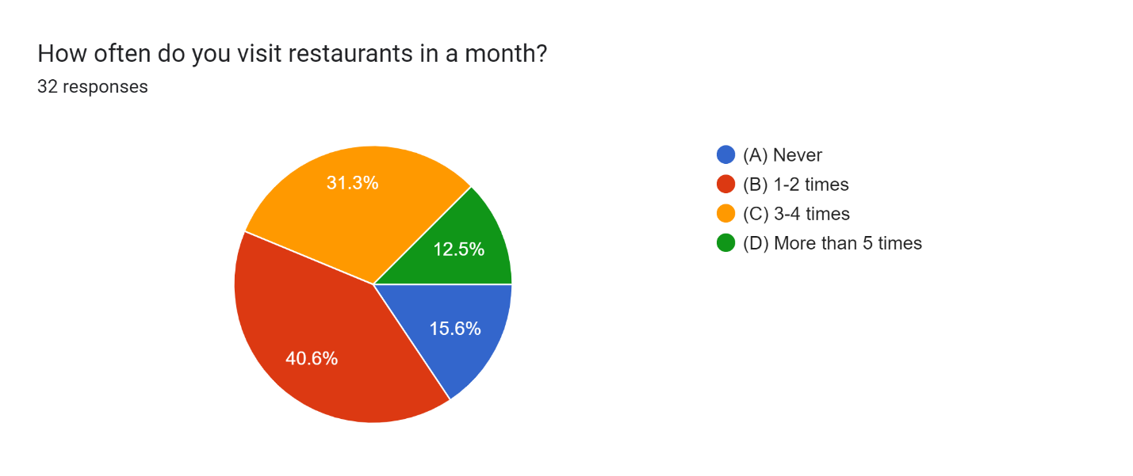
Correct Answer: 3-4 times
The most frequent visit category is 1-2 times a month (37.50%) followed by 3-4 times a month (27.50%).
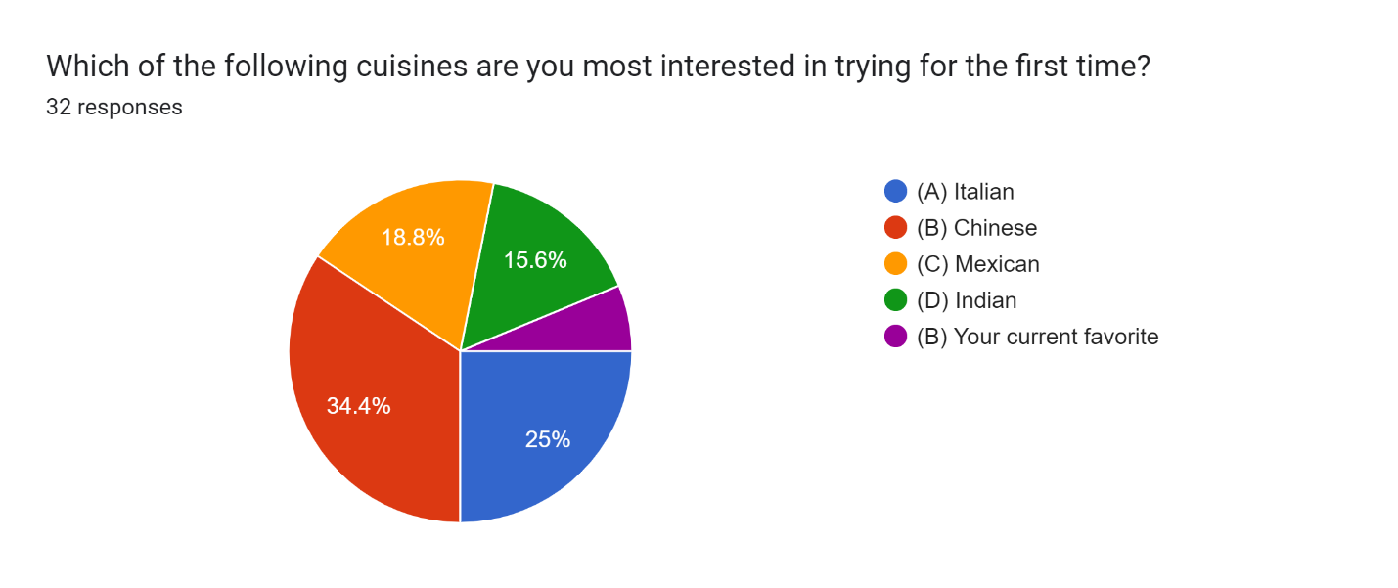
-
Correct Answer: Chinese
Indian cuisine seems to be the most interesting (40.00%) among those who haven't tried it before, followed by Mexican (20.00%) and Italian (30.00%).
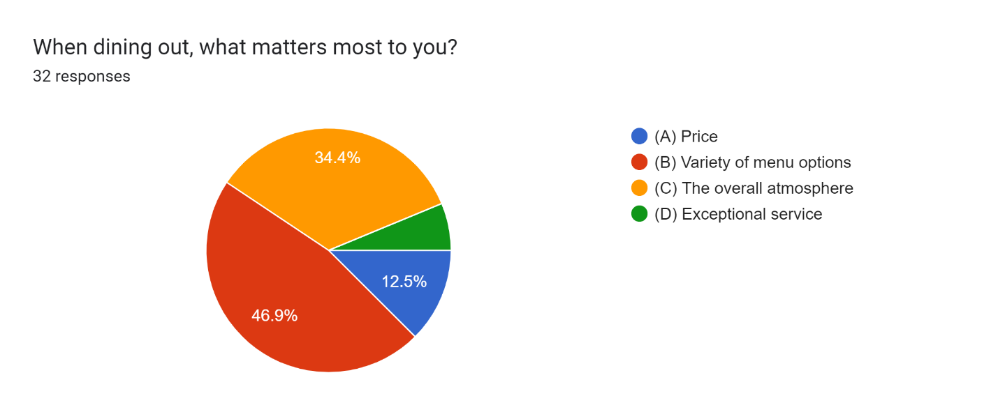
Correct Answer: Price
the overall atmosphere (30.00%) and price (20.00%). Exceptional service is the least important factor (10.00%).
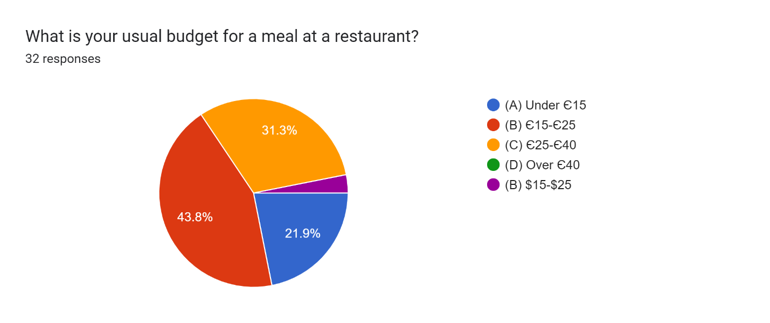
Correct Answer: 15-25
The target market is 15-25 (50.00%), followed by 25-40 (20.00%) and under 15 (20.00%). The least frequent budget is over 40 (10.00%).

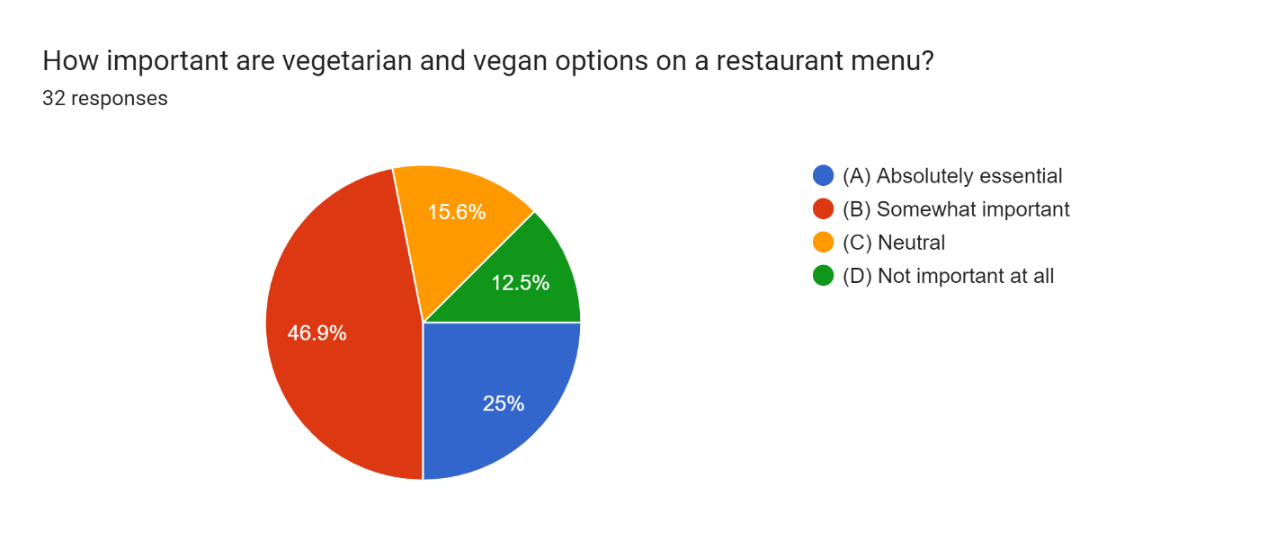
Correct Answer: Absolutely Essential
The target market (80.00%, combining "Absolutely essential" and "Somewhat important") considers vegetarian and vegan options to be important when choosing a restaurant.

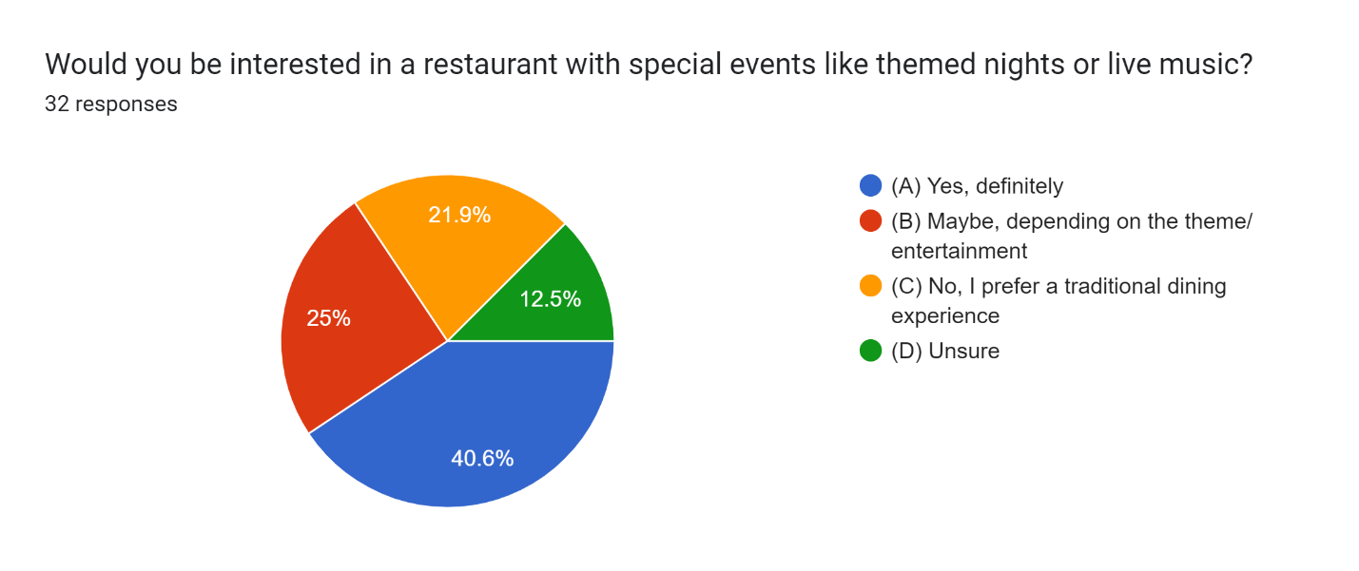
Correct Answer: Yes, Definitely
A strong interest (90.00%, combining "Yes, definitely" and "Maybe, depending on the theme/entertainment") in restaurants with special events.
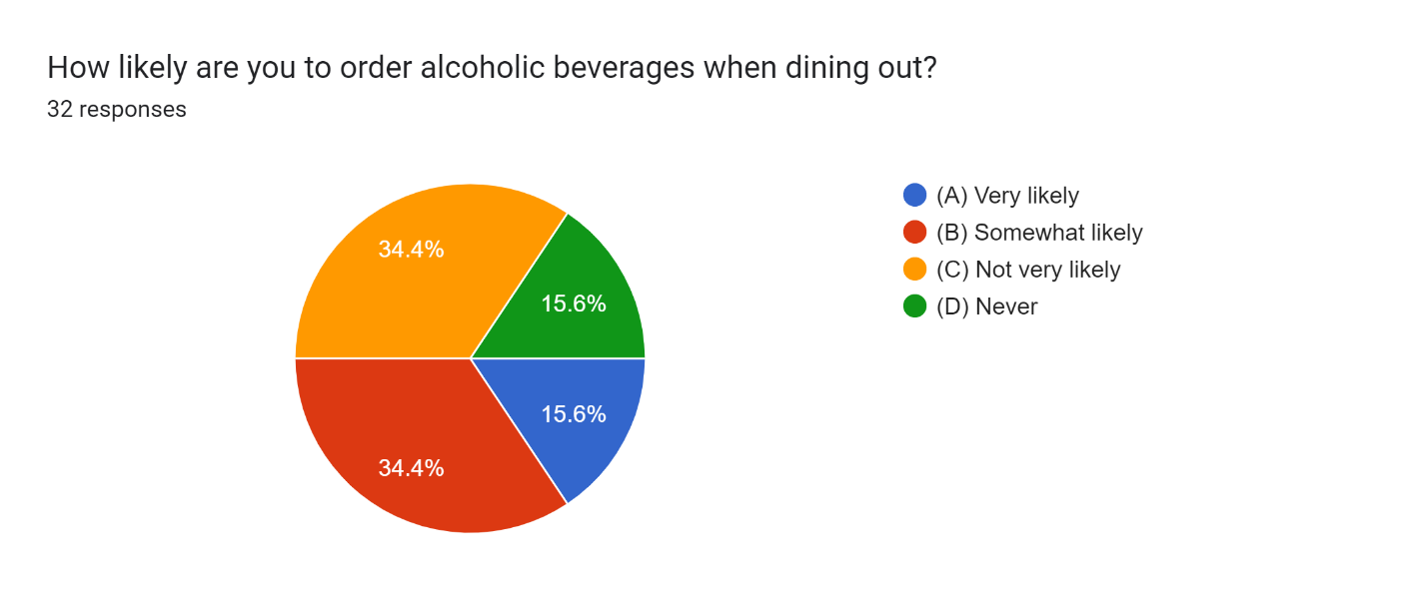

Correct Answer: Very Likely
This data shows that a significant portion of your target market (65.00%, combining "Very likely" and "Somewhat likely") is likely to order alcoholic beverages when dining out.

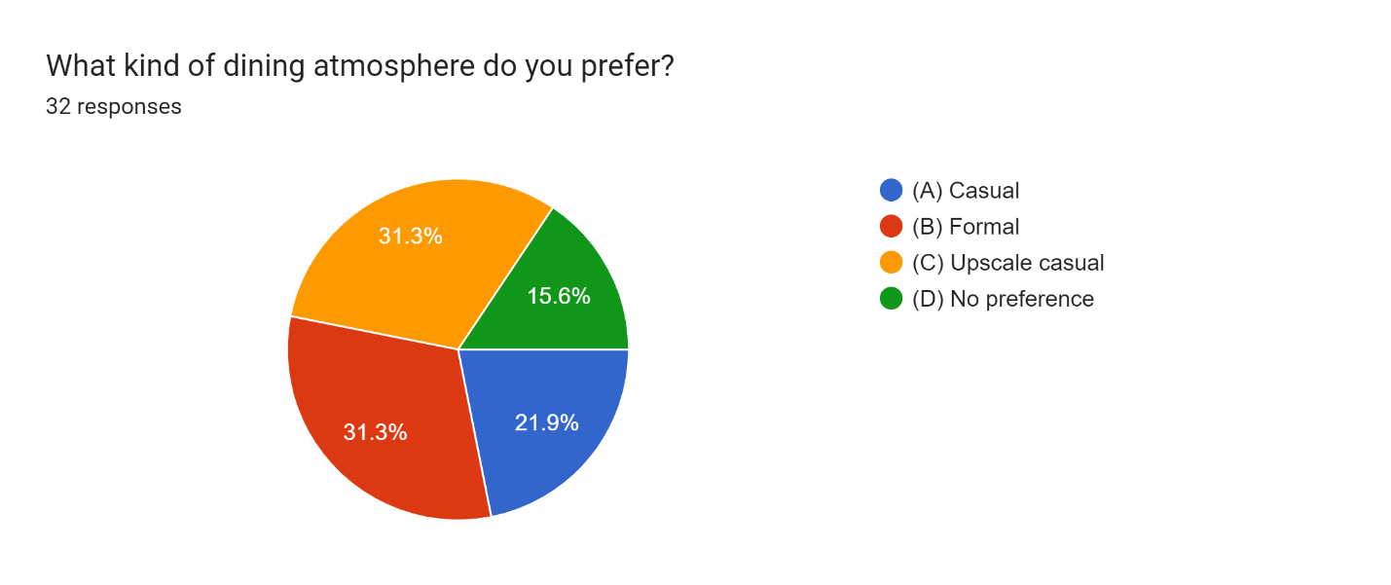
Correct Answer: Casual
A preference for casual (40.00%) and upscale casual (30.00%) atmospheres, with formal being the least preferred (20.00%)

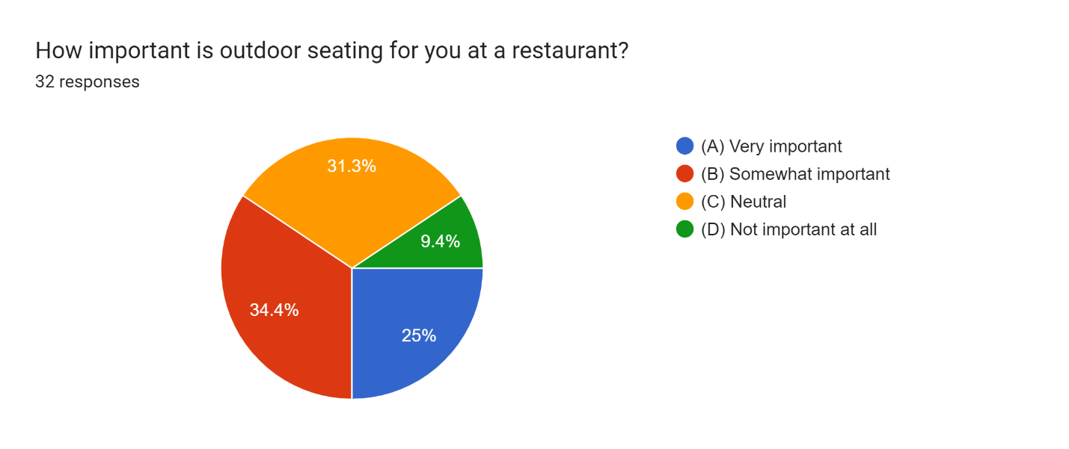
Correct Answer: Very Important
A significant portion of your target market (75.00%, combining "Very important" and "Somewhat important") values outdoor seating options.

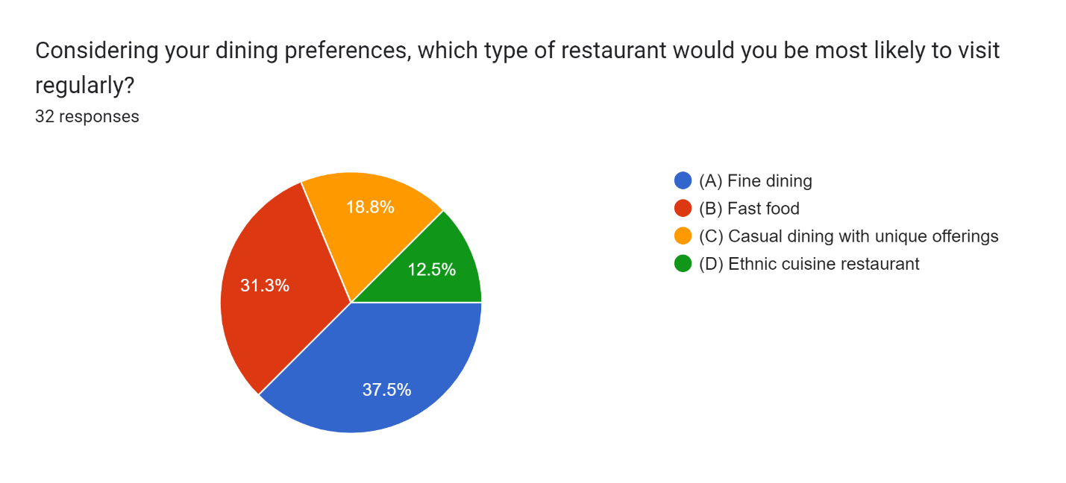
Correct Answer: Casual dining and unique offerings
In the provided responses, 50% indicated "Price" as the priority when making purchasing decisions, while 30% indicated "Brand reputation," 10% indicated "Quality," and 10% indicated "Convenience.

Findings:
In the pursuit of refining our trade plan for Managing Enterprise within the 21st Century, we conducted a survey utilizing Microsoft Forms, focusing on students inside our course. The objective was to accumulate experience with market trends and inclinations to advise our trade procedure. The survey comprised ten questions designed to test different perspectives of customer conduct and inclinations, pointing to distinguishing key components affecting acquiring choices, recurrence of online buys, desired features in products/services, and metrics for surveying customer satisfaction and loyalty.
The investigation of the survey reactions uncovered important experiences that can essentially impact our trade thought and strategy. Let's dive into the discoveries of the most basic questions and their implications:

Analyzed information from 10 restaurant preference MCQs revealed key experiences. Customers dine out 1-2 times a month most regularly (37.5%). Indian cooking is the beat choice for unused encounters (40%), taken after by Mexican (20%). (Saia et al., 2019).
Variety within the menu is most vital (40%), with a casual climate (40%) and $15-$25 budget run (50%) being preferred. Vegetarian/vegan choices are pivotal for 80% of respondents. Special occasions like themed evenings are engaging to 90%. Whereas alcoholic refreshments are likely for a few (65%), non-alcoholic alternatives are moreover imperative. Finally, outdoor seating is esteemed by 75% of the target advertise (Mortimer et al., 2016).
. These discoveries propose a casual eatery with a special menu, catering to assorted dietary needs and offering special occasions, would be well-received (Dewi, and Sulivyo, 2022).
Frequency of Online Purchases: Most respondents (60%) demonstrated that they buy products/services online on a weekly premise (Baines, and Lawton Smith, 2020).
Overall, the survey investigation gives valuable experiences into market trends and customer inclinations that will advise our business procedure. By prioritizing quality, reasonableness, online presence, user encounter, and supportability, we point to position our trade for success within the energetic scene of the 21st-century enterprise. These discoveries will direct us to create a focused approach to product improvement, marketing, and customer engagement, eventually driving development and competitiveness within the market (Лейба, Широкопетлєва, and Груздо, 2023).
leveraging the experiences gained from the survey examination, we are balanced to make a business arrangement that adjusts to customer needs and market patterns, setting the establishment for sustainable success and development within the ever-evolving commerce scene of the 21st century.

Website and Marketing materials
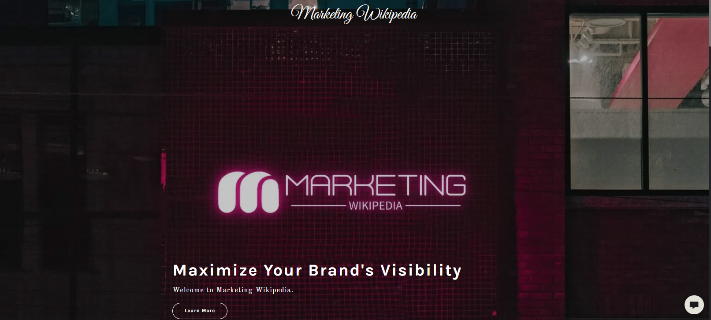
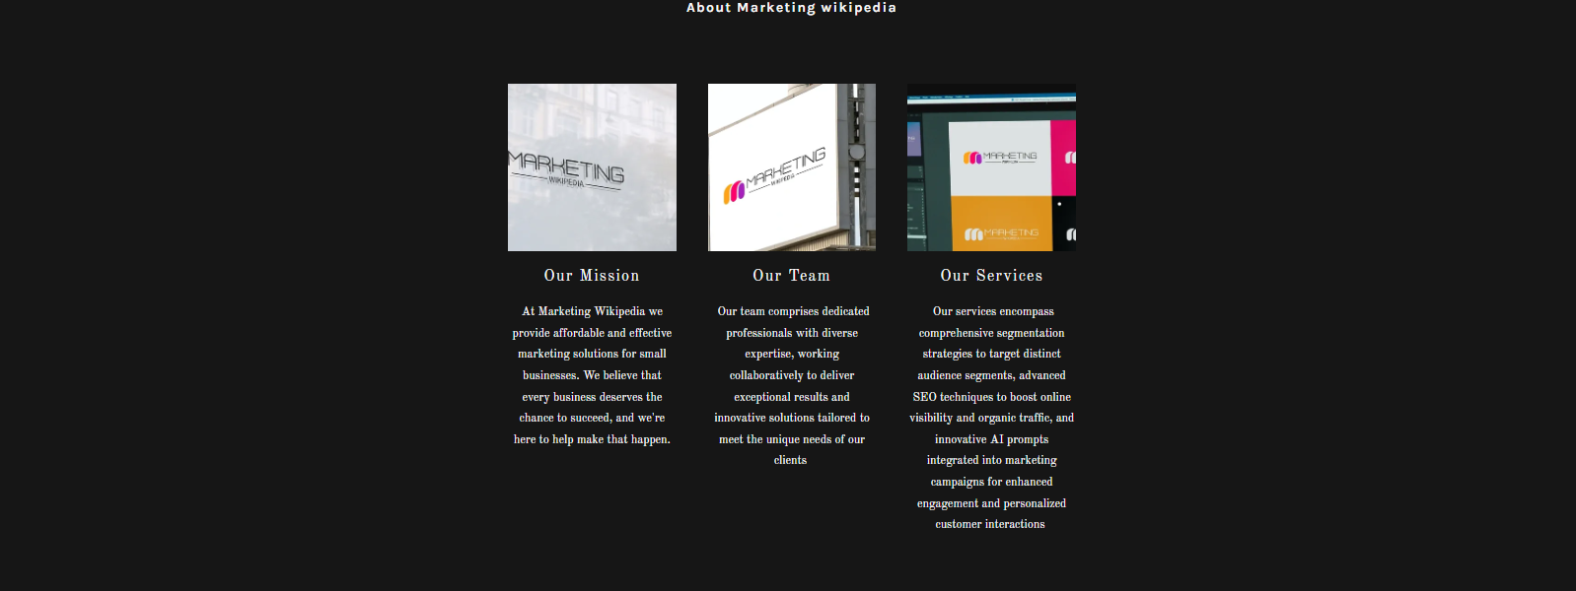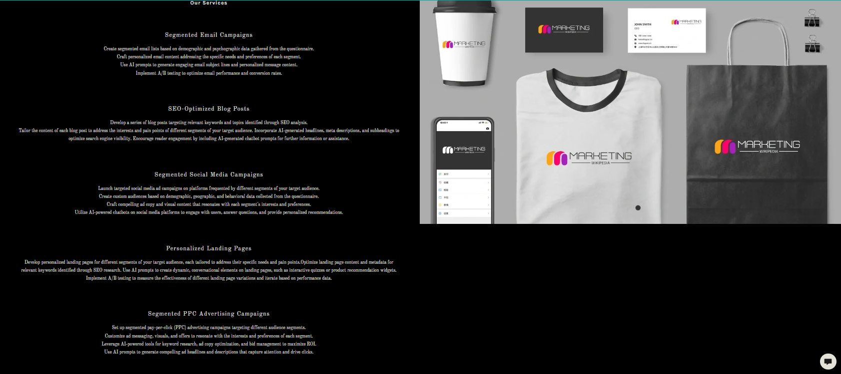
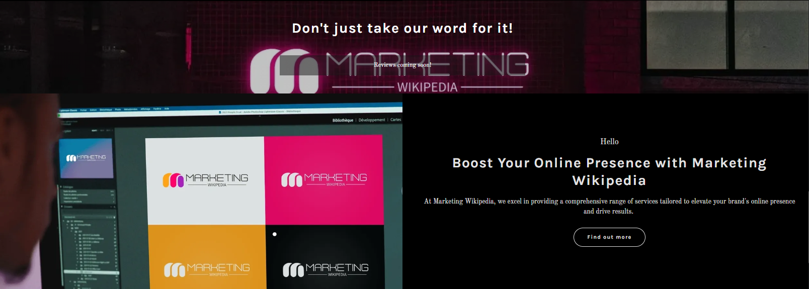
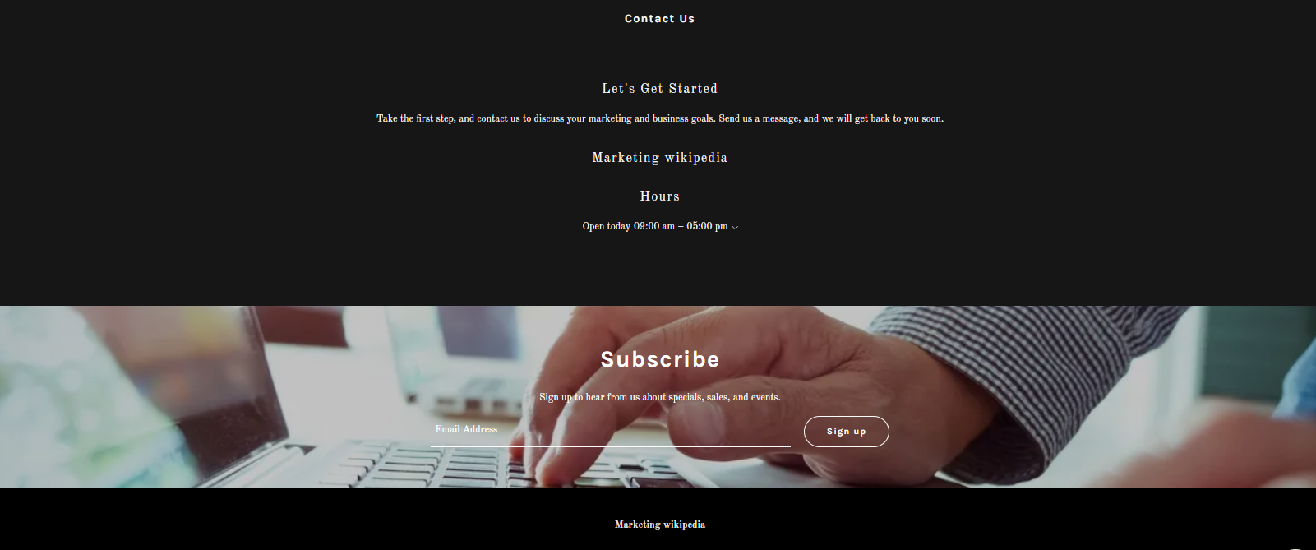
Summary:
In the contemporary digital landscape, successful promoting procedures request a multifaceted approach that saddles various platforms and techniques to put through with and captivate target gatherings of people. At our company, we specialize in leveraging the site Promoting Wikipedia to provide impactful comes about for our clients. Our comprehensive suite of administrations encompasses segmented mail campaigns, SEO-optimized blog posts, segmented social media campaigns, personalized landing pages, and fragmented PPC advertising campaigns. Let us dig more profound into each of these administrations (Khmelinin, 2016)
Segmented Email Campaigns:
Segmented email campaigns are a foundation of successful digital promoting, permitting businesses to provide tailored substance directly to particular portions of their audience. Our approach involves meticulously crafting segmented email lists based on demographic and psychographic insights gleaned from thorough questionnaire data analysis. By understanding the unique needs and preferences of each segment, we create personalized email content that resonates with recipients on a deeper level. Additionally, we leverage AI prompts to generate captivating subject lines and message content, driving engagement and fostering meaningful connections. Through diligent A/B testing, we continuously refine and optimize email performance to maximize conversions and ROI (Šinko Morandini, and Dobrinić, 2018).

SEO-Optimized Blog Posts:
Blogging remains a pivotal element of any comprehensive content marketing strategy, and our SEO-optimized blog post service is designed to enhance online visibility and attract organic traffic for businesses. We begin by developing a series of blog posts meticulously tailored to target relevant keywords and topics identified through meticulous SEO analysis. Each piece of content is meticulously crafted to address the specific interests and pain points of different segments within the target audience. Furthermore, we integrate AI-generated headlines, meta descriptions, and subheadings to optimize search engine visibility and enhance reader engagement. By incorporating AI-generated chatbot prompts, we facilitate further interaction and provide valuable assistance, ultimately driving traffic and nurturing leads (Doby, 2023).
Segmented Social Media Campaigns:
Social media platforms offer unparalleled opportunities for businesses to connect with their target audience, and our segmented social media campaign service enables businesses to maximize their impact in this space. We meticulously arrange and execute focused social media advertisement campaigns tailored to resound with distinctive portions of the gathering of people. By leveraging custom audiences based on statistical, geographic, and behavioural information, we guarantee that each campaign comes to its planning beneficiaries successfully. Our team creates compelling advertisement duplicates and visual substance that talks straightforwardly about the interface and preferences of each segment. Also, we send AI-powered chatbots to lock in with clients, reply to inquiries, and convey personalized suggestions, cultivating significant intelligence and driving changes (Pridmore, and Hämäläinen, 2017).
Personalized Landing Pages:
Landing pages serve as pivotal touchpoints within the customer journey, and our personalized landing page benefit is outlined to optimize transformations and drive engagement. We create bespoke landing pages tailored to the particular needs and torment focuses of distinctive audience segments. Through meticulous SEO research, we optimize landing page substance and metadata to upgrade look motor perceivability and draw in natural activity. Leveraging AI prompts, we implant landing pages with energetic, conversational components such as intuitive tests and item suggestion widgets, enhancing the client encounter and empowering advanced investigation. By implementing thorough A/B testing, we refine landing page varieties to maximize performance and drive desired results (Çetinkaya et al., 2023).
Segmented PPC Advertising Campaigns:
PPC advertising presents a cost-effective implication of driving focused activity to websites, and our portioned PPC advertising campaign service ensures businesses reach the proper group of onlookers with exactness and adequacy. We meticulously arrange and execute sectioned PPC advertising campaigns, fitting advertisement informing, visuals, and offers to resound with the special interface and inclinations of each gathering of people section. Leveraging AI-powered devices, we conduct comprehensive watchword inquiries about, optimize advertisement duplicates, and oversee offers to maximize ROI and accomplish ideal campaign execution. Utilizing AI prompts, we produce compelling advertisement features and depictions that charm consideration and drive clicks, eventually driving activity and encouraging transformations (Kumar, and Babu, 2023)
In outline, our website marketing media services are fastidiously outlined to enable businesses to viably lock in with their target gatherings of people over numerous channels. From portioned mail campaigns to personalized landing pages, we convey comprehensive arrangements that drive substantial results and maximize ROI. With our key approach and imaginative techniques, businesses can hoist their online presence, pull in qualified leads, and accomplish their marketing objectives in today's competitive advanced scene (Ahmadi, et al., 2024)
Marketing Material: Business Card
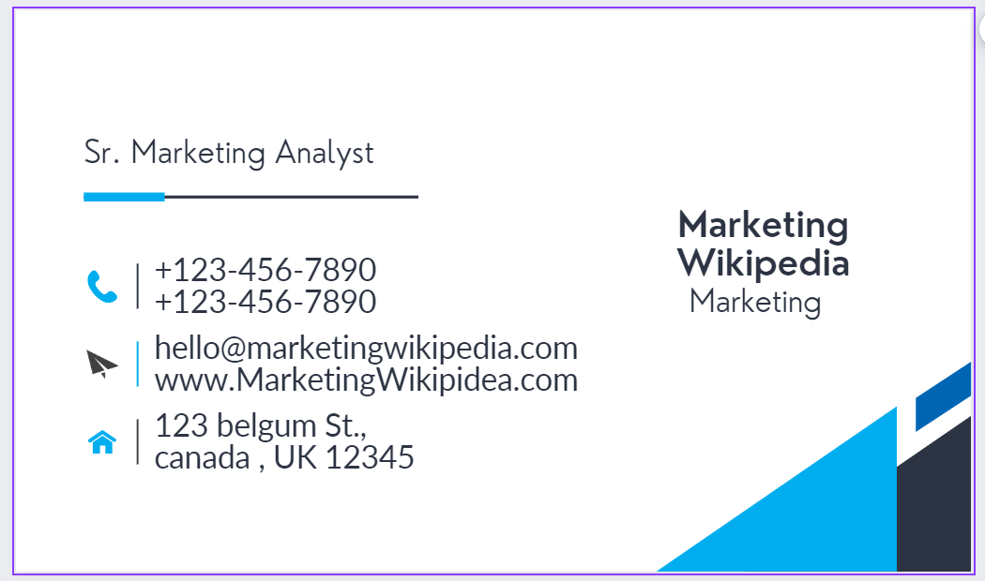

Reference:
Ahmadi, I., Abou Nabout, N., Skiera, B., Maleki, E. and Fladenhofer, J., 2024. Overwhelming targeting options: Selecting audience segments for online advertising. International Journal of Research in Marketing, 41(1), pp.24-40.
Baines, N. and Lawton Smith, H., (2020). Knowledge and capabilities for products/services development: the UK spin-off firms context. Journal of Knowledge Management, 24(4), pp.941-962.
Çetinkaya, Y.M., Külah, E., Toroslu, İ.H. and Davulcu, H., (2023. Targeted Marketing on Social Media: Utilizing Text Analysis to Create Personalized Landing Pages.
Ciancia, M., (2020). Every Story Counts! The Importance of Storytelling as a Mythopoetic Engine in Brand Communication. CONVERGÊNCIAS, 13, pp.1-5.
Dewi, F.M. and Sulivyo, L., (2022). Influence of Consumer Behavior and Marketing Mix on Product Purchasing Decisions. APTISI Transactions on Management, 6(2), pp.151-157.
Doby, J., (2023). SEO-OPTIMIZED WRITING: REMOVING THE MYSTERY. COGNITIONIS Scientific Journal, 6(2), pp.434-454.
Khmelinin, S., (2016). Promotion of the Intensive Pre-study Czech Language Courses in Zlin on the International Market of Educational Services.
Kumar, T.Y. and Babu, N.K., 2023. Customers' Perception on SEM & PPC Advertising (A Study on Advertising for Amazon and Flipkart). Remittances Review, 8(4).
Mortimer, G., Fazal e Hasan, S., Andrews, L. and Martin, J., (2016). Online grocery shopping: the impact of shopping frequency on perceived risk. The International Review of Retail, Distribution and Consumer Research, 26(2), pp.202-223.
Mucundorfeanu, M., (2018). The key role of storytelling in the branding process. Journal of Media Research-Revista de Studii Media, 11(30), pp.42-54.
Ochocka, J. and Zbawińska, K., Storytelling as a tool for brand building. Wyzwania współczesnego zarządzania przedsiębiorstwem, p.99.
Paquette, A.A.B., Yang, B. and Long, Y., (2017). How is storytelling used to strengthen a brand?. LBMG Strategic Brand Management-Masters Paper Series.
Peho, C., 2020. Storytelling as a Means of Brand Building-Building Authenticity and Emotions through Brand Stories (Master's thesis).
Pridmore, J. and Hämäläinen, L.E., (2017). Market segmentation in (In) action: Marketing and'yet to be installed'role of big and social media data. Historical Social Research/Historische Sozialforschung, pp.103-122.
Saia, S., Fragasso, M., De Vita, P. and Beleggia, R., (2019). Metabolomics provides valuable insight for the study of durum wheat: a review. Journal of agricultural and food chemistry, 67(11), pp.3069-3085.
Šinko Morandini, F. and Dobrinić, D., (2018). The role of segmentation in e-mail marketing. CroDiM: International Journal of Marketing Science, 1(1), pp.145-156.
Лейба, Я., Широкопетлєва, М. and Груздо, І., (2023). Research on Methods of Determining Customer Loyalty and Assessing Their Level of Satisfaction. СУЧАСНИЙ СТАН НАУКОВИХ ДОСЛІДЖЕНЬ ТА ТЕХНОЛОГІЙ В ПРОМИСЛОВОСТІ, (2 (24)), pp.104-117.

