Levelling Procedure and Reduced Level Computation

Created By:
T.Williams

Created For:
J.Dauda

Table of Contents
1.0 Introduction 3
2.0 General Overview of Levelling Surveying 4
3.0 Equipment used in Levelling 4
3.1 Dumpy Level 4
3.2 Surveyors Tape 4
3.3 Tripod 5
3.4 Measuring Staff 5
3.5 Levelling Book 6
4.0 Levelling Procedure 6
5.0 Computation and Plotting Levels 7
6.0 Conclusion 8
References 9

1.0 Introduction

This report will aim to give a general overview of levelling in surveying. It will also give examples of levelling equipment that was used in carrying out the levelling survey for the proposed major road reconstruction around the Swansea city campus. It will also give a step by step account of the levelling process, and will show the data collected during the process. Along with the computations of the results, giving the volume of earthworks required to level the ground between the temporary benchmark (TBM) and the last station.

2.0 General Overview of Levelling Surveying

On construction sites, surveying is the process and method to determine distances and angles between locations for both the purposes of levelling and laying out works. The precision and efficiency of surveying are dependent on having the correct instruments. For land surveying, mapping and setting out, surveyors utilise a variety of devices. The process of levelling involves establishing the position of one level in relation to another. It is used in surveying to determine a points elevation corresponding to a datum or to determine a points height relative to a datum (Anon, 2022).
You must always use a BM point to start your survey from, if there is no BM nearby to your site you can establish a Temporary Benchmark (TBM) at an arbitrary height. An example of this would be 100m to ensure all heights are positive. At some point you will also need to find the nearest BM, to tie your TBM into and then make your final level calculations.

3.0 Equipment used in Levelling

3.1 Dumpy Level
A dumpy level is an instrument similar to a telescope that is mounted on a tripod and used to establish or verify points along the same horizontal plane. During building surveys, it is used in conjunction with a vertical staff to determine height differences as well as transfer elevations (Anon, 2022).
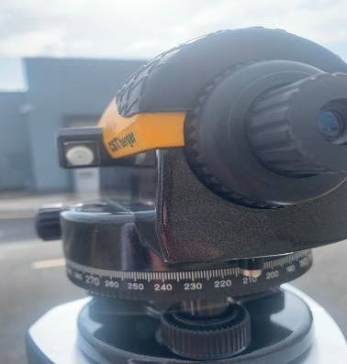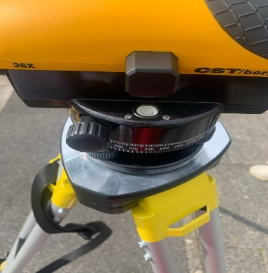

3.2 Surveyors Tape

The Surveyor's Tape is made of tough ABS plastic and contains a built-in ground spike. It has a comfortable grip handle that makes it easy to hold. The reel handle folds out for easy usage and allows you to retract the tape quickly. The tape can be manufactured out of reinforced fibreglass, which is extremely robust and strain resistant. A flip out blade hook is included at the tape's end for secure anchoring. Durable imperial and metric graduations are printed on both sides of the tape. The tape comes in three lengths: 30m (100ft), 50m (165ft), and 100m (330ft) (Anon, 2021).

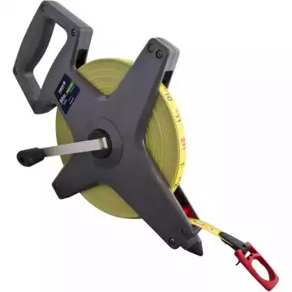 (sccssurvey, 2022).

3.3 Tripod

Because inaccurate data might lead to rework and significant expenditures, surveying leaves little space for mistake. As a result, surveying devices should be stabilised when used outside, especially in areas with slopes, hills, and other obstacles. A tripod, which has three legs attached to a head using mounting screws or a clamp, is the greatest tool for providing stability to total stations, transit levels, theodolites, and other instruments. Position the tripods three legs and adjust their lengths to a comfortable and even height before assembling it. After fastening the tripod, simply clamp or screw the instrument snugly on the tripods head. Surveying equipment may be sturdy and precise without much effort with this simple arrangement. There are tripods that are intended expressly for a surveying instrument, but the majority of them may be used with any other equipment. They are composed of tough materials like aluminium, wood, fibreglass, and carbon fibre to withstand the elements. Some of these tripods are elevating, allowing surveying equipment to function at a greater range. Surveying tools will function to their maximum precision with tripods like these (sccssurvey, 2022).

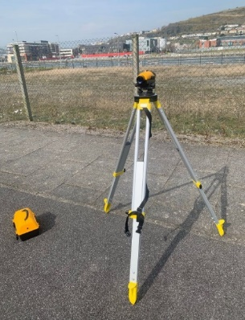

3.4 Measuring Staff

Staffs and levels should be treated with caution. This is because they are prone to damage. They should be checked for evidence of wear and tear on a regular basis. Misreading the staff is a typical mistake, therefore it's critical to take the time to verify correct readings. The staff must remain upright. The following are the most effective methods for avoiding errors. You should hold a little spirit level against the staff. The staff should always be grasped in front of you while standing upright, with both hands up the sides of the staff. The lowest reading should be recorded after rocking the staff back and forth (sccssurvey, 2022).

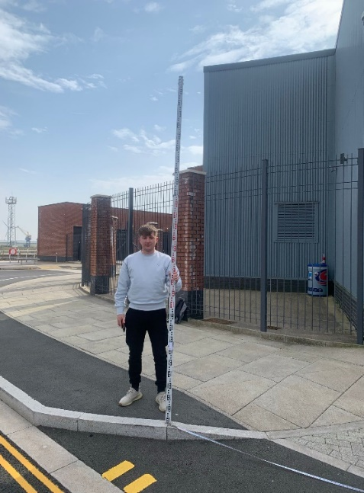

3.5 Levelling Book

The actions to take while booking observations are; A new job should always be started on a fresh page of the levelling book. The information should go at the top of the page and all findings should be written down in a legible manner. Instead of overwriting figures, if a mistake is made, it should always be crossed out then the correct value noted above this. Each member of the staff should have their own line. In the remarks column, there ought to be an entry. Work should be distributed properly (Anon, 2022).

4.0 Levelling Procedure

To commence our levelling survey, we arrived at the workshops to collect and check the instruments. This check was performed to make sure they were working correctly. We then proceeded to the chosen area where we were going to set up and start taking our levels from. I, along with my group, chose a position to set up our tripod and optic level. Firstly, I placed the tripod and levelled it by eye, then I connected the dumpy level to the tripod using the screw in connector. I then used the levelling bubble on the dumpy level to make sure the instrument was level once I got it in the correct position. I asked the other members of the group to check they were happy that it was level. We all agreed that it was set up correctly, then we proceeded to choose a starting position for our survey and use as a TBM (temporary benchmark).
Following this I took the staff to where we had decided to use as a TBM. I held the staff upright and made sure that it was straight and not leaning one way or the other with the help of the group. Elliott then took the height measurement of the TBM using the dumpy level, and he then recorded the back sight measurement on the new booking sheet. Steff then gave me one end of the tape measure to hold, and we measured out 20m horizontally to the east from the TBM (Datum A) to our first intermediate Sight (Station B). We recorded the height of station B and we measured 20m to the east again from (B) to (C). I moved the staff to (C) and we recorded the height. This this was a fore sight measurement as it is the last measurement before we moved the instrument to CP1 (change point 1). I stayed in the same position with the staff, as this needs to be recorded again from the new instrument position. The other two members of the group re positioned the instrument and made sure it was level again (as per the levelling bubble) at CP1 before we continued. We took and recorded the back sight measurement from the new instrument position to (C).
We measured out a further 20m from (C) and moved the staff to this point, we then measured and recorded the results at (D), we moved the staff to position (E) and recorded the measurement. We continued the process at 20m intervals through positions (F), (G), (H). At (I) we recorded the fore sight measurement at (I), as we had approached the corner of the building and would not have been able to record anymore from the current instrument position. I stayed at that position with the staff while the team moved the instrument and re levelled again. We again took and recorded a back sight measurement of (I) from CP2.
We carried on with recording of the measurements at 20m intervals to the south from point (I), through points (J), (K), (L), (M), (O), (P) to (Q) where we took a fore sight measurement again, as were unable to go further until the instrument was moved. We moved the instrument and once it was set up, we recorded the back sight to (Q) from CP3.
Next, we proceeded to record the measurements at 20m intervals to the east again from (Q) through points (R), (S), (T), (U), (V), (W) to (X) where we took a fore sight measurement, as we were moving the instrument to our final change point. We moved the instrument and set it up. We then took a final back sight measurement of (X) from CP4. We moved the staff 20m to the northeast from (X) and recorded our final fore sight measurement (Datum B).

5.0 Computation and Plotting Levels

The Rise and Fall technique and the Height of the Plane of Collimation method (HPC/HOC) are the two approved procedures for scheduling observations. Neither strategy is superior to the other in terms of accuracy. Rise and Fall has an extra check on the observations arithmetical reduction, which makes it more popular for line levelling. Because the height of the instrument must always be known, the HPC approach is utilised for setting out (Anon, 2022).
I chose to do the rise and fall method to calculate my results, as can be seen in the image below and have done the extra check on the observations arithmetical reduction. I have also created a line graph and used this to calculate the volume of earthworks needed. The use of a line graph allows a clearer understanding and interpretation of the results.
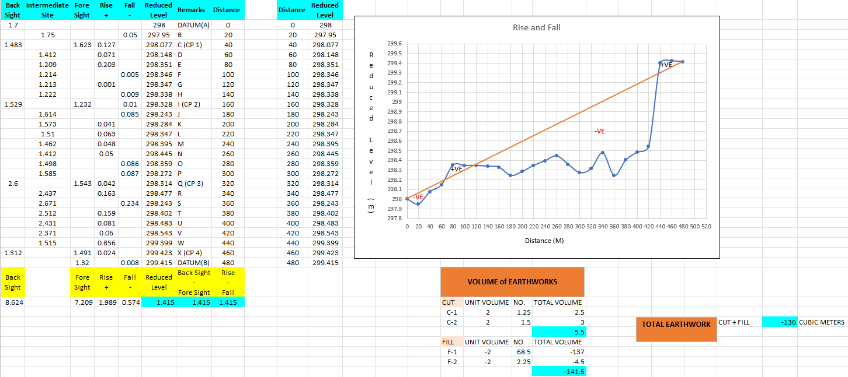

6.0 Conclusion

This report has given a brief overview of levelling survey, along with detailing of the equipment used to perform this. I have used our recent levelling survey of the Swansea city campus as an example of the procedure that was followed. I have included a detailed step by step account of the levelling survey procedure that I carried out along with the group I was working with. I have included a screen shot of the computation and plotting done through excel. From this you can see extra check on the observations arithmetical reduction. You can also see the Volume of earthworks that will need to be carried out. This involves cutting 5.5 cubic meters that is above the road line and filling with 136 cubic meters below the road line to create a flat road. The results for the volume of earthworks have been collated using a line graph. Using this method allows for easier understanding and interpretation of the results.
Through my own example above, it demonstrates that the process of levelling survey is an effective and accurate method of surveying, and certainly proves why it is a successful method widely used in the construction industry in current times.

References
Anon, 2021. [Online]
Available at: www.nhbs.com
Anon, 2022. [Online]
Available at: Designbuildings.co.uk
sccssurvey, 2022. [Online]
Available at: www.sccssurvey.co.uk

