
VISIONS FOR THE FUTURE - THEORETICAL PERSPECTIVES ON MANAgEMENT
Huy (Kieran) Tran
2524388

August 21, 2026
University of Wales Trinity Saint David

Table of Contents
Abstract 3
1. Introduction 4
2. Literature Review 5
2.1 Evolution of Technology in Business 5
2.2 The Rise of e-Commerce 6
2.3 The Emergence of e-Business 7
2.4 Organisational Structure 8
2.5 Theories of Management: Classical vs Modern 11
3. Digital Transformation of 21st Century Corporations 13
3.1 Digital Connectivity and Global Market Integration 13
3.2 Digital Transformation as a Business Strategy 14
4. Obsolescence of Traditional Organisation Structures 15
4.1 Flat Organisations and Hierarchical Organisations 15
4.2 Alternative Organisational Structure and Working Models 17
5. Redefining Management Roles 19
5.1 Transformational Leadership 19
5.2 Technological Literacy 20
6. The Digital Challenges 20
6.1 Overcoming Resistance to Change 21
6.2 The Balance between Human and Technology 21
7. Conclusion 22
7.1 Recommendation 23
7.2 Implications for Future Research 24
Reference 25

Table of Figures
Figure 1 Hierarchical Structure 8
Figure 2 Functional Structure 9
Figure 3 Divisional Structure 10
Figure 4 Fayol's 14 Principles of Management 12
Figure 5 Flat Organisational Structure 16
Figure 6 Horizontal Communication 17

Word Count: 7844

Topic Example 2: “Technology advances - specifically in the areas of e-Commerce and e-Business have rendered traditional models of organisational structure and theories of management roles obsolete in the light of the changing nature of 21st century corporations.” Evaluate whether this claim is justified - in relation to a business sector of your choice - and provide evidence for or against it, especially in relation to the management changes it implies

Abstract
e-Commerce and e-Business, two aspects that are closely related to retail supply chain have changed significantly with the digital era. This report will critically evaluate the claim that e-Commerce and e-Business have rendered traditional organisational structures and management roles obsolete, using the retail supply chain sector as the chosen sector. The study examines how digital technologies have transformed how organisations coordinate operations, communicate and respond to information in a dynamic market. The attention now is given to the transition from traditional hierarchical structures towards flatter, decentralised organisation, along with changes in managerial responsibilities. The findings suggest that technology has reduced the need for extensive layers of managers by enabling faster information sharing and greater autonomy in decision-making. Consequently, the role of managers is increasingly shifting from commanding and controlling employees towards collaboration, developing technological literacy and providing teamworking based communication. Within retail supply chains, physical activities such as warehousing, transportation, supplier coordination and fulfilment continue to require human oversight and operational control. Furthermore, digital transformation introduces challenges including resistance to change, anxiety, data security and over-reliance on technology. Therefore, the report concludes that traditional structures have not become entirely obsolete; rather, technology has changed where and how hierarchy, coordination and managerial authority are applied.

Introduction
The Fourth Industrial Revolution (4IR) has accelerated and shaped the global economy massively that no businessman from 20 years ago could have envisioned what can be done with just a laptop and the internet. Digital technologies have advanced so much that organisations nowadays have to change their operational approach and method of delivering value to customers. In particular, the emergence of e-Business and e-Commerce have transformed the traditional retailing industry that businesses nowadays don’t necessarily need a physical store to operate efficiently. Hence, practitioners and scholars who looked into theories of management and traditional models of organisational structure have questioned whether they are still suitable for operation in this digital-focused era.
Traditional organisational structures like horizontal or hierarchical structures, characterised by functional specialisation, centralised decision-making, and rigid hierarchies, were developed and used during times when companies operate in a stable and forecast-driven environment. Similarly, classic management theories like Weber’s Bureaucratic Theory, Taylor’s Scientific Management (Taylorism), and Fayol’s Administrative Management (Fayolism) were formed based on strict authority, micro-management, and standardisation to increase organisational efficiency. These traditional structures and management concepts, while proven to be useful back in the day, are distinct from today’s modern leadership styles that focus on human relations and teamwork. Furthermore, this era of digitalised business process introduced new challenges like higher demand for flexibility from customers, faster customer support, and real-time information sharing. Ultimately, many organisations have to change their approach by adopting a flatter organisational structure and using digital software to streamline the process and increase responsiveness in an increasingly demanding market.
However, despite these newly developed technology and development, the statement that said “e-Commerce and e-Business have rendered traditional models of organisational structure and theories of management roles obsolete” is still up for debate. Undoubtedly, while digital technology has somewhat changed the organisational structure and management styles, the core principle of employee management, coordination, and control still remain important. Instead of replacing the classic theories, a good organisation must be able to combine those principles with the modern approach to get the best out of them. Therefore, this research only partially agrees with the statement: e-Business and e-Commerce together with technological advancement did make rigid hierarchical management less effective, but they do not render traditional organisational theories obsolete. Instead, this could be turned into an opportunity for organisations to combine classical management with an agile digital approach to meet customers’ demand.
Additionally, this report will take a deep look into the Retail Supply Chain sector to see how e-Business and e-Commerce has affected the industry. Retail in the supply chain is a suitable chosen topic as it has been at the forefront of the digital transformation over the past two decades. Various technological advancements like ERP systems, AI, digital platforms, and omnichannel retailing are factors that have changed how organisations manage their logistics, inventory, and fulfilment. Consequently, these changes not only reshaped organisational structure but also management methods, for example, from managing individual personnel in a supply chain team to managing a digital dashboard. This discussion will critically examine the evolution of organisational structures, evaluate the changing role of managers within digitally enabled retail supply chains, and assess whether technology has fundamentally replaced or merely adapted traditional management theory.

Literature Review

Evolution of Technology in Business
There is no doubt that the transformation of technology in business has created significant value and changed how internal operations are managed. Everybody thought that Henry Ford’s assembly line and mass production were the pinnacle of manufacturing (Mohajan, 2020), until the discovery of digital technology. The early technological developments mainly focused on production efficiency through automation; however, the creation of the internet shifted manufacturing capability. Most noticeably, the Third Industrial Revolution initiated a movement from analogue and mechanical electronic technology to digital electronics, changing how internal communication and exchange of information across organisations (Mohajan, 2021). Since this transition, information became a strategic resource rather than mere words and numbers.
As information became more valuable, tools were created mainly for the purpose of creating, sharing and storing information, including Internet of Things, data analytics, cloud servers, and most recently artificial intelligence. With real-time capture of information, it significantly improves visibility, coordination, and decision-making. From a theoretical perspective, the Resource-based View theory emphasises the value of difficult-to-imitate and internal resources to achieve competitive advantages (Cuervo-Cazurra et al., 2021). Although traditional competitive advantage was largely related to tangible assets like equipment or machines, the digital era has increased the importance of intangible assets like information and software; therefore, tools like ERP are a must for any firms who want to respond quickly and effectively to its customers.
In Retail Supply Chain, the digital advancement has completely changed the logistics activities. For example, manual stock taking in supermarkets is not required anymore, as Inventory Management System automatically deduct the stocks when customers scan it at the till. Simultaneously, procurement or warehousing activities can also be automated. The ability to utilise real-time information is a key source of competitive advantage to avoid backlogs or supply chain disruptions.
Although these technological innovations are major driver of organisational change, their primary functions remain focused on operational efficiency and productivity, much like the objectives of traditional organisational structures. Therefore, rather than e-Commerce and e-Business rendering traditional approaches obsolete, these approaches evolved to complement digital technologies while still retaining their core functions.

The Rise of e-Commerce
E-Commerce is defined as the act of buying or selling goods through a digital platform where transactions can be made without needing a brick-and-mortar physical store (Jain et al., 2021). Interestingly, e-Commerce is not limited with physical product transactions but also includes transactions of non-physical products like services and information trading, simplifying the supply chain network in specific buying fields (Chaffey, 2022, p.12). One thing that can be said is that not only have consumers reaped substantial benefits from the development of the digital business era, but organisations also enjoy the benefits. However, as expectations are being surpassed, customers’ demands of their sellers also increased. For example, in retail, the rise of e-Commerce altered the traditional supply chain patterns, moving from bulk purchasing to smaller and highly variable ordering patterns. This transformation placed high pressure on retail stores, where shorter lead-time, greater flexibility and last-mile delivery is required.
Technology also modernised the 4 basic principles of e-Commerce: Business-to-Business (B2B), Business-to-Consumer (B2C), Consumer-to-Consumer (C2C), and Consumer-to-Business (C2B). Although each e-Commerce models serve every market participant differently, they simultaneously demonstrate how digital technology handles commercial relationships beyond the traditional buyer and seller interaction, for example:
- Business-to-Business
Modern supply chain operations depend on electronic data interchange (EDI) to streamline communication between organisations (Okoye and Obi, 2015)
- Business-to-Consumer
This model benefits the most from digital advancement, as companies and their target consumers can now instantly transfer information and messages, like real-time location tracking, online payment and invoicing, and personalised request. (Agwu and Murray, 2014)
- Consumer-to-Business and Consumer-to-Consumer
Although the two models target different audiences, they function the same way with the help of technology. With a digital platform, both consumers and businesses can have a meeting ground to negotiate price and types of services (Okoye and Obi, 2015). Apart from using digital platforms, consumers can further strengthen their position by utilising different tools like targeted advertisement, social media, or affiliate network.
In retail, this partnership between commerce and technology didn’t only reshape the retail industry but also brought it to the next level by creating a new digital environment. Businesses nowadays are expected to operate 24/7 with next day delivery consistently between all products without having to go to a physical store (Danish et al, 2014). The emergence of platform-based technology, such as TikTok Shop or Amazon Marketplace are examples where sellers just only need to perfect their product, while the website handles all other factors like marketing, communication, and payment (AWS, 2026; TikTok Shop, 2026). Therefore, it is needless to say that e-Commerce has come a long way from 20 years ago, and it’s expected to do more in the upcoming years. It has intensified the need for an organisational structure and management redesign, as businesses that are unable to follow and adapt with technology will have no means of connection or communication with any other parties who use digital software; and ultimately, they will be eliminated.

The Emergence of e-Business
A documentary made by BBC News highlighted the influence of livestream commerce by interviewing more than 10 small businesses, ranging from eyelash serum to fresh meat and vegetable as their primary selling platform. One of them reportedly generated more than £100,000 by livestreaming a 10-hour session (BBC News, 2026). It was reported that, compared to a physical store which averaged 5 to 10 customers per hour, a livestream gathered more than 500 interactive viewers per day, opening opportunities for business owners to showcase their product nationally (BBC News, 2026). Furthermore, TikTok Shop is far beyond an online selling marketplace, it also offers logistics solution and operational needs for businesses using their platform. For example, free door-to-door pickup from the seller’s warehouse, fulfilled by TikTok (known as FBT), where inventory is stored and shipped directly from a TikTok fulfilment centre, and multi-channel tracking, advertising, and targeted algorithms (TikTok Shop, 2026). This demonstrates how digital technologies have significantly lowered the barrier to entry for businesses, as they no longer need to manage every single operational activity, which can be outsourced to a third-party provider.
By definition, e-Business is much broader than e-Commerce, which is simply a method of conducting commercial external transactions online. e-Business is a broader term that covers all aspects of running an online enterprise, forming a network that incorporates everything a company does, but online (Chaudhary et al., 2019). The TikTok Shop example refers to the Digital Coordination Theory, where digital technologies allow organisations to coordinate independent activities through a shared cloud-based ecosystem. Jabbari et al. (2025) compared the Digital Coordination Theory with its predecessor, saying that the traditional coordination theories assume simplified workflows that are preplanned and linear, where responsibilities are well-defined within a centralised organisational control. In contrast to the rigidity of traditional models, digital tools support a more flexible, interconnected environment where resources are allocated dynamically. Moreover, with real-time data being collected rapidly, human and non-human participants (AI, autonomous vehicles, ERP systems) can use predictive analytics to respond according to the operational needs (van de Berg et al., 2022). As a result, competitive advantage nowadays depends not only on the efficiency of individual departments but also on the whole organisation’s ability to digest information and coordinate across the entire business network.

Organisational Structure
Technological advancement will have no use if a company choose to ignore its organisational structure. It is defined as a framework of authority and reporting relationships within a company, including the responsibilities and roles of everyone who is involved toward a common goal (Ahmady et al., 2016). An optimal organisational structure creates a communication channel that facilitates the hierarchy for reporting and receiving reports.
Traditional organisational structures follow a recurring direction, a pyramid system that is commonly defined by a clear chain of authority, distinct departmental roles, and centralised power passing from higher executives down to front-end staff (Harmon, 2019). As mentioned, classic organisation structure, like hierarchy, functional, and divisional structures, were normally used in a stable business environment with predictable customer demand, where they thrived. Such structures are highly effective because of their standardisation and specialisation that generate high operational efficiency.
- Hierarchical Organisational Structure
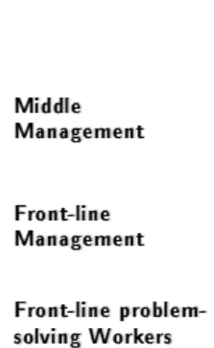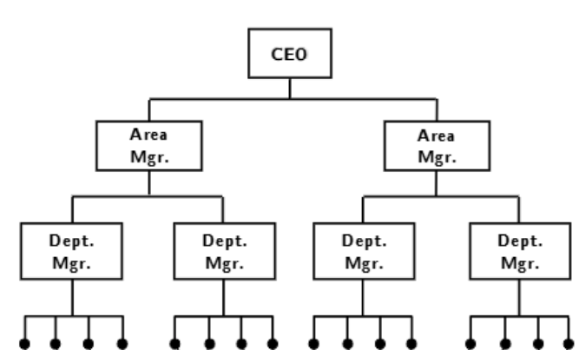
Figure 1 Hierarchical Structure, from Mihm et al. (2010)
The classic of classical organisational structure. This top-down model features a direct line of command where each staff member reports to a direct supervisor (Mihm et al., 2010).

- Functional Organisational Structure
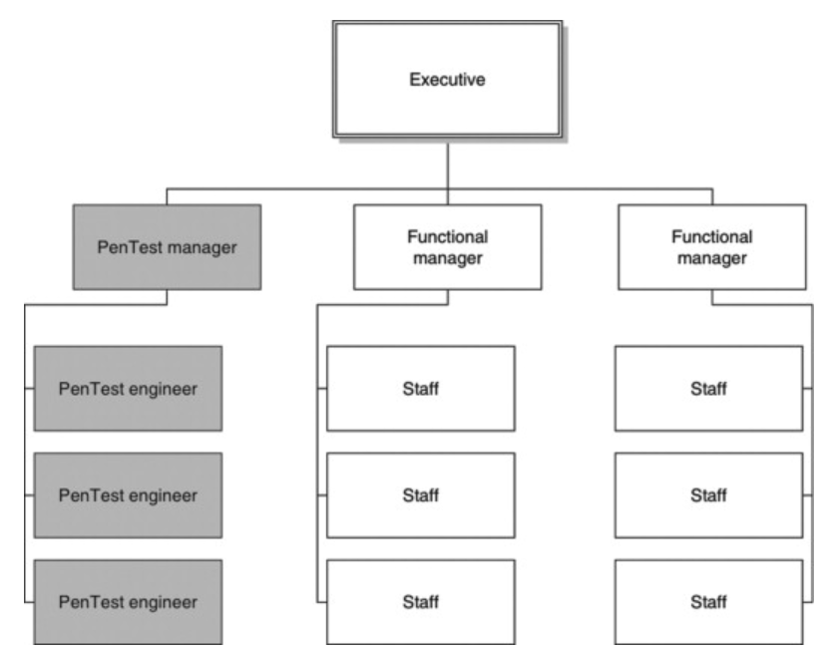
Figure 2 Functional Structure, from Wilhelm (2013)
For this model, the company is divided into specific departments that operate independently. Each group is set up to categorise workers by their specific skills and knowledge, like finance, HR, marketing… (Wilhelm, 2013)

- Divisional Organisational Structure
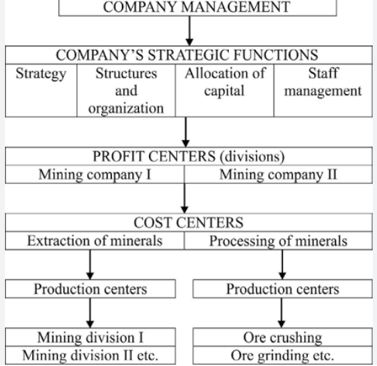
Figure 3 Divisional Structure, from Kudelko (2016)
Finally, a divisional structure splits an organisation into different units based on the markets, regions, or products. This model is suitable for companies with a broad range, allowing them to respond independently and effectively to different needs.
While such organisational structures were highly effective in gaining operational efficiency, why are they considered “traditional”? As businesses increasingly become globalised and digitally connected, the idea of isolated functional departments slowly shows its limitations. In modern times, organisations depend heavily on quick information exchange, fast decision-making, and cross-functional collaboration; therefore, reducing the effectiveness of structures where departments work independently. This transition, as Zhang and Zhao (2026) called it: from “Data Silos” to “Collaborative Symbiosis”. The term Data Silos is used to refer to knowledge that is scattered across multiple business units and is stored in a heterogeneous format, which prevents an organisation from achieving optimisation and results in only a surface-level understanding (for example, the procurement team doesn’t know there is a promotion campaign, or marketing doesn’t know about the inventory shortage). On the other hand, tools such as an ERP system or Internet of Things facilitate continuous communication and information sharing across all departments, creating a Collaborative Symbiosis relationship where distinct entities (warehouse, logistics, procurement, forecast…) work together toward a mutual benefit. Consequently, this report conceptualised a movement away from individual performance and hierarchical management to a collaborative and teamwork integration, creating organisational success across the entire value chain.

Theories of Management: Classical vs Modern
According to Drucker (1974), management is the act of getting things done with the help of people and other resources, and to successfully manage, there has to be a combination of planning, leading, organising, and controlling people in the same group. The fundamental objective of management has always been the same: coordinating assets to help the organisation reach its goals. However, similar to organisational structure, management theories have also been through lots of changes. This chapter will explain and analyse the difference between the two eras.
- The Classical Era
Taylor’s Scientific Management Theory (or Taylorism) is the groundwork of classic management theories that treats enterprise like a factory machine, with managers and staff similar to a cog to serve its supervisors. Theorists who studied Taylorism believed that a company’s success depends on 3 factors: a hierarchy run by powerful leaders and obedient management, the specialised division of labour, and the financial motivation of employees (Su, 2017). To find the most efficient way to perform any task, Taylor drew a precise line between thinking (managers design the process) and doing (workers execute the process). This approach proved highly effective in a manufacturing environment where processes and production are standardised. Roughly at the same time, Henry Ford invented the mass production system that also focused on standardisation of workers’ tasks (Degen, 2011). Fordism and Taylorism’s standardisation required minimal qualification as tasks were mostly repetitive; so, the workforce was considered a variable cost, and this cost was always tried to be reduced to improve the company’s profit. Hence, the unbearable environment of the workers created the expression of cog and machine.

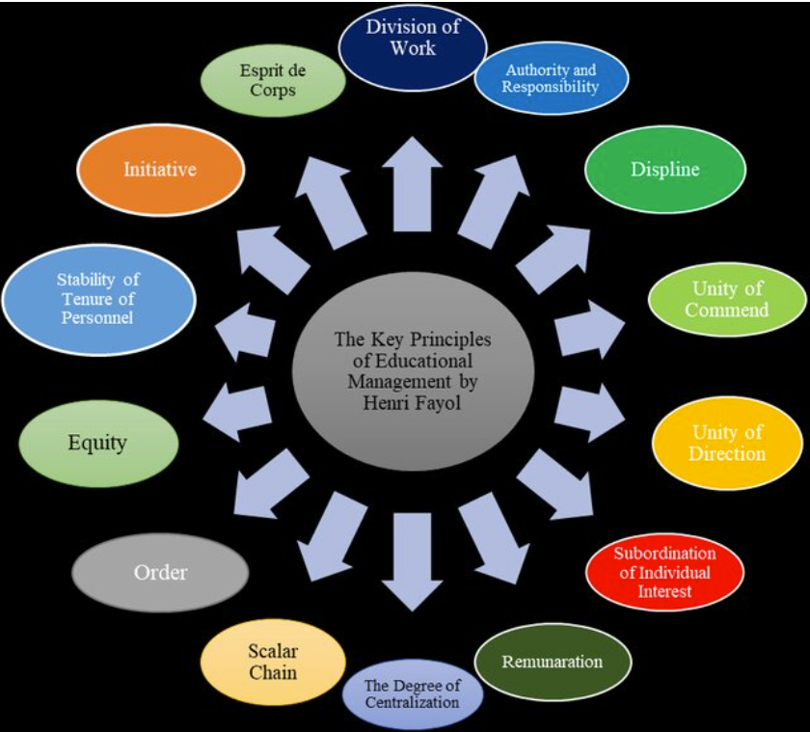
Figure 4 Fayol's 14 Principles of Management, from Ali et al. (2021)
Another well-known classical theory is Henry Fayol’s Administrative Management Theory, developed in 1916. Building on personal experience as a senior manager, Fayol's Administrative Theory focused on 14 principles of management (Figure 4) and 6 functions of management: Forecasting, Planning, Organising, Commanding, Coordinating, Monitoring (Nadrifar et al., 2013). It is said that Fayol’s theory is the world’s blueprint of management concept and is still being used until today. Unlike his peers’ focus on productivity and technical processes, Fayol’s framework addressed a distinct professional discipline with teachable functions, order, and a rewarding system.
Similarly, Weber’s Bureaucratic Theory is defined by organisational hierarchies, standard procedures, and strict authority to ensure control and accountability (Hashimov, 2025). It is said that Weber himself acknowledged the drawbacks of his process, like erosion of individual creativity and suppression; he still rationalised it as a superior mode of management and a goal-directed idea (Weber, 1978, p.139). It can be said that the majority of classical theories were not designed for the comfort of the individual under normal circumstances but instead were structured for the whole and collective society. One can argue that these ideas were influenced by the war, where military authority and obedience were heavily required.
- The Modern Era
The main feature of classical management theory is rewards and incentives to motivate employee to work at their highest level of productivity. However, until the middle of the 20th century, the idea of being machine-like cogs where productivity and profit are more valued than creativity and individuality created doubts and needs for change. As a result, management theories gradually shifted towards human relations and teamwork. Elton Mayo’s Human Relation Theory, often used as a counterpart to Taylor’s theory, demonstrated that teamwork, communication, creativity, and employee motivation significantly improve productivity (Emmanuel, 2021). Gary Hamel was also famously known for reinventing management by dismantling the rigid bureaucracy and promoting a human-centric organisation to build on transparency and experimentation (Grant, 2008). It is thought that humanocracy, the worldview that human freedom and growth are the centre of any activity, is vital in today’s era of technological evolution. From control and micromanagement that prevent employees from expressing themselves to transparency in sharing information across the organisation instead of holding it at the top.
Furthermore, the meaning of the word “leadership” is more defined in today’s modern management theory, from power in authority to role model in influencing trust and vision (Bruce and Nyland, 2011). Mintzberg argued in his management theory that managers should perform multiple decisional, informational, and interpersonal than simply supervising employees (Mintzberg, 1979). With that being said, there is a clear direction that newer management theories are going toward: a fluid and fast-paced environment rather than a neatly organised traditional approach like controlling and planning. This can be directly linked to the retailing supply chain industry, where the volatile e-business environment, which is often disrupted by fluctuate demands, the planning process was slowly transitioned into forecasting and adapting to demand. Consequently, the changes were also reflected in the supply chain, most noticeably in the Push and Pull strategy. A Push strategy produces products based on demand planning and drives them toward the customer, while a Pull strategy is a responsive model that produces based on real-time customer demand (Pyke and Cohen, 1990). Ford’s mass production system and Taylor’s manufacturing efficiency were a prime example of the Push approach, where production is maximised rather than waiting for individual real-time orders. On the other hand, as information is being displayed on an online dashboard in e-business nowadays, businesses are able to quickly fulfil orders right away, reducing the cost of inventory holding and over-production. Managers now act as what is called “the visible hand of management” by collecting information, coordinating activities and making decisions based on the needs of the company (Bucheli et al., 2010).

Digital Transformation of 21st Century Corporations

Digital Connectivity and Global Market Integration
Digital technology didn’t only transform how businesses operate by removing geographical limitations, it allowed significant expansion of scope and speed for global connectivity. Real-time data systems and cloud platforms have been fully utilised to enable firms to interact instantly. One phenomenon that is gaining recognition thanks to digital connectivity is called Virtual Organisation or Virtual Enterprise. This is a form of product-focused partnership that requires a systematic approach to accomplish a common goal and breaks up after the goal has been achieved (Igbaria and Mahatanankoon, 2003). Moving away from the traditional type of physical office-based and face-to-face meeting, work can happen remotely from home through tech-driven communication methods. This widespread structure also increases the adoption of global talent hiring, opening opportunities to manage cross-border expansion. This has many different advantages, like saving money from office renting and quick adaptation to global market trends.
However, hiring global talent also comes with drawbacks. Firstly, it is more difficult to build trust within the organisation when most of the employees are from a different cultural background. Savolainen (2014) argued that if a manager is hiring staff globally, daily e-leadership skills become one of the most important traits. According to the scholar, the ability to influence people and build trust remotely is more difficult than building trust face-to-face, as there is definitely a learning curve in combining technology integration, virtual presence, and even bilingual communication. Furthermore, semi-globalisation is another term that has appeared recently. Ghemawat (2003) defined it as a reality where the world is neither fully integrated nor fully isolated; more specifically, people from all over the world can connect thanks to the internet but cannot eliminate legal or cultural differences. Zheng (2017) reported a case study where Home Depot failed and closed all of its retail stores after 6 years of entering the Chinese market. The primary reason for this failure was the cultural mismatch, as Chinese consumers would rather have a “do-it-for-me” than a “do-it-yourself”. Moreover, with cheap labour available nationwide, it was preferable to hire contractors rather than manual labour, conflicting with consumer habits.
It is said that the global logistics industry saw a 30% increase in efficiency and cost reduction in 2024 thanks to digital transformation (Mutambik, 2024). Within that, the gains are attributed to automated processes, improved inventory and transportation visibility, and the greatest contribution towards cost reduction is global sourcing. According to CIPS (n.d.), sourcing is the act of procuring products across international borders to capitalise on cheaper labour and raw material costs. While local sourcing traditionally offered greater visibility, control, and agility during supply chain disruptions, the integration of digital technology has effectively bridged this gap; in fact, it can be argued that it might perform better with real-time tracking, quicker adaptability, and enhanced data analytics. Walmart (n.d.) reported that they have been sourcing fresh products from 22 countries, over 4000 suppliers, and more than 400,000 unique products. This trend of global sourcing aligns strongly with modern management theories that prioritise collaboration and innovation. Therefore, it demonstrates how digital connectivity enables organisations to manage complex supply chain networks, which would be extremely difficult to achieve under traditional organisational structures that are rigid, have sequential communication, and localised decision-making.

Digital Transformation as a Business Strategy
Digital transformation should not just be viewed as creating an online selling channel alone, but rather a comprehensive redesign of the business strategy and building the organisation around that online sales channel. Businesses that fail to integrate and utilise it as a strategy will risk losing competitive advantage despite having a strong brand on the market. Toys R Us is a classic case study of how the biggest toy retailer in the US failed because of their strategy application. Founded in 1948, the company opened nearly 1700 owned stores in more than sixty countries in 2005 (Lazarus, 2008). However, despite its global presence, they used the wrong strategy to adapt to the digital environment. Instead of treating their online business as a strategic capability, they saw it as an outsourced operational activity. Nicolau and Scannell (2017) observed that Toys R Us outsourced their whole online operations to Amazon instead of developing their own digital platform and supply chain network. So, while this strategy initially reduced capital requirements, the company wasn’t able to obtain any analytic data in important areas, like regional demands, fulfilment, transportation… And following the separation from Amazon because of internal issues, they were left with an immature e-commerce network; the business went bankrupt in 2018. Linking back to Zhang and Zhao (2026) “Data Silos” and “Collaborative Symbiosis”, Toys R Us created an online business and put it in the Data Silos: disconnected and isolated from the business completely, rather than operating it through a Collaborative Symbiosis, where supply chain, marketing, sales… are integrated through a shared platform.
It can be seen that digital technology significantly lowered the barrier to market entry, as the 4IR era saw a growing trend of small and medium-sized enterprises (SME) competing with global brands without investing heavily in physical infrastructure. Furthermore, many SMEs are able to adopt a scalable business model without significant investment requirements, as most of the operational activities can now be outsourced or handled by AI. Therefore, businesses can now focus their resources on digital growth or other value-creating activities.
These digital strategic changes also affected the economic implications, specifically the employment factor. Gu and Lukin (2025) found that, particularly in SMEs, a 1% increase in digitalisation accounted for 13,7% increase in employment demand. Interestingly, it is not wrong to say that entry-level roles for industries like accounting, administration, or procurement and inventory management are slowly being automated by AI, creating an employment paradox where, because of mismatched job skills, high numbers of job seekers fail to match with open positions, while businesses fail to fill their vacancies. Therefore, e-commerce and digital technology not only reshape business strategy but also indirectly redefine the workforce requirements, reflecting a shift towards digital literacy and technological capability.

Obsolescence of Traditional Organisation Structures

Flat Organisations and Hierarchical Organisations
It has been established that a Hierarchical structure works based on a level of authority and chain of command. This top-down, multi-level structure is defined by Fayol’s Scalar Chain principle. It illustrates a management rule saying that responsibility and authority flow in a clear, undisruptive line from the highest position down to the lowest worker and forms a direct line of command where every position reports back only to their supervisor (Desai, 2021). It gained much success in previous centuries as it established clear accountability and responsibility because the employees understood who to report to and who could make decisions. The Scalar Chain forms a formal channel where instructions and decisions are communicated, clarifying them between different levels of management. Therefore, although being criticised as a rigid structure, it benefits from the control and consistency across the organisation.
However, as times change, such managerial layers can’t keep up with the volatile digital environment. In a time-sensitive industry like supply chain, waiting for the information to pass through several levels can delay decision-making. So, using digital technologies, top-level management can instantly communicate with employees, requiring less dependence on managers to act as a middle layer and pass through the information. With ERP platforms to directly access the information, organisations, or more noticeably, start-ups, have the opportunity to reduce the number of hierarchical layers, introducing the Flat Organisational structure. Ganiyu et al. (2018) described it as having one or a few levels of management, creating a single level of members with equal authority (Figure 5). Compared with traditional structures, this flat structure allows workers to make their decisions in their own department and report directly to the manager (Garge and Bhatt, 2023).
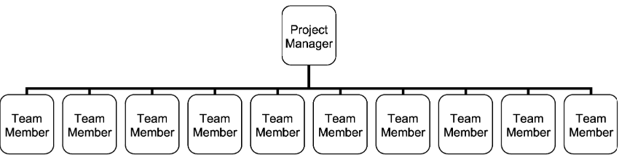
Figure 5 Flat Organisational Structure, adapted from Ganiyu et al. (2018)
Apart from quick flexibility and adaptability in decision-making, with a single line of authority, the exchange of communication between the team members runs freely. This creates what is called horizontal communication, a flow of information and ideas between peers that is shared through the same hierarchical rank in an organisation (Figure 6) (Dhanapala, 2023). Dauphine (2019) interestingly argued that communication in a flat organisational structure becomes an important feature, as the conversation can be formed through suggestion and consultation rather than command or critique, encouraging employees to give immediate feedback and contribute ideas. Furthermore, Rishipal (2014) suggested that reducing the number of management layer make the employee more accountable for their work, as they have fewer opportunities to delegate responsibility upwards or downwards, creating an environment in which employees take greater ownership of their decisions. At Netflix, the authority was deliberately decentralised to encourage employees to make decisions within the organisation (Luna, 2021). The company’s culture supported directness and openness in communication by using methods to communicate candidly and challenge existing ideas, said a report by CNBC (2016).
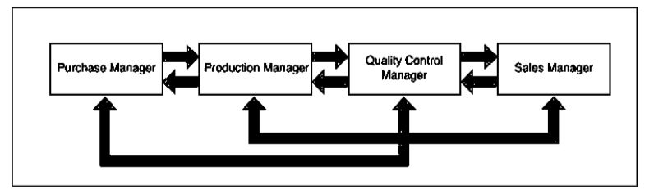
Figure 6 Horizontal Communication, from Dhanapala (2013)
Nevertheless, there are disadvantages associated with a flatter structure. First, removing different management layers creates difficulty in career progression. Rishipal (2014) noted that employees who have fewer opportunities for promotion may lack motivation and retention. Moreover, not all individual within the company has the experience or confidence to make independent decisions. Dauphine (2019) emphasised the importance of a leadership figure to maintain employee performance, be knowledgeable in every department, and direct individuals toward the organisational goals. Without saying this, these limitations become more significant as the company grows in size; the greater the number of staff and activities, the harder it is to coordinate in a decentralised environment. An example of this would be Valve, a video game production studio that adopted a highly decentralised “boss-free” structure that allows employees to have substantial freedom (BBC, 2013). At first, this approach was seen as a genius move by supporting creativity and contribution, creating internationally recognised titles. However, as the company grew, it experienced difficulty in coordination and scalability. Moller and McCaffey (2021) reported that the organisational disputes have contributed to the abandonment of highly anticipated projects, creating disappointment for fans all over the world.
As there are pros and cons for both modern and traditional methods, this report emphasised that there should not be an obsolescence of the outdated method and a transition to the modern method, but a combination of both. Hierarchical structure provides stability, structure and accountability, while flat structure provides autonomy, flexibility, and greater communication. With the help of digital tools, the advantages of both methods increase by making information exchange more efficient and reducing the need for managers to control every aspect of the organisation.

Alternative Organisational Structure and Working Models
While Hierarchical and Flat organisational structure are presentative of classic and modern structure, there are several alternative structures and working models that distribute authority and collaboration without removing any layers of management.

- Matrix Organisations
A matrix structure sees an employee report to more than one manager, typically a line manager and a project manager, rather than the traditional line supervisor (Wilhelm, 2013). In a typical matrix structure, the functional manager is responsible for the development of the department, and the project manager is responsible for the delivery of a particular project, balancing day-to-day functional expertise with responsive project-based progress. This arrangement suits a larger-sized company that has regional branches, multiple products and markets, and different projects because employees from different functions can share their specialised knowledge.
However, it can be said that the distribution of command complicates accountability, as employees face risks of having conflicting instructions. When there are two sources of authority, another decision must be made before the actual instruction arrives at the employee, delaying the process rather than improving responsiveness (Pakarinen and Virtanen, 2017). From a critical perspective, the matrix structure is an evolution from a hierarchical structure, as now there are two bosses to report to. With the intention to increase flexibility, it now doubles the amount of command and authority faced by the employee, which can turn into a big weakness in a modern-type structure. So, while this structure is exceptional for organisations with different functions, the team member has to deal with more responsibility and stress of dual reporting.
- Cross-functional Teams
A cross-functional team groups workers by their specific skill set and departments with a single chain of command (Pakarinen and Virtanen, 2017). This approach allows interaction between different departments like finance, supply chain, marketing… and works best with digitally enabled organisations. By bringing different functions together, it can reduce isolation and improve responsiveness to customer requirements. An example from the author’s personal experience was the release of the Barbie movie. As a young and trendy haircare company, a blond-hair dye marketing project was proposed. A combination of the demand planning team, who used data to reveal which city had the most teenage girls who would love to go blond; the supply chain team, who ensured there was enough stock for the high demand; and the marketing team, who made viral TikTok videos to spread the campaign. As a result, the company saw a 300% increase in sales of blond hair dye in 2 weeks.
Similar to any organisational structure, there are pros and cons. As workers are introduced to peers from different functions, there might be communication or cultural clashes between teammates who do not share a common technical language (i.e. the IT or finance team might not be as “outgoing” as the marketing or sales team) (Mishra and Jhunjhunwala, 2013). This again emphasises the importance of a good leader who can communicate effectively and link the team together. Nevertheless, this approach is quite popular among companies as a method that can increase collaboration.
- Decentralisation and Empowerment
In traditional organisational structures, employees are responsible for carrying out decisions made by their supervisor, whereas a decentralised environment gives employees greater authority and makes decisions based on their own judgement (Uddin, 2017). The development of digital platforms strengthens this aspect as the worker can now access information directly and instantly. For example, when a customer service team member is asked about the status of a particular order, they are able to access data from the main system about the delivery status, track location, change delivery location, and even cancel the order if needed. This allows decisions to be made closer to the point where the problem occurs (from the customer) and reduces the bottleneck of waiting time for managerial intervention. Mueller and Farkhondeh (2021) called this Holacracy, a term that describes an agile and responsive organisation that effectively self-manages throughout the whole institution. Of course, this new way of organising saw few applications by companies and research from scholars, with the main reason being giving too much authority to employees. Zappos, the name that is now known for the failure of adopting Holacracy. When the company eliminated the traditional hierarchy structure, the employees grouped into self-governing circles that have their own rules and tactical decisions; resulting in nearly 15% of the workforce departing (Golden et al., 2017).

Redefining Management Roles
Throughout the duration of this research, it has been said that the role of management was inevitably affected by the changes in organisational structure. The need for traditional types of supervisors has been reduced, paving the way for employees to communicate directly, express creativity, and make small operational decisions with greater autonomy. However, this doesn’t mean that managers have become obsolete; instead, managers have to change their controlling routine to coordinating and leading the team. In this chapter, the research will discuss two important changes that modern managers must have: Transformational Leadership and Technological Literacy.

Transformational Leadership
As time moves on, organisations depend less on a rigid hierarchy, but rather on a figure of example. The distinction between leadership and headship is becoming clearer. Headship describes a structural, formal role of running an organisation, bound by accountability and statutory responsibility; in contrast, leadership is a broader term that describes the process of influencing, inspiring, and setting a vision for change across the organisation (Orunbon, 2025). In this sense, holding a fancy managerial title doesn’t automatically mean that this individual is an effective leader. One can predict which version of management is becoming more influential in today’s era.
It can also be argued that the characteristic of contemporary workers affects the managerial role. In this digitally enabled environment, where the young demographic can learn and rapidly access all sorts of information online, employees can possess knowledge that even exceeds that of their manager. This changes the normal “command and control” approach of traditional managers, as they can’t realistically be expected to provide an answer to every technical problem. Additionally, the changing characteristics of the modern workforce have shifted this development. As digital technology makes communication immediate and less formal, the so-called “Gen Z” nowadays is more direct and casual, compared to senior management, who expected them to follow instructions. Consequently, the manager’s role increasingly involves giving direction, motivating employees, and encouraging them to contribute beyond their day-to-day tasks.

Technological Literacy
Imagine a situation when an employee raises a technical issue, and the boss, who is not the most proficient in technology, is unable to answer the question. It would create discomfort for both parties, as the employee might feel uncertain about the boss’ competence, while the boss might feel embarrassed with their subordinate. Such a simple scenario emphasises the importance of technological literacy in today’s digital era. Managers need not be a technological expert to do the task themselves, but so that they can understand, communicate, and evaluate the situation with their team (Matsunaga, 2024). With everything nowadays revolve about dashboard and online platforms, managers who are struggling to adapt cannot influence or participate in a meaningful discussion.
Additionally, Krehl and Buttgen (2022) again emphasised the importance of building and maintaining relationships with team members in a virtual setting by utilising the available digital toolset. As organisations increasingly adopt remote working and even international hiring, managers can no longer rely on physical presence to monitor performance. For example, it could be setting up an informal schedule for a weekly catch-up, using tools like Power BI to turn complex data into insights that can be discussed collaboratively, or applying generative AI as a way of generating ideas or problem-solving. These practical examples are ways of focusing on outcomes and building trust with the team, rather than just showing presence by tracking online hours. However, this doesn’t mean that technology should be used to track employees excessively, as it might cause distraction and undermine trust.

The Digital Challenges
It has been established previously that enabling technology in your business doesn’t guarantee success; it has to be managed correctly in order to get the best out of it. Therefore, the adoption of digital technology should not be viewed as an entirely positive process. While it certainly opens new doors in terms of expanding the business, managers have to lead differently and redesign their organisational structure to avoid the following challenges.

Overcoming Resistance to Change
Looking back at the Toys R Us case study, another explanation for the company’s continued focus on physical store expansion was their belief in the value of creating an immersive environment where children could interact with the toys, making physical stores an important aspect in their retail strategy. From a critical perspective, the reluctance to move away from brick-and-mortar to an online store is understandable, as it has previously contributed to the company’s success. A similar challenge that can be observed at the individual level is that employees and managers are unable to adapt to technology. There can be many reasons, such as competency anxiety or fear of being replaced by AI (Sutra and Mansur, 2025). Experience is valuable, but experience that is based entirely on routines that have been developed for years can be difficult to change.
To overcome the difficulty of digital literacy, both the employers and the employees must be willing to change. First, as roles with repetitive administrative and operational tasks become less relevant thanks to AI taking over, employees mustn’t only be willing to learn how to use digital tools, but also evolve their soft skills around creativity, data handling, AI prompting… On the other hand, managers also have new responsibilities to handle during this transition. An important challenge that managers should overcome is not to automatically interpret employees who are unwilling to change as a lack of motivation or ability. Instead, managers should recognise the existing skills that employees already possess and consider how to further utilise them. Therefore, management should learn to communicate why existing practises need to change and provide employees with opportunities to develop new skills rather than immediately replace them.
In conclusion, resistance to technological change is a sensitive topic and should not be viewed simply as an obstacle to overcome. It indicates that employees are uncertain of their future within the company and afraid of how their existing knowledge will still be relevant in a changing organisation. As a result, an effective manager should balance the human aspect of understanding and preserving their worker’s knowledge while still adapting to new technological development.

The Balance between Human and Technology
One might ask: if technology can increasingly coordinate supply chain activities, what role do humans play in this industry? There is no doubt that technology, and AI specifically, can now be designed to automate tasks that humans have been doing for a long time, like automated inventory management, route optimisation, forecasting, and now even autonomous DoorDash delivery robots. As a result, junior and even more experienced positions in supply chain are now being taken by technology. This raises a question regarding the boundary between what technology can handle and whether human involvement is still essential.
In practise, the boundary is closer than one might think. As e-commerce makes the front-end or customer-facing side of retail digital, the physical side of the supply chain does not change. Somebody still needs to drive the cargo, load and unload a shipment, talk to suppliers, do quality checks… This creates a contradiction between the front end where it becomes more decentralised, and the back end which still requires coordination and control (indirectly challenged by the fact that “traditional approaches” are being obsoleted). Although there are fulfilment and delivery services offered by Amazon or TikTok Shop, as mentioned in chapter 2, companies who want to maintain long-term competitive advantage should not completely outsource their whole supply chain network (proven by the Toys R Us example). Small and medium-sized businesses who prioritise profit should still decide where the stocks are stored, which suppliers to use, which orders to prioritise… Essentially, technology is the infrastructure, but the organisation decide how to use that infrastructure. Furthermore, the activities handled by digital tools also do not guarantee success. Data analysed by AI still needs human-based judgement before decisions are made, specialised requirements from suppliers or customers still need to be managed by a human, and over-reliance on technology creates new vulnerabilities.

Conclusion
This report critically evaluated the statement that “Technology advances - specifically in the areas of e-Commerce and e-Business have rendered traditional models of organisational structure and theories of management roles obsolete in the light of the changing nature of 21st century corporations.” Using evidence in the supply chain sector and case studies from global organisations, the findings revealed that this saying is partially justified. While e-commerce does in fact reduce the influence and suitability of traditional organisational structures and management theories, it doesn’t render them obsolete or completely change traditional methods. Companies nowadays still use a hierarchical structure to maintain authority, but rather than using a command-and-control approach, human management now revolves around cross-functional collaboration, the need for creativity, and decentralisation.
The development of e-business opens new opportunities for entrepreneurs as it has changed the traditional retail model. They no longer require a physical store to reach their customers; instead, a well-designed online platform can introduce their products on a nationwide or even global scale. At the same time, services offered from Amazon Marketplace or TikTok Shop fully streamline operational activities like logistics, finance, and marketing that traditionally required individual attention. With information now being accessed instantly through a digital dashboard, it is arguable that the supply chain industry or supply chain activities specifically, can now be more integrated and responsive to overcome disruptions.
There are mixed opinions on both traditional and modern organisational structures. The scalar chain proves that authority in business is useful for establishing accountability and responsibility to maximise productivity and efficiency. However, an excessive number of management layers or levels of control can backfire, as it can reduce employees’ motivation to come to work. On the other hand, modern organisational structures that involve flat, cross-functional teams and matrix organisations that have a decentralised approach are getting more attention lately. With information now being accessed in real-time through dashboard systems, employees are able to make operational decisions independently. However, a certain level of management is still required to maintain control and ensure the workplace is culturally appropriate.

Recommendation
- Organisational Flexibility
First, organisations should look into a more balanced, flexible approach and use an organisational ambidexterity approach that avoids sticking to a single structure. For example, after completing a big project using a cross-functional team design, the structure should turn back to its traditional hierarchical form to maintain stability. Additionally, Selective Decentralisation is an approach where organisations choose a specified function to distribute control while keeping others centralised (Hui and Tucker, 2023), for example, choosing to decentralise the headquarters to generate business ideas and centralise different national branches to maintain productivity.
- Investment in ERP Systems
While it can be difficult for small organisations to invest in a comprehensive digital infrastructure, it should be viewed as a core business asset. Looking back at the Resource-based View or the Collaborative Symbiosis theory, an ERP System is a valuable internal competency that generates competitive advantages, especially in a supply chain environment that has many functions that require monitoring. Additionally, this investment should also come with digital literacy by including training and supports to the employees. Managers should also develop sufficient technological literacy to deliver direction and informed decisions.
- Maintain Appropriate Human Oversight
Not all core functions can be or should be autonomised. Technology can help with identifying patterns, providing recommendations, and automating repetitive tasks, but it should not be used to make important business decisions. Especially in supply chain, an industry that was traditionally built on negotiation, specialised demands, and supplier relationships, there should be a certain level of human connection to maintain relationships in the long-term.

Implications for Future Research
It is unclear what the future holds for the digital industry, as in a few years there can be another technological invention that again completely changes how e-commerce and e-business work. But for now, these are opportunities for future research:
- Reducing Dependence on E-commerce
It is said that global companies like Amazon and TikTok hold immense power in their hands, that force individuals to follow their policies. Verhoef et al. (2021) raised a specific challenge involving the over-dependence on digital selling platforms, as they have the ability to determine the survival of the business by shutting down shops or increasing fees, creating another form of hierarchy that controls businesses even though they are external stakeholders.
This emphasises the need for a self-managed supply chain network. For future research, a simple method of maintaining an in-house supply chain is to focus the delivery network on the Milk Run concept, a delivery method that enables multiple drop-offs in one trip. This means that businesses can reduce inventory cost, infrastructure cost, and simplify the delivery network.
- Cybersecurity and Data Protection
As nearly all aspects of a business go digital, they are vulnerable to a cyberattack that can extract data and information. As it has been mentioned that data is now an asset of a company, private data like customer banking details, if exposed, can lead to legal actions.
Additionally, as data can now be viewed democratically, meaning that they are accessible at all levels, there should be security measures to ensure that data is being protected even from internal leakage.

Reference
Ahmady, G., Mehrpour, M. and Nikooravesh, A. (2016). ‘Organizational Structure’ Procedia - Social and Behavioral Sciences, 230, pp. 455–462. Available at: https://www.sciencedirect.com/science/article/pii/S1877042816311582
Agwu, M.E. and Murray, J.P. (2014). ‘Drivers and Inhibitors to E-Commerce Adoption among SMEs in Nigeria’ Journal of Emerging Trends in Computing and Information Sciences, 5(3), pp. 192-199. Available at: https://papers.ssrn.com/sol3/papers.cfm?abstract_id=3113119
Ali, I., Nayan, F.K., Sarker, A.R., Kadery, T.R. and Firmansah, Y. (2021) 'Management skill development of academic institutional heads in Bangladesh: a conceptual study on Henri Fayol's management principles', International Journal of Human Resource Studies, 11(3), pp. 1–15. Available at: https://www.researchgate.net/publication/352476600_Management_Skill_Development_of_Academic_Institutional_Heads_in_Bangladesh_A_Conceptual_Study_on_Henri_Fayol%27s_Management_Principles
Amazon Web Services. (2026) ‘AWS Marketplace’ Available at: https://aws.amazon.com/partners/marketplace/?ref_=header_modules_sell_in_aws
BBC. (2013). ‘Valve: How going boss-free empowered the games-maker’ Available at: https://www.bbc.co.uk/news/technology-24205497
BBC News. (2026). [Instagram post]. Available at: https://www.instagram.com/p/DbEswZZlYK3/
Bruce, K. and Nyland, C. (2011). 'Elton Mayo and the deification of human relations', Organization Studies, 32(3), pp. 383–405. Available at: https://www.researchgate.net/publication/270726475_Elton_Mayo_and_the_Deification_of_Human_Relations
Bucheli, M., Mahoney, J. and Vaaler, P. (2010). ‘Chandler’s living history: The Visible Hand of vertical integration in 19th century America viewed under a 21st century transaction costs economics lens’ Journal of Management Studies, 47, p. 859-883. Available at:
https://www.researchgate.net/publication/228253432_Guest_Editors'_Introduction_Moving_Forward_by_Looking_Backward_-_Business_History_and_Management_Studies
Chaffey, D. and Ellis-Chadwick, F. (2022). ‘Digital Marketing’ Harlow: Pearson. Available at: https://sinhvien.dinhtienminh.net/wp-content/uploads/2025/01/Dave-Chaffey-Fiona-Ellis-Chadwick-Digital-Marketing-2022-Pearson.pdf
Chaudhary, G., Patel, S.K. and Anshari, K.M. (2021). ‘E-Business’ International Advanced Research Journal in Science, Engineering and Technology, 8(11). Available at: https://www.researchgate.net/publication/356643184_E-_BUSINESS
CIPS. (n.d.) ‘Global sourcing’ Available at: https://www.cips.org/intelligence-hub/sourcing/global-sourcing
CNBC. (2016). ‘Netflix redefined American company culture. Will it do the same abroad?’ Available at: https://www.cnbc.com/2016/06/20/netflix-redefined-american-company-culture-will-it-do-the-same-abroad.html
Cuervo-Cazurra, A., Dieleman, M., Hirsch, P., Rodrigues, S.B. and Zyglidopoulos, S. (2021). 'Multinationals’ misbehavior', Journal of World Business: JWB, 56(5). Available at: https://doi.org/10.1016/j.jwb.2021.101244.
Danish, M.K., Farmeena, K. and Ehmer, M.K. (2014). ‘Growing Importance of E-Commerce in Global Market’ Information and Knowledge Management, 4(5), pp. 48-52. Available at: https://www.iiste.org/Journals/index.php/IKM/article/view/12904/13244
Dauphine, R.T. (2019). ‘Analytical Perspective on the Importance of Coordination in Implementing Vertical and Horizontal Organizational Designs’ International Journal of Humanities and Social Science, 9(12) Available at: https://ijhss.thebrpi.org/journals/Vol_9_No_12_December_2019/9.pdf
Degen, R.J. (2011) 'Fordism and Taylorism are responsible for the early success and recent decline of the US motor vehicle industry' International School of Management Paris. Available at: https://www.researchgate.net/publication/254442015_Fordism_and_Taylorism_are_responsible_for_the_early_success_and_recent_decline_of_the_US_motor_vehicle_industry
Desai, S. (2021). ‘Role of hierarchy/scalar principle in organisational administration’ International Journal of Advanced Scientific Research, 6(5), pp. 14-17. Available at: https://www.allscientificjournal.com/assets/archives/2021/vol6issue5/6-5-15-358.pdf
Dhanapala, D. (2023). 'The role of business communication on the systematised operations of business ventures: a comprehensive review' Journal of Management Matters, 10(1), pp. 35-47. Available at: https://www.researchgate.net/publication/378120671_The_Role_of_Business_Communication_on_the_Systematised_Operations_of_Business_Ventures_A_Comprehensive_Review
Drucker, P.F. (1974). Management: Tasks, Responsibilities and Practices. New York: Harper and Row.
Emmanuel, O.O. (2021). ‘The Application of Elton Mayol's Human Relations Theory and Douglas McGregor’s Theory X and Y to Achieve Organization Objectives’ Arabian Journal of Business and Management Review, 11(4). Available at: https://www.hilarispublisher.com/open-access/the-application-of-elton-mayols-human-relations-theory-and-douglas-mcgregors-theory-x-and-y-to-achieve-organization-obje.pdf
Ganiyu, S., Alabi, I., Abdulrazaq, A. and Ismail, A. (2018). ‘Hierarchy extraction for covert network destabilization and counterterrorism mechanism’ 1st International Conference on ICT for National Development and Its Sustainability, pp. 290-302. Available at: https://www.researchgate.net/publication/342362336_Hierarchy_extraction_for_covert_network_destabilization_and_counterterrorism_mechanism
Garge, D.M. and Bhatt, R. (2023). ‘Efficiency in Emergency: A Perception Study of Hierarchical Versus Flat Organizational Structures for Joint Disaster Response in the Bay of Bengal Region’ Strategic Analysis, 47(1), pp. 61-78. Available at: https://www.researchgate.net/publication/369036633_Efficiency_in_Emergency_A_perception_study_of_Hierarchical_vs_Flat_Organizational_Structures_for_Joint_Disaster_Response_in_the_Bay_of_Bengal_Region
Ghemawat, P. (2003). ‘Semiglobalization and international business strategy’ Journal of International Business Study, 34, pp. 138–152. Available at: https://link.springer.com/article/10.1057/palgrave.jibs.8400013#citeas
Golden, B., Pandey, A. and O’Rourke, J. (2017). ‘Zappos: An experiment in Holacracy’ Available at: https://www.researchgate.net/publication/330125812_Zappos_An_Experiment_in_Holacracy
Grant, R.M. (2008). ‘The future of management: Where is Gary Hamel leading us?’ Long Range Planning, 41(5), pp.469–482. Available at: https://www.sciencedirect.com/science/article/pii/S0024630108000654
Hashimov, A. (2025). Max Weber’s bureaucratic theory: Its strengths and weaknesses, and adaptation to the modern era – a theoretical and empirical analysis. Acta Globalis Humanitatis et Linguarum, 2(4), pp.128–166. Available at: https://www.researchgate.net/publication/393470236_Max_Weber's_Bureaucratic_Theory_Its_Strengths_and_Weaknesses_and_Adaptation_to_the_Modern_Era_-_A_Theoretical_and_Empirical_Analysis
Hui, X. and Tucker, C.E. (2023). ‘Decentralization, Blockchain, artificial intelligence (AI): Challenges and opportunities’ Social Science Research Network. Available at: https://papers.ssrn.com/sol3/papers.cfm?abstract_id=4601788
Igbaria, M. and Mahatanankoon, P. (2004). ‘Virtual organizations’ pp.573–587. Available at: https://www.sciencedirect.com/science/chapter/referencework/abs/pii/B0122272404001933
Jabbari, A., Lasfer, A. and Kazantsev, N. (2025). ‘Digital Coordination: How Data, Intelligence, and Transparency Reshape Organizational Practice’ The Hawaii International Conference on System Sciences. Available at: https://www.researchgate.net/publication/395715508_Digital_Coordination_How_Data_Intelligence_and_Transparency_Reshape_Organizational_Practice
Jain, V., Malviya, B., Arya, S. (2021). ‘An Overview of Electronic Commerce (e-Commerce)’ Journal of Contemporary Issues in Business and Government, 27(3), pp. 665-670. Available at: https://www.researchgate.net/publication/351775073_An_Overview_of_Electronic_Commerce_e-Commerce
Kudelko, J. (2016). ‘Structurization of mining companies’ Gospodarka Surowcami Mineralnymi, 32(4), pp. 157-180. Available at: https://www.researchgate.net/publication/312268804_Structurization_of_mining_companies
Krehl, E. H., & Büttgen, M. (2022). ‘Uncovering the complexities of remote leadership andthe usage of digital tools during the COVID-19 pandemic: A qualitative diary study’ German Journal of Human Resource Management, 36(3), pp. 325-352. Available at: https://doi.org/10.1177/239700222210836
Lazarus, C. (2008). ‘Toy Titan’ Available at: https://perma.cc/4H22-X2UC
Luna, Y.V.V.D. (2021). ‘NETFLIX: A Study on How Diverse Manufacturing Managers Create Organizational Effectiveness in a Changing Global Environment’ Available at: https://www.researchgate.net/publication/351977610_NETFLIX_A_Study_on_How_Diverse_Manufacturing_Managers_Create_Organizational_Effectiveness_in_a_Changing_Global_Environment
Matsunaga, M. (2024). ‘The Role of Digital Literacy in Leadership’ Employee Uncertainty Over Digital Transformation. Available at: https://www.researchgate.net/publication/377070023_The_Role_of_Digital_Literacy_in_Leadership
Mihm, J., Loch, C.H., Wilkinson, D.M. and Huberman, B. (2010). ‘Hierarchical Structure and Search in Complex Organizations’ Management Science, 56(5), pp. 831-848. Available at: https://www.researchgate.net/publication/220534200_Hierarchical_Structure_and_Search_in_Complex_Organizations
Mishra, R.K. and Jhunjhunwala, S. (2013). ‘Chapter 7 - Skill Diversity’ Diversity and the Effective Corporate Board, pp. 87-95. Available at: https://www.sciencedirect.com/science/chapter/monograph/abs/pii/B978012410497600007X
Mintzberg, H. (1979). ‘The Five Basic Parts of the Organisation’ Available at: https://projectinspire.eu/wp-content/uploads/2023/04/1979_Parts-of-the-Org_Mintzberg.pdf
Mohajan, H. K. (2020). ‘The Second Industrial Revolution has brought Modern Social and Economic Developments’ Journal of Social Sciences and Humanities, 6 (1), pp. 1-14
Available from: https://www.researchgate.net/publication/356831155_Third_Industrial_Revolution_Brings_Global_Development
Mohajan, H.K. (2021). ‘Third Industrial Revolution Brings Global Development’ Journal of Social Sciences and Humanities, 7(4), pp. 239-251. Available at: https://www.researchgate.net/publication/356831155_Third_Industrial_Revolution_Brings_Global_Development
Moller, U., and McCaffrey, M. (2021). Levels without Bosses? Entrepreneurship and Valve’s Organizational Design. The Invisible Hand in Virtual Worlds: The Economic Order of Video Games. Available at: https://doi.org/10.2139/ssrn.3884844
Mueller, B and Farkhondeh, M. (2021). ‘Holacracy: A New Way of Organizing?’ Management Revue, 32(4), pp. 302-317. Available at: https://www.researchgate.net/publication/356468845_Holacracy_A_New_Way_of_Organizing
Mutambik, H. M. (2024). ‘Predictive performance analytics in smart logistics’ Journal of Emerging Supply Chains, 5(1), pp. 66–84. Available at: https://doi.org/10.12345/jesc.2024.50103
Nadrifar, A., Bandani, E. and Shahryari H. (2013). ‘An Overview of Classical Management Theories: A Review Article’ International Journal of Science and Research, 5(9). Available at: https://www.academia.edu/38076565/An_Overview_of_Classical_Management_Theories_A_Review_Article
Nicolaou, A., Scannell, K. (2017) ‘Toys R Us buckled under private equity ownership’ Available at: https://www.ft.com/content/02a5edbe-9d93-11e7-8cd4-932067fbf946
Okoye, H.I. and Obi, C.A. (2015). ‘Development of E-Commerce in Nigeria: The Entrepreneurial Opportunities and Challenges’ IOSR Journal of Business and Management, 17, pp. 34-39. Available at: https://www.scirp.org/reference/referencespapers?referenceid=2716501
Orunbon, N.O. (2025). ‘Fundamentals of Institutional Headship’ Classic Lecture. Available at: https://www.researchgate.net/publication/393750279_FUNDAMENTALS_OF_INSTITUTIONAL_HEADSHIP
Pakarinen, M. and Virtanen, P.J. (2017). ‘Matrix organizations and cross-functional teams in the public sector: a systematic review’ International Journal of Public Sector Management, 30(3), pp. 210-226. Available at: https://www.researchgate.net/publication/315895368_Matrix_organizations_and_cross-functional_teams_in_the_public_sector_a_systematic_review
Pyke, A. E., and Cohen, M. A. (1990). ‘Push and pull in manufacturing and distribution systems’ Journal of Operations Management, 9(1), pp. 24-43. Available at: https://www.researchgate.net/publication/256523706_Push_and_pull_in_manufacturing_and_distribution_systems
Savolainen, T. (2014). ‘Trust-Building in e-Leadership: A Case Study of Leaders' Challenges and Skills in Technology-Mediated Interaction. Journal of Global Business Issues, 8(2), pp. 45-56. Available at: https://www.researchgate.net/publication/328216132_Trust-Building_in_e-Leadership_A_Case_Study_of_Leaders'_Challenges_and_Skills_in_Technology-Mediated_Interaction
Su, Y. (2017). ‘Taylor Scientific Management Theory Carding and Significance of Organization Management’ Social Sciences, 6(4). Available at: https://www.researchgate.net/publication/320423587_Taylor_Scientific_Management_Theory_Carding_and_Significance_of_Organization_Management
Sutra, D. and Mansur, A. (2025). ‘Change Resistance and Acceptance in Digital Transformation of Manufacturing Industry: A Systematic Literature Review’ International Journal of Current Science Research and Review, 8(10), pp. 5197-5214 https://ijcsrr.org/single-view/?id=24307&pid=24156
Tiktok Shop. (2026). ‘Turning Discovery into Delivery’ Available at: https://seller.tiktok.com/blog/turning-discovery-into-delivery/10025162/
Uddin, N. (2017). ‘Empowerment through Decentralization: Conceptions, Contrivances and Connections’ Dynamics of Public Administration, 34(1). Available at: https://www.researchgate.net/publication/315175896_Empowerment_through_Decentralization_Conceptions_Contrivances_and_Connections
van de Berg, D., Petsagkourakis, P., Shah, N., and Del Rio-Chanona, E. (2022). ‘Data-driven coordination of subproblems in enterprise-wide optimization under organisational considerations’ AIChE Journal, 69(4). Available at: https://aiche.onlinelibrary.wiley.com/doi/full/10.1002/aic.17977
Verhoef, P.C, Broekhuizen, T., Bart, Y., Bhattacharya, A. Qi Dong, J., Fabian, N. and Haenlein, M. (2021). ‘Digital transformation: A multidisciplinary reflection and research agenda’ Journal of Business Research, 122, pp. 889-901. Available at: https://www.sciencedirect.com/science/article/pii/S0148296319305478
Walmart. (n.d.). ‘Walmart Sourcing’ Available at: https://corporate.walmart.com/about/international/about/sourcing
Wilhelm, T. (2013). ‘Chapter 5 - Pentest Project Management’ Professional Penetration Testing (Second Edition), 1, pp. 89-150. Available at: https://www.sciencedirect.com/science/chapter/monograph/abs/pii/B9781597499934000057
Weber, M. (1978). ‘Economy and Society’ Available at: https://mega.nz/file/xlgzhb6R#Q4eVuIoaK96JVmQUDVW8EYfGGBzniGofVSl667RFOhY
Zhang, W. and Zhao, Y. (2026). ‘From “Data Silos” to “Collaborative Symbiosis”: How Digital Technologies Empower Rural Built Environment and Landscapes to Bridge Socio-Ecological Divides: Based on a Comparative Study of the Yuanyang Hani Terraces and Yu Village in Anji’ Buildings, 16(2). Available at: https://www.researchgate.net/publication/399679394_From_Data_Silos_to_Collaborative_Symbiosis_How_Digital_Technologies_Empower_Rural_Built_Environment_and_Landscapes_to_Bridge_Socio-Ecological_Divides_Based_on_a_Comparative_Study_of_the_Yuanyang_Hani_
Zheng, S. (2017). ‘The Failure of Home Depot in China - A Case Study’ Business and Management Studies, 3(4). Available at: https://redfame.com/journal/index.php/bms/article/download/2791/2987

