Research in Context (ADAD5003)

Provide an account of the function of silence in the sound-image relationship. Include at least two short analyses of film scenes of your choice to help articulate your discussion

Karol Schwarz - 1801245

Computer Animation

Word count: 2750

Robert Jones

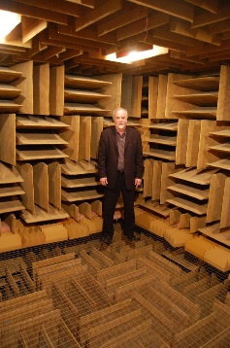
Silence is the absence of sound or noise and we experience it consciously and subconsciously every day, it can have a different effect depending on the situation for example we all experienced awkward silence at some point, on the other hand resting in silence after a long and stressful day is calming and silence can also build tension for example when waiting for an answer. During some of these situations we don’t realise the silence playing part. But do we ever experience real silence? There is always some ambient noise which isn’t always noticeable and that we aren’t in control of, such as weather, traffic and technology. This would mean that it is impossible to experience silence, and what we are experiencing is partial silence or quietness. The closest that we have come to experience absolute silence is in “the quietest room in the world” which is located at Orfield Labs in Minneapolis. The room has an average sound level of -9 decibels, in comparison a normal conversation is around 60 decibels and leaves rustling around 30 decibels. Spending time alone in the quietest room would result in hearing nothing but your own organs working, this experience has caused hallucinations and the record time spent in the room is 45 minutes. Because absolute silence is impossible in an ordinary everyday scenario, for this case it is important to define silence as absence of sound and noise excluding inevitable ambient noise (which can be hard to pick up consciously). Let’s move on to how silence has effect in media, more specifically movies. The use of sound is crucial in the making of movies, that includes diegetic sound which is within the story world, and non-diegetic sound which is sound which isn’t heard in the story world by the characters, an example is soundtrack. And then we have silence in movies, which has an equal role or arguably an even greater impact if applied correctly. Most would assume that silence in movies is rather uncommon but there are some good exceptions such as A Quiet Place and Man with a Movie Camera. The two movies are very different but are both great examples of how silence can be utilised in a movie. The main difference the two movies have is the use of silence, A Quiet Place uses silence to build tension and suspense while Man with a Movie Camera has no diegetic sound at all. One thing they both have in common is their use of the score. There are many more honourable mentions such as the Chaplin movies, but let’s focus on A Quiet Place and Man with Movie Camera. The function of silence in account to the sound and image relationship can have a big impact on the quality of the movie and an effect on the audience. The reason this topic is so intriguing is because it seems to get overlooked and taken for granted. People don’t analyse and credit silence in movies like they praise the screenplay, actor performances and soundtrack while it can have as big of a role in the final product.

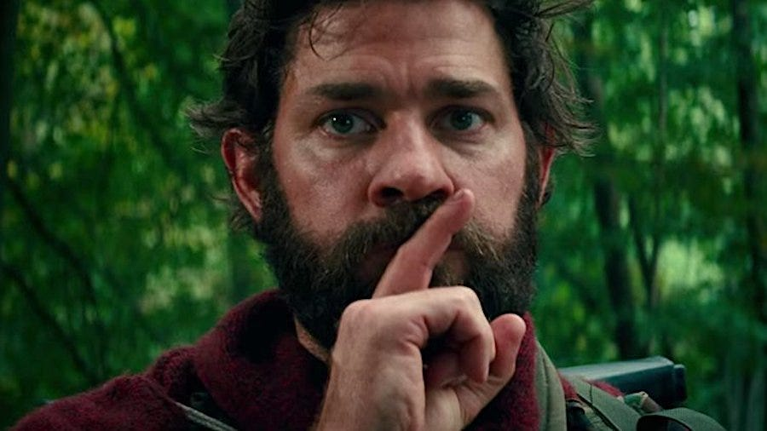
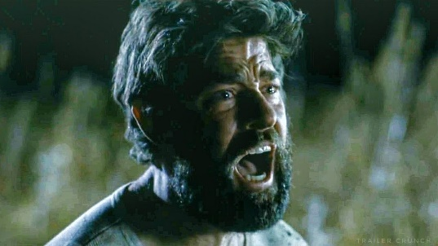
In the opening scene of A Quiet Place which is an American Horror film directed by John Krasinski we have a good example of the use of silence in the sound-image relationship. In the four minute scene there is have no audio dialogue and very little sound, the scene starts with the Abbott family in a shop and within the first twenty seconds of the clip, tension is built when Beau Abbott (the youngest child) picks up a toy spaceship, Lee Abbott approaches him slowly to take the toy off his son and proceeds to take the batteries out, there is no diegetic sound only a quiet non-diegetic sound meaning that the tension was built using silence. The first interaction between the characters is also silent and is done using sign language: “Listen to me -- Too loud.” Signed by Lee Abbott. (If the audience is oblivious to the backstory of the film it can be confusing as to why the scene is so silent, but this is well explained towards the end of the scene). After this the parents and Marcus proceed to walk out the shop, leaving Beau and Regan behind, without the parents there Regan smiles at Beau and picks up the spaceship handing it to him, it seems like she looked at the empty battery socket making me believe she did the right thing giving her younger brother the toy to cheer him up without the possibility of it making any noise, this does set off alarms though as there must have been a reason to Lee taking the spaceship off Beau. Beau obviously looks happy to receive the toy off his sister and as soon as she walks out the shop, he picks up the batteries and at this point it’s safe to assume that nothing good is coming from this action. Once Beau leaves the shop with his battery loaded spaceship he regroups with his family and they walk down the in road single file. During their trip we see an extreme close up shot of them walking bare foot which signifies how important it is to be silent. Approaching a bridge we get a close up of some of the characters and can spot beau playing with his toy behind Regan, as soon as the camera goes back on Lee we can hear some toy sounds and his face instantly changes from a resting face to a worried expression, within seconds we see him sprint towards Beau, Regan looks baffled and at this moment the audience realises she’s deaf. While sprinting towards Beau we see different shots of the Abbotts in shock and tears and background music intensifies still hearing the spaceship and noises of trees and branches rustling, as Lee is getting closer, we see a glimpse of the monster which seconds later snatches Beau and scene cuts to black. One of the reasons why tension was building without sound is because the audience is being kept in suspense, without sound our other senses sharpen which lets us focus more with our vision and pick up more on the body language and expressions of the actors that do a great job of expressing emotion. There is an even better scene towards the end of the film that uses silence to create stronger emotions. The scene is set at a later time and starts off with Lee being flung by the monster. The camera instantly cuts to Marcus as he opens the car door and leaning out of it screams “DAD”. This sends the audience to high alert as we get a cut to a close up zoom of a worried Evelyn, followed by Regan running into the car with brother is in slamming the door shut. In these short 10 seconds so much is going on, quick cuts, different shots but minimum sound, it seems like the movie is relying on breaks between short sounds to build that tension as well as using the soundtrack which is hard to pick up consciously and took me a couple of playbacks to notice how it affects this scene, there is definitely suspense from the amount of silence but works well with the soundtrack. While Regan and Marcus are hiding in the car the monster picked up on the noise they made and at this point it’s evident that they are in trouble. While hiding in the back seat of the car we hear a loud screeching noise coming from Regan’s hearing aid which is clearly causing her a lot of discomfort forcing her to turn it off. There’s roughly ten seconds of silence which means no noise at all, that makes the audience feel stressed watching it, especially seeing Regan oblivious to what’s going on (as she can’t hear anything) while Marcus is looking out the far window with a terrified expression. The first thing heard is the impact of the glass shattering which brings us back to reality followed by the monster trying to rip apart or flip the vehicle. That short 10 seconds was so effective in that shot as it put the audience in Regan’s position and built the climax and suspension well. The next shot cuts to a close up of the same axe Lee was holding when he got flung earlier, the camera is panning down the axe and we can see Lee’s hand reaching to grab it and during this sequence we hear the background noise from the car fade out and quiet soundtrack fading in, we see Lee stand up holding his wounds and helping himself up with the axe followed by shots of the monster trying to break into the car and a worried Regan in the car. The camera cuts back to Lee struggling to stand and a close up of his face which is full of emotion and tears building up, he drops his axe and the monster stops and looks in his direction. The camera alternates between the monster, Regan and Lee. Regan looks confused looking at her father and he signs “I love you.” Regan starts getting more emotional, “I have always loved you” Lee signs with a very touching expression and while all of this is going on there is no diegetic sound at all. Lee breaks the silence by screaming as loud as he can to get the monsters attention away from his children resulting in sacrificing himself. This is one of the most emotional parts of the whole film and was made using a complete absence of dialogue and sound until Lee let out his scream. There is soundtrack in this shot which is relatively quiet and doesn’t take away from the silence but in my opinion works well with it. The scene ends with the monster charging at him and his children rolling back to safety in the car, the last thing we see is Regan’s face in tears. This scene is a lot more tense than the opening and relied more heavily on silence, as well as the fast-paced jump scare action. Overall this scene has a lot more going on and plays on emotion with the fact that Lee sacrificed his life for his children which was perfectly acted by John Krasinski, so his strong performance added to the feels after the high tension was built with silence. The whole movie and its emphasis on silence is successful and the high reviews of this film back this point, A Quiet Place received a critic rating of 95% and audience rating of 83%.

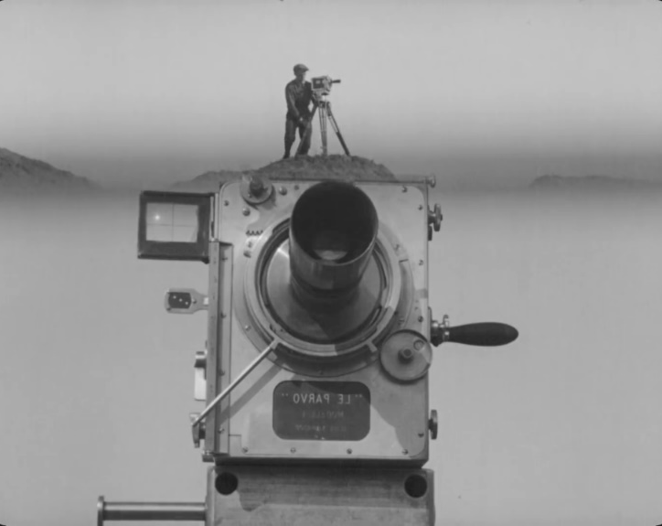
Man with a Movie Camera is an experimental silent documentary film directed by Dziga Vertov published in 1929, what makes it so special is the revolutionary approach Vertov took. It is regarded as “the greatest ever documentary” according to a poll by the BBC and is also as described as ahead of its time. The entire movie has no diegetic sound at all and relies on its innovative range of cinematic techniques that Vertov invented, as well as the score, which is quiet impressive and you could credit that that success at least partly to the fact the movie is silent as it makes it more immersive and lets the audience think for itself. The opening scene of the movie is completely silent without a score playing, it’s quiet captivating and a lot is going on, without the sound the sole focus is on the scene and the experience is quiet relaxing. The scene takes place in a theatre room in a Soviet city and the focus is on showing the full picture, using jump cuts, extreme close ups as well as other cinematic techniques. The theatre room starts to fill with people as we await an orchestra to start playing and that’s when we first hear the score, not no be confused with diegetic sound. It’s a good transition from complete silence to partial silence and makes the watching experience more enjoyable but still relies on the absence of diegetic sound which gives it that experience, whether it is intentional or not. There’s a lot less to analyse with Man with a Movie Camera when it comes to the function of silence as it’s silent all the way throughout the movie but serves as a good comparison to A Quiet Place.

Even though there are ninety years between the two movies, and they have their differences, they do have some things in common. A Quiet Place is a high production value American Horror movie while Man with a Movie Camera is a Soviet documentary originally described as “pointless camera hooliganism” but apart from all the obvious surface differences let’s look at the two movies from more of an analytical perspective. Both movies utilise silence to their advantage but use it for different effect, that’s most likely due to the genre and what the directors wanted to put across. The primary function that silence has in A Quiet Place is to build tension and it does so really well which relies on the fear of the unexpected, it also makes the audience think and try to fill in the gap using their own ideas. On the other hand, the silence in Man with a Movie Camera allows the audience to focus more on the visual aspect of the movie, which makes the viewing experience more relaxing as a result of not having any diegetic sound. This also allows the audience to think outside the box and try to substitute the lack of sound using their imagination but in this case for a different reason. Overall both movies benefit from silence for different reasons and in different measures, A Quiet Place is a well-rounded box office movie while Man with a Movie Camera is an experimental movie definitely ahead of its time and is arguably revolutionary, I’m definitely not trying to take away from it and what I’m trying to say is that during the ninety year gap A Quiet Place took advantage of the new techniques, better technology and a higher budget and managed to use the function of silence to perfectly fit the horror mood and use its effect to their advantage, paired with a great soundtrack and high quality film making.

In conclusion it’s safe to say that silence plays a key role when it comes to building tension and bringing out emotion within the audience, silence also gains the attention of the audience subconsciously, you can spot this in a cinema or even at home as in moments of silence the audience stops eating their popcorn during the climax. Using the analysis from A Quiet Place we know well that silence plays a key part and its function is to build that tension, but you also have to give credit to the screen play, cinematic techniques and a good score, as silence by itself could be misinterpreted or overlooked but when paired with all those techniques and great actors it’s so effective it’s unnoticeable. While A Quiet Place gives us a great example of the account of silence building tension, we have another great example from Man with Movie Camera of how silence makes the audience think and use their interpretation of what they perceive is going on. The way humans react to silence is fascinating, the way it grabs our attention so subconsciously in movies may be due to the fact we don’t want to miss out on anything or have some sort of expectation for something to happen. Quiet simply it could be that we are attracted to silence as it is known to have positive effects on the brain, according to an article by Jessica Stillman “It's an active good that has profound positive effects on us physiologically and psychologically.” This would make sense as “about 40% of the population in EU countries is exposed to road traffic noise at levels exceeding 55 db” according to the World Health Organization. Overall, it’s safe to conclude that the function of silence in a movie when used correctly is crucial when it comes to suspense or a climax and has been used for many years in the filmmaking industry.

Bibliography

Merriam-webster.com. (2019). Definition of SILENCE. [online] Available at: https://www.merriam-webster.com/dictionary/silence [Accessed 11 Dec. 2019].

KnowledgeNuts. (2019). True Silence Will Drive You Mad - KnowledgeNuts. [online] Available at: https://knowledgenuts.com/2014/06/02/true-silence-will-drive-you-mad/ [Accessed 11 Dec. 2019].

Myhealth.alberta.ca. (2019). Harmful Noise Levels. [online] Available at: https://myhealth.alberta.ca/Health/Pages/conditions.aspx?hwid=tf4173 [Accessed 11 Dec. 2019].

Youtube.com. (2019). A Quiet Place - Opening Scene (Beau Abbott Dies) [HD]. [online] Available at: https://www.youtube.com/watch?v=T_FdjXqSZlc [Accessed 11 Dec. 2019].

Youtube.com. (2019). A Quiet Place (2018) - I Have Always Loved You Scene (8/10) | Movieclips. [online] Available at: https://www.youtube.com/watch?v=5WvXdaXIbYw [Accessed 11 Dec. 2019].

Rotten Tomatoes. (2019). A Quiet Place (2018). [online] Available at: https://www.rottentomatoes.com/m/a_quiet_place_2018 [Accessed 11 Dec. 2019].

Youtube.com. (2019). Man with a Movie Camera (1929) movie. [online] Available at: https://www.youtube.com/watch?v=cGYZ5847FiI [Accessed 11 Dec. 2019].

BBC News. (2019). Silent film tops documentary poll. [online] Available at: https://www.bbc.co.uk/news/entertainment-arts-28602506 [Accessed 11 Dec. 2019].

BFI. (2019). Man with a Movie Camera (1929). [online] Available at: https://www.bfi.org.uk/films-tv-people/4ce2b6a21d217 [Accessed 11 Dec. 2019].

Feaster, Felicia. Man With a Movie Camera. Turner Classic Movies, Inc. [online] Available at: http://www.tcm.com/unavailable

Inc.com. (2019). The Incredible Brain Benefits of Silence. [online] Available at: https://www.inc.com/jessica-stillman/science-silence-is-really-good-for-you.html [Accessed 11 Dec. 2019].

The Independent. (2019). How noise pollution can affect your health. [online] Available at: https://www.independent.co.uk/life-style/health-and-families/features/how-noise-pollution-can-affect-your-health-a6853746.html [Accessed 11 Dec. 2019].

Euro.who.int. (2019). Data and statistics. [online] Available at: http://www.euro.who.int/en/health-topics/environment-and-health/noise/data-and-statistics [Accessed 11 Dec. 2019].

