Task 1A

Essential skills are needed for study and employment and this can be split into two types of skills. These skills are academic skills and employability skills.
Below is a list of academic skills and employability skills.
Academic skills -
- Academic writing – Clear and concise: A clear outline of the content is essential to make it easy to understand and answer the question concisely.
Well-structured: Make sure your writing is logical and linear, connecting related content in an easy-to-read way.
Formal tone: Don't use flowery or embellished phrasing and focus on using the appropriate terminology and phrasing.
clear and concise ,well structured.
- Critical thinking - justify your ideas through rational thinking and evidence
- Time management – To be on punctual and projects on time
- Presentation and public speaking -
[1]
Employability skills –
- Problem solving - write in own words
- Digital skills
- Communication skills
- Self-motivated - Work individually or in a team

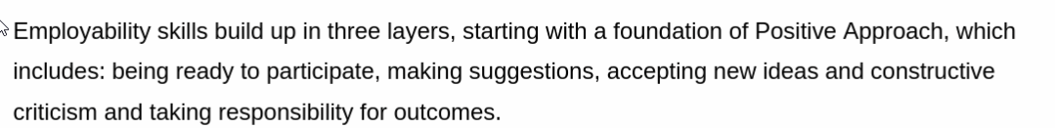
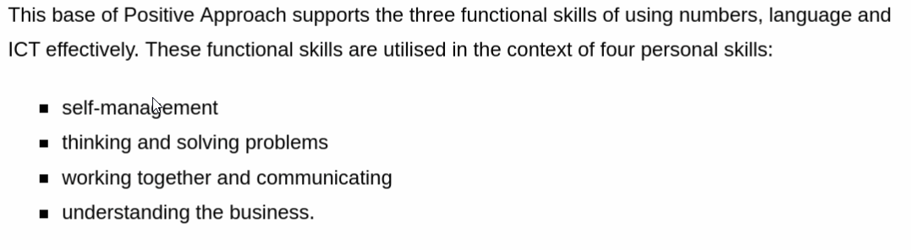[2]

The development of these skills will not only support and help with employment but also with lifelong learning and day to day life. The development of these skills will help to get a career path change.
The development of specific skills plays a crucial role in shaping your career after graduation. Here’s how honing particular skills can support you:
- Technical Skills: Mastering the technical aspects of your field ensures you are job-ready. For example, if you’re in IT, coding, data analysis, or cybersecurity skills are essential. These abilities allow you to contribute immediately to projects and problem-solving tasks, making you an attractive candidate for employers.
- Communication Skills: Whether it’s verbal or written, communication is key in any career. Strong communication skills enable you to effectively collaborate with teams, convey ideas clearly, and articulate solutions to clients or stakeholders. This ability helps in building relationships and advancing in your career.
- Critical Thinking & Problem-Solving: Developing these skills helps you approach challenges with creativity and logic, making you a valuable asset in any professional setting. These skills will also help you stand out in interviews, as employers value employees who can think independently and make decisions under pressure.
- Leadership and Teamwork: Whether you want to lead or collaborate with others, the ability to work in teams and take on leadership roles will help you in almost every career. These skills prepare you for managerial roles or working within cross-functional teams, providing opportunities for advancement.
- Time Management: Developing the ability to manage multiple tasks efficiently is vital. Being able to meet deadlines, prioritize effectively, and handle stress will make you more productive and successful in a fast-paced work environment.
- Adaptability: In an ever-changing job market, the ability to adapt to new tools, technologies, and work environments is crucial. If you have developed flexibility and a growth mindset, you’ll be able to thrive in dynamic industries and stay ahead in your career. [3]

References

[1] | “Indeed,” 02 july 2024. [Online]. Available: https://uk.indeed.com/career-advice/career-development/academic-skills. [Accessed 27 01 2025].
[2] | Holmes, K 2017, What Employers Want : The Employability Skills Handbook, Trotman Publishing, Bath. Available from: ProQuest Ebook Central. [31 January 2025].
[3] OpenAI’s ChatGPT, private communication, Feb. 2023

