Roxana Maria Burlacu

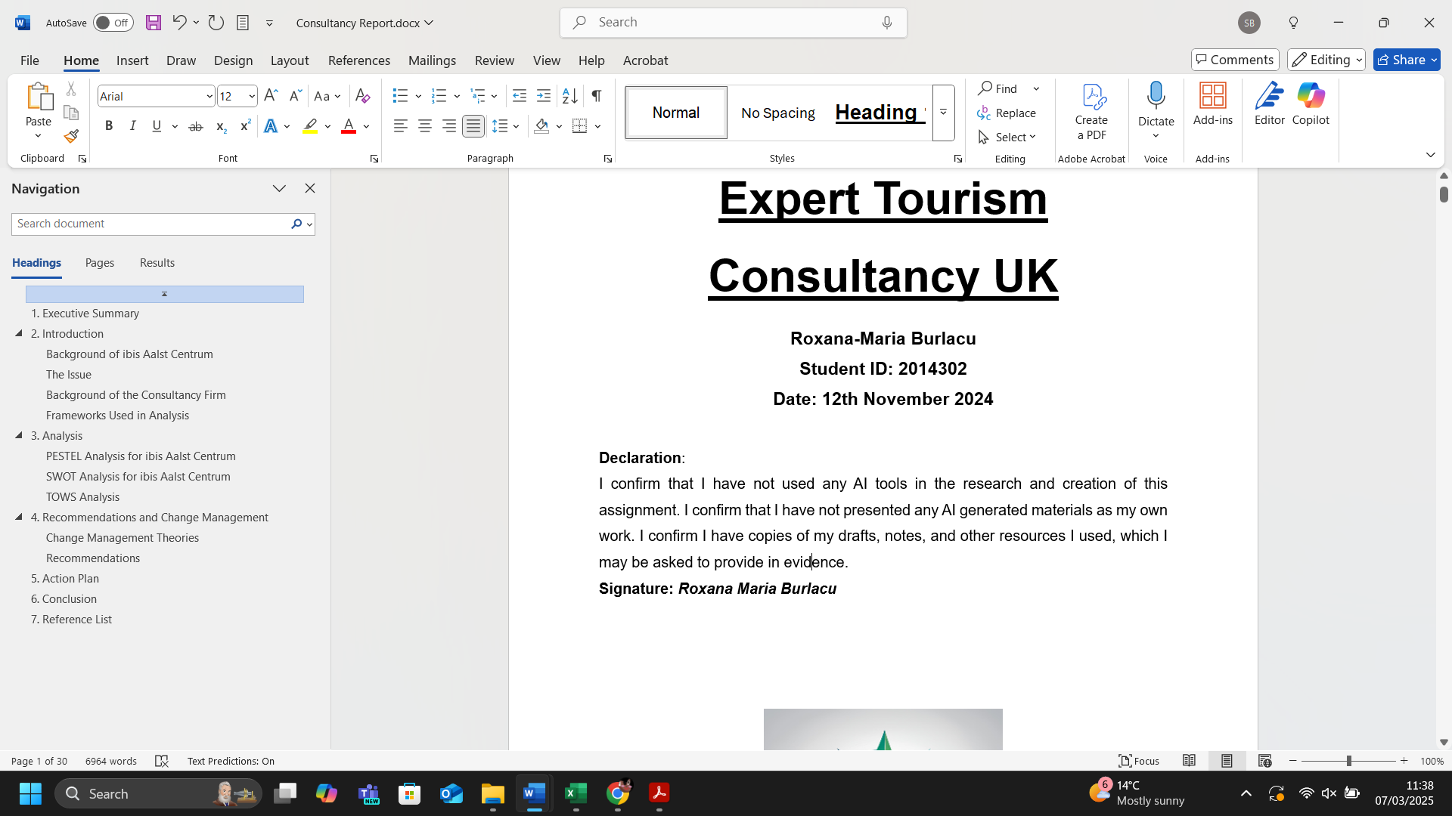

BMIH6004 Hotel Placement – Managing Hotel Administration
Learning Log

Table of Contents
1. Introduction 2
2. Reflection 2
2.1. Concrete Experience 2
2.2. Reflective Observation ​ 3
2.3. Abstract Conceptualisation 3
2.4. Active Experimentation 3
3. Critical Analysis 4
4. Reflecting on Organisational Issues 4
5. Conclusion and Action Plan 5
6. References 6

Introduction
The Reception/Front Office department of Premier Inn London Stansted is accountable for managing check-ins and check-outs, reservations, supplying information and support to customers, and ensuring a smooth and welcoming experience for all visitors.
One’s learning objectives include the following:
- to develop an understanding of the administrative and operational tasks within the aforementioned department. ​
- to increase communication and customer service skills. ​
- to understand and apply suitable tactics to manage guest inquiries and complaints effectively. ​
- to gain insights into the use of hotel management software.

Reflection
This section of the report aims to reflect on my experience and personal development in the reception/front office department at Premier Inn London Stansted, using Kolb's Reflective Cycle (Kolb, 1984).
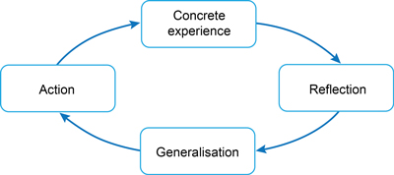
Figure 1. Kolb's Reflective Cycle
Source: Kolb, 1984

2.1. Concrete Experience
During my placement, I had the opportunity to shadow a supervisory role within the Reception/Front Office department. My tasks comprised managing guest check-ins and check-outs, reservations, and attending guest enquiries and complaints, and ensuring a smooth and welcoming experience for all customers.

2.2. Reflective Observation ​
During my experience at Premier Inn London Stansted, I observed that the reception department plays a crucial role in influencing the guest experience, as demonstrated by Özdemir, Çolak, and Shmilli (2019), and Safitri, Mataram, and Widana (2021). In the hospitality sector, the efficiency and friendliness of the reception staff significantly impact guest satisfaction (Knežević et al., 2015; Ali et al., 2021; Febrianti, 2023). I was particularly impressed by the new digital system for managing hotel operations, which streamlined many tasks and improved overall efficiency. However, I also faced challenges, such as remembering the names of employees and a few technical details regarding the use of the digital system.

Abstract Conceptualisation

From my observations, I learnt the importance of effective communication, teamwork, and task management in the reception and front office departments. Receptionists must produce a good first impression to guests, using communication skills to effectively manage the check-in process, provide necessary information, potentially address their concerns, etc. Also, using high-tech digital systems can make operations much more efficient (Lukanova and Ilieva, 2019; Nam et al., 2020), but Solnet et al. (2019) say it's just as important to keep a personal touch when talking to guests. My experience has highlighted the need for increased organisational skills and the capability to manage multiple tasks at the same time. Additionally, I realised the critical value of a supportive and friendly work place in fostering employee satisfaction and productivity (Naz et al., 2020).

2.4. Active Experimentation
Based on the above reflections and understanding, I plan to implement several strategies to improve my performance in future roles in hospitality, including:
- The enhancement of my communication skills to better interact with guests and colleagues.
- The development of my organizational skills to manage multiple tasks more efficiently.
- The increase of technical skills related to advanced digital systems to streamline operations. ​
- Fostering a positive work environment by being supportive and friendly to colleagues. ​

To sum up, my placement experience has been instrumental in increasing my work-based skills and technical knowledge. Applying Kolb's reflective cycle has helped me to appreciate in hotel management the need of efficient communication, teamwork, and task management. These realisations will guide my future professional activity in the hotel sector, therefore enabling me to deliver outstanding guest service and support the general performance of the organisation.

Critical Analysis
Throughout my placement at Premier Inn London Stansted, I developed several essential work-based skills and technical knowledge crucial for effective hotel administration. Firstly,​ effective communication was paramount, as it facilitated smooth interactions with guests and colleagues, ensuring a welcoming and efficient service (Özdemir, Çolak, and Shmilli, 2019; Safitri, Mataram, and Widana, 2021). Teamwork was another critical skill (Hussain, Soni, and Shah, 2024), considering that the coordination with other departments and team members was necessary to handle guest requests and resolve issues promptly. ​​Moreover, technical knowledge, particularly in using the hotel's digital management system, was vital for managing reservations, check-ins, and check-outs efficiently (Lukanova and Ilieva, 2019; Nam et al., 2020; Forman and Udvaros, 2023). This system streamlined operations, reduced errors, and improved overall guest satisfaction (Forman and Udvaros, 2023).​ Furthermore, task management skills were also essential, as the ability to prioritise and handle multiple tasks simultaneously ensured that all guests' needs were met promptly and effectively. Moreover, personal skills such as patience, empathy, and problem-solving were crucial to addressing guest complaints and inquiries and enhancing the overall guest experience. My experience underlined the need of these abilities in preserving operational effectiveness and excellent service standards in the Reception/Front Office area of a hotel.

Reflecting on Organisational Issues

During my placement at Premier Inn London Stansted, I observed relatively frequent errors in the booking digital system, which led to overbookings and incorrect reservations. These errors caused frustration for both guests and staff, as resolving these issues required additional time and effort. Hence, ensuring robust IT support and regular system maintenance is crucial for minimising disruptions and improving operational efficiency, because addressing this organisational issue is essential for improving guests' satisfaction and operational efficiency. Premier Inn can greatly enhance the guest experience and operational effectiveness by making sure the booking system is dependable and staff members have both technical and interpersonal skills under good control.

Conclusion and Action Plan

The placement at Premier Inn London Stansted has provided invaluable insights into the operational challenges and areas for improvement. The issue identified is represented by errors in the booking digital system. To address these challenges, I propose the following action plan:
- Enhance IT Support and System Maintenance:
- Conduct a comprehensive review of the current booking system to identify and rectify recurring errors. ​
- Implement regular system updates and maintenance schedules to ensure the booking system operates smoothly (Lukanova and Ilieva, 2019; Nam et al., 2020). ​
- Provide additional training for staff on troubleshooting common technical issues to reduce downtime and improve service continuity. ​
- Feedback Mechanism:
- Establish a structured feedback mechanism to regularly gather guest and staff input on their experiences.
- Use this feedback to identify recurring issues and areas for improvement, allowing for timely interventions.
Thus, Premier Inn can enhance its operational effectiveness, increase customer satisfaction, and maintain its reputation as a leading hotel brand. This action plan aims to create a more reliable and welcoming environment for guests, eventually contributing to the long-term performance of the hotel. ​

References
Ali, B.J., Gardi, B., Othman, B.J., Ahmed, S.A., Ismael, N.B., Hamza, P.A., Aziz, H.M., Sabir, B.Y., Sorguli, S. and Anwar, G. (2021). ‘Hotel service quality: The impact of service quality on customer satisfaction in hospitality’. International Journal of Engineering, Business and Management, 5(3), pp. 14-28. Available at: DOI: 10.22161/ijebm.5.3.2
Febrianti, N. (2023). ‘Quality Service Analysis of Front Office Department to Enhance Customer Satisfaction at Klapa Resort’. International Journal of Glocal Tourism, 4(4), pp. 314-332. Available at: https://ejournal.sidyanusa.org/index.php/injogt/article/view/578
Forman, N. and Udvaros, J. (2023) ‘Digital innovation in hospitality: bridging the gap between concierge services and hotel guests’. Journal of Environmental Management & Tourism, 14(6), pp. 2673-2684. Available at: 10.14505/jemt.v14.6(70).15
Hussain, S., Soni, G. and Shah, F.A. (2024). ‘Soft Skills and Interpersonal Skills for Tourism and Hospitality Industry’. In International Handbook of Skill, Education, Learning, and Research Development in Tourism and Hospitality (pp. 119-138). Singapore: Springer Nature Singapore. Available at: https://doi.org/10.1007/978-981-97-4318-6_7
Knežević, M., Tomka, D., Bizjak, B., Fabjan, D. and Kukulj, S. (2015) ‘The physical appearance of hotel guests: The impact on service providers’ communication and quality of service’. International Journal of Hospitality Management, 51, pp. 8-14. Available at: https://doi.org/10.1016/j.ijhm.2015.08.007
Kolb, D. A. (1984) Experiential learning: Experience as the source of learning and development. Englewood Cliffs, NJ: Prentice-Hall.
Lukanova, G. and Ilieva, G. (2019) ‘Robots, artificial intelligence, and service automation in hotels’. In Robots, artificial intelligence, and service automation in travel, tourism and hospitality (pp. 157-183). Emerald Publishing Limited. Available at: https://doi.org/10.1108/978-1-78756-687-320191009
Nam, K., Dutt, C.S., Chathoth, P., Daghfous, A. and Khan, M.S. (2021) ‘The adoption of artificial intelligence and robotics in the hotel industry: prospects and challenges’. Electronic Markets, 31, pp. 553-574. Available at: https://doi.org/10.1007/s12525-020-00442-3
Naz, S., Li, C., Nisar, Q.A., Khan, M.A.S., Ahmad, N. and Anwar, F. (2020) ‘A study in the relationship between supportive work environment and employee retention: Role of organizational commitment and person–organization fit as mediators’. Sage Open, 10(2), p.2158244020924694. Available at: https://doi.org/10.1177/2158244020924694
Özdemir, A.İ., Çolak, A. and Shmilli, J. (2019) ‘Business process management in hotels: with a focus on delivering quality guest service’. Quality & Quantity, 53(5), pp. 2305-2322. Available at: https://doi.org/10.1007/s11135-018-0727-4
Safitri, R.H., Mataram, I.G.A.B. and Widana, I.P.K.A. (2021) ‘Analysis of receptionist service quality to increase guest satisfaction at hotel Yusro Jombang’. International Journal of Green Tourism Research and Applications, 3(2), pp. 58-68. Available at: https://doi.org/10.31940/ijogtra.v3i2.58-68
Solnet, D., Subramony, M., Ford, R.C., Golubovskaya, M., Kang, H.J. and Hancer, M. (2019) ‘Leveraging human touch in service interactions: Lessons from hospitality’. Journal of Service Management, 30(3), pp. 392-409. Available at: https://doi.org/10.1108/JOSM-12-2018-0380

