Assessment
MANAGING PERFORMANCE
Student name: Parminder kaur
Student ID: 2124229
Module code: LCMB7011
Lecturer name: Terry Walcott

Abstract
To retain its position in the market a company has to go through plenty of challenges. To balance their costs, British Gas has started using fire and rehire policy which is leading to heavy backlash from the employees. Many unions have launched strikes against British Gas and such policies. The practices of fire and rehire are slowly increasing in the UK labour market which is leading to challenges among the employees as they can either accept the offer or will be dismissed. HRM strategies can be used for knowing more about the employees and understanding their point of view.
The concept of employee engagement and Employee Relationship management should be understood by HR so that they can develop better relationships with the employees. This would help in increasing the retention rate. Legal factors can also be considered by the employees if they are forced into certain contracts. The impact of changes on employee engagement is also vast and HR should consider better conversations to maintain employee relations. It can also be recommended that British Gas can use Kurt Lewin's Force Field Analysis to implement the changes effectively.

Table of Contents
Abstract 2
Introduction 4
Case Overview 5
Practices of hire and rehire in the UK labour market 6
HRM strategies, planning and approaches to the labour markets including recruitment, retention, turnover and dismissal 9
Legal implications of changing contractual employment terms 12
The potential impact of any changes on employee engagement 14
HR Involvement in managing contemporary employment relations. 17
Recommendations for British Gas 21
Conclusion 23
References: 24

Introduction
The fire and rehire strategies have been heavily used recently in the market. Many companies are planning to use new strategies where they provide very less to the employees and make them work more. The policies have led to the negative outcome on the thoughts of employees due to which this report has been prepared. The report helps in analysing the fire and rehire strategies in the UK labour market. The HRM strategies, planning and approaches which they follow in the UK labour markets are better understood in the research. various difficulties are faced in retaining the staff due to such conditions so the role of HR in such situations is understood through the report.
Developing new changes in the market leads to a high impact on employee engagement. The report assists in understanding the impact of changes on employee engagement. HR is also involved in implementing the changes and developing a better connection with the employees. The strategies that HR should follow to maintain employee engagement are described in the report. Proper recommendations will also be provided for British Gas so that the company can enhance their policies and develop a better connection with its employees.

Case Overview
A long-running dispute has been faced by British gas with the boiler engineers. The dispute has been raised over changes in employment terms and conditions. Numerous strikes have been observed by the company over the period of the past 9 months due to disputes. Strikes were caused by British Gas Engineers which was backed by the GMB trade union. All the engineers of British Gas were asked to sign new contracts. The new contract described that working hours will be increased without any kind of additional pay. This has been a negative factor which decreased the morale of employees and also led to strikes. When 1000 of the engineers disagreed with the new policies, fire and rehire strategy was adopted by British Gas. This strategy led to additional chaos among the employees and a huge backlash was faced by British Gas.
The new fire and hire strategy suggested that the employees can either sign new contracts or they will be dismissed from the service. Many engineers had to accept the contract but around 2% of them disagreed due to which they were dismissed. For a better understanding of the situation faced by employees of British Gas and the point of view of British Gas, it is necessary to conduct an analysis. This will help in knowing about the fire and hire tactics in the UK labour market and the legal implications of changing contractual employment terms.

Practices of hire and rehire in the UK labour market
According to, Smith, et al., (2022), great pressure is faced by the UK government to outlaw fire and rehire practices. Fire and rehire are termed as a practice where an employer has the power to dismiss a worker and rehire the same employees on less favourable agreements. Due to the pandemic, the practices have become more common, and it has become hard for the employees to find the right jobs. Many campaigns are launched by unions such as British Union Unite against the strategy and various strikes are also carried out. Hundreds of engineers are lost by British Gas due to their fire and rehire strategy. The procedure of fire and rehire is also known as section 188 notice.
The practice is mostly used for mass redundancies but can be introduced in companies where employees are refusing to accept their terms and conditions. In the UK labour market, the practice can change the superficial aspect of an employment contract, but they can’t alter the fundamental substance of the contract till both parties agree to it (Kokkodis, et al., 2015). If an employee is asked to accept lower pay and they refuse it, then the only option left with companies is to give them a notice and terminate them till they accept the new notice.

(Figure 1: Fire and Rehire policy)
(Source: King, 2021)
Due to the pandemic employees from all segments such as transport or energy are falling victim to the fire and rehire strategy. The economic blow on the companies is one of the major reasons which has led to companies adopting this strategy. For example- In the year 2021, a deal with a 20% cut in pay was accepted by pilots of British Airways. This deal also led to a loss of more than 200 jobs which was a major shock. Even British Airways had to suffer a loss of 7.4 billion euros during the period. Many workers in the GMB Union have been engaged in various disputes as the companies planned to implement a hire and rehire strategy (Daovisan and Chamaratana, 2020). Plenty of issues were faced by the employees from mental health to the work-life balance due to long working hours, fewer weekends at home and no increase in pay. Many Unions have claimed that the hire and rehire strategy is ripping workplaces like a disease. A survey resulted that around 2,231 workers in the Trades Union Congress Umbrella group got to know that every 1 in 10 individuals was asked to reapply for their jobs or they would face dismissal. This issue was straight a negative factor for the people working in the UK labour market.
As per, Naegele, et al., (2019), in the neighbouring countries of Ireland, a ban has been imposed on fire and rehiring. People see this strategy as an assault on the rights of the employees. This shows that less focus is made on the rights of the workers in the UK. A negative factor is observed by the employees from different industries and, and they see this as a negative factor. Many employees are not able to determine how they should approach the situation and ultimately fall victim to the strategy. Different organisations have different approaches to the fire and rehire strategy. They change the contractual terms to reduce costs in terms of salary, benefits, or overtime. The companies can use these strategies for aligning with the competitive or comparable market factors. They can use these contracts for changing the actual range of working hours, introducing new shift patterns, meeting customer demands, increasing flexibility, using multiple skills, enhancing operational efficiency, and also imposing post-termination of the employees (Peeters, et al., 2017).
Few contracts are done with the concept of employees while a majority of them are done on the condition that they can either accept the offer or will be terminated from the organisation. Various things are permitted to the employers in the notice which they have been using in a negative way. All the employees have developed a negative sense of feeling towards the organisations and they have lost their motivation to work in an efficient way (Basnyat and Lao, 2019). They feel it as a loss of their basic working rights. It is necessary for the organisations to consider the consent of employees and make sure they do not face such bad working propositions and they are not dismissed.

HRM strategies, planning and approaches to the labour markets including recruitment, retention, turnover and dismissal
According to, Stuart, et al., (2021), in the labour market of the UK, HRM strategies are constantly changing depending on the situation. It can be seen that the hire and rehire strategy has affected the HR functions and their credibility. The social and economic transformation in policies has led to changes in the management of HR functions. In the field of Human Resource Management, the impact of changes is wide. There are various tasks in the HR functions and each task needs a lot of focus. It is necessary to understand the organisational recruitment and HRM process in the labour market of the UK.
A recruitment process or procedure is used to find and obtain several suitable individuals that have the necessary knowledge, abilities, and experience. They must permit an organisation to choose the most qualified candidates in accordance with the job descriptions and requirements to fill the open positions (Sawaneh and Kamara, 2019). The reason it is the most significant aspect of HR management is that it ensures that prospective employees are ideal for the company. The term "HRM" refers to a variety of initiatives, activities, and management techniques for achieving both organisational and employee goals.
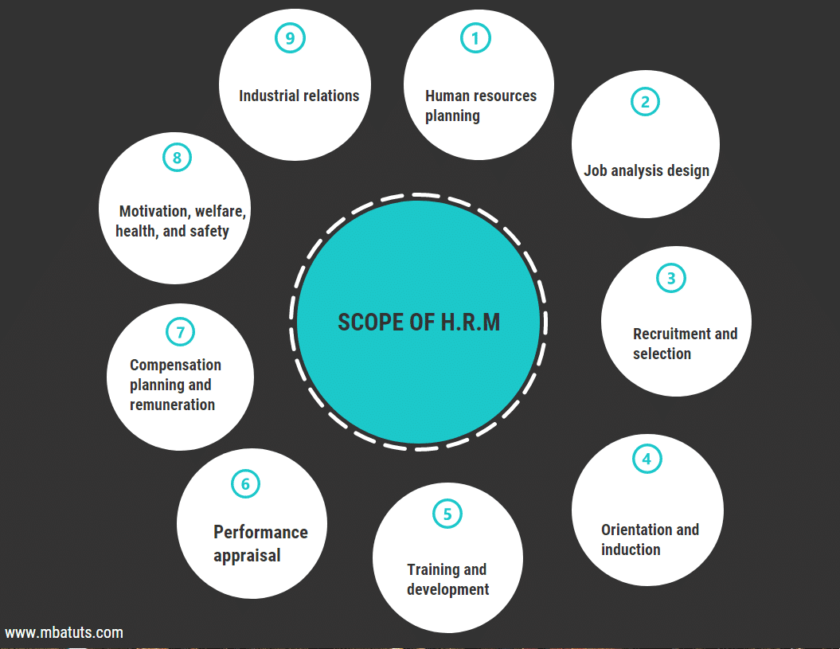
(Figure 2: Scope of HRM)
(Source: MBATUTS, 2017)
The following factors can be used to explain human resource management ideas while looking after recruitment, retention, turnover and dismissal. The first is human resource planning, which attempts to make sure that the company has the right employee on hand at the right moment. It creates a resource inventory for the needs, availability, and potential consequences for human resources in the present and the future. Organization and job implementation is the second principle of HRM. It is employed to establish the relationship and assign duties. The qualifications for the job also indicate the type of people who will suit the description. The third idea in HRM is selection and staffing, which explains how to choose the best applicant for the job who can also live up to expectations set by the business. The fourth area is training and development which provide great support in retaining the employees. Human resources must make sure that each employee receives the correct instruction so they can perform at their current jobs and profit from it for the organization's future demands.
The fifth factor is organisational development, which is crucial for interacting with other organisations to foster a positive work environment and strong bonds between them (Reilly, 2018). The sixth item on the list is pay and benefits, which are crucial to any work before dismissal. It is the responsibility of HR to establish incentives and rewards that promote employee welfare and business expansion. There is also a need for proper pay and benefits before dismissal so that it can be made sure employees are provided rights. The seventh concept is employee help or feedback; in this idea, the employee has the rights they are up against in the business. HR needs to identify and address the issue in this situation. An information system is yet another concept. This idea outlines the goals, objectives, and behaviours of the employees. A working environment is created by technological advancement. The idea also examines data interchange using efficient, motivation-based communication systems. All these factors are to be considered so that proper recruitment can be done, and employees can be retained.
In the words of, Rondeau and Wagar, (2016), the management of human resources is one of the variables influencing recruiting efforts. They have prepared for both the present and future human resources in different organisations. While bearing in mind that the human resources management of the company acts for hire, they have a strategy that they will hire a specific number of people in their organisation and will be able to hire some applications within a certain period of time. If there is any doubt, they must immediately hire more staff (Galdino, et al., 2022). The hire and rehire plan will cause problems for the human resources department. The company's size and expansion are some elements that affect recruiting efforts. The administration of an organization's human resources is in charge of meeting its expansion and growth requirements. In order to preserve balance throughout hiring and rehire procedures, they must think about and plan their recruitment operations.

Legal implications of changing contractual employment terms
According to, Mik, (2017), contract of employment can be said as an agreement that is done between an employee and employer which helps in outlining rights and duties. At any point, if anyone of the employee or employer wants to make any change in the contract of employment, they need to have an agreement with each other. All the changes need to be done after proper negotiation between both employee and employer. Changes in the employment contracts can be made through an agreement between employee and employer. A collective agreement is seen to be a negotiation between the employer and trade union or the staff. The implication is also said to be a change between the customs and practice. There are many reasons for making changes in the employment contract (Raskin, 2016). When it comes to employers in the situation changes are to be made due to the economic circumstances. There can be changes made due to reorganisation of business or move towards new location following the rules and regulations. Based on the study of British Gas the contractual changes are made by the company in rates of pay, working time, duties and responsibility and other factors.
As per, Hur and Perry, (2020), if the rules are not followed by the employer while making changes in the contract, they can apply for breach of contract. If any of the statutory employment rights are breached by an employer, then Industrial Tribunal Claim can be applied. It is important for the employer and employees to maintain proper contracts while working. In the fire and rehire strategy salary of employees is reduced; work timings are increased, and also extra holidays of employees were cancelled without giving any kind of extra pay. In such cases, there are certain legal implications where the employees can file for unlawful deduction of wages if the pay is reduced. If the situation after rehiring is not effective and employee faces more degradations from employers, then they can resign from the job and also claim constructive dismissal (Gawke, et al., 2017).
Many laws are made for making sure the employees and employers follow all the rules while working such as Breach of employment contract, pay deductions and being paid and payslips. There are also many segments where they can get help if the employer is not following the rules such as Labour Relations Agency (LRA), seeking legal advice from solicitors and NI. There are many risks which should be considered while working in an organisation. When contracts are made and changes are needed in the same, tensions can be caused. If lawful methods are not followed many risks can be faced by the employees and employers. The biggest risks incorporate damaging the working relations. Legal claims due to a breach of contract also lead to constructive dismissal. If the employees are rehired and their pay is cut, they lose their commitment to the company and performance is degraded (Wong and Law, 2017). Increased level of stress is observed among employees due to no following of legal implications. Changing contractual employment terms are sensitive matter and proper negotiation should be considered between employees and employers by following the law.

The potential impact of any changes on employee engagement
According to, Karanika-Murray, et al., (2015), the changes will eventually impact the employees in a negative way. The employees have lost trust in organisations that adopt fire and rehire strategies. They feel that such organisations can make changes in their policies at any point in time which will affect their career. The engagement of employees in the UK labour market has been drastically declined due to the pandemic. Many companies due to the pandemic started operating on a different model where they provide employees with a condition where they would have to work harder for lower pay. This situation is seen to be mentally as well as physically draining of the employees.
Many employees even felt mental pressure due to the strict policies developed by companies where they don’t even have any choices for selecting their way of working. The employees can either accept their offer or they will be dismissed (Van Wingerden, et al., 2017). This is a negative issue which has led to a heavy decline in employee engagement. The employees are not happy with the policies and think of changing their companies. The retention rate has decreased, and employees feel that these policies will get worse in future and are not good for their careers. It is important or employers to address the emotions of employees before making any changes.
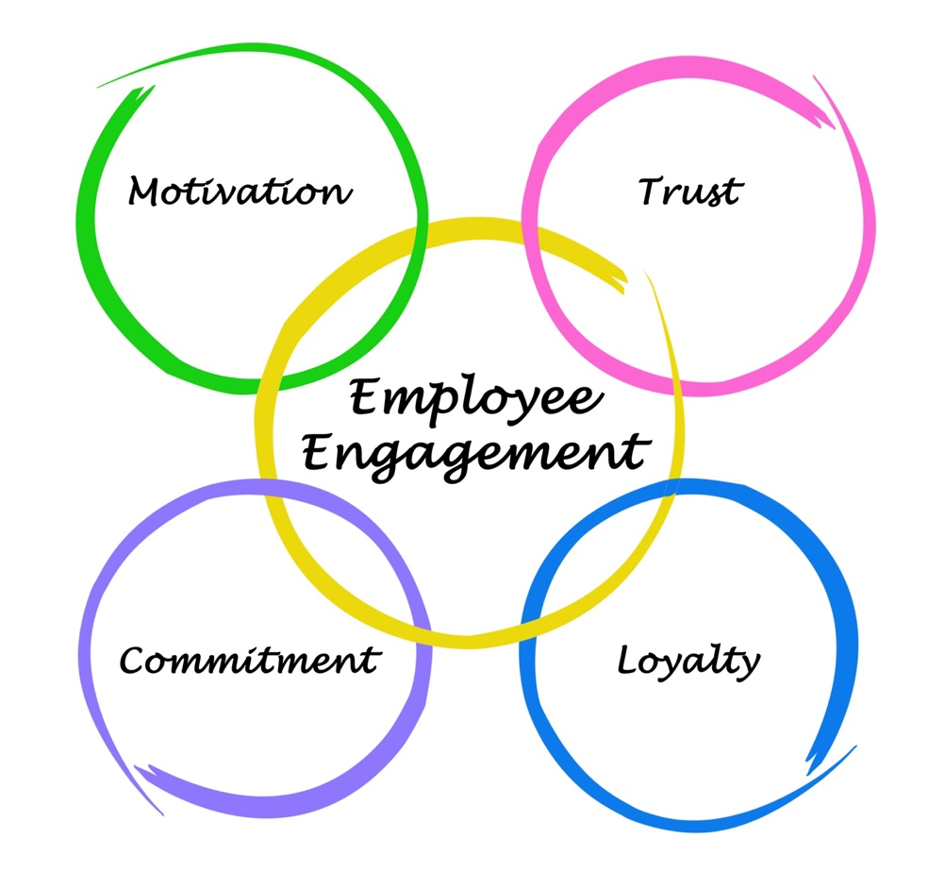
(Figure 3: Employee Engagement)
(Source: PeopleG2, 2015)
The concept of employee engagement is surrounded by four factors motivation, trust, commitment and loyalty. Due to the fire and rehire strategy the motivation of employees to work in a company is drastically reduced. They are not interested in contributing their skills to the companies which is a major negative factor. Due to less motivated employees, their performance will decline which will eventually affect the profits of the company. The trust of the employees is also broken, and they are not able to trust the organisation in which they are employed due to their policies (Conway, et al., 2016). If an organisation offers an employee fewer benefit and asks them to either work or get terminated they will eventually lose trust in that organisation. The retention rate has also decreased due to this policy as they are not able to earn the trust of employees. The other factor is commitment, employee can’t commit to any business outcome as they are not committed by an organisation for a fixed pay. The loyalty and well as commitment factors both will be missed as the companies are not providing employees with their rights. The employees find it difficult to be loyal to an organisation that doesn’t value their hard work.
As per, Knight, et al., (2017), the changes are not communicated properly, and the employees are not informed regarding how the company will decline their requests and ask them to resign and again rehire them on new conditions. Another major factor which is observed when employee engagement is lost during a change in their participation in decision making. If the employees are not allowed to participate in the decision-making process due to any reason, they start feeling negative towards an organisation. These situations are not good for the company, and they can lead to plenty of complications. The employees will feel that the company does not value their decisions and participation. When it comes to employee engagement it is necessary to keep the employees feel that they are valued in the organisation and their decisions are considered (Harju, et al., 2016).
The change in the organisation should also be slow so that the employees get a chance to consider the changing environment. If the changes are happening quickly without thinking much it can lead to too much for the employees and they might feel unvalued in an organisation. Too much top-down change should be ignored, and employees should be provided with the right to adapt to changes slowly. Better employee engagement strategies should be considered carefully as the change can impact employees in a negative way. The employees can face higher stress levels, uncertainty, resistance, and other issues due to constant changes (Roof, 2015). The employee engagement will be lost, and the high-performing employees can leave the organisation which could lead to extra costs, reduction in quality, and loss of productivity in an organisation. For improving employee engagement, organisations need to consider job satisfaction, work environment, culture, and other factors required by the employees.

HR Involvement in managing contemporary employment relations.
According to, Duggan, et al., (2020), employee Relationship Management is termed as a procedure of managing relations in a company. These relationships can be considered between co-workers or employees and the organisation. There is a need of having a creative environment so that the employees can be more productive. HR plays a significant role in managing contemporary employee relations. It is done with the help of effective HRM strategies. These techniques serve as the foundation for all other critical components, including recruitment, performance evaluation, development, and pay. In general, these strategies can be broken down into four parts (Latorre, et al., 2016).
The organization's talent, or human capital, is the first factor, and it is crucial to the functioning of the whole company. The success or failure of the initiatives is determined by the second component, which is the leadership inside the business. The third component is creating a talent plan for your firm. The fourth phase entails creating a welcoming workplace environment for workers using clear performance evaluation standards. Changes that the current strategy does not account for necessitate the development of a new HRM strategy.
In the UK labour market, HR must constantly be adaptable to change because the hiring process now requires ongoing innovation. Rapid adaptation is hampered by the procedures and processes used as well as the sort of technology being used. By skipping over the requirement to read, analyse, and evaluate candidates based solely on their resumes and moving straight to a competency-based, people-centric perspective, the firm may save time and steps throughout the hiring process (Kaufman, 2019). Even in the most complex and uncertain situations, the organisation can experiment, learn, and adapt for the better because it operates in a disruptive, change-hungry, trend-driven environment. As a result, businesses must concentrate on both the creation of effective strategies and their capacity to innovate.
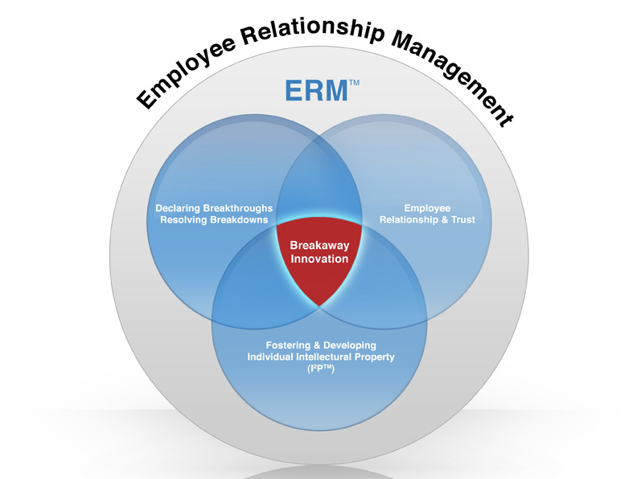
(Figure 4: Employee Relationship Management)
(Source: Breakway, 2022)
The image above shows the factors of Employee Relations management that are to be followed by an organisation. In the concept, innovation should be broken down and new factors should be developed. These factors would help HR in building better relationships with the employees in the current situation. The ERM process creates strategies for policing commercial practices that govern better employer-employee interactions. By creating and fostering a productive work environment within the company, ERM's primary goal is connected to employees' relationships with the company. The achievement of a company's business goals can be assessed with the help of excellent relationship management (Renwick, et al., 2016). One of the key elements that drive good employment relationships with employees is excellent communication.
In order to build employee connections and achieve company goals, ERM offers a variety of standardised ways. The efforts of British Gas and other organisations to standardise methods for managing employee relations and company operations should be guided by an international strategy. MNCs provide particular attention to global strategies such the multi-domestic, transnational, and ethnocentric strategies. HR needs to take each strategy into account, and various standardised procedures should be used to increase companies' efficiency across numerous nations while being adaptable to changing market conditions of fire and rehire (Kaufman, 2015).

(Figure 5: Approaches of Employee Relationship Management)
(Source: By Author)
The diagram above shows the three key approaches to Employee relations management which can be used by HR. In a company, HR needs to first understand all three approaches and then apply the most suitable so that they can maintain employee relations. The globalisation transnational approach looks for a link between many domestic strategies and employment relations. The business that effectively takes into account the transaction approach aims to strike a balance between the effectiveness of business operations and employment relations (Johnson and Szamosi, 2018). Creating appropriate strategy and upholding an appropriate corporate culture aid in giving businesses on the global market long-term competitive advantages. To preserve a greater competitive and strategic advantage, HR have found the transaction approach to globalisation to be a strategic asset.
According to, Fu, et al., (2015), HR effectively take into account the ethnocentric approach in order to oversee commercial operations and manage staff. The ethnocentric strategy offers companies composite differentiations for overseeing their international operations. Companies think about handling challenges in the HRM (Human Resource Management) division at a higher level of employee relations. The primary goal of HR considering an ethnocentric strategy is to transfer the organisational culture of the parent company to the foreign nation (Guerci, et al., 2015). The multi-domestic strategy can be used by HR to hire employees when a company plans to grow in a foreign market. This strategy can help HR in gaining maximum local responsiveness by hiring more talent from local markets.
HR professionals are attempting to standardise employment relationships by taking into account how to establish rules that will encourage employees to operate businesses in the global market. The norms and regulations are put in place to stop further employee exploitation. The International Labour Organization (ILO) is a governmental body in charge of establishing proper laws and norms regarding labour unions, workers' health and safety, etc. While HRM policies and practices mostly concerned affirmative firms setting both labour and local legislation in terms of legal criteria (Renwick, et al., 2016). Whether HR is focusing on positive or negative employment relations depends on how these factors are being met. This shows that HR plays an important role in managing employee relations and fulfilling the needs of employees so that they can work effectively in an organisation. The productivity and efficiency of the employees are also increased when a proper relationship is maintained by the HR with employees.

Recommendations for British Gas
From the above analysis, it can be recommended that British gas needs to focus more on the rights of employees. They should consider the efforts made by the employees and manage their compensation as per their work timings. Even if the company plans to apply fire and rehire strategies, it should negotiate with employees regarding future benefits that they can gain. The change in their working hours and compensation should be temporary and they should be provided with better future benefits, once the economic condition of the market comes back to normal. This will help the company in retaining the employees and making them agree to their terms and conditions. British Gas can also adopt new strategies so that it can implement change smoothly. Kurt Lewin's "Force Field Analysis" is a useful tool that enables business leaders to identify and evaluate the forces against and toward a proposed change within a work environment, as shown in the image below. This is relevant to the need to determine the effectiveness of a change management decision.
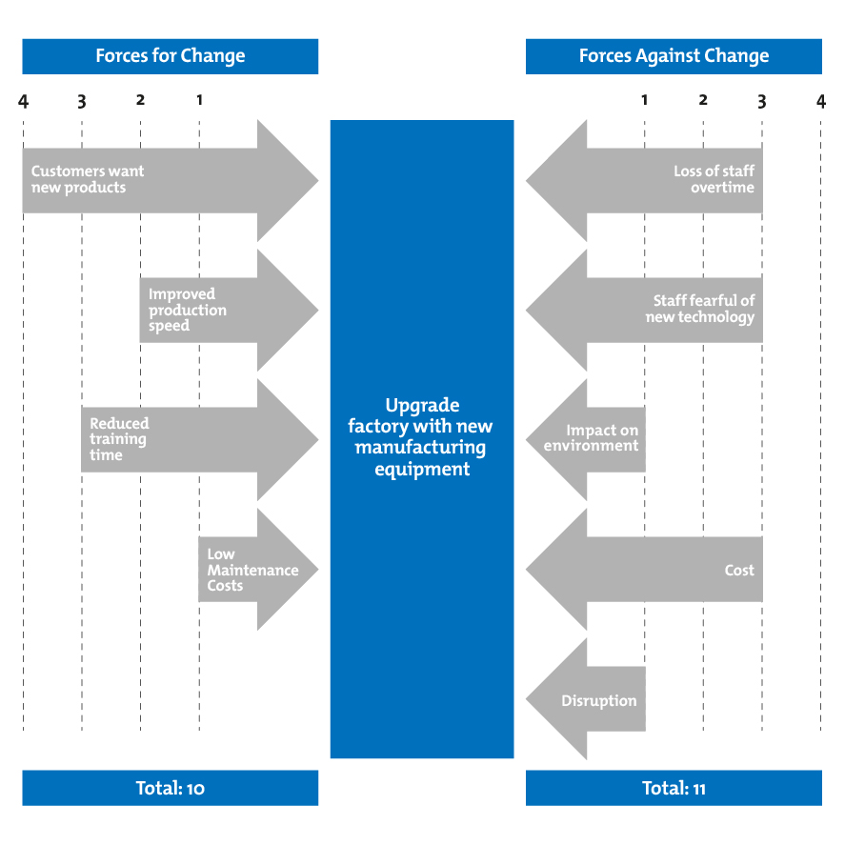
(Figure 6: The Force Field Analysis)
(Source: Mind Tools, 2022)
The Force Field Analysis tool makes it possible to identify and take action against the forces that are working against a proposed change, ensuring that it is implemented successfully inside the workplace. As a result, given the benefit, Force Field Analysis aids in the rational decision-making process when it comes to workplace changes. The model can be applied by British Gas so that they can implement the new change and make sure the employees follow the new changes.
The company will also need to consider the point of view of employees. This will help them in keeping the retention rate high. For the employees who have been terminated the company should hire them again with better negotiations so that the image of the company can be enhanced in the UK market. If the company does not provide better facilities to the employees it will face more backlash in future. Due to this British gas should develop balanced negotiations with employees which will help them in decreasing their turnover ratio. The relationship management process should also be improved and HR should be instructed to carry out meetings with the employees.
The company needs to understand the needs of employees and see what facilities they can provide so that it becomes a win-win situation for the employees and the company. Social interactions should be promoted between the teams and also Cross-Functional teams should be developed. Team building activities need to be conducted in a better way and the company should also use more communication tools. By conducting more meetings with the teams the company will be able to motivate the employees and develop trust among them. Developing trust will also help in improving retention and it would be easier for the company to make employees accept its new offers. These strategies would be helpful for developing a great team for British Gas and also motivating them to work in a better way.

Conclusion
It can be concluded that British Gas has been using wrong policies which are affecting the thoughts and the monetary conditions of the employees. Due to high increase in working hours and reduction of salary employees are not satisfied with the jobs. The only option left with the employees is to either accept the changes or resign. The file helps in knowing about the hire and rehire practices in the UK labour market. The impact of these practices on the employees and the market is also understood through the research. HRM strategies and the way in which they can help the company in planning can be understood.
It explains the recruitment, retention, turnover and dismissal factors linked to HR. There are also many legal implications of changing contractual employment terms. If a company wants to change employment terms it will need to negotiate with the employees and change it on common grounds. For managing contemporary employment relations a great involvement is done by HR. They make sure a positive relationship is maintained between the employees and the company. Based on all the analysis proper recommendations are provided to British gas so that they can change their fire and rehire policies.

References:
Basnyat, S. and Lao, C.S.C., 2019. Employees’ perceptions on the relationship between human resource management practices and employee turnover: A qualitative study. Employee Relations: The International Journal.
Breakway., 2022. Employee Relationship Management. [Online]. Available at: https://www.breakaway-innovation.com/erm_process/popup_companywide_embodiment.html. [Accessed on: 07/08/22].
Conway, E., Fu, N., Monks, K., Alfes, K. and Bailey, C., 2016. Demands or resources? The relationship between HR practices, employee engagement, and emotional exhaustion within a hybrid model of employment relations. Human Resource Management, 55(5), pp.901-917.
Daovisan, H. and Chamaratana, T., 2020. Do linking social, human and financial capital matter for the labour force in Lao PDR? The relationship between occupational well-being and life satisfaction. Employee Relations: The International Journal.
Duggan, J., Sherman, U., Carbery, R. and McDonnell, A., 2020. Algorithmic management and app‐work in the gig economy: A research agenda for employment relations and HRM. Human Resource Management Journal, 30(1), pp.114-132.
Fu, N., Flood, P.C., Bosak, J., Morris, T. and O'Regan, P., 2015. How do high performance work systems influence organizational innovation in professional service firms?. Employee Relations.
Galdino, M., Lesch, L. and Wicker, P., 2022. (Un) Sustainable Human Resource Management in Brazilian Football? Empirical Evidence on Coaching Recruitment and Dismissal. Sustainability, 14(12), p.7319.
Gawke, J.C., Gorgievski, M.J. and Bakker, A.B., 2017. Employee intrapreneurship and work engagement: A latent change score approach. Journal of Vocational Behavior, 100, pp.88-100.
Guerci, M., Radaelli, G., Siletti, E., Cirella, S. and Rami Shani, A.B., 2015. The impact of human resource management practices and corporate sustainability on organizational ethical climates: An employee perspective. Journal of Business Ethics, 126(2), pp.325-342.
Harju, L.K., Hakanen, J.J. and Schaufeli, W.B., 2016. Can job crafting reduce job boredom and increase work engagement? A three-year cross-lagged panel study. Journal of Vocational Behavior, 95, pp.11-20.
Hur, H. and Perry, J.L., 2020. Job security rule changes and employee organizational commitment. Review of Public Personnel Administration, 40(4), pp.641-668.
Johnson, P. and Szamosi, L.T., 2018. HRM in changing organizational contexts. In Human resource management (pp. 27-48). Routledge.
Karanika-Murray, M., Duncan, N., Pontes, H.M. and Griffiths, M.D., 2015. Organizational identification, work engagement, and job satisfaction. Journal of Managerial Psychology.
Kaufman, B.E., 2015. Evolution of strategic HRM as seen through two founding books: A 30th anniversary perspective on development of the field. Human Resource Management, 54(3), pp.389-407.
Kaufman, B.E., 2019. Managing the human factor. In Managing the Human Factor. Cornell University Press.
King, B., 2021. Fire-and-rehire: What is it and why is it controversial? [Online]. Available at: https://www.bbc.com/news/business-57670287. [Accessed on: 07/08/22].
Knight, C., Patterson, M. and Dawson, J., 2017. Building work engagement: A systematic review and meta‐analysis investigating the effectiveness of work engagement interventions. Journal of organizational behavior, 38(6), pp.792-812.
Kokkodis, M., Papadimitriou, P. and Ipeirotis, P.G., 2015, February. Hiring behavior models for online labor markets. In Proceedings of the Eighth ACM International Conference on web search and data mining (pp. 223-232).
Latorre, F., Guest, D., Ramos, J. and Gracia, F.J., 2016. High commitment HR practices, the employment relationship and job performance: A test of a mediation model. European Management Journal, 34(4), pp.328-337.
MBATUTS., 2017. Scope of Human Resource Management. [Online]. Available at: https://www.mbatuts.com/scope-human-resource-management/. [Accessed on: 07/08/22].
Mik, E., 2017. Smart contracts: terminology, technical limitations and real world complexity. Law, Innovation and Technology, 9(2), pp.269-300.
Mind Tools., 2022. Force Field Analysis. [Online]. Available at: https://www.mindtools.com/pages/article/newTED_06.htm. [Accessed on: 07/08/22].
Naegele, L., De Tavernier, W., Hess, M. and Frerichs, F., 2019. A tool to systematise discrimination in labour market integration: An application to ageism. International Journal of Manpower.
Peeters, T., Szymanski, S. and Terviö, M., 2017. The Survival of Mediocre Superstars in the Labor Market.
PeopleG2., 2015. Employee engagement is a must. [Online]. Available at: https://www.peopleg2.com/blog/employee-engagement/. [Accessed on: 07/08/22].
Raskin, M., 2016. The law and legality of smart contracts. Geo. L. Tech. Rev., 1, p.305.
Reilly, P., 2018. Building customer centricity in the hospitality sector: the role of talent management. Worldwide Hospitality and Tourism Themes.
Renwick, D.W., Jabbour, C.J., Muller-Camen, M., Redman, T. and Wilkinson, A., 2016. Contemporary developments in Green (environmental) HRM scholarship. The International Journal of Human Resource Management, 27(2), pp.114-128.
Rondeau, K.V. and Wagar, T.H., 2016. Human resource management practices and nursing turnover. Journal of Nursing Education and Practice, 6(10), pp.101-109.
Roof, R.A., 2015. The association of individual spirituality on employee engagement: The spirit at work. Journal of Business Ethics, 130(3), pp.585-599.
Sawaneh, I.A. and Kamara, F.K., 2019. Evaluating employee retention strategies on job performance. Science Journal of Business and Management, 7(3), pp.67-73.
Smith, L., Sellers, B., Mayo, M. and White, J., 2022. Trade unions and the fight against fire and rehire. Theory & Struggle, 123(1), pp.110-121.
Stuart, M., Spencer, D.A., McLachlan, C.J. and Forde, C., 2021. COVID‐19 and the uncertain future of HRM: Furlough, job retention and reform. Human Resource Management Journal, 31(4), pp.904-917.
Van Wingerden, J., Derks, D. and Bakker, A.B., 2017. The impact of personal resources and job crafting interventions on work engagement and performance. Human Resource Management, 56(1), pp.51-67.
Wong, C.S. and Law, K.S., 2017. The effects of leader and follower emotional intelligence on performance and attitude: An exploratory study. In Leadership Perspectives (pp. 97-128). Routledge.

