PROGRAMME:
BA (Hons) Leadership and Management Skills in the Workplace

MODULE:
BMSW5104

LECTURER:
Aderemi Ojebode

TITLE:
Project Management Plan
STUDENT:
Kamil Kazimierz Lenczowski ,student number 2120445

Contents
INTRODUCTION 3
What is project management? 3
Introduction of the organisation and reason for our project 3
PROJECT DESCRIPTION 5
PROJECT SCOPE 7
WORK BREAK-DOWN STRUCTURE 10
QUAD CHART 11
GANTT CHART 12
STAKEHOLDER MANAGEMENT 12
ALLOCATION OF RESOURCES 14
RISK ANALYSIS 16
Risk probability&impact (Matrix) 16
CONCLUSION 19
REFERENCES 20
APPENDIX I 22
Project life cycle 22
APPENDIX II 23

INTRODUCTION

What is project management?

Project management is like a roadmap helping organisations successfully carry out different projects. It involves a set of strategic steps, including planning, scheduling, and control, providing a systematic approach to achieving organisational goals.
Digging deeper, planning is not just about setting goals but also creating a detailed plan that shows the step-by-step process for completing the project. Scheduling takes this step further by organizing tasks logically to ensure a smooth flow of activities. The control aspect is an ongoing evaluation process, involving monitoring progress, addressing deviations, and making necessary adjustments to keep the project on track. (Karzner. H,2009.).
In the article of Project management: a systems approach to planning, scheduling, and controlling, the Author wants us to know that the rules of project management work everywhere, not just in one type of job. Whether it is building project, dealing with technology or organising events, these rules are like a toolbox that can be used in many different situations. This shows how flexible and useful project management can be in different areas of work. It is like having a set of tools that can be adjusted to fit whatever project you are working on.

Introduction of the organisation and reason for our project

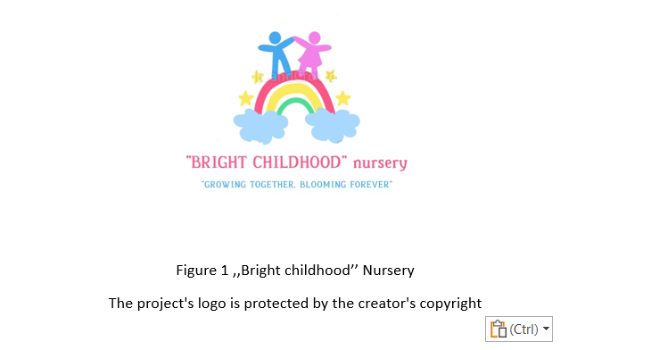
Our project management plan for "BRIGHT CHILDHOOD" Nursery, an innovative venture focused on delivering high-quality childcare services in Derby. Initiated by three enthusiastic entrepreneurs with a financial commitment of £30,000, this project aims not only to meet the childcare needs of parents but also to contribute to community development. Bright Childhood Nursery aims to leverage technology and innovation to provide accessible, high-quality childcare services to families in Derby, launched by three entrepreneurs, who bring in business leadership experience.

The "BRIGHT CHILDHOOD" project is a response to the challenges faced by families in Derby, particularly in accessing high-quality childcare. We recognise gaps in existing childcare units and the need for creating an innovative digital platform that facilitates parents in finding suitable care for their children. Our Project Objectives:

Family Support: Provide parents with easy access to reliable childcare, enabling them to participate seamlessly in their professional lives.

Child Development: Create an environment where young children can thrive and learn, ensuring a strong start in life.
The project goes beyond childcare; it aspires to enhance Derby's overall quality of life for all residents. By tackling childcare challenges, the project not only contributes to the city's economic growth but also invests in the future fabric of the community. Additionally, our commitment extends to staying competitive in the market, striving to be at the forefront of the industry, and maintaining a competitive edge. Ensuring long-term sustainability and excellence will be our top priorities.

PROJECT DESCRIPTION

In contrast to competitors, we go beyond the ordinary, as we launch a new nursey in the neighbourhood that offers a dedicated sensory room that serves as a hub for exploring feelings. We believe in the power of creative expression, which is why our arts and crafts room is a space where imagination takes flight. Our focus on preparing children for the transition to primary school is not just a milestone; it is a comprehensive approach to their future success.
"BRIGHT CHILDHOOD" Nursery introduces on-demand playtime service, catering to the dynamic needs of modern families. We provide a simple, user-friendly online platform, ensuring that parents are seamlessly connected and engaged in their child's daily experiences. Our emphasis on holistic child development means your child is not just cared for but nurtured to thrive.
We take pride in our commitment to inclusivity, offering an available disabled vehicle for those with special needs. Our spacious outdoor areas, featuring a baby-friendly garden, provide an all-weather playground, ensuring fun and exploration no matter the conditions.

Our offering provides more than the average nursery service such as various rooms for activities, an active play area, and even a party hosting service for special occasions. We understand the importance of flexibility, offering affordable daycare options up to 50 hours a week to suit the diverse needs of families.
At "BRIGHT CHILDHOOD," we promote healthy living, offering nutritious food options, including exclusive memberships for parents. We provide an online platform for parent engagement, keeping you connected with your child's development journey.
To succeed our goals we aim to rent the facility that allow us to that.

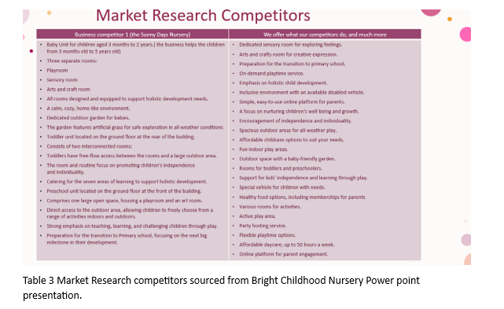

PROJECT SCOPE

The project scope is like a roadmap, detailing the necessary steps to complete a specific product or service in a project. It outlines the practical tasks needed to meet the project's goals. On the other hand, the product scope defines the features and qualities expected in the final deliverables, measured against specific requirements. (Nabeel, M., Mirza, Z., Pourzolfaghar, Z., Pourzolfaghar, M. S. December 2013).
The primary goal of the project is to introduce an innovative childcare service in Derby, addressing the existing gaps and challenges faced by families. This involves a multi-faceted approach, including researching competitors, evaluating childcare options, and enhancing services to meet the diverse needs of families. All of the tasks need to be completed within twelve months time.
To initiate the project, the owners will conduct a thorough examination of existing childcare providers in Derby.
The rules set down by project initiators include having a fixed budget, sticking to the plan, and making sure the project is done within a year.
To efficiently use our resources and finish on time, we need to keep a close eye on health and safety. Even though the owners will deal with safety measures and understand the role of a food inspector, they will make sure the kitchen follows all the rules. "BRIGHT CHILDHOOD" will be careful to guarantee the safety of the children.
Major Goals in the Nursery Project:
- Provide high-quality, flexible childcare options for parents.
- Create an engaging learning environment for kids.
- Make the nursery sustainable long-term.
- Provide a safe and nurturing environment for children aged up to 5 years.
- Develop and implement an engaging curriculum that promotes early childhood development.
- Hire qualified and experienced staff to ensure the well-being and development of the children.
- Build positive relationships with parents and the local community.
What We Will Do:

- Physical setup of the nursery facility, including classrooms, play areas, and administrative spaces.
- Outdoor playground with games.
- Healthy and tasty meals every day.
- Apps to share updates with parents.
- Hire and train caring teachers.
- Safe, cheerful nursery for 40 kids.
- Marketing and community outreach efforts.
- Initial setup of IT infrastructure and security systems.
- Recruitment, hiring, and training of staff.
- Compliance with regulatory requirements.
- Curriculum development and implementation.
- Developing a new services or improving existing ones.

We will also be focused on risk management

• Regularly assess and update the risk possibilities
• Conduct staff training on emergency procedures.
• Collaborate with local authorities and childcare experts to stay informed about potential risks.
What We Will not Do:

- Pick up or drop off kids ( this options will be only for disable kids).
- Offering specialised medical services.
- Extensive renovations or construction beyond cosmetic changes.

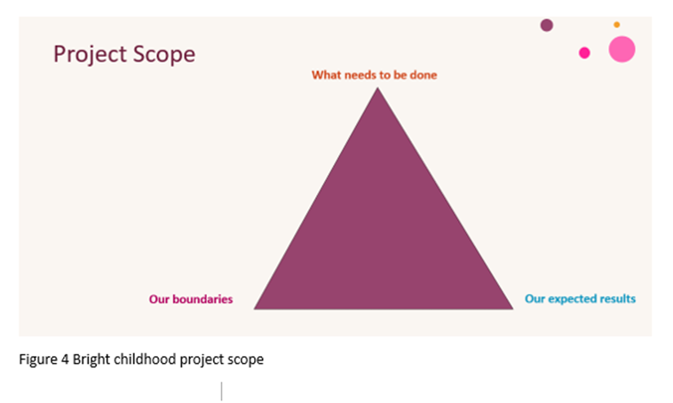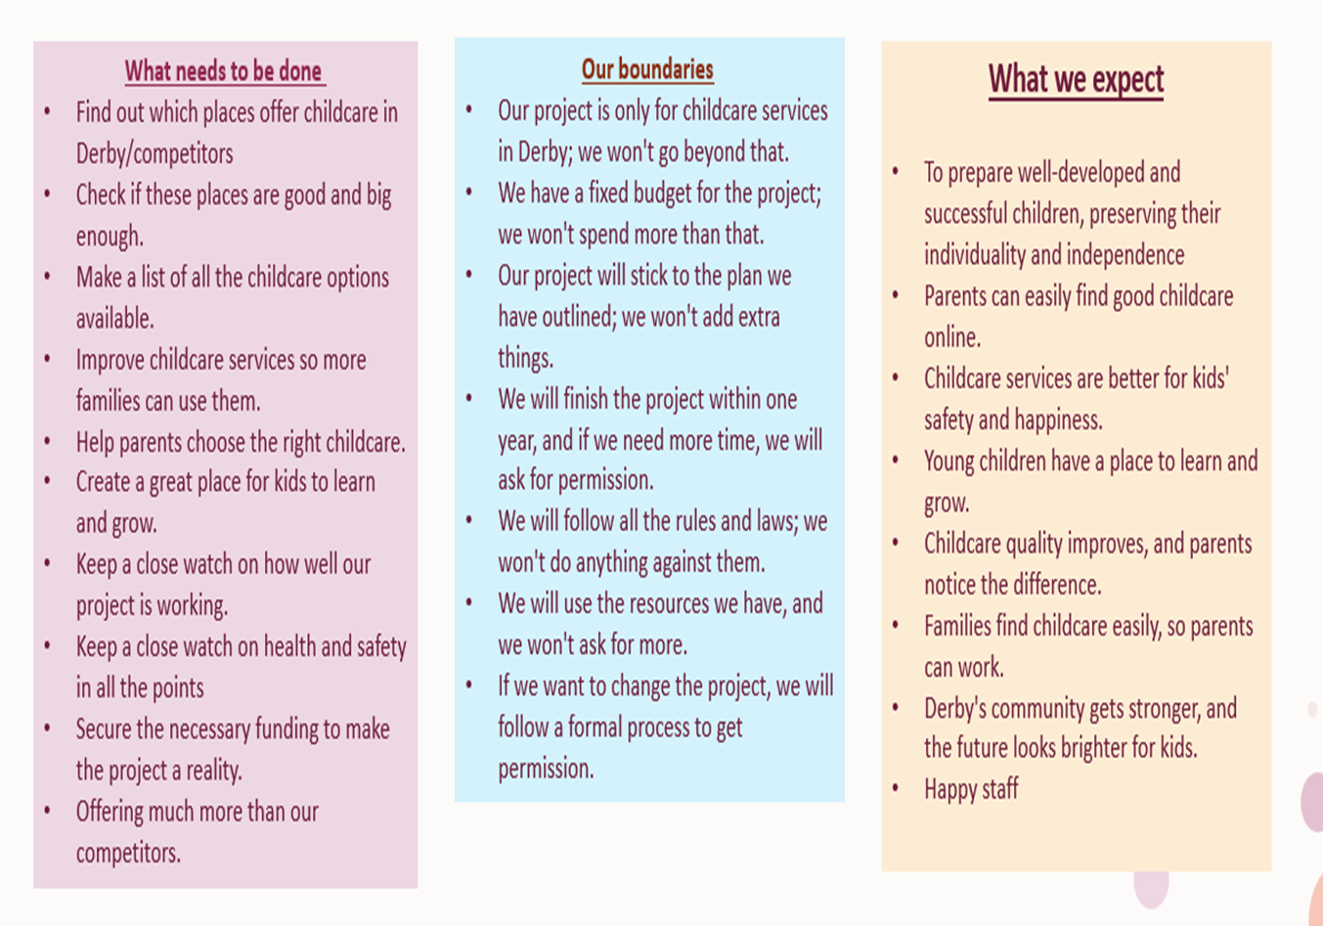
Figure 5 Bright childhood nursery scope
Our project requires time for implementation, and we have set a 12-month timeline for the opening of our nursery. We have several phases to go through, all of which are outlined in the Gantt chart (see Gantt chart section).

To ensure that all tasks within the project scope are captured effectively, the final step involves creating a Work Breakdown Structure (WBS) plan. Think of the WBS plan as the last button you need to click to organise and break down all the tasks into a structured and manageable format. This plan acts as a roadmap, helping you visualise and manage each task systematically, making it easier to understand and implement the entire scope of the project.

WORK BREAK-DOWN STRUCTURE

Work Breakdown Structure (WBS) is a hierarchical framework in project management, decomposing the entire project into manageable components. It organises tasks, aids resource allocation, and facilitates project control. Created by project managers, it ensures accurate organisation, defines responsibilities and identifies milestones. WBS enhances project estimation, minimising risks, and contributes to effective communication with stakeholders, playing a crucial role in project success. (Devi and Reddy,2012).
Project managers rely on Work Breakdown Structures (WBSs) as essential building blocks for effective project management. (Ramos, D,2023).
WBS template serves as a tool for crafting work breakdown structures, breaking down complex projects into manageable work packages. This organisational tool aids project managers in scheduling, tracking, and managing tasks, providing a visual representation of project scope and structure.
Beginning with an example that vividly showcases the potential of Work Breakdown Structures (WBS), the Bright Childhood Nursery project stands out as a compelling case study. Here, the use of tailored templates plays a pivotal role in task organisation, progress tracking, and ensuring efficient project management. Project managers establish specific phases to ensure the success of the implementation process.
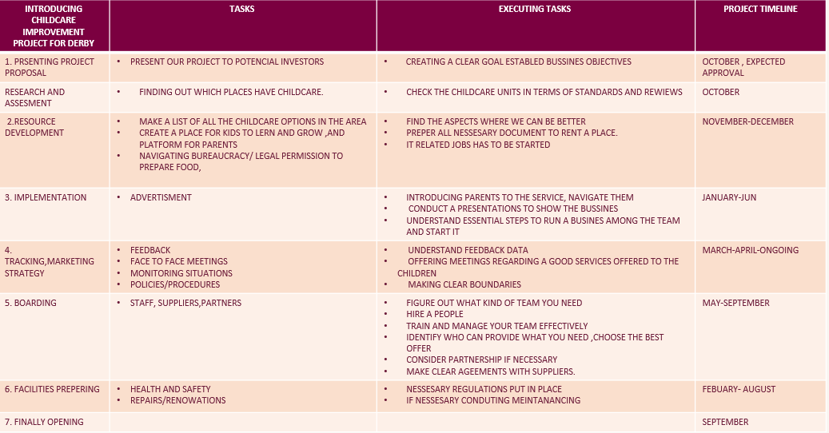

Table 6 WBS at BRIGHT CHILDHOOD NURSERY

QUAD CHART

A Quad chart is a kind of tech document used to quickly describe an invention or innovation with text and images. It is called, quad ’because it is split into four sections on one page in a landscape layout. Makes decisions fast. Even though it is short, quad charts are like white papers and both are usually asked for together. Quad charts and white papers are often requested together because they both serve a similar purpose. (Keenan, R.,2020).
The Quad Chart is like a quick guide to share important info about our Bright Childhood Nursery project. It is made just for us, with section : PURPOSE, CUSTOMERS/STAKEHOLDERS, DESIRED/RESULTS/MEASURES OF SUCCES, so we can make sure everything goes well. It is easy to read, helps us when it comes to decision-making. Fast decisions and efficiency are improved, and it works great with white papers. It is a simple way for project leaders to get the big picture sometimes simpler to understand than a detailed document.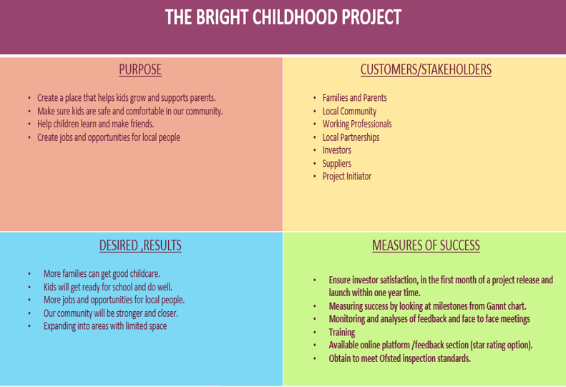
Table 7 QUAD CHART BRIGHT CHILDHOOD PROJECT

GANTT CHART

A Gantt Chart is a visual tool used for planning and tracking projects. It presents a timeline with tasks represented as horisontal bars, indicating their start and end dates. This graphical representation aids in monitoring progress, resource allocation, and identifying task dependencies. Gantt Charts are vital project management tools across various industries, facilitating efficient scheduling and coordination. ( Grant, M., 2022).
The Gantt Chart for the Bright Childhood project is our project planner. It helps us plan our tasks and adjust quickly if things change. It shows how tasks are connected, so we avoid delays and solve problems fast. This is crucial in a project about early childhood, where specialists work together. However, it is important to balance strict planning and staying flexible to manage the project well. Our team agreed that we should allow more time for specific tasks and components to be completed on time. This way, we can keep things tidy and not worry that we do not have enough time to do so. However, by adopting additional time for certain tasks, we are still aware of time management and our scope, accepting our time frame boundaries.
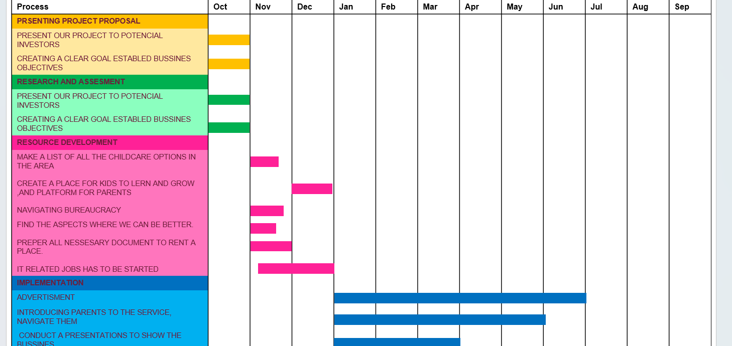
The Gantt Chart for the Bright Childhood project is our project planner. It helps us plan our tasks and adjust quickly if things change. It shows how tasks are connected, so we avoid delays and solve problems fast. This is crucial in a project about early childhood, where specialists work together. However, it is important to balance strict planning and staying flexible to manage the project well. Our team agreed that we should allow more time for specific tasks and components to be completed on time. This way, we can keep things tidy and not worry that we do not have enough time to do so. However, by adopting additional time for certain tasks, we are still aware of time management and our scope, accepting our time frame boundaries.

STAKEHOLDER MANAGEMENT
Table 8 Bright childhood nursery`s Gannt chart
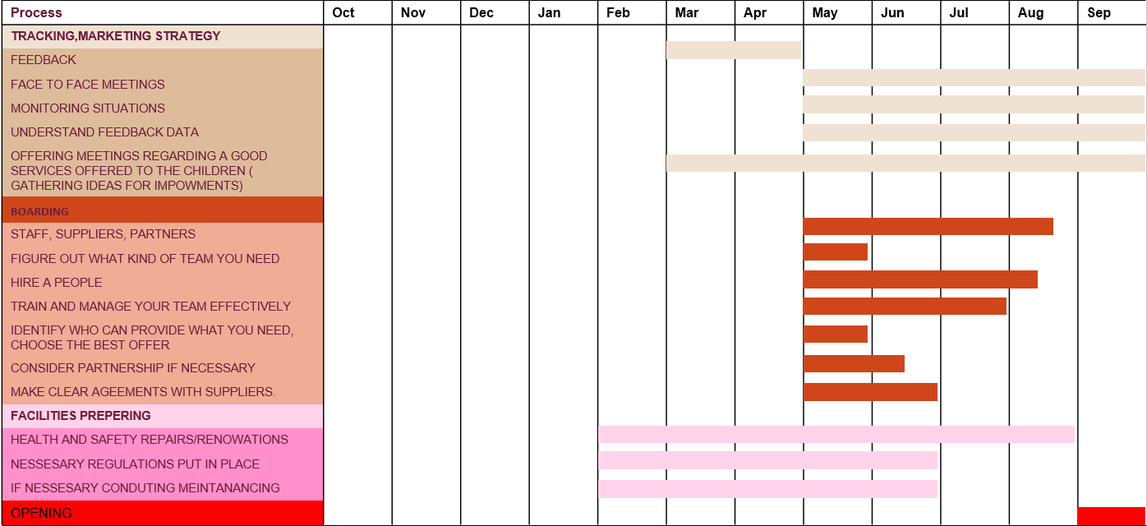
Table 9 Bright Childhood nursery`s Gannt chart

ALLOCATION OF RESOURCES

Stakeholder management involves how a company interacts with various groups (stakeholders) that have an interest in or are affected by its activities. In the early stages, these stakeholders provide diversity and competitive advantages to the company. For instance, customers, employees, competitors, suppliers, and the government all play roles in shaping the firm's resource base. However, over time, stakeholders' preferences shift towards industry-wide shared practices, leading to homogeneity. (Verbeke, A., Tung, V,. 2013).
Stakeholder management is the process of managing relationships with entities that impact or are impacted by an organisation. It involves adapting to changing stakeholder needs and aligning with industry norms to ensure positive interactions and outcomes for the organisation. ( Bukowska, U., 2008).
Bright Childhood Nursery actively involves parents, staff, and regulators, focusing on their impact on success. We are dedicated to managing these relationships for effectiveness and strategically balancing diverse stakeholder expectations. Considering various influences and being aware of changing stakeholder preferences, we aim to position ourselves for a competitive edge.
To better understand and visualise, it is recommended to refer to our presented stakeholder management analyses below, especially for those with a visual memory based on graphic visualisations. The table below will show several internal and external stakeholders and the level of their influence on the business, represented in multiple colors (INTEREST LEVEL). Stakeholder's interest is placed in different aspects, making it visible where exactly influence can occur.

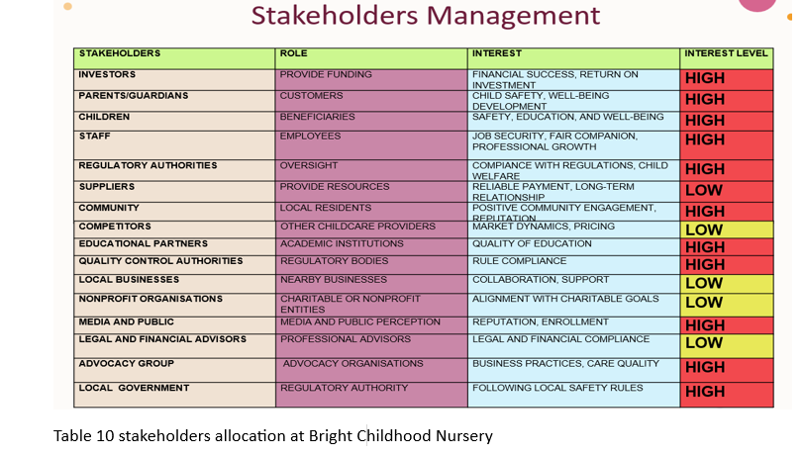

The table below covers all the key players, including people and equipment, giving a clear picture of how they impact our business. However, it explains the possible cost of the initial stage and a monthly simulation of expenses.
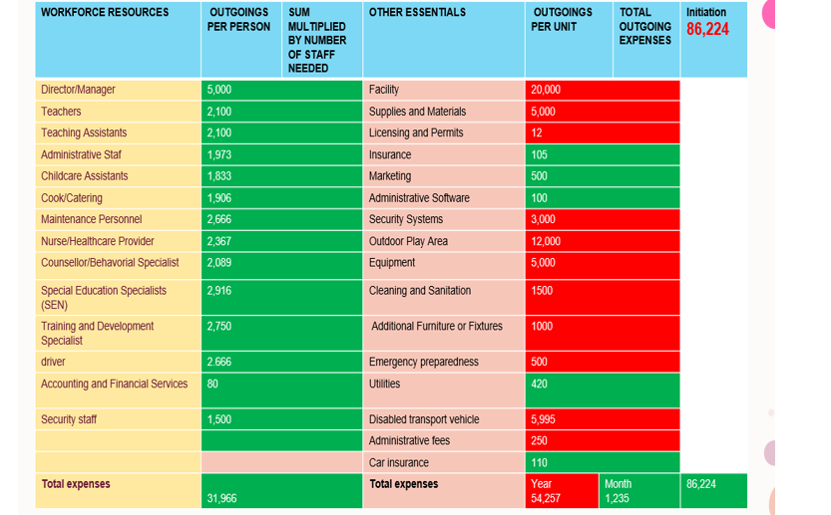
Investors will initially be entitled to 40% of the project's profits, providing a robust return on investment. Although it is anticipated that profits may experience a gradual decline as the project advances, the enduring potential for growth remains a fundamental asset. Our steadfast dedication to financial transparency guarantees that investors receive regular updates on the project's performance. Additionally, post the agreed founding, the company will actively work on implementing an exit plan, underscoring our commitment to collaborative and comprehensive business strategies.

Table 11 Allocation of resources and budget analysis at the Bright Childhood Nursery

RISK ANALYSIS
Risk analysis involves identifying, understanding, assessing, and planning in the context of projects. It includes anticipating potential issues, evaluating their probability and impact, and planning preventive actions. This tool enables project managers to be prepared for potential challenges, minimise negative consequences, and maintain flexibility during project execution. (Raftery, J., 1993).
Bright Childhood Nursery is well-prepared to face and handle possible challenges, understanding the seriousness of different situations. At every stage of business planning, it sticks to the usual steps, making sure to cover everything from the start of the project to its finish. The nursery has a strong plan for managing risks, carefully including all project components. This detailed approach spans from when the project begins, where risks are identified, to the planning phase, where strategies are made, and finally to the implementation stage, where every part is done with care. This solid risk management plan shows that Bright Childhood Nursery is dedicated to keeping a high standard of excellence in every aspect of its business.

Risk probability&impact (Matrix)
A 5x5 risk matrix is a tool that helps assess and manage risks by sorting them based on their likelihood and potential impact. It is like a visual map that shows which issues need attention first. Using colors or labels, the matrix indicates which risks are high-priority, making it easier for teams to decide how to address and handle potential problems. ( Duan, Y, Zhao, J, Chen, J, & Bai, G Year,.2016).
Preparations for opening the nursery involved processes such as brainstorming, risk classification, understanding potential threats, and developing mitigation plans. The company focused on a strategy to be prepared for any potential issues rather than being caught off guard. Preventive measures will be implemented to effectively manage risks and ensure a smooth transition during the nursey unit opening process. This approach will allow the company to flexibly respond to challenges and increase the chances of success in this realistic project. In the future, the company plans to continue this strategy, maintaining a proactive approach to risk management and swift response to potential challenges.

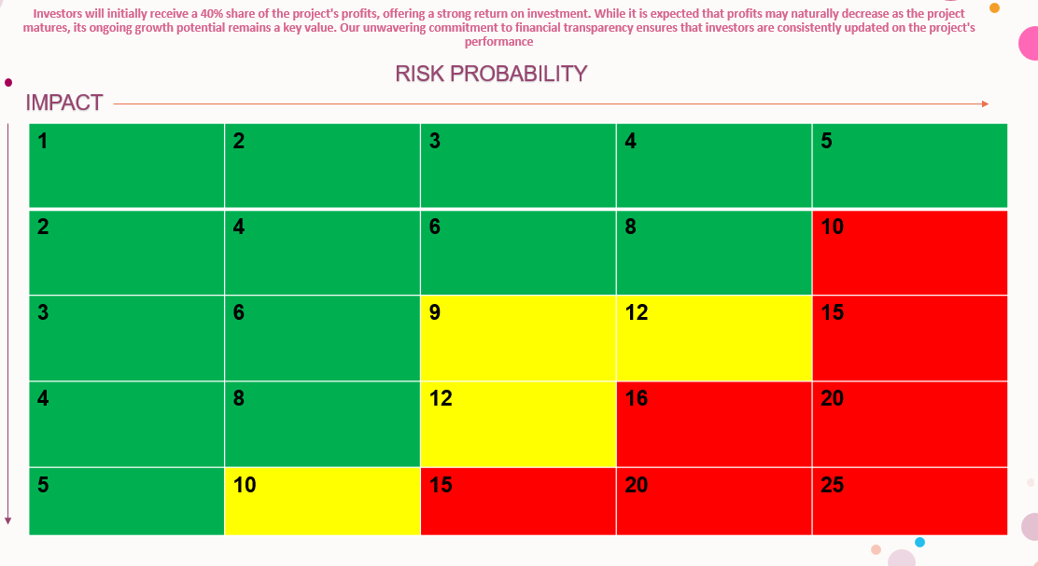
Table 12 Risk Matrix

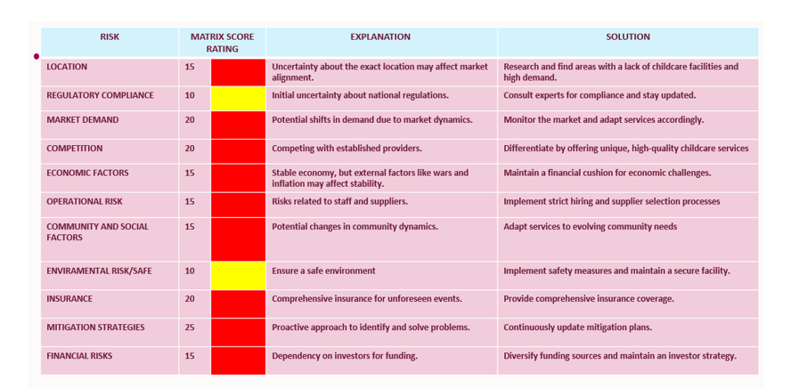
Table 13 Risk Analysis at the Bright childhood Nursery
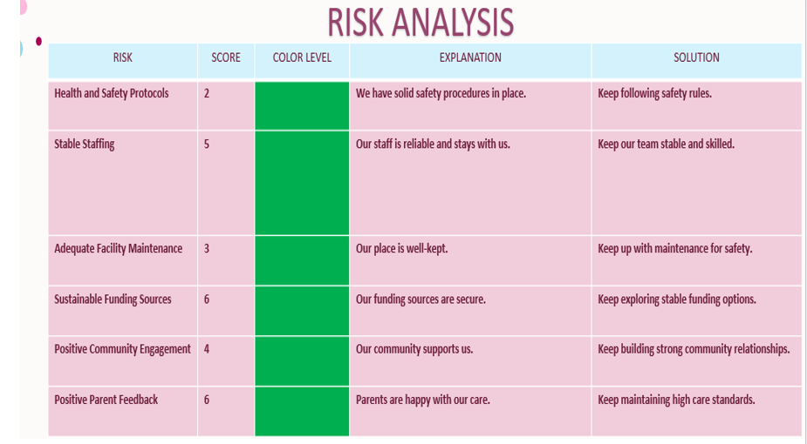
Table 14 Risk Analysis at the Bright childhood Nursery

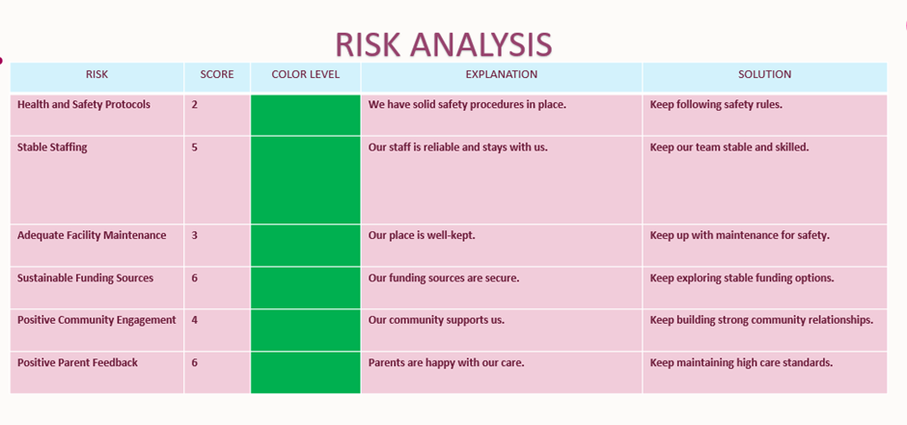

CONCLUSION
In summary, our idea for the Bright Childhood Nursery project in Derby is like a big plan to create a fantastic place for kids and parents. Three colleagues are enthusiastic about kickstarting this initiative with some initial funding, and other individuals, who share similar concerns, have joined the business. We want to build a place that is not just average but innovative and tailored specifically for children.
Our approach involves not only providing regular or average options for kids, but also being inspired to address different needs. We envision rooms designed for specific purposes, such as a space for cultivating emotions and another for drawing and crafting. Additionally, we have designated special playtimes for occasions when kids or their parents desire it. We leverage phones and apps to keep parents informed about their kids' day, providing updates on the available options or addressing any concerns.
Our plan covers everything, from making sure teachers are nice and trained to having a safe and fun place for 50 kids. We made a timetable that shows when things will happen in the next 12 months.
There are some easy guides, like a Quad Chart, which helps us make quick decisions, and a Gantt Chart which helps us follow the plan. We also talk a lot with parents and other important people to make our plan better.
The most important thing is to make sure kids have a happy and safe place to learn and play. We also want to help parents by being flexible and using new ideas. This plan is not just for today; it is for making Derby a better place for families in the future.

REFERENCES
Brown, R. (2023) The Cost of a Running Children's Care Home, Rangewell, available at: https://rangewell.com/care-homes/guides/childrens-care-home-running-costs
Bukowska, U. (2008) Proces zarządzania interesariuszami, Wydawnictwo Uniwersytetu Ekonomicznego, available at: https://r.uek.krakow.pl/handle/123456789/2342
Devi, T.R., Reddy, V.S. (2012) Work Breakdown Structure of the Project, Department of Computer Science, Kakatiya University, available at: https://scholar.google.co.uk/scholar?hl=en&as_sdt=0%2C5&q=work+breakdown+structure+devi+and+reddy+2012&btnG=
Duan, Y., Zhao, J., Chen, J., Bai, G. (2016) A risk matrix analysis method based on potential risk influence: A case study on cryogenic liquid hydrogen filling system, available at: https://www.sciencedirect.com/science/article/abs/pii/S0957582016300167
Grant, M. (2022) Gantt Charting: Definition, Benefits, and How They're Used, Investopedia, available at: https://www.investopedia.com/terms/g/gantt-chart.asp
Guevara, P. (2023) A Guide to Understanding 5x5 Risk Matrix, Safety Culture, available at: https://safetyculture.com/topics/risk-assessment/5x5-risk-matrix/
Harold, K. (2013) Project management: a systems approach to planning, scheduling, and controlling, available at: https://zlib.pub/book/project-management-a-systems-approach-to-planning-scheduling-and-controlling-5hfhpv9t3730
Jackson, J. (2023) Children’s nursery insurance: what you need to keep your business protected, Blossom, available at: https://blossomeducational.com/blog/childrens-nursery-insurance-what-you-need-to-keep-your-business-protected/
Keenan, R. (2020) A brief intro to Quad(rant) charts, Positioning Insights, available at: https://positioninginsights.com.au/quad-charts/
Kiskis, D. (2020) The Quad Chart as a Strategic Planning Tool, Part 1.4 of Case Study: Strategic Analysis for a Healthcare Analytics Department, Medium, available at: https://publication.usingstrategy.com/the-quad-chart-as-a-strategic-planning-tool-eed259cf66a7
Mirza, M. N., Pourzolfaghar, Z., Shahnazari, M. (2013) Significance of Scope in Project Success, Limkokwing University of Creative Technology, available at: https://www.researchgate.net/publication/275539061_Significance_of_Scope_in_Project_Success
Rahman, H.(2012) Henry Fayol and Frederick Winslow Taylor’sContribution to Management Thought: An Overview, ABC Journal of Advanced Research, available at: https://d1wqtxts1xzle7.cloudfront.net/37409499/Henry_Fayol_and_Frederick_Winslow_Taylors_Contribution_to_Management_Thought_An_Overview-libre-libre.pdf
Ramos, D. (2023) Free Work Breakdown Structure Templates for Google Sheets and Google Docs, Smart Sheet, available at: https://www.smartsheet.com/content/wbs-templates-google-sheets-docs
Siami-Irdemoosa, E., Dindarloo, S. R., Sharifazadeh, M. (2015) Work breakdown structure (WBS) development for underground construction, available at: https://www.sciencedirect.com/science/article/abs/pii/S0926580515001594
Verbeke, A., Tung, V. (2013) The Future of Stakeholder Management Theory: A Temporal Perspective, J Bus Ethics, available at: https://link.springer.com/article/10.1007/s10551-012-1276-8#Sec5

APPENDIX I

Project life cycle
The life management cycle is a model depicting the main phases of executing a project from start to finish. It consists of stages such as defining, planning, executing, and delivering. At each phase of this process, all activities are kept under control to ensure proper project implementation. The purpose of the life management cycle is to maintain oversight of the project at every step - from initiation, through planning, execution, and progress monitoring, to eventual close-out and recap. This allows for the timely completion of the project according to goals and requirements. ( Rahman. H.2012).
The purpose of this Project Management Plan is to discuss how the management of a nursery will place significant emphasis on implementing the life cycle model for all key initiatives. This entails embracing core components of structured project management, including:
Project Initiation: Clearly defining project goals, tasks, scope, and involving stakeholders from the start.
Project Planning: Developing detailed plans covering tasks, milestones, resources, budgeting, and managing risks.
Project Execution: Implementing all tasks with careful oversight to track progress and make adjustments as needed.
Project Close: Following specific procedures to formally accept completed work and learn from the process.

By using these strong project management methods, we aim to ensure timely and budget-friendly delivery of impactful programs that align with our goal of nurturing young minds.

APPENDIX II
Anonymous (2017) S3001: Guidelines for Risk Management, NASA, available at: https://www.nasa.gov/wp-content/uploads/2015/10/s3001_guidelines_for_risk_management_-_ver_g_-_10-25-2017.pdf
Anonymous (2018) Risk and How to use a Risk Matrix, Let's Learn Public Health, available at: https://www.youtube.com/watch?v=-E-jfcoR2W0
Anonymous (2022) Website of the Sunny Days Nursery, available at: https://sunnydaysnursery.com/
Anonymous (2022) What is the cost of starting a limited company in the UK in 2022?, The formations company, available at: https://www.theformationscompany.com/knowledge-base/what-is-the-cost-of-starting-a-limited-company-in-the-uk-in-2022
Anonymous (2023) Business Energy Quotes, Money Supermarket, available at: https://www.moneysupermarket.com/gas-and-electricity/business-energy/
Anonymous (2023) Business vehicle, VOLKSWAGEN CADDY WHEEL CHAIR ACCESSIBLE MPV 1.6 DIESEL AUTOMATIC 19K MILES, Ebay, available at: https://www.ebay.co.uk/itm/404542858186?hash=item5e30a223ca:g:o1sAAOSwTh5kgzAG
Anonymous (2023) Children's nurse, Job profile, Prospects, available at: https://www.prospects.ac.uk/job-profiles/childrens-nurse
Anonymous (2023) Early years teacher, Job profile, Prospects, available at: https://www.prospects.ac.uk/job-profiles/early-years-teacher
Anonymous (2023) Nursery Teaching Assistant average salary in United Kingdom, 2023, Talent.com, available at: https://uk.talent.com/salary?job=nursery+teaching+assistant
Anonymous (2023) Property for the nursery, available at: https://propertylinkassets.estatesgazette.com/images/20231020/1-117321166.pdf
Anonymous (2023) Average childcare costs, Money Helper, available at: https://www.moneyhelper.org.uk/en/family-and-care/becoming-a-parent/childcare-costs
Anonymous (2023) Average Security Guard Hourly Pay in United Kingdom, Pay Scale, available at: https://www.payscale.com/research/UK/Job=Security_Guard/Hourly_Rate
Anonymous (2023) Business Energy Bills, Money Supermarket, available at: https://www.moneysupermarket.com/gas-and-electricity/business-energy/a/business-gas-electricity-average-bills/
Anonymous (2023) Child care director salary in United Kingdom, Indeed, available at: https://uk.indeed.com/career/child-care-director/salaries
Anonymous (2023) Childcare and Education Worker, Totaljobs, available at: https://www.totaljobs.com/job/child-care-worker/argyle-bute-council-job101436351?Keywords=&r=1|SalaryChecker
Anonymous (2023) Emergency planning, Derby City Council, available at: https://www.derby.gov.uk/advice-and-benefits/emergencies/civil-emergency-plan/index.html
Anonymous (2023) General Information & Fees, La Petite Academy, available at: https://lapetiteacademy.co.uk/derby-nursery-fees​
Anonymous (2023) Learning & Development Specialist, Indeed, available at: https://uk.indeed.com/q-learning-&-development-specialist-jobs.html?vjk=076e88d3f79d16d8
Anonymous (2023) Major industrial accidents, Derbyshire Prepared, available at: https://www.derbyshireprepared.org.uk/risks-derbyshire/major-industrial-accidents/
Anonymous (2023) Nursery Cook average salary in United Kingdom, 2023, Talent.com, available at: https://uk.talent.com/salary?job=nursery+cook
Anonymous (2023) Safeguard your child's future with an informed school choice, Map with inspection rating, available at: https://www.locrating.com/
Anonymous (2023) Special educational needs (SEN) teacher, National Careers Service, available at: https://nationalcareers.service.gov.uk/job-profiles/special-educational-needs-sen-teacher

What Sets Us Apart | Community Impact
1. Embracing Emotions: Unlike others, we prioritise emotional development with our dedicated sensory room. It is a haven where kids explore and understand their feelings in a comforting space. | Inclusivity matters: With our specially designed vehicle, we ensure inclusivity for children with different needs. Every child is welcome, fostering a sense of community and acceptance.
2. Creative Havens: Our arts and crafts room is a hub of creativity. Kids dive into artistic expression, fostering imagination and individuality in ways others might miss. | Exciting choices for every child: Varied rooms for play, learning, and even party hosting create an environment where every child's interests are catered to, promoting social an d cognitive development.
3. Beyond Babysitting: We are not just watching kids; we are preparing them for the next big step – primary school. Our focus on early education ensures a solid foundation for lifelong learning. | Flexible and affordable solutions: Recognising diverse family needs, we offer flexible and affordable daycare options. Our goal is to support families while making quality childcare accessible to all.
4. Playtime on Your Terms: We break the model with an on-demand playtime service. Flexibility is key, offering parents a childcare solution that fits their unique schedules. | Promoting healthy habits: We care about well-being, providing nutritious options and exclusive memberships for parents who value healthy living for their families.
5. Effortless Parental Engagement: Our user-friendly online platform is designed to keep parents effortlessly engaged in their child's daily adventures. Stay connected easily and stay informed. | Our commitment to community: "BRIGHT CHILDHOOD" Nursery is not just a childcare facility; it is a community builder. By prioritising emotional development, fostering creativity, and offering flexible solutions, we contribute to the overall well-being of families in Derby. Our commitment is to create an inclusive, engaging, and supportive space that goes beyond traditional childcare.

