Economics of Sustainability

EXTREME WEATHER EVENTS

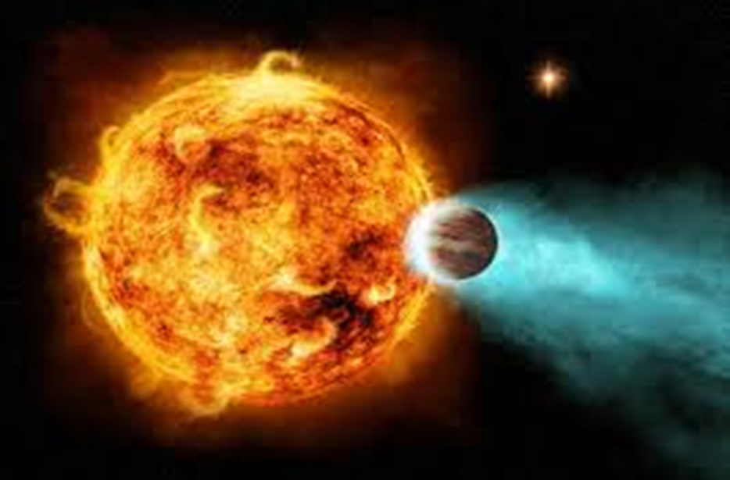
https://kopalniawiedzy.pl/media/lib/298/goracyjowisz-18c6c8246c7892d8222302212808f3bc.jpg

Magdalena Janas
2107190

Executive summary

This report refers to the World Economic Forum's report "Global Risk 2024", which identifies the greatest global challenges in the coming years. This report discusses extreme climate change and ecosystem collapse and examines how these threats may impact sustainable development. The report refers to a variety of credible sources to assess human-made environmental damage.
The report also analysed the potential impact of ecosystem loss and applied sustainable development theory, the Maltese population theory, Ricardian rent theory and the environmental Kuznets curve. The report also considered how sustainable development goals relate to climate change and ecosystem loss. The report concludes with three recommendations that could be useful in stopping extreme weather changes and the loss of natural ecosystems.

Contents:
- INTRODUCTION
- MAIN BODY
  - Overview of extreme weather events
  - The impact of climate change on life on Earth
  - Sustainable Development Goals (SDGs)
- CONCLUSION
- RECOMMENTATION
- REFERENCES

- Introduction

This report aims to identify global risks and discuss how identified risks may impact global contributions to sustainable development. For the purposes of this report, the threats that will be discussed are extreme climate change and ecosystem loss, which are among the most serious global threats. The report also applies several sustainability theories to better understand how climate change and nature loss may impact sustainability (1). To achieve this goal, the report presents four main goals:

1. Conduct secondary research to determine the environmental, social and economic impacts of climate change.
2. Conduct secondary research to identify the main factors contributing to ecosystem loss.
3. Applying Malthusian theory, neo-Malthusian theory and neoclassical theory to understand how extreme weather conditions can impact sustainable development.
4. Providing a set of recommendations supporting sustainable development and mitigating the risks associated with climate change and ecosystem loss.
Every year, the World Economic Forum (WEF) publishes an annual report titled "Global Risks." The World Economic Forum's Global Risks Report 2024 identified extreme weather events and critical changes in Earth systems as the greatest concerns facing the world in the coming decade. The report identifies the four most serious threats over the next ten years, namely: extreme weather phenomena, critical changes in Earth systems, loss of biodiversity and ecosystem collapse, and shortages of natural resources. The effects of climate change are already being felt around the world. According to the IPCC Special Report "Global Warming of 1.5°C", with an increase in the average global temperature by 2°C, there will be much more serious consequences than previously forecast. There will be storms, floods, heat waves, droughts, winds, fires, frost strikes, rising sea and ocean levels all over the world. As a result, there will be economic losses, climate migrations, easier spread of infectious diseases and increased political tensions (2).
In the second chapter of the latest report "Global Risk" (WEF), the WEF presented the most important risks for the next ten years. The diagram below shows the responses from GRPS and ranks each risk by severity. According to respondents, the four biggest challenges over the next ten years are environmental threats such as extreme weather events, critical change in earth systems, and natural resource shortages (3). The report will therefore examine extreme weather events and ecosystem collapse in more detail and present possible solutions that can be implemented to address the challenges posed by these risks.

FIGURE 1. Top 10 Risks
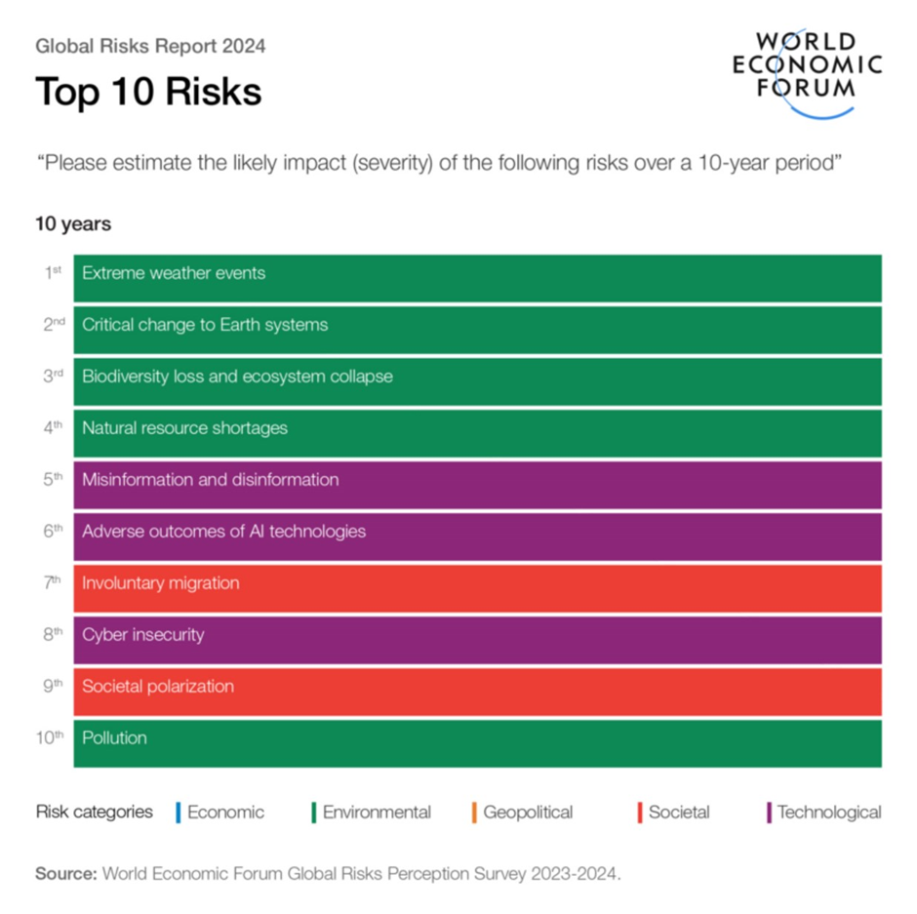
https://pbs.twimg.com/media/GEFiHZNWEAAVBvo.jpg:largehttps://pbs.twimg.com/media/GEFiHZNWEAAVBvo.jpg:large

- Main body

2.1. Overview of extreme weather events
The climate on Earth is constantly changing, and these changes are increasingly manifesting themselves in previously unrecorded intensity of weather phenomena. It is becoming necessary for humanity to adapt to extreme weather phenomena. It is becoming necessary to adapt to climate change, i.e. to teach society new reactions and behaviours that favor balance on the planet. Global warming in the future will be the result of current and future carbon dioxide emissions. If emissions of CO₂ and other greenhouse gases are not reduced in the coming decades, global warming will exceed the thresholds of 1.5°C and 2°C in the 21st century. This will result in an increase in the intensity of extreme weather phenomena, such as regional temperature increases, changes in rainfall patterns, and changes in soil moisture (Nationa Geografic 2022).
It is increasingly visible how the burning of fossil fuels, cutting down forests and the breeding of livestock affect the Earth's climate and temperature. Many greenhouse gases occur in natural conditions, but human activity increases the presence of some of them in the atmosphere, especially: carbon dioxide (CO₂), methane, nitrous oxide, and fluorinated greenhouse gases. By 2020, the concentration of CO₂ in the atmosphere had increased to 48% above pre-industrial levels, i.e. from 1750. Other greenhouse gases are emitted in smaller amounts as a result of human activity. For example, methane is a more potent greenhouse gas than CO₂, but it stays in the atmosphere for a shorter time. Nitrous oxide, like CO₂, is a long-lived greenhouse gas that accumulates in the atmosphere for decades or even centuries. Non-greenhouse gas pollutants, including aerosols, have a variety of warming and cooling effects, including issues such as poor air quality(4).

Many studies show that higher temperatures will cause a geographical shift of climatic zones, which will affect the distribution and abundance of many plant and animal species. Today, we can already see how many animal species are under pressure related to habitat loss and environmental pollution. The increase in temperature may also influence phenology, i.e. the behaviour and life cycle of animal and plant species. This may contribute to an increase in the number of pests and invasive species, and thus to an increased incidence of certain diseases in humans. At the same time, yields and profitability of agricultural activities and animal production may be reduced, as well as a weakening of the ability of ecosystems to provide important services and goods, such as the provision of clean water or cool and clean air(5). Higher temperatures increase water evaporation, which, combined with a lack of rainfall increases the risk of severe drought periods(6).
Drought is an example of a threat whose development may also be caused by human activity through changes in land use, improperly carried out drainage works, cutting down trees and shrubs, and excessive exploitation of surface water and groundwater resources. Spring droughts may cause abnormal development of vegetation, lower harvest quality, reduced yields and, consequently, increase in food prices(7).
Large amounts of plastic are one of the seven key areas recognised by the European Commission as crucial for achieving a circular economy in the EU by 2050. The effects of single-use and subsequent disposal of plastic packaging are already visible on the coasts of seas and oceans. Plastic waste is increasingly polluting the oceans, and it is even believed that by 2050 there will be more plastic than fish in the oceans(8).
As experts from the Intergovernmental Panel on Climate Change (IPCC) point out, population growth increases greenhouse gas emissions but rising incomes have an even greater impact on emissions per person on Earth. In the richest countries, CO₂ emissions are 50 times higher than in the poorest countries, but it is in the countries with the lowest income and minimal emissions that the population is growing the fastest(9).
Concrete production contributes to extreme weather events. Taking into account all stages of production, concrete is responsible for between 4 and 8 percent of global CO₂ emissions. Among raw materials, only coal, oil and gas are a greater source of greenhouse gases. Half of concrete's CO₂ emissions occur during the production of cement clinker, the most energy-intensive part of the cement production process. The problem of CO₂ emissions in concrete production is greater than that of plastic, but it is generally considered less serious. Concrete does not come from fossil fuels, but it absorbs vast swathes of fertile soil, causing obstruction of rivers and choking animal habitats(10).
Many factors influence bee populations. To protect them from declining in numbers, a map was created showing their distribution around the world. Research conducted in 2019 confirmed that the number of insects decreases by 2.5% every year. Scientists from China and Australia have shown that bees, ants and beetles are dying eight times faster than mammals, birds and reptiles. If this trend does not change, there may be no insects left on Earth in 2119. Bees are responsible for as many as 4,000 varieties of vegetables. The International Union for Conservation of Nature (IUCN) and the European Commission estimate in the Red List that in Europe, nearly one bee species in ten is at risk of extinction(11).

FIGURE 2. Trends in heat related mortality
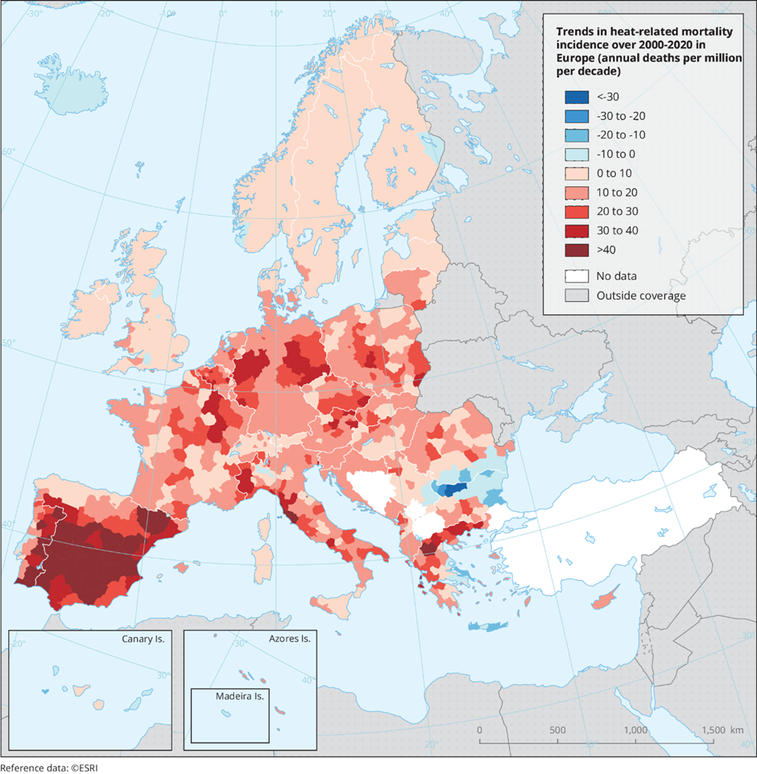
https://www.eea.europa.eu/data-and-maps/figures/trends-in-heat-related-mortality/map3-4-153690-trends-heat.eps/MAP3.4-153690-Trends-heat-related-v5.eps.75dpi.png

  - The impact of climate change on life on Earth

Malnutrition of millions of children around the world slows down their development. 150 million children under the age of five, or 1 in 5 children in this age group, are shorter than the norm for their age, and more than 50 million are underweight. It is also not optimistic that 32.8% of women of reproductive age suffer from anemia, which may have serious health consequences not only for them, but also for their offspring(12).
Most hungry people live in Asia, Africa and Latin America. It is estimated that in total, hunger or severe malnutrition affects 821 million people, i.e. every ninth inhabitant of the planet. Many reports show that hunger is increasing in regions of the world where climate change is most noticeable and in societies heavily dependent on crops and agriculture. According to the Oxfam report, in the 10 countries most affected by the consequences of climate change, the number of people suffering from severe hunger has increased by 123% over the last 6 years, and it is the governments of these countries that appeal most to the UN for help due to heat, drought and downpours(13).
This trend supports the "Malthusian theory of population", a theory developed by economist Thomas Malthus. The theory assumes that the human population is growing faster than the global food supply. Moreover, this theory is supported by the “Law of Diminishing Returns,” which states that once an optimal level of production is reached, everything produced after that point results in a lower level of production (Investopedia, 2022). According to this theory, there is a large imbalance between human population growth and food supply, which unfortunately causes food shortages in the event of exponential population growth (Economics Online, 2019).
Economist David Ricardo believed that there are biophysical limits to economic growth and that human population growth leads to overexploitation of agricultural land. The "Ricardian theory of rent" states that as the human population increases, the demand for land increases, thereby increasing the price of land. However, as land prices increase, the quality of land decreases through exploitation, which leads to decreasing profits (Investopedia, 2022).
Figure 3 shows the average price of farmland in the UK since 1973. The data shows that the price of farmland has increased significantly since 1993, supporting the 'Ricardian theory of rent'. As the demand for land increases, the demand for food also increases, which has led to higher food prices (United Nations, 2021). Figure 4 shows that the "World Food Price Index" has increased sharply since 2000.

FIGURE 3. The average price for farmland in the United Kingdom
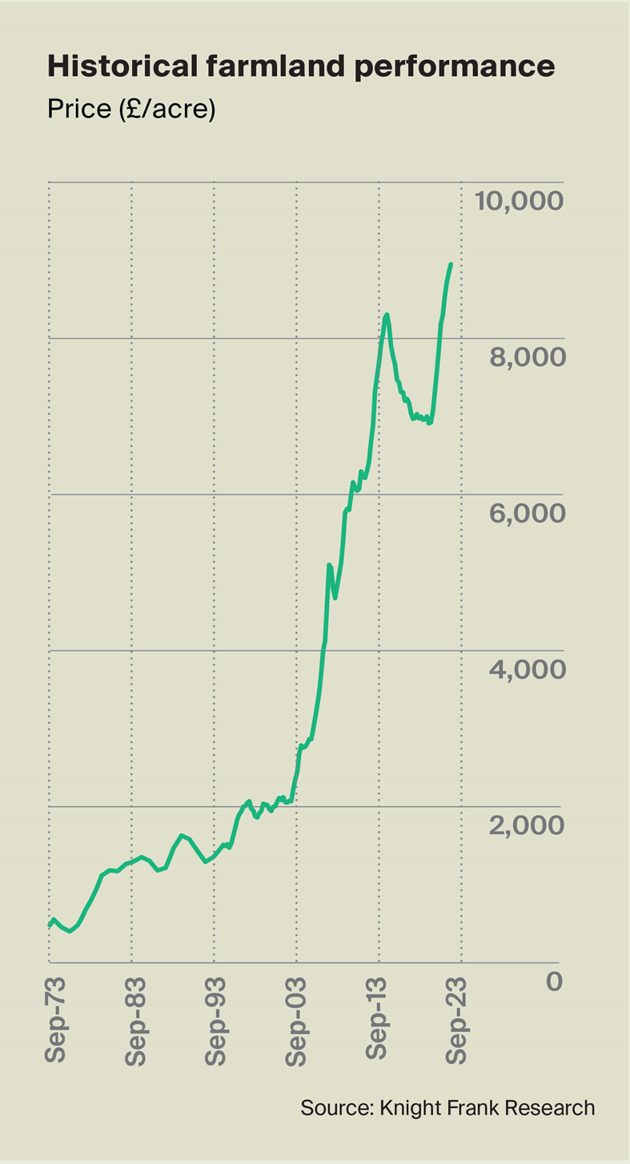
https://content.knightfrank.com/blog/2023/10/b7cd9e47-dde0-44d7-b9a9-da4729dedf97/kf-farmland-q3-2023fig1.jpg

FIGURE 4. World Food Price Index
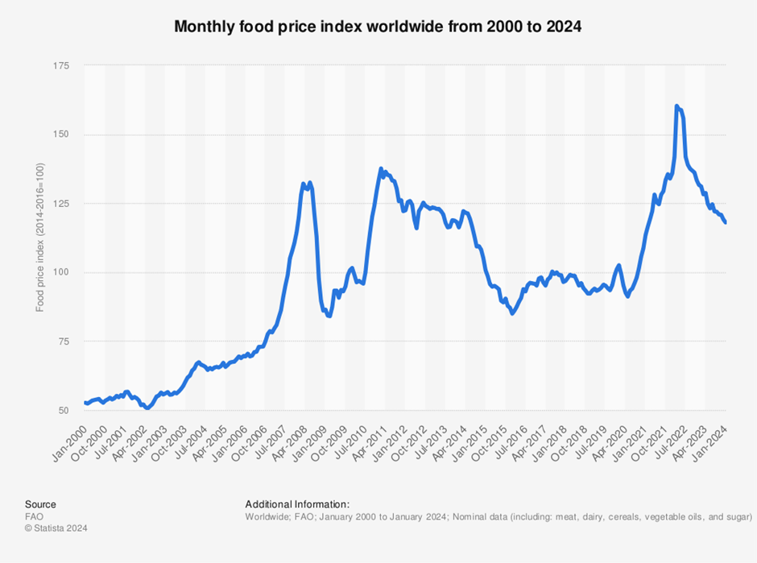
https://www.statista.com/graphic/1/1111134/monthly-food-price-index-worldwide.jpg

Malthusian and neo-Malthusian theorists believe that there are biophysical limits to economic growth and population growth. Theorists supporting this point of view believe that the Earth's resources are limited and that rapid economic growth is slowly leading to climate change and ecosystem collapse. Neoclassical theorists argue that economic growth is an effective strategy for reducing humanity's impact on the environment, and some theorists suggest that economic growth helps reduce pollution and limit environmental damage caused by human activities (Steiguer, 1995). Neo-Malthusianism, defined as the fear that a large population size may lead to a humanitarian and ecological catastrophe and that the fight against overpopulation is a great problem, and its consequences are felt all over the world(15).

Economist Simon Kuznets developed the "Environmental Kuznets Curve" (EKC), which assumes that environmental degradation decreases when countries reach an optimal level (GDP). Kuznet's theory suggests that as economies develop, countries develop more efficient processes and use innovative technologies to extract natural resources more efficiently, which helps reduce pollution, and the extraordinary development of new technologies restores hope for containing climate change(16).
Figure 5 shows that as countries move towards industrialisation, they have significant impacts on the environment. However, once GDP reaches a certain point, countries shift to a service-based economy, which helps reduce high levels of industrial pollution.

FIGURE 5. Diagram of Kuznets Curve
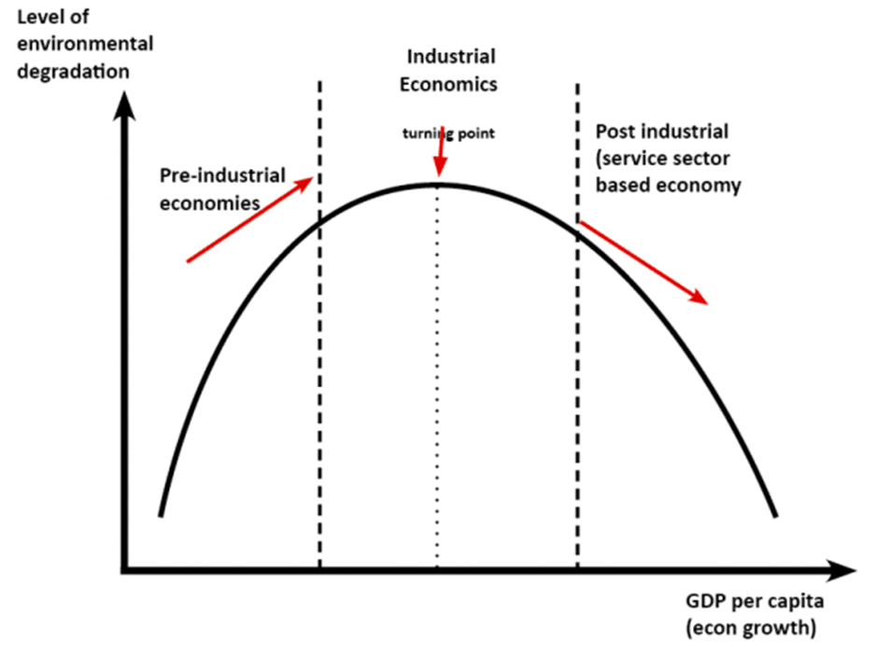
https://www.economicshelp.org/wp-content/uploads/2015/09/kuznets-environment.png.webp

The Environmental Kuznets Curve (EKC) hypothesis states that there is an inverted U-shaped relationship between environmental degradation and income. Significant recent work has tested the EKC by monitoring the impact of economic development on environmental indicators such as climate change, the ozone layer, air quality, water quality, and waste generation. Research by the Office for National Statistics (ONS) supports the EKC theory and shows that there is a relationship between the emission rate (GDP) and emissions (CO₂)(17).
The Global Carbon Budget report, published by scientists from over 90 institutions around the world, shows that total global CO₂ emissions in 2023 will reach 36.8 billion metric tons, an increase of 1.1% compared to 2022(18).

FIGURE 6. CO₂ emissions
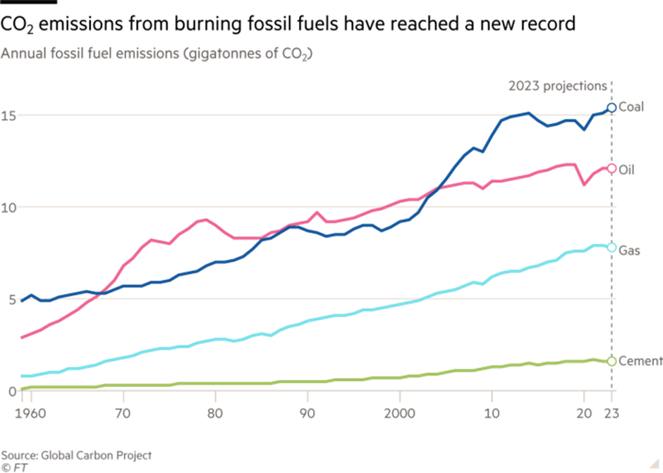
https://www.ft.com/__origami/service/image/v2/images/raw/https%3A%2F%2Fd6c748xw2pzm8.cloudfront.net%2Fprod%2F74b7fc00-9524-11ee-b09b-c1e68ee3ede4-standard.png?source=next-article&fit=scale-down&quality=highest&width=700&dpr=1

  - Sustainable Development Goals (SDGs)

The Sustainable Development Goals are an action plan for change and transformation of the world in which the needs of the present generation can be met in a sustainable way, with respect for the environment and taking into account the needs of future generations. The Sustainable Development Goals were introduced in 2015 by 193 countries and contain 17 goals to be achieved by all parties, i.e. state governments, international organisations, non-governmental organisations, the science and business sectors, as well as citizens. They focus on 5 areas: people, planet, prosperity, peace, and partnership(19).
The Sustainable Development Goals mainly include an economy free from net greenhouse gas emissions by 2050. In addition, the Sustainable Development Goals are intended to safeguard, protect and enhance natural capital and protect the health and well-being of citizens from environmental threats(20).
The Sustainable Development Goals promote the introduction of a circular economy, an economic model that attempts to extend the life cycle of a product through reuse, recycling, repurposing and refurbishing (EU, 2015). Therefore, to address the threats posed by extreme climate change and ecosystem collapse, it is essential that entrepreneurs transition from a linear to a circular economy(21).

- Conclusion

The report discusses the global risk of ecosystem loss and extreme weather changes. The data presented in the report highlights the extent to which human activities have caused catastrophic damage to global biodiversity. It can be concluded that extreme climate change has the potential to significantly reduce global GDP and negatively impact global food security. Additionally, the report discusses Malthusian and neo-Malthusian theories, which suggest that human population growth leads to resource scarcity and land degradation.
The report uses EKC theory that shows the separation of emissions (GDP) from emissions (CO₂). Finally, the report refers to the SGDs and discusses targets that can reverse human-caused environmental damage. The report's findings show that extreme weather changes and ecosystem loss are undoubtedly a major global problem that must be addressed as soon as possible for future generations.

- Recommendations

This part of the report presents three recommendations aimed at preventing climate change and ecosystem loss. The recommendations are as follows:
1. Establishment of protected areas on land
Individual countries should make every effort to minimise cutting down forests and draining water reservoirs. Instead of building new buildings on forested areas, they can be built on demolished vacant buildings, which will protect the natural ecosystem. In addition, entry bans to the forest may be introduced due to the possibility of starting a fire.
2. Promoting a vegetarian diet
Reducing meat consumption can be promoted by organising programs encouraging people to adopt a vegetarian or vegan diet. Such programs can be organised in schools or workplaces.
3. Implementation of deposit return systems to reduce plastic waste pollution
Introduce refund machines in stores, i.e. devices where you can return used plastic bottles or aluminum cans. The machine, unlike an ordinary waste bin, could selectively accept reusable containers using a barcode scanner.

- References

1.Agenda 2030,Cele zrownowazonego rozwoju,(Accessed on 02.05.204): https://www.un.org.pl/files/170/Agenda2030PL_pl-5.pdf
2.Business Insider, (05.12.2023), Tniemy, płacimy, a emisja CO2 rośnie. Ludzkość pobiła record, (Accessed on 02.05.2024), https://businessinsider.com.pl/gospodarka/tniemy-placimy-a-emisja-co2-rosnie-ludzkosc-pobila-rekord/vspfvc6#:~:text=Z%20raportu%20Global%20Carbon%20Budget,w%20por%C3%B3wnaniu%20z%20rokiem%202022.
3.Burgess,J.C., Barbier, E.B. (2021),International Encyclopedia of the Social & Behavioral Sciences, Environmental Kuznets Curve,(Accessed on 02.05.2024), https://www.sciencedirect.com/topics/economics-econometrics-and-finance/environmental-kuznets-curve#:~:text=Environmental%20Kuznets%20curve%20(EKC)%20hypothesis,between%20environmental%20degradation%20and%20income.https://pbs.twimg.com/media/GEFiHZNWEAAVBvo.jpg:large
4.DW,(05.09.2020),Zaludnienie naszej planety a klimat,(Accessed on 02.05.2024): https://www.dw.com/pl/czy-mniej-ludzi-wyjdzie-naszej-planecie-na-dobre/a-54824098#:~:text=To%20prawda%2C%20%C5%BCe%20%E2%80%93%20jak%20wskazuj%C4%85,mieszka%C5%84ca%20Ziemi%20wywieraj%C4%85%20rosn%C4%85ce%20dochody.
5.Earth Org,(21.12.2023), The State of the Global Climate in 2023,(Accessed on 02.03.2024), https://earth.org/the-state-of-the-global-climate-in-2023-a-recap/
6.EEA,(02.10.2020),Różnorodność biologiczna – ekosystemy,(Accessed on 02.05.2024), https://www.eea.europa.eu/pl/themes/biodiversity/intro#:~:text=R%C3%B3%C5%BCnorodno%C5%9B%C4%87%20biologiczna%20(bior%C3%B3%C5%BCnorodno%C5%9B%C4%87)%20to%20termin,funkcje%20podtrzymuj%C4%85ce%20gospodarki%20i%20spo%C5%82ecze%C5%84stwa.
7.EEA,(07.11.2023),Fale upałów i inne ekstremalne zjawiska związane z klimatem zagrażają zdrowiu, zwłaszcza osób najbardziej wrażliwych,(Accessed on 02.05.2024), https://www.eea.europa.eu/pl/sygna142y/sygnaly-2023/artykuly/fale-upalow-i-inne-ekstremalne
8.EN,(23.05.2023),Ekstremalne zjawiska pogodowe wiosną,(Accessed on 02.05.2024), https://www.uni.lodz.pl/aktualnosc/szczegoly/ekstremalne-zjawiska-pogodowe-wiosna-komentarz-eksperta-ul#:~:text=Najwi%C4%99cej%20ekstremalnych%20zjawisk%20atmosferycznych%20towarzyszy,downburst%20(silne%20pr%C4%85dy%20zst%C4%99puj%C4%85ce)
9.European Parliament, (2015), Circular economy: Definition, importance and benefits,(Accessed on 02.05.2024), https://www.europarl.europa.eu/topics/en/article/20151201STO05603/circular-economy-definition-importance-and-benefits
10. Follett,C.(21.07.2020),Neo‐Malthusianism and Coercive Population Control in China and India: Overpopulation Concerns Often Result in Coercion,(Accessed on 02.05.2024), https://www.cato.org/policy-analysis/neo-malthusianism-coercive-population-control-china-india-overpopulation-concerns
11. FOB, (10.01.2024),Global Risks Report 2024,(Accessed on 02.05.2024): https://odpowiedzialnybiznes.pl/publikacje/global-risks-report-2024/?cn-reloaded=1
12. GGN, (13.01.2024),Forum Ekonomiczne Davos ocenia świat AD 2024,(Accessed on 02.05.2024): https://gnn.pl/forum-ekonomiczne-davos-2024/
13. GOV.pl,(2023), Cele zrównoważonego rozwoju,(Accessed on 02.05.2024): https://www.gov.pl/web/polskapomoc/cele-zrownowazonego-rozwojuHaladyj,A.(2014), Strategic Natural Resources – critical remarks,(Accessed on 02.05.2024): file:///C:/Users/zuzy/Downloads/kkarpus,+%7B$userGroup%7D,+Ha%C5%82adyj.pdf
14. Investopedia,(2022),Law of diminishing marginal returns: Definition, example, use in economics,(Accessed on 0.05.2024), https://www.investopedia.com/terms/l/lawofdiminishingmarginalreturn.asp
15. Investopedia, (2022), Who is David Ricardo and what is he famous for?,(Accessed on 02.05.2024): https://www.investopedia.com/terms/d/david-ricardo.asp
16. Journal of Futures Studies (2018), Towards an Explicit Research Methodology: Adapting Research Onion Model for Futures Studies ,(Accessed on 02.05.2024): https://jfsdigital.org/articles-and-essays/2018-2/towards-an-explicit-research-methodology-adapting-research-onion-model-for-futures-studies/
17. Kagan,J.(16.04.2024),Investopedia, Who Is Thomas Malthus?,(Accessed on 02.05.2024), https://www.investopedia.com/terms/t/thomas-malthus.asp#:~:text=The%20Malthusian%20growth%20model%20is,population%20doubles%20at%20predictable%20intervals.
18. Klimat,(26.03.2020),Zmiany klimatu istotnie wpływają na różnorodność biologiczną: prawie jedna czwarta gatunków Europy jest zagrożona wyginięciem,(Accessed on 02.05.2024), https://klimada2.ios.gov.pl/klimat-a-roznorodnosc-biologiczna/#:~:text=Jak%20wynika%20z%20bada%C5%84%2C%20najbardziej,znan%C4%85%20nam%20dzi%C5%9B%20r%C3%B3%C5%BCnorodno%C5%9B%C4%87%20biologiczn%C4%85.https://www.rp.pl/gospodarka/art39421641-koszty-zmian-klimatycznych-rosna-usa-ujawnily-kwoty
19. Komisja Europejska,Przyczyny zmian klimatu,(Accessed on 02.05.2024): https://climate.ec.europa.eu/climate-change/causes-climate-change_pl#:~:text=Spalanie%20paliw%20kopalnych%2C%20wycinanie%20las%C3%B3w,efektu%20cieplarnianego%20oraz%20globalnego%20ocieplenia.
20. Komisja Europejska, (2019),Całościowe podejście Unii do zrównoważonego rozwoju,(Accessed on 02.05.2024): https://commission.europa.eu/strategy-and-policy/sustainable-development-goals/eu-whole-government-approach_pl
21. Komisja Europejska,(2023), Skutki zmiany klimatu,(Accessed on 02.05.2024): https://climate.ec.europa.eu/climate-change/consequences-climate-change_pl
22. Lenxess, (28.07.2022), Earth Overshoot Day.How can we turn things around?,(Accessed on 02.05.2024): https://lanxess.com/en/INSIDE-LANXESS/X-PLAIN/Stories/2022/Earth-Overshoot-Day
23. Malthus T.R. (1798), An essay on the principle of population, Oxford.
24. MIK, (2019),Beton, najbardziej destrukcyjny material swiata,(Accessed on 02.05.2024), https://www.autoportret.pl/artykuly/beton-najbardziej-destrukcyjny-material-swiata/
25. National Geographic, (07.03.2022), Jak przystosować się do zmian klimatu?,(Accessed on 02.05.2024), https://www.national-geographic.pl/artykul/jak-przystosowac-sie-do-zmian-klimatu#:~:text=Globalne%20ocieplenie%20w%20przysz%C5%82o%C5%9Bci%20b%C4%99dzie,C%20jeszcze%20w%20XXI%20wieku!
26. National Geographic, (28.09.2017), Ekstremalna pogoda – skąd się bierze,(Accessed on 02.05.2024), https://www.national-geographic.pl/artykul/ekstremalna-pogoda-skad-sie-bierze
27. National Geographic, (14.01.2023), Zanieczyszczenia wód – przyczyny, skutki i zapobieganie. Jak dbać o czystość wód,(Accessed on 02.05.2024): https://www.national-geographic.pl/artykul/zanieczyszczenia-wod-przyczyny-skutki-i-zapobieganie-jak-dbac-o-czystosc-wod
28. OKO, (31.10.2023), Unikniemy najgorszego? Niezwykły rozwój nowych technologii przywraca nadzieję dla klimatu, (Accessed on 02.04.2024), https://oko.press/unikniemy-najgorszego-niezwykly-rozwoj-nowych-technologii-przywraca-nadzieje-dla-klimatu
29. ONZ,(21.10.2015), Zgromadzenie Ogólne,(Accessed on 02.05.2024): file:///C:/Users/zuzy/Downloads/Agenda_2030_na_rzecz_zrownowazonego_rozwoju.pdf
30. Parliament Europejski,(17.11.2023), Plastik w oceanach: fakty, skutki oraz nowe przepisy UE,(Accessed on 02.05.2024): https://www.europarl.europa.eu/topics/pl/article/20181005STO15110/plastik-w-oceanach-fakty-skutki-oraz-nowe-przepisy-ue#:~:text=Plastik%20nie%20tylko%20za%C5%9Bmieca%20wybrze%C5%BCa,ich%20organizm%C3%B3w%20toksyczne%20zanieczyszczenia%20chemiczne.
31. Parliament Europejski, (09.06.2021), Utrata bioróżnorodności: znaczenie i przyczyny,(Accessed on 02.05.2024): https://www.europarl.europa.eu/topics/pl/article/20200109STO69929/utrata-bioroznorodnosci-znaczenie-i-przyczyny
32. Parliament Europejski, (31.10.2023), Jak zachować różnorodność biologiczną: polityka UE,(Accessed on 02.05.2024), https://www.europarl.europa.eu/topics/pl/article/20200519STO79422/jak-zachowac-roznorodnosc-biologiczna-polityka-ue-wideo
33. Polskie Radio, (20.09.2017), Skarby Ziemi na wyczerpaniu. Kiedy ich zabraknie? (Accessed on 02.05.2024): https://www.polskieradio.pl/10/5367/Artykul/1858922,Skarby-Ziemi-na-wyczerpaniu-Kiedy-ich-zabraknie
34. Pomagamy,(2023), O pszczołach,(Accessed on 02.05.2024): https://www.pomagamypszczolom.pl/o-pszczolach/
35. Rada Europejska,(2022), Zmiana klimatu pochłania ofiary i pieniądze,(Accessed on 02.05.2024), https://www.consilium.europa.eu/pl/infographics/climate-costs/#:~:text=Zmiana%20klimatu%20powoduje%20straty%20gospodarcze,wszystkie%20wsp%C3%B3lne%20polityki%20i%20programy.https://www.wwf.pl/aktualnosci/3-miliardy-zwierzat-ucierpialy-w-wyniku-pozaru-buszu-w-australii
36. Smith,A.B.(08.01.2024), 2023: A historic year of U.S. billion-dollar weather and climate disasters,(Accessed on 02.05.2024), https://www.climate.gov/news-features/blogs/beyond-data/2023-historic-year-us-billion-dollar-weather-and-climate-disasters#:~:text=Adding%20the%202023%20events%20to,376%20events%20exceeds%20%242.660%20trillion
37. Steiguer, J-E. (1995). Three theories from economics about the environment. BioScience Journal. Vol. 45. (8). Pp. 552-557.
38. Teraz Srodowisko,(12.09.2018),Wpływ zmian klimatu: co dziewiąty człowiek na świecie jest głodny,(Accessed on 02.05.2024): https://www.teraz-srodowisko.pl/aktualnosci/Wplyw-zmian-klimatu-co-dziewiaty-czlowiek-na-swiecie-jest-glodny-5369.html#:~:text=Szacuje%20si%C4%99%2C%20%C5%BCe%20%C5%82%C4%85cznie%20na,co%20dziewi%C4%85tego%20mieszka%C5%84ca%20naszej%20planety.&text=Raport%20dowodzi%2C%20%C5%BCe%20g%C5%82%C3%B3d%20wzrasta,zale%C5%BCnych%20od%20plon%C3%B3w%20i%20rolnictwa.https://klimat.rp.pl/na-talerzu/art37079811-48-mln-ludzi-cierpi-z-powodu-dotkliwego-glodu-najbardziej-poszkodowani

39.Testbook, (2012),Ricardian Theory of rent,(Accessed on 02.05.2024): https://testbook.com/question-answer/according-to-ricardian-theory-of-rent-rent-is-a--5f7c61289eaa9aa445bbd75b
40. TVN Bis, (19.09.2022), "Guardian": grupa państw chce nowego podatku. Ma pokryć ich straty powodowane przez zmiany klimatu,(Accessed on 02.05.2024), https://tvn24.pl/swiat/zmiany-klimatu-nowy-podatek-na-pokrycie-strat-zaproponuje-grupa-panstw-w-onz-guardian-st6119563
41. TVN Meteo, (20.11.2020),Pszczoły giną. By je ocalić, stworzyli mapę ich zagęszczenia na świecie, (Accessed on 02.05.2024), https://tvn24.pl/tvnmeteo/najnowsze/pszczoly-gina-by-je-ocalic-stworzyli-mape-ich-zageszczenia-na-swiecie-ls4958647
42. UK Parliament. (2022). Impact of climate change and biodiversity loss on food security, (Accessed on 02.05.2024), https://lordslibrary.parliament.uk/impact-of-climate-change-and-biodiversity-loss-on-food-security/#heading-1
43. United Nations. (2015). 193 Member states: United Nations sustainable development,(Accessed on 02.05.2024), https://www.un.org/sustainabledevelopment/blog/tag/193-member-states/
44. WWA,(22.12.2023),Climate change fuelled extreme weather in 2023; expect more records in 2024,(Accessed on 02.05.2024), https://www.worldweatherattribution.org/climate-change-fuelled-extreme-weather-in-2023-expect-more-records-in-2024/
45.WWF, (2023), Bez natury nie powstrzymamy kryzysu klimatycznego, Accessed on 02.05.2024), https://www.wwf.pl/bez-natury-nie-powstrzymamy-kryzysu-klimatycznego
46. WWF,(10.01.2024),Climate change and nature loss pose greatest risks for humanity: WEF Global Risk Report 2024,(Accessed on 02.05.2024), https://www.wwf.eu/?12625966/Climate-change-and-nature-loss-pose-greatest-risks-for-humanity-WEF-Global-Risk-Report-2024
47. WWF,(14.07.2021), Uwazaj na burze,pomoz w ochronie klimatu,(Accessed on 02.05.2024), https://www.wwf.pl/aktualnosci/uwazaj-na-burze
48. WWF, (2024),Klimat,(Accessed on 02.05.2024): https://www.wwf.pl/srodowisko/klimat
49. WWF, (20.02.2017),Morza i oceany,(Accessed on 02.05.2024): https://www.wwf.pl/srodowisko/morza-i-oceany
50. WWF, (10.01.2024),WWF statement on WEF Global Risks Report 2024,(Accessed on 02.05.2024): https://wwf.panda.org/wwf_news/?10497966/WWF-statement-on-WEF-Global-Risk-Report-2024#:~:text=WWF%20statement%20on%20WEF%20Global%20Risks%20Report%202024%20%7C%20WWF&text=The%20World%20Economic%20Forum%20(WEF,world%20over%20the%20next%20decade.
51. Wyborcza.pl, (17.09.2022), Zmiany klimatyczne wywołują klęskę głodu. Nowy raport Oxfamu, (Accessed on 02.05.2024): https://wyborcza.pl/7,75399,28919636,najgoretsze-miejsca-na-planecie-dotyka-tez-kleska-glodu-nowy.html

