8/17/2026
University of Wales Trinity Saint David
London campus
2423378@student.uwtsd.ac.uk
Alexandr Iancovschi
SPC Assignment on
Smart Home Device Manager System for Bright Minds Academy
Module Name: Scripting and Programming Concepts
Module Code: ACCA 5036

Student Name:
Student ID:

Lecturer’s Name: Koushik Modak

Code link: https://github.com/dvanolidva/Smart-Home-Device-Manager/blob/main/Smart_home_device_manager.py

Table of Contents
Introduction 2
Main Body 3
1. Analysis 3
2. Software Design and Development 6
Design: 6
Implementation Decisions 10
Source Code: 12
3. Testing and Debugging Report 16
Importance of Programme Testing 16
Types of Programming Errors and Debugging 17
Test Cases and Validation 18
4. Evaluation 22
Challenges Faced: 22
Future Improvements 23
Self-Reflection 23
Conclusion 25
References 26
Appendices 27

Introduction
The increasing use of smart technologies within educational environments creates a need for effective methods of monitoring and managing connected devices. Bright Minds Academy, a small tutoring centre, is introducing smart classroom technology including lighting systems, thermostats and projectors. As the number of devices increases, managing them manually becomes less practical because staff require an efficient way to identify individual devices, determine their location and monitor their current operational status. Therefore, the development of a simple device management application provides an appropriate solution to the requirements presented in this scenario.
The purpose of this project was to design and develop a Python-based Smart Home Device Manager that provides a centralised interface for managing smart devices. The application was implemented as a console-based system in Python. Its core functionality enables the user to register a new device, update an existing device’s status, display all registered devices and search for a specific device by name. Each device is represented using three principal attributes: its name, physical location and operational status. The available statuses are Online, Offline and Under Maintenance, allowing the system to provide a clear representation of the current condition of each registered device.
During development, additional functionality was implemented to improve the practical usefulness of the application. A user can remove an existing device when it is no longer required, while JSON-based data persistence allows device information to remain available after the application has been closed and subsequently restarted. Input validation was also incorporated throughout the program. For example, the application prevents empty device names and locations, rejects duplicate devices, handles invalid menu and status selections, and provides appropriate messages when a requested device cannot be found. These measures improve reliability while maintaining a simple user experience.
The implementation applies fundamental programming concepts including user-defined functions, conditional statements, iteration, dictionaries and modular program structure. Individual functions were created for the main operations of the application, which separates responsibilities within the source code and makes the program easier to understand, test and maintain. A menu-driven interface was selected because it provides a straightforward method of interaction without introducing unnecessary complexity for the intended application.
This report presents the analysis, design, implementation, testing and evaluation of the Smart Home Device Manager. The design is documented using a flowchart and pseudocode, while testing covers valid and invalid inputs with evidence from the running application. Finally, the solution is evaluated to identify its strengths, limitations and possible improvements.

Main Body
- Analysis
• Requirements Analysis
Before developing the Smart Home Device Manager, it was necessary to analyse the scenario and translate the needs of Bright Minds Academy into clear software requirements. The organisation requires a relatively small system; however, the application still needs to provide reliable management of multiple smart devices and present information in a form that can be understood easily by staff. The analysis therefore focused on identifying the required functionality, expected behaviour of the application and appropriate constraints for the proposed solution.

Functional Requirements

- The primary functional requirement is the ability to add a new smart device. When registering a device, the user provides its name and location, while the system assigns an initial status of Offline. Each device must be identifiable by its name so that subsequent operations can be performed on the correct record.

- A second requirement is the ability to update the operational status of an existing device. Three status values are supported: Online, Offline and Under Maintenance. Restricting the available statuses to these predefined values prevents inconsistent information from being entered and provides a standard representation of device availability.

- The application must also provide a device list containing the name, location and status of every registered device. This gives the user an overview of the devices currently managed by the system. In addition, a search function is required so that a particular device can be located by name without manually examining the entire list. When a match is found, the program displays the corresponding location and status.

- During implementation, two additional capabilities were incorporated. First, an existing device can be removed from the system when it is no longer required. Secondly, device information is stored persistently in a JSON file. This prevents registered information from disappearing whenever the Python program terminates and allows the application to restore its previous state when it is started again.

Non-Functional Requirements

In addition to functionality, the system must meet several quality criteria:
- Usability is an important requirement because the application is intended to provide a straightforward method of managing devices. A numbered console menu was therefore used to provide consistent access to each operation. Messages inform the user whether an operation has completed successfully or whether corrective action is required.

- Reliability is supported through input validation and error handling. The system rejects empty device names and locations, duplicate device names, unsupported status selections and invalid main-menu choices. It also checks whether a requested device exists before attempting operations such as updating, searching or removing it. These controls reduce the possibility of invalid data being stored and prevent common user mistakes from causing the program to terminate unexpectedly.

- Maintainability was another consideration. The program is divided into separate user-defined functions rather than implementing all functionality within one large block of code. This structure makes individual operations easier to understand, test and modify. The use of a Python dictionary provides a suitable lightweight data structure for the current scale of the application, while JSON provides simple persistent storage without requiring a database [1], [2].

Constraints and Assumptions
The current implementation is a local, console-based application and is therefore intended for relatively small-scale use. It assumes that device names are sufficiently unique to identify individual devices and that users have access to the computer on which the program and JSON data file are stored. It does not currently provide authentication, network-based device communication or simultaneous access by multiple users. These limitations are acceptable for the scope of the prototype but would need to be reconsidered if the system were expanded for larger-scale deployment.

2. Software Design and Development
In this section of the report, you will document the design and development of the software. Your submission should include:
Design: Represent the algorithm of your solutions as follows: •
- The flowchart was developed to represent the overall logic of the Smart Home Device Manager before considering the individual implementation details. The application follows a menu-driven structure in which the user selects an operation and the program performs the corresponding process. The main available operations are adding a new device, updating an existing device status, displaying all registered devices, searching for a device, removing a device and exiting the application.
- When the program starts, previously stored device information is loaded from the JSON file. The main menu is then displayed and the user is asked to enter a choice. The program evaluates this choice and directs execution to the appropriate operation. Input validation is applied where necessary, for example when checking device names, locations and status values. After an operation has been completed, the application returns to the main menu so that another action can be performed. This process continues until the user selects the exit option, at which point the current device information is saved and the program terminates.

Start

Load devices
from JSON file

Display Main Menu

User Choice?

Exit
Remove Device
Search for Device
Display All Devices
Update Device Status
Add New Device

Validate input and remove device
Save devices to JSON file
Validate input and add device
Validate input and update status
Retrieve devices and display list
Validate input, search and display result

End

Display Main Menu

Pseudo-code:
START
Load previously saved device data from the JSON file
REPEAT
Display the main menu
Ask the user to select an option
IF the user selects Add Device THEN
Ask for device name
Ask for device location
Validate the entered information
IF the information is valid THEN
Add the device with status "Offline"
Save the updated device data
ELSE
Display an error message
END IF
ELSE IF the user selects Update Device Status THEN
Ask for device name
Check whether the device exists
IF the device exists THEN
Ask for the new status
Validate the status
Update the device status
Save the updated device data
ELSE
Display "Device not found"
END IF
ELSE IF the user selects Display All Devices THEN
IF devices exist THEN
Display each device name, location and status
ELSE
Display a message that no devices are registered
END IF
ELSE IF the user selects Search Device THEN
Ask for device name
Search for the device
IF the device exists THEN
Display its name, location and status
ELSE
Display "Device not found"
END IF
ELSE IF the user selects Remove Device THEN
Ask for device name
IF the device exists THEN
Remove the device
Save the updated device data
ELSE
Display "Device not found"
END IF
ELSE IF the user selects Exit THEN
Save device data to the JSON file
Exit the program
ELSE
Display an invalid option message
END IF
UNTIL the user selects Exit
END

Implementation Decisions
Data Structures:
The main data structure used in the Smart Home Device Manager is a Python dictionary. A dictionary was selected because it provides a simple and efficient method of associating each device name with its corresponding information [1].
In the program, the device name is used as the dictionary key, while the value contains the device location and current operational status. This structure is appropriate for the current scale of the application because it allows individual devices to be retrieved, updated and removed directly by name without requiring a more complex database system.
The dictionary also supports the validation logic implemented throughout the application. For example, before a new device is added, the program checks whether the entered device name already exists as a key. Similarly, update, search and remove operations first check whether the requested device can be found in the dictionary. This reduces the risk of duplicate records and allows the program to display an appropriate error message when a device is not available.
Persistent storage is provided using a JSON file. The dictionary is serialised to devices.json whenever device information is changed and is loaded again when the program starts. JSON was chosen because it is lightweight, human-readable and supported directly by Python [2]. It is suitable for this prototype because the amount of data is relatively small and does not require the additional complexity of a database server.
Several variables are used to support the operation of the system. devices stores the current device dictionary in memory, while DATA_FILE identifies the location of the JSON file. Variables such as name, location and choice temporarily store user input. The status value represents the current condition of a device, using the predefined options Online, Offline and Under Maintenance. These variables are intentionally simple because the application focuses on a small set of clearly defined device-management operations.

- Programming Constructs:
The program uses several programming constructs to control its behaviour and respond to user input. Conditional statements are used throughout the application to make decisions. The main menu uses if, elif and else statements to determine which operation the user has selected. Additional conditions are used to check whether a device exists, whether the entered information is valid and whether a selected status is supported.
A loop keeps the main menu running until the user chooses to exit the application. After an operation is completed, the program returns to the menu, allowing the user to perform another action without restarting the program.
User-defined functions separate the main operations of the application. Different functions are responsible for adding, updating, displaying, searching and removing devices, as well as loading and saving device data. This makes the program easier to understand, test and modify because each function performs a specific task.
Input validation and error handling are used to prevent invalid data and unexpected program behaviour. Invalid menu choices, empty inputs, unsupported status values and requests for devices that do not exist are handled by displaying an appropriate message instead of terminating the application.

- Python Modules and Libraries:
The program uses Python’s built-in json module to provide persistent storage for device information. This module allows the device dictionary to be converted into JSON format and stored in the devices.json file. When the application starts, the same module is used to read the file and restore the previously saved device data [2].
The json module was selected because it is included with Python and therefore does not require any additional installation. JSON is also suitable for this application because the stored information is relatively simple and consists of device names, locations and status values. The format is human-readable and works naturally with Python dictionaries.
No external libraries are required for the application. Keeping the program dependent only on Python’s standard library makes the prototype easier to run on another computer and avoids unnecessary dependencies.

Source Code:
The complete source code for the Smart Home Device Manager was developed in Python and organised into separate functions for the main operations of the application. This structure keeps individual tasks separated and makes the program easier to read, test and maintain.

Comments are included within the source code to identify important sections and explain the purpose of the main functions. Consistent indentation, descriptive variable names and separate functions were also used to keep the implementation clear and organised [5].

The following screenshots show key sections of the implemented source code and demonstrate how the main functionality described in the design was translated into Python.
Figure 1: JSON data loading and error handling
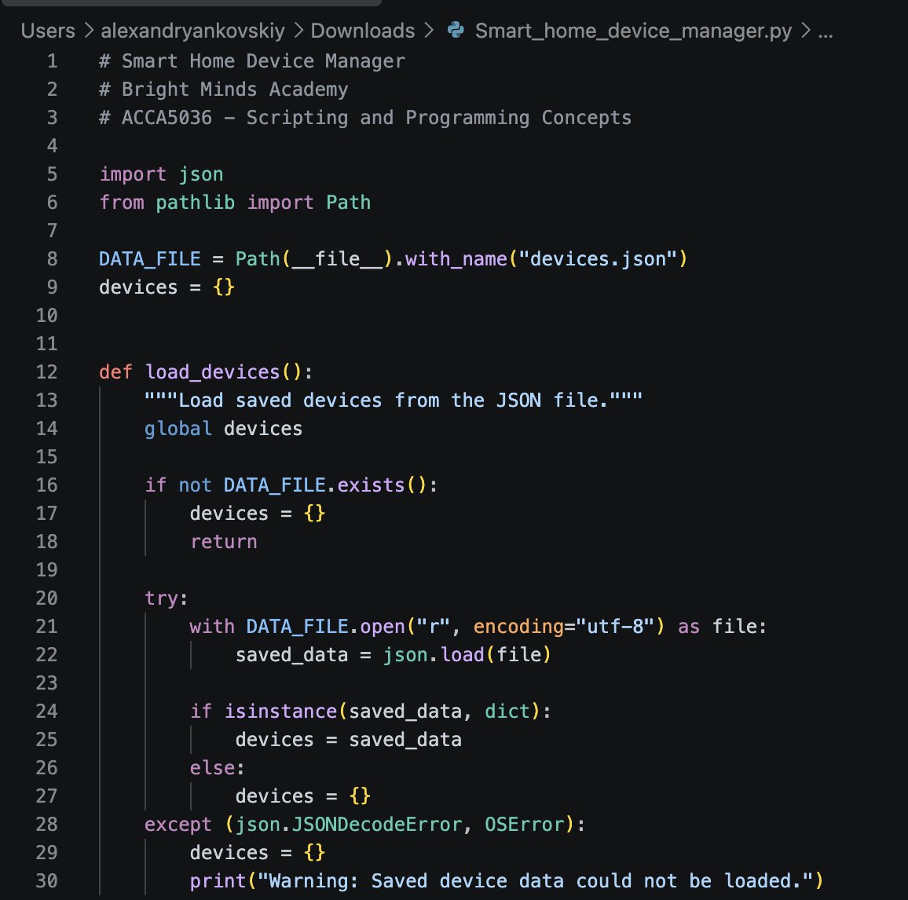
Figure 1 shows the load_devices() function used to load previously saved device information from the JSON file. The function checks whether the file exists and uses exception handling to prevent the program from terminating if the stored data cannot be loaded [3], [4].
Figure 2: Adding a New Device – Source Code
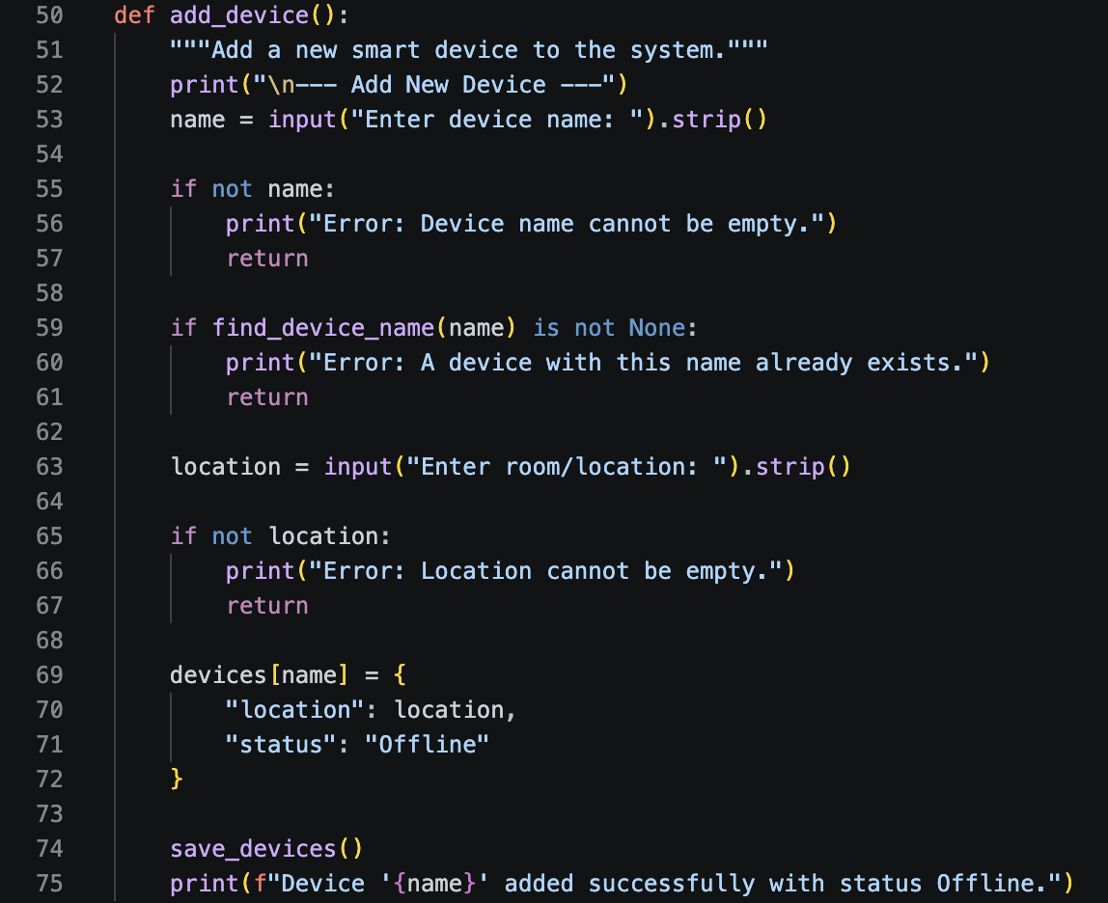
Figure 2 shows the add_device() function, which validates the device name and location, prevents duplicate entries, assigns the default Offline status, and saves the new device to the JSON file.

Figure 3: Updating Device Status – Source Code
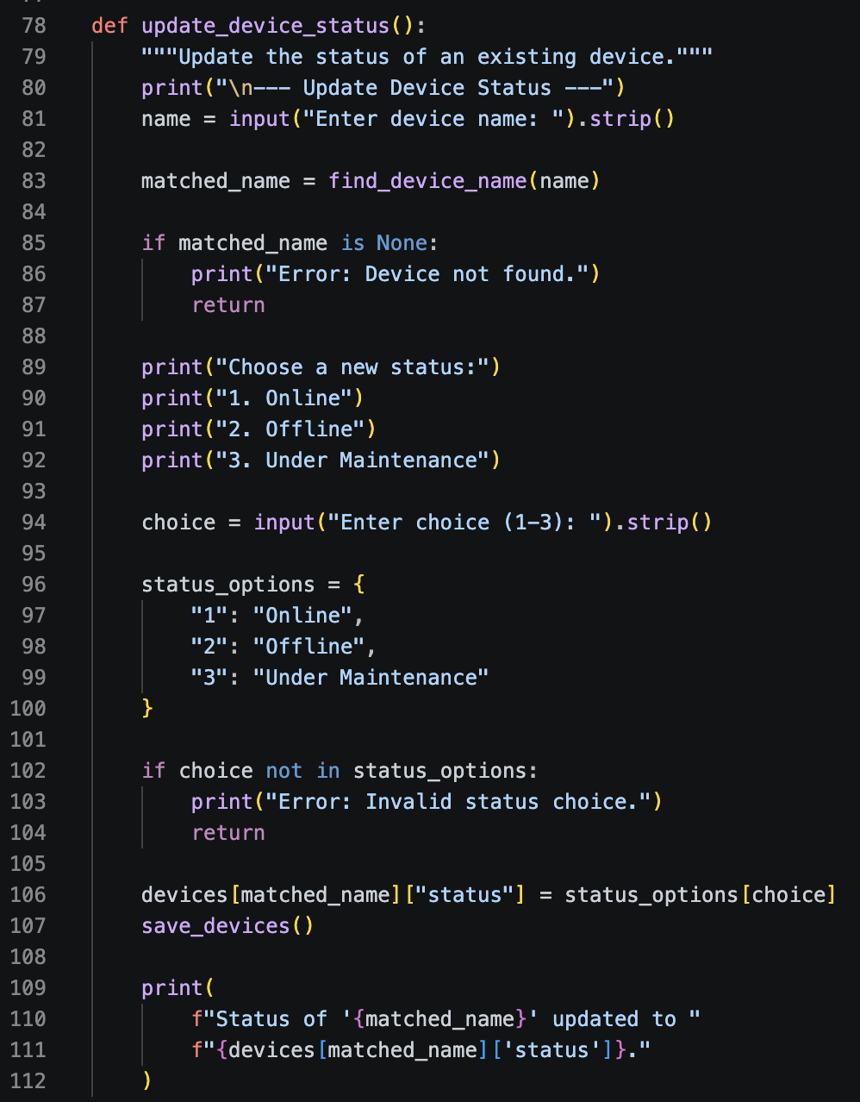

Figure 3 shows the update_device_status() function. It checks that the requested device exists, provides the available status options, validates the user input, updates the selected device and saves the changes.
Figure 4: Main Program Control – Source Code
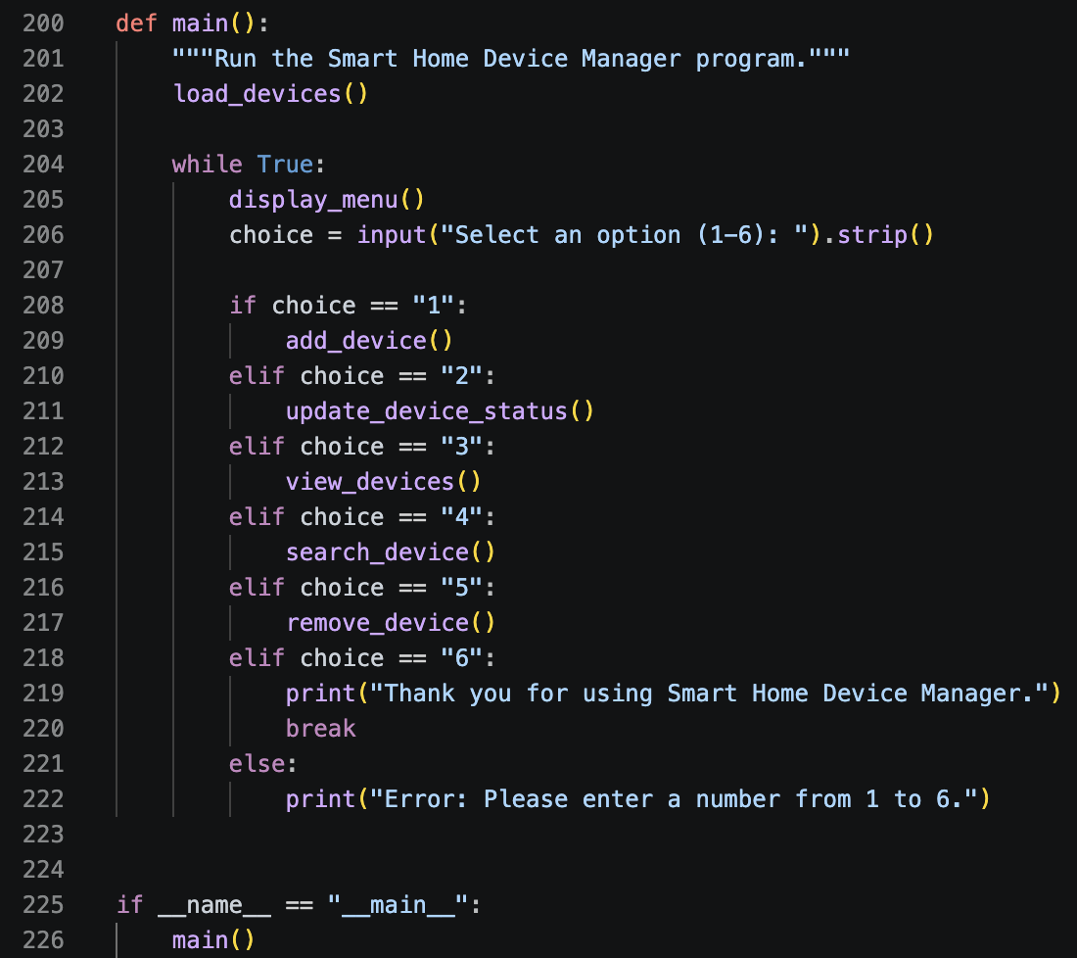
Figure 4 shows the main() function that controls the program. It displays the menu in a loop, processes the user’s selection and calls the appropriate function for each available operation.

3. Testing and Debugging Report

Importance of Programme Testing
Programme testing is an essential stage of software development because it provides evidence that an application behaves according to its requirements and can respond appropriately to different user actions. A program may execute successfully during development but still contain logical errors, validation problems or unexpected behaviour that only becomes visible when different inputs are tested. Testing therefore helps identify defects before the software is considered complete and improves confidence in the reliability of the final solution [6].
Testing was particularly important for the Smart Home Device Manager because the application depends heavily on user input. Users can enter device names and locations, select menu options and change device statuses. Without appropriate testing, invalid or unexpected values could result in incorrect data being stored or could cause the application to behave unpredictably. For this reason, both valid and invalid inputs were considered during the testing process.
Functional testing was used to confirm that the principal operations performed their intended tasks. This included adding devices, updating their status, displaying registered devices, searching for devices and removing records. The JSON persistence functionality was also tested by closing and restarting the application to confirm that previously stored device information remained available.
Validation and edge-case testing were used to examine situations in which the user provides inappropriate input. Examples included selecting a menu option outside the permitted range, entering an invalid status option, leaving required information empty, attempting to create a duplicate device and attempting to access a device that does not exist. The expected behaviour in these situations was for the application to display an informative error message and continue running rather than terminating unexpectedly.
Overall, the testing process provided evidence that both the normal functionality and error-handling mechanisms of the application operated as intended.

Types of Programming Errors and Debugging

Developing the Smart Home Device Manager required attention to different types of programming errors. Even when a program appears to work correctly, errors can exist in the source code or become visible only when a particular input is entered. For this reason, debugging was carried out alongside the implementation and testing of the application.

Syntax Errors: These errors occur when an instruction is written in a way that Python cannot interpret. In this project, potential examples included incorrect indentation, missing brackets or quotation marks, and missing colons after if, elif or function statements. Since the application contains several functions and conditional branches, maintaining correct indentation was particularly important. Syntax errors can normally be identified from the message and line number displayed by the Python interpreter, allowing the affected section of code to be corrected before the program is executed again [4].

Runtime Errors: A runtime error occurs after the program has started and is usually caused by a problem encountered during execution. This was relevant to the project because device information is loaded from and saved to a JSON file. For example, the application could encounter a problem if stored JSON data was invalid or the file could not be accessed correctly. The final implementation therefore uses try and except when working with stored data. This allows the application to respond to file-related problems in a controlled way rather than immediately terminating.

Logical Errors: Logical errors are different because the program may continue running while producing an incorrect result. For the Smart Home Device Manager, this could include accepting a duplicate device, updating the wrong status or failing to reject an invalid menu selection. These problems are best identified by comparing the expected result of an operation with the actual output produced by the application.

The debugging process involved repeatedly running the program and testing individual functions after changes were made. Both normal and unusual inputs were used to examine how the application responded. When an issue was identified, the relevant logic could be reviewed and corrected before the same scenario was tested again. This approach was used to check the device-management functions, input validation, menu behaviour and JSON data storage before completing the final version.

Test Cases and Validation

Test ID | Test Scenario | Input | Expected Result | Actual Result | Status
TC01 | Add a new device | Name: Camera; Location: Living Room | Device is added successfully with default status Offline | Camera was added successfully with status Offline | Pass
TC02 | View registered devices | Select option 3 | The device list displays the device name, location and current status | Camera, Living Room and Offline were displayed correctly | Pass
TC03 | Invalid status selection | Select Update Device Status; enter status option 9 | The program rejects the value and displays an error without terminating | Error: Invalid status choice. was displayed and the menu remained available | Pass
TC04 | Update a device that does not exist | Device name: Smart Door Lock | The program should report that the requested device cannot be found | Error: Device not found.  It was displayed | Pass
TC05 | Duplicate device name | Attempt to add Camera when Camera already exists | The duplicate entry should be rejected | The program displays an error stating that a device with this name already exists | Pass
TC06 | Empty device name | Leave the device name blank when adding a device | The program should reject the empty input | The program displays Error: Device name cannot be empty. | Pass
TC07 | Valid status update | Device: Camera select a valid status such as Under Maintenance | The selected status should replace the existing status and be saved | The status was updated successfully and displayed in the device list | Pass
TC08 | Invalid main-menu option | Enter an option outside 1–6 | The program should reject the menu selection and continue running | An error message is displayed and the menu is shown again | Pass

Figure 5: Invalid Status Input Validation

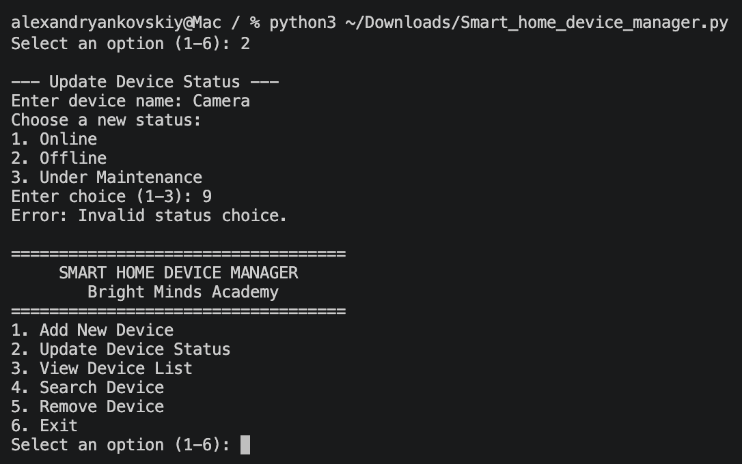

The program validates the status selection and displays an error message when an invalid option is entered.

Figure 6: Adding a New Device

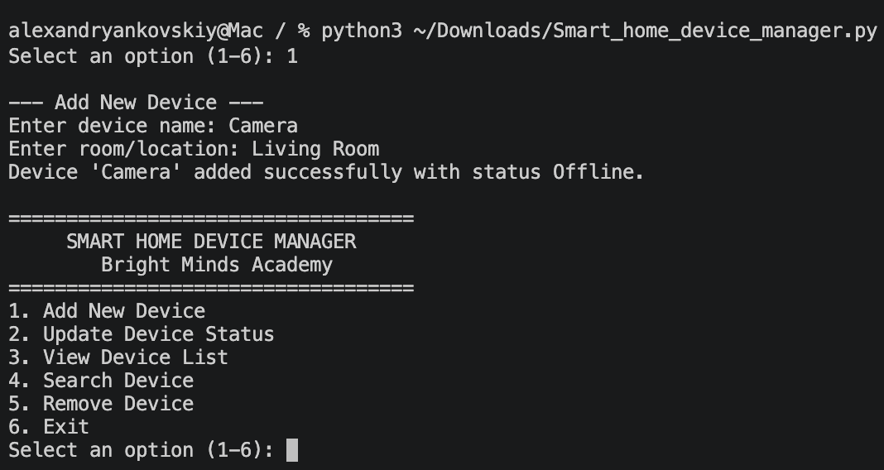

The program successfully adds a new device with its location and default Offline status.

Figure 7: Device Not Found Error Handling

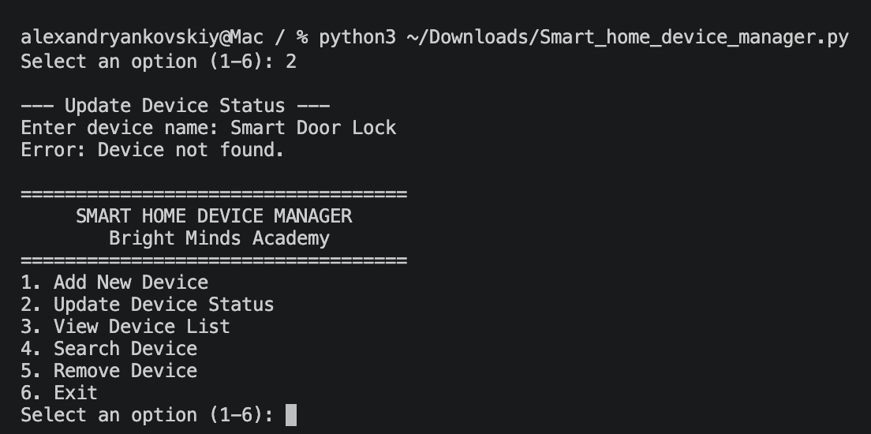

The program displays an appropriate error message when the user attempts to update a device that does not exist.

Figure 8: Viewing the Device List

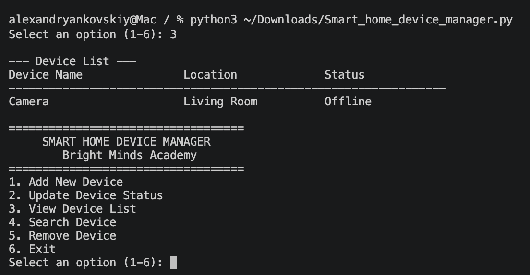

The program displays the registered device together with its location and current status.

4. Evaluation

Challenges Faced:
One of the main challenges I faced during this project was developing an application that could handle different types of user input without producing unexpected results. The Smart Home Device Manager requires the user to enter device names and locations as well as select menu options and device statuses. During development, I realised that simply implementing the main functions was not sufficient because users could enter incorrect or unexpected values. I therefore introduced validation for empty inputs, duplicate device names, invalid menu selections and unsupported status choices. I also ensured that operations such as updating, searching and removing a device first check whether the requested device exists.
Another challenge was deciding how device information should be stored. A Python dictionary provided a suitable structure while the application was running, but the information would otherwise be lost when the program was closed. To address this limitation, I implemented JSON-based persistent storage. The program can load previously stored device information when it starts and save changes when device records are modified. I also used exception handling for file operations so that problems with stored data could be handled more safely.
Ensuring that the program behaved correctly in less predictable situations was also challenging. During development, I repeatedly tested individual operations using both valid and invalid inputs and compared the actual output with the expected result. Cases involving invalid status values, duplicate device names and devices that did not exist helped reveal where additional validation was required and allowed me to improve the reliability of the final solution.
During development, I also expanded the solution beyond the core device-management functionality. In addition to adding, updating, viewing and searching for devices, I implemented a Remove Device function and JSON-based persistent storage. These additions made the final application more practical because outdated records can be removed and device information remains available between different program sessions.

Future Improvements
Although the completed application meets the main requirements and includes additional functionality, there are several ways in which it could be developed further. One significant improvement would be the introduction of a graphical user interface. The current console menu is appropriate for a prototype, but a GUI containing buttons, forms and clearly presented device information could make the system more accessible to staff who have limited experience with command-line applications.
Another future improvement would be to replace JSON storage with a database if the application were deployed on a larger scale. JSON is appropriate for the current number of records, but a database could provide more structured storage, improved querying and better support for a larger number of devices. User authentication and different access permissions could also be introduced to prevent unauthorised users from changing device information.
The application could additionally be integrated with real smart devices rather than relying on statuses entered manually by the user. For example, a future version could communicate with supported devices over a network and automatically retrieve whether they are online or offline. Other useful improvements could include filtering devices by location or status, sorting the device list, recording a history of status changes and providing timestamps for updates.
These improvements would allow the project to develop from a local prototype into a more comprehensive smart-device management system while retaining the basic structure established in the current implementation.

Self-Reflection
At the beginning of the project, the application appeared to be a relatively simple menu-driven program. However, the development process showed me that implementing the visible functions was only one part of producing a reliable solution. The program also needed to preserve its data, reject invalid input and continue operating when a user made a mistake. This changed the way I approached the project because I began to consider not only whether a function worked, but also how it behaved under different conditions.
Testing became particularly useful when I started checking situations outside the normal use of the program. I tested cases such as an invalid status option, a duplicate device name and an attempt to update a device that did not exist. Comparing the expected result with the actual output helped me identify whether the validation worked as intended. This showed me that testing is not only about confirming that a program runs, but also about checking how reliably it responds when the user provides unexpected input.
Overall, the project gave me practical experience of moving through several stages of software development, from analysing requirements and designing the program logic to implementation, testing and evaluation. It also increased my confidence in using Python functions, conditional statements, loops, dictionaries, JSON storage and exception handling. If I developed a similar application in the future, I would plan the validation and testing requirements earlier in the development process and consider future scalability when selecting methods of data storage.

Conclusion
The development of the Smart Home Device Manager provided a complete solution for managing device information within Bright Minds Academy. Starting from the initial requirements, the project progressed through planning, design, implementation and testing, resulting in a working Python application that performs the intended device-management tasks. The completed system allows device records to be added, viewed, searched, updated and removed through a consistent menu-driven interface.
Attention was given to how the application responds when users provide unexpected or incorrect information. Validation checks prevent empty device names, duplicate records, unsupported status values and invalid menu selections from being accepted. The use of JSON storage also means that changes to device information are preserved after the application is closed rather than existing only during a single program session. Together, these features make the prototype more reliable and practical for its intended purpose.
Testing confirmed that the main functions produced the expected results across both valid and invalid input scenarios. It also helped verify that errors were handled without unnecessarily terminating the program and that stored device information remained consistent after changes were made. Overall, the final application satisfies the main objectives established during the design stage and provides a functional foundation that could later be expanded with a graphical interface, database storage or direct communication with smart devices.

References

[1] Python Software Foundation, “Data Structures — Dictionaries,” Python Documentation. [Online]. Available: https://docs.python.org/3/tutorial/datastructures.html. [Accessed: 16-Aug-2026].

[2] Python Software Foundation, “json — JSON encoder and decoder,” Python Documentation. [Online]. Available: https://docs.python.org/3/library/json.html. [Accessed: 16-Aug-2026].

[3] Python Software Foundation, “pathlib — Object-oriented filesystem paths,” Python Documentation. [Online]. Available: https://docs.python.org/3/library/pathlib.html. [Accessed: 16-Aug-2026].

[4] Python Software Foundation, “Errors and Exceptions,” Python Documentation. [Online]. Available: https://docs.python.org/3/tutorial/errors.html. [Accessed: 16-Aug-2026].

[5] G. van Rossum, B. Warsaw and A. Coghlan, “PEP 8 – Style Guide for Python Code,” Python Enhancement Proposals. [Online]. Available: https://peps.python.org/pep-0008/. [Accessed: 16-Aug-2026].

[6] S. Susnjara and I. Smalley, “What is software testing?,” IBM, Jun. 22, 2026. [Online]. Available: https://www.ibm.com/think/topics/software-testing. [Accessed: 16-Aug-2026].
Appendices
The complete source code for the Smart Home Device Manager is provided below.
# Smart Home Device Manager
# Bright Minds Academy
# ACCA5036 - Scripting and Programming Concepts

import json
from pathlib import Path

DATA_FILE = Path(__file__).with_name("devices.json")
devices = {}

def load_devices():
"""Load saved devices from the JSON file."""
global devices

if not DATA_FILE.exists():
devices = {}
return

try:
with DATA_FILE.open("r", encoding="utf-8") as file:
saved_data = json.load(file)

if isinstance(saved_data, dict):
devices = saved_data
else:
devices = {}
except (json.JSONDecodeError, OSError):
devices = {}
print("Warning: Saved device data could not be loaded.")

def save_devices():
"""Save the current devices dictionary to the JSON file."""
try:
with DATA_FILE.open("w", encoding="utf-8") as file:
json.dump(devices, file, indent=4)
except OSError:
print("Warning: Device data could not be saved.")

def find_device_name(search_name):
"""Return the stored device name using a case-insensitive search."""
for device_name in devices:
if device_name.lower() == search_name.lower():
return device_name
return None

def add_device():
"""Add a new smart device to the system."""
print("\n--- Add New Device ---")
name = input("Enter device name: ").strip()

if not name:
print("Error: Device name cannot be empty.")
return

if find_device_name(name) is not None:
print("Error: A device with this name already exists.")
return

location = input("Enter room/location: ").strip()

if not location:
print("Error: Location cannot be empty.")
return

devices[name] = {
"location": location,
"status": "Offline"
}

save_devices()
print(f"Device '{name}' added successfully with status Offline.")

def update_device_status():
"""Update the status of an existing device."""
print("\n--- Update Device Status ---")
name = input("Enter device name: ").strip()

matched_name = find_device_name(name)

if matched_name is None:
print("Error: Device not found.")
return

print("Choose a new status:")
print("1. Online")
print("2. Offline")
print("3. Under Maintenance")

choice = input("Enter choice (1-3): ").strip()

status_options = {
"1": "Online",
"2": "Offline",
"3": "Under Maintenance"
}

if choice not in status_options:
print("Error: Invalid status choice.")
return

devices[matched_name]["status"] = status_options[choice]
save_devices()

print(
f"Status of '{matched_name}' updated to "
f"{devices[matched_name]['status']}."
)

def view_devices():
"""Display all devices, locations and statuses."""
print("\n--- Device List ---")

if not devices:
print("No devices have been added yet.")
return

print(f"{'Device Name':<25} {'Location':<20} {'Status':<20}")
print("-" * 65)

for name, details in devices.items():
print(
f"{name:<25} "
f"{details['location']:<20} "
f"{details['status']:<20}"
)

def search_device():
"""Search for a device by name."""
print("\n--- Search Device ---")
search_name = input("Enter device name: ").strip()

if not search_name:
print("Error: Search value cannot be empty.")
return

matched_name = find_device_name(search_name)

if matched_name is None:
print("Device not found.")
return

details = devices[matched_name]

print("\nDevice found:")
print(f"Name: {matched_name}")
print(f"Location: {details['location']}")
print(f"Status: {details['status']}")

def remove_device():
"""Remove an existing device from the system."""
print("\n--- Remove Device ---")
name = input("Enter device name: ").strip()

if not name:
print("Error: Device name cannot be empty.")
return

matched_name = find_device_name(name)

if matched_name is None:
print("Error: Device not found.")
return

confirm = input(
f"Are you sure you want to remove '{matched_name}'? (y/n): "
).strip().lower()

if confirm == "y":
del devices[matched_name]
save_devices()
print(f"Device '{matched_name}' removed successfully.")
elif confirm == "n":
print("Device removal cancelled.")
else:
print("Error: Please enter y or n.")

def display_menu():
"""Display the main menu."""
print("\n===================================")
print(" SMART HOME DEVICE MANAGER")
print(" Bright Minds Academy")
print("===================================")
print("1. Add New Device")
print("2. Update Device Status")
print("3. View Device List")
print("4. Search Device")
print("5. Remove Device")
print("6. Exit")

def main():
"""Run the Smart Home Device Manager program."""
load_devices()

while True:
display_menu()
choice = input("Select an option (1-6): ").strip()

if choice == "1":
add_device()
elif choice == "2":
update_device_status()
elif choice == "3":
view_devices()
elif choice == "4":
search_device()
elif choice == "5":
remove_device()
elif choice == "6":
print("Thank you for using Smart Home Device Manager.")
break
else:
print("Error: Please enter a number from 1 to 6.")

if __name__ == "__main__":
main()
Appendix A – Full Python Source Code

