Pear Mummification in Different Salt Variants and its Successes

HPAH5080

By Elizabeth Jasper

Word count: 2033
Date: 29.03.2026
Abstract
This report evaluates the use of different salts on pear segments and the effects they have on the dehydration process in the context of ancient Egyptian mummification. Quarters of pear were placed in zip lock bags with either table salt, Epsom, a mixture or nothing inside. Over the 15 day experiment the pear segments in the salt had reduced to approximately half their body mass with the ones in table salt increasing in weight on the last inspection. Evidence shows that the mixture of the salts and the duration of the dehydration process are both crucial in the desiccation of organic matter.

Key words
Mummification: the process of preserving a body by drying.
Desiccation: the process of removing all moisture from something.
Epsom Salt: Magnesium sulfate
Table Salt: Sodium Chloride

Introduction
The aim of this report is to analyse the effect certain types of salt have on the dehydration process of pear segments and its success; in relation to the desiccation process in Ancient Egyptian mummification. There is a fluidity to the development of mummification, as it has its roots in the predynastic era where those in Upper Egypt would bury their dead in the sand, exposed to the sun to encourage desiccation (Sluglett, 1990, pp.75), natural mummification. It was not until the Old Kingdom in which mummification became a scientific process where the removal of internal organs and wrappings became popular among the elite (Sluglett, 1990, pp.77) with it continually expanding from there. This report will focus on standard table salt, Epsom salts and a mixture of both of them in order to analyse the effects they cause on the organic fabric and how it compares to the soft tissue on Egyptian mummies. The results from the experiment are estimated to be that segments covered in salt will reduce in weight and expel a majority of their moisture while shrinking and becoming tough.

Method
Throughout the experiment the following equipment was utilised: a weighing scale, a beaker, a manual scaler, four zip lock bags and a small kitchen knife.
A pear is selected as the subject for the experiment and analysed for its colour, scent, texture and appearance. After documenting, the pear is then cut into four segments with a small kitchen knife; stem, seeds and core are left in situ. One segment was placed into each of the four zip lock bags and labelled control, table salt, Epsom salt and 50/50. In a beaker one hundred grams of table salt was measured and emptied into the accompanying zip lock bag. This was then repeated with the Epsom salt. For the 50/50 mixture, fifty grams of table salt and fifty grams of Epsom salt were combined in the same bag. One segment is left in an empty bag to form the control. Once all applicable segments are completely covered with the variable, the bags are then rolled to expel any excess air before being locked and taped to ensure the pear will not be uncovered. They are then left in the corner of a room and not touched, apart from periods of examination, for a further fifteen days.
At the end of each week, every seven days, the segments were again analysed for the aforementioned aspects. Segments were taken out of their bags, cleaned with a manual scaler and weighed. All changes were recorded. They were then placed back in their respective bags and buried within the same salt that was placed in week one, rolled and left for another seven days. After the seven days the process was repeated before being disposed of.
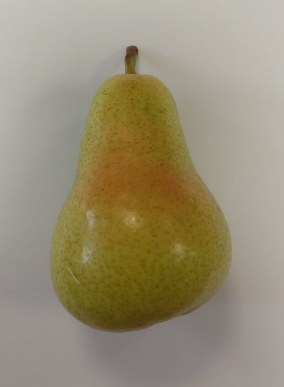
Results
At the start of the experiment, week one, the pear was a vibrant green with slight colour variance on one portion of the peel. Its smell was subtle and both the flesh and the peel were hard with no signs of discolouration from decomposition (see figure 1). The beginning weights of the segments can be found in table one.

Figure 1
Table 1:
Segment | Weight (g)
Control | 29.3g
Table | 33.2g
Epsom | 20.5g
50/50 | 25.3g

On the second week, at day seven, the segments were analysed within and outside of the bag. The control bag showed no signs of perspiration and once opened contained the same subtle smell as week one. Brown bruises had formed on the flesh namely around the core and alongside the peel. The vibrant green of the peel persisted, the lenticels had however grown darker in colour. To the touch it was still firm and plump showing no signs of significant shrinkage; weighing 29 grams.
The table salt bag contained more moisture with a clumpy appearance in areas. A strong, sweet aroma came from the opened bag but showed no notes of rot. The flesh had significant bruising nearer the core while the higher end preserved a ripe look. The peels colour had dulled and browned at the base. It was shrivelled and felt leather like with the edges curling around the shrunken flesh, yet felt overall firm. At the end it weighed 18.7 grams.
There was large amounts of moisture built up in the Epsom salt bag, enough to pool under the segment. Much like the table salt, the smell was strong once released from the bag. The flesh had shrivelled greatly and turned a light brown colour covered in the residual moisture. The sides of the peel had curled prominently around the flesh and turned brown, however, the whole peel retained most of its vibrant green colouring. It felt fragile and weighed in at 10.2 grams.
The mixture, or 50/50, had a moist appearance with familiar clumps inside the bag. The flesh held its ripe appearance despite being shrivelled with bruising contained alongside the peel. There was a similar curving of the peel edges; the colour dulling uniformly. It was structurally sound and weighed 10.9 grams.
By the third week, day fifteen, the control had little visual change from inside the bag. The smell was the same, however it had become more faint. The flesh was still hydrated yet had more bruising dispersed throughout the whole segment, with blackening in the areas where the seeds sat. The peel had changed into a yellow yet still had not wrinkled. It was still solid and did not show signs of moisture loss. The weight came to 28.6 grams.
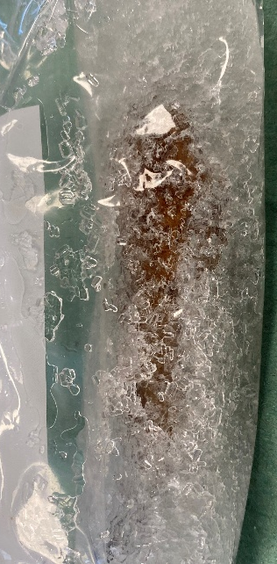
The table salt bag had a similar look to week two and the smell was again strong but did not smell of decomposition. More bruises had formed on the flesh, the previous darkening in colour, yet the higher end still kept a ripe appearance. The peel had not wrinkled more than the previous week and the colour had stayed at the same dullness. It felt tough and dry to the touch, similar to a dehydrated fruit. At the end it had increased to a weight of 20.2 grams.
Figure 2
The Epsom salt bag had an increased amount of excess liquid that had soaked through all grains (see figure 2). The flesh had become further shrivelled and brown, almost disappearing completely. The peel had a similar effect, turning a deep brown with all green lost and highly wrinkled. The segment was squishy on the outer parts, turning more firm in the centre nearer the core but still coated in the remaining moisture. It came to a weight of 8.2 grams.
The mixture had retained a similar appearance in the bag with a strong smell once opened. The light bruising from week two had persisted with little change and still a ripe appearance to the colour. The peel had wrinkled more yet not drastically and the colour had otherwise yellowed further. It had become more fragile and had excess liquid covering the flesh that had shrunken. It had also increased in weight to 12.1 grams.
The following table (table 2) showcases the weight of the segments throughout the experiment and how they compare to each other. For a full photo library see appendix 1.
Table 2:
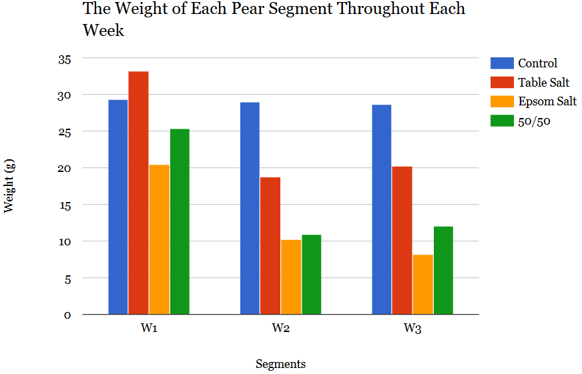

Discussion
All segments have decreased in weight, however, it is to be noted that if this were to be replicated then the weight of each segment should be cut more equally as the mass of the subject affects the rate of dehydration. Therefore in the chart it is shown that the table salt decreased quite drastically compared to the others, however, this is mainly due to the fact that it was the largest and therefore had the most moisture out of those in salt. Regardless of this, it showcases that the absorption of moisture into the salt is higher in the 50/50 salt mixture as it lost over half its starting weight.
As evident in the table there was an increase in the weight on the segments that contained table salt, this is due to the duration of the experiment and the ways in which the sodium chloride reacts with the organic matter. Being covered in the compound the surface of the organic matter becomes a place of high osmotic pressure which draws out the moisture and therefore decreases the mass in order to reach equilibrium (Mari, Parisouli and Krokida, 2024). However, if left in the solution too long the subject can obtain mass as the salt diffuses inwardly which creates solid weight gain which is possibly what occurred with these segments (Mari, Parisouli and Krokida, 2024). Therefore, looking at mummification, the length of time which the subject is in the salt is just as important as understanding which salt to choose as it may have adverse effects if left in the solution for too long.
The environment the experiment was performed in was a classroom that had a running stream of students, this may have affected the rate of dehydration or decomposition as the act of closing or opening the windows would have changed the temperature and therefore the rate at which bacteria would grow (Zwietering et al., 1994, pp.200). If it were to be done again then an environment that had a regulated temperature would reduce this risk and therefore produce more reliable results with an easily replicable method. Temperature regulation is additionally important as the experiment was performed at the beginning of spring and therefore the temperatures are fluctuating which can create humidity in the zip lock bags and increase bacterial development. However the use of a plastic zip lock bag reduce the risk of bugs, namely flied, eating the matter and increasing decomposition.
Furthermore, the recording of the weight, texture, smell and colour of the segments could have been improved through the use of measurements with callipers or a ruler which would allow for a metric analysis of the shrinkage the different salts caused. In conjunction with this the level of salt decreased at each analysis point as the segments were cleaned and therefore the excess salt was thrown away, this would therefore slow the rate of reaction. Therefore the salt should have been replenished after every revaluation in order to keep it a stable 100 grams throughout the whole experiment. During analysis the subjects were taken out of the salt and therefore new bacteria was possibly introduced into the environment which would affect the rate of decomposition as they were handled more and placed on objects that were not sanitised such as scales and paper towels which could have left debris. In the context of ancient Egyptian mummification this is one of the main factors that would not be present in the original process as it may cause negative effects to the end product.

Conclusion
In conclusion the hypothesis of the experiment was partially correct as the subjects did lose half of their mass however it did not account for the increase in weight by those affected with table salt. The evidence therefore suggests that the mummification of these segments is time sensitive and those in ancient Egypt had to be aware of the adverse effects that may compromise the mummy both in its fragility and drying. Additionally, it shows that the use of Epsom salts, or magnesium sulfate, speed up decomposition as they were covered with bruising and an unlikely choice to dehydrate organic matter. Overall the experiment was in part successful as the pear segments did lose a majority of their moisture if they were in a salt and with possible further experimentation would result in more successful desiccation.

References
Mari, A., Parisouli, D.N. and Krokida, M. (2024). Exploring Osmotic Dehydration for Food Preservation: Methods, Modelling, and Modern Applications. Foods, 13(17), p.2783. doi:https://doi.org/10.3390/foods13172783.
Sluglett, J. (1990). Mummification in Ancient Egypt. West of England Medical Journal, [online] 105(4), p.75. Available at: https://pmc.ncbi.nlm.nih.gov/articles/PMC5114957/.
Zwietering, M.H., Cuppers, H.G.A.M., de Wit, J.C. and van ’t Riet, K. (1994). Evaluation of Data Transformations and Validation of a Model for the Effect of Temperature on Bacterial Growth. Applied and Environmental Microbiology, 60(1), p.200. doi:https://doi.org/10.1128/aem.60.1.195-203.1994.

Bibliography
Ancient author (2017). Mummification - Livius. [online] Livius.org. Available at: https://www.livius.org/sources/content/herodotus/mummification/.
Ikram, S. (2010). Mummification. UCLA Encyclopedia of Egyptology, [online] 1(1). Available at: https://escholarship.org/uc/item/0gn7x3ff.
Saheeda Mujaffar and Sankat, C.K. (2005). The mathematical modelling of the osmotic dehydration of shark fillets at different brine temperatures. International Journal of Food Science & Technology, 41(4), pp.405–416. doi:https://doi.org/10.1111/j.1365-2621.2005.01086.x.

Appendix 1:
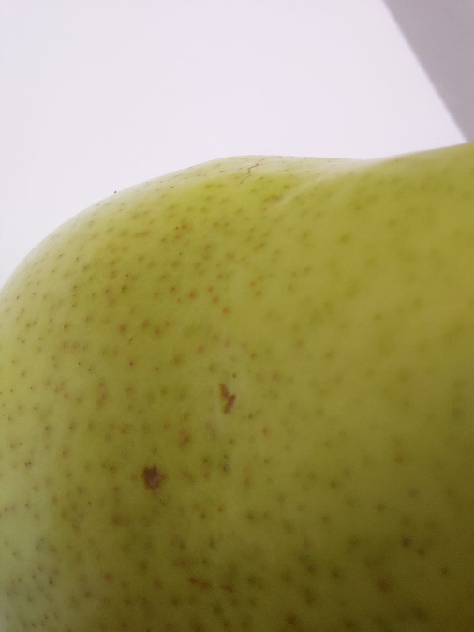
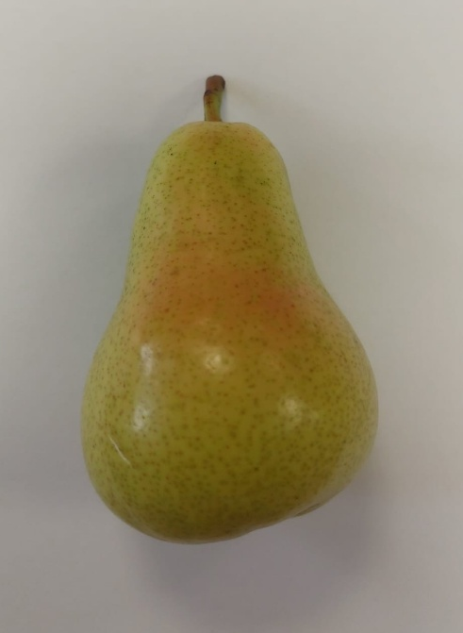
Week one:

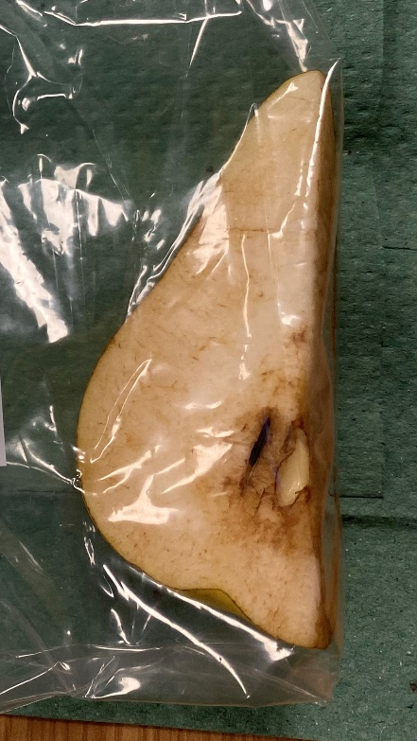
Week two:
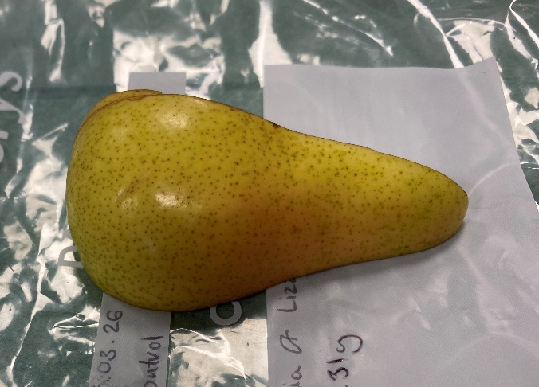
Control-

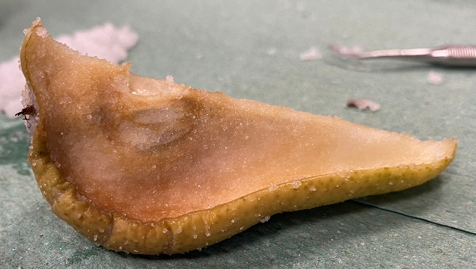
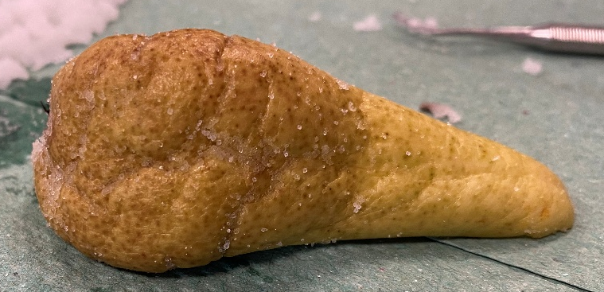
Table-

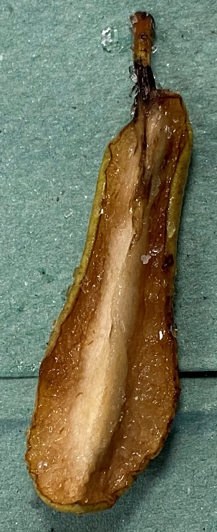
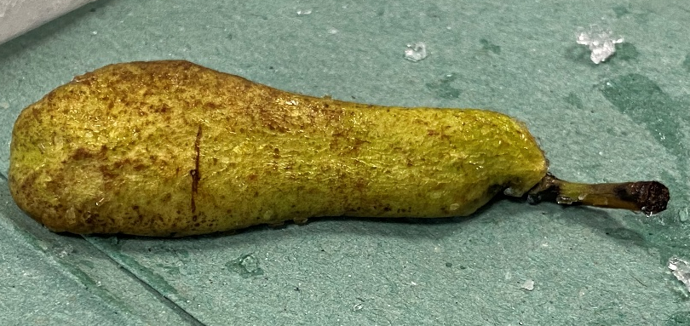
Epsom-

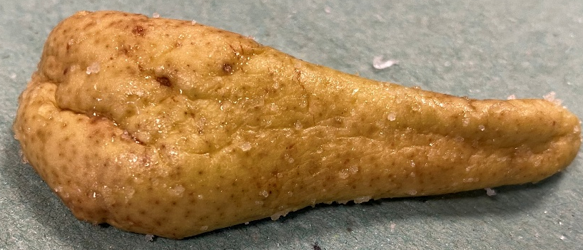
50/50-
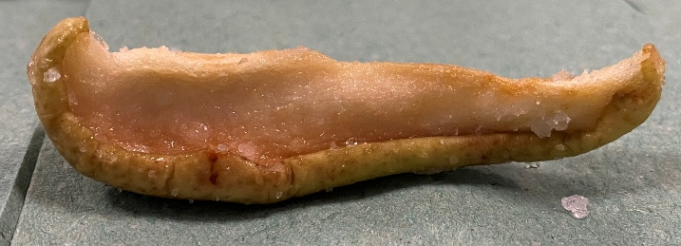

Week 3:
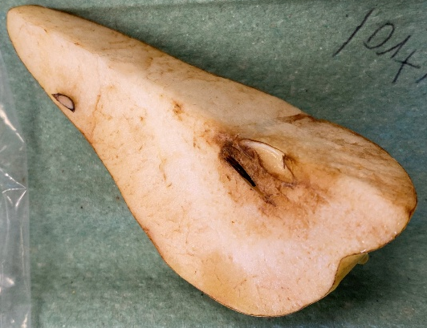
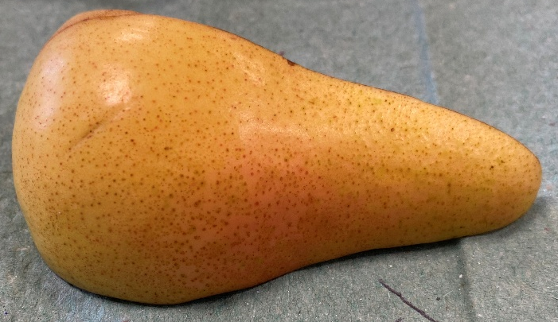
Control-

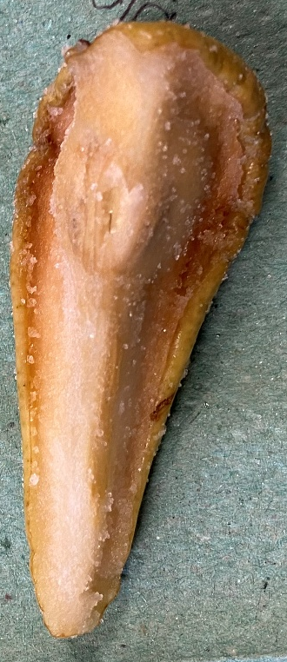

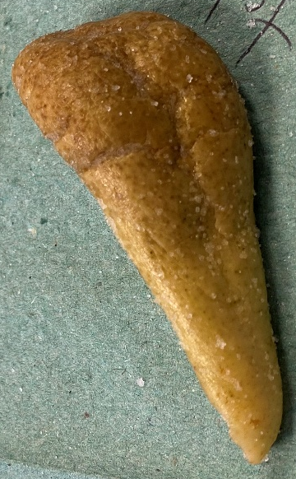
Table-

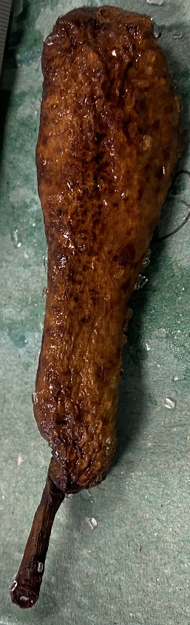
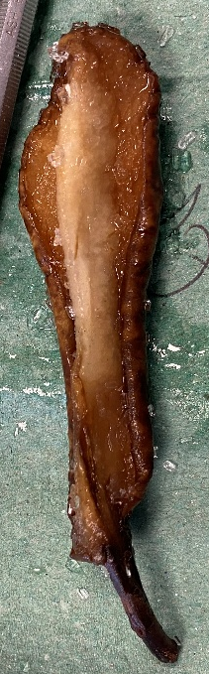
Epsom-
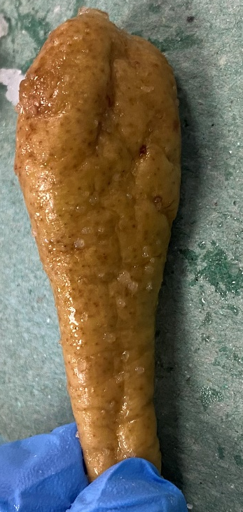
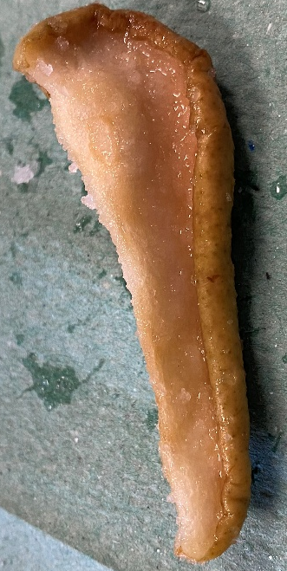

50/50-

