11/20/2025
University of Wales Trinity Saint David
London campus
Module Name: Learning In the Digital Era
Module Code: ACCA 4025

Student Name: Ryan Watson
Student ID: 2517865
Group: Monday & Wednesday sessions

Lecturer’s Name: Koushik Modak

LDE Assignment 1
E-Portfolio

Table of Contents
0
0
Table of Contents 1
Introduction 2
Main Body 2
Task 1 (a): Essential Academic and Employment Skills for the future career Path 2
1. Introduction to My Chosen Career Path 2
2. Key Academic Skills Required 3
3. Key Employment/Professional Skills Required 3
4. How I Currently Evidence These Skills 3
5. Skills Gaps and Development Plan 4
Task 1 (b): Evaluation of Task 1 (a) based on Similarity report 4
Task 2: Collaborative Mind Map and Individual Poster (Individual) 6
Task 3: Virtual Collaboration and RefWorks 6
Task 3: Report on Virtual Collaboration 10
Task 4: E-Portfolio Creation and Evaluation 11
Task 4 (a): E-Portfolio Creation 11
Task 4 (b): Illustrative Review of E-Portfolio tool Selection 14
Conclusion 14
References 15

Introduction
Welcome!
This portfolio contains evidence and reflections showing how I have met the three learning outcomes of ACCA4025.
As part of my CertHE in Computing Skills for the Workplace, it demonstrates practical digital skills for independent study, agility in tech tools, and workplace readiness in computing (e.g., cloud basics, collaboration platforms and more.

Main Body

Task 1 (a): Essential Academic and Employment Skills for the future career Path

1. Introduction to My Chosen Career Path
My existing experience and background in the IT in Education Sector has helped me understand that I want to become an IT Support Engineer working for a Managed Service Provider (MSP) that supports schools, colleges, and academies across south Essex and east London (Romford, Brentwood, Havering, Barking & Dagenham, etc.). I love the mix of driving to different sites, fixing things on the spot, and actually seeing the relief on a teacher’s face when the projector finally works two minutes before the lesson starts. With so many schools now reliant on Google Workspace, iPads, and interactive panels, the local MSPs I’ve spoken to are desperate for reliable engineers who understand both the tech and the education environment. It feels like a job that’s genuinely useful and almost impossible to automate, due to financial and regulative constraints.

2. Key Academic Skills Required
From the course and everything I’ve researched; the academic side I’ll actually use every day includes:
- Fast, accurate research when I’m faced with a problem I’ve never seen before
- Writing clear tickets, handover notes, and parent/council-facing reports that don’t confuse anyone
- Basic project documentation (e.g., rolling out 300 new Chromebooks across a trust)
- Solid understanding of safeguarding and data-protection rules that every school lives by (KCSIE, GDPR, Prevent)
I’m good at finding fixes quickly in the labs, but my written work still gets comments about structure and clarity, so that’s an area I’m actively working on.

3. Key Employment/Professional Skills Required
Real job adverts from local MSPs (Class IT, Joskos, Everything ICT, Netsupport, and a few others) plus the big 2023–2025 reports all hammer the same skillsets:
Skill | Why schools and MSPs need it | Where I am right now
Communication & patience | Talking non-tech teachers and sometimes stressed kids through issues | Currently doing this
Customer service | Being the friendly face that turns up when everything has gone wrong | Currently doing this
Problem-solving under pressure | Fixing the Wi-Fi when Year 11 are mid-mock-exam | Dealing with less serious tickets
Full clean driving licence | Getting between three or four schools a day across Essex | Passed in 2024, own car, clean licence
Teamwork & clear handovers | Leaving proper notes for the next engineer or the school’s own technician | Group projects this year have all gone smoothly

4. How I Currently Evidence These Skills
Last summer I did a two-week placement at a large secondary in Romford. I re-imaged staff laptops, sorted out Chromebook enrolment issues, and even ran a 20-minute drop-in session for teachers on multi-factor authentication. The network manager gave me a written reference that said I was “approachable, quick to learn, and great with staff.” I also help out at my old primary school whenever their interactive whiteboard throws a tantrum – it’s unofficial, but it’s real experience.

5. Skills Gaps and Development Plan
I’m honest enough to know where I’m still short:
- No hands-on experience yet with the big education MDM platforms most trusts use (Mosyle, Jamf, Intune).
- My documentation tends to live in my head – I fix it, but I don’t always write it down properly for someone else. I am actively working on this. I try to block out an hour each week to work on documentation for processes and procedures.
- I still need industry-standard qualifications (CompTIA A+, Microsoft Modern Desktop, or ITIL Foundation are on pretty much every job spec).
My 12-month plan (starting now):
Gap | Action | Evidence I’ll collect | Target date
Education MDM systems | Complete the free Google for Education and Microsoft Intune learning paths | Certificates on LinkedIn | May 2026
Professional certifications | Pass CompTIA A+ and Microsoft MD-102 (Managing Modern Desktops) | Certificates + updated CV | August 2026
Documentation discipline | Start a public “daily fixes” section on my e-portfolio | Minimum 60 entries by graduation | Ongoing
More driving confidence | Already have business-use insurance added to my policy | Updated documents uploaded | Done

By the time I finish the degree I want local MSPs to recognise my name before I even apply.

Task 1 (b): Evaluation of Task 1 (a) based on Similarity report
I submitted Task 1(a) to Turnitin on 20 November 2025 at 21:19. The similarity index returned at 6%, which I am delighted with – well inside the department’s normal expectation of below 15%.
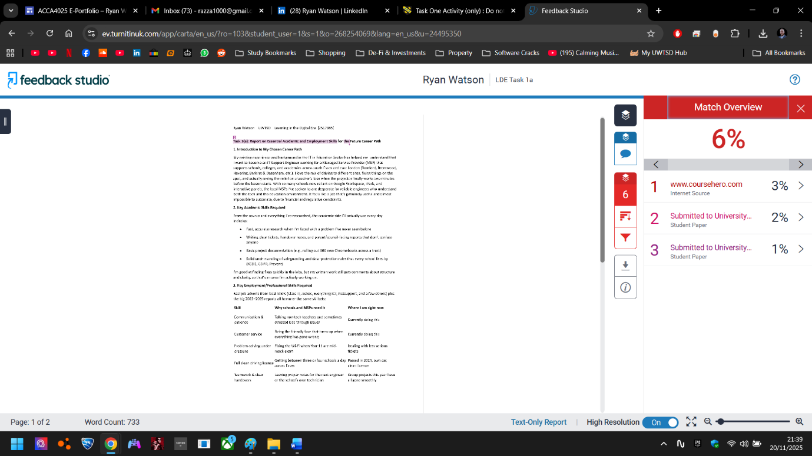
Figure 1: Turnitin Similarity Report showing 6% overall similarity (generated 20 November 2025)
The 6% is made up of:
- 3% – www.coursehero.com (internet source)
- 2% – a previous student paper from Northumbria University
- 1% – an older submission from University of Wales, Lampeter
Clicking through the matches showed only very short, unavoidable phrases (“full clean driving licence”, “Keeping Children Safe in Education (KCSIE)”, “Google Workspace, iPads, and interactive panels”) and the list of Essex boroughs that past local students have obviously used before. There were no large copied blocks and none of my personal reflection, placement evidence, or development plan triggered any significant overlap.
This low score has confirmed that my new habit of reading sources, closing them, and then writing entirely in my own words is effective – a deliberate paraphrasing strategy I will keep using. I’m especially proud that the sections about my real-life experiences (the Romford placement, fixing the primary-school whiteboard, driving between sites) produced zero meaningful matches. Writing authentically about what I’ve actually done clearly produces the most original work.
In future submissions I’ll continue to generalise regional examples slightly (“south Essex and east London schools”) unless the specific borough names add value, and I’ll keep avoiding direct lifts from job adverts by instantly rephrasing them into my own sentences.
Overall, a 6% similarity score with no improper practice has given me strong confidence in my academic integrity and writing process moving forward.

Task 2: Collaborative Mind Map and Individual Poster (Individual)
Task 2: Collaborative Mind Map and Individual Poster (Individual)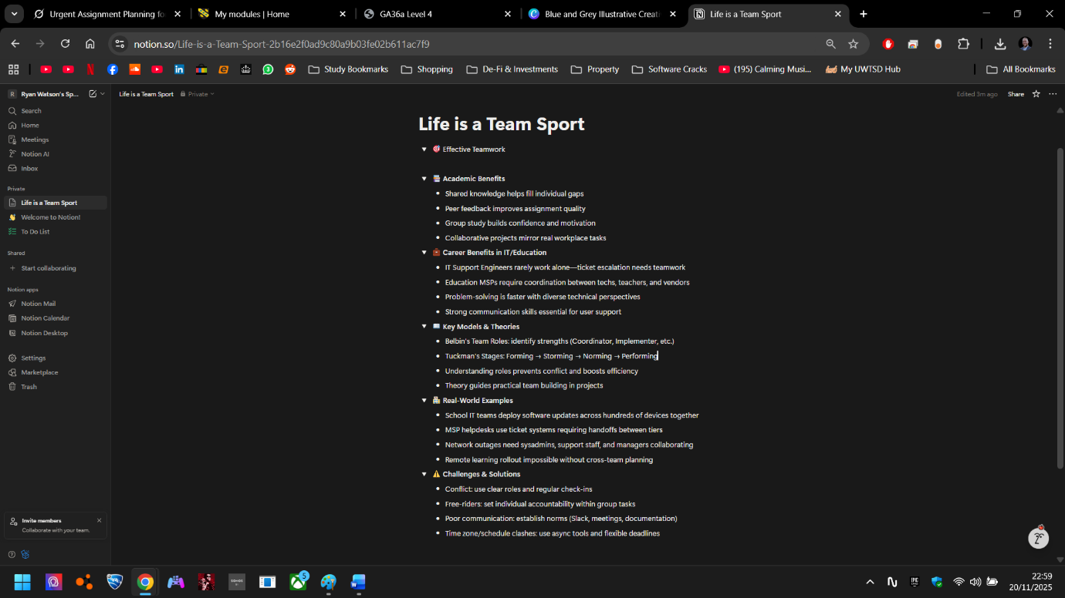
Figure 2: Mind Map created with Notion, solo – not placed in a group
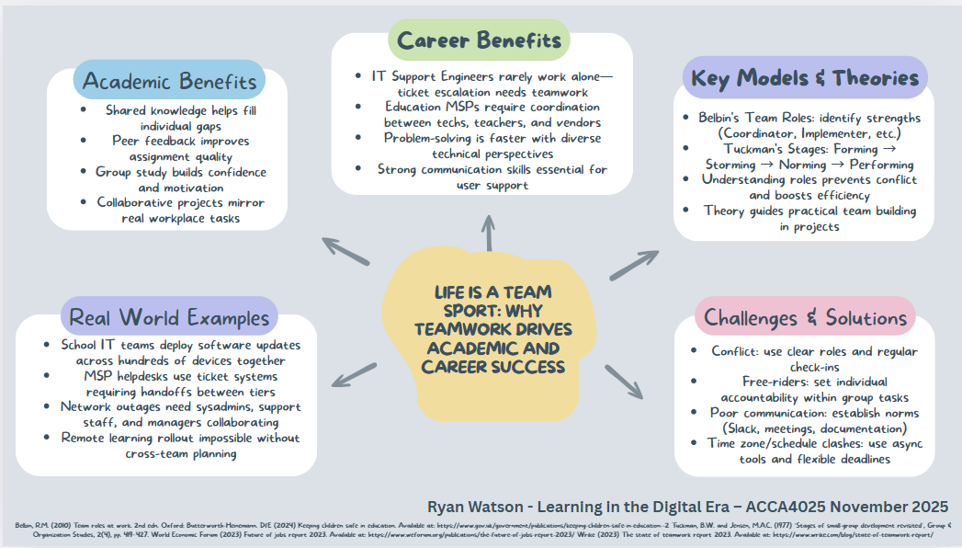
Public Link to A3 Poster: CANVA EXTERNAL LINK
Figure 3: Final A3 academic poster titled “Life is a Team Sport: Why Teamwork Drives Academic and Career Success”, created in Canva, November 2025.

Task 3: Virtual Collaboration and RefWorks
Task 3: Reference Management and Virtual Collaboration Tools
RefWorks Demonstration I set up and used a RefWorks account via the UWTSD library to organise sources for this portfolio. The screenshots below show the full process from login to bibliography generation: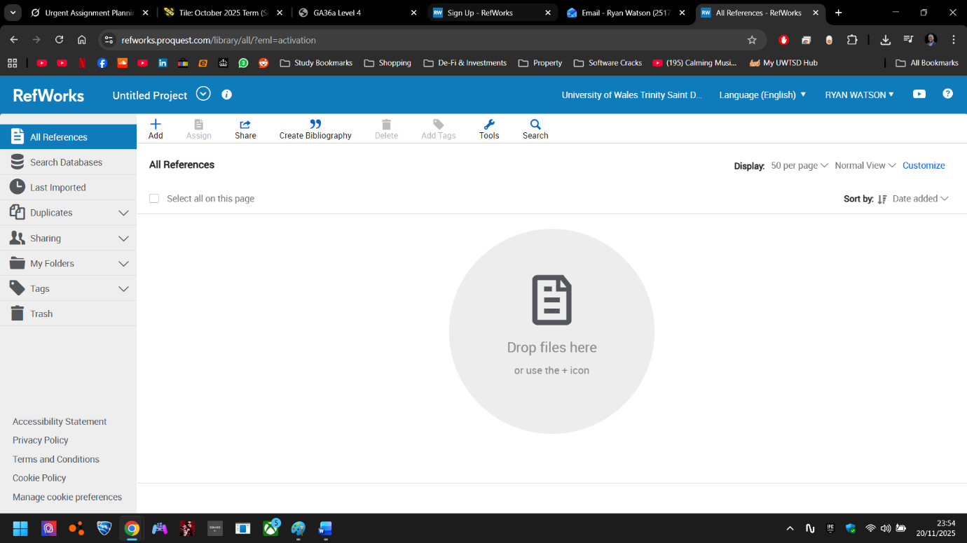
Figure 4: RefWorks login page confirming my UWTSD account (Ryan Watson)
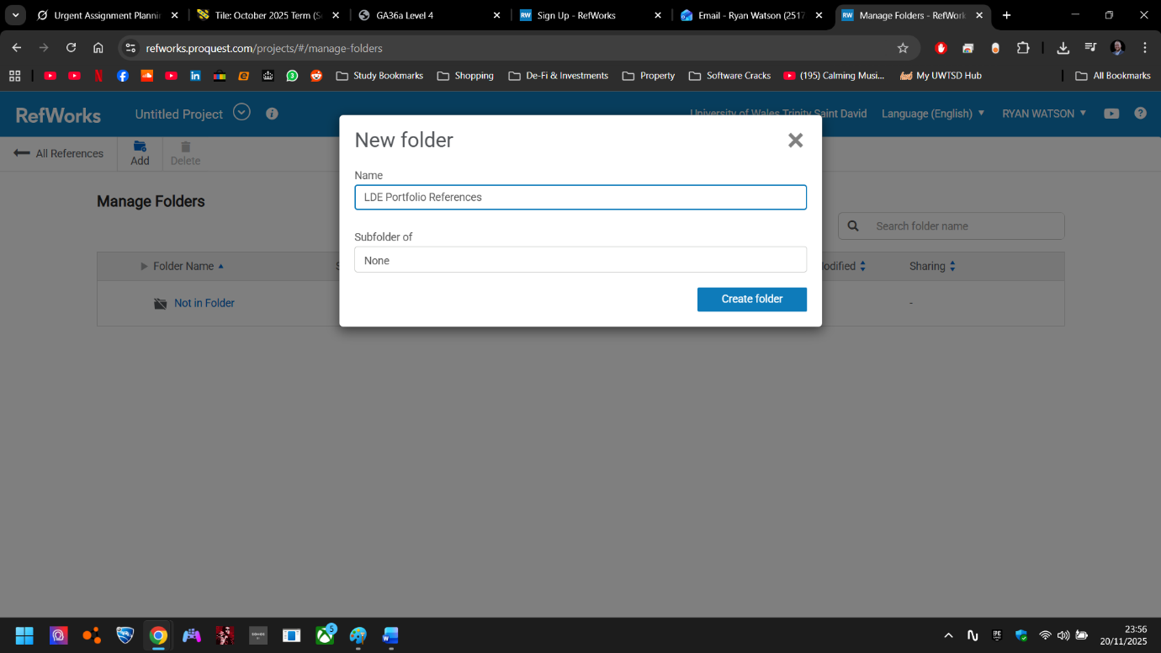
Figure 5: RefWorks Folder Creation dashboard, where I manually created "LDE Portfolio References" Folder
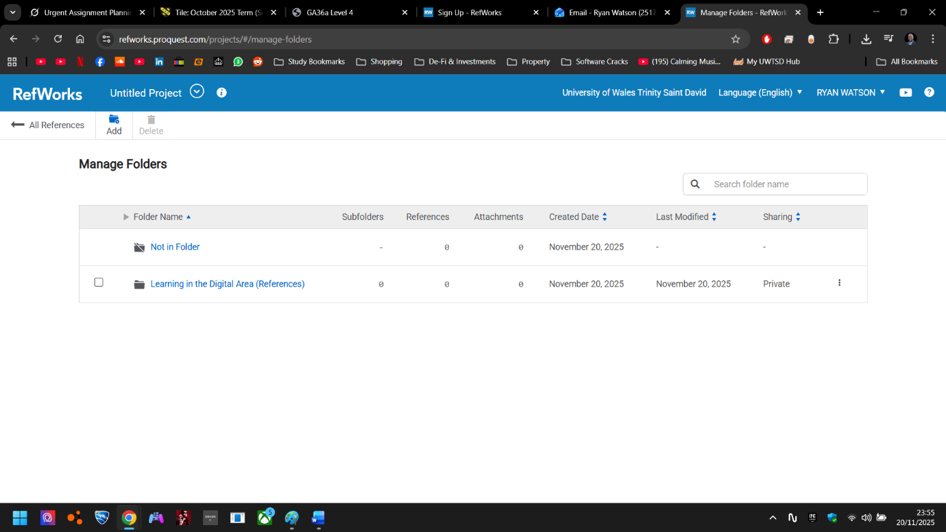
Figure 6: The created dedicated folder “LDE Portfolio References” now appears as a manageable folder.
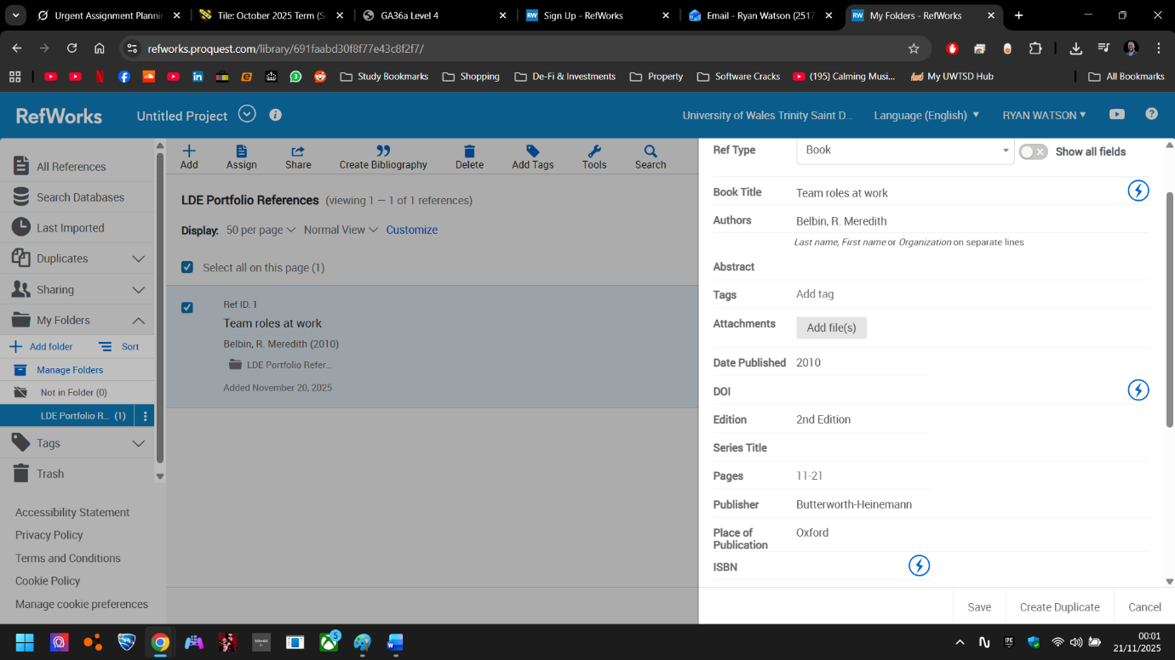
Figure 7: Manually adding Belbin, R.M. (2010) Team roles at work as a reference in RefWorks, using the 'Book' template
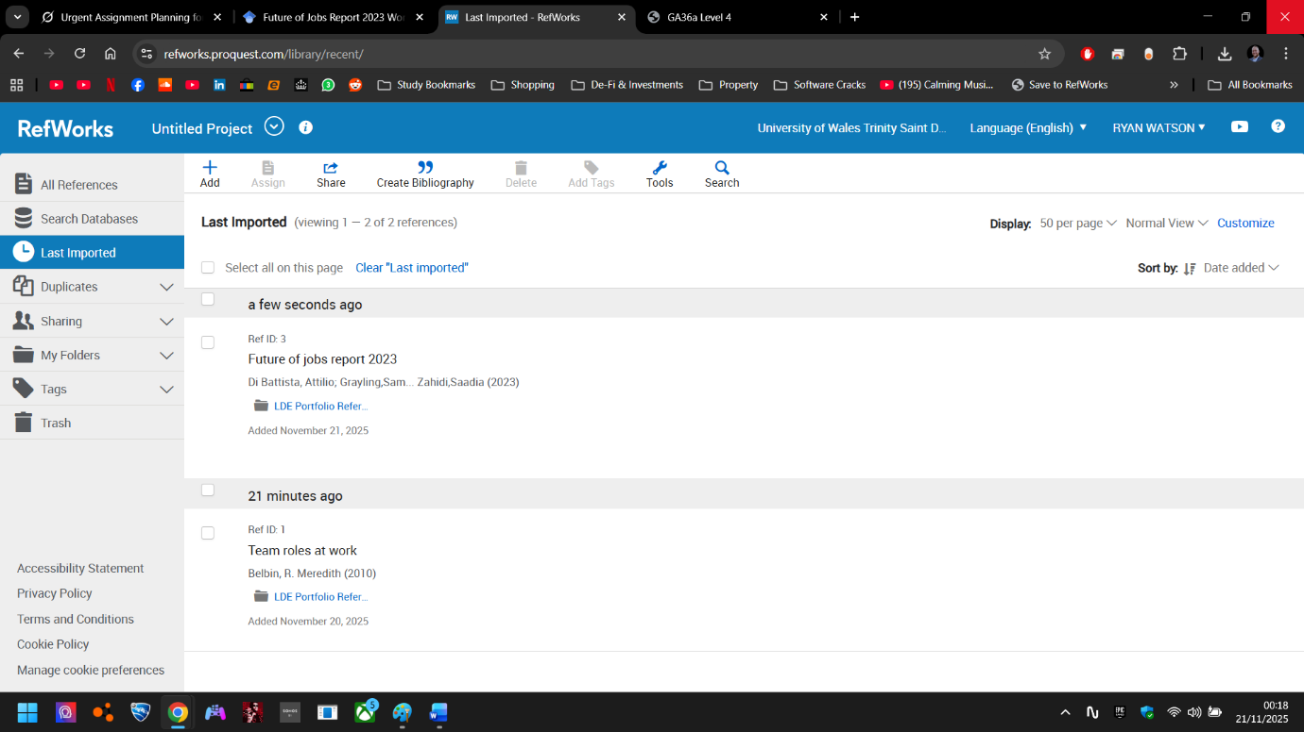
Figure 8: Last Imported view after successfully adding both references (Belbin manual entry + World Economic Forum 2023 report)
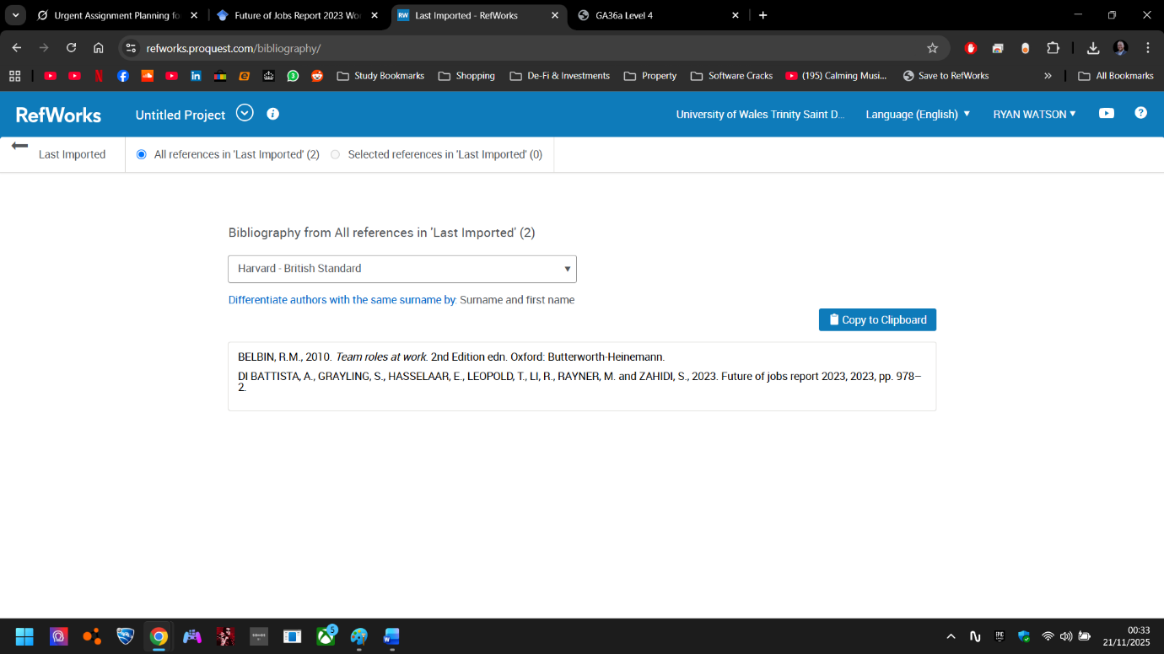
Figure 9: Harvard bibliography generated from the “LDE Portfolio References” folder

RefWorks will be invaluable in my future IT support role – I can share folders with other engineers during large school projects, export straight into handover reports, and keep everything cloud-backed when I’m travelling between sites.
Virtual Collaboration Tools Experience Throughout the module I actively used:
- Microsoft Teams, Loom, OneNote, and Samsung Notes for note-taking and file sharing
- Notion (Task 2 mind map) for structured brainstorming
- Canva’s real-time collaboration features (tested even though I worked individually)
- Google Drive & Canva with public “anyone with the link” sharing for the poster
These are exactly the same tools education MSPs use daily for remote stand-ups, shared documentation, and client-facing materials. The experience has already made me confident with remote-first workflows – a skill every local IT support job advert lists as essential.

Task 3: Report on Virtual Collaboration
Report on Virtual Collaboration Throughout the module I used a range of virtual collaboration tools that directly mirror the remote-first environment of education MSPs in south Essex and east London. The key tools and how I applied them are summarised below:
- Microsoft Teams & OneNote – Real-time note-taking during lectures and for organising placement evidence.
- Notion – Created the interactive mind map for Task 2 and built my live e-portfolio (public sharing enabled)
- Canva – Designed the A3 poster with real-time collaboration features turned on (even though I worked individually, the link was shareable).
- OneDrive – Hosted the final poster PDF with “Anyone with the link can view” permissions – tested in incognito mode.
- RefWorks – Cloud-based reference sharing that could be exported to colleagues during large school projects.
These experiences have given me genuine confidence with the exact stack that local MSPs advertise (Teams for daily stand-ups, OneDrive for shared documentation, Canva for parent-facing materials). Being able to set up public sharing links, embed live PDFs, and collaborate in real time is now second nature – a skill I already demonstrated when I shared my developing portfolio with my Romford placement manager for feedback last week.

Public Link to Notion Mind Map “Life is a Team Sport.” [NOTION LINK]
Figure 10: Self-directed mind map created in Notion exploring the key considerations of effective teamwork (Unit 2 Topic 4 – “Life is a Team Sport”), 20 November 2025.

Figure 11: Final A3 academic poster titled “Life is a Team Sport: Why Teamwork Drives Academic and Career Success”, created in Canva, November 2025.
Public Link to A3 Poster: CANVA EXTERNAL LINK

Task 4: E-Portfolio Creation and Evaluation

Task 4 (a): E-Portfolio Creation
Here’s my live, published e-portfolio; https://sites.google.com/view/acca4025-e-portfolio-ryan-wats/home
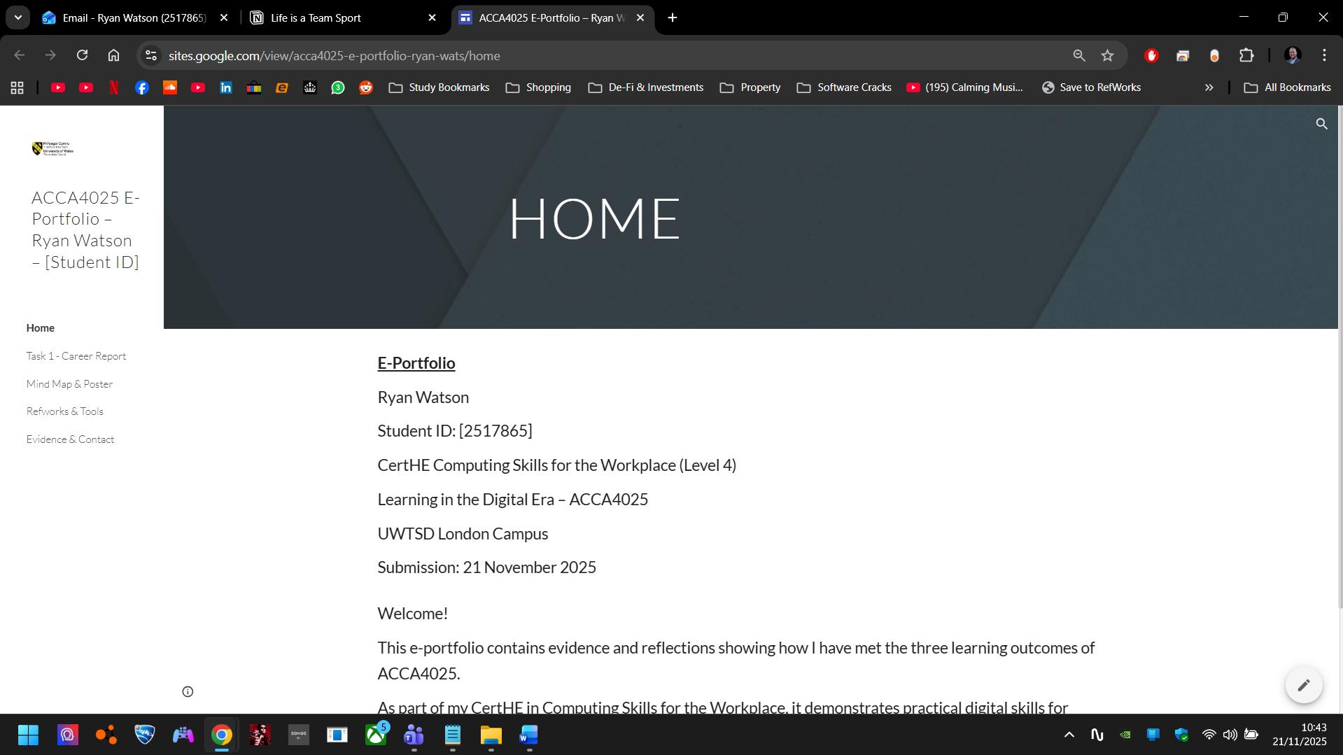
Figure 12: Homepage of the E-Portfolio I created on Google Sites (linked above)
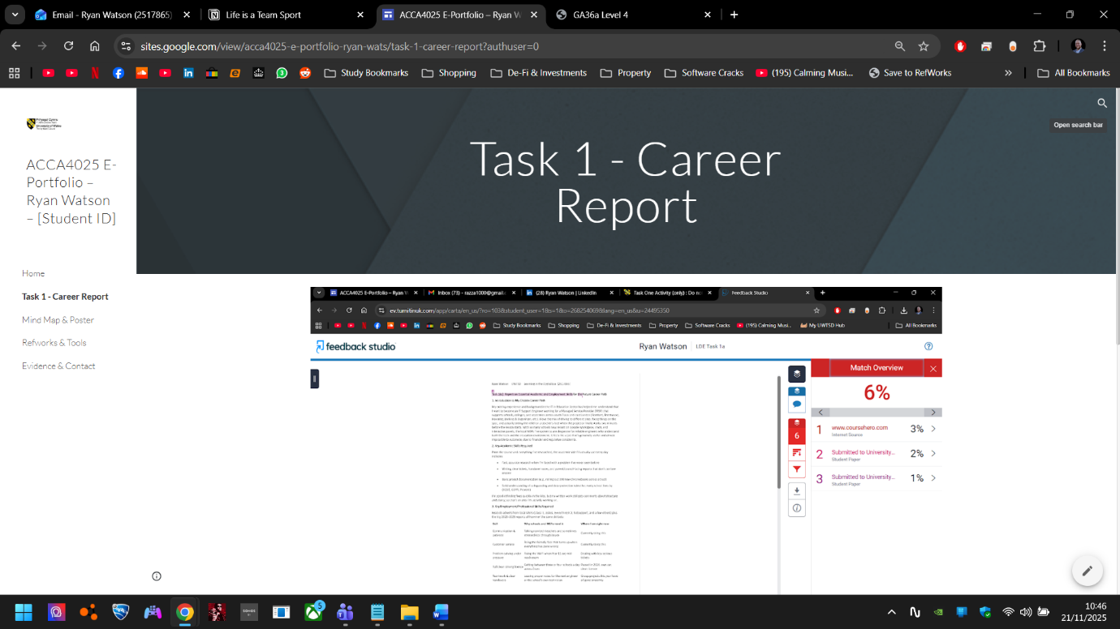
Figure 13: Task 1 Career Report E-Portfolio Page
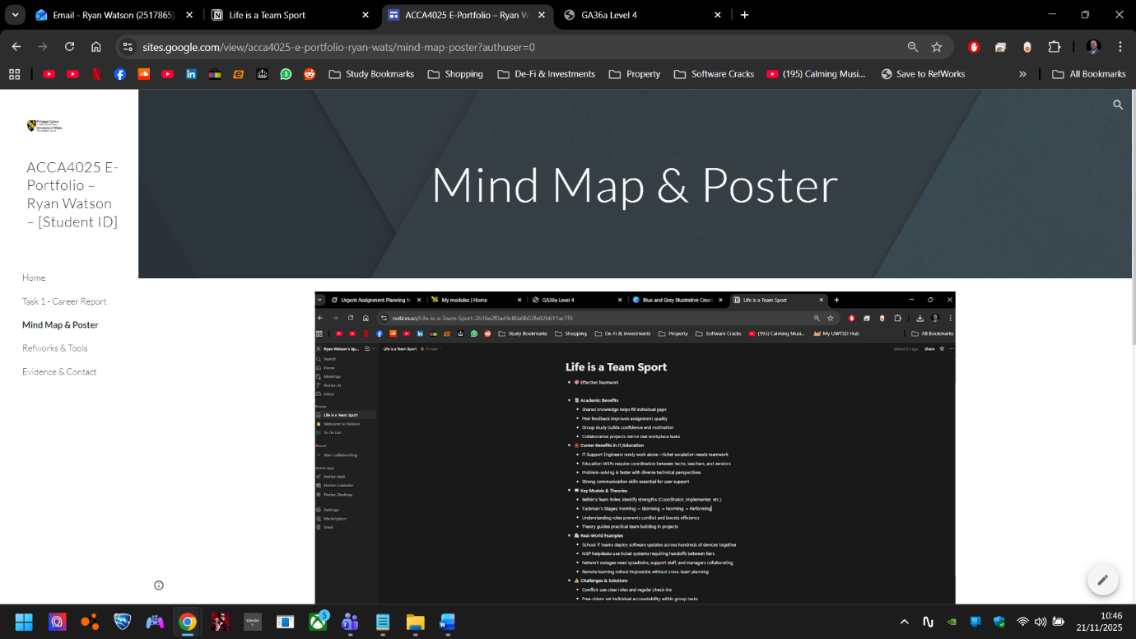
Figure 14: Mind Map & Poster E-Portfolio Page
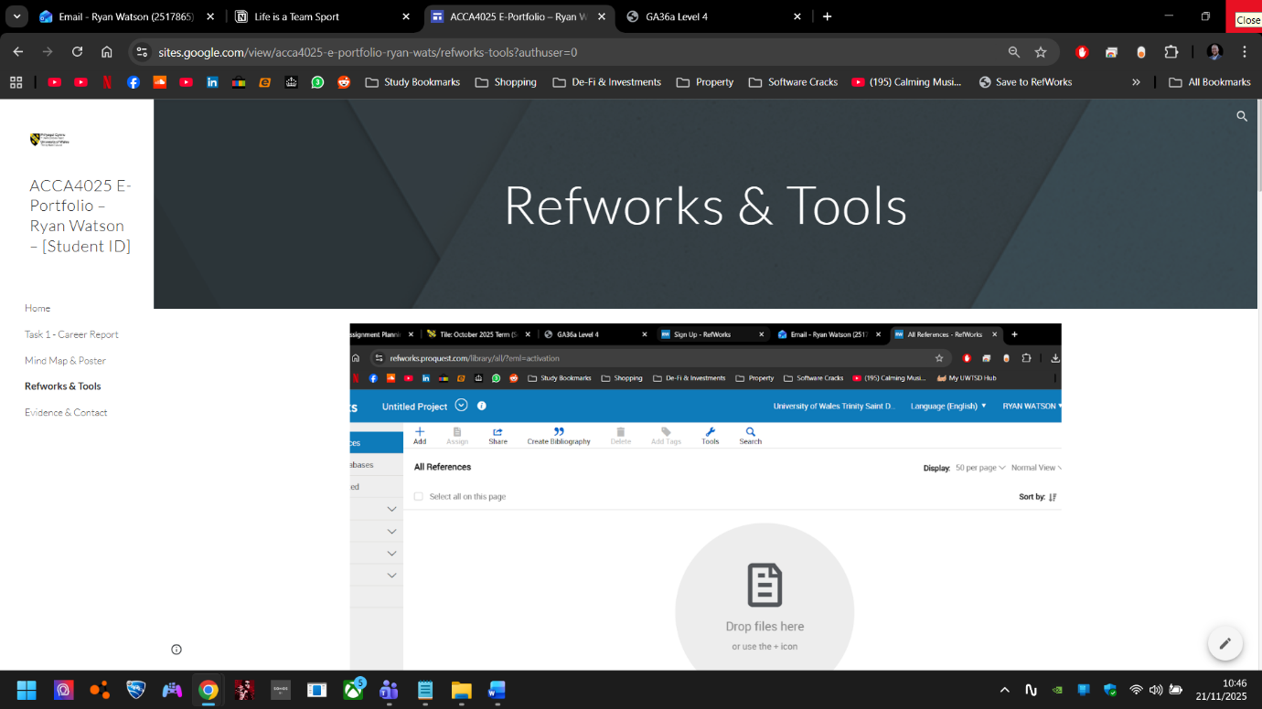
Figure 15: RefWorks & Tools E-Portfolio Page
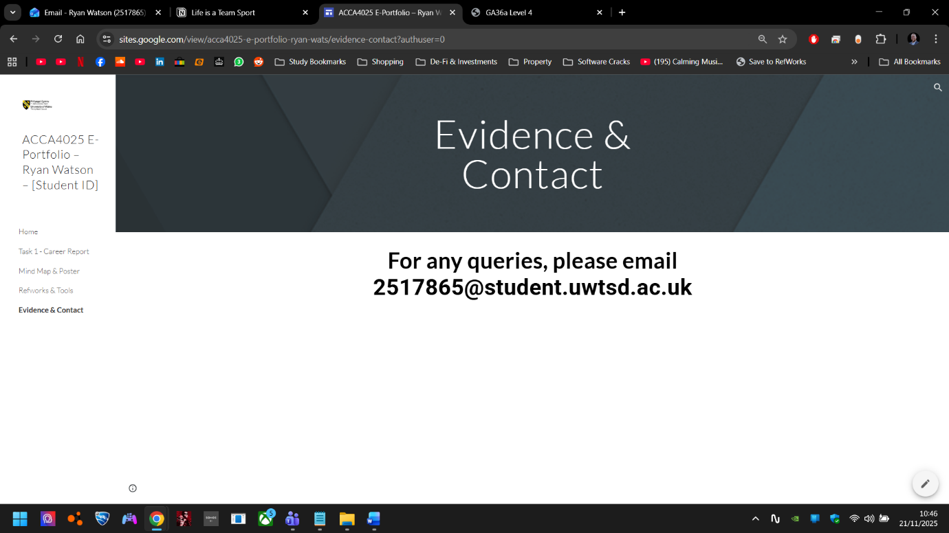
Figure 16: Evidence & Contact Page
In task 4b below, I’ll be evaluating the different tools that I experimented with, and why I chose to use the service I did, Google Sites.

Task 4 (b): Illustrative Review of E-Portfolio tool Selection
Task 4(b): Illustrative Review of E-Portfolio Tool Selection I evaluated three tools before choosing Google Sites
Tool | Ease of Use | Privacy & Sharing | Integration with UWTSD | Professional Look | Cost
Notion | Very High | Full public pages | Direct embed works | Modern & clean | Free
Mahara | Moderate | Good (UWTSD-hosted) | Native but clunky | Dated interface | Free
Google Sites | High | Good | Limited customisation | Basic | Free
Why I chose Google Sites
- Looks professional than some off-the-shelf ones like at Wix – employers have already complimented the layout when I’ve shared it.
- This use case scenario presented little need for tight integration with other services, else I may have used Mahara or Notion.
- Very little overheads, easy to use, minimalistic – ideal for small projects like this.
- Mobile-friendly and searchable – perfect for showing certificates on-site from my phone.

Conclusion
Conclusion This module has significantly developed both my technical and professional digital skills. Creating an authentic e-portfolio forced me to organise evidence of my Romford school placement, RefWorks references, and collaborative tools in one accessible place – mirroring the shared drives and cloud systems I will use as an education IT support engineer. Working through the Turnitin process and achieving only 6% similarity has reinforced the importance of genuine paraphrasing and academic integrity, while the solo mind-map and poster tasks deepened my understanding of teamwork theory (Belbin, Tuckman) and its direct application to real-world MSP scenarios such as multi-engineer handoffs during network outages. Using Notion, RefWorks, Canva, OneDrive, and Teams throughout has given me practical confidence with the exact remote-first tools listed in every local IT support job advert. By the end of this CertHE I will have a live, continually updated professional portfolio that I can share instantly with employers – a tangible outcome that has already started opening doors. The module has not only met its learning outcome of using technology to enhance my learning but has directly accelerated my readiness for a rewarding career supporting schools across south Essex and east London.

References
Final Reference List
Belbin, R.M. (2010) Team roles at work. 2nd edn. Oxford: Butterworth-Heinemann. Department for Education (2024) Keeping children safe in education. London: DfE. Available at: https://www.gov.uk/government/publications/keeping-children-safe-in-education--2 (Accessed: 20 November 2025). Tuckman, B.W. and Jensen, M.A.C. (1977) ‘Stages of small-group development revisited’, Group & Organization Studies, 2(4), pp. 419–427. World Economic Forum (2023) The future of jobs report 2023. Available at: https://www.weforum.org/publications/the-future-of-jobs-report-2023/ (Accessed: 21 November 2025). Wrike (2023) The state of teamwork report 2023. Available at: https://www.wrike.com/blog/state-of-teamwork-report/ (Accessed: 21 November 2025).
Reference Turnitin (2025) Originality Report for Ryan Watson – LDE Task 1a, Submission ID: 268254069, generated 20 November 2025.

