

Sustainable Hospitality & Tourism
Management LEVEL 5
BMIH5006

Student Name: Viorica Cornelia Lacatas
Student Number: 2117500
Lecturer’s Name: Christopher Wilkin

Executive Summary
This report aims at looking at the effects of the shuttle buses applied in the hospitality industry. Although shuttle buses are one of the most convenient means of transport for guests, they are involved in pollution through the emission of carbon, traffic jams, and low energy efficiency. Fossil energy sources cause climate change and negatively impact the quality of air particularly in large cities. These problems are tackled in the present report, with recommendations for the implementation of electric and hybrid shuttle buses as Much more energy efficient and producing no emissions at all. The case of some industries, for instance, Marriott and Accor Hotels shows that sustainable transport strategies can be feasible. Moreover, they also indicated that improvements in shuttle bus routes via the Global Positioning System (GPS), and an implementation of increased shared shuttle services among hotels may be useful for the reduction of fuel consumption and emissions. Even though electric and hybrid vehicles may be costly at first particularly when considering the acquisition of buses, the long-term paybacks on fuel and maintenance, not to mention damage to the environment, make such solutions the best shot. In sum, it is important to promote sustainable transport to decrease the negative impact of the hospitality industry on the environment.

Table of Contents
Executive Summary 2
Introduction 4
Main Findings 5
Damage Caused by Shuttle Buses 5
Possible Solutions 7
Industry Examples 10
Conclusion/Recommendation 12
References 13

Introduction
Hospitality transport is a transportation-related service mainly used to transport guests to and from very vital destinations like airports, popular tourist attractions and places of interest for instance shopping centres, etc carried out by hotels, resorts and any other related establishments. Buses are one of the most widely spread means of transport in the hospitality field because they can transport many people at a time, and this is much cheaper in comparison with other forms of transport. It turns out that they are a necessity for the clients as they create comfort and are easily accessible. However, the same conventional shuttle buses, especially those using fossil fuel, present considerable pollution effects. These buses emit pollutants and greenhouse gases, and they are sources of natural resource consumption. Besides, their operation causes deterioration of traffic congestion within the urban areas and hence contributes to further pollution of the environment. Since more pressure has been put on the hospitality industry to implement sustainable measures in its operations, it has been important for the transport service providers to evaluate its effects on the environment. The environmental impact of shuttle buses is highlighted in this report, and this paper looks into strategies that could be adopted to decrease the shuttle’s environmental impact without compromising its efficiency and guest satisfaction.

Figure 1: Eco-Friendly Practices in Hotel Housekeeping: Promoting Sustainability and Guest Satisfaction
(Source: DPMI, 2023)

Main Findings
Transportation within the hospitality industry, especially through the use of shuttle buses for the convenience of guests, has the following consequences:- In this section, the leading issues resulting from the application of conventional shuttle buses will be highlighted, and then possible interventions to mitigate the environmental effects of these transport solutions will be provided (Hall, Le-Klähn, and Ram, 2017).

Damage Caused by Shuttle Buses

1. Air Pollution
Shuttle buses that may be powered conventionally with compressed diesel/gasoline have a significant number of negative effects on the environment. These buses release a significantly high level of CO2, nitrogen oxides (NOx), and particulate matter that add to the pollution of the environment (Wang and Tang, 2022). That is why CO2 is the main greenhouse gas that causes climate change, while NOx and particulates are dangerous to people’s health and are known to cause respiratory and cardiovascular diseases. Statistics show that transport, in general, contributes approximately 23% of total energy-related CO2 emissions, and this is inclusive of Road transport, which includes buses (Landrigan, 2017).
In the transport sector, most of the companies operating in the hospitality industry provide shuttle services whereby guests are ferried to and from airports, tourist destinations, and other relevant destinations. Such buses are normally used on fixed routes, even during off-peak hours. This leads to energy wastage and pollution because the buses use fuel (Manisalidis et al., 2020). Moreover, because shuttle buses may cover a considerable number of hours daily, they play a big role in producing both ambient air pollution and greenhouse gas emissions. Where most hotels and resorts are in urban centres, multiple shuttle operations several times a day could prove injurious to the quality of air as experienced in regions that attract high tourism activities.
Furthermore, shuttle buses discovered to have substandard or inefficient emissionscontrolling devices or those that inadequately implement current advanced technologies also add to excess pollution. These older models cost higher amounts of fuel/energy and discharge more CO2 emissions than do newer models and electric vehicles (EVs), thus increasing the damage to the environment.

2. Traffic Congestion
This is because, for guests’ transportation, facilities such as shuttle buses end up being a constant source of traffic jams, especially within proximity to urban areas and other key tourist attractions. In tourist cities, shuttle buses cause traffic congestion, which leads to increased travel time and traffic inefficiencies (Nguyen-Phuoc et al., 2018). Also, because most hotels provide their shuttles, there are way too many buses on the road at any given time. This can lead to very many problems of congestion and flow, particularly in areas where the transport networks are poorly suited to such densities.
Traffic congestion works hand in hand with fuel consumption, making the latter a domino effect. Whenever the buses are in congestion, or the general speed is low, the fuel consumption rate is high, hence, high emission rates per unit distance (Sakshi et al., 2020). This inefficiency, therefore, compounds the effect of shuttle bus services to exert considerable pressure on the hospitality environment.

3. Energy Inefficiency
The other potential problem with conventional shuttle buses relates to their energy utilisation: notably, the shuttle buses themselves frequently consume a great deal of fuel. Hotel shuttle buses are often old and do not have fuel efficiency as a priority factor (Wu et al., 2018). These buses may be missing modern energy-saving features which would make them perhaps less fuel efficient thereby increasing the overall emission levels.
Conventional shuttle buses are said to be less efficient compared to modern models that use a more efficient fuel consumption approach (Zhou, Jin, and Wang, 2016). Due to poor efficiency, such buses also add negative impacts to the environment plus raise hotel operational expenses. More fuel consumption means that vehicles require frequent refuelling, which leads to high maintenance costs, and make frequent trips to the repair shops. However, older buses lack energy efficiency, which raises total hotel expenses when using shuttle buses as a means of transportation (Tang et al., 2021).
In addition, many hotels have organisations of shuttle buses which may not consider their route as being most efficiently shortened and the same applies to fuel. Such vehicles may ply substandard routes; and may cover certain distances at relatively slower rates or take extra turns which cause greater energy utilisation and consequently, emissions.
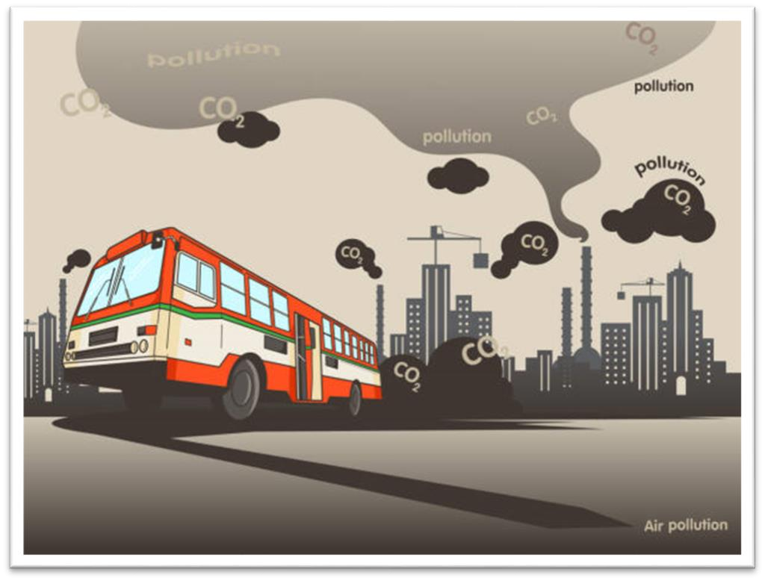
Figure 2: transportation have pollution ,city have air pollution,bus vector
(Source: iStock, 2019)

Possible Solutions
Environmental degradation by shuttle buses presents one of the most pressing issues in the usage of shuttle buses as part of the hospitality industry solutions to minimise pollution and increase efficiency, offering an opportunity to meet the objectives within sustainable development goals (Wickham, Donnelly, and French, 2021). The following solutions are realistic and would be of great value to both hotels and their users.

1. Electric Shuttle Buses
Among the solutions, it is possible to make the following conclusion: one of the most efficient ones is the usage of electric vehicles (EVs) to replace existing shuttle buses, they do not emit fumes into the atmosphere, hence the reduction of greenhouse gases in the atmosphere (Manzolli, Trovao, and Antunes, 2022). These are buses that run on electricity and, where charged via photovoltaic energy or wind power, help make a green and eco-friendly transport sector.
The use of electric buses is especially relevant in the sphere of the hospitality industry, especially if companies operate in cities with poor air quality. Electric buses can help decrease a hotel’s carbon impact going below as well as improve the air quality of the sites (Robin, Pedroche, and Astorga, 2017). Moreover, electric buses are known to be less noisy than conventional buses. Thus, the eradication of noise is a plus for the hotel guests and the residents of the surrounding area.
They, however, found that electric buses provide operational cost savings in the long run of the business to the hotel operators. The cost of electric buses is quite high in the initial stage in terms of investment in vehicle purchases and charging stations, but overall life cycle costs are cheaper than conventional buses and trucks. Electric vehicles are cheaper in energy consumption compared to diesel models. Also, they have a low rate of breakdown and fuel costs are also low (Burnham et al., 2017). However, overall expenses have been reduced in the long run, where the costs of fuel and major vehicle maintenance are considered, thus making electric shuttle buses economical for hotels.

2. Hybrid Shuttle Buses
In those regions where there is no supporting, charging stations or they are inaccessible, the efficient and functional solution would be the hybrid shuttle buses. These buses are as known as dual-fuel buses because they have both internal combustion engine and electric motor that allows them to switch between fuel and electricity. These buses are slightly smaller than conventional buses more energy efficient and emit fewer pollutants (Legrand, Chen, and Laeis, 2022).
Since many hotels are situated in regions with a low level of charging infrastructure, including remote ones, the use of hybrid buses can be considered reasonable. They allow the dispensation of services in a manner that adverse operations can be mitigated by being independent of electrical-only systems. Hybrid shuttle buses also have a better fuel economy than standard buses, which is good news for hotels wishing to minimise their carbon footprint (Pan et al., 2018).
These buses are also like regular buses in the sense that they run in half on fossil fuel, but other than this, they emit far less than those that solely rely on fossil fuel. They also have improved fuel efficiency, and the engines use less fuel to achieve a given number of miles (Topić et al., 2020). From the perspective of hotel operators, hybrid solutions are convenient to use because they provide an opportunity to continue to use shuttles without losing benefits.

3. Optimising Routes and Scheduling
The other significant solution is to reduce environmental effects by increasing the suitability of routes and schedules of shuttle buses. Improve over time shuttle schedules routes to target efficiently through GPS innovation together with routeplanning applications that help hotels in this area (Păcurar, Albu, and Păcurar, 2021).
Hence, data received will allow hotels to plan the movement of shuttles using traffic conditions as well as the number of guests demanding the services. This eliminates wastage of time on routes that may be blocked or areas that may limit one’s movement thus making buses cover the least possible distance as envisaged by efficient fuel consumption. Moreover, the buses can be scheduled to cover arrival and checkout times to avoid a situation where most of the buses will be idle most of the time.
Not only does route optimisation result in financial and ecological advantages but it also enhances the satisfaction of the guests. Less number of stopovers and short travelling time means more comfort and convenience more attractive to environmentally friendly consumers.

4. Collaborative Shared Shuttle Services
Another method is the provision of combined Shuttle Bus Services with the other consequential hotels to minimise the number of buses on the road and hence emissions. Coordinated transportation means several hotels providing a shuttle service to customers travelling to commonly frequented places like airports and tourist destinations, among others (Narayanan, Chaniotakis, and Antoniou, 2020).
Through joint procurement of resources and sharing different expenditures incurred in providing shuttle services, then the hotels will be accustomed to minimising the affectation they have on the environment besides boosting operation efficiency. This translates to lower emission of gas, little fuel usage and distortion, which also leads to less traffic (Gallo and Marinelli, 2020). In the same manner, commingles transport, which is normally acquired with shared shuttle solutions, needs to ensure that the guest gets more often and at varied convenient times, therefore enhancing their stay.
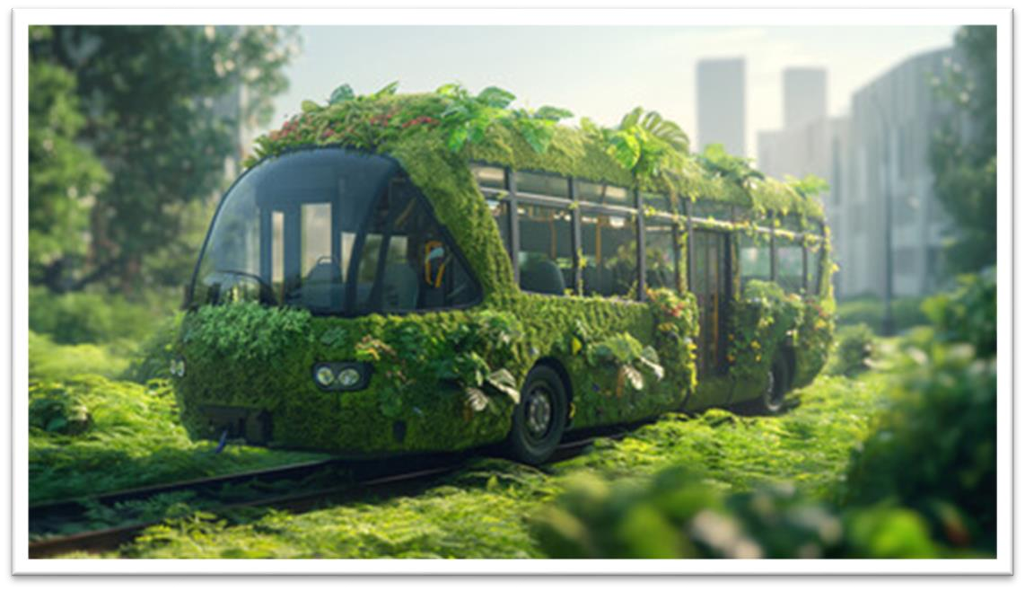
Figure 3: eco-friendly bus designed to blend seamlessly with nature. It's adorned with lush greenery, including leaves and plants, and is positioned in a lush green field
(Source: Adobe Stock, 2021)

Industry Examples
Many hotel chains have also incorporated sustainable types of transport to give evidence of best practices of environment-friendly measures. Marriott International, for example, has employed electric shuttle buses in the Marriot “Spirit to Serve” sustainability plan to cut emissions, improving the quality of air surrounding the firm’s property. Similarly, Accor Hotels’ current ‘Planet 21’ framework involves the use of electric vehicles in every hotel experience, with electric shuttle services in every hotel (Korstanje, George, and Nedelea, 2020). Furthermore, to improve efficiency, the hotels located in areas densely populated by tourists have also formed tenders for shared shuttle services. Some of these hotels have developed together combined passenger transport services to and from airports, thus reducing the flow of traffic on our roads and emissions, hence cutting on costs and the environment while at the same time improving the overall operations of the hotel (Edgell, 2020).

Conclusion
Lastly, the focus will be on the general recommendation about the application of shuttle buses in the hospitality industry as important for guests’ transfer as it creates an unfavourable impact on the environment, including air pollution, traffic congestion, and energy consumption. Nevertheless, by adopting innovative transport technologies such as electrical and blended motor coaches, efficient routing, and combined shuttling services, the hotels will greatly decrease their ecological impact. The electric and hybrid buses specifically are better to use than traditional gasoline buses and help the hotels take concrete steps towards both sustainability objectives as well as better air quality. Additional savings may be realised by optimising the shuttle routes to make better use of the GPS technology to decrease fuel consumption. Such solutions have been adopted by Marriott and Accor brands in the industry. Another model has been a co-operation shared service arrangement that has also been a successful tool for reducing the circulation of cars, especially in crowded cities and improving business operations. These projects show that global sustainability in transportation is not simply an achievable dream, but it is also affordable for the hotels which are keen to make a positive change towards our environment-free hospitality.

References
Burnham, A., Dufek, E. J., Stephens, T., Francfort, J., Michelbacher, C., Carlson, R. B., ... and Tanim, T. R. (2017). Enabling fast charging–Infrastructure and economic considerations. Journal of Power Sources, 367, 237-249.
Edgell. (2020). Managing sustainable tourism: a legacy for the future (Third edition).
Routledge.
Gallo, M., and Marinelli, M. (2020). Sustainable mobility: A review of possible actions and policies. Sustainability, 12(18), 7499.
Hall, C. M., Le-Klähn, D. T., and Ram, Y. (2017). Tourism, public transport and sustainable mobility (Vol. 4). Channel View Publications.
Korstanje, George, B., and Nedelea, A. (2020). Strategies for promoting sustainable hospitality and tourism services. IGI Global.
Landrigan, P. J. (2017). Air pollution and health. The Lancet Public Health, 2(1), e4e5.
Legrand, W., Chen, J. S., and Laeis, G. C. (2022). Sustainability in the hospitality industry: Principles of sustainable operations. Routledge.
Manisalidis, I., Stavropoulou, E., Stavropoulos, A., and Bezirtzoglou, E. (2020). Environmental and health impacts of air pollution: a review. Frontiers in public health, 8, 14.
Manzolli, J. A., Trovao, J. P., and Antunes, C. H. (2022). A review of electric bus vehicles research topics–Methods and trends. Renewable and Sustainable Energy Reviews, 159, 112211.
Narayanan, S., Chaniotakis, E., and Antoniou, C. (2020). Shared autonomous vehicle services: A comprehensive review. Transportation Research Part C: Emerging Technologies, 111, 255-293.
Nguyen-Phuoc, D. Q., Currie, G., De Gruyter, C., and Young, W. (2018). Exploring the impact of public transport strikes on travel behavior and traffic congestion. International journal of sustainable transportation, 12(8), 613-623.
Păcurar, C. M., Albu, R. G., and Păcurar, V. D. (2021). Tourist route optimization in the context of Covid-19 pandemic. Sustainability, 13(10), 5492.
Pan, S. Y., Gao, M., Kim, H., Shah, K. J., Pei, S. L., and Chiang, P. C. (2018). Advances and challenges in sustainable tourism toward a green economy. Science of the total environment, 635, 452-469.
Robin, C. F., Pedroche, M. S. C., and Astorga, P. S. (2017). Revisiting green practices in the hotel industry: A comparison between mature and emerging destinations. Journal of cleaner production, 140, 1415-1428.
Sakshi, Shashi, Cerchione, R., and Bansal, H. (2020). Measuring the impact of sustainability policy and practices in tourism and hospitality industry. Business Strategy and the Environment, 29(3), 1109-1126.
Tang, C., Li, X., Ceder, A., and Wang, X. (2021). Public transport fleet replacement optimization using multi-type battery-powered electric buses. Transportation Research Record, 2675(12), 1422-1431.
Topić, J., Soldo, J., Maletić, F., Škugor, B., and Deur, J. (2020). Virtual simulation of electric bus fleets for city bus transport electrification planning. Energies, 13(13), 3410.
Wang, N., and Tang, G. (2022). A review on environmental efficiency evaluation of new energy vehicles using life cycle analysis. Sustainability, 14(6), 3371.
Wickham, M., Donnelly, T., and French, L. (2021). Strategic sustainability management in the event sector. Event Management, 25(3), 279-296.
Wu, J., He, H., Peng, J., Li, Y., and Li, Z. (2018). Continuous reinforcement learning of energy management with deep Q network for a power split hybrid electric bus. Applied energy, 222, 799-811.
Zhou, M., Jin, H., and Wang, W. (2016). A review of vehicle fuel consumption models to evaluate eco-driving and eco-routing. Transportation Research Part D: Transport and Environment, 49, 203-218.

