Research on gas pipeline leakage detection and location method based on UWFBG
- Introduction
With the development of economy, the scale of each city is also growing. Pipeline transportation, as the main transportation mode of gas, is also growing in the underground area of the city. Gas is an indispensable part of People's Daily life, which provides great convenience for life and is also widely used in the field of economic production. However, in the process of pipeline transportation, safety risks always exist, such as pipeline aging or pipeline leakage caused by corrosion of various media and other destructive behaviors. The occurrence of leakage will not only cause certain pollution to the environment, but also cause fire and explosion accidents, which will bring huge economic losses to the society and great personal threat to the people. Found in time, there is no major harm, if long-term leakage is not found, the consequences will be unimaginable. According to incomplete statistics, 50% of the world's pipe network has been used for more than 30 years, due to various reasons may occur leakage accidents.
The factors of gas pipeline leakage can be summarized into three aspects:
- Personal factors. During the actual operation of transportation pipeline, because of the shortcomings in the production, installation and use process, it often causes damage to the gas pipeline, resulting in leakage. There are deformation and toughness failure caused by excessive pressure, low stress brittle fracture and brittleness failure caused by defects in the production process, corrosion failure caused by buried pipeline in saline environment, fatigue failure caused by cyclic load changes and creep failure caused by high temperature and high pressure environment, etc.
- Human factors. Driven by interests, some criminals drill holes to steal oil and gas pipelines and commit crimes crazily, which brings serious economic losses and security risks to our pipeline transportation industry. The overburden pressure of the pipeline is too large to harm the pipeline, the pipeline pressure occupation causes fracturing damage accidents also occur from time to time, if the pipeline leakage is not found and repaired in time, in case of high temperature open flame, it will cause secondary disasters, causing a serious threat to urban residential areas; Third party construction will also lead to pipeline damage. Many towns and cities need to carry out exploration, foundation excavation and other work for infrastructure development. If there is no sign at the pipeline line, or the construction party does not grasp the information of the pipeline network in the area, it is easy to be damaged by the third party construction. Although the quality of the people has been improving, but these criminals still exist, we need to be on guard against such a situation.
- Environmental and geological factors. Earthquake fault, slope, flood, ground collapse and other geological disasters will cause pipeline bending, compression, distortion, crack and other behaviors, bring huge economic losses. The pipelines in the western region are mainly subjected to geological disasters such as debris flow, flood erosion, wind erosion and salt corrosion because they pass through the Tarim Basin, Tianshan Mountain, the lower hills of Beishan Mountain and the Hexi Corridor. The pipeline in the central region is mainly subjected to geological disasters such as landslide, collapse, debris flow, flood erosion, wind erosion sand burial, mining collapse and loess collapsion because it passes through the Ordos Plateau, the Huangshang Plateau and the Shanxi mountains, and the Linfen Basin. The pipelines in the eastern region pass through the Yellow and Huaihai Plain and the Yangtze River Delta, and the Wansu Hills between them are densely populated and economically developed. Geological disasters are closely related to human activities, so the main geological disasters are ground subsidence, ground fractures, gob collapse and expansion.
Therefore, the pipeline safety and health monitoring is very necessary and very severe, we need to do a good job in the pipeline construction at the beginning of its long-term leakage monitoring, in order to guard against its infinite safety risks. The research of pipeline leakage detection method has very important practical significance and social economic value.

- Literature Review
With the development of economy, the scale of each city is also growing. Pipeline transportation, as the main transportation mode of gas, is also growing in the underground area of the city. Gas is an indispensable part of People's Daily life, which provides great convenience for life. However, in the process of pipeline transportation, security risks always exist, such as pipeline leakage, if found in time, there is no major harm, if long-term leakage and not found, the pipeline corrosion may occur in light cases, and even explosion in serious cases, causing great security risks to the people's livelihood. Based on the safety risks brought by pipeline leakage, it is particularly important to monitor the transportation status and structure of the pipeline. Predecessors have proposed many methods of pipeline leakage monitoring. At present, there are many methods of pipeline leakage monitoring, which are listed as follows:
  - Direct leak detection method
    - Manual inspection method
Manual inspection method is one of the simplest and most direct detection methods to determine whether the pipeline leaks. Experienced pipeline maintenance workers judge whether the thermal pipeline leaks through the phenomena around the pipeline. The results obtained by this method vary from person to person. Different maintenance workers get different results due to their different experience. They may not be able to find out the leak location in the first time. In addition, the length of underground pipe network can reach hundreds of kilometers, and the cost of manual inspection is extremely high, which needs to occupy a large number of social labor and resources. Therefore, manual inspection is not a widely applicable method, only suitable for use in a relatively limited scope. Manual inspection is gradually replaced by more advanced only inspection methods.
    - Thermal infrared imaging^{[1]}
Thermal infrared imaging technology is a kind of advanced technology, it uses infrared ray to detect the temperature degree, and display on the screen. If the pipeline leakage accident occurs, the ambient temperature of the soil around the pipeline will change dramatically. At this time, the temperature change can be obtained by the difference of infrared radiation. Humans (or small aircraft) move along the pipeline with infrared cameras and analyze temperature differences in the surrounding environment to determine whether there are leaks. Tiny leaks can be identified using spectral analysis. The gas temperature in the pipeline is different from the ambient temperature of the surrounding soil or air. Infrared imaging equipment can be used to obtain the image formed by the temperature difference. As long as there is a leakage accident in the pipeline, the ambient temperature of the surrounding soil or air must change, which can conclude that there is leakage in the pipeline. The disadvantage of thermal infrared imaging is that it is difficult to monitor due to deep pipeline laying and complex heat source in the city. The best use is to detect leaks in heating pipes during the winter months
    - Gas imaging method^{[2]}
Gas imaging technology is also widely used in leak detection of natural gas pipelines. The basic principle is as follows: by taking advantage of the differences in gas physical properties, different infrared radiation and absorption bands of target gas are used to distinguish signals in spectral domain and spatial domain, and the leakage gas image is obtained at any time, so as to realize the detection and recognition of colorless gas under visible light ^{[3]}. This method has high efficiency, good accuracy and real-time performance, but it can only conduct preliminary positioning of the leakage area. More accurate positioning needs to be combined with other methods for later processing and verification.
    - Tracer detection method^{[4]}
The technology was developed in the 1950s and 1960s, and tracers are still widely used at home and abroad as a nondestructive pipeline detection technology. The tracer is added to the liquid transmitted in the pipeline. The tracer flows together with the liquid in the pipeline. When the pipeline leaks, the liquid will flow out of the pipeline, and the tracer will also flow out and come into contact with the external environment, resulting in a significant difference between the exposed part of the external environment and the uncontacted part. The leak location of the pipeline can be determined by analyzing the surrounding environment with a tracer detector. This detection method involves water, oil and gas pipelines, etc^{[5]}.
    - Probe ball method^{[6-7]}
The method was developed in the 1980s to detect leaks inside pipelines. The probe ball is probed along the inside of the pipeline. With the characteristics of the probe ball moving along with the objects transported inside the pipeline, the information in the pipeline is collected by magnetic leakage, ultrasonic, eddy current, video and other technical means, and then the collected information is analyzed and processed to detect the leakage and determine the location of the leakage. The method has high accuracy and accuracy. However, the disadvantage is that only intermittent detection can be carried out, and it is easy to lead to pipeline blocking, transportation stop and other situations, and the price is high ^{[8]}.
  - Indirect leakage detection method
    - Flow and pressure abrupt change method
This method is similar to the mass or volume balancing method in that it is based on monitoring the pressure and flow rate of the fluid. The pressure and flow detection device is set in the pipeline inlet and outlet. If the pressure or flow change amplitude exceeds the preset closing value, the leakage will be judged and the alarm will be issued. This method is simple but inaccurate and prone to false positives ^{[9]}.
    - Negative pressure wave detection method
When a gas pipeline leaks, natural gas pressure and flow rate will plummet at the leak point, and such decompression will generate pressure waves along the pipeline to both sides at the leak location ^{[10]}. The medium in the tube is rapidly lost under the action of internal and external pressure difference, causing the leakage point and the adjacent area to produce a large pressure difference, the high pressure area of the medium flow to the low pressure area of the leakage point, resulting in a large pressure difference in the adjacent area of the leakage point, the high pressure area of the medium flow to the low pressure area of the leakage point, resulting in the fluid density and pressure reduction in the adjacent area of the leakage point, This phenomenon results in negative pressure waves (also known as decompression waves) that travel at a certain speed at the leak point. The basic principle of negative pressure wave is to locate the leak point by setting dynamic pressure sensors at both ends of the pipeline according to the propagation speed of negative pressure wave and the time difference between the two ends of the pressure sensor to capture the negative pressure wave. Due to the complex working condition of pipeline transportation system, the influence of external factors such as electronic interference, pipeline transportation vibration, valve regulation, temperature, environment and so on is inevitable, leading to the pressure signal collected on site contains a lot of noise; At the same time. Due to the system voltage fluctuation, the third party artificial knock or extrusion damage pipeline, etc., the collected signal may also appear wrong signal deviating from the truth value of the original signal.
In order to solve the above problems, the Fourier transform method is often used to eliminate the noise in the original pressure signal. However, when the frequency bands of the original signal and the noise overlap, the effect of eliminating the noise is poor. The propagation rate of negative pressure wave is related to the thickness of the pipe wall, the conveying medium in the pipe and the pipeline environment. For the long distance and complex environment of natural gas transportation, the negative pressure wave method is not accurate enough. Negative pressure wave is suitable for the detection of sudden large leakage, small leakage or leakage has not good effect, and easy to be interfered and false positive.
    - Acoustic method
When aging corrosion or rupture occurs somewhere in the natural gas pipeline, the gas in the pipeline will be expelled due to the pressure difference between the inside and outside of the pipeline. At this time, the sound source will be formed and the energy will radiate outward to form sound waves. The leakage sound wave propagates from the leakage point to both ends of the pipeline under the guidance of the transmission medium in the pipeline, and the leakage signal is captured by the detection device installed on the pipeline and downstream, so as to achieve the purpose of locating the leakage point. The acoustic wave method can continuously monitor the safety state of the pipeline in real time, locate the leakage position of the pipeline in time, and ensure the safe operation of the pipeline. However, the pipeline transportation environment is harsh and the conditions are complex. In the detection process, acoustic signals are often mixed with a large number of interference signals, which makes signal extraction difficult ^{[11]}.
    - Stress wave detection method
When pipeline leakage occurs, a high-frequency vibration noise propagates along the pipe wall in the form of stress wave, and the noise intensity decreases exponentially with the propagation distance ^{[12]}. The leakage is determined by analyzing the change of the power spectrum of the stress wave signal caused by reflection, refraction, scattering and mode conversion at the discontinuity in the process of propagation.
    - Statistical and pattern recognition methods^{[13-14]}
Xuejun Zhang[15] first proposed the basic idea of statistical leak detection and the basic model of the algorithm in the early 1990s, and judged whether pipeline leakage occurred based on the principle of mass balance. The statistical method leakage detection software was developed in 1996. In the case of no leakage, the mass conserved between input and output, and the deviation detection was carried out by the sequence probability test (SPRT). However, this method could not realize leakage location.
    - Pipeline leakage monitoring method based on fluid model
At present, most of the models in the literature are based on the mass balance equation, momentum balance equation and energy balance equation of the fluid in the pipeline. On this basis, the state estimator is designed to estimate the fluid state of the pipeline, and the leakage is detected by comparing the estimated value and the measured value. This kind of literature based on the fluid model is relatively common. Throughout the existing literature, there are different model building methods. According to the different solving domain of fluid equation, it can be divided into subsection pipeline modeling and whole pipeline modeling. The method of dividing the pipeline into several sections is usually used to estimate the leakage, but its disadvantage is that more filters need to be designed and the calculation is more complicated.
For example, DIGNERNES^{[16]} designs an independent filter at each assumed leakage point, and uses the information of each filter to estimate the leakage in combination with statistical methods. BENKHEROUF et al. ^{[17]} divided the pipeline watershed into several sections, used Kalman filter to estimate the leakage at each segment point, and realized leakage location by comparing the leakage at each segment point. Since pipeline gas flow was regarded as a nonlinear parameter distribution system, the spacing of each filter could be increased without reducing the positioning accuracy. The disadvantage of requiring more filters is avoided. In terms of leakage estimation, Sun Jianfei et al. ^{[18]} summarized the relationship between different leakage hole models (small hole model, broken pipe model and large hole model) and pipeline leakage. JO et al. ^{[19]} proposed a large-hole model for gas pipelines to estimate the gas leakage rate. The results show that the relative error of this model increases with the increase of the leakage aperture, and the maximum relative error can reach 20%. To this end, LUO et al. ^{[20]} proposed a new leakage model, which added kinetic energy term on the basis of the model in literature ^{[19]} and reduced the relative error to less than 7%. Fluid modeling in the whole pipeline is a more common fluid modeling method, which can be divided into steady-state model and transient model. Sun Liang et al. established the steady-state model of pipeline gas flow and proposed the isothermal positioning method and the variable step length Longerkutta method respectively. Through calculation, the average error of leakage positioning of the variable step length Longerkutta method is 5.43%, less than the 5.97% of the isothermal positioning method, and the average error of positioning is reduced by 9.05%. Fluid leakage will inevitably lead to pressure drop in the pipe, so it is often used to model the transient model by describing the attenuation of pressure wave. According to the leakage state, it can be divided into steady-state model modeling and transient model modeling.
  - Pipeline leakage detection method based on artificial intelligence
    - Based on artificial neural network
Pattern recognition (classification) technology in artificial intelligence is to solve the dependency between system input and output according to a given training sample, so that it can predict the unknown output of the system as accurately as possible. Therefore, pattern recognition (classification) technology of artificial intelligence can be fully applied to the identification of pipeline leakage. Each development of pattern recognition (classification) method will provide a new way to identify the source of pipeline leakage. Common artificial intelligence pattern recognition (classification) methods include cluster analysis, neighbor classification and artificial neural network. WALT^{[21]} et al. compared and analyzed the application of Bayesian probability analysis, support vector machine and artificial neural network in pipeline leakage detection through experiments. The three methods have their own advantages, and none of them is completely superior to the other two methods. Meanwhile, compared with support vector machine and artificial neural network, Bayesian probability analysis requires more observation data.
Artificial Neural NetWorks (ANN) are connected by many neurons and have self-organization, self-adaptation and self-learning functions. As an important method for pattern recognition, Artificial neural networks (ANNs) have become one of the methods for pipeline leak detection ^{[22]}. Liu Xiaoben et al. ^{[23]} trained negative pressure wave signal parameters through self-organizing mapping neural network, and used this neural network to identify the samples of negative pressure wave working conditions. LI et al. ^{[24]} extracted and selected leakage characteristic indexes from pipeline acoustic emission signals, and built a classifier to judge leakage based on artificial neural network. Qian Hong et al. ^{[25]} took time series as the input of artificial neural network and obtained the neural network model of time series leakage of heat transfer tube through training. The simulation analysis results showed that this model could diagnose and identify the degree of pipeline leakage
BP (Back Propagation) algorithm, known as error back Propagation algorithm, is a common supervised learning algorithm in artificial neural networks. Yan Zongwei ^{[26]} built a pipeline leakage detection model based on BP artificial neural network, extracted leakage features from pressure signals, and inputted them into the network for training and testing. In order to improve the accuracy of leakage identification, MOHSEN^{[27]} divided the pipeline into four sections and established an artificial neural network model based on input and output pressure in each section.
Traditional ANN learning convergences slowly, tends to fall into local optimization, and the training results may be unstable. Therefore, in recent years, many scholars begin to use Convolutional Neutral Networks (CNN) to identify pipeline leaks ^{[28]}. CNN is one of the representative algorithms of deep learning and belongs to a kind of deep learning neural network. It is an organic combination of deep learning and neural network. CHUANG et al. ^{[29]} extracted the Melle cepstral coefficient of frequency from the pipeline leakage acoustic signal as a leakage characteristic index and input it into CNN to identify the leakage, which improved the identification accuracy from 96.6% to 99.4% of the traditional method. Wang Xinxing et al. ^{[30]} input appropriate acoustic emission characteristic parameters into CNN for leak classification and diagnosis. The results show that the accuracy of test set of CNN model classification is 98.54%, which is higher than the pipeline leak diagnosis accuracy of BP artificial neural network 87.36%.
Traditional artificial neural networks require a large number of samples, while Support Vector Mechines (SVM) are based on the theory of small sample statistics, which does not require a large amount of data. In addition, support vector machine is global optimization, while artificial neural network is local optimization, so from the current literature query, the literature related to support vector machine is more than that of artificial neural network^{[31]}. For example, NI et al. ^{[32]} combined the theory of Partical Swarm Optimization (PSO) with SVM and proposed the combined algorithm PSO-SVM. The calculation results showed that SVM was superior to BP artificial neural network. There are also literatures that combine PSO theory with SVM to diagnose pipeline leakage ^{[33]}.
    - Pattern recognition technique
In addition to artificial neural network and support vector machine, other pattern recognition techniques are also applied to the identification of pipeline leakage. For example, HOI et al. ^{[34]} combined k-nearest neighbor method with SVM to classify valve working states, and then estimated valve leakage rate by regression model. Wang Cong ^{[35]} carried out fuzzy clustering of pressure sensitivity matrix to analyze sensor layout for leakage monitoring of urban water supply network. Xiao Qiyang et al. ^{[36]} used fuzzy correlation classifiers to classify pipeline leaks. The results showed that when the sample data was small, the recognition accuracy was above 95%, higher than that of BP artificial neural network and support vector machine.
The pipeline leakage detection method based on signal processing is the main means to be considered in this topic, mainly through the analysis of vibration signals, strain signals and temperature signals inside and outside the pipeline, and then realize the pipeline leakage detection. Through the simulation experiment, a variety of signals in the leakage and non-leakage areas are compared and analyzed, and the characteristics of a number of different signals in the two states of the pipeline are obtained, so as to determine whether leakage occurs comprehensively.
At present, widely used signal processing methods include wavelet analysis ^{[37]}, principal component analysis ^{[38]}, empirical mode decomposition ^{[39]}, variational mode decomposition ^{[40-41]}, compressed sensing and local mean decomposition ^{[42-45]}. Hao Yongmei et al. ^{[46]} proposed the global local mean decomposition on the basis of local mean decomposition, and combined multi-scale entropy to identify pipeline leakage signals.
All kinds of leakage detection work in the early stage is ultimately for positioning and service, positioning of leakage location is the ultimate goal, the accuracy of positioning is related to whether the leakage location can be timely processed, to avoid the subsequent safety risks and economic losses. Need through the quantitative analysis of each physical quantity, through the amplitude, phase and other information for analysis and processing to achieve the effect of positioning.
Pipeline leakage detection, as one of the hot spots in today's research, has been born a lot of detection and location methods, how to reasonably use them and dig new things from them is worth thinking about.
- Methods
  - Detection method
Interference fiber vibration sensing technology has high sensitivity, and combined with FBG whose reflected light intensity is higher than Rayleigh scattered light, the detection signal with higher signal-to-noise ratio can be obtained. The secondary complementarity of Ultra Weak Fiber Bragg Grating (UWFBG) can complete the grating of monitoring area with a wide range and a long distance. The above technologies are combined to complement each other, so as to complete the distributed vibration detection of a wide range and a long distance monitoring area. Starting from the basic structure of interferometric grating array vibration sensing system, this chapter will deduce and study the key technologies used in the system successively, and test the system performance through experiments
The interferometric grating array vibration sensing system is mainly composed of UWFBG array and non-equilibrium Michelson interference structure. The UWFBG array is a sensor network. Every two adjacent UWFBG and the optical fibers in it constitute a sensing area, and the reflectance, bandwidth, and central wavelength of each UWFBG are basically the same. The non-equilibrium Michelson interference structure mainly consists of a 3×3 coupler, two delay optical fibers with different lengths and two Faraday rotation mirrors. The optical path difference of the two delay fibers is the same as the distance between adjacent UWFBGs, which is used to compensate for the optical path difference between adjacent UWFBGs. Both Faraday rotation mirrors use a 45° rotation Angle to eliminate polarization effects in the interferometer.
The basic structure of interferometric grating array vibration sensing system is shown in the figure, in which the light source is a narrow-width laser, and the continuous light from the light source is modulated by Semiconductor OpticalAmplifier (SOA) to produce optical pulse sequences with fixed pulse width. The pulsed light is then amplified by an Erbium Doped Fiber Amplifier (EDFA) and fed into the UWFBG array through the circulator Cl, where the spacing between adjacent UWFBGs is the same. The pulsed light sequence reflected by the UWFBG array is sent to the non-equilibrium Michelson interferometer through the ring C1 and C2. The three output ports of the 3x3 coupler respectively output three-way signals with a phase difference of 2T/3. Two of the signals are reflected by two delay fibers and Faraday rotation mirrors and then meet at the 3x3 coupler. Since the length difference between the delayed fibers is the distance of the sensing measuring area, the delay between the two interference signals is equal to the time difference between the detection light and the two UWFBGs of the sensing measuring area, that is, each interference pulse is the coherent result of the reflected light of the two UWFBGs of the corresponding measuring area. Finally, three photodetectors (PD1, PD2, PD3) were used to convert the three-way output optical signals of the 3x3 coupler into electrical signals, and then vibration signals were restored according to the phase changes caused by vibration.
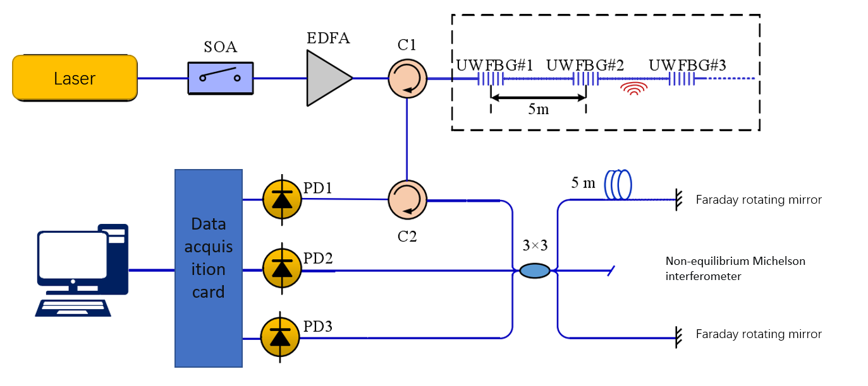
The structure of optical fiber includes core and cladding. People usually doping the core to make its refractive index greater than that of cladding, so as to form a waveguide. Because the fiber core has ultraviolet photosensitivity, when the ultraviolet laser irradiates on the fiber core, the refractive index of the fiber core will be periodically modulated in the axial direction, forming FBG. FBG can selectively reflect the input wideband light. Only the light that meets the central wavelength condition of FBG can be reflected back, and the light in the rest wavelength range will continue to conduct forward after passing through FBG, as shown in the figure.
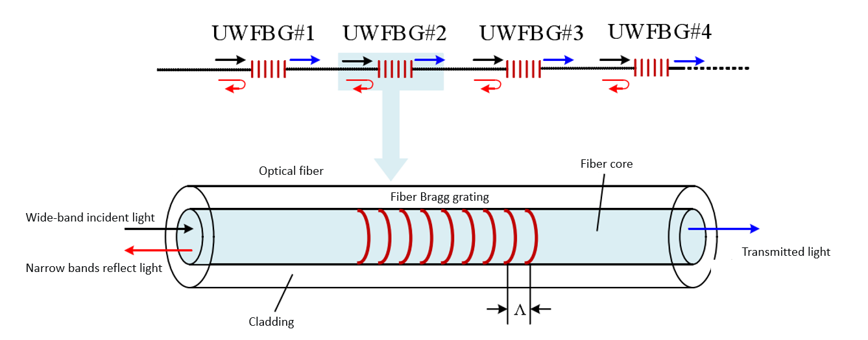
  - Research methods and technical routes to be adopted
Relevant simulation experiments were carried out to control the leakage point, and three types of sensors including vibration, strain and temperature were placed near the leakage point.
- The leakage non-leakage information is known, and the signal characteristics of the three types of sensors in the two cases are obtained respectively and compared to get the differences and find the leakage characteristics.
- The vibration signals of DAS cable, array cable and electrical sensor were compared under the condition of leakage.
- The difference between the third party conditions and the leakage and non-leakage signals is analyzed from the three aspects of vibration, strain and temperature.
- Analyze the leakage point and the signal characteristics near the leakage point and find out the rule.
- Combined with the above signal characteristics, pipeline leakage is regarded as an unknown condition to identify and locate pipeline signal leakage.
- Results
  - Expected research results
- The amplitude and frequency characteristics in the time domain and frequency domain are obtained under the condition that the pipeline is normally inflated.
- When the pipeline leaks, the time-domain characteristics of the temperature and strain signals and the time-frequency characteristics of the vibration signals at and around the leakage point are found out.
- The difference of temperature, strain and vibration signal at the leakage of covered and non-covered parts is obtained.
- Determine the signal difference at different depths from the leak.
- The leakage signal is regarded as unknown condition, and the leakage condition is judged by various types of signal.
  - Data format and statistical procedures
Through the initial understanding of the instrument, the data format is as follows.
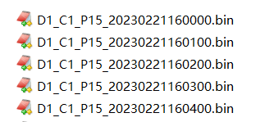
The data is binary bin file. The data is time domain data collected by the demodulation instrument in real time. The sampling frequency is 1000Hz. Therefore, Matlab is used to analyze and process the data. The code looks something like this, the read data needs to be high-pass filtered to eliminate phase drift.
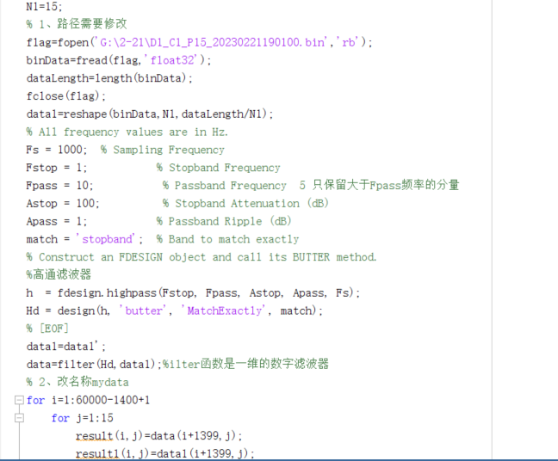
- Evaluation
Optical fiber sensing technology has become a hot research topic due to its advantages of being free from electromagnetic interference, large capacity and long sensing distance. Fiber sensing technology is based on the phenomenon of fiber waveguide, using a fiber as a sensitive element, when the laser pulse issued by the light source through the fiber or injection fiber is affected by external factors (such as temperature, pressure, etc.), the characteristics of the light (amplitude, phase, polarization state) is modulated, according to the data signal received by the processing sensor can get the change of external parameters. To achieve the measurement of each physical quantity.
Yang Xu et al. used Raman distributed fiber optic sensor to detect pipeline leakage and realized a positioning accuracy of 1 meter. Stajanca et al. used fiber distributed acoustic sensing to detect pipeline leakage and realized high-sensitivity monitoring. Png et al. designed an annular integrated Mach Zehnder interferometer fiber optic sensor to monitor pipeline leakage and determine whether pipeline leakage occurs by analyzing vibration signals. Jia et al. monitored pipeline leakage by using fiber Bragg grating strain sensors to monitor pressure drop caused by pipeline leakage. Wang et al. monitored pipeline leakage by using fiber Bragg grating pressure sensor to monitor the pressure variation trend along the pipeline.
Although optical fiber sensing technology has great advantages over traditional technology, it also has shortcomings. The monitoring accuracy of distributed fiber sensing technology is low due to the influence of resolution, and the monitoring distance of traditional fiber Bragg grating sensing technology is limited. A new low reflectivity grating array sensing technology combines the advantages of distributed and traditional fiber Bragg grating sensing technologies, and makes up for the shortcomings of both. This technology can not only realize large capacity, long distance sensor network, but also achieve high resolution. Grating array sensor technology is a good choice for pipeline monitoring. In order to effectively reduce the false alarm rate and false alarm rate of pipeline leakage monitoring, multi-parameter simultaneous monitoring is a necessary research direction in addition to using low reflectivity grating array sensing technology.
The schedule is as follows:
Time | Content
2023.3-2023.4 | Refer to domestic and foreign literature about pipeline leakage, and carry on the related summary and summary
2023.4-2023.6 | Sorted out the data collected in the early stage, built the experimental platform, designed relevant experimental schemes, and determined the experimental technical route
2023.6-2023.7 | Start the experiment, get the expected experimental data, and carry on the relevant analysis, and finish the first draft of the paper
2023.7-2023.8 | Improve the experimental data, revise and finalize the paper

- Reference
[1] Fu Daoming, Sun Jun, He Zhigang, Yu Xichong. Research progress of pipeline leakage detection technology at home and abroad [J]. Petroleum Machinery,2004,03:48-51.[in Chinese]
[2] Liu Dawei. Research on Gas pipeline leakage monitoring based on distributed fiber sensing technology [D]. Anhui University of Science and Technology,2019. [in Chinese]
[3] Zhou Peng. Application of leakage detection Technology in long distance pipeline [J]. Automation of Petrochemical Industry,2018,54(05):62-64. [in Chinese]
[4] Wang Likun. Research on Some Key Technologies of Oil Pipeline Leakage Detection [D]. Tianjin University,2003. [in Chinese]
[5] Li Peng, Yi Lu, Guo Chao, An Haiyan. Buried oil and gas pipeline leak detection systems research and application [J]. Journal of electronic test, 2018 (17) : 35 + 37. DOI: 10.16520 / j.carol carroll nki. 1000-8519.2018.17.014. [in Chinese]
[6] Chen Huabo, Tu Yaqing. Pipeline Technology and Equipment,2000(01):38-41. [in Chinese]
[7] Chen Chungang, Wang Yi, Yang Zhenkun. Review on leakage detection techniques of long distance oil and gas pipelines [J]. Chemical Industry of Oil & Gas,2002(01):52-54+0. [in Chinese]
[8] Jiang Bo. Development direction and related technical problems of natural gas pipeline in China [J]. Chemical Industry Management, 2017(10):63. [in Chinese]
[9] Chang Jinglong, Li Tie. Selection and Optimization of Gas pipeline Leakage Detection Technology [J]. Oil & Gas Storage and Transportation, 2000,05:9-13. [in Chinese]
[10] Zhang Weiguo. Research on Pipeline Leakage Detection with different Leakage holes based on negative pressure wave method [J]. Petrochemical Technology, 2018,25(08):303. [in Chinese]
[11] Zhou Yangfei. Research on location technology of continuous acoustic emission signal for Gas pipeline Leakage [J]. Modern Chemical Industry, 2018,38(09):184-187. [in Chinese]
[12] Eidenshink,J C.D Detection of Leaks in Buried Rural Water Pipelines Using Thermal Infrared Images[J], Hotogrammetric Engineering and Remote Sensing,1985,51(5):561-564.
[13] Qiu Dongqiang, Tu Yeqing. Research on current situation and Problems of pipeline statistical leak detection method [J]. Pipeline Technology}--J Equipment, 2002,03:1-2. [in Chinese]
[14]Jun Zhang.Designing a Cost-effective and Reliable Pipeline Leak-detection System .Pipes &Pipelines lnternationa).Jan-Feb.1997:26.
[15] Xue Yan, Hu Na. Discussion on Pipeline leakage detection Technology and its Application [J]. Chemical Industry of Oil & Gas, 2002,02:106-108. [in Chinese]
[16]DIGERNES T. Real Time Failure Detection and Identification Applied to Supervision of Oil Transport in Pipelines「J」.Modeling,Identification and Control，1980(1):39-49.
[17]BENKHEROUF A，ALLIDINA A Y. Leak Detection and Location in Gas Pipelines「J].Control Theory and Applica-dons，1988，135(2):142-148.
[18] Sun Jianfei, Li Yansong, Liang Shuitu. Research progress on leakage rate model of gas pipeline [J]. Oil & Gas Storage and Transportation, 20,39(5):512-518. [in Chinese]
[19]JOYD，AHN B J. A simple model for the release rate of hazardous gas from a hole on high-pressure pipelines[J].Journal of Hazardous Materials，2003，97(1):31-46.
[20]LUO J H，ZHENG M，ZHAO XW，etal. Simplified expression for estimating release rate of hazardous gas from a holenon high-pressure pipelines[J].the Process Industries,2006,Journal of Loss Prevention in 19( 4):362-366.
[21]WALT J C Van Der，HEYNS P S，WILKE D N .Pipe net-work leak detection:comparison between statistical and machine learning techniques「J」.URBAN WATER JOUR-NAL，2018，15(10):953-960.
[22]SHEHADEH M，STEEL J A，REUBEN R L. Acoustic emission source location for steel pipe and pipeline applications:the role of arrival time estimation「J」.Proceedings of the Institution of Mechanical Engineers Part E-Journal of Process Mechanical Engineering，2006，220( E2):121-133.
[23] Liu Xiao-ben, Zhang Hong, Xia Meng-ying, et al. Pipeline leakage identification Method based on Principal component analysis and neural network "J". Oil & Gas Storage and Transportation, 2015(7); 737-740. [in Chinese]
[24]LI Suzhen，SONG Yanjue，ZHOU Gongqi. Leak detection of water distribution pipeline subject to failure of socket joint based on acoustic emission and pattern recognition[J].Measurement，2018(115):39-44.
[25] Qian Hong, Jiang Cheng, Pan Yuekai, et al. Diagnosis of Leakage Degree of Steam Generator Heat Transfer Tube Based on Time Series Neural Network [J]. Nuclear Power Engineering (in Chinese), 2020, 41(2):160-167. [in Chinese]
[26] Yan Zongwei. Research on Pipeline Leakage Detection Based on Neural Network "D". Fushun: Liaoning Shihua University, 2019. [in Chinese]
[27]MOHSEN Rahmati. Modeling of has pipeline in order to im-plement a leakage detection system using artificial neural networks based on instrumentation[J].International Journal of Numerical Modelling，2019，32(2):1-15.
[28] Wang Haijian. Research on Leakage detection algorithm of water supply pipeline based on one-dimensional Convolutional Neural network "D]. Hohhot: Inner Mongolia University, 2019. [in Chinese]
[29]CHUANG Weiyi，TSAI Yaolong，WANG Lihua. Leak Detection in Water Distribution Pipes Based on CNN with Mel Frequency Cepstral Coefficients[C]//Association for Computing Machinery.Suzhou，China:ICIAI，2019:83-86.
[30] Wang Xinxing, Yang Taiwang, Song Xingshuai, et al. Urban gas pipeline leakage diagnosis Method [J]. Fire Science and Technology, 2018,37(6); 834-838. [in Chinese]
[31] Liu Haoyu. Pipeline Leakage Detection Based on Ultrasonic Wave Velocity and Support Vector Machine "D]. Fushun: Liaoning Shihua University, 2019. [in Chinese]
[32]NI Lei,JIANG Juncheng,PAN Yong.Leak location of pipe-lines based on transient model and PSO-SVM[J].Journal of Loss Prevention in the Process Industries，2013(26):1085-1093.
[33] Wang Xueyuan, Chen Zhigang, Zhong Xinrong. Water supply pipeline leakage diagnosis based on SVM particle swarm optimization [J]. Modern Electronics Technique, 2018,41(7)156-164. [in Chinese]
[34]HOI Yin Sim，RAHIZAR Ramli，AHMAD Saifizul，etal.Detection and estimation of valve leakage losses in reciprocating compressor using acoustic emission technique[J].Measurement，2020(152):1-15.
[35] Wang Cong. Research on Sensor Layout for Leakage Monitoring of urban Water Supply Network [D]. Changchun: Jilin University, 2020. [in Chinese]
[36] Xiao Qiyang, Li Jian, Sun Jiedi. Small Leakage detection of Pipeline based on EWT and Fuzzy Correlation Classifier [J]. Journal of Vibration and Shock, 2018,37(14):122-129. [in Chinese]
[37] Zhao Ya, Wang Qiang, Zhai Shuijun, et al. Distributed fiber optic Gas Pipeline Leakage Monitoring and experimental Analysis based on Wavelet packet Energy spectrum [J]. Journal of Applied Optics, 2018,39(2):295-300. [in Chinese]
[38]SUWAN Parka，JAEHONG Haa，KIMIN Kimb.The principal component analysis for detecting leaks in water pipe networks utilizing flow and leak record data[J].Desalination and Water Treatment，2019(143):69-77.
[39] MAO Min,WANG Xiaodong,WU Jiande. Leakage detection method of slurry pipeline based on EMD and VPMCD[J].Sensors and Microsystems,2018,37(1); 149-153. [in Chinese]
[40] Ma W P. Research on Feature extraction and detection technology of Natural gas pipeline leakage signal based on VMD [D]. Daqing: Northeast Petroleum University, 2018. [in Chinese]
[41] Wang Xiufang, Zhu Daohong, Ge Yanliang. Research on Denoising of small leakage Signal of Natural Gas Pipeline based on VMD-EV [J]. Pressure Vessel, 2019, 36(3):69-73. [in Chinese]
[42] Sun Jiedi, Hao Yali, Wen Jiangtao, et al. Underdetermined blind Separation of High-pressure Gas Pipeline Leakage Signals based on EMD [J]. Journal of Vibration and Shock, 2013(18):81-86. [in Chinese]
[43] Sun Jiedi, Xiao Qiyang, Wen Jiangtao, et al. Pipeline leakage Location with improved LMD and High-order ambiguity Function [J]. Chinese Journal of Scientific Instrument, 2015(l0):2215-2223. [in Chinese]
[44] Xiao Qiyang, Li Jian, Sun Jiedi, et al. Small leakage detection of pipeline based on EW7 and Fuzzy Correlation Classifier [J]. Journal of Vibration and Shock, 2018,37(14):122-129. [in Chinese]
[45] Wen Jiangtao, Fu Lei, Sun Jiedi, et al. Leakage Aperture Identification of Natural Gas pipelines based on compressed sensing combined with Convolutional networks "J]. Journal of Vibration and Shock, 20,39(21); 17-23. [in Chinese]
[46] Hao Yongmei, Du Zhanghao, Yang Wenbin. Pipeline leakage signal identification based on improved ELMD and multi-scale entropy [J]. China Safety Science Journal, 2019,29(8):105-111. [in Chinese]

