BMIH6001 Contemporary Themes in the Hotel and Hospitality Sector

Student ID:2026294
Student Name:Urszula Anna Joniak
Module Leader: Scott James
Academic Year: 2023/2024
Executive Summary
The technology is the contemporary trend with which scientific knowledge can be improved while meeting the practical purposes as expected. In the research paper it was identified that there are various strengths and weakness which can be created by the same that has huge impact on the operations of the business. This was challenging for them to maintain as growth was not achieved as expected and they faced issues in maintaining cost. It was identified that hotels invested $158.67 Million in software in 2020 to improve their practices. Due to this it was recommended that virtual and augmented reality was to be introduced for making stay easier for travellers.

Table of Contents
1. Introduction 4
2. Overview of Literature 4
3. Application to Hotel and Hospitality Sector 9
4. Evaluation of Future Policy and Management 10
5. Conclusion 12
6. References 13

1. Introduction
Technology is defined as the practice where scientific knowledge can be applied while ensuring that practical purposes can be easily implemented (Dawson, Lemelin and Stewart, 2012). This contemporary trend eventually ensures that scientific principles can be followed as expected while applying necessary changes as expected in the procedure adopted for the development. Technology is important to ensure that efficiency can be easily improved for the employees such that the daily lives can be developed as expected (Darcy, Ambrose and Bulhalis, 2012). This is essential for hospitality industry because due to this inventory, reservations, customer data and bookings can be easily monitored such that practices are developed as expected.
Technology ensures that daily operations of the hospitality sector can be conducted and goals are achieved as expected to develop the understanding. The Hospitality sector ensures that tourists are able to visit the place and conduct different practices as expected. The use of technology is prevalent in the industry as overall operations are easily completed and customers’ needs can be easily fulfilled as anticipated. The present research paper analyse the literature and concept can be easily applied to hospitality sector as expected. This is because management options can be easily used while providing necessary recommendations.

2. Overview of Literature
As per the view of Kansakar, Munir and Shabani (2019), technological trend is essential for the hotel industry as due to this they can improve their capability to cater to customers needs. This is because they can easily improve the efficiency of their business with the help of which their revenue can be developed as expected and growth can be achieved. Technological trend ensures that hotel industry can use strength of reliable working practices with the help of which relevant growth can be achieved. From the below image it can be identified that 24% uses technology to improve their guest experience and 18% uses to grow profits (Statista, 2021). There are 16% and 15% respondents who use technology to future proof the organisation and gain competitive advantage to support the overall practices as expected.
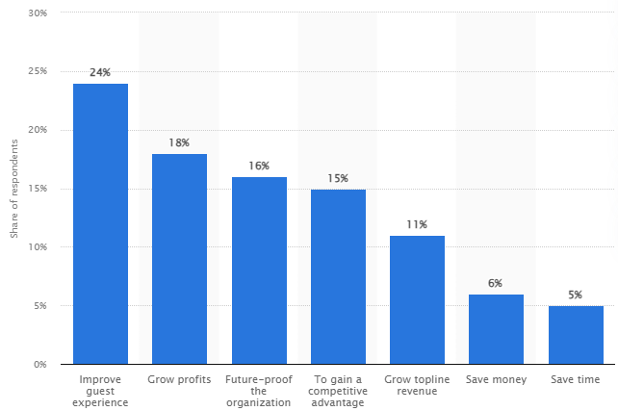
Figure 1 Reasons Hotels Use Technology
(Source: Statista, 2021)
In opposite to this Bisoi, Roy and Samal (2020), stated that technology can replace the employees which is not beneficial for the hotel industry as growth cannot be achieved as expected. Technology can create weakness as employee’s importance might be lost and the contribution towards the company can be reduced. The inability to retain employees is not beneficial for the company as their brand value might be lost and they will face issues in contributing to the overall development as expected. The technology can also create issue where hacking of the software is conducted and the critical information is stolen. This has also cause issues in maintaining employees interest as it can be identified that in 2020 there were 58 number of trade union members in 1000 which was 4.4%. This eventually decreased in to 51 in 1000 by 2022 which was 3.2% (Statista, 2023).
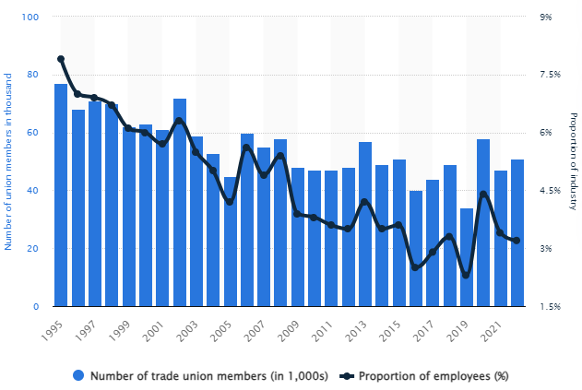
Figure 2 Number of Trade Union Members in Hotel Industry
(Source: Statista, 2023)
In the view of Bittendorfer et al. (2019), technological trend creates opportunity for expanding the business operations as different activities can be simultaneously conducted to get the needs of customers fulfilled. This is essential as innovative practices can be introduced as expected to provide the support for the overall development of business as expected. The use of technology ensures that the business is capable of making relevant growth as expected in the market to ensure that practices are developed as desired. This is one of the reasons that the Hotel industry is increasing the investment in technology as shown in below figure. In 2020 the spending was $158.67 Million which is expected to increase till $346.32 Million by 2024 (Statista, 2022).
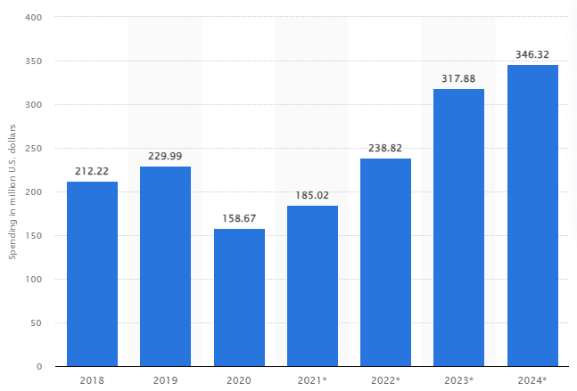
Figure 3 Investment on Software by Hotel Industry
(Source: Statista, 2022)
However D’Souza and D’Souza (2023), argued that technology can increase the threat of cyber-attacks which is not beneficial for the company as their brand value will be affected. In this the customer’s data will be stolen and the company will face issues in maintaining the interest as expected as the customers will start losing their trust in the business. This eventually reduces the ability to achieve the growth as expected while considering the use of technology as data breach is conducted by the management. Technology is not beneficial for the business as the practices are highly affected and they find it difficult to meet the needs of the customers as expected. It eventually creates issues of privacy for the customers and the people that are connected with the business for achieving the overall growth.
Technological trends in the hotel industry ensures that the services towards the customers can be improved as record taking is improved which ensures that the overall development of the practices can be conducted as expected (Cooper and Hall, 2019). As in the recent period contactless solutions has been introduced such that safety and convenience can be embraced as expected as the physical interactions can be reduced. This can be check-in applications, managing operational expenses and various other factors which ensure that practices can be developed as expected. Voice Assistant technology will be implemented to ensure that personalised services can be provided while ensuring that practices can be maintained as expected. This is reliable because the Voice Assistants Market Size is expected to increase to $22.2 Billion by 2030 while it was $2.90 Billion in 2022 (Acropolium, 2024). This creates strength of having strong customer value while opportunity to increase customers can be created that ensures that the growth can be achieved as expected.
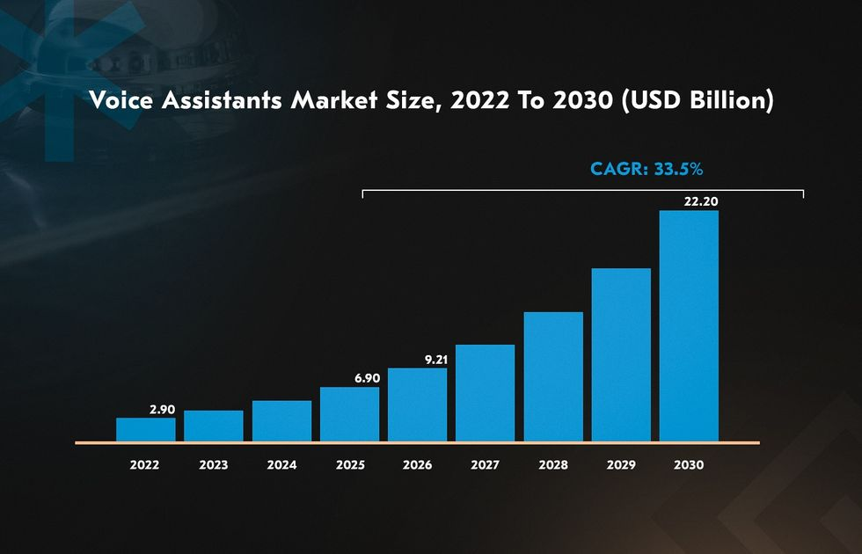
Figure 4 Voice Assistants Market Size
(Source: Acropolium, 2024)
There are various challenges created due to the technological trends for the companies which can lead to threats and weaknesses for the businesses. The ability to maintain customers relationship with the use of technology is challenging for the company as their ability to grow in the market is highly affected due to the customer’s interest (Conrady and Buck, 2012). The challenge is also present in providing smart room services which has huge impact on the business as virtual assistants might not meet the needs of the employees. This is challenging as practices are highly impacted and they face issues in the marketplace which affects the ability to achieve the growth as expected. In this they also face challenges in creating differentiated practices that affects the overall ability to maintain the relevant practices as expected (Ford and Sturman. 2020). This creates challenges for the business in maintaining their customer’s interest to retain the operations as expected.

3. Application to Hotel and Hospitality Sector
The chosen area of Hotel Industry is Front Office where the direct contact with the customers can be established such that the needs can be easily fulfilled for the customers. This eventually enables the management to have better opportunity to make the operations easy and customers can cooperate with the staff members (Tribe, 2009). Front office department uses advanced technology to ensure that check-in and other services for the customers can be made easier. This is essential to support the overall information development and stay can be made easy for the customers as overall services can be easily reached by the customers. It is identified that the companies are adopting the new technologies to ensure that personalised services can be provided to the customers with whom their operations can be improved for the overall development as expected (Clegg. Skyttermoen and Vaagaasar. 2021).
They ensure that real time communication is easily established while ensuring that the guest experience is developed such that the practices can be maintained as desired (Brotherton. 2015). This is essential to ensure that the business can easily achieve the growth while managing customer’s interest and expectations. The companies also ensure that Automated Guest Communication is established with the help of which efficiency is maintained as anticipated such that the growth as desired could be achieved. It is necessary to improve the reliability of the services while ensuring that practices are developed for the company’s ability to grow as expected (Sukach, Kozlovska and Sushko, 2021). The use of technology ensures that management can easily improve their guest experience and retain them for a longer period with which they have better opportunity to grow as anticipated.
As per the view of Ruel and Njoku (2020), the use of technology ensures that the business is able to improve their customer’s interest and easily meet their demands. The ability to meet their demand eventually ensures that management is capable of improving their ability to operate and compete with others while considering certain practices as expected. The hotel industry is introducing Artificial intelligence such that the customer’s data can be stored and their interest can be easily recognised. This eventually ensures that the capabilities are developed as expected while ensuring that overall operations are aligned easily as expected. For example, Premier Inn introduced what3words in more than 800 Premier Inn Hotels with the help of which travellers can easily locate the different areas of hotels. This makes front desk work easier and customers’ needs can easily fulfil as there were 62% travellers were facing hotels different locations (Premier Inn, 2024).
However Jalilvand et al. (2019), opposed that the use of technology can lead to weakness for the companies where they find it difficult to motivate the employees. This is because their work load is reduced and they find it difficult to conduct certain activities as expected and the practices can be highly impacted as expected. The use of technology has huge impact on the business as their capabilities might be compromised. This can also affect the ability to introduce innovation as expected which is challenging for the business to improve the presence in the market with revenue capabilities. This is not beneficial as the customers might not be retained in the organisation for longer period as they feel comfortable in the hotel only when the familiar employees are present with them as their needs are easily understood by them.
According to the Limna (2022), technology use ensures that the business have better chance in meeting the needs of the customers as their needs can be anticipated easily while making necessary changes. The front office uses technology to maintain the keys of the rooms as mobile keys are provided to maintain the cost incurred for lost keys. This is beneficial as strength of high profit can be earned as expected while ensuring that the customers can easily manage their stay in the hotel. The strength can be created by introducing Robotic Personnel with which personalised services can be provided to maintain the overall operations as expected. It is relevant for the business to improve the efficiency in use of different practices with the help of which cost and profits can be managed as expected.
In opposite to this Mejia (2019), stated that the use of technology might increase hacking cases and the front office might be misled for the customers identity. This is challenging for the business to get their needs satisfied as expected might not be achieved and their efficiency might not be maintained as anticipated. The hotel chatbots usage might affect the customers’ ability to get their needs fulfilled as tracking cannot be maintained as expected. This is challenging for them to maintain the network process as information might be leaked and their capabilities might be sacrificed. The use of technology can have huge impact on the ability to meet the emerging trends as expected as practices might be sacrificed. The contactless travel might not be provided as expected due to the increase in the cost of operations and the negative impacts can be imposed on the overall growth capabilities.

4. Evaluation of Future Policy and Management
There are various future policies and management options that can be introduced by the Hospitality Industry to maintain the contemporary issues created by Technology. This is essential to ensure that practices can be easily maintained as expected while ensuring that changes can be introduced as required. Those recommendations are provided further:
- It is suggested that industry should introduce a safety technology which can act as Cyber Security such that the data breach can be maintained as expected. This is challenging for the business to implement as cost can be increased but is essential to ensure that the practices are improved and they can easily contribute to the success of the business while ensuring that customer’s interest is considered as anticipated (Morais, 2022). This makes it easy to conduct various operations and introduce Artificial intelligence to make the service delivery easy and ensure that customers’ needs can be easily identified to develop the practices. The use of this Policy will ensure that management can easily train their employees in meeting and understanding customers need such that growth can be achieved as anticipated. This Policy ensures that employee’s productivity can be improved and they have better chance in achieving the targets established.
- They can introduce a technology which provides all services of the hotels in one place and with one touch to ensure that service delivery can be improved. The introduction of this technology will ensure that business can easily provide the services to their customers for improving their interest and improving the profitability of the business as expected. This technology eventually ensures that customers will not get confused about the ways they can acquire the services which ensures that they will visit the hotel again in their future visit (Wynn and Lam, 2023). This is to ensure that investment on marketing can be maintained and they have better chance in improving the overall efficiency as expected and relevant growth can be achieved to expand into new country and sustain the operations. Due to this the customers can get their needs fulfilled easily and the ability to grow can be developed as expected.
- It is recommended that virtual and augmented reality can be introduced by the management such that the environment of working can be improved. The employees will be hired by expanding the operations such that the capabilities are developed to support the overall growth of the business. With introduction of Virtual and Augmented Reality the business have better chance in getting their needs fulfilled while ensuring that hotel tour can be provided easily. This helps the customers to identify the areas that they have to focus on to ensure that capabilities can be developed to maintain the operations (Ben Youssef and Zeqiri, 2022). By introducing this customers have better understanding of their plan for the tour such that their experience can be improved as expected.

5. Conclusion
From the report it has been identified that with technology helps to improve the employees productivity while ensuring that practices can be easily maintained. The technology can reduce the interest of the employees as Robots might replace the humans and they might start losing the jobs. This is not in the favour of the management as overall goals might not be achieved and practices will be highly impacted. The technological theme is essential for the food and beverage areas of hotel industry. This is because orders can be easily prepared and managed to meet the customers’ needs as expected.

6. References
Acropolium, (2024). TOP HOSPITALITY TECHNOLOGY TRENDS TO EMBRACE IN 2024 [Online] Available Through <http://surl.li/pxesd> [Accessed on 29 January 2024]
Ben Youssef, A. and Zeqiri, A., (2022). Hospitality industry 4.0 and climate change. Circular Economy and Sustainability, 2(3), pp.1043-1063.
Bisoi, S., Roy, M. and Samal, A., (2020). Impact of artificial intelligence in the hospitality industry. International Journal of Advanced Science and Technology, 29(5), pp.4265-4276.
Bittendorfer, T., Bunt, J., Grunder, L., Riedel, D., Magnus, B. and Salzlecher, T., (2019). Technology in tourism: How voice assistants influence the hospitality industry. Iscontour, pp.328-338.
Brotherton. B., (2015) Researching Hospitality & Tourism 2nd Edn. Sage. London.
Clegg. S.R, Skyttermoen. T. and Vaagaasar .A.L, (2021) Project Management: A Value Creation Approach. Sage, London.
Conrady, R., and Buck, M. (2012) Trends and Issues in Global Tourism, Springer.
Cooper, C. and Hall, M. (2019) Contemporary Tourism: An International Approach, 4th Edn. Goodfellows, Oxford.
D’Souza, E. and D’Souza, K., (2023). A study on the impact of innovative technologies in the hospitality industry. Journal of Tourism, Hospitality and Culinary Arts, 15(1), pp.1-23.
Darcy, S. Ambrose, J. and Bulhalis, D. (2012) Best Practice in Accessible Tourism: Inclusion, Disability, Ageing Population and Tourism, Channel View, London.
Dawson, J. Lemelin, H. and Stewart, E. (2012) Last Chance Tourism: Adapting Tourism Opportunities in a Changing World, Routledge, London.
Ford.R.C, and Sturman.M.C (2020) Managing Hospitality Organizations 2nd Edn. Sage, London.
Jalilvand, M.R., Khazaei Pool, J., Khodadadi, M. and Sharifi, M., (2019). Information technology competency and knowledge management in the hospitality industry service supply chain. Tourism Review, 74(4), pp.872-884.
Kansakar, P., Munir, A. and Shabani, N., (2019). Technology in the hospitality industry: Prospects and challenges. IEEE Consumer Electronics Magazine, 8(3), pp.60-65.
Limna, P., (2022). Artificial Intelligence (AI) in the hospitality industry: A review article. Int. J. Comput. Sci. Res, 6, pp.1-12.
Mejia, C., (2019). Influencing green technology use behavior in the hospitality industry and the role of the “green champion”. Journal of Hospitality Marketing & Management, 28(5), pp.538-557.
Morais, J.F.M., (2022). Technology in hospitality: how generation X perceives this trend (Doctoral dissertation).
Premier Inn, (2024). Premier Inn adopts addressing technology what3words [Online] Available Through <http://surl.li/ltenp> [Accessed on 29 January 2024]
Ruel, H. and Njoku, E., (2020). AI redefining the hospitality industry. Journal of Tourism Futures, 7(1), pp.53-66.
Statista, (2021). Main reasons for hoteliers to use technology worldwide as of February 2021 [Online] Available Through <> [Accessed on 29 January 2024]
Statista, (2022). Total software spending in accommodations, restaurants and nightlife industry in the United Kingdom from 2018 to 2024 [Online] Available Through <http://surl.li/pxbkc> [Accessed on 29 January 2024]
Statista, (2023). Number and proportion of trade union members working in accommodation and food service activities in the United Kingdom from 1995 to 2022 [Online] Available Through <http://surl.li/pxbpx> [Accessed on 29 January 2024]
Sukach, O., Kozlovska, S. and Sushko, N., (2021). Modern management technologies in the hospitality industry. Baltic Journal of Economic Studies, 7(3), pp.168-176.
Tribe J., (2009) Philosophical issues in Tourism (Aspects of Tourism), Channel View.
Wynn, M. and Lam, C., (2023). Digitalisation and IT strategy in the hospitality industry. Systems, 11(10), p.501.

