Blended learning and traditional learning
Student ID: 2026061
Student Name: Luminita Daniela Mircea
Module : Academic and Employability Skills
Module Code : BMSW 4001

Table of Contents

Task 2 3
Introduction 3
Reflection on Feedbacks 4
Employability Skills 7
Time Management 8
Research Skills 9
Presentation Skills 10
Conclusion 12
Referencing 13
Appendix 15
Appendix 1: Classroom Activity Feedback Form 15

Task 2

Introduction
Employability skills are the qualities or features of an individual or a person that completes the entire personality and make the person eligible to become an employable person in a reputable organisation after completing the graduation or respective qualification for the job role. In today's learning environment it has become really difficult for people to enhance their employability skills and get selected in a good job role because there are numerous applicants for the single position that have common skills and knowledge. As a result, it becomes truly difficult for the recruiter to identify quality applicants which will be suitable for the job role and have all the employability skills essential for working in that organisation (Cotronei-Baird, 2020). The report is a reflection report that shares my experience about the employability skills that I have learnt during the module with the support of several learning models like call learning cycle Gibbs reflective cycle classroom activities etc.

Reflection on Feedbacks
During the learning of the module, I got to know several things about blended learning and its advantages and disadvantages in the classroom for modern students. This is because in my assignment 1 where I have to discuss the pros and cons of blended learning as well as its impact on the students and present learning environment. Therefore I can say that while experiencing the module I got an opportunity to explore more and more about the Tools and techniques used in the present learning environment for the students by the teachers to enhance learning (Asonitou, 2015). Also, there was a classroom activity that I performed that included performing an assignment on time which I have to submit on time but due to my carelessness and poor time management skills, I find it difficult to submit my assignment on time. With the support of the Gibbs reflective cycle that was introduced in the year 1988 by Graham Gibbs, I will be sharing my experience or reflection on the feedback given by my teacher for assignment 1 as well as the classroom activity that I have performed. There are six stages in the Gibbs reflective learning cycle that I have addressed below and the context of the feedback given for activity 1 and classroom activity by the tutor (Nisha et al., 2018).

Figure 1: Gibbs Reflective Cycle
Source:
- Description: In this, I will be giving or describing my experience for the feedback given by my tutor on assignment 1 as well as on classroom activity. With the use of feedback given by my teachers as well as with the learning module, I got an amazing experience and that has contributed to improving my employability skills as a final year student who will be entering the professional world soon completing the education (Scott et al., 2019).
- Feelings: It includes all the experiences of mine That I developed while learning the module and got to know about from the feedback from the tutor about assignment 1 and the classroom activity. There are skills that I learnt or developed within me to become employable like time management skills, team working skills, research skills and communication skills etc. I feel that all these skills that I developed while learning the module are going to benefit me for the rest of my life are special in professional terms (Adeani et al., 2020).
- Evaluation: After describing and experiencing feelings about the developed employability skills in me there are two categorizations that I can make for my experience that are good and bad. For example, while I was learning the module my tutor gave me several assignments and tasks to perform that I performed but also I faced several challenges and bad experiences while performing those assignments and tasks that helped me to grow and be a warrior who will be always ready for the challenges. The good that happened was an improvement in employability skills that will benefit me in the future for my dream job role (Husebo et al., 2015).
- Analysis: In this stage of the module I will be analyzing my previous experience of mine regarding the learning that I got from the module as well as from my tutor so that I can extract the good and bad learning’s and ensure to not repeat the mistakes that I have done in the past. The employability skills that I have developed during the learning module is like Communication skills, time management skills, research skills etc are good analyses from my past where are the challenges that I suffered to learn these skills are bad and would like to ensure that the mistakes will not be repeated in the future (Adeani et al., 2020).
- Conclusion: It is the last second stage of the model where I have to conclude my entire experience and finalize the positive and negative learning from the same. From the learning module, it can be concluded that there are several employability skills that I developed within me and these employability skills are going to benefit me for the rest of my life especially in professional growth and development. For example, I have a dream of becoming an HR manager in a reputable retail organisation in the UK and these employability skills that I learned while learning the module are going to benefit me for achieving my dream in the future (Husebo et al., 2015).
- Action Plan: The last stage of the Gibbs reflective cycle is preparing an action plan to implement the actions or ideas extracted for improving the weak areas of the personality. The skills that I have developed by module learning are employability skills but still, I need to focus on my improvements on presentation skills and team working skills. For the same I will be developing an Action plan further in the report (Adeani et al., 2020).

Employability Skills
Being employable means having all the essential skills in a personality that makes a person capable enough to grab a good job opportunity after completing the respective education and have a stable source of earning their daily bread. As I have addressed earlier, there are certain skills that I developed with the help of the learning module as it helped me to improve my personality and develop it according to the requirement of the modern changes in the business environment as well as in the job roles. There are several actions that I performed to improve the main three employability skills : time management skills, research skills and presentation skills while learning the module (Cotronei-Baird, 2020). For example, to improve my time management skills I used the 4D model time management model that helped me a lot to improve my time management skills and also to understand the importance of time in professional life. For research skills, I gave a CRAAP test to know my knowledge and information of mine regarding the respective job role. To improve my presentation skills I have prepared an action plan that is going to help with improved presentation and team working skills. Here is the detailed discussion about the actions and activities performed by me while accessing the learning module and improving my employability skills (Asonitou, 2015).

Time Management
Time is essential for an individual, especially for the people that are looking for a good professional career after completing their education and qualification in a particular field. There will be several tasks that a person has to perform to become a successful employee in the professional world. For example, an HR manager has to perform a lot of multitasking at a time that makes it important to have excellent time management skills to avoid stress and conflicting situations at the workplace. There are 4D's of a time management model that helped me with enhancing my time management skills (Nisha et al., 2018). The 4 D’s of the model are Delete, Delegate, Defer and Do. The Delete element of the model states that I have to delete all the unnecessary work from my to-do list that is not time-sensitive. The second element of the model states that I have divided the work and delegated it to the other team members to complete it on time and with quality. The third element of the time management model is Defer which means to prioritize the work and postpone all other work that is not essential to do on time. The last element of the model is Do which means to do the work in any situation to make it complete on the decision or the given time duration. The benefit of using the time management model to me is that now I can finish all of my work on time and also manage stress pre-professional life at the workplace (Kirillov et al., 2015).
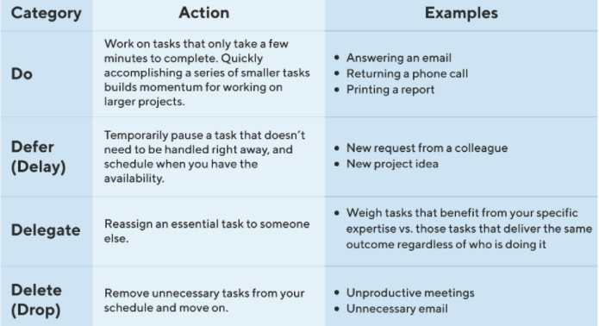
Figure 2: 4D Time Management Model
Source: (Kirillov et al., 2015)

Research Skills
Research skills help an individual to achieve the desired level of information that needs to be provided in the assignment of the tasks. Also at the workplace for business expansion and effective marketing strategies, HRM strategies and effective research skills are really important. While learning the module and with the support of my teacher I have developed research skills that are going to ease my professional life (Husebo et al., 2015). To improve my research skills I have performed the CRAAP test that refers to an evaluation method used by most people to analyze their research skills and plan the future development actions according to the score earned in this test. The CRAAP stands for Currency, Relevance, Authority, Accuracy and Purpose. The benefit of using the test is that it is going to enhance my research skills but on the other hand there is a major drawback that the test results are not reliable and does not help a student or a professional to trust the source of information (Carey, 2017).
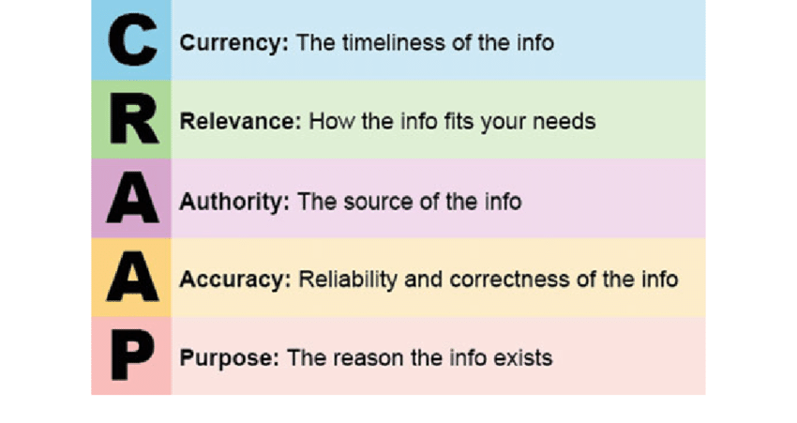
Figure 3: CRAAP Test
Source: (Carey, 2017)

Presentation Skills
To become an employable person and have an effective performance at the workplace the persons like me need to improve their presentation skills because in the professional environment there will be several opportunities when I have to perform presentations in front of the employees, seniors and clients etc. to improve the presentation skills I have prepared an action plan that benefits me with enhanced communication, team working and presentation skills. On the other hand, the drawback of using the action plan is that it is very time consuming and the solutions mentioned in the action plan are less reliable in comparison to the guidance provided by the teacher (Theobald, 2016).
PDP Plan
Skills to be Improved | Actions for Improvement | Experiencing the Improvement | Time Taken for Improvement
Presentation Skills | To improve this skill I will be practising in front of the mirror at home to improve my confidence and communication skills. | I am experiencing an improvement within me about my presentation skills because the implemented solution has helped me a lot with the developed communication and confidence that collectively developed my presentation skills. | 6 months
Team Working Skills | I will be participating in more group tasks like group discussions, presentations, assignments, debates etc to be habitual in working in a team with diverse members. | Now I am an effective team player and know how to deal with a team of diverse backgrounds and avoid the situation of conflicts and chaos at the workplace. | 3 months
Table 1: PDP Plan
Source: (Dixon et al., 2015)

Conclusion
The report concludes that the learning module has helped a lot in my growth and development of the mine in terms of professional growth and development. The discussion presented in the report is being supported by strong evidence like models and theories. The evidence used in the report to support the arguments is Gibbs reflection cycle, 4D model of time management, CRAAP tests, action plans etc. It was a reflection report that addressed my experience while learning the module as well as the employability skills that I have developed while module learning.

Referencing
Adeani, I. S., Febriani, R. B., and Syafryadin, S. (2020). Using Gibbs reflective cycle in making reflections of literary analysis. Indonesian efl journal, 6(2), 139-148.
Asonitou, S. (2015). Employability skills in higher education and the case of Greece. Procedia-social and behavioural sciences, 175, 283-290.
Carey, M. (2017). Qualitative research skills for social work: Theory and practice. Routledge.
Cotronei-Baird, V. S. (2020). Academic hindrances in the integration of employability skills development in teaching and assessment practice. Higher Education, 79(2), 203-223.
Husebø, S. E., O'Regan, S., and Nestel, D. (2015). Reflective practice and its role in simulation. Clinical Simulation in Nursing, 11(8), 368-375.
Kirillov, A. V., Tanatova, D. K., Vinichenko, M. V., and Makushkin, S. A. (2015). Theory and practice of time-management in education. Asian Social Science, 11(19), 193-204.
Nisha, S. M., and Rajasekaran, V. (2018). Employability skills: A review. IUP Journal of Soft Skills, 12(1), 29-37.
Scott, F. J., Connell, P., Thomson, L. A., and Willison, D. (2019). Empowering students by enhancing their employability skills. Journal of Further and Higher Education, 43(5), 692-707.
Theobald, T. (2016). Develop your presentation skills. Kogan Page Publishers.

Appendix

Appendix 1: Classroom Activity Feedback Form


