CRITICAL PERSPECTICTIVES REPORT



MAY 2020

MODULE NAME: CRITICAL PERPECTIVES ON MANAGEMENT
Name: CAI ELLIS
Student Number: 170665

Table of Contents

- Introduction……………………………………………………….. Page 4
- Key concepts & theories……………………………………..Page 5
- Business Ethics……………………………………………………Page 5
- Corporate Social Responsibility…………………………..Page 6
- Shareholder Theory……………………………………………Page 7
- Stakeholder Theory…………………………………………….Page 8
- A brief history of Facebook…………………………………Page 9
- Case Study…………………………………………………………Page 10
- Conclusion…………..……………………………………………Page 13
- Recommendations…………………………………Page 14
- References……………………………………………..Page 15

- Introduction

Within this report we will analyse theories of CSR and their relation to social media sites, using relevant content to support evaluation. The models discussed within this report are shareholder theory, stakeholder theory, and Carroll’s CSR pyramid. A case study is then undertaken to analyse the CSR engagement of social media platforms, using Facebook as an example. We discuss their responsibilities to their users, discussing duty of care. Ethical performance is a focal point of this report, Facebook are no stranger to controversy and mistakes made by the organisation are scrutinized on a global scale. Once these ethical issues have been identified and addressed, the report will conclude with recommendations that will improve Facebooks ethical performance.

- Key concepts and theories

This section will examine the key concepts discussed throughout the report, utilising models when appropriate to aid the understanding of said concepts. The key elements in question are corporate social responsibility (CSR) and business ethics. Shareholder and stakeholder theories will also be defined as they are contrasting perspectives which are prevalent when discussing CSR.

- Business ethics

Owen (1978) defines ethics as an array of principles which determine whether a human’s actions are deemed to be moral or immoral. This unformulated standard of ethics is applied to organisations, pertaining to their practices and decisions. Stoner (1989) believes a business’s culture has an extreme impact on its ethics and is crucial to the understanding of governing ethical decisions. An abstract from Facebook’s code of conduct states; “”Facebook Personnel”, are expected to act lawfully, honestly, ethically, and in the best interests of the company while performing duties on behalf of Facebook” (Facebook, 2019).

- Corporate social responsibility (CSR)

As defined by Carroll in 1979, CSR is a range of obligations that an organisation owes to its direct environment. Carroll’s model within this journal states these responsibilities as economic, legal, ethical, and discretionary. However, Carroll revised the discretionary aspect in 1991, altering it to philanthropic upon the creation of his CSR pyramid. Pictured below, the pyramid encompasses the social responsibilities of a business. As is evident, the primary responsibility of a corporation is to create profit as this is a paramount requirement for a business in our society. The legal aspect of this pyramid is also an obligation the organisation must adhere to as operating within the law is compulsory. Next, we have ethical responsibilities, the duty of operating in a moral manner. Unlike the previously mentioned aspects, ethical practices are only expected by society. Finally we have philanthropic responsibilities, these are desired by society. Although this model is clear when defining CSR, it has often been criticised for its simplicity. Crane and Matten (2003) scrutinized this model for its failure to include the overlapping nature of these aspects, stating the affiliated nature of these components are integral when analysing CSR.

Figure 1 – Carroll’s CSR Pyramid
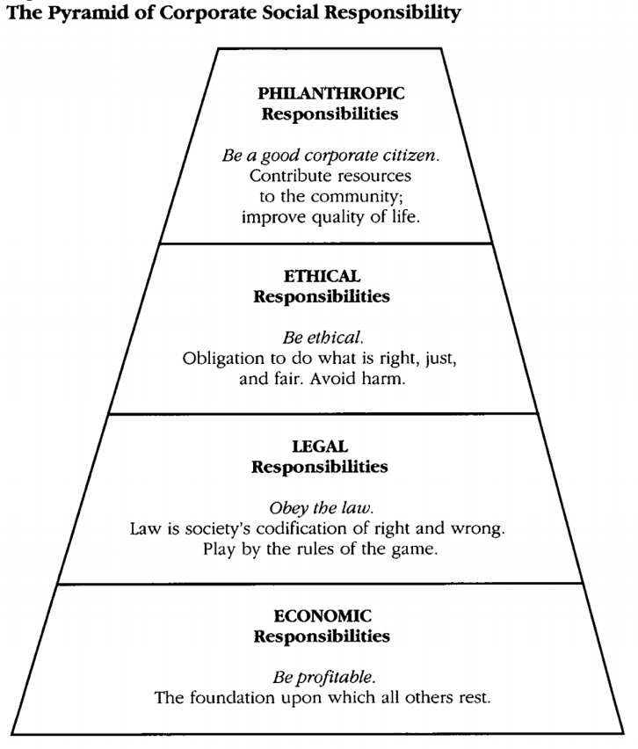

- Shareholder Theory

Economist Milton Friedman created this theory in his 1970 article “The Social Responsibility Of Business Is To Increase Its Profits”, it concerns maximizing shareholders’ returns (New York Times, 1970). Friedman argued that returning profits to shareholders was the sole responsibility held by managers. He believed that investing in social activities only reduced shareholder returns. This was a long held perspective of Friedman’s, discussed years before in 1962. His book “Capitalism and Freedom” introduced the early depiction of this theory. Here he emphasises that the lone social responsibility is for organisations to increase their profits (Friedman, 1962). He asserts that they must utilise their means to undertake enterprises which will increase returns, so long as they operate fairly within the free market when doing so.

- Stakeholder theory

A stakeholder is defined as: any group or individual which can have a direct impact or will be directly impacted by an organisations practices (Freeman, 2010). The figure below depicts a firms stakeholders. Robert E. Freeman has been credited as the father of stakeholder theory. He believes each of these stakeholders play a pivotal role within the success of an organisation which is why they must be considered when strategizing, as engagement would provide opportunity. This theory focuses on organisations operating in a just manner as the organisation holds a responsibility to those they affect.

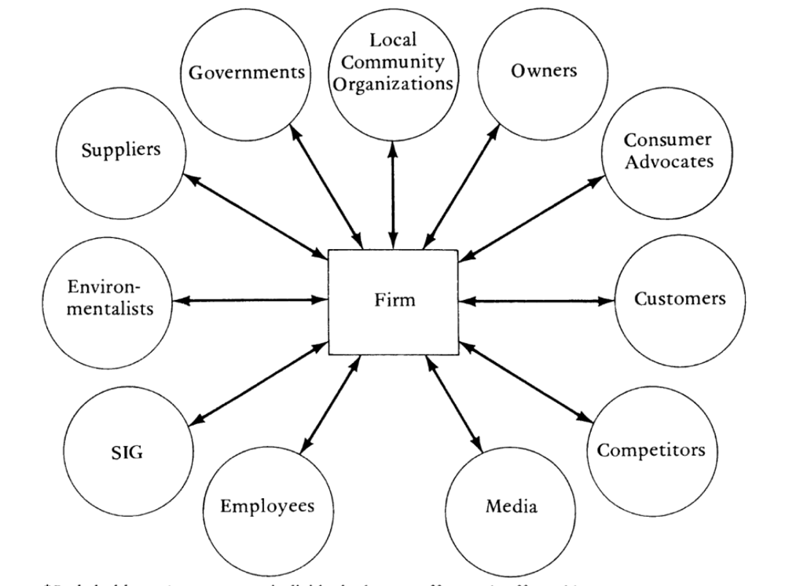

Figure 2 – An example of an organisations stakeholders

- Brief history of Facebook

Facebook was founded by Mark Zuckerberg in 2004 with the original purpose being to connect students within his university (Street, 2019). Since its creation, it has seen both significant and consistent growth, as seen in the figure below which highlights its userbase from 2008 to 2019. At the end of its first year, Facebook had 1 million active users. 15 years later, it has over 2.6 billion. Facebook is a social media platform which provides users the opportunity to stay connected with one another, allowing them to share their photos and videos with friends. Businesses may also utilise the platform to connect with customers, providing the ability to develop their brand. Due to its popularity and ease of use, many users also receive their news from the platform. Although, various complications have arisen regarding misleading information. Facebook’s mission statement is to; “give people the power to build community and bring the world closer together”. As is evident from the figure below, they are currently achieving said mission (Facebook, 2020).

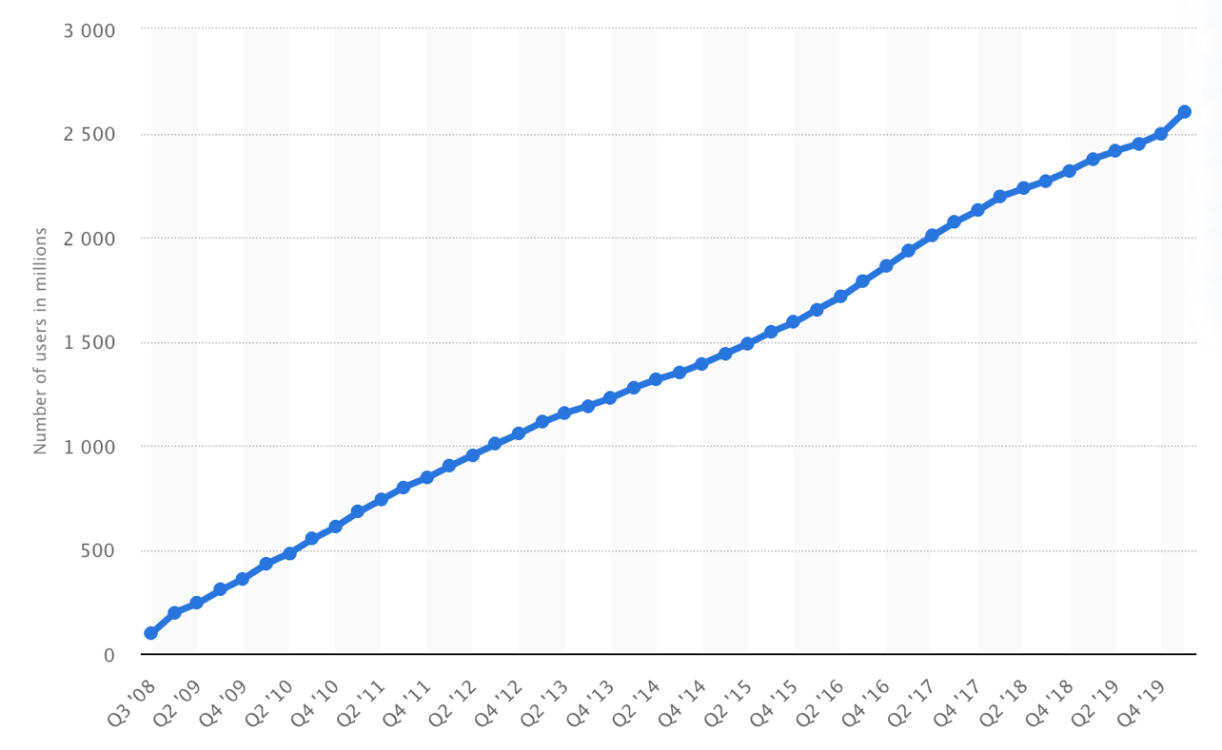

Figure 3 – Number of active Facebook users, 2008 - 2019

- Case Study

Facebook is no stranger to controversy and has been involved in one of the largest scandals in recent years. This was the situation regarding Cambridge Analytica, which transpired in early 2018, where millions of Facebook users had their personal data unknowingly harvested. This data was harvested through an app which was disguised as a quiz. The Facebook users had to connect their Facebook accounts in order to take part in the questionnaire and, upon linking the account, user data, and the data of their friends, was able to be collected. Cambridge Analytica amassed this data in order to create psychographic profiles which they could then sell to political parties. These profiles aided the creation of personalized ads which enabled parties to target individuals and attempt to manipulate their vote. This was Facebooks largest data breach, though it did ignite discussions on data reform. Due to Facebooks failure to protect user data, they failed to adhere to their CSR obligations, as previously outlined in this essay with reference to Carrol’s theory. Facebook failed both legal and ethical responsibilities, which are expected by society. Additionally, though their failure had a direct impact on their stakeholders. Facebook possessed a duty of care to their users data, and this breach created significant mistrust. Failure was also prevalent within Freidman’s definition of social responsibility, as the scandal broke over $100 million dissolved from Facebooks share price (Independent, 2018). Facebook have since updated the actions they take in order to prevent election interference, tripling the size of their teams within the safety and security departments(Facebook, 2020).

Due to its accessible nature and convenience, Facebook is a platform many users obtain their news. Although many legitimate news sources are being shared, the platform is also being used to spread fake news. Fake news as defined by Cambridge dictionary is “false stories that appear to be news, spread on the internet or using other media, usually created to influence political views” (Cambridge, 2020). An American study conducted within 2019 said that Conservatives were more likely to share fake news articles, with users 65 and over sharing seven times more than the youngest age group. This continuous spread of misinformation is not limited to political topics, recently Facebook have been engaged in a battle to counter the spread of misinformation regarding COVID-19 (BBC, 2019).

A study conducted by Avaaz, an online activist network, found that mis informative posts were shared over 1.5million times, gaining over 110 million views (Avaaz, 2020). These posts would contain harmful information regarding false cures to the virus, other fake claims would include prevention methods such as using hairdryers.

In order to combat this Facebook have begun to label false content, and instantly remove posts that contain misinformation which will cause physical harm to users (Guess, 2019). Though it was discovered it could take Facebook up to 22 days to remove posts which have been reported, below is an infographic created by Avaaz which displays the percentage of probed content which remained without a warning label (Avaaz, 2020).

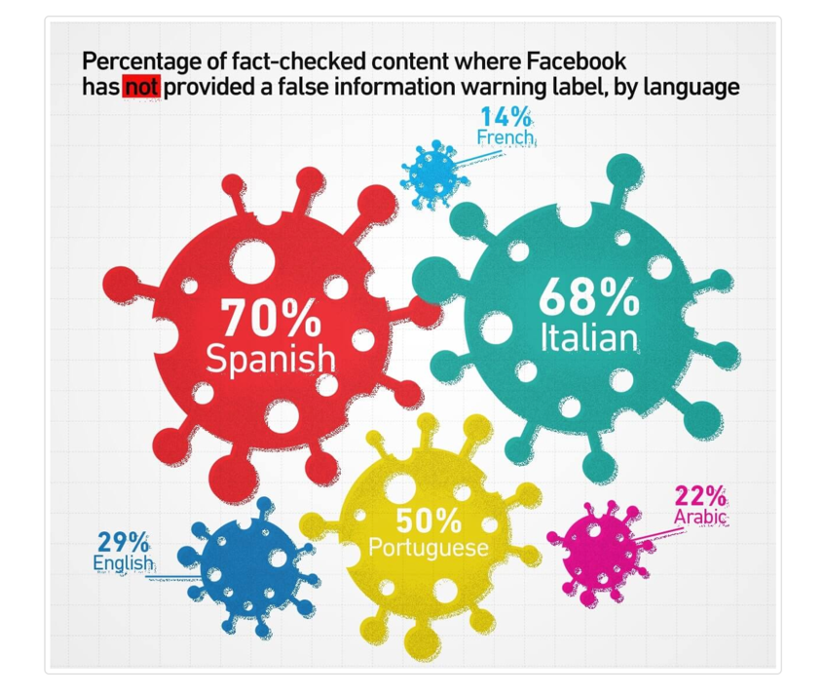

Figure 3 – Avaaz infographic on Facebook misinformation

As we can see from the graphic, the majority of mis informative posts discovered on the Spanish and Italian language Facebook remained active. This is an extreme lapse in responsibility, the organisation have been inefficient in labelling and removing content on their platform.

As stated earlier within the report, older demographics are more likely to share fake news, this group is also increasingly vulnerable to COVID-19. Any misinformation has the possibility to create harm when relating to the virus, Facebook are neglecting their duty of care to users. Links are provided to COVID-19 information centers, though it is not sufficient as content must be moderated closer. Zuckerberg stated that when Facebook has labeled false information 95% of users choose not to view the content, such a substantial success rate has not translated to targeting false content quicker.

An addition which may help counter this spread is Facebook News, this was announced to the platform as a permanent feature which will appear in 2019/2020 (Facebook, 2019). This section will contain news from over 200 outlets, from over 1000 reporters. Facebook News will allow the user to personalize the content they view, providing the ability to hide publishers or articles which are of no interest. This feature will debut in the U.S, no announcements have been made about its availability to other regions.

Facebook has evolved beyond the sharing of basic things such as text and pictures, through Facebook live users are given the ability to remotely live stream to their friends and followers. This feature is provided as a tool to engage with friends or supporters, though it raises ethical issues as the tool has been used to broadcast disturbing content such as murders. The Christchurch mass shooting is an example, where a gunman opened fire in a mosque killing 50 people and injuring 49 (BBC, 2019). Targeting multiple mosques, he live streamed the first attack on Facebook. Copies were created of the live stream, and were appearing on numerous websites. Facebook itself had to remove around 1.5 million copies from its own site, the incident resulted in a change to their live stream policy. Implementing a ‘one strike’ policy, which stated that an user caught violating rules would no longer be able to go live. Though this is not enough to deter disturbing content, as one strike is all a user will need to display their harmful content. It is a near impossible task for Facebook to regulate live content, due to the sheers size of its user base. In order for Facebook to limit the amount of unethical content which gets streamed through live, they should regulate which users have the ability to do so. Facebook offer verified badges to public figures, celebrities, or brands, only these verified accounts should possess the ability to stream live (Facebook, 2019). Potential verified users must apply to Facebook in order to receive their badge, providing authentic documentation when doing so. This would substantially limit the amount of unethical content which may be displayed, if this content then gets streamed Facebook would be able to directly provide authorities with evidence on the offender.

- Conclusion

This report has examined how CSR models can relate to social media sites, evaluating their relevance to this topic. Using Facebook as an example, we have analyzed their CSR engagement and explore the responsibilities they have to their users. Upon completing the analysis a set of recommendations have been listed below, which will assist Facebook in the development of their ethical issues.

- Recommendations

Facebook are succeeding in completing their mission to “bring the world together”, as the largest social media platform in the world they are achieving their goal of creating communities. It also provides organisations, no matter the size, the opportunity to expand and reach potential consumers around the globe. Ethical issues will certainly accompany an organisation of this size and nature, and here are the recommendations to Facebook to improve their ethical performance:

- Facebook should provide senior members an educational course for online awareness, available to existing members or new accounts. This course would provide them with rudimentary knowledge on avoiding fake news or scams.
- Improved misinformation department, as highlighted by Avaaz Facebook are in need of a review within this department. More funding may be required to better combat this spread.
- Limiting the use of Facebook live, as suggested earlier in the report this feature would benefit the organisation.
- Finally, Facebook could increase the rollout speed of Facebook News in order to combat the spread of mis information, and seek to expand it globally.

- References

Owens, J., 1978. Business ethics: Age-old ideal, now real. Business Horizons, 21(1), pp.26-30.

De George, R.T., 1989. There is ethics in business ethics; but there's more as well. Journal of Business Ethics, pp.337-339. – levels of ethics

Stoner, C.R., 1989. The foundations of business ethics: Exploring the relations. SAM Advanced Management Journal, 54(3), p.38.

Stratton, W.E., Flynn, W.R. and Johnson, G.A., 1981. Moral development and decision making: A study of student ethics. Journal of Enterprise Management, 3(1), pp.35-41.

Carroll, A. (1979). A Three-Dimensional Conceptual Model of Corporate Performance. The Academy of Management Review,4(4), 497-505. Retrieved May 10, 2020, from www.jstor.org/stable/257850

Carroll, A.B., 1991. The pyramid of corporate social responsibility: Toward the moral management of organizational stakeholders. Business Horizons, 34(4), pp.39–48.

Schwartz, M. & Carroll, A., 2003. Corporate Social Responsiblity: A Three-Domain Approach. Business Ethics Quarterly, 13(4), pp.503–530.

Freeman, R.E., 2010. Strategic management: A stakeholder approach. Cambridge university press.

M. Friedman, “Capitalism and Freedom” (Chicago: University of Chicago Press, 1962), 133.

M. Friedman “The Social Responsibility of Business Is To Increase Its Profits,” New Yorl Times Magazine, Sunday, Sept 13, 1970, sec.6, p. 32

Guess, A., Nagler, J. and Tucker, J., 2019. Less than you think: Prevalence and predictors of fake news dissemination on Facebook. Science advances, 5(1), p.eaau4586.

Statistica (2020) Number of monthly active Facebook users worldwide as of 1st quarter 2020, Available at: https://www.statista.com/statistics/264810/number-of-monthly-active-facebook-users-worldwide/ (Accessed: 1st May 2020).

Anne Sraders (2019) History of Facebook: Facts and What's Happening, Available at: https://www.thestreet.com/technology/history-of-facebook-14740346 (Accessed: 1st May 2020).

Avaaz (2011) What is Avaaz?, Available at: https://secure.avaaz.org/page/en/about/ (Accessed: 3rd May 2020).

Avaaz (2020) How Facebook can Flatten the Curve of the Coronavirus Infodemic, Available at: https://secure.avaaz.org/campaign/en/facebook_coronavirus_misinformation/ (Accessed: 3rd May 2020).

Facebook (2019) Introducing Facebook News, Available at: https://www.facebook.com/news (Accessed: 3rd May 2020)

Facebook (2019) Facebook News Coming Soon, Available at: https://www.facebook.com/news/comingsoon/ (Accessed: 4th May 2020)

Facebook (2020) Facebook Live, Available at: https://www.facebook.com/facebookmedia/solutions/facebook-live (Accessed: 4th May 2020).

BBC (2019) Christchurch shootings: Social media races to stop attack footage, Available at: https://www.bbc.co.uk/news/technology-47583393 (Accessed: 4th May 2020).

BBC (2020) Coronavirus: Facebook alters virus action after damning misinformation report, Available at: https://www.bbc.co.uk/news/technology-52309094 (Accessed: 4th May 2020).

Facebook (2019) How do I request a verified badge on Facebook?, Available at: https://www.facebook.com/help/1288173394636262 (Accessed: 5th May 2020).

