
Skills for the Workplace
Module Assignment Submission
Student Name: | Jemma Rees
Student Number: | 2008032
Module No: | BMSK4005
Module Title: | Professional Career Development

Statement of Confirmation of Authenticity
By the act of making this submission, the student declares that this is the work of the student named above. The work has not, in whole or in part, been knowingly presented elsewhere for assessment, or where assessment has been built on a previous assessment, this has been identified. Where materials have been used from other sources it has been properly acknowledged. If this statement is untrue, the student acknowledges that an assessment offence has been committed.
Attention is drawn to the plagiarism and unfair practice policies of both the University and of ILM.

Table of Contents
Section 1: Know how to identify development needs 2
1.1 Identify learning styles for self and another 2
1.3 Identify potential barriers to learning for self and another. 5
1.4 Explain how these barriers to learning can be overcome. 6
Section 2: Know how to develop self & others to achieve organisational objectives 7
2.1 Analyse learning/development options to meet needs of self & another. 7
2.2 Identify support mechanisms for the development of self & another 8
2.3 Prepare development plans for yourself and another person 9
2.4 Method used to monitor the development of self & another. 12
Section 3: Know how to prepare for the recruitment process 14
Reflection on the recruitment process 14
3.1 Description 14
3.2 Feelings 14
3.3 Evaluation 15
3.4 Analysis 15
3.5 Conclusion 15
3.6 Action Plan 16
References 17
Appendix A 18
Appendix B 19
Appendix C 29
Appendix D 31

Section 1: Know how to identify development needs

Identify learning styles for self and another

I have chosen to explore the Honey and Mumford learning style, (Honey and Mumford. (1986b) the VARK (Flemming and Mills. (1987) questionnaire and the Dantec Method (Dantec, C. (2007) to identify my learning style (self). After research into these methods I chose the Honey and Mumford learning style (Honey. P and Mumford. A (1986a) and the VARK questionnaire (Flemming and Mills. (1987) for Mark (another). Detailed in Appendix A.

  - Use a simple technique for identifying development needs for self & another

After researching techniques, I have decided to utilise the SWOT analysis. As detailed by (Helms, M.M. and Nixon, J. (2010) it is stated that the SWOT analysis “is used in virtually every published business case positioned for business student analysis” therefore the SWOT analysis appears to be the most suitable tool to identify and measure developmental needs.

SWOT Jemma

STRENGTHS  - Hardworking  - Punctual  - Communication  - Eager to lean  - Kind  - Considerate  - Honest  - Loyal  - Well-liked by the team  - 5yrs + office management  - Organised  - Teaching  - Practical  - Logical  - Calm under pressure  - Responsible  - Prince 2 | WEAKNESSES  - Concentration  - Off topic  - Lack of confidence  - Financial issues  - Overthinking  - Lack of education/certificates  - Hasty  - Anxiety  - Stress  - Nervous  - Migraines  - Depression  - Low self esteem  - Clumsy  - Poor maths skills  - Confusion  - Poor memory
OPPORTUNITIES  - Degree achieved  - Higher salary  - Project management  - Chartered  - More confidence in abilities  - More experience  - More financially secure | THREATS  - Time  - Responsibilities  - Being tired/poorly  - Financial support in employment  - Money to pay for:  - Chartership  - Associate memberships  - Courses  - Exams

SWOT Mark

STRENGTHS  - Confident  - Friendly  - Hardworking  - Loyal  - Determined | WEAKNESSES  - Impatient  - Lack of concentration  - Hearing  - Hasty
OPPORTUNITIES  - MBA  - Progression with current business  - Better academic understanding | THREATS  - Working hours  - Responsibilities  - Business concerns

Conversion and Matching Strategies - Jemma

My weaknesses all relate to 'issues' in early childhood, I missed a lot of education due to the extensive care needs of my sibling. As my mother was on her own, I was expected to be responsible and mature beyond my years. Although this does also link in with some of my strengths, I feel that I was disadvantaged from an academic perspective.

However, my anxiety and overthinking can be an advantage at times as I feel I have to work harder to make an impact. I spend longer checking and double checking my work to make sure it is the right tone, context, and content.

Although my weaknesses are likely to have been developed as a coping mechanism, I am constantly trying to convert these into strengths and use them to my advantage.

Once I have achieved academically, I am hopeful that more opportunities will be available to me. The positions that appeal to me, require a degree as a minimum. As noted in my strengths I am hard working and eager to learn, I put this in to practice regularly by taking on challenges and have recently studied and passed my Prince 2 Foundation and Practitioner exams.

My weaknesses and strengths can be matched to my career aspirations of Project Management. My current strengths of maturity, practicality and organisational skills perfectly match this career. I have an optimistic view of my weaknesses to change these into strengths. I believe that once I have achieved some of my goals, some of my weaknesses will be proven incorrect or irrelevant giving me the confidence to keep going and try harder.

Conversion and Matching Strategies - Mark
Mark has a few weaknesses caused by being impatient and a hearing disability. He did not complete his education at school age but as he is hardworking and determined he now has several qualifications and runs his own companies. Listed as one of Mark's weaknesses is being impatient; although this can be perceived as a weakness it can also be converted into a strength it can be used to push on projects to ensure that all work is completed on time

With the support of his partner, he can reduce the threats and concentrate on building his company, this support will also benefit the opportunities, allowing Mark to focus on his MBA.

As Mark is the director of his own companies, he is using his strengths in being friendly and confident to approach new customers and building professional relationships.

Identify potential barriers to learning for self and another.

Jemma

Work life balance
- I work 45+ hrs per week
- 2 dogs, 1 cat, 1 snake
- Husband and a son
- Mother

Childcare
Although my son is 16, he has autism and still needs guidance and support

Financial
I cannot afford to pay for my studies, so I am utilising student finance

Geographical
I live some distance from the university sites

Social Barriers
I am the first person in my family to go to university

Mark

Work life balance
- Working 45+ hrs per week
- 2 young children and a partner
- Studying a master’s degree

Childcare
Mark has two children under the age of three

Social Barriers
Mark is the first person in his family to go to university
Mark did not finish education

1.4 Explain how these barriers to learning can be overcome.

Jemma

Considering the above barriers, I have thought carefully how a full-time university course could impact upon my family, directly or indirectly, and the impact to me. I am very mindful that working a lot of hours means I will be tired, there is not much time available to run and manage my household. After deciding to pursue further education I spoke with my husband and have his full support. He will take on more duties around the house, my son will help and the nights and weekends that I do not have lessons will be used to recuperate, getting some much-needed rest.

I had a difficult childhood which meant I spent a lot of time away from education, this has been my biggest barrier to learning as I have very little education and little confidence in my abilities. I have worked very hard over the years to try and overcome this. I want to do better and reach my potential, after much reflection I decided that an outreach course would fit around my current work and life commitments. I work approximately 30 miles from home and the nearest university to offer this course is another 30 miles away. Luckily, this course offers lessons online and at outreach centres which are closer to home or on my way home from work.

I am utilising student finance to pay for my studies, I am hopeful that after I have completed my degree better paid opportunities will be available to me enabling me to pay back the finance.
I was very apprehensive embarking on this journey, as I am the first person in my family to have sought higher education, I did not have anyone to discuss the process with. I did a lot of research myself and with the support of my husband I decided that I should go for it.

Despite my lack of education, I have always pushed myself to do better. I am a tenacious person and once I set my mind to something it has my full attention. I can overcome barriers within my personal life with the support of my husband and son. Where I know there are educational barriers, I have sought assistance from the university and have completed assessments to ascertain where additional support could be beneficial. Unfortunately, due to coronavirus, I was unable to meet with the assessor directly and unable to gain a formal diagnosis. But They have indicated that I may have ADHD, Dyspraxia and Dyslexia.

To summarise, wherever I have felt disadvantaged or where barriers have presented themselves, I always strive to overcome these. There will always be difficulties in modern life, personally and within the workplace. But I believe that if you want something and are prepared to work hard enough there is always a way to overcome any obstacle.

Mark
Mark has a busy schedule; he is the director of 2 young companies and regularly works 6 days a week. He has 2 small children, both under the age of 3. He is supported by his partner as she takes care of the children whilst he is studying and working. He makes sure that he has every Saturday off to spend time with the family and to rest. Mark has mentioned to me that he is not 'academic' as he did not finish school and was unable to read fluently until he was 25, much of his study until this time was self-taught. He has gone on to gain many qualifications.

Mark was undecided to enrol on the master’s degree as he has a lot of commitments. He carefully considered the options of study and discussed with his partner as to what support he would need. He decided that the master’s degree would not only benefit him in continuing his personal and professional development but that any additional knowledge would be beneficial to the running of 2 companies. His partner is fully supportive in his academic journey.

To summarise, Mark has worked hard to be self-sufficient and has support in place to avoid potential barriers. He must balance his time carefully between work, study, and family.

Mark is a very hard-working individual; he is always striving to learn more and regularly explores avenues for CPD and further education. The barriers that he faces are minimal and with his determination, are unlikely to pose a threat.

Section 2: Know how to develop self & others to achieve organisational objectives

2.1 Analyse learning/development options to meet needs of self & another.

Jemma:

The career I have chosen to pursue requires a degree and several years of experience. After reflecting upon my SWOT analysis (Mindtools, (2016) I do not meet the academic criteria for these positions nor have the required experience.

However, once I have completed my degree, I will have achieved the required qualification, I will also be three years into my current employment, providing me with ample experience.

After completing several learning style questionnaires VARK (Flemming and Mills. (1987) Honey and Mumford (Honey and Mumford. (1986b) I decided upon one more, DANTEC (Dantec, C. (2007).

The outcome of the first two questionnaires indicate that my learning style is ‘hands on’ and practical. Interestingly the Honey and Mumford (Honey and Mumford. (1986b) questionnaire suggests that to be a successful leader, strengths in all areas are required. Based on my results of this questionnaire I appear to already have strengths in most areas; however, the lowest scoring section is ‘activist’ which indicates I need to be aware and develop this skill further. The main characteristic of this section is ‘learn by doing’ I feel that this accurately matches my preferred learning style, however, it does refer to ‘role play’ and ‘group work’, these areas are difficult to me as I sometimes lack confidence in social interactions.

Reviewing this final questionnaire, I have ascertained my learning style is reflective and dynamic. The key traits of these two styles are: learning by listening and doing, flexibility, the ability to view evidence from many perspectives, being reflective and my favourite trait “You often reach accurate conclusions in the absence of logical justification” (Dantec, C. (2007) I would agree that these statements closely represent my professional and academic approach.

Mark:

Initially Mark trained to be a carpenter, he has gone on to learn most building trades. He has used his professional experience to obtain MCIOB and an NVQ7. He has decided to complete an MBA in estate management to further his academic ability and to benefit the company. I asked Mark to complete the SWOT analysis (Mindtools, (2016), this shows that he already has the necessary ‘strengths’ to succeed in business.

Mark also completed the VARK (Flemming and Mills, 1987) and the Honey and Mumford learning style questionnaire (Honey and Mumford, 1986b). The results of the VARK (Flemming and Mills, 1987) questionnaire indicates that he is ‘Multimodal – AK’ aural and kinaesthetic.

The results of these questionnaires indicate Mark prefers listening, talking and practical tasks, again I feel this is a true reflection, the Honey and Mumford learning style questionnaire (Honey and Mumford, 1986b) shows that Mark primarily needs to focus on developing his skills in the ‘theorist’ section. The ‘theorist’ likes to understand the theory behind the actions, this too is an accurate representation as Mark does not always want to dig deeper and understand the ‘why?’ but prefers to take immediate action.

2.2 Identify support mechanisms for the development of self & another

Jemma
The support mechanisms I will utilise are, support from my tutor and the online resources. I will ensure the recent results of my assessments are shared with my tutor. This will enable my tutor to know exactly what kind of support I will need and the specific learning difficulties I face.

In addition to this I will seek assistance from my husband and son where I need additional support around the house and for any moral support that I may need over the duration of my studies.

Mark
He will seek support externally, from his partner and close family. During his studies for his MBA, he has access to a support network of other learners, the university, and a tutor. In addition to the above, Mark has a private tutor to assist him in completing assignments.

2.3 Prepare development plans for yourself and another person

Part 1: Personal Analysis
Jemma

My weaknesses all relate to 'issues' in early childhood, I missed a lot of education due to the extensive care needs of my sibling. As my mother was on her own, I was expected to be responsible and mature beyond my years. Although this does also link in with some of my strengths, I feel that I was disadvantaged from an academic perspective.

However, my anxiety and overthinking can be an advantage at times as I feel I have to work harder to make an impact. I spend longer checking and double checking my work to make sure it is the right tone, context, and content.

Although my weaknesses are likely to have been developed as a coping mechanism, I am constantly trying to convert these into strengths and use them to my advantage.

Once I have achieved academically, I am hopeful that more opportunities will be available to me. Many positions I would like to apply for, require a degree as a minimum. As noted in my strengths I am hard working and eager to learn, I put this in to practice regularly by taking on challenges and have recently studied and passed my Prince 2 Foundation and Practitioner.

My weaknesses and strengths can be matched to my career aspirations of Project Management. My current strengths of maturity, practicality and organisational skills perfectly match this career. I have an optimistic view of my weaknesses to change these into strengths. I believe that once I have achieved some of my goals, some of my weaknesses will be proven incorrect or irrelevant giving me the confidence to keep going and try harder.

Mark
During the analysis I found that Mark is a very hardworking individual who continues to develop himself professionally and academically. Although he has weaknesses, these do not hold him back or stop him from achieving his goals. Most importantly he is aware of his weaknesses and continues to develop strategies to overcome these.
His personal drive to succeed is mirrored in his strengths and opportunities in wanting to succeed personally and professionally.

Part 2: Setting Goals
Jemma
What do I want to learn? | What do I have to do? | What support and resources will I need? | How will I measure success? | Target Date for Review
Leadership and Management | Attend all classes | Access to the Hwb and guidance from my tutor | Based on the results and feedback of my assignments | October 2021
How to make decisions better and quicker | Continuing studies | Tutor support and guidance. Information supplied in Teams and the library resources | I will know that I have learnt this skill by putting into practice decision making | October 2021
How not to panic when time is short | Research different time management skills | I will need support from my tutor, and I will research these skills online or via the UWTSD library | Once I can work to a tight deadline without excess anxiety, I will have succeeded | March 2021

Mark
What do I want to learn? | What do I have to do? | What support and resources will I need? | How will I measure success? | Target Date for Review
MBA estate management | Mark will need to attend all lectures and submit assignments on time | He will require support from his tutor and peers. Resources will be accessed online via the university | Once the assignments have been marked and returned Mark will be able to see how he is progressing and if he is on track for a pass. | August 2021
Leadership | As Mark progresses through his course he is learning about leadership and will implement these new skills into the workplace | He will seek support from his peers and colleagues to compare and discuss what has worked well | Success will be apparent in the workplace in the way that the team work together and improvement of processes | March 2021
Time management | Mark will need to set a daily plan to keep to a schedule of activities to ensure effective time management | Support will be provided by the office staff to ensure that he adheres to the schedule, where this is not possible to ensure that he gets back to the schedule as soon as possible | Mark will be able to measure success by completing tasks on time and not rushing to complete assignments and tenders | March 2021

Part 3: Personal Objectives
Jemma
Short Term Goals (next 12 months)
To complete the first year of the course and gain the ILM level 4 and the CERTHE for leadership and management
Medium Term Goals (2-3 years)
To complete the full three-year degree course and obtain a Batchelors degree

Long Term Goals (3-5 years)
To continue studies to further my knowledge and obtain professional memberships

Mark
Short Term Goals (next 12 months)
To complete the MBA and achieve a pass
Medium Term Goals (2-3 years)
To apply the skills and knowledge learnt to advance in business

Long Term Goals (3-5 years)
To be able to step back from the business and spend more time on other projects or with the family

2.4 Method used to monitor the development of self & another.
I propose to use the below learning log to detail my recent studies and to use this learning log as a key point in my continuing studies. I will use the same learning log to detail Mark’s academic achievements.

BMSK4005 Professional Career Development  PDP Monitoring Learning Log | Date: 9/11/2020
STUDENT NAME: Jemma Rees

What happened?

What did I do?
I spent 6 months learning and studying the Prince2 foundation and practitioner courses in preparation for the final exams.
How do I think/feel about this?
I felt very nervous and questioned my ability to learn something new. I felt overwhelmed at times when I felt certain topics were difficult or I could not commit the time that I had promised.
How well or how badly did it go?
My studying went very well. I persisted and kept trying.
My conclusions/reflections/lessons learned

What did I learn?
I learnt the project methodology to high level and gained a string understanding of how to manage projects in various situations
What have I achieved?
I have achieved the Prince2 foundation and practitioner qualifications
How have I put any theory into practice?
In my current position at work I am required to assist and oversee projects and processes, having the knowledge of how projects work I have been able to apply my newly learnt skills to assist in a smoother process and a swifter delivery of projects.
What have I learned about myself?
I am more capable than I first thought. I doubted my ability and proved to myself that I can do anything I put my mind to.

How does what I am doing lead me to becoming better at a skill?
The fact that I have already spent a large proportion of the year learning, I have recognised areas in which I may struggle and areas in which I feel more comfortable
How can I use this to plan for the future?
As I am more aware of how I like to learn and what really works for me, I can tailor this to my current university studies.
How can I use this to plan new learning experiences?
Knowing that I need a very-hands on approach I can prepare myself ahead of time, whether it is at work preparing for a meeting or in my studies and preparing for a class. I know that I need to have a lot of physical material to work with and work better having information to hand that I can freely annotate or highlight.
My plan to do something better/different by using what I have learned

What will I do differently next time?
I plan to approach daunting subjects slowly and to take my time in reading and understanding the materials presented to me.
How will I do it differently next time?
I will make sure that I am prepared ahead of time by printing out necessary documents and taking physical notes that I can refer to later if needed.

BMSK4005 Professional Career Development  PDP Monitoring Learning Log | Date: 23/11/2020
NAME: Mark Evans

What happened?

What did I do?
Mark has recently completed the first module of his assignment and has handed it for marking.
How do I think/feel about this?
He feels apprehensive as he does not feel academically capable of achieving this qualification

How well or how badly did it go?
The module has not been returned from marking, so he is unaware of the result
My conclusions/reflections/lessons learned

What did I learn?
During the time taken to research and write the assignment Mark has found his time management tricky due to external factors.
What have I achieved?
Handing the assignment in on time.
How have I put any theory into practice?
Mark has implemented appointments and time slots into his work diary to help schedule his day and better manage his time

What have I learned about myself?
He has learnt that although the first assignment was daunting, he has completed it and did not struggle as much as he expected

How does what I am doing lead me to becoming better at a skill?
By completing this course Mark hopes to become a better businessman and grow the company

How can I use this to plan for the future?
Mark plans to use the skills and knowledge gained from this course to grow the business and to eventually step away from the daily operation
How can I use this to plan new learning experiences?
Now that he has completed the first assignment, he feels better prepared to tackle the next one
My plan to do something better/different by using what I have learned

What will I do differently next time?
Plan ahead
How will I do it differently next time?
Mark will read all literature associated with the assignment before attempting a first draft

Section 3: Know how to prepare for the recruitment process

Reflection on the recruitment process
I have chosen the ‘Gibbs Reflective Cycle’ (Gibbs, G. (1988) to reflect upon the recruitment process.
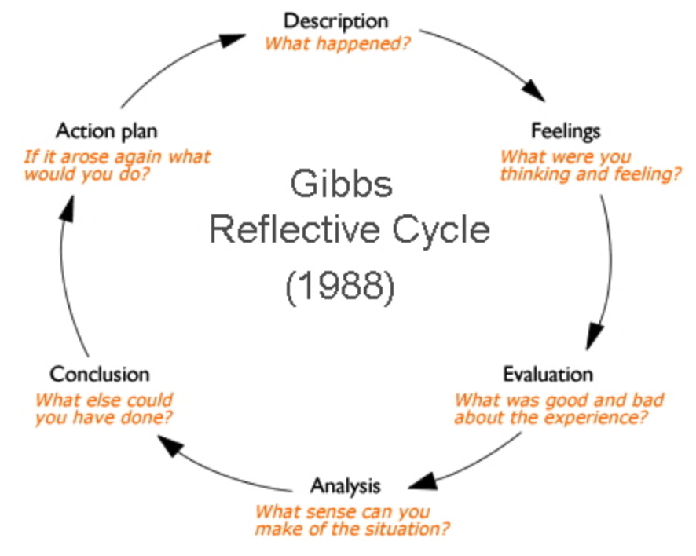

3.1 Description
In June 2020 I applied for the position of office administrator I was chosen for an interview due to circumstances this year with coronavirus the interview was carried out at home via teams and lasted approximately 40 minutes the Gibbs model (Gibbs, G. (1988) is used below to reflect upon the interview.

3.2 Feelings
Before the interview I felt apprehensive, I have never attended an online interview therefore I was uncertain as to what to expect. Initially I felt very nervous but once the interviewer and I had met and the introductions were complete I felt much more relaxed, taking turns in talking was difficult and we regularly talked at the same time, this was awkward and slightly embarrassing. Once the interview was complete, I felt much better and overall, it went well.

3.3 Evaluation
As the interview was took place at home I was not as nervous as usual, this was preferable to me. Communication with the other person was not as fluid as it would have been face to face, due to this the interview was harder and neither of us were completely sure when to start or stop talking. Normally upon completing an interview, there is a clear end and a socially accepted way to conclude the meeting. Without being physically present this was disjointed the interviewer tried to conclude as best as possible and promised to let me know the outcome. I found the farewell difficult as neither of us were familiar with internet interview etiquette.

3.4 Analysis
Overall, the interview went well, the most difficult aspect was the non-verbal communication, the fact the meeting was not face to face inhibited this greatly.
This is explained further by Adams, Albohn and Kveraga (June 2017)
“when we perceive a face, we perceive a person's mind including all its behavioural intentions and their potential consequences for us”
Because we were communicating via an online meeting platform the fluidity of the facial expressions was dependent on the Wi-Fi strength, there may have been minute non-verbal indicators that would have been visible in person, but perhaps missed altogether online. This stimulus is imperative for humans to communicate effectively and without this I believe it was detrimental to the interview. Even in the current pandemic, I would have been willing to attend a socially distanced interview, as it would have aided me in a better social connection with the interviewer. Due to the interview being conducted at home it was less formal and more personal, during our conversation one of my dogs made a whining noise, as I had shut myself away for quiet and privacy. The interviewer heard this and commented that she had the same problem when working online at home, so even though non-verbal communication was stunted we found another way to connect with a brief conversation about dogs and our love of them. Without this more personal interaction, I would have found it harder to convey my personality, I feel that if we had not been limited to time it would have benefitted me more to have to discuss this further. I use body language and hand gestures when communicating, as this was not possible, I would have felt misrepresented had we not had a personal connection thanks to my dog's interruption. Ultimately, we both found the online interview unusual and we both referred to the incongruity of the situation. It that appears that when certain aspects of communication are hampered, that we seek out alternative methods to find a likeness or a common connection.

3.5 Conclusion
Now that I have attended several on my meetings and interviews I feel better place to look for ways around the usual communication methods that we seem to do instinctively facial expressions cannot wholly be relied upon to portray feelings or to read the situation overall the intimacy of the interview was an unexpected bonus in going forward I would like to try and replicate this in future interviews where possible I also learned that I have a strong fear of the unknown but that I am able to adapt quickly to a situation where maybe unfamiliar this actually gave me reassurance in my abilities as I see this as a strength.

3.6 Action Plan
Following this interview, I have learned that I should spend more time researching the potential employer and thinking about possible questions and answers. I tend to spend a lot of time worrying about a situation and ultimately factors that I cannot influence. I need to spend more time reading about the company's person specification. I will research the S.TA.R method (National Careers, v3.0.) as this will enable me to be better prepared to answer questions as they are presented.
The interview went well and upon reflecting using the Gibbs method (Gibbs, G. (1988) I have learned a lot about my thoughts, feelings, and approach to unknown situations. I plan to implement the skills I have learned throughout this module to enable me to be better prepared in future interviews.

References

Adams, Reginald B; Albohn, Daniel N; Kveraga, Kestutis (June 2017). “Social vision: Applying a social-functional approach to face and expression perception” [online] available at: https://www.ncbi.nlm.nih.gov/pmc/articles/PMC5873322/ (accessed on 5/11/20)
Dantec, C. (2007). ‘What is your learning style?’ [online] available at: http://loc.llas.ac.uk/lob/5/standalone/index.html (accessed on 17/11/20)
Gibbs, G. (1988). Learning by doing: A guide to teaching and learning methods. London: Further Education Unit.
Helms, M.M. and Nixon, J. (2010), "Exploring SWOT analysis – where are we now? A review of academic research from the last decade", Journal of Strategy and Management, Vol. 3 No. 3, pp. 215-251. [online] available at: https://doi.org/10.1108/17554251011064837 (accessed 1 December 2020).
Honey, P. and Mumford, A. (1986a) The Manual of Learning Styles, Peter Honey Associates. [online] available at: http://www.automaticandmobilityinstruction.co.uk/files/Learning-styles.pdf (accessed 29/10/2020)
Honey, P. and Mumford, A. (1986b) Learning Styles Questionnaire, Peter Honey Publications Ltd. [online] available at: http://www.automaticandmobilityinstruction.co.uk/files/Learning-styles.pdf (accessed 29/10/2020)
National Careers, v3.0. The S.T.A.R method, [online] available at: https://nationalcareers.service.gov.uk/careers-advice/interview-advice/the-star-method Contains public sector information licensed under the Open Government Licence v3.0. (accessed 27/11/2020)
Neil D. Fleming and Colleen Mills publication, Not another inventory, rather a catalyst for reflection published in: To improve the academy, Vol. 11, 1992, Page 137. Authors Neil D. Fleming and Colleen Mills VARK 1987.[online] available at: https://vark-learn.com/ (accessed 5/11/2020)
Mindtools, 2016."SWOT Analysis: Discover New Opportunities, Manage and Eliminate Threats" [online] available at: https://www.mindtools.com/ (accessed 5 November 2020).

Appendix A

Jemma
Honey and Mumford's learning style results (Honey and Mumford, 1986b) and VARK (Flemming and Mills, 1987) questionnaire results below.

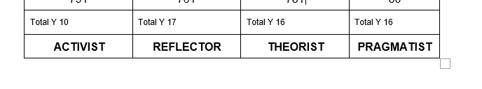
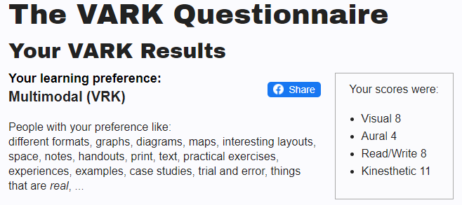
Mark
Honey and Mumford's learning style results (Honey and Mumford, 1986b) and VARK (Flemming and Mills, 1987) questionnaire results below.

Total Y 12 | Total Y 17 | Total Y 9 | Total Y 13
ACTIVIST | REFLECTOR | THEORIST | PRAGMATIST

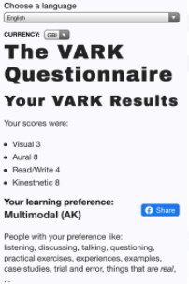

Appendix B
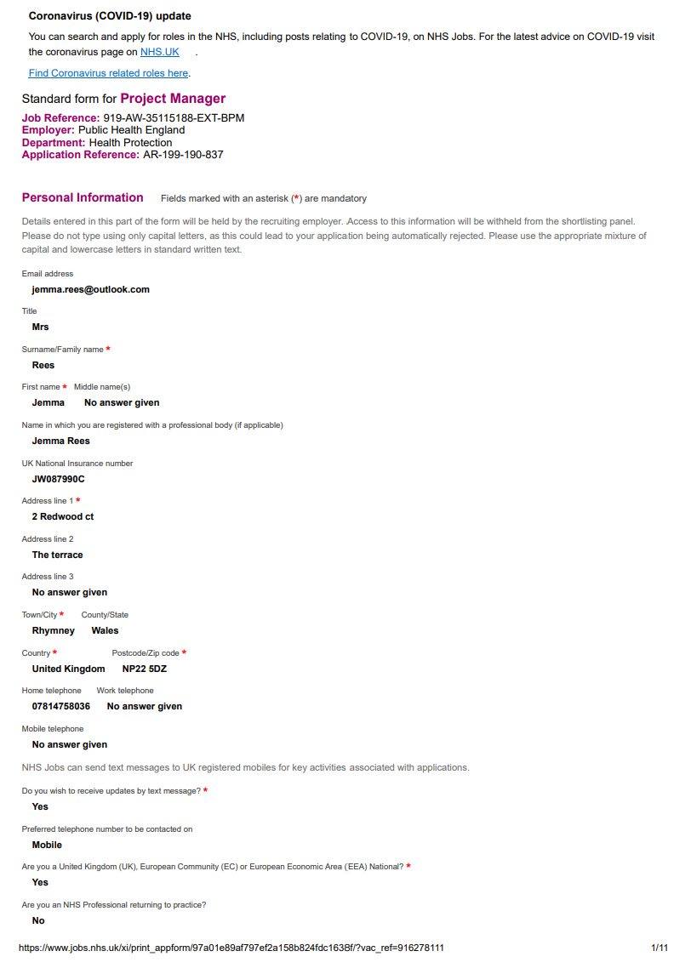
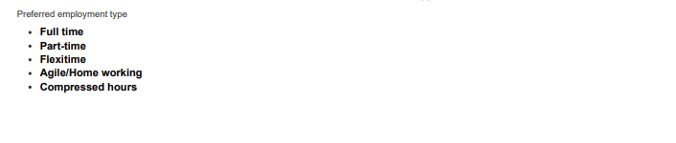
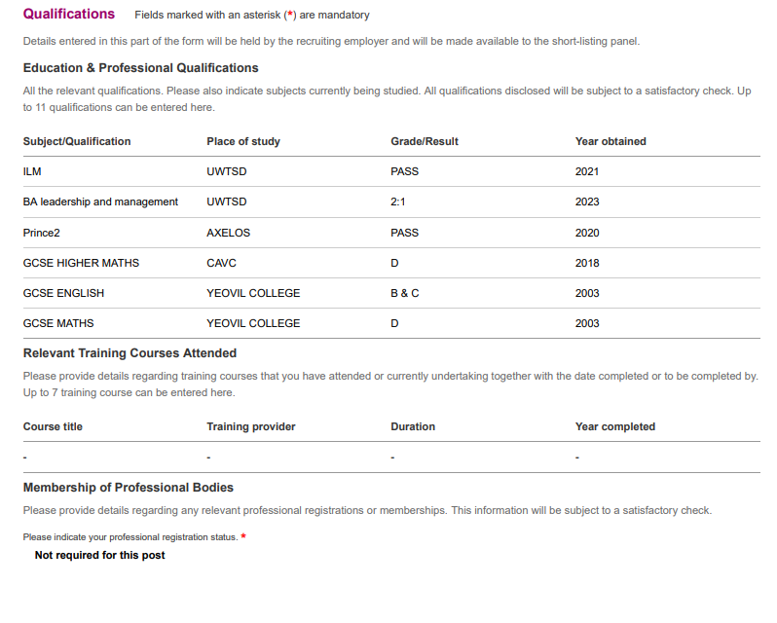

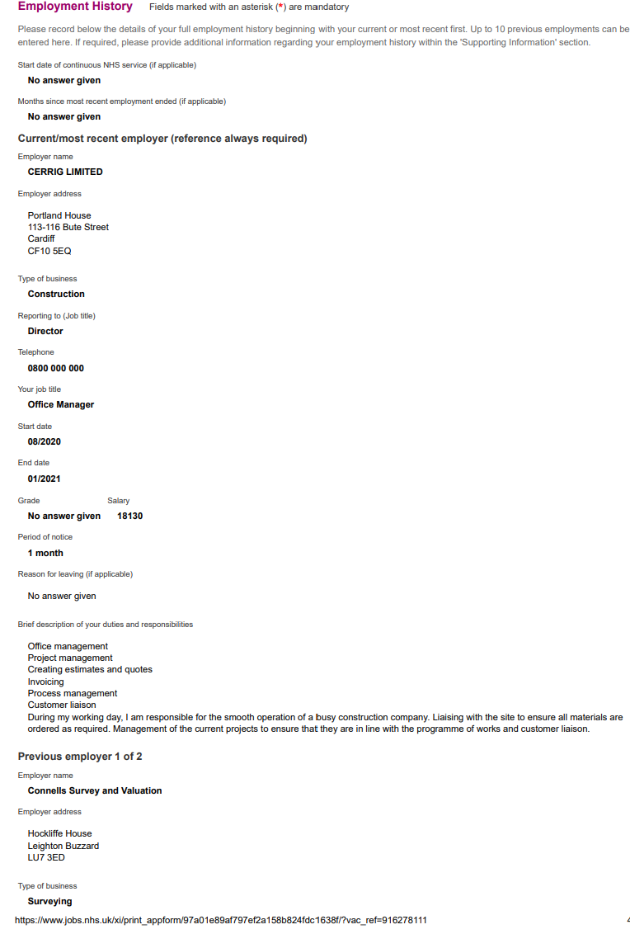
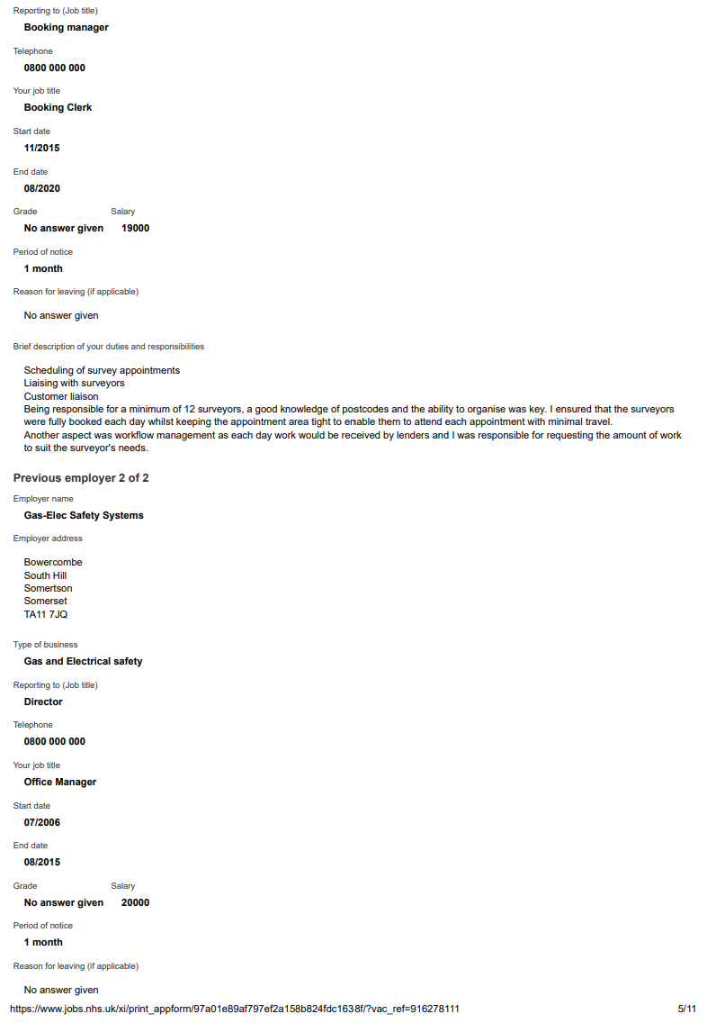
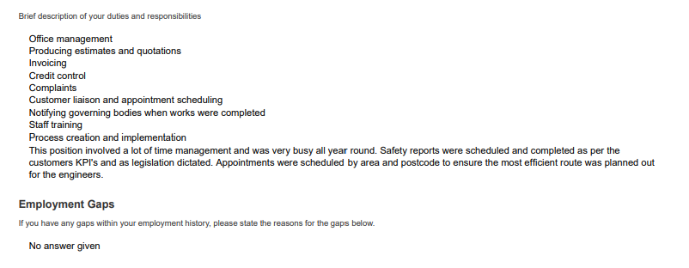

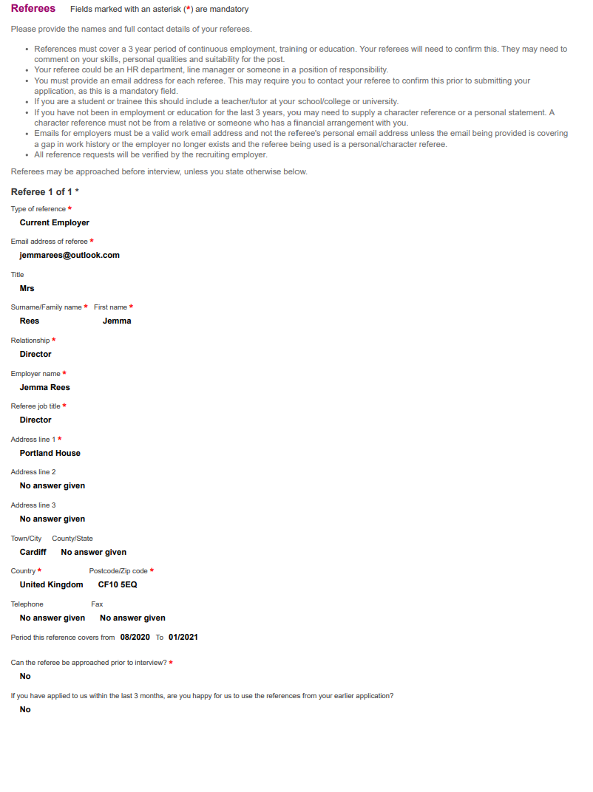

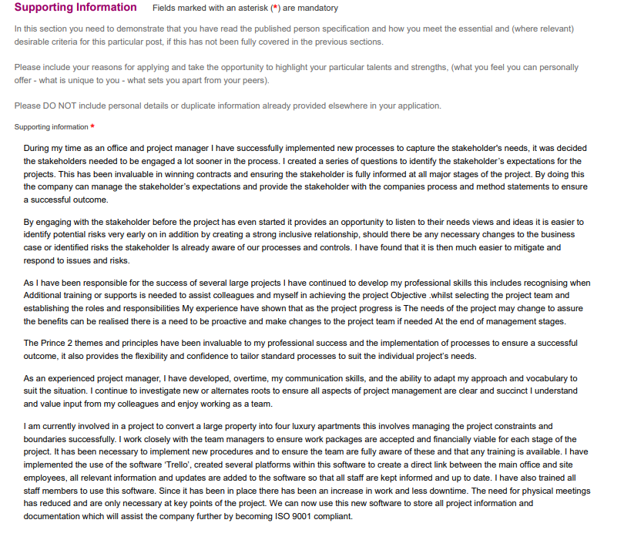

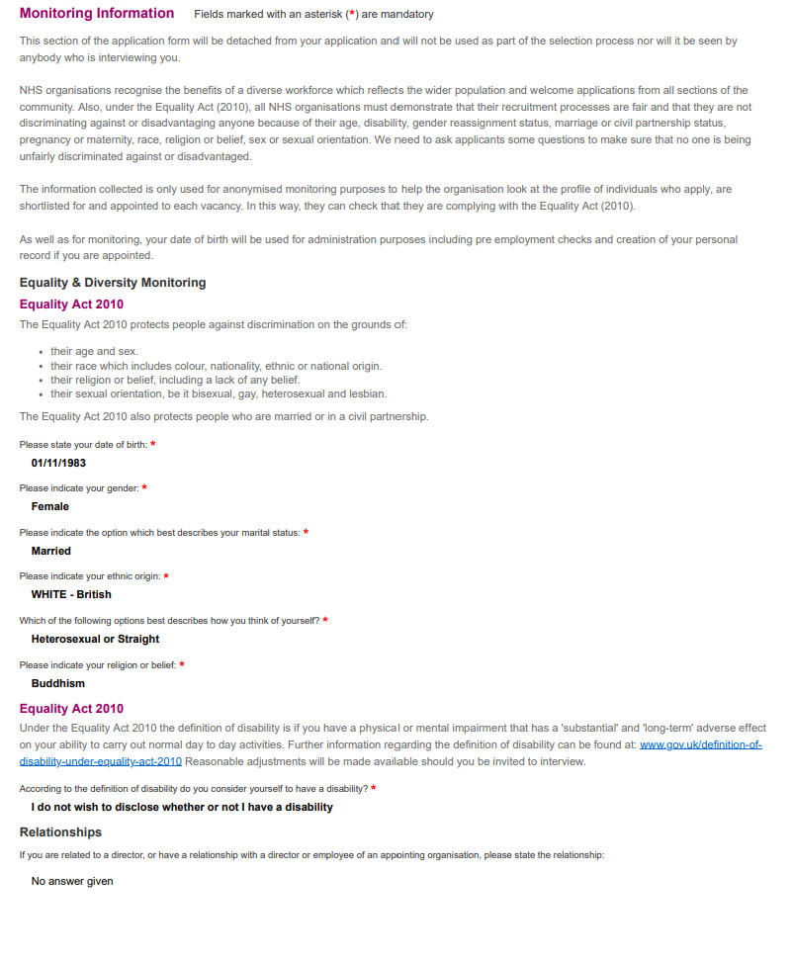
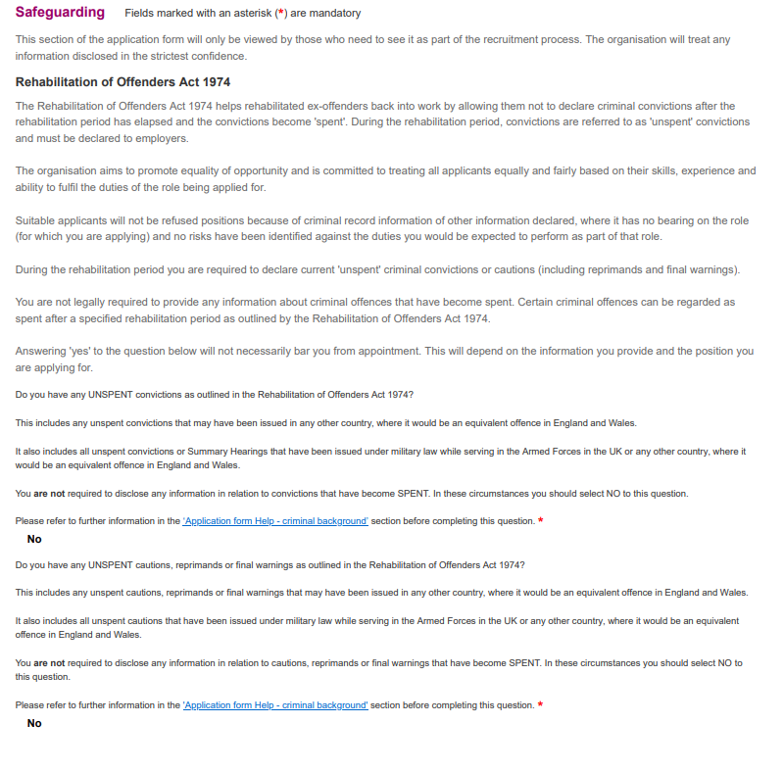

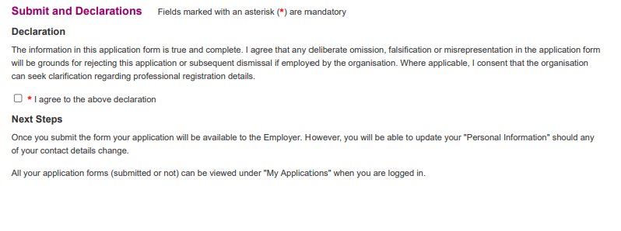

Appendix C

Jemma Rees

2 redwood Court
The terrace
Rhymney
NP22 5DZ
Telephone (mobile) 07814 758036
E-mail: jemmarees@outlook.com

Personal Profile
An accomplished office and project manager, successfully managing the day-to-day running of a busy construction and MEP company, ensuring that all projects are kept to schedule and within budgets. Qualified Prince2 Practitioner and recent graduate in leadership and management (BA Hons). I hold professional memberships with CIOB, APM & ILM.

Skills
- Highly motivated, using my own initiative to achieve the successful outcome of projects
- Team Player, assisting and leading others to ensure completion of tasks on time
- Excellent communication, negotiation, and presentation skills
- Able to organise and prioritise tasks congruously
- Computer literate in all Microsoft packages
- Training, professional development and mentoring of team members

Work Experience
Aug 2020 – Present

Office and Project Manager, Cerrig Limited, Cardiff

Currently I manage the daily running of a busy construction office and the management of their sister company PEGMIST. There are several projects running at any one time, I am responsible in managing the projects, office, and site staff to ensure the projects complete on schedule and within budget. Responsibilities include but are not limited to, take off’s, invoicing, estimating, recruitment, implementation of processes and HR functions.

Nov 2015 – Aug 2020
Booking clerk, Connells Survey and Valuation, Cardiff

I was responsible for several surveyor’s ensuring full occupation of their time, making sure that they were booked for a full day’s employment to maximise efficiency, value for money, accuracy & timeliness for each booking logistical planning was a critical skill needed to ensure the surveyors diaries were adequately booked each day. Strict adherence to service level agreements with each of our clients.
This also involved managing estate and letting agents, vendors, purchasers, and tenants to arrange suitable appointment dates and times, the company provides services to the whole of the United Kingdom,

Jan 2011 - Aug 2015
Office Manager, Gas & Electric Safety Systems, Somerset

As office manager, I was responsible for staff training, progress reviews to the companies own appraisal system. Implementing new office procedures.
I was instrumental in developing, testing, and improving a new software system for the company to manage productivity in a much more efficient way. I was also responsible for the personal management of large clients and their accounts, including their annual renewals.

May 2008 - Jan 2011
Office Administrator, Gas & Electric Safety Systems Somerset

Duties included general office administration as required, scheduling and confirming appointments for engineers to attend, database management, invoicing and answering calls. Communicating directly with the customer taking bookings and answering their enquiries. Notifying the relevant governing bodies when electrical/gas works were being carried out. I was also responsible for credit control using the SAGE computer system.

Licences

Full UK Driving Licence (No Penalty points)

Education and Qualifications

University of Wales, Trinity St David
Leadership and Management BA Hons

Axelos
Prince2 Foundation and Practitioner

English GCSE B & C
Mathematics GCSE D
Higher Maths GCSE D
IT Key Skills Level 1,2,3.
Health & Social care NVQ Level 1
Palmerston learning centre
Confidence Course Pass
Introduction to counselling Pass

Appendix D

Jemma Rees
2 Redwood Court, The Terrace
Rhymney
Tredegar,
NP22 5DZ
10/11/2020

A Price
Business Manager
Central South Consortium
Valleys Innovation Centre,
Navigation Park
Mountain Ash,
Abercynon
CF45 4SN

Dear Ms Price,

I am writing to apply for the position of project manager as advertised on Indeed. After viewing the post details and person specification, I was very keen to apply for this interesting role.

Whilst completing my degree I gained invaluable knowledge and experience within a local construction company as the office manager. Since completing my BA I have undertaken a more demanding and senior role as the project manager.

As part of my continued professional development, I regularly participate in on-line learning via CIOB, AXELOS and ILM. This enables me to not only learn the most up-to-date techniques whilst adhering to best practices but to also engage with the professional community providing access to a variety of perspectives and ideas.

Please find attached a copy of my CV for your consideration.

Yours Faithfully
Mrs. Jemma Rees

