University of Wales Trinity Saint David
BA- Business Management
Level 5 - Term 2 - Weekend
June 2022
Data Handling & Business Intelligence
Mr. Gasso Mwaluseke
LCBB5000
Assessment 2
Presented by:
Rositsa Mateva
(ID: 2022688)

Part I
Figure 1 below shows the line chart of Sales from 2009 to 2012. There seems to be no particular trend in general for the sales. In other words, Sales seem to fluctuate between 200,000 to 500,000 throughout the years of 2009 to 2012. There is no apparent overall increasing or decreasing trend throughout the entire time period.
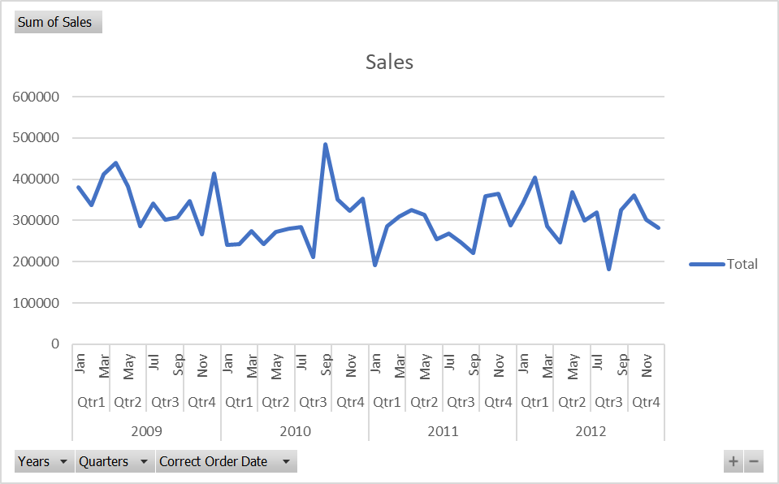
Figure 1. Line Chart of Sales from 2009 to 2012
Figure 2 below shows the line chart of Profits from 2009 to 2012. There seems to be an overall decreasing trend in profit from 2009 to 2012. The lowest profit was recorded during the 3rd quarter of 2012.

Figure 2. Line Chart of Profits from 2009 to 2012

Excel Can Load Large Amounts of Data
One advantage of using Excel is its capability of storing large amounts of data. The rows of an Excel file represent the elements or units of analysis while the columns represent the variables in a dataset. This is the staple orientation of an Excel dataset, though it still flexible, depending on the creator and user of the data made in Excel. Excel is capable of storing millions or rows of data, making it an ideal platform for data warehousing, data analysis, and data visualization. This software allows you to store a lot of data. This software has the ability to store all annual data. Additionally, this software's charts and other visualization features can be used to arrange data. With your data, you can store millions of rows.
Essential Functions for Preprocessing Data
Excel contains various functions that are indispensable to preprocessing data. Some of the most important functions are:
- IF function - this function checks a condition and returns a specified value accordingly.
- IFERROR function - this function helps in error handling. In Excel, the most common errors are #N/A, #VALUE!, #DIV/0!, #REF!, #NAME?, #NUM!.
- LEFT function - this function returns first ’n’ characters of a string.
- RIGHT function - this function returns the last ’n’ characters of a string.
- MID function - this function returns a substring of a string if we input the starting number and number of characters to return.
- FIND function - this function returns the position of the first occurrence of a substring/character in a string.
- ISNUMBER function - this function returns TRUE if a given input is a number else returns FALSE.
- ISTEXT function - this function returns TRUE if the given input is a string/text else returns FALSE.
- SUBSTITUTE function - this function replaces the ‘nth’ occurence of a substring in a string with a replacement string.
- TRIM function - this function removes the leading and trailing whitespaces from a string.
- COUNTA function - this function returns the count of non-empty cells in a range of cells.
- COUNTBLANK function - this function returns the count of the empty cells in a range of cells. This function helps in finding the count of missing values in a column.
- COUNTIF function - this function returns the count of a specified value in a range of cells. This is useful to find the count of missing values which are masked by values like 999, -1000, -, ?, etc.
Clearly, these functions are very simple to understand but once used and combined to preprocess a data in Excel, a lot of things could be done and achieved to make the data 100 percent ready for analysis. Using these functions various things could be done in a data such as:
- Finding the number of occurences of a word in a string.
- Counting the number of words in a string.
- Extracting the first words of a string.
- Extracting the last word of a string.
- Extracting the ‘nth’ words of a string (the general case).
- Min-max normalization to manipulate a range of values to be between 0 and 1.
- Discretization to convert a numerical feature into a categorical feature.
The Power of Pivot Tables for Cleansing Data
In MS Excel, pivot tables are strong and interactive capabilities that may be used to summarize, analyze, and highlight patterns and trends for large amounts of data, according to studies. A succinct report on the subsets of context-relevant data is presented by the pivot table, which in particular offers a subtotal and aggregate numeric data through filtering. Users of this reporting tool can take action quickly, which is quite advantageous in the corporate sector. The fact that pivot tables restructure and display data based on the results is a key feature. This indicates that the table adapts in line with the variables that are added to or removed from the data. Additionally, they use names and other significant data to categorize and modify charts and algorithms in accordance with the new data.
Data Manipulation
Spreadsheets make data manipulation simple. You may make pivot tables, get data from other tabs, get rid of duplicates, multiply, divide, and add datasets. You can also search all rows and columns for a particular word or parameter. However, there is a drawback to this. If you unintentionally delete some data that was necessary for a formula or computation, a spreadsheet may become irreparably damaged. It's also simple to unintentionally move data from one cell to another, and by the time you realize it, it can be too late.
Data Visualization Using Excel
Spreadsheets can be used to show data, but you need to know how to utilize them. To see your data immediately represented on a program like Excel, you simply need to visit the reporting dashboards tool. Spreadsheets may accomplish the same task, but in order to avoid errors, you'll need to know how to select the data properly. You can easily construct charts and graphs using a spreadsheet's visualization capabilities if you learn how to use them.
Business users can utilize data visualization to understand their massive data sets. They gain from being able to spot fresh patterns and data errors. Making sense of these patterns helps the users pay attention to areas that represent red flags or progress. This procedure then propels the company forward. Excel is a flexible, strong tool for professionals of all levels who want to study and visualize datasets even if it isn't visualization software per se. Some of the data visualization tools that can be created in Excel are pie charts, bar charts, line charts, histograms, area charts, scatter plots, timelines, Gantt charts, heat maps, highlight tables, and bullet graphs.
When excel is used to create Pivot tables, such tables can then be used to create Pivot Charts which are interactive in nature, thus an easy way to create interactive charts using Excel.
Making Reports Using Excel
Using Microsoft Excel's advanced version has a lot more benefits. By adding text labels to every column in the dataset, it especially enables the building of an interactive spreadsheet. Additionally, the organization is kept up to date on the business dynamics within a constrained data frame through daily or monthly forecasting reports. Excel-based dashboard reporting has enabled businesses to browse and contrast data from various sources.
Excel Has Been the Staple Software for Many Companies and Organizations
Being a pioneer in the spreadsheets industry, Excel has paved the way for companies and organizations to utilize spreadsheet in storing and keeping data, which could later be used for analysis and reports. One advantage of using Excel is that the utilization of this software has somehow become ubiquitous in today’s world. All industries and lines of businesses and services seem to make use of Excel for storing and keeping data and also for doing data analysis, visualization (through the charts and graphs that could be generated in Excel), and reporting. This is the main reason why Excel had become a requirement to almost any job that requires office work.
Excel Datasets are Easily Integrable with Other Similar Software
It is significant to note that Microsoft Excel's extended version's ability to seamlessly integrate with other software is a key element that contributes to its appeal. It has been reported that many businesses have been able to stop data loss and pin crucial information to dashboards using Business Intelligence with data and data tools available in Microsoft Office. This is done by exporting external data files and using analytical software such as R, SPSS, SAS, and others to analyze the data effectively without copying and pasting. Therefore, the ongoing production of big data has led to a fundamental divide between businesses investing in tools to analyze massive datasets and developing the technical capacity to comprehend customer perspective. The need for business analysts, data scientists, and other experts to drive the big data revolution has also dramatically expanded as a result of exploring the software's analytical capabilities. Therefore, it is possible that using extended versions of Microsoft Excel will have an effect in the near future.
Ease of Use
Another advantage of using Excel for data preprocessing and evaluation is that it is available everywhere. And by everywhere, we mean it can be accessed through your laptop, computer, tablet, and even in your mobile phone. The software is available on Windows, Mac, iOS, and android operating systems. There is even an online version where collaborations among teammates and coworkers happen.
Difficulty To Learn
There is, however, a caveat in using Excel for data preprocessing and visualization. First of all, just like other software out there for data preprocessing and visualization, Excel must be learned. People who are not familiar or versed with spreadsheet software could find learning excel a challenge and using excel a very difficult task to do. In learning excel, it is important to know where the buttons are located, memorize or at least be familiar with the formulas, and in general know the syntax and the language excel uses to interact with the user. Although learning excel is not as difficult as learning a new programming language, practice is very important and continuous usage of this software is necessary to really learn how to use it and be well versed with it.
Not Free
Excel, first and foremost, is not a free software. Other data preprocessing and visualization tools such as R are available freely to anyone. Excel however usually comes in an MS package together with its sister software MS Word and MS Powerpoint. It is not a free tool. Thus, if one need to use it for data preprocessing and visualization, one must own it. And another caveat to this is that MS Excel is actually quite pricy. Its high price tag is the main reason why only a few individuals own the software by themselves. Most workers have copies of this software through the provision of their companies. On the case of students, the academic institutions they are enrolled in are usually the ones who give legal copies and access of this software to their students.

Part II
2.1
As shown in the table and chart below generated using SPSS, 95 of the students like vanilla flavour of ice cream. This is the highest frequency among the three flavors.
ice_cream
 |  | Frequency | Percent | Valid Percent | Cumulative Percent
Valid | 1 | 95 | 47.5 | 47.5 | 47.5
Valid | 2 | 47 | 23.5 | 23.5 | 71.0
Valid | 3 | 58 | 29.0 | 29.0 | 100.0
Valid | Total | 200 | 100.0 | 100.0

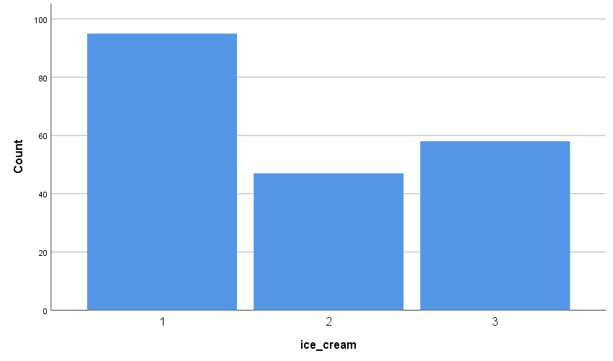

2.2
As shown in the pie chart below, there are 91 males and 109 females. There are slightly more females (54.5 percent) than males (45.5 percent) in this dataset.

female
 |  | Frequency | Percent | Valid Percent | Cumulative Percent
Valid | 0 | 91 | 45.5 | 45.5 | 45.5
Valid | 1 | 109 | 54.5 | 54.5 | 100.0
Valid | Total | 200 | 100.0 | 100.0

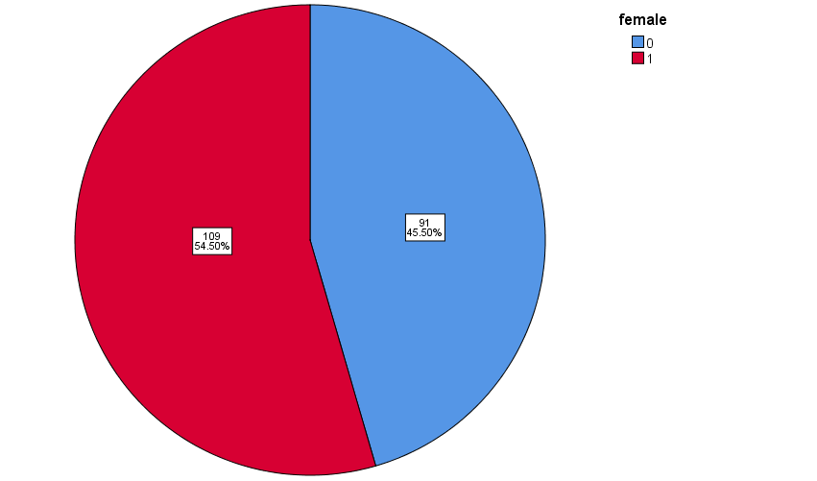

2.3
As shown below, the mean puzzle score of participants who like chocolate ice cream is 47.32 with a median of 46. The mean video score of participants who like chocolate flavour ice cream is 47.70 with a median of 47.

On the other hand, the mean puzzle score of participants who like strawberry ice cream is 57.14 with a median of 61. The mean video score of participants who like strawberry flavour ice cream is 55.45 with a median of 58.
Report
ice_cream |  | puzzle | video
1 | Mean | 52.03 | 51.71
1 | N | 95 | 95
1 | Std. Deviation | 9.973 | 8.926
1 | Median | 51.00 | 53.00
2 | Mean | 47.32 | 47.70
2 | N | 47 | 47
2 | Std. Deviation | 10.837 | 10.413
2 | Median | 46.00 | 47.00
3 | Mean | 57.14 | 55.45
3 | N | 58 | 58
3 | Std. Deviation | 9.962 | 9.795
3 | Median | 61.00 | 58.00
Total | Mean | 52.40 | 51.85
Total | N | 200 | 200
Total | Std. Deviation | 10.736 | 9.901
Total | Median | 52.00 | 53.00

2.4
The figure below shows the configuration for the K-means clustering done for the video and puzzle variables. The number of clusters set was 2.
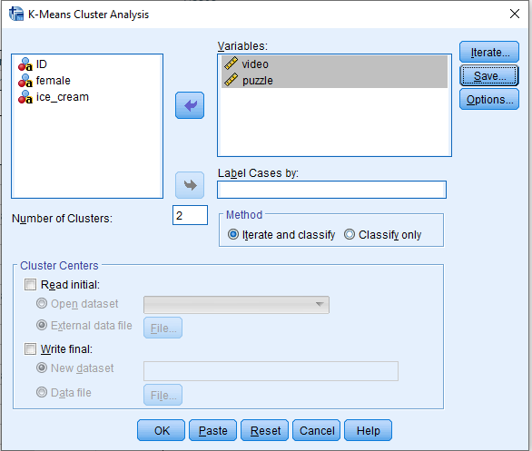

The resulting final clusters are shown below:
Final Cluster Centers
 | Cluster
 | 1 | 2
video | 45 | 58
puzzle | 44 | 60
The graph below shows the resulting two clusters. Cluster 2 has a higher value for both video and puzzle than cluster 1.
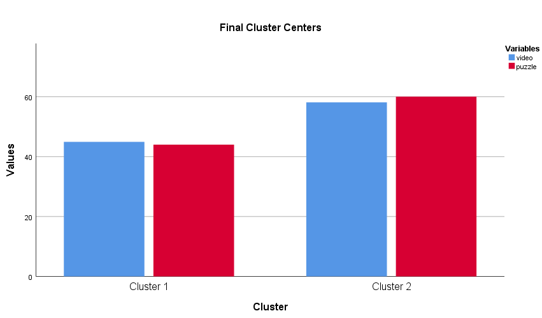

The ANOVA table below shows that both video and puzzle are significant variables for the clustering algorithm.

ANOVA
 | Cluster |  | Error |  | F | Sig.
 | Mean Square | df | Mean Square | df | F | Sig.
video | 8700.783 | 1 | 54.579 | 198 | 159.415 | .000
puzzle | 12815.244 | 1 | 51.116 | 198 | 250.709 | .000
The F tests should be used only for descriptive purposes because the clusters have been chosen to maximize the differences among cases in different clusters. The observed significance levels are not corrected for this and thus cannot be interpreted as tests of the hypothesis that the cluster means are equal.

Three clusters were also tested. The resulting configuration is shown below:
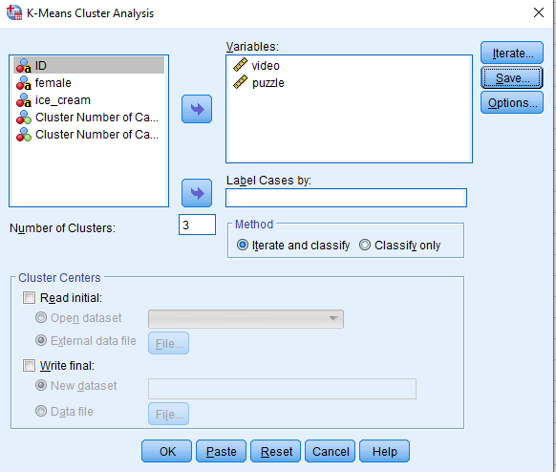

The resulting final three clusters are:

Final Cluster Centers
 | Cluster
 | 1 | 2 | 3
video | 41 | 58 | 56
puzzle | 46 | 61 | 39

The figure below shows the result for the three clusters. Although the ANOVA table shows that both variables are significant indicators for the resulting three clusters, the 2-cluster result seem to make more sense.
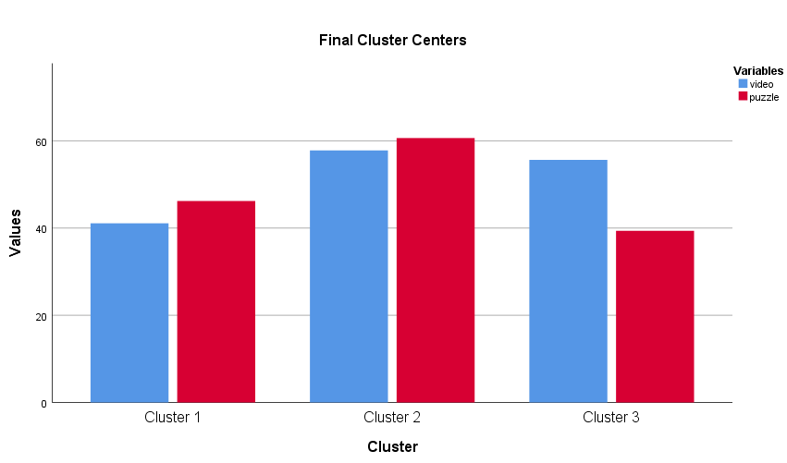

ANOVA
 | Cluster |  | Error |  | F | Sig.
 | Mean Square | df | Mean Square | df | F | Sig.
video | 5889.952 | 2 | 39.226 | 197 | 150.153 | .000
puzzle | 7430.226 | 2 | 40.994 | 197 | 181.253 | .000
The F tests should be used only for descriptive purposes because the clusters have been chosen to maximize the differences among cases in different clusters. The observed significance levels are not corrected for this and thus cannot be interpreted as tests of the hypothesis that the cluster means are equal.

2.5
The following are the data mining and text mining techniques very useful these days:
Information Extraction
The most well-known text mining method is this one. The process of separating pertinent information from enormous quantities of textual material is referred to as information exchange. Identifying the extraction of entities, properties, and their relationships from unstructured or semi-structured texts is the main goal of this text mining technique. Whatever data is extracted is then kept in a database for retrieval and access in the future. Precision and recall techniques are used to check and assess the efficacy and relevance of the results.
Information Retrieval
The practice of collecting pertinent and related patterns from a particular set of words or phrases is known as information retrieval (IR). IR systems use several algorithms in this text mining technology to watch and analyze user actions and find pertinent data as a result. The two most well-known IR systems are Google and Yahoo.
Categorization
One of the "supervised" learning methods used in text mining, this method categorizes natural language documents according to their content and assigns them to one of a predefined set of subjects. In order to find the appropriate subjects or indexes for each text document, categorization, or more precisely Natural Language Processing (NLP), is a process of gathering text documents and processing and analyzing them. In NLP, the co-referencing technique is frequently used to extract pertinent synonyms and abbreviations from textual input. NLP is being employed as an automated process in a variety of applications, including the distribution of targeted advertisements, the detection of spam, the classification of web pages according to hierarchical criteria, and much more.
Clustering
One of the most important text mining approaches is clustering. In order to arrange pertinent information into useful subgroups or "clusters" for additional analysis, it aims to discover inherent structures in textual material. The development of meaningful clusters from the unlabeled textual data without any prior knowledge of them is a significant difficulty in the clustering process. Standard text mining tools like cluster analysis help distribute data or serve as a pre-processing step for other text mining algorithms that run on identified clusters.
Summarization
The practice of automatically creating a compressed version of a certain text that contains useful information for the end-user is known as text summarization. This text mining technique aims to browse through numerous text sources to provide succinct summaries of texts that contain a significant amount of information while essentially maintaining the overall content and intent of the original documents. The numerous text classification techniques, including as decision trees, neural networks, regression models, and swarm intelligence, are integrated and combined in text summarization.

2.6
The table below summarizes the advantages and disadvantages of using SPSS and Excel with practical examples:
SPSS |  | Excel
Advantages | Disadvantages | Advantages | Disadvantages
SPSS is a comprehensive statistical software. | Not free. Expensive to purchase especially for students. | Useful for organizing data. Information can easily be placed in neat columns and rows and then sorted by information type. | Excel has micros features. Due to macros, any person can inject a virus into the Excel file and your computer will be attacked with the virus also.
Many complex statistical tests are available as a built in feature. | Users need training to be able to utilize all available features. | Tables are easy to create. | Learning this software is difficult than MS Word or any other software. There are formulas used in the software and learning formulas are harder for a newbie.
Results are easy to interpret. | Graph features are not as easy to interpret and edit like Microsoft Excel. | Tables are dynamic using pivot tables. | This software has a high price. There are many alternatives to it that you can use for creating spreadsheet files.
Data tables can be easily and quickly displayed. |  | Tables can be easily modified using calculated columns. | If you apply any wrong formula then your data will become wrong. Also discovering errors in this software is difficult. As you can store millions of records in this software so finding errors in it becomes complex.
Graphs can be generated directly from tables generated. |  | Column headers of the Excel table always stay visible | If you save a lot of data in this software then using the software becomes slow. The software will respond to user actions in a slow manner and it takes you more time to enter or view the data in it.
Expandable |  | Retrieve data deleted using the in-built User form of Excel

