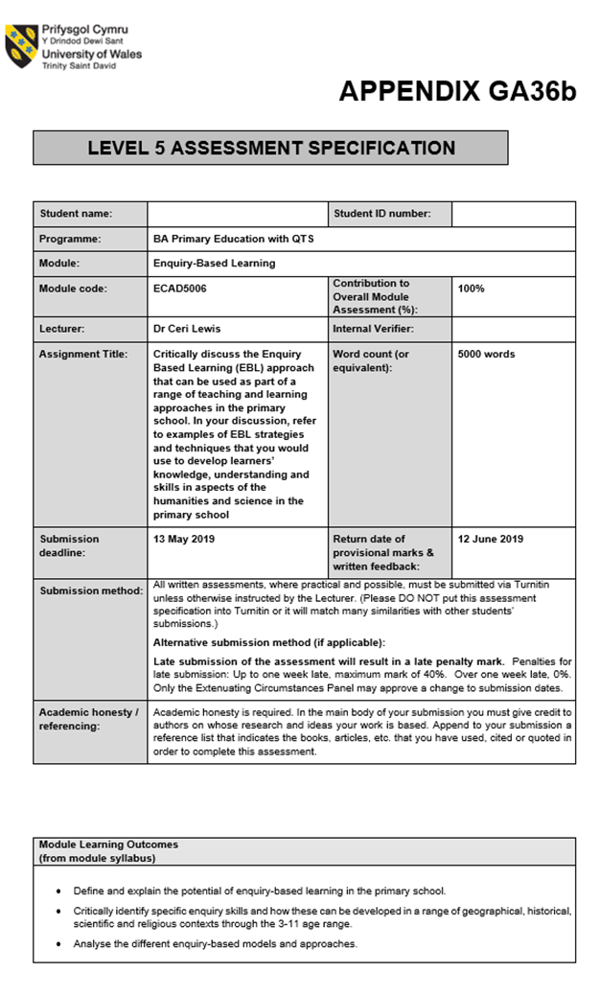
Critically discuss the Enquiry Based Learning (EBL) approach that can be used as part of a range of teaching and learning approaches in the primary school. In your discussion, refer to examples of EBL strategies and techniques that you would use to develop learners’ knowledge, understanding and skills in aspects of the humanities and science in the primary school.

Introduction
The tutor establishes the task and supports or facilitates the process, but the students pursue their own lines of enquiry, draw on their existing knowledge and identify the consequent learning needs. They seek evidence to support their ideas and take responsibility for analysing and presenting this appropriately, either as part of a group or as an individual supported by others. They are thus engaged as partners in the learning process.
(Khan & O’Rourke, 2005, p. 2)

We are a naturally inquisitive species: we peer round corners, touch the wet paint to test it, we ask questions (De Bóo, 2004). EBL is about harnessing this inquisitiveness and providing time and a platform for children to ignite this curiosity. The aim is not only for children to learn, but to enjoy the learning journey and for the knowledge to be deep-rooted. However, as noted by Cross et al (2016) curiosity should not be reserved purely for children but given to everyone searching for knowledge, a greater understanding and higher levels of skill. When utilising an EBL framework, teachers can fulfill their professional objectives through the Qualified Teacher Status Standards (QTS) S 1.3, S 1.7 and S 2.7 when they ‘motivate and inspire’, continue their own ‘professional development’ and when they provide a ‘range of strategies to establish a purposeful learning environment’ (Welsh Gov, 2009, pp. 5-8). Enquiry Based Learning (EBL) is a process of enquiry, the difference is that in EBL it is the pupil who leads their own line of enquiry, not the teacher; the teacher’s role is as a facilitator to the learning, there to introduce a topic and scaffold the learning around the child. The line of enquiry could start with a visit to somewhere there is a wish to investigate further. It could be an artefact, picture or even a sound to be discussed. The teacher could step away from the scaffolding even more and simply ask the children what they would like to discover, this works better with older children as they can construct their own learning around the enquiry.

There are six main models of EBL within the humanities; they each are suited to certain topics of enquiry, such as the humanities and sciences; although each one can be adjusted to fit in with the subject to be investigated.
The 4 Stage Model ‘The Investigative Cycle’ suits a fieldwork approach and ensures the children are fully engaged and active participants in all areas of enquiry (Samuel, 2009). The following method is followed during this model:
- Generate – A question of idea to be investigated, consideration should be given to how you will find out the answers.
- Do – Carry out research into this, through fair testing and trial and error. The teacher can help scaffold through questioning and assessment for learning (AFL).
- Analyse – Collect, process and evaluate data collected, and make sense of findings.
- Reflect – Through discussion the pupils consider what happened and why.
From this model the children should deepen and develop their understanding of topics and develop key skills for life.
The ‘Enquiry and Questioning Model’ is based on having an ‘Overarching question’ followed up by ‘Subsidiary questions’ to help answer the bigger picture. For example the first question could be ‘Why is our school here?’, to understand all of the possible reasons we could ask subsidiary questions such as: ‘Why do schools exist?’, ‘Who goes to school?’, ‘How long has it been here?’ ‘What was here before?’ etc. The research could be supported here by old photographs, a visit to the local library for more information and even a talk from a past teacher or pupil.
There is a Religious Education (RE) element to the ‘5 Stages of Enquiry Model’, although again this can be adjusted to encompass other areas of the curriculum. The stages are as follows:
- Formulating questions – The teacher supports the learners to decide what they want to find out.
- Planning the enquiry – Pupils and the teacher decide how they will conduct their research.
- Conducting the enquiry - comparing and analysing evidence.
- Presenting findings - Use a variety of methods including: creative, visual, oral, and written or holding a celebration.
- Thinking and responding – Encourage children to think of their own ideas related to the issues raised by the topic.
Ofsted highlight in their 2010 report on RE that in primary schools there are ‘weaknesses in teachers’ grasp of pedagogy; understanding how pupils’ learn in each subject’ (OFSTED, 2010, p.44). Teachers who harness this type of enquiry-based learning may see improvements in their own and their pupils’ depth of knowledge.
Michael Storm’s 5 Question Model was devised in 1989 through his paper ‘The five basic questions for primary geography’ (1989, cited in Pickford, Garner and Jackson 2013 and GeogSpace, 2009). Further stating that practitioners have adapted these geographical lines of enquiry and variations have developed since then. Scoffham and Bridge (2014) discuss how Jean Piaget first identified that young children assume the physical environment was created by humans. Further research into childhood misconceptions and the significance of this was highlighted by Howard Gardner. From these notions came more recent research into how children understand their place in the world through studying maps and places. The 5 Question Model is a useful tool in developing a line of enquiry following children’s understanding of the world and attitudes to other cultures. It can help provide structure for the teacher to support the class.
The 6 Stage Enquiry Framework follows pre-determined stages of enquiry. Scoffham (2014) notes how the stages are designed to help structure a process for enquiry; this is important as it gives freedom to creativity as there is an anchor point from which to develop an understanding (Yu-Sien Lin, 2011). This goes on to develop cognitive abilities, discussed in Gardner’s Multiple Intelligence theory (O’Niel, 1992) and supported by Sattler (1992) who states one of the intelligences is ‘global capacity to act purposefully, think rationally, and deal effectively’, this will be developed through an enquiry based approach.
- Stage 1a: Raising questions
- Stage 1b: Generating enabling questions
- Stage 2: Collecting and recording information
- Stage 3: Processing the gathered information
- Stage 4: Drawing conclusions from the processed data
- Stage 5: Sharing the learning and affective outcomes
- Stage 6: Evaluation by all concerned
This is supported by Pike (2016, p. 25), who goes on to state that enquiry based learning builds on the idea that ‘questions should frame the content of geography’. Furthermore the most important person when it comes to enabling learning is the teacher; going back to a key factor of EBL in that the teacher should be a facilitator, there to scaffold the learning, not simply to regurgitate information.
All of the EBL models have a format to follow which structures the teacher and learners lines of enquiry. This draws similarities with De Bono’s (2009) Thinking Hats technique of questioning where there is a specific focus on the intended outcome. There is also science enquiry models which are very closely linked to EBL in the nature of investigation. The science curriculum in Wales promotes thinking and communication skills, vital skills to develop in children to use in their future roles in the world. The current national curriculum also supports an EBL approach through the methodology of ‘planning, developing and reflecting’ and looks to foster:
‘curiosity and creativity and be interesting, enjoyable, relevant and challenging for the learner. They should enable learners to initiate, explore and share ideas, and extend, refine and apply their skills, knowledge and understanding in new situations. They should allow time for thinking, peer discussion and reflection.’ (Welsh Gov, 2008, p.10).

Although various models of EBL have been discussed, this paper will focus on the ‘S’ Model; this is suitable for a local-area study and something which has been a staple of primary schools for many years (Historic England, 2016). Figure 1 in appendix highlights the key areas of the ‘S’ Model, which is useful for good enquiry at all levels especially suited to the humanities. Proposed by Grigg and Hughes (2013) the ‘S’ model would be beneficial at developing children’s understanding of history and geography. From personal experience there are a lot of people who don’t have even a basic understanding of geography and their place in the world. This may well be down to teachers’ own lack of knowledge in how to deliver key ideas to develop pupils’ understanding.

EBL is a constructivist learner-centered approach with connections to social-constructivism.
Piaget, Vygotsky developed constructivist theories based on the belief that we need to activate what is already known and provide a framework to build on this knowledge (Powell and Kalina, 2009 and Sigel, & Hooper, 1969). Ensuring the jumps from one level to the next are small enough to support the learner, but large enough so that new knowledge and skills are gained. Supported by Black and Wiliam (2005) who promote assessment for learning in the classroom which ties in to this constructivist way of thinking. John Dewey theorized that the child learns best when they are doing, rather than being a passive learner, they are actively engaged in developing their understanding. Supported by Black and Wiliam (2005) who go on to state that alongside good AFL strategies, it places the child at the centre of the learning and the teacher’s focus should be on understanding the child’s interests and allowing the individual to follow the enquiry on their own path of discovery. From this the child takes more enjoyment from the learning journey as they have more ownership over it (Black et al. 2003).
EBL challenges the teacher to ‘engage with and constructively analyse the learning process’ (Lakin, 2013, p. 1) This could be seen as a challenge, but also a benefit as the teacher is developing their pedagogical knowledge and application. There are challenges due to age restrictions as the pupils need to be old enough to take on the learning for themselves. A major factor in the current climate is the availability of resources to structure and support the learning. There is scope for using assessment for learning (AFL) to accelerate progress within EBL and this can be utilised from the start of a new topic when the teacher advocates discussion of the class’ ideas. This is an idea supported within Donaldson’s (2015) 12 principles of pedagogy and supported by Black and William (1998). A benefit to using EBL to deliver a topic is that enquiry in this way can build self-efficacy, Bandura describes this as ‘a person’s sense of being able to deal effectively with a particular task’ (Woolfolk, Hughes and Walkup, 2013). It is the confidence people have in their own ability and the competence to complete projects well. Grigg (2015) notes that through development of self-efficacy comes confidence and a desire to overcome challenges, rather than see them as threatening. Donaldson (2015, p. 25) supports this in the new curriculum guidance, stating we need ‘Confident individuals: responses referring to aspects of personal efficacy and self-assurance.’ It is understood that the EBL learning methodology is not suited to all subjects taught; lessons such as math is developed through rote learning and English lessons generally follow a more formulaic process of acquiring knowledge. However, by utilizing the EBL techniques in planning humanity and science lessons, children will develop vital skills for life. These skills are found in all purposes of the new curriculum, but through EBL, children will develop to be ‘ambitious, capable learners, ready to learn throughout their lives’ (Donaldson, 2015, p. 29).

Main body
The project will focus on a year 5 class studying the Celts and Celtic life in the time of the Iron Age. To start the process of enquiry there should be an exceptional hook or introduction to grasp the children’s attention. Once there is authentic interest in the subject, the class are much more likely to be engaged in the learning and want to find out more about the topic. Prior to the topic being introduced the teacher will have visited the site themselves to talk to staff and collect information about what can be expected. They would also need to carry out a risk assessment of the location and factor in any additional learning needs (ALN) which may have an impact on the visit. For the topic of the Celts in Wales the ideal hook will be with a visit to Castell Henllys, which includes ‘expertly-recreated Iron Age roundhouses built exactly where they would have stood more than 2,000 years ago’ (Pembrokeshire Coast National Park, 2019). The site is set in stunning Pembrokeshire countryside, with a woodland walk up to the hilltop-fort. The centre provides rich experiential learning through role-play and educational activities; from this, visitors can experience what life was like in an Iron Age village. This type of class visit fits perfectly with the new curriculum for Wales, which states ‘children and young people want lessons to be relevant and engaging, with more practical lessons, more fun, more interactivity, and more out-of-classroom activities’ (2015: 17). When the topic is introduced to the class they will be informed they are going on a trip as they will need to get permission slips signed by parents/guardians in order to attend. Considering the S model, the class would work through the 4 stages of enquiry roughly in order, although there is always space to revisit a stage to evaluate and refine the process:

Select
This would start with a classroom based session where the teacher may have just said the topic name of the Celts and from this ask the children what they already know about this topic. This is a great way to develop AFL, for the teacher to understand the current level of the children’s understanding and areas where there are shortfalls. The teacher can record the feedback through a mind map on the board, notes taken by the teacher or a recording to be reviewed later. The teacher should consider Blooms Taxonomy for higher-order thinking at all stages but during this stage, the children will be using more of the lower-order thinking such as ‘remember’, ‘understand’ and ‘apply’ techniques (cited in Krathwohl, 2002). Through well-planned open questions, the pupil not only activates but also consolidates their prior knowledge. From the initial discussion the teacher, acting as a scaffolder for the learning, should ask the class what else they would like to find out about life in a Celtic tribe. Getting the children to think of questions they can ask when they are on the visit. Historical enquiry will be used to develop a chronological awareness when children are given a treasure hunt to complete. The teaching staff will have hidden parts of an Iron Age timeline around the school grounds for the children to find. Once collected they can piece the timeline together, working in mixed ability groups to build collaboration and discussion skills. They will then ‘use timelines to sequence events’ (Welsh Gov, 2008, p. 12). There are strong links to so many areas when studying this topic. This leaves the scope for children’s ideas and questions to be wide –ranging. The humanities have obvious links such as geography and the location of Celtic tribes developing ‘a sense of place and identity’ (Welsh Gov, 2008, p. 8). This geographical closeness to people of the past should foster an even stronger desire to learn. The children may bring up ideas about the Celts eating habits, leading to more of a health and science focus.

Search
The trip will be a multi-layered way for the children to experience Celtic life and develop a deep understanding of what life was like in Celtic times and why the people made certain decisions. As noted by Welsh Gov (2008), it is an important historical skill to compare and contrast our lives and the lives of those in the past. This will also harbor a sense of empathy in children as they are stepping into the shoes of their predecessors. The staff at Castell Henllys are experts in delivering a varied and rich experience, which utilizes the resources at Castell Henllys through role-play and hands-on activities. As the class walk to the hillfort they are transported back in time by the staff, who are in full Celtic dress and acting a role as a member of the Demetae tribe. There is questioning about why the tribe may live at the top of a hill, getting the children to think about the physical landscape and make further connections to the lives of these people. As the children near the entrance to the fort, there is a holding for some pigs, a chance to discuss the Celts diets and for the children to understand where their own food comes from. There is a staged attack by the Celts on site and the excitement generated is felt by all the children and cemented as experiential learning. Now the class is split into separate groups and each group will go with a member of the staff from the tribe appendix figure 2. There are four main areas to explore on site:

- The chief’s house where there is face painting and tales of war and battles. The children will learn about the Celts religious beliefs of the various gods and goddesses. This can be developed further back in school when the class complete a comprehension piece of work, covering the whole curriculum responsibilities of the LNF when they ‘show understanding of main ideas and significant details in texts’; during this task they will also cover skills around the pursuing of their own interests (Welsh Gov, 2008, p. 7). Here the children can also have a go at bread making by grinding grain into flour and mixing it with water before putting it on the fire to cook.
- The blacksmith’s work area where children can use a bellows to fan the fire and talk about the weapons that would have been made here. There is also a discussion about the move from Bronze to Iron, an important science element as well as giving context to children’s understanding of history in chronological order.
- An area where a new roundhouse is being built, here the children learn more about the walls of a roundhouse and learn subject-specific language when one of the tribe tells them about wattle and daub. The children use pliable willow branches and work as a team to weave into a wall, before applying mud to the wall using their hands. In nature, this activity is hands on and the children get a lot from it when they get their hands muddy. Some children experience an otherwise sterilized upbringing where playing outside is either not promoted by parents, so it is good to see them allowed to play with the natural world.
- The final area is a family roundhouse where the children learn about how roundhouses were built. There are links to the design and technology curriculum when they ‘develop their understanding of the made world’ (Welsh Gov, 2008, p.10). As the roundhouses were made from natural materials this is a good point to discuss the children’s ideas around sustainability and environmental issues.

Sift and Synthesise
Through previous discussions in class the children will have decided what they wish to find out more about during their visit and will have settled on the best way to record the information. Implementing the DCF they can take photographs using an ipad as there is a lot of activities to fit in and this may be the quickest way to record information to use at a later date. During the trip the teacher can be recording extra information through their own notes. These can be used back in school to help the children relive the experience and help them remember key points that they wish to explore further. When the children are back in the class they can carry out further research themselves through the use of internet sources and books provided by the teacher. When carrying out this research it is important for the teacher working with the year 5 class to highlight the importance of children using trusted sources and understanding the positives and negatives of different websites. If the children wish to understand more about this topic then there could be a discussion around the agendas of different websites, newspapers and books. From all of these various sources and their own experiences on the visit, the children should begin to develop their own understanding of life in the Iron Age and how it differs from their own. Would they prefer to live in those times and why? These debates are a good way to consolidate learning and develop children’s interest in the subject further. After the visit to Castell Henllys and further research carried out there may still be further questions to be answered. The children should be supported by the teacher to think of these themselves and given time and space to investigate these further. It is important as this stage for the teacher to question the class on what part of the trip they most and least enjoyed and why. A good activity to follow on from these ideas is a recount story; here the children will set out a story including key moments and things they enjoyed. From all of these experiences the children will begin to build a real picture of the lives of Celtic tribes in the Iron Age in their heads. This is where the real deep rooted knowledge acquisition takes place. An activity which follows on from the visit takes place in the outdoors of the school, if there is a wooded area nearby then this is ideal. Here the class will aim to build their own roundhouses. They can be split into groups or complete this as a whole class. Teamwork is naturally developed when pupils help each other carrying logs and finding branches to build their own versions of the roundhouses they saw at Castell Henllys. The children will be developing their art skills when they are asked to draw and annotate a diagram of a roundhouse. Here they can work in groups using A3 sheets of paper to all be involved in the work. Depending of the level of learner the teacher can differentiate the work by providing pupils with an outline of the roundhouse so that they can focus on the annotation to include as much information as they can.

Share
Interviews can be carried out in class between learners, these could be recorded and used to aid a presentation to the school in assembly. This could be furthered through a role-play activity, harnessing drama elements when the children dress up and recreate life for a Celtic tribe and developing higher order thinking when children create. Further work can be carried out for children to create from this project when they talk about how tribes would defend their forts in Celtic times. The class may get an idea about the use of bows and arrows and this may be the next area for discovery. There may be children in the class who have more outdoor experience than others and may have used or made a bow and arrow previously. Some of the class may have visited Perriswood archery centre, they may wish to look at pictures or research archery on the website https://www.perriswood.com/. If there are children who feel more confident doing so they could take the role of the teacher. The teacher needs to be careful who is selected and to support them in supporting the other learners. Here there can be good links to design and technology as well as science when materials and their properties are discussed and understood. The teacher could use Carroll diagrams to sort materials into soft and hard properties and why these are important. The next stage is to collect and build the bow and arrow. The class can be split into smaller groups of two or three per group. In this way collaboration is built but the children get a hands on experience in a ratio which enables strong experiences. Once the bow and arrow are built the pupils will be firing these on the school yard. Personal experience has shown that the children are so engaged by this stage that they constantly ask when they can fire their arrows. There are hazards when making the weapons as the pupils will be using sharp tools and when firing the teacher needs to explain about basic safety. Although there is a heightened risk involved, if safety measures are considered and carried out then the benefits will outweigh the risks. Furthermore children will develop in themselves an understanding of perceived risk, this is a vital skill for later life. Can record our interviews and views on the trip and send to Castell Henllys to use in promotional material for the centre. Cited in Krathwohl (2002) the end of the project is the best time to use higher order questioning from Blooms Taxonomy, the teacher should get the class to evaluate and analyze the project and carefully consider their findings, what they would keep the same and change if they were to do a similar project in the future.

Conclusion
From these experiences, the children will be using inductive reasoning by using all of the information they have gathered and understood to be their own and from it they have drawn conclusions about the general ideas which support it. The children will have had experiential learning and the hope is that this is something they will remember for their lives and subconsciously develop many skills off the back of these experiences. Once the pupil has completed the activities themselves they will be able to teach these to others, in this way skills and learning is passed down. Through these activities, pupils will develop an understanding of themselves and their place in Wales and the wider world. They will enjoy experiences outside of the classroom and develop a greater understanding of Wales in history and how that effects current issues. With a range of experiences that provide links to many subjects and areas of learning the EBL approach to education should be understood and used where appropriate to develop willing learners who can contribute to group and wider community projects. The metacognitive, physical and emotional positives of working in real environments with experiential learning have been widely researched and supported by theorists such as Vygotsky and Piaget. Further supported by Black and Wiliam in their assessment for learning approach to teaching. The new curriculum was Wales looks to promote a way for teachers to take authority over their own lessons. In this way the teacher themselves is more autonomous than in previous generations and this will have beneficial and far-reaching benefits for the whole education system. Donaldson looks to engage learners in a cross-curricular approach to learning which promotes outdoor learning and activities which are engaging and have deeper knowledge spectrums for learners. Practitioners across the country should be using enquiry based learning approaches to engage learners and provide a learning environment which lasts the test of time.

Reference list
Black, P., Harrison, C., Lee, C., Marshall, B. and Wiliam, D. (2003). Assessment for Learning. Putting it into practice. 1st ed. Maidenhead: Open University Press.

Black, P. and Wiliam, D. (1998). Inside the black box. 1st ed. NferNelson: London.

Black, P. (2005). Testing: friend or foe?. London: RoutledgeFalmer.

Cross, A., Borthwick, A., Beswick, K., Board, J. and Chippindall, J. (2016). Curious learners in primary maths, science, computing and DT. London: Sage.

De Bono, E. (2010). Six thinking hats. London: Viking.

De Bóo, M. (2004) Enquiring children, challenging teaching. Maidenhead, Berkshire: Open University Press.

Donaldson, G. (2015) Successful Futures. Welsh Government. Cardiff: Crown.

GeogSpace. (2019) Geographical inquiry. Australian Geography Teachers Association.
Available at: https://www.geogspace.edu.au/support-units/geographical-inquiry/gi-overview.html
(Accessed: 07/05/2019)

Grigg, R. and Hughes, S. (2013) Teaching Primary Humanities. Harlow: Pearson.

Historic England. (2016) Planning Outstanding Local History and Heritage Projects at Key Stages 1, 2 and 3.
Available at: https://historicengland.org.uk/content/docs/education/explorer/planning-outstanding-local-history-and-heritage-projects-pdf/
(Accessed: 08/05/2019)

Kahn, P. and O’Rourke, K. (2005) Understanding enquiry-based learning. Handbook of enquiry and problem based learning. Galway: CELT.

Krathwohl, D. (2002) A Revision of Bloom's Taxonomy: An Overview.
Available at: https://cmapspublic2.ihmc.us/rid=1Q2PTM7HL-26LTFBX-9YN8/Krathwohl%202002.pdf
(Accessed: 02/05/2019)

Lakin, L. (2013) Developing independent learning in science. Maidenhead, Berkshire: Open University Press.

Ofsted. (2010). Transforming religious education Religious education in schools 2006 ̶ 09. Available at: https://dera.ioe.ac.uk/1121/1/Transforming%20religious%20education.pdf
(Accessed:08/05/2019)

O’Niel, T. (1992) The concept of distributed intelligence in Gardner’s theory of Multiple Intelligences.
Available at: https://s3.amazonaws.com/academia.edu.documents/35264060/Gar.pdf?AWSAccessKeyId=AKIAIWOWYYGZ2Y53UL3A&Expires=1557607641&Signature=%2Btk7zybfGTuId9RDe5ymn0kt0sk%3D&response-content-disposition=inline%3B%20filename%3DGardner_s_theory_of_Multiple_Intelligenc.pdf
(Accessed: 09/05/2019)

Pembrokeshire Coast National Park. (2019)
Available at: https://www.pembrokeshirecoast.wales/default.asp?PID=264
(Accessed: 08/05/2019)

Pickford, T., Garner, W. and Jackson, E. (2013). Primary Humanities. London: Sage.

Pike, S. (2016) Learning Geography. London: Sage.

Powell and Kalina. (2009) Cognitive and Social Constructivism: Developing Tools for an Effective Classroom.
Available: https://eric.ed.gov/?id=EJ871658
(Accessed: 06/05/2019)

Samuel, E. (2009) Investigating our World: Developing investigation skills in KS2 Geography. Caerphilly: G.Ap. Publishers.

Sattler, J. M. (1992). Assessment of children (eds.). San Diego, CA: Author.

Scoffham, S. (2014) Primary Geography Handbook. Sheffield: Geographical Association.

Scoffham, S. and Bridge, C. (2014) Primary Geography Investigation. Glasgow: Collins.

Sigel, & Hooper. (1969). Logical thinking in children: Research based on Piaget's theory. London: Holt, Rinehart and Winston.

Woolfolk, A., Hughes, M. and Walkup, V. (2013) Psychology in education. Harlow: Longman.

Welsh Government. (2008) Design and technology in the National Curriculum for Wales.
Available at: https://s3-eu-west-1.amazonaws.com/hwb-live-storage/fc/e6/50/ad/019d4635aac2cfa4a9b6d629/design-and-technology-in-the-national-curriculum.pdf
(Accessed: 03/05/2019)

Welsh Government. (2008) Geography in the National Curriculum for Wales. Cardiff: Crown.
Available at: https://s3-eu-west-1.amazonaws.com/hwb-live-storage/48/69/a0/be/fea54ae8bf819f0664bb129e/geography-in-the-national-curriculum.pdf
(Accessed: 03/05/2019)

Welsh Government. (2008) History in the National Curriculum for Wales. Cardiff: Crown
Available at: https://s3-eu-west-1.amazonaws.com/hwb-live-storage/b0/fc/09/ba/29244972b0f62a9f7ecbca49/history-in-the-national-curriculum-for-wales.pdf
(Accessed: 03/05/2019)

Welsh Government. (2016) Programme of Study for English Key Stages 2–4. Cardiff: Crown.
Available at: https://s3-eu-west-1.amazonaws.com/hwb-live-storage/58/3b/33/5a/8e5c4c088b27480d80d27a90/english-programme-of-study.pdf
(Accessed: 03/05/2019)

Welsh Government. (2008) Science in the National Curriculum for Wales. Cardiff: Crown.
Available at: https://s3-eu-west-1.amazonaws.com/hwb-live-storage/b4/45/ec/d8/824b421a8c4822b0a605e0e4/science-in-the-national-curriculum.pdf
(Accessed: 03/05/2019)

Welsh Government. (2009) The Qualified Teacher Status Standards Wales 2009.
Available at: https://gweddill.gov.wales/legislation/subordinate/nonsi/educationwales/2009/3220099/?lang=en
(Accessed: 08/05/2019)

Yu-Sien Lin. (2011) Fostering Creativity through Education—A Conceptual
Framework of Creative Pedagogy. New Taipei City. National Academy for Educational Research.
Available at: https://www.researchgate.net/publication/276489233_Fostering_Creativity_through_Education_-_A_Conceptual_Framework_of_Creative_Pedagogy
(Accessed: 10/05/2019)

Appendix

Figure 1.

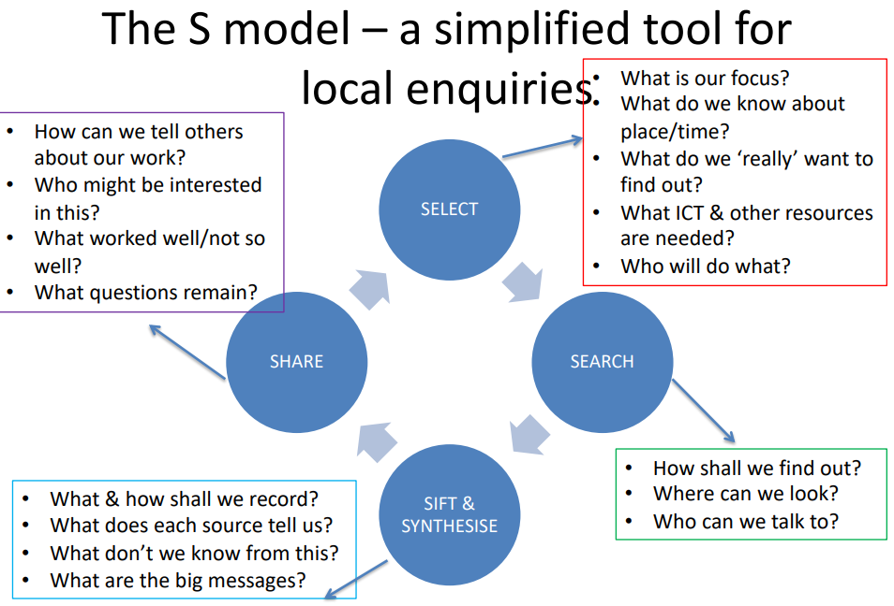

Hughes, S. (2019) Session 2 Lecture - Enquiry-Based Learning (EBL) in practice in the Humanities. Carmarthen: UWTSD

Figure 2.
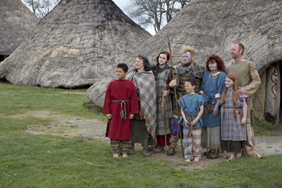 Available at: https://www.pembrokeshirecoast.wales/default.asp?PID=735
(Accessed: 05/05/2019)

