
Applied Leadership and Management in the Workplace
Module Assignment Submission
Student Name: | Danielle Dower
Student Number: | 231688
Module No: | BMSK4012
Module Title: | Enterprise and Intrapreneurship

Statement of Confirmation of Authenticity
By the act of making this submission, the student declares that this is the work of the student named above. The work has not, in whole or in part, been knowingly presented elsewhere for assessment, or where assessment has been built on Invalid source specified. assessment, this has been identified. Where materials have been used from other sources it has been properly acknowledged. If this statement is untrue, the student acknowledges that an assessment offence has been committed.
Attention is drawn to the plagiarism and unfair practice policies of both the University and of ILM.

Executive summary

Gleam Clean cleaning services.
Green and clean is the dream.
Here at Gleam Clean we are dedicated to bringing the up most professional, reliable, and friendly cleaning to your home and office. We aim use Eco friendly cleaning products that are safe for your home children and pets. We will offer a wide range of cleaning services from a small a little cleans by simple dusting hoovering dishes general clean in the home to deep cleans that will be far more exclusive to our customers tailored wants and needs. We pride our work and our services to make your life that little bit easier. Our goal is to help others while delivering exceptional services that exceed all our clients’ expectations. Gleam clean will be operating mobile and will be run primarily by myself with the hope to add staff in the next 12 months. We aim to target to working families, older generation who struggle to get around and commercial businesses. The location of this business is mobile so this will be run from our cleaning company van.
My start up fund will be £4000 and this will cover cleaning supplies and tools to use while on jobs and to secure a second-hand small van that will fit all the equipment. A uniform will also be essential for advertising and hygiene.
Our marketing strategy will be advertising on all social media platforms, word of mouth, putting business cards in local shops.

Contents
Executive summary 2
Introduction 4
Business background/idea 4
Business details 5
Legal status 5
Owner /Management team details 6
Product/service details 7
Market and competitors 7
Market overview, size and trends 7
PEST (LE) analysis 8
Swot analysis 8
Customer/target markets 9
Competitor analysis 9
Sales and marketing strategy 9
Marketing objectives 10
Marketing strategies 11
Target market 12
Pricing strategy 12
Budget and timeline 13
Operations 13
Locations/premises/equipment 13
Production and distribution process 14
People/staff/suppliers 14
Health and safety/quality control/legal compliance 14
Financial Information 0
Cashflow forecast as a minimum 0
Set-up and operational costs 0
Sources of finance/funding requirements 0
Profit & loss statement 0
Appendices 0
Evidence of market research 0
Letters from potential customers/firm orders 0
References/Previous work 2
Price list 2
Sample promotional material 3
Reference 4

Introduction
Gleam clean is a professional small friendly reliable run business in Swansea, dedicated to offering high quality competitive prices and thorough cleaning services for residential and commercial clients. Our aim is to provide high quality cleans tailored to meet our customers’ needs and wants that exceed our customers’ expectations. Our desire is to become one of the best companies in Swansea with our affordable prices and Eco-friendly products along with excellent customer service. We pride on building long term relationships with our client’s thorough trust, professionalism and integrity. Gleam cleans vision is to become a fast up and coming cleaning company within the industry and beat our competitors within the next 5 years. It was founded at the end of 2023 and promises to commit to the highest cleanliness and hygiene standers with eco environmentally friendly practices.

Business background/idea
Gleam Clean company will provide a professional service to all clients. With a passion for cleaning and high standers that will not be disappointed. When Danielle started this business, it become a passion of hers as her daughter was born 10 weeks premature and when she came home from the hospital it became almost robotic to keep somewhat sterile home it started a passion for cleaning and helping those who needed it trying to find the least harmful products that are safe for children and animals.

Business details
In the first year of business, Gleam Clean will be owned and operated by Danielle Dower who has many years’ experiences with personal house cleans and has had many house hording jobs done to the highest standards. Danielle has many regular customers who have raved reviews about high standers and professionalism.

Legal status
Gleam Clean will operate as a limited liability company as I am not solely responsible for any disadvantages that may happen, you can keep my trade name and bring anyone into the business if I chose to do so.
One of the advantages of starting a limited liability company is that it offers protection that specifically caters to the owner of that company you can sell shares in that company, Employees can own a share in the company. Suppliers are more eager to work with a limited company. Your business name is protected, and you can continue to trade even if a partner leaves.
One of the disadvantages of having a limited liability company is the legal and financial aspects the requirements and taxes will be higher. According to (Moore, 2023) limited companies pay less in tax than sole trades.

One advantage of being a sole trader is that it’s much simpler to operate and comes with less hassle. According to (Goodwin, 2022) A sole trader pays on all their profits, but you can choose to draw a regular salary, which is taxed as normal income or also earn dividends, which are taxed lower rate. You don’t need much investment with a sole trader, and you are your own boss and less admin do. However, One of the disadvantages of being a Sole trader is you must pay national insurance and income tax on any profits you make in that business, if that business has a more profitable year, then you will have to pay more tax that the year before. There are many long hours no holiday pay very limited time of with family and all the responsibility, with little access to finance. Insurance is paramount which puts your own assets at risk.

A partnership is a business where a formal agreement is met between two or more individuals who agree to be co-owners and share responsibility for the day to day running of that business. They also share the profit or loss of that organization and bare the full responsibilities if any loss incur. This business is not incorporated. According to (Shweta & Brette, 2024) A limited partnership (LP) is a business entity with at least one general partner (who has unlimited personal liability) and one limited partner (whose liability is limited to their investment in the company). The general partners are responsible for managing the business and making the business decisions to achieve the business goals.

Owner /Management team details
In the short term this business will be run and operated by Danielle Dower who has many years’ experiences within the cleaning industry who has many regular clients and high regards in her working environment. This business will be run as a limited liability company after researching all the best ways to run and operate a business having a limited liability company has been the best choice and seems the less risk going forward.
Danielle Dower will be responsible for the day to day running of this business and for the first year of business or until the business gets going at a faster pace she will work alone until the need to take on further staff if or when its needed.

Product/service details
Gleam Clean is a one-person small cleaning business operating in the Swansea area and will offer a wide range of cleaning services from residential cleans they will include Dusting, Vacuuming, Moping, General cleaning up kitchen/bathrooms making beds.
Deep clean will offer a more thorough clean scrubbing, hard marks, appliance cleaning, kitchen cupboards, sofas i.e. underneath and back of sofas.
End of tenancy cleans this will include a complete deep thorough including skirting boards, windows, top to bottom.
Commercial cleans will offer office space most common areas bathrooms and most workstations.
Specialised cleaning this package will include what the client needs and tailored to specific cleans i.e. carpet/rugs and upholstery including sofas. This can be to organize or declutter their home to the highest standard.

Market and competitors

Market overview, size and trends
According to (Council, Key facts, 2024) There are 105,00 houses in Swansea.
Also according to (insert reference) there are 38 cleaning companies in Swansea this shows that there is room for more competitors to come inti the industry and there is a demand for more cleaners in Swansea.

PEST (LE) analysis
According to (Kenton, 2024) Pest analysis political, economic, social and technological is a management method whereby an organization can accesses major external factors that influence its operation to become more competitive in the market.

Strengths: I have many years’ experience within the cleaning industry. Personalised service flexible service and strong customer base. | Weaknesses: I need to learn to be better at my bookkeeping and more organised with receipts etc. One person business so a lot of responsibility.

Swot analysis
According to (Humphery, 2005) swot analysis was invented in the 1960s by a management consultant Albert Humphery it is a basic straight forward model that assesses what an organization can and cannot do as well as its potential opportunities and threats. It’s a business strategy tool that compares to its competition.

Opportunities: The demand for more cleaners. The eco friendly market up and coming more as people taking more interest in the environment. | Threats: More established businesses that can afford to undercut me or hire more people to get the job done faster.

Customer/target markets
Our target audience and clientele is largely based on working busy families and older generation that struggle with the day to day clean of their homes. We will take on commercial cleans also but our target market will be more based on the above clients. According to (Weinstein, 2004) Marketers need to know about defining segmenting and targeting business markets, assessing customers needs, gauging the competition, designing winning strategies, and maximising corporate resources.

Competitor analysis
Other competitors in Swansea such as https://www.mrs-bucket.co.uk/

(Bucket, 2024) Mrs Bucket has been around for many years with a multi-award-winning commercial cleaning business they offer services in the public and private sector across the UK. The company was founded in 2005 by a woman named Rachel Flanagan at the impressively young age of 18. She has grown the business to the high service it is today and is a well renowned company with a huge clientele. They offer many different cleaning services including deep cleans window cleans and preventative decontamination as well as tailored commercial cleaning. They have a booking system where you can get a free no obligation quote. They offer the same service as Gleam clean but on a much bigger scale.

Sales and marketing strategy

Marketing objectives
- Build brand awareness – Building brand awareness will bring more visibility and recognition to old and new customers it establishes your cleaning company before others so the familiarity can lead to you being chosen. Trust and credibility is paramount for customer loyalty.

- Attract new customers – Attracting new customers by local advertising including flyers business cards posters in local shop windows attracts higher traffic for your business. Word of mouth is paramount for good quality reviews as knowing you have had customers that are happy with your work will encourage others to book. Social media platforms are a huge marketing advantage to getting your business recognised a platform to leave reviews speaks for itself. Offering promotions and discounts also raffles on social media for a limited offer of a 2 hour clean for a small ticket will entice more people to book as its nit a lot to lose if don’t win the ticket.

- Retain existing customers- It is crucial for the long success of your company you can encourage this asking for feedback offering special requests to the customers preference, having regular communication with your clients this can be phone calls text messaging or emails and if requested in person chats. You can offer rewards for regular clients by offering a loyalty service. Consistency with maintaining a good friendly reliable service showing respect and good time keeping within your services. Addressing any problems with grace and offering a quick resolution to what ever the issue is with honesty and respect and always maintaining a professional standard being transparent and clear communication at all times and most of all having appreciation for all your clients on small and bug jobs. Being able to adapt to any situation that may arise.

Marketing strategies
- Word of mouth
- All social media platforms
- Loyalty reward schemes
- Website
By using the above marketing strategies this will allow for the business to grow by advertising and many of these platforms are free. This is an advantage to the business and has a wide reach to different generations this will bring visibility to the company. By advertising it reaches on different interest’s locations and demographic audiences. This enables direct interaction on customer feedback and reviews this information will be vital on how to stay a success as you learn to grow along with the business. While this can be a huge advantage it is also very much time consuming by running many social media accounts engaging with customers who expect instant responses could become an issue. Negative feedback can also be a disadvantage as it’s a platform for others to see and having negative criticism can be disheartening but if handled the correct way and maintain a positive outlook, but you can’t please everyone. There is also a high competition on social media, so you must make your account stand out that bit more. Another issue with using social media as a main source of advertising is technical issues if that platform goes down then that means you are potentially losing business.

Target market

Our target market audience we would like to reach is friendly and laid-back customers who we can eventually build friendships with. With that we will also be targeting professional commercial cleans so we will alter our persona as we need to.
A persona in business is profile of a product’s typical customer. It’s a fictional business strategy to help market your business and help reach your targeted audience to understand key traits behaviours and responsibilities for a specific type of use.
According to (Dopson, 2024) Personas are a powerful tool for guiding product and marketing decisions. Every business has a target audience typically defined by demographics, age, gender, ethnic background and psychographics, such as interests, hobbies and budgets.

Pricing strategy

- Cost leaders
- Cost plus
- Differentiated pricing

By using the above pricing strategy, it helps focus on being one of the lowest cost providers on the market. By checking out other local business pricing we can then have an advantage by going I at a lower price. By cost plus It minimizes costs, such a bulk buying. Attracting customers with fair prices can lead to higher customers, being transparent with prices clients know what they are getting for their money no hidden costs. By understanding theses pricing strategy, it allows us to meet the market demands differentiate itself from our competitors and therefore have financial sustainability.

Budget and timeline
Our budget is for the day to day running of the business if we need more stock, or fuel we will have enough budget to see us through. The timeline we want to be up and running is with immediate effect. We aim to reach 3 cleaning jobs per week as initially stated but hope to reach many more by the end of the year so we have a smooth running of clients that take us to full time.

Operations

Locations/premises/equipment
We will operate this business as a mobile company as this allows us to get to each client and each commercial building in a timely manner.
The start up fund of £4000 will be used to purchase all our products in bulk up front and to secure a small reliable van with our cleaning company logo on. This will also include uniform and tools needed e.g. Hoover, Mop/Steamer bigger bulk equipment.

Production and distribution process
Our production will be run on a appointment only basis this will be done through social media and telephone/text service.

People/staff/suppliers
This business will be managed and run by Danielle Dower however if the business increases, then this will be explored at a later date.

Health and safety/quality control/legal compliance
Health and safety compliance following the rules that are regulated in the health and safety for the workplace this makes a safe working environment for employee and client. Safety compliance is defined as an ongoing process of compliance with the legislations and bodies. I have all the relevant training and in Health and safety certificates ISSA OSHA and a business license. This company will have full liability insurance and public liability.

Financial Information

Cashflow forecast as a minimum
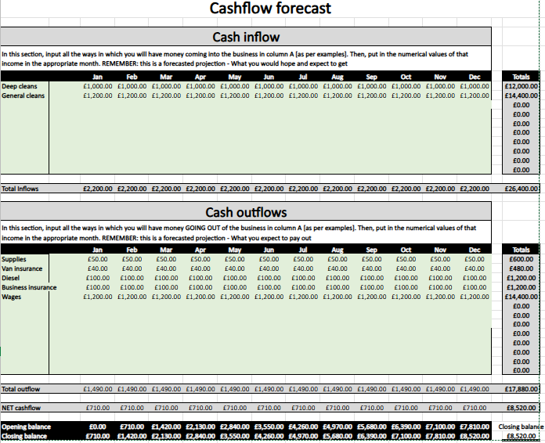

Set-up and operational costs

The start-up fund of £4000 will be used to purchase all our products in bulk up front and to secure a small reliable van with our cleaning company logo on. This will also include uniform and tools needed eg Hoover, Mop/Steamer bigger bulk equipment. I will secure this with my personal savings account.

Sources of finance/funding requirements
Other sources of a start up or investment could come from.
- Bank loan
- Investors
- Crowdfunding
- Personal loan
- Friends/family

(The investopdia team, 2024) states that all the difference among the thousands of companies in the world across varies sectors, there are only a few sources of funds available to all firms.

Profit & loss statement
Gleam Clean |  |  |  | Mission statement: |  | Afforable cleans HIgh statnders Friendly service.
Income
Deep cleans |  |  |  |  |  |  | £12,000.00
General cleans |  |  |  |  |  |  | £14,400.00
0 |  |  |  |  |  |  | £0.00
0 |  |  |  |  |  |  | £0.00
0 |  |  |  |  |  |  | £0.00
0 |  |  |  |  |  |  | £0.00
0 |  |  |  |  |  |  | £0.00
0 |  |  |  |  |  |  | £0.00
Expenses
Supplies |  |  |  |  |  |  | £600.00
Van insurance |  |  |  |  |  |  | £480.00
Diesel |  |  |  |  |  |  | £1,200.00
Business insurance |  |  |  |  |  |  | £1,200.00
Wages |  |  |  |  |  |  | £14,400.00
0 |  |  |  |  |  |  | £0.00
0 |  |  |  |  |  |  | £0.00
0 |  |  |  |  |  |  | £0.00
0 |  |  |  |  |  |  | £0.00
 |  |  |  |  |  | Gross income: | £26,400.00
 |  |  |  |  |  | Total expenses: | £17,880.00
 |  |  |  |  |  | Tax rate: | 19%
 |  |  |  |  |  | Tax amount: | £1,618.80
 |  |  |  |  |  | Earnings before tax: | £8,520.00
 |  |  |  |  |  | Net earnings: | £6,901.20

Appendices

Evidence of market research

https://www.mrs-bucket.co.uk/

Letters from potential customers/firm orders

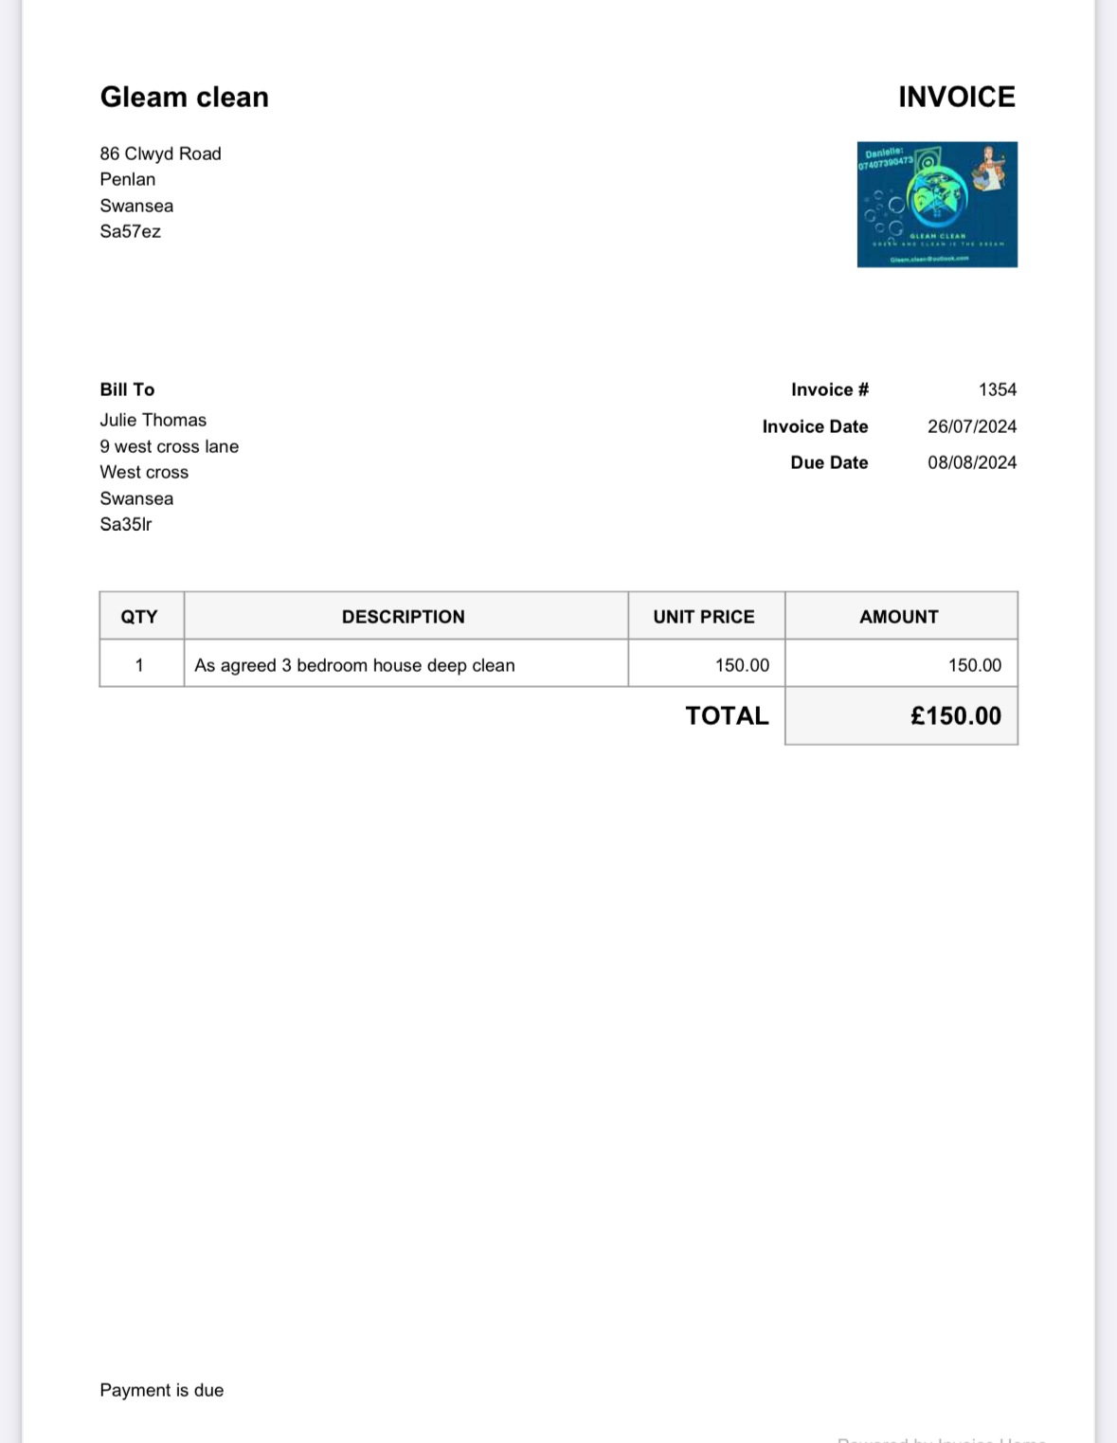

References/Previous work

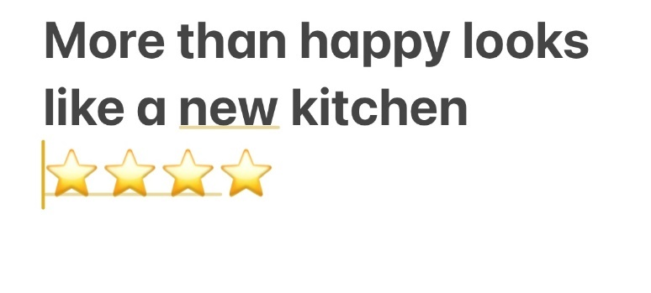
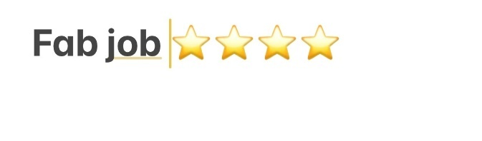
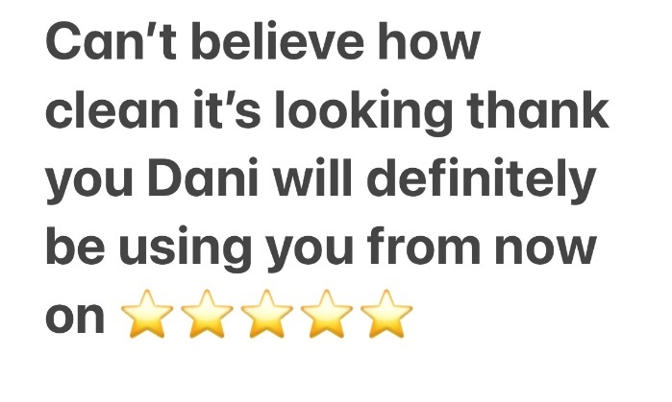


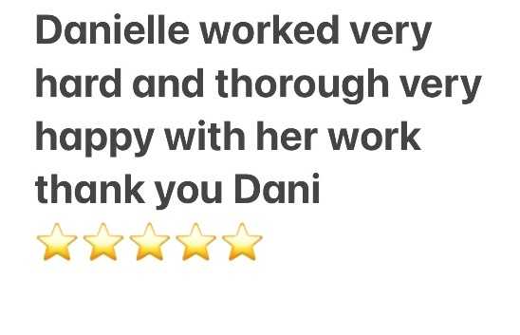

Price list
- Residential Cleaning – Regular cleaning £10-£15 per hour
- Deep Cleaning - £15-£20 per hour
- End of Tenancy Cleans - £100 - £300 depending on property size and condition
- Carpet Cleaning - £25-£50 per room
- Window Cleaning £20- £40 per room
- Commercial cleaning – Office Cleaning £12- £20 per hour
- Retail Cleaning - £15-£25 per hour
- Post Construction Clean £15-£25 per hour
- Specialised Cleaning Service/ Tailored Cleans ask for no obligation quote.
- Additional tasks i.e. Laundry, ironing will be extra ask for quote.
- Packages including 3-hour clean room of choice starts at £40
- One off deep clean service of 3-bedroom house starts at £150

Sample promotional material

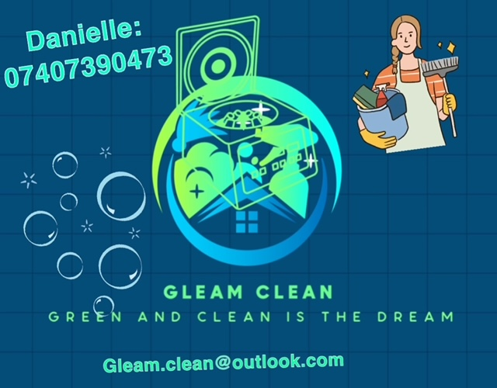

Reference
(Bucket, 2024)
(Council, Key facts, 2024)
(Council, key facts, 2024)
(Goodwin, 2022)
(Humphery, 2005)
(Kenton, 2024)
(Moore, 2023)
(Shweta & Brette, 2024)
(The investopdia team, 2024)
(Weinstein, 2004)
(Dopson, 2024)

