
Programme Name: Master of Business Administration

Module Name: Marketing Management

Module Code: LCMB7024

Portfolio: Presentation, Report, AND Reflection
Lecturer’s Name: Haoran Liu

Student Name: Patel Naitik
Student ID: 2538069

Submission Date: 14th august2026

Table of Contents
Element 1: Poster presentation 2
Element 2: STDP analysis 4
Element 3: 7P Marketing mix 8
Element 4: Reflection 10
References 13

Element 1: Poster presentation
Brief introduction
The Body Shop was established in 1976 with the principles that business can be a force for good (The Body Shop, 2025). The brand has been working to earn the trust of consumers because of cruelty-free testing, entirely vegan products, and its Community Fair Trade programme where they source small producers on fair and long-lasting terms (Javed and Mirza, 2024).
Purpose for brand extension
The next logical step in this mission is household cleaning. It is among the few unoccupied spaces in the house, and the demand is changing rapidly: according to forecasts, the global market of sustainable household cleaning will rise not only to approximately US 114 billion by 2025, but also to more than US 307 billion by 2033 (ViditGite, 2026).
Appeal of the brand extension in the existing market and its alignment with the sustainability agenda
The Body Shop Home is suggested as a refillable, vegetarian household cleaning collection based on the identical Community Fair Trade sourcing that currently supports the skincare business of the brand. Reusable bottles are replenished at in-store dispensers, and single-use plastic is reduced, without charging much higher than a regular cleaning product. To investors, the extension enters a highly growing category with assets owned by the brand already: an established ethical reputation, refill infrastructure and a customer base. To shoppers, it provides a convenient, cost-effective method to make one more room of the house more sustainable, without changing the brand or trust.
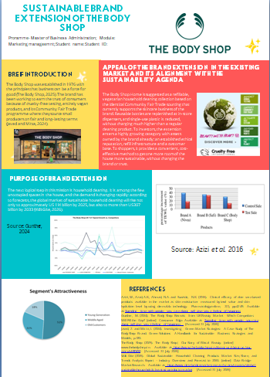

Element 2: STDP analysis
Segmentation
Segmentation separates a general market into sub-groups of consumers who have similar needs, enabling a firm to make a more specific offer (Kotler and Armstrong, 2010). In the case of The Body Shop Home, there are four variables.
Geographic segmentation: The Body Shop already sells its natural household cleaners category in the UK and Western Europe through the extensive network of owned and franchise stores, and the share of the segment revenue is the highest in these areas (Sheridan, 2024; Grand View Research, 2025). First priority is given to urban and suburban areas that have high refill-store footfall.
Demographic segmentation: The core segment is adults aged 25-44, with a higher proportion of women but with an increasing proportion of men who do their shopping, in mid-to-upper income families that can afford a small price premium for sustainability credentials.
Psychographic segmentation: The target consumer has a health and sustainability (LOHAS) lifestyle. This segment is proactive in thinking about the environment during purchasing, and at the same time it is growing cynical of unspecific green marketing; a study in the UK indicates that more than six out of ten adults would struggle with which claims of sustainability to believe (Mintel, 2025). This scepticism should influence the manner in which the extension is promoted and not only the target group.
Behavioural segmentation: Existing Body Shop customers who already use in-store refill stations to get shower gel and haircare will be the most valuable segment. These customers already exercise the refill habit, and therefore there is low behavioural switching cost of introducing the household cleaning to the refill habit. The broader category of green cleaning adopters is the secondary segment, the category that is actively expanding by approximately 10-13% compound annual (Global Market Insights, 2017; ViditGite, 2026), and is not yet a customer of The Body Shop, but is already buying eco-friendly cleaning products in other locations.
Targeting
The Body Shop Home uses a differentiated targeting approach whereby the primary target is the loyalists of The Body Shop and secondarily the wider green-cleaning market. The priority should be existing customers since they are already ready to trust the brand with its ethics, and they are used to the refill process, which means that acquisition cost will be low and cross-category loyalty will probably be high. The less expensive to purchase secondary segment is the bigger long-term growth potential since the overall household cleaning market is estimated to be over US 200 billion and is expected to grow further (Global Market Insights, 2017). By operating with a single differentiated strategy, which targets both segments, The Body Shop can defend near-term profitability, but gain (over time) access to a larger addressable market.
Differentiation
The sustainable cleaning market competitors are expert green brands like Method and Ecover, direct-to-consumer refill competitors like Grove Collaborative and more plausible supermarket own-label lines (Spark, 2025). The Body Shop Home stands out on three levels. First, provenance of ingredients: in certain instances, the Community Fair Trade programme used by the brand has supported the maintenance of thirty-year sourcing relationships with named producer communities. This provides it with the level of traceability that is difficult to duplicate by newer challenger brands (HPC Today, 2024).
Second, physical infrastructure: with refill stations established in hundreds of stores, The Body Shop already has the physical infrastructure needed to roll out the extension; online-only challengers will need to create their own distribution at first but can do so at the same time (The Body Shop, 2025).
Third, brand heritage and activism: the decades of cruelty-free and fair-trade activism that the brand has undertaken provide it with a credibility message that a newcomer would struggle to attain by advertising alone.
This distinction must, however, be demonstrated, not alleged. Studies of green brand extensions by large, established corporations reveal that consumers are able to react sceptically to such actions, especially when the environmental performance of the parent brand is not turned into tangible and provable statements (Hesse et al. 2022). The current ECOCERT-approved Community Fair Trade certification of The Body Shop thus is a key point of difference as opposed to a marketing statement due to the independent verification, which most consumers with doubts tend to believe in (Raihana and Purwanegara, 2023).
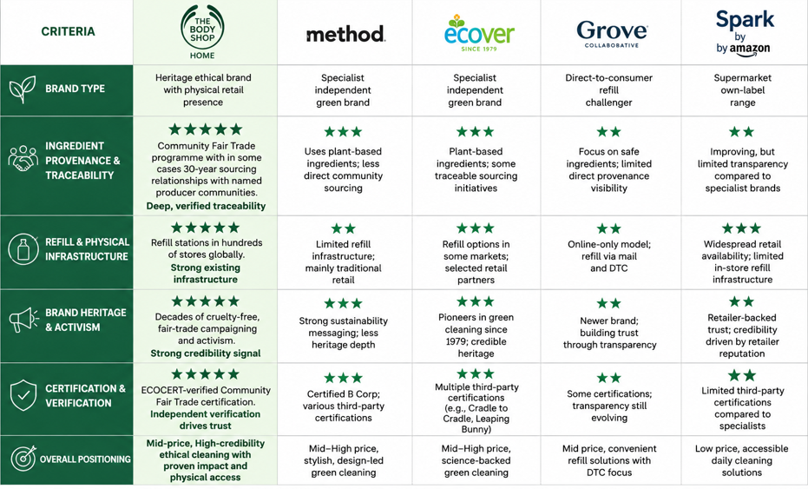
Figure 1: Competitor analysis
(Source: Self-created)
Positioning
The proposed positioning statement is: for environmentally friendly households that cannot make a trade-off between a clean house and a clean world, The Body Shop Home is the home-sourced and community-based refill cleaning collection that transforms household duties into a minor form of activism. It is a positioning that is based on benefits and integrates both a functional promise (effective, affordable cleaning) and a values-based promise (verified ethical sourcing).
On a straight perceptual map, where price is plotted on one axis and perceived ethical credibility on the other, supermarket own-label eco cleaners are located in the low-price, medium-credibility segment, premium niche challengers are located in the high-price, high-credibility segment, and The Body Shop Home is located in the middle: a mid-price, high-credibility offer. This middle position is grounded in the fact that attributes of green products and price signals are the two aspects of the green marketing mix that exhibit the strongest influence on brand attitude, compared to distribution channel selections alone (Liu and Kim, 2025). The aim to position the extension as credible but not premium and exclusive will help to address the maximum number of markets and not risk the trust that the parent brand has established in the market over nearly fifty years.
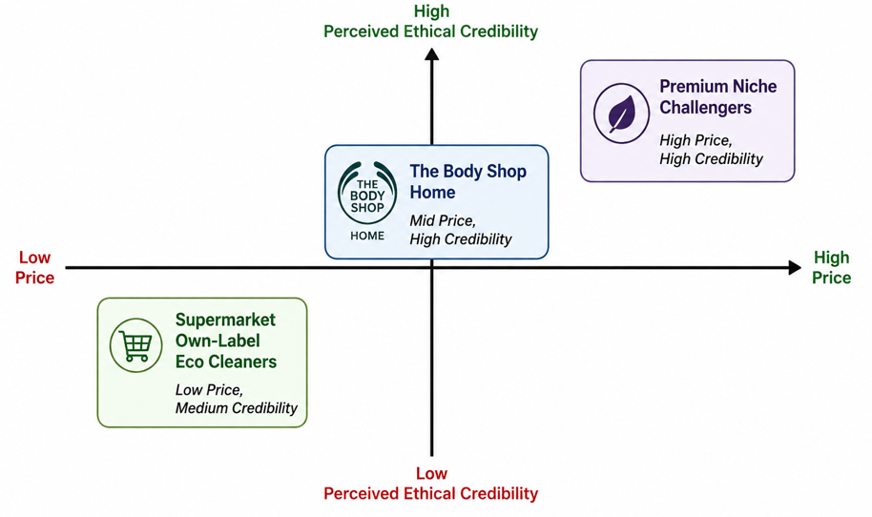
Figure 2: Perceptual map
(Source: Self-created)

Element 3: 7P Marketing mix
Product- The main product is a refillable, vegetable-based household cleaning line consisting of four starter lines: an all-purpose spray, washing-up liquid, a bathroom cleaner and a floor cleaner. They will both be developed on Community Fair Trade botanical ingredients that the brand is already familiar with, including tea tree oil and shea-derived surfactants. The biodegradable formulations are in durable and reusable bottles made of aluminium or recycled PET and are meant to be refilled and not discarded. The evidence supporting this product choice is quite robust: in a structural model of green marketing mix effects, the green product factor proved to be the most effective one to trigger the positive brand attitude among sustainability-oriented consumers (Liu et al. 2025). This is why the credibility of formulation and packaging should be considered ahead of other mix elements.
Brand fit is also dependent on range architecture. Expanding into the household cleaning area as opposed to a non-related category like food keeps the extension within the existing parent brand competencies of formulation, sourcing of ethical ingredients and personal-care retail. This limits the possibility of the adverse brand-fit responses which can arise when a famous brand extends much beyond its best-known attributes (Hesse et al. 2022). All products are created to be compatible with the refill bottle format already known to Body Shop customers, so the extension does not seem like an unrelated new product but more like a natural extension to the existing line.
Price- A modestly premium pricing is suggested; a little higher than mainstream cleaning products, but generally on a par with, or even lower than, specialist green cleaning brands, as the refill model eliminates the packaging cost per repeat purchase. Studies have shown that when environmentally conscious customers perceive the premium price as either a sign of an actual added value, like certified sourcing or improved environmental performance, and not due to the label itself, they are usually ready to pay that higher price (Thompson et al. 2009). This makes The Body Shop more resistant to the price sensitivity and scepticism surrounding less credible green brands since the premium is based on a genuine, independently audited sourcing programme and not a marketing statement (Mintel, 2025).
In the long term, with an increase in volumes of refills and further reductions in packaging costs as compared to those of competing single-use products, it is possible to reduce the price difference with mainstream cleaning products even more. This is important strategically since the entire household cleaning market is price sensitive and is expected to continue expanding steadily even beyond its sustainable segment (Global Market Insights, 2026). A pricing model where the premium begins as a values-based but moves toward a mainstream price point with scale provides the extension with a viable path to the larger, price-sensitive market segment without having to compromise its ethical image (CaputiTornelli, 2026).
Promotion- Promotion builds on the existing storytelling content of the brand, instead of a traditional advertising launch. The Body Shop already has an estimated 20 million followers on social platforms, and in-store workshops where the origin stories of ingredients are explained are already a part of its marketing (Sheridan, 2024). In the case of The Body Shop Home, this would mean brief, informative content that demonstrates the origin of cleaning ingredients and the process of refilling the product, backed by the ECOCERT certification of the brand. This strategy deals directly with the threat of greenwashing claims: since ambiguous environmental claims have been shown to undermine trust and reduce repurchase intention, promotion is developed on the basis of specific, verifiable statements, and not general claims of being green.
Place- Distribution takes advantage of the already existing refill stations of the brand, which the company has already been implementing in the store estate, eliminating the necessity of new physical infrastructure. This is topped with a post-refill pouch service to customers who are not within the convenience store range, and gradual expansion into the network of more than seventy markets of the brand. This is a blend of owned, franchise and digital channels. The main channel used is physical retail, which is a planned strategic decision: it turns an existing operational asset, refill stations designed in terms of other product lines, into a launch advantage that the online-only green clean competitors do not possess (Gauri et al. 2021).
People- There are two groups of people at the centre of delivery. In-store personnel are also trained to be refill assistants and informal sustainability educators, capable of telling the Community Fair Trade story behind the range at point of sale, as front-line employee credibility on a claim is often what turns a curious customer into a first-time buyer. In the background, the extension will tap into the current ethical sourcing team at the brand that already has Community Fair Trade relationships of up to three decades with ingredient producers (HPC Today, 2024). Expanding this proven sourcing capacity to cleaning ingredients, instead of creating a new supply chain, minimises cost and reputational risk. This implies that the process of new supplier vetting can be based on a governance model that the company has tested over a long period of time.
Process: The customer process is made easy; a shopper can take a reusable bottle or can borrow one in-store, fill up at a special station and pay depending on the volume dispensed. Hiding behind this uncomplicated front-end is a more intricate traceability procedure. It will trace every ingredient of Community Fair Trade producers to shelf, which follows the four principles of sustainable packaging already adopted by the brand. The brand commitment is in line with the compostable or refillable design, application of renewable materials, and application of recycled materials in cases where refill is not possible (The Body Shop, 2024). The aim of maintaining the customer-facing process straightforward, with the supporting sustainability process being more stringent, is to ensure sustainable choice is the effortless option as opposed to the difficult one.
Physical evidence- Physical evidence encompasses the visible structure of the refill stations, the reusable bottles themselves and on-pack ECOCERT certification marks that render the sourcing claim tangible instead of abstract. This is important since, when there are no reliable physical or verifiable indicators, environmentally conscious customers will be more likely to doubt the claims of a brand in the long run (Raihana and Purwanegara, 2023). Physical evidence thus acts as a signal of trust which reinforces the positioning created: a brand that is believable with its claims visible and verifiable, rather than merely declared.

Element 4: Reflection
The process of creating a sustainable brand extension strategy for The Body Shop was a very useful experience in bridging the gap between classroom theory and a live, contestable business issue. Beginning with the Brand Development Strategies matrix, I needed to be specific about the type of growth that I was in fact proposing. The Body Shop Home could have been casually characterized as a new sustainable product, though the deliberate placement in the brand-extension quadrant, an established brand in a new product category, helped me to understand which risks and opportunities I had to research: brand fit, image transfer, and the fact that consumers would view the move to sustainability within a large, established company as suspicious, not enthusiastic.
The aspect of the task which altered my thinking about strategy the most was the STDP analysis. Prior to this assignment, I considered segmentation and positioning very different processes. Their construction on one actual brand clarified the degree of interdependence between them: the segment of the psychographics I selected, the sceptical yet values-driven consumers, directly influenced the positioning statement and, consequently, the promotion strategy as a component of the marketing mix. I was forced to also face one I had not anticipated: that big brands that seek to go green with extensions are often met with more consumer scepticism rather than less due to their size and current reputation (Hesse et al. 2022). Including that crucial evidence, and not relying solely on data that gave me my original idea, was a valuable exercise, and it made the finished strategy lean towards demonstrable points of proof like ECOCERT certification, and not vague statements about sustainability.
The study and implementation of the 7Ps mix helped me understand a distinction between describing a marketing mix and justifying one. My initial product and promotion sections just told what The Body Shop Home will do. Restating them in a more evidence-based manner, such as rewording the discovery that green product attributes are the most significant source of brand attitude, made the recommendations much more justifiable and, I believe, more convincing to a sceptical reader like an investor or examiner (Liu and Kim, 2025).
The most challenging aspect of this portfolio to me was preparing the poster presentation as I find it easier to write at length than compress an argument into a tight, spoken three-to-five minutes of oral delivery. Reducing the entire strategy to a 200-word script meant that I had to decide what one idea was the most important; here, the extension converts assets. The Body Shop already possesses a new category, which has rapid growth, and to do away with supporting detail which, although interesting, was not needed in the first hearing of the idea (Indian Retailer Bureau, 2026). It is a transferable professional-practice skill in that the senior stakeholders do not often have the time to go through the entire analysis; they need the headline argument expressed in a very clear and concise manner.
Looking forward, I realise there are two areas to improve. To begin with, at the present stage of analysis, I have performed solely secondary research; a more robust incarnation of this project in the future would involve primary research, like a brief consumer survey, to directly test the willingness to pay and response to the proposed positioning statement, as opposed to the literature in the surrounding area. Second, I would like to feel more confident in the timed, oral delivery to ensure that presentations are practised to be paced as much as the written argument is proofread. Comprehensively, this portfolio has not only reinforced my strategic marketing knowledge but also my capacity to concisely present a business case, which I project I will call upon directly in the future when engaging in professional practice.

References
Caputi Tornelli, N.J. (2026). Valuation of firms in IPO and M&AS field lab: macroeconomic analysis of birkenstock’s IPO. [online] Handle.net. Available at: http://hdl.handle.net/10362/203041 [Accessed 31 July 2026]
Gauri, D.K., Jindal, R., Ratchford, B., Fox, E., Bhatnagar, A., Pandey, A., Navallo, J.R., Fogarty, J., Carr, S. and Howerton, E. (2021). Evolution of Retail formats: Past, present, and Future. Journal of Retailing, 97(1), pp.42–61.
Hesse, A., Bündgen, K., Claren, S. and Frank, S. (2022). Practices of brand extensions and how consumers respond to FMCG giants’ greening attempts. Journal of Brand Management, [online] 29(29). doi:10.1057/s41262-022-00274-w
Household Cleaning Products Market Share and Statistics - 2027. (n.d.). [online] Global Market Insights Inc. Available at: https://www.gminsights.com/industry-analysis/household-cleaning-products-market [Accessed 31 July 2026]
Indian Retailer Bureau (2026). Retail India News: The Body Shop Expands Delhi Network with New Store. [online] Indian Retailer. Available at: https://www.indianretailer.com/news/retail-india-news-body-shop-expands-delhi-network-new-store [Accessed 31 July 2026]
Kotler, P. and Armstrong, G. (2010). Principles of marketing. Pearson education.
Liu, X. and Kim, D. (2025). The Effect of Green Marketing Mix on Outdoor Brand Attitude and Loyalty: A Bifactor Structural Model Approach with a Moderator of Outdoor Involvement. Sustainability, 17(9), pp.4216–4216. doi:10.3390/su17094216
Liu, X., Kim, T.-H. and Lee, M.-J. (2025). The Impact of Green Perceived Value Through Green New Products on Purchase Intention: Brand Attitudes, Brand Trust, and Digital Customer Engagement. Sustainability, 17(9), p.4106. doi:10.3390/su17094106
Mintel (2025). The Clean Beauty Market & The Rise of Conscious Cosmetics | Mintel. [online] Mintel. Available at: https://www.mintel.com/insights/beauty-and-personal-care/conscious-cosmetics-the-rise-of-clean-beauty/ [Accessed 31 July 2026]
Natural Household Cleaners Market Size, Share | Industry Report, 2025. (n.d.). [online] www.grandviewresearch.com. Available at: https://www.grandviewresearch.com/industry-analysis/natural-household-cleaners-market [Accessed 31 July 2026]
Panel discussion on Sustainability in the cosmetics industry - Experts - Body Shop - HPC_TODAY_5_2024. (2024). [online] H5mag.com. Available at: https://tks-hpc.h5mag.com/hpc_today_5_2024/panel_discussion_on_sustainability_in_the_cosmetics_industry_-_experts_-_body_shop [Accessed 31 July 2026]
Raihana, J. and Purwanegara, M.S. (2023). Exploring The Impact of Perceived Greenwashing on Repurchase Intention of Green Personal Body Care Products. Indonesian Journal of Business and Entrepreneurship. doi:10.17358/ijbe.9.1.152
Sheridan, N. (2024). The Body Shop Marketing Strategy 2024: A Case Study – Latterly.org. [online] Latterly.org. Available at: https://www.latterly.org/the-body-shop-marketing-strategy/ [Accessed 31 July 2026]
Spark, M. (2025). Europe Eco Friendly Cleaning Products Market Size. [online] Marksparksolutions.com. Mark & Spark. Available at: https://marksparksolutions.com/press-releases/europe-eco-friendly-cleaning-products-market-size [Accessed 31 July 2026]
The Body Shop (2025). The Body Shop| Our Story of Ethical Beauty. [online] www.thebodyshop.in. Available at: https://www.thebodyshop.in/about-us/about-us/our-story/e/e80450 [Accessed 31 July 2026]
Thompson, D.W., Anderson, R.C., Hansen, E.N. and Kahle, L.R. (2009). Green segmentation and environmental certification: insights from forest products. Business Strategy and the Environment, 19(5), pp.n/a-n/a. doi:10.1002/bse.647
Vidit Gite (2026). Global Sustainable Household Cleaning Products Market Size, Share, and Trends Analysis Report – Industry Overview and Forecast to 2033. [online] Data Bridge Market Research. Available at: https://www.databridgemarketresearch.com/reports/global-sustainable-household-cleaning-products-market [Accessed 31 July 2026]

